Preliminary
Design

MedITrak

Visual Design Technologies

December 2, 2003

Prepared by: Kenneth Abbatiello
Peter Kitz, Team Leader

Ryan Krisolofsky

Ryan Newsome

Anthony Puglisi

Brett Rhymestine

MedITrak
Preliminary Design

Table of Contents

1.0 Scope

Section 1.1: System Objectives 2
Section 1.2: Hardware, Software, and Human Interfaces 2
Section 1.3: Major Software functions 2
Section 1.4: Externally defined database 2
Section 1.5: Major design constraints and limitations 3

2.0 Design Description

Section 2.1: Data Description 3
Section 2.1.1: Review of data flow 3
Section 2.1.2: Review of data structures 3
Section 2.2: Derived program structure 39
Section 2.3: Screen Shots 40

3.0 Modules

Section 3.1: Processing Narrative 72
Section 3.2: Interface Description for Blackboard 78
Section 3.3: Health Professions Website Module 79
Section 3.4: Health Professions Website Screenshots 81
Section 3.5: Data Organization 82

4.0 File Structures and Global Data

Section 4.1: External File Structure 83

5.0 Cross Referencing 84

6.0 Appendix

Section 6.1: Updated Gantt Chart 85

Section 6.2: Glossary 86

1.0: Scope

1.1 - System Objectives

MediTrak will use the Blackboard Information System to set up six different class categories for the Health Professions. Each User/Student will be able to register in one of the following six categories: Pre-Med, Pre-Dental, Pre-Optometry, Pre-Vet, Physical Therapy, and Physician’s Assistant. Each user will be able to modify and add content only to their account on the Blackboard database. MediTrak will help organize and keep track of the progress of each Health Profession’s student as they seek admission in graduate programs in the Health Professions. User/Student accounts will have limited access in the Blackboard system. The Administrator account will have access to all user accounts on MediTrak and will have access to create, modify, and view each student’s progress throughout their academic careers at Siena.

The Health Professions website will be used as a reference for the Health Profession students and all external users interested in the Health Profession career fields. The site will be maintained and kept up to date by Dr. LaRow and staff to remind students of deadlines and other news items of importance.

1.2 - Hardware, Software, and Human Interface

Blackboard’s System will be configured and used for our MediTrak project. All the data stored in Blackboard by the User and Administrators will be saved on Blackboard’s Database. All users will work on the system through a web browser, Internet Explorer 6.0 and Netscape Navigator 7.0, since Blackboard will be accessed through a web interface.

1.3 - Major Software Functions

Blackboard and the Health Profession’s web site will give Dr LaRow functionality. MediTrak will give Dr LaRow an electronic means to keep track of the Health Profession’s students he advises. The different features in the control panel of Blackboard will give Dr LaRow the functionality needed to keep track of his student’s progress.

1.4 - Externally Defined Database

MediTrak will use Blackboard’s Database, which is built into the Blackboard system.

1.5 - Major Design Constraints and Limitations

A major constraint for developing MediTrak is the limited flexibility we have to totally customize the system to the needs of the Health Professions. Blackboard is the creation of another development team; we may only configure and work within their system to accommodate our needs for MediTrak. Time is another constraint the development team of MediTrak is facing, since each phase of the project must be completed by its appropriate time on the project time line we have provided our clients.

Design Description

2.1 Data Description

The MediTrak system is configured to allow two different types of users, students and the administrator, to send and receive Health Professions information through the Blackboard web-based system. What follows are our Data Flow Diagrams, which begin at the Context Diagram. This diagram shows the basic interaction of our two types of users with the MediTrak system. From there, additional detail is provided as needed through our many detail diagrams. The “level” of the diagram indicates the level of detail.

2.1.1 Review of Data Structures

All data structures within MediTrak will be provided and managed by the Blackboard Information system.

2.1.2 Review of Data Flow

Represents the flow of data.
Represents the user(s) of the software system.
Represents a process or task that will be performed by the software.
Represents the object that will store the data.
Legend:

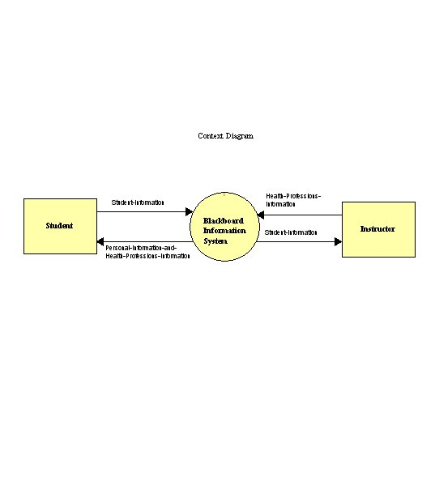
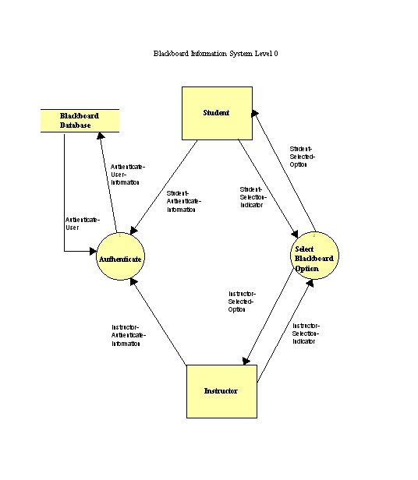
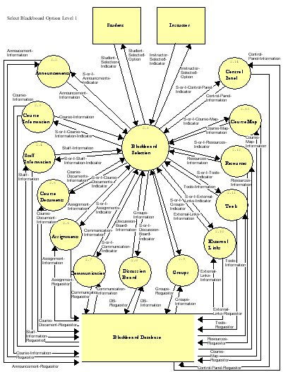

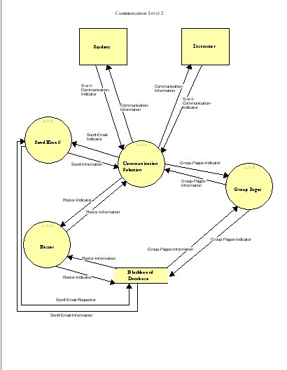

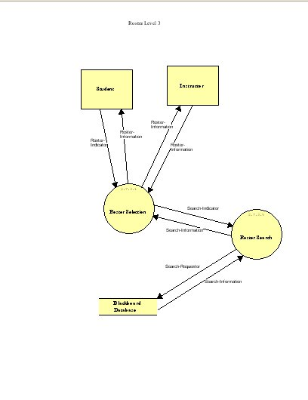
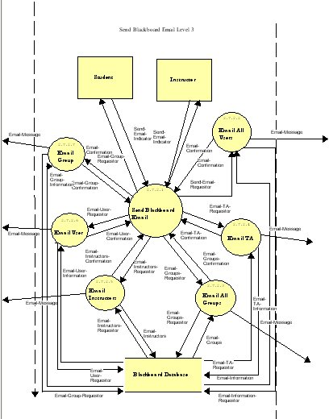
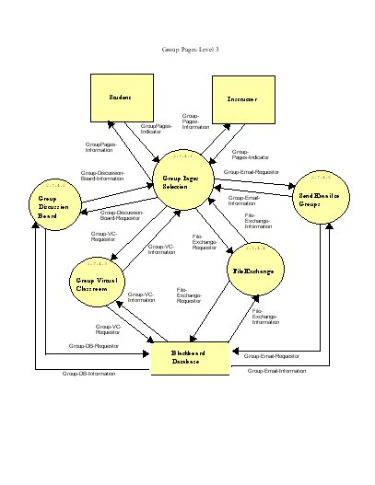
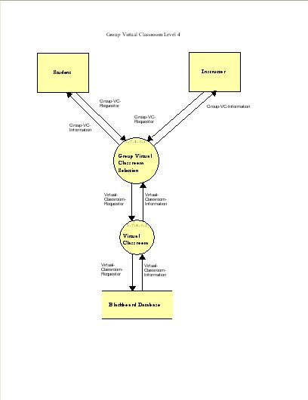
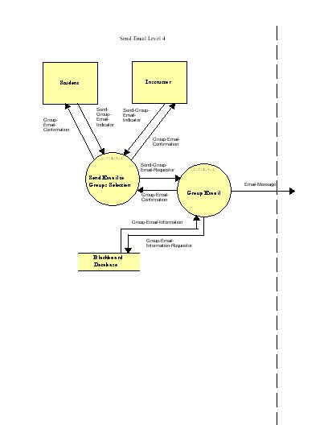
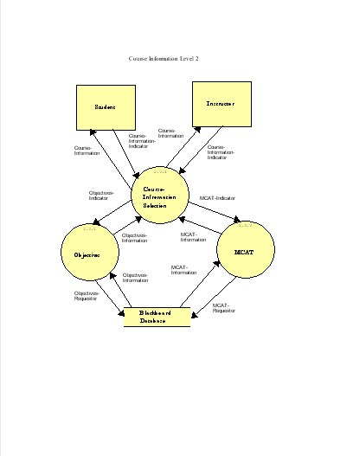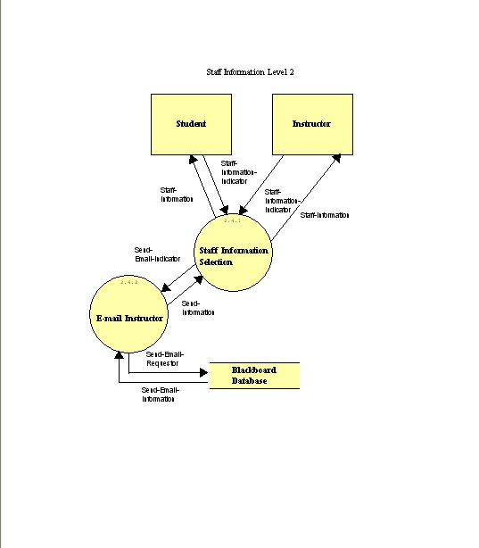
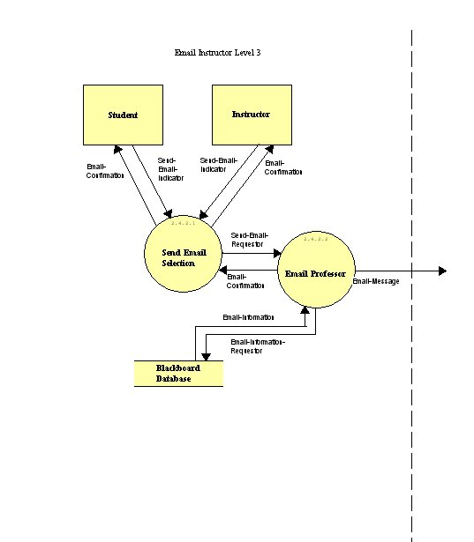
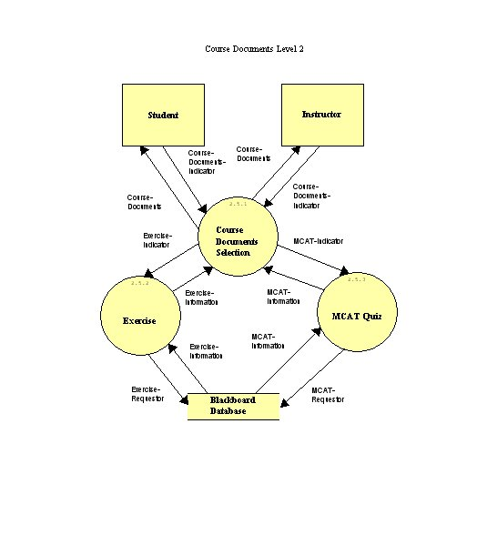
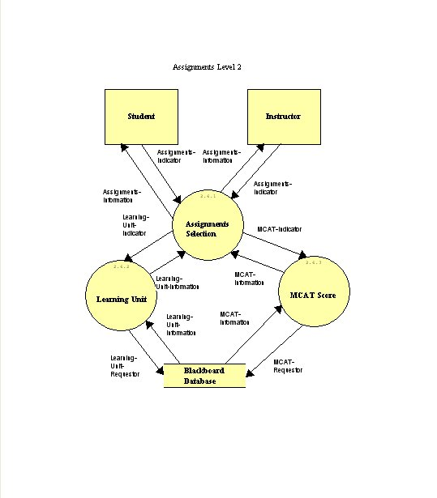
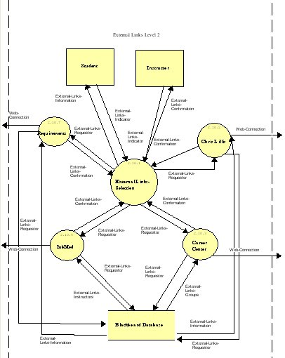

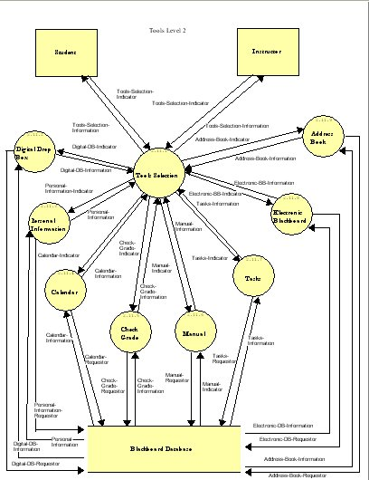
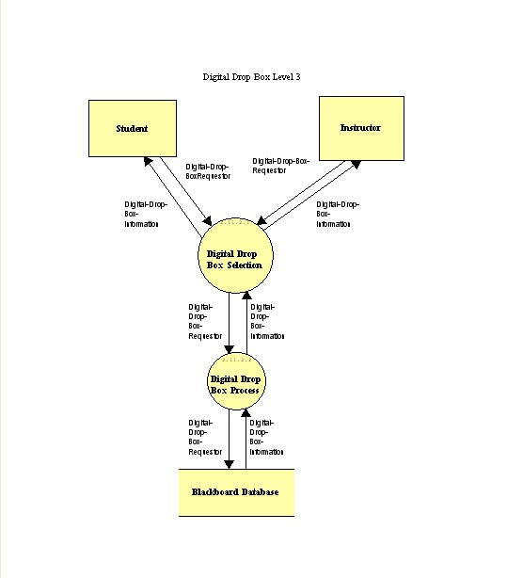
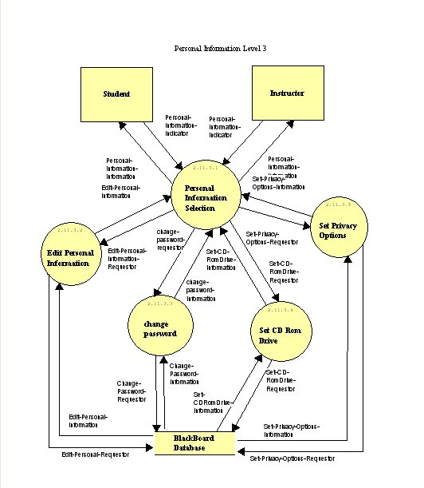

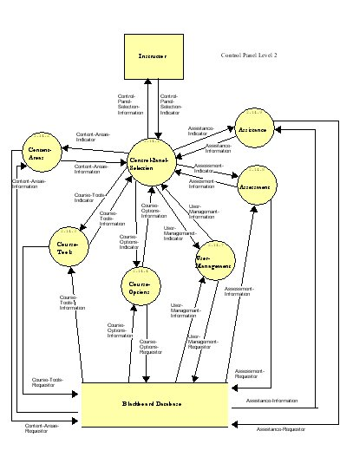
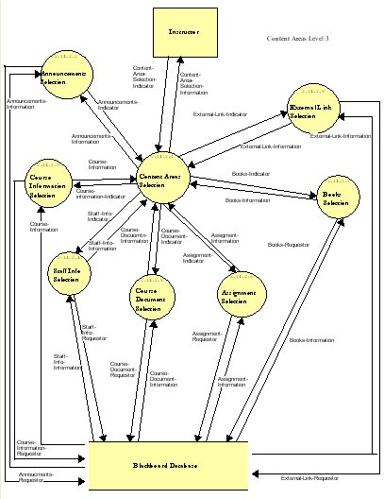

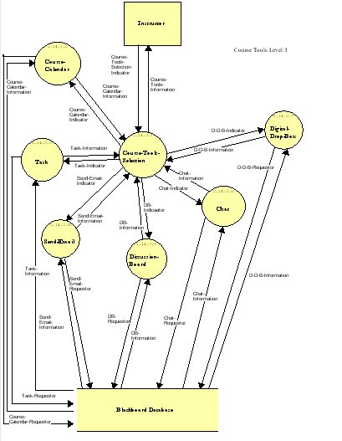

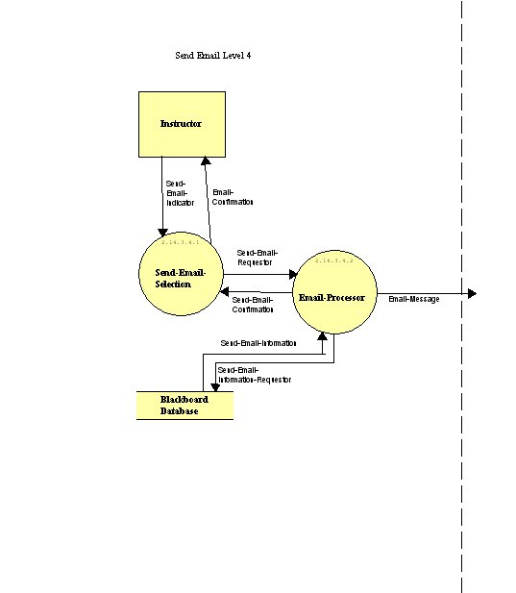

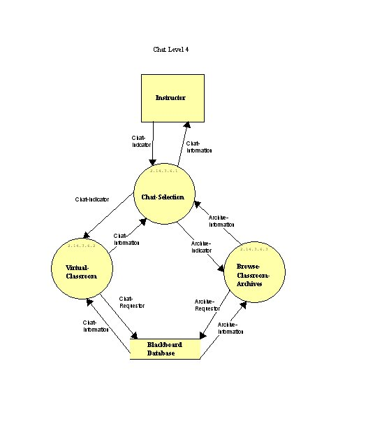
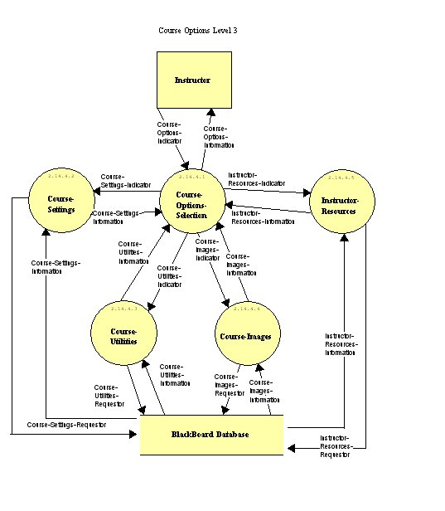
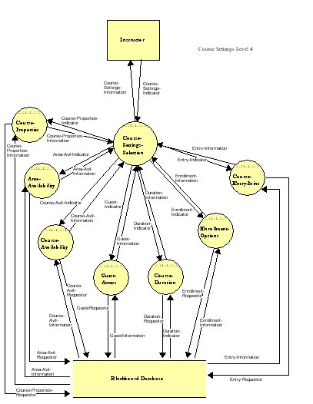

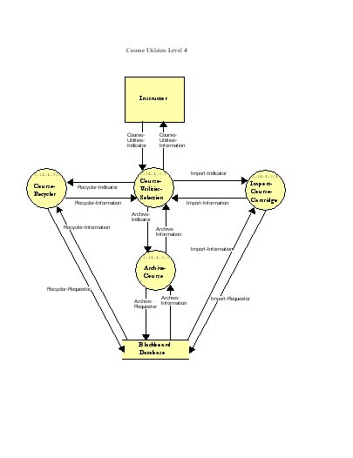
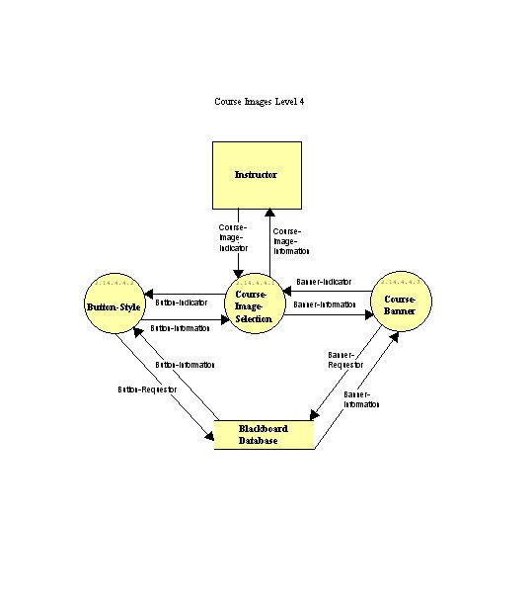
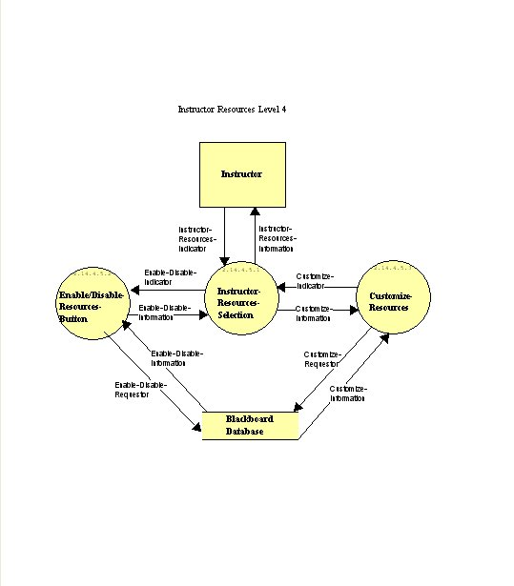
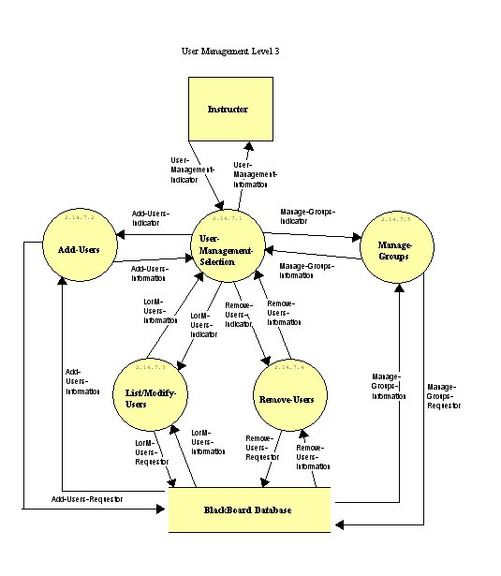
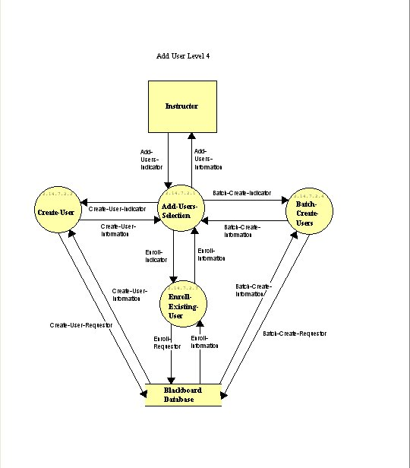

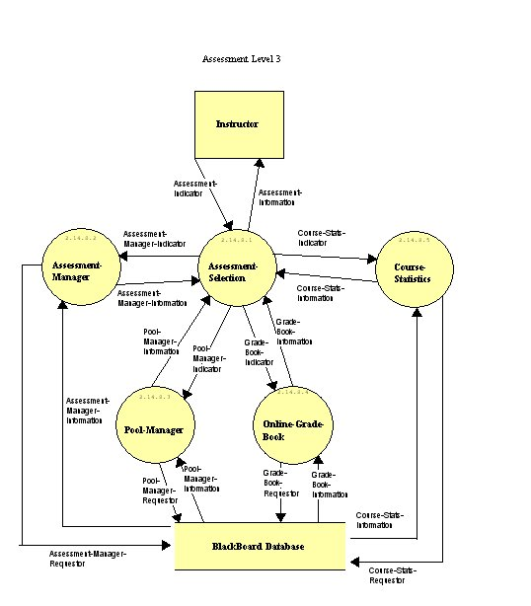
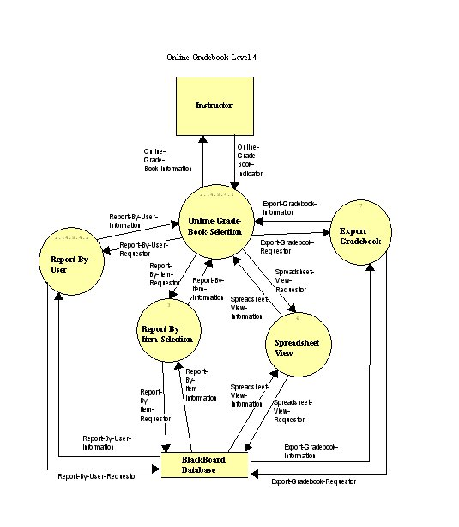
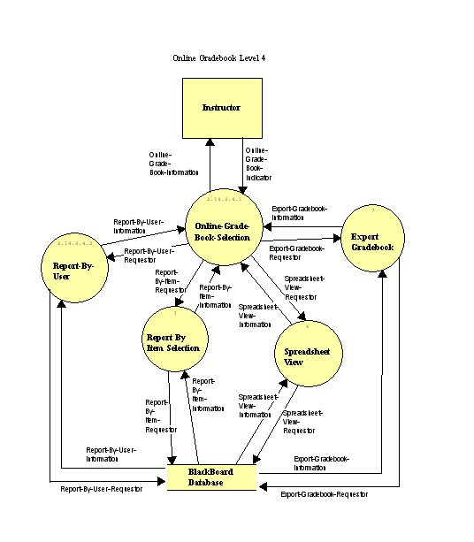
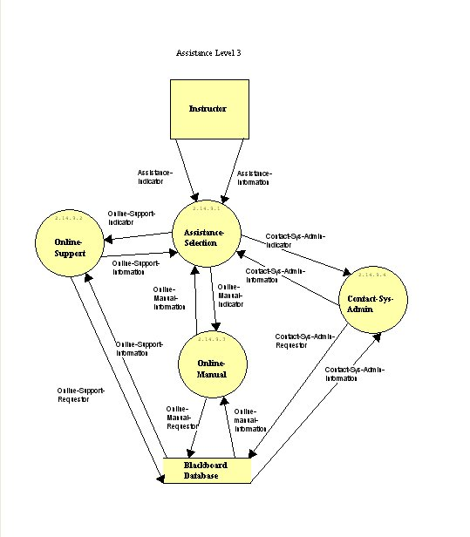
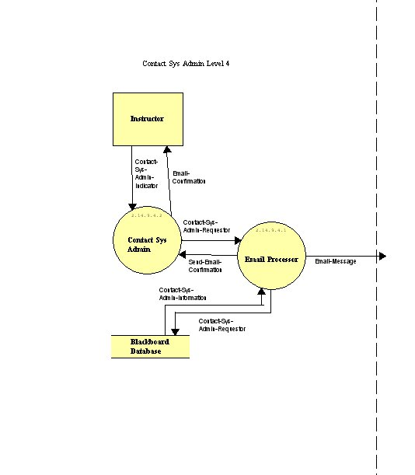

  - Derived Program Structure

MediTrak uses the Blackboard system as its interface. Blackboard is a courseware information system that is very similar to Prometheus, which is currently in use at Siena College. Access to information will be based upon type of user. For example, student users will not be able to access administrator-only features.

We have designed MediTrak for two different types of users, Students and the Instructor. Once registered with Blackboard, each user will have access to the information stored inside MediTrak. However, access to Instructor features will be limited to the Instructor user. The Instructor will be able to access everything that Student users can, as well as additional the Instructor features.

2.3 – Screen Shots

2.31 - Blackboard Main Page

This is the home page for the blackboard system. When the user enters his/her login information, this is the screen which students and the instructor will see. It will have links to options on the left side, along with the course for Health Professions on the bottom to be entered. The screen also has the announcements for the courses for the students to have advisement.

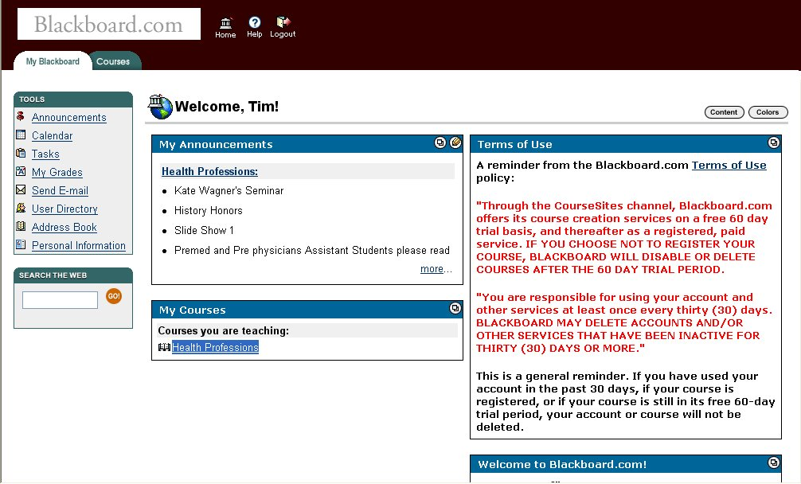

2.32 - Health Professions Main Site

This will be the first screen which the user will see when entering the Health Professions course. The Announcements is the first screen, which pops up for displaying any information the Instructor, feels necessary for the Students to be aware of. Along the left side are all of the options which can be used and accessed for the Instructor. The same ones are listed for the Student; however they do not get the option to go into the Control Panel which is only for the Instructor. From this first page they will be able to view any pages which they need to for using the Health Professions Course.

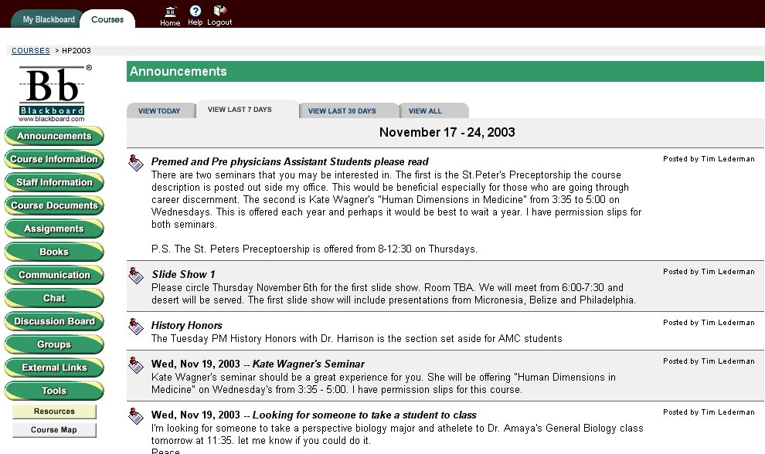

2.33 – Announcements (Add new, Step 1)

By clicking on announcements from the control panel content area, you will be brought to the Announcements page. From here you can view the most current announcements, or choose to view them all. The Instructor will be able to modify or remove any announcement from any time period. He/She will also have the ability to add announcements by clicking the corresponding button near the top of the page.

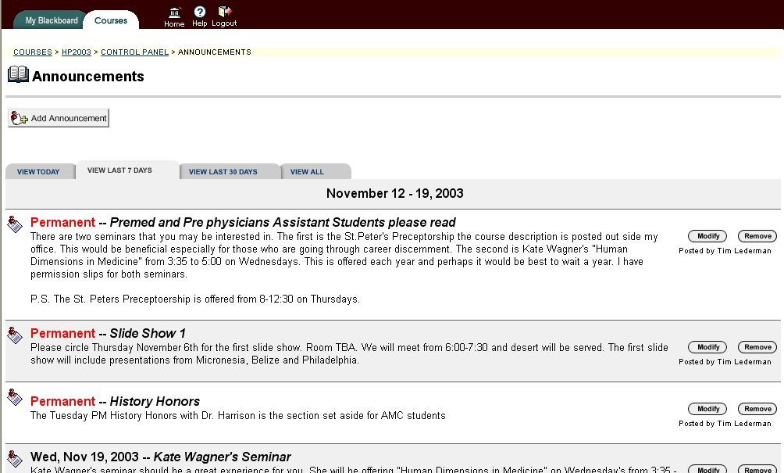

2.34 - Announcements (Add New, Step 2)

This is where the administrator can add announcements. The first section is the announcement information. Here is where you will enter the subject of the announcement, and the message you would like displayed under it, using the type of text chosen with the radio button on the bottom of the message area.

The second section has several options that apply to the announcement. You can choose to always have it viewable on the main page, or set a specific date range when it will be posted as a current announcement. Finally, in section three, if you are done entering the information and choosing its viewing options, you can click on the submit button to have it entered, or choose to cancel the process.

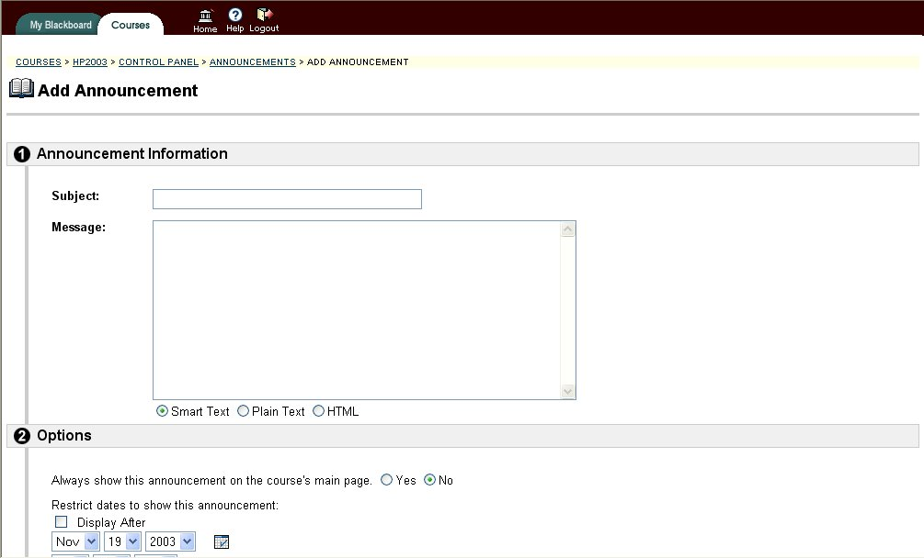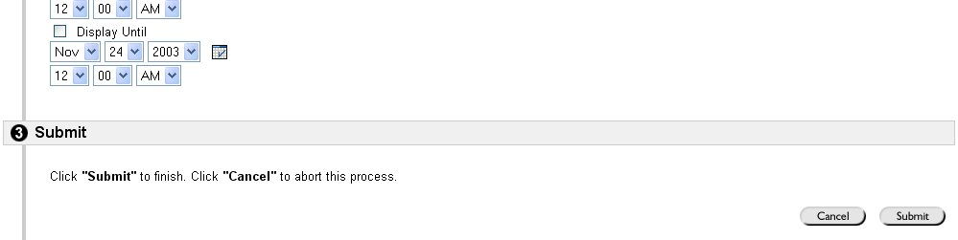

Announcement (Add New, Step 3)

After clicking on the submit button, Blackboard will give you an announcement receipt on a new page if the submission was successful. It will display that the Health Professions course has been updated.

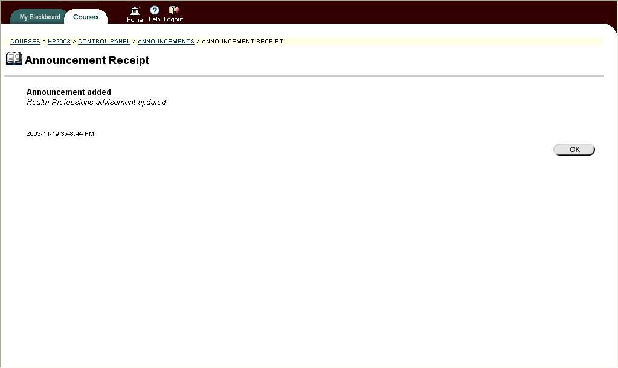

2.35 - Course Information

By clicking on Course Information from the content area in the control panel you will be brought to that page. From here, you can view all of the content that has been submitted, or add more.

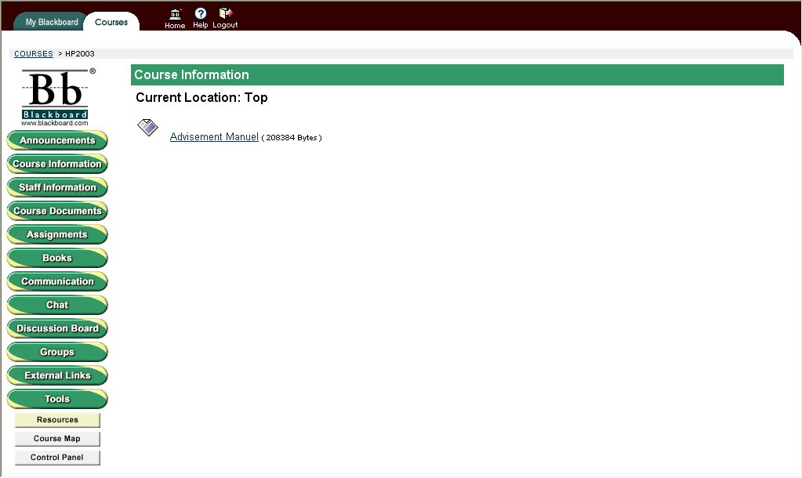

2.36 - Course Information

By clicking on add item in the course information section, you will have the ability to add content for the Health Professions course. In the first sections, you can choose a content name from the drop down box, or specify one of your own in the appropriate area. Then you can choose the color of the content name, and type any relevant information about the subject in the text box using the type of text chosen with the radio button below the text box.

In the second section, you can attach one or more files to the content being added. First, you must choose the file to be attached by typing its path in the box or browsing for it. Next you type the name of the link that will appear below the content name. Then you choose how the file will be displayed after it is clicked on by a user.

In section three, you can choose several options for the content you are adding:

- Whether or not to make the content visible
- Adding offline content
- Tracking the number of views the content receives
- Whether or not you would like to add metadata
- The availability dates when the content will be viewable

Finally, in section four, you can submit the new content, or cancel the process.

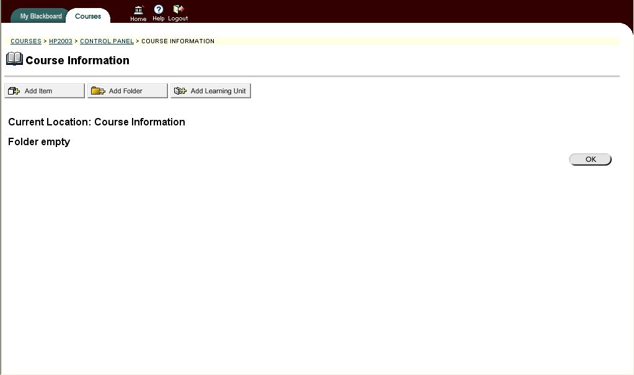
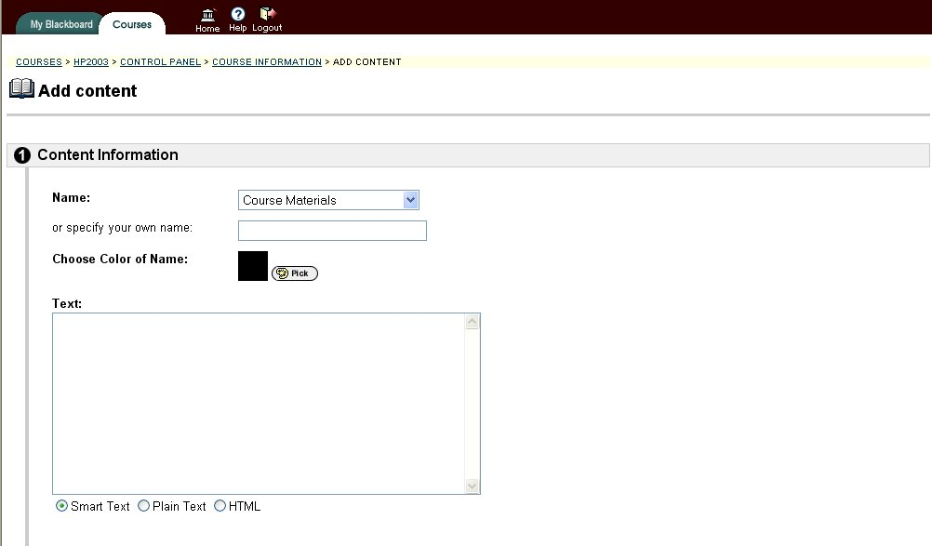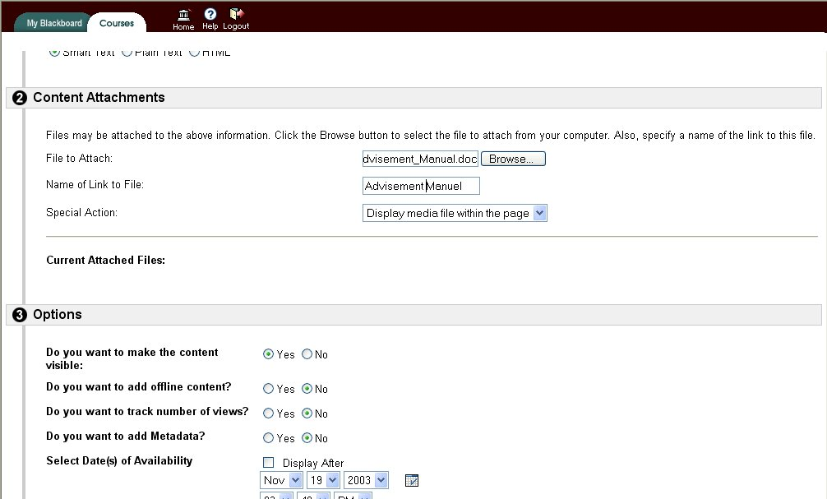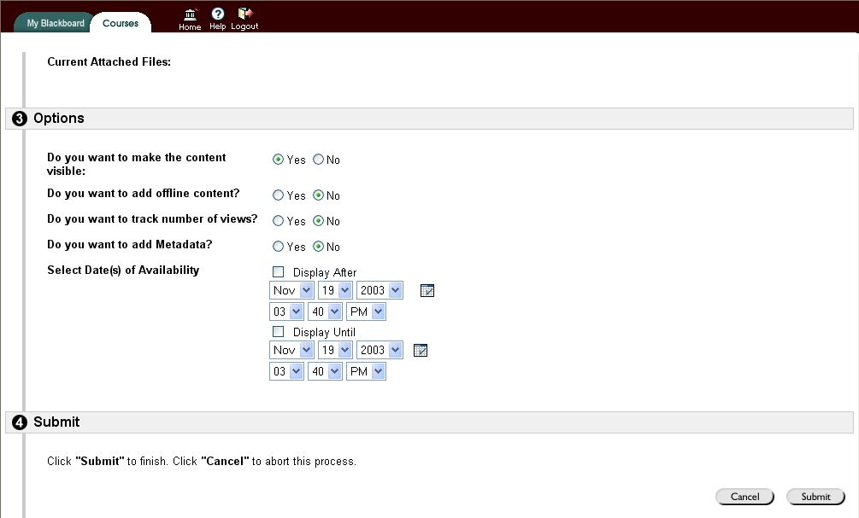

2.37 - Course Information (Content Receipt)

After clicking on the submit button, Blackboard will give you a content receipt on a new page if the submission was successful. It will display the name of the content and its size in bytes

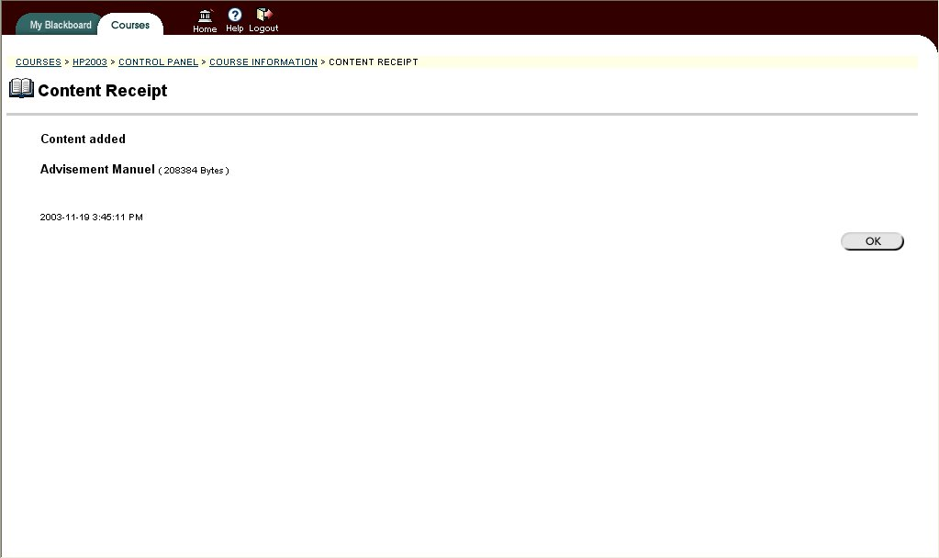

2.38 - Course Information (After content has been added)

After you have added the content you can check it in the course information section. When you click on course information, that page will now have the new content added. You can see that the link is the name you specified and clicking on it will allow you to view its contents the way you specified in section two when you were adding the item.

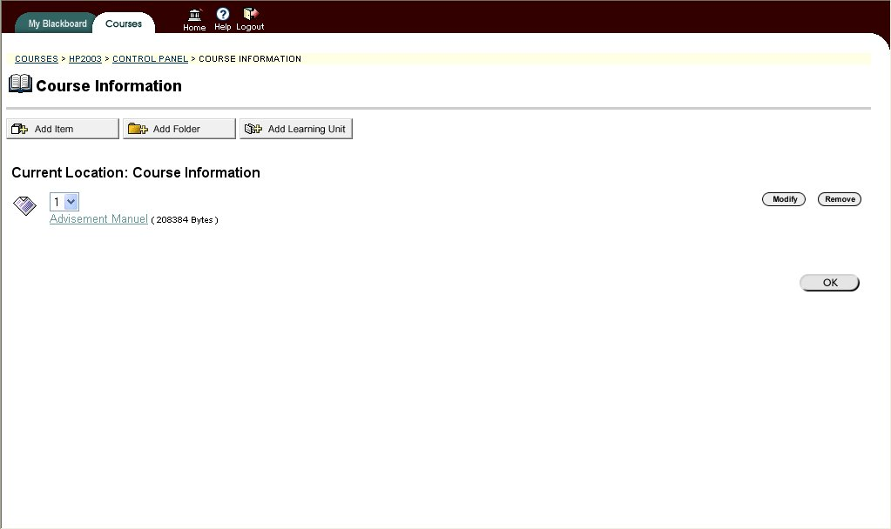

2.39 - Staff Information

Staff information is a document about Dr. LaRow. He felt that there should be a page which students can see information about him and his life. It is a small bio about Dr. LaRow with a picture. It also has his email and office location just incase the students might have misplaced it.

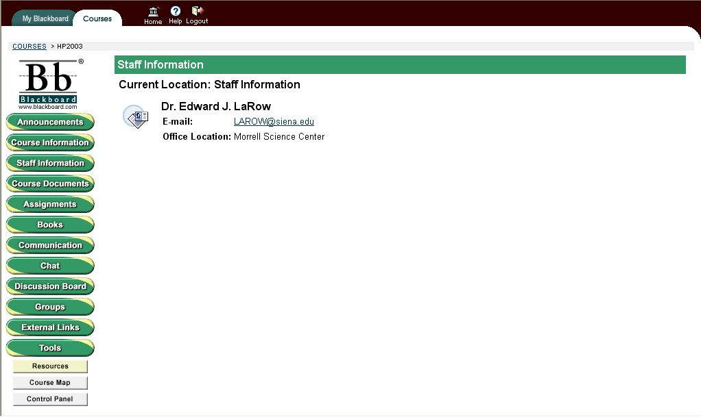

2.40 - Staff Information

By clicking on staff information in the content are of the control panel you will be brought to the page containing information sections for each of the staff members in the Health Professions course. From here, you can also add a new profile.

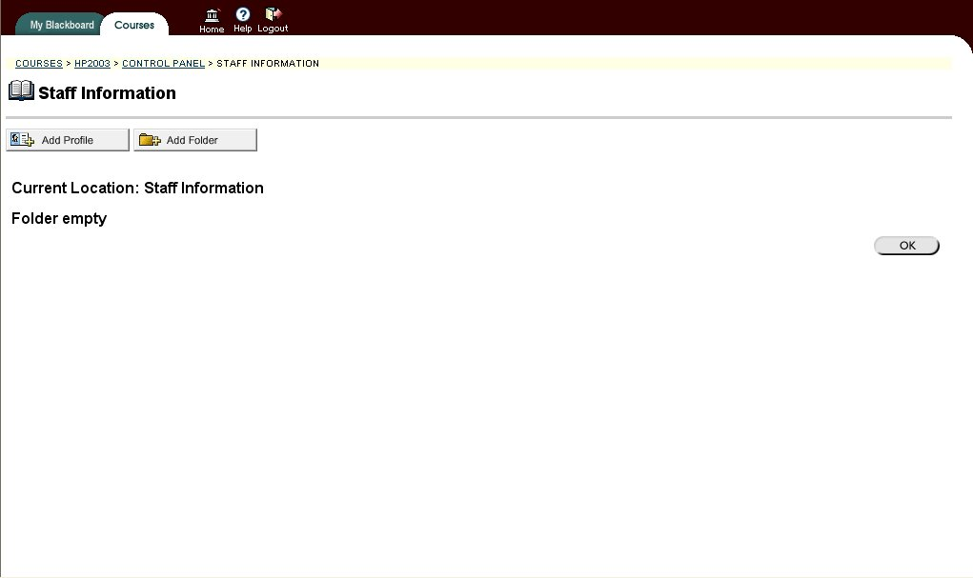

2.41 - Staff Information (Add Profile)

Here is where you can enter the basic information for the new profile:

- Title
- First and Last Name
- Email
- Work Phone
- Office Location and Hours
- Any notes about the staff member

In the second section, you are given options for this new profile. You can choose whether or not to make the profile visible. You can also choose to have a picture added to the profile by providing its path or browsing for it. A personal link for each staff member may also be used with the profile. Then in section three you can submit the new profile or cancel the process.

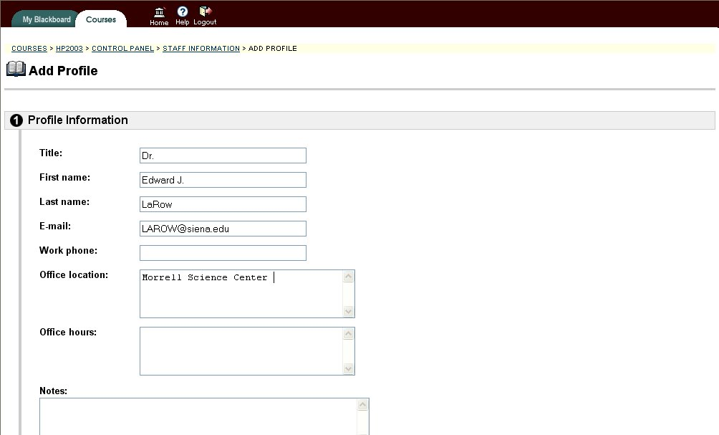

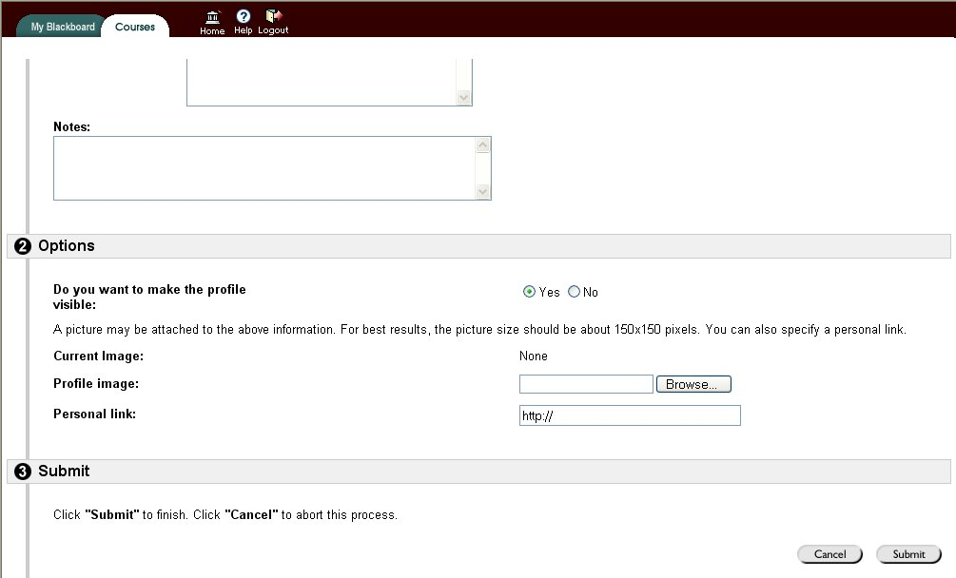

2.42 - Communication

Communication is a page where you can find the best way to communicate to other students and the instructor. There is an email option to email anyone you wish. There are also links to the group pages, discussion board and others which the students can use to communicate to each other.

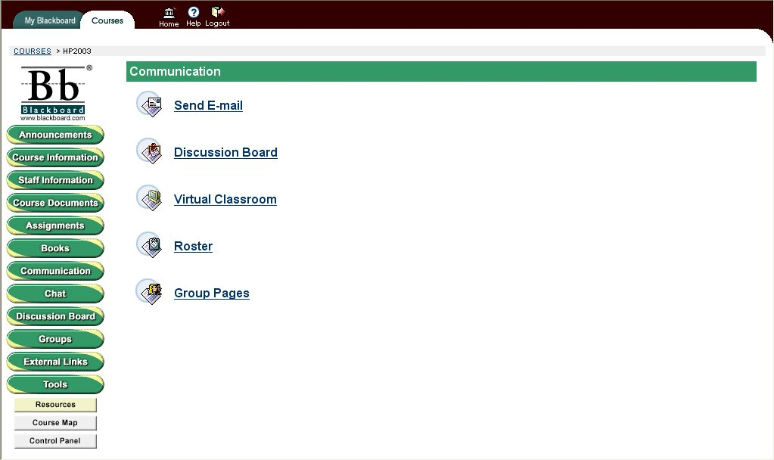

2.43 - External Links

Links is there for students to be able to visit pages which are linked to the Health Professions course. Some meaningful links are Requirements for the course, Career Center, and other web related information which students can use and read and find it useful.

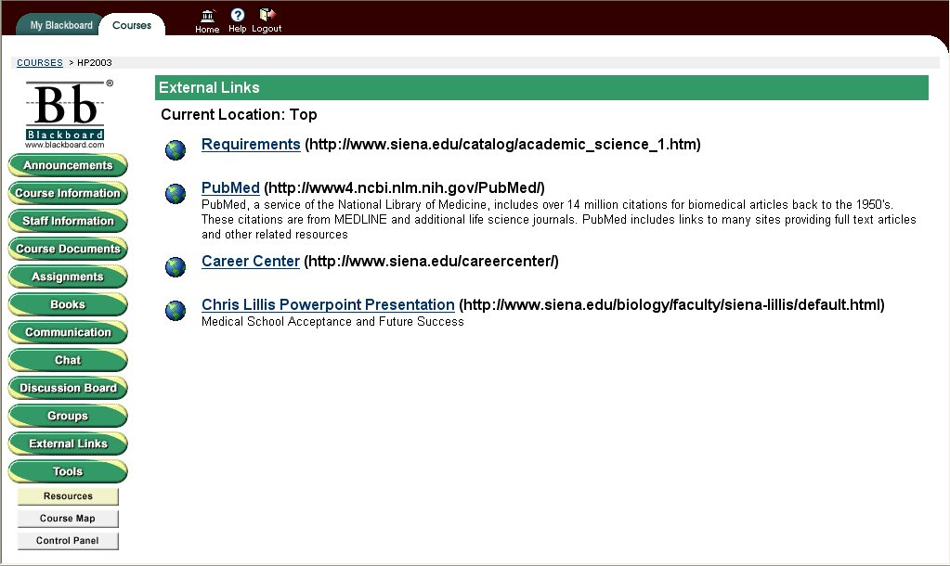

2.44 - Tools

The Tools page will be used often by students and the instructor. Here is a list of links which most of them will be used for students to customize and use their Blackboard system most efficiently. Students will be able to edit personal information here along with a calendar to plan activities. There are also other course related options which students can use check their course information.

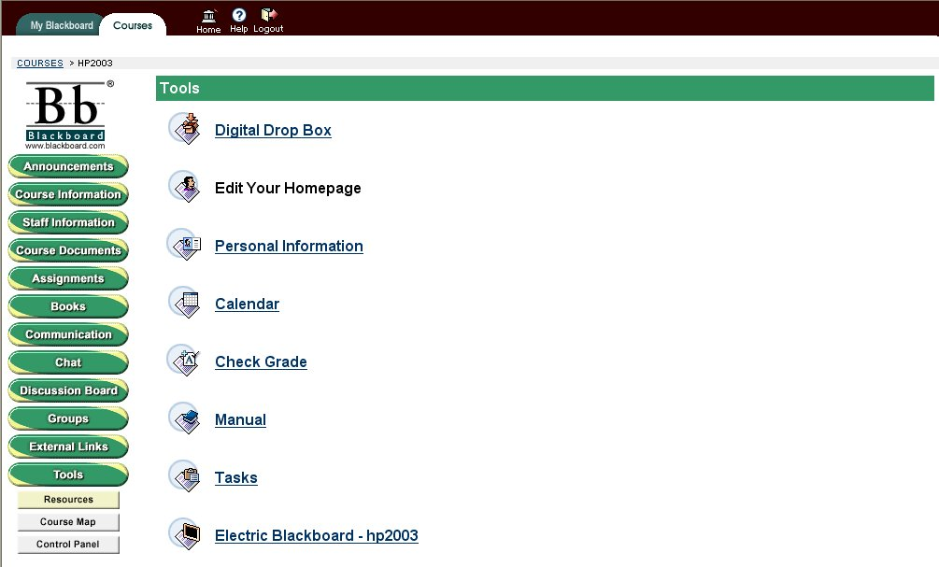

2.45 - Edit Personal Information 1

This screen is the one off of the tools button on the side, then clicking personal information. Here you have four options. Edit Personal Information, Change Password, Set CD-ROM drive and Set Privacy options. At this point you may go into any of these as a Student user and change your personal settings. Privacy options are good for showing or not showing your email address among other information. Edit Personal Information is good for giving your email address and displaying home address information.

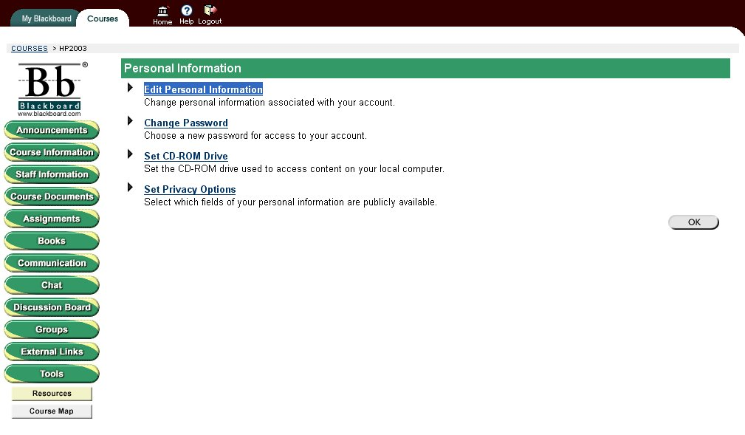

2.46 - Edit Personal Information 2 + 3

This screen shows what you see after you click on Edit Personal Information. Here you can enter your names, email address, home address and phone numbers. This information can be shown to the other students by going through your privacy options. This information is good for getting contact information with communication. It will allow the Blackboard system to be more personalized.

You simply have to fill in the fields to which you want to fill out, then click submit. This will save information to the Blackboard Database and then to be displayed later.

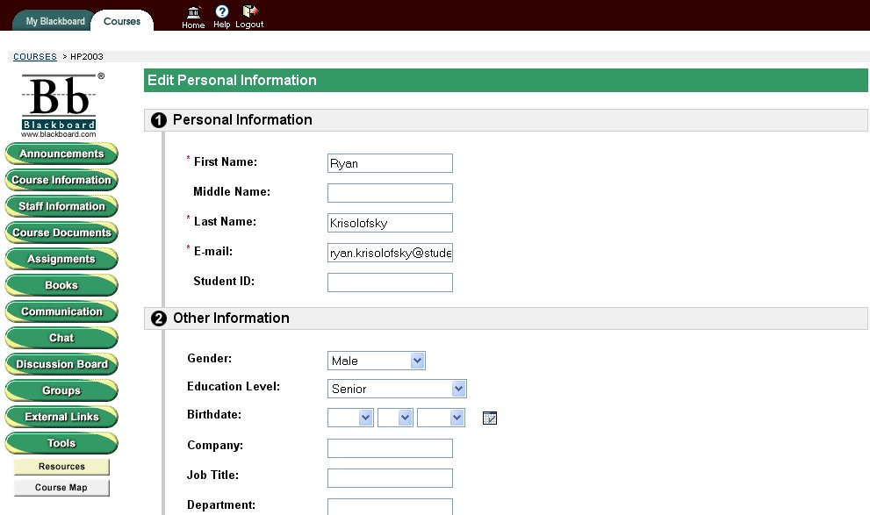

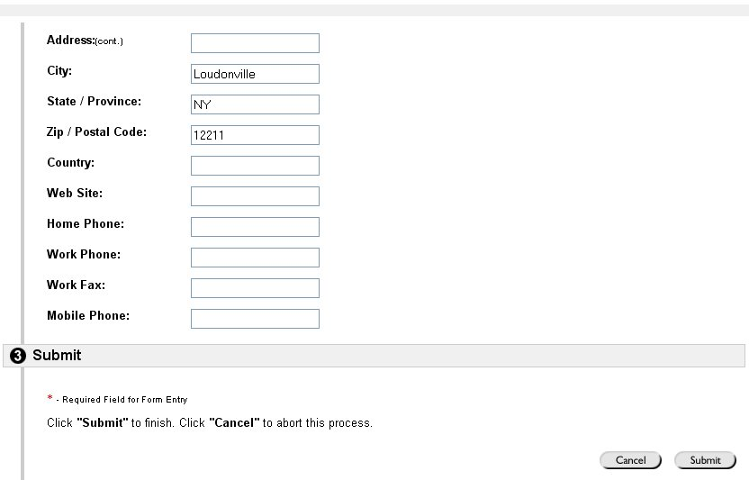

2. 47 - Digital Drop Box

Here is our sample data for our Digital Drop Box. This is a place where students can come and drop off files and send files to the Instructor. This will be a great place for when students are required to scan in their scores and information from recent exams and other college applications for graduate school. The Instructor will manage the Digital Drop Box and he will be able to put files in as well. He can also have files for the Students to receive or not.

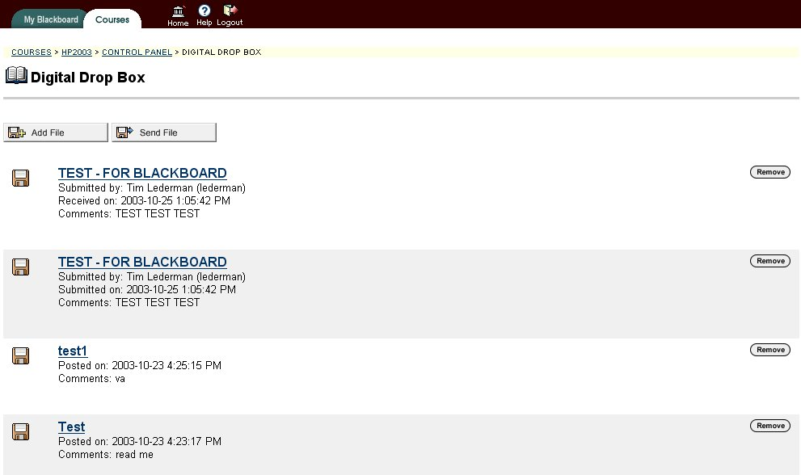

2.48 - Calendar

This is the course calendar that is available to all the Student users as well as the Instructor. Here you can set events that will be able to remind you for important meetings or anything which you feel necessary. It has a complete list of all dates and all hours of the day. Also it has the option to change views by clicking the tabs at the top. This will allow you to have a greater range of what you calendar can do. This can be useful if you feel you have a lot of work to do and you need to plan out your weeks.

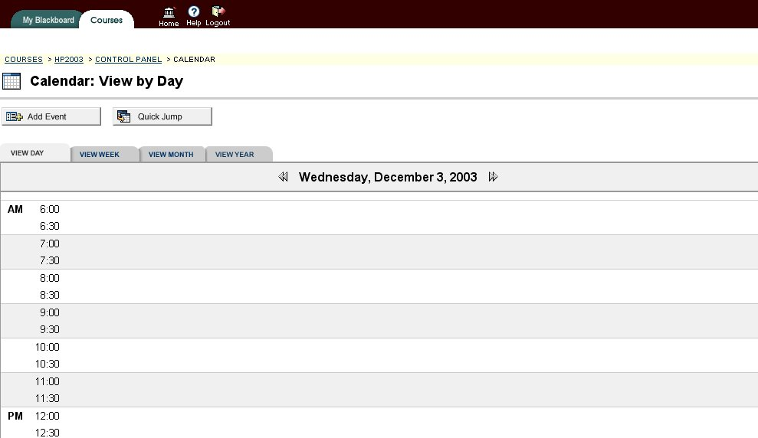

2.49 - Add Users

By clicking add users under the user management section in the control panel you will be brought to a screen where you can:

- Create a new user and enroll them into the course
- Enroll an existing user into the course
- Upload a file containing users to the course.

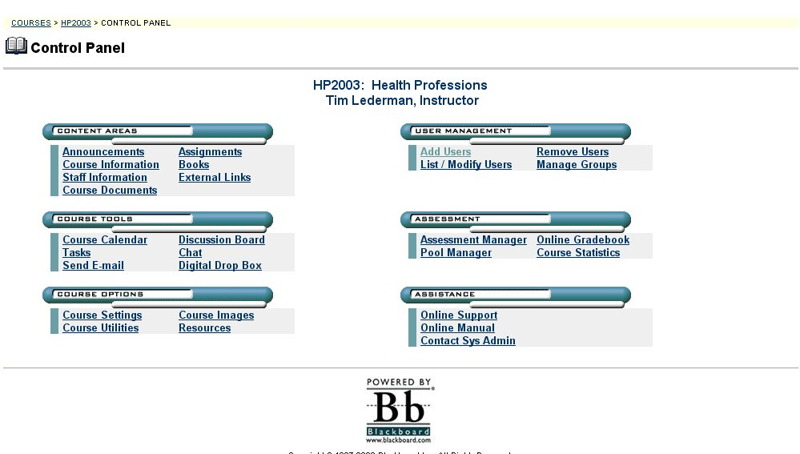

2.50 - Add Users (Enroll Existing User)

From here you can enroll an existing user either by:

- Searching for them by their name (using his/her last or first name)
- Finding them alphabetically or numerically, simply by choosing a letter or number that corresponds with the user’s name
- Listing all users and finding the name you wish to add to the course

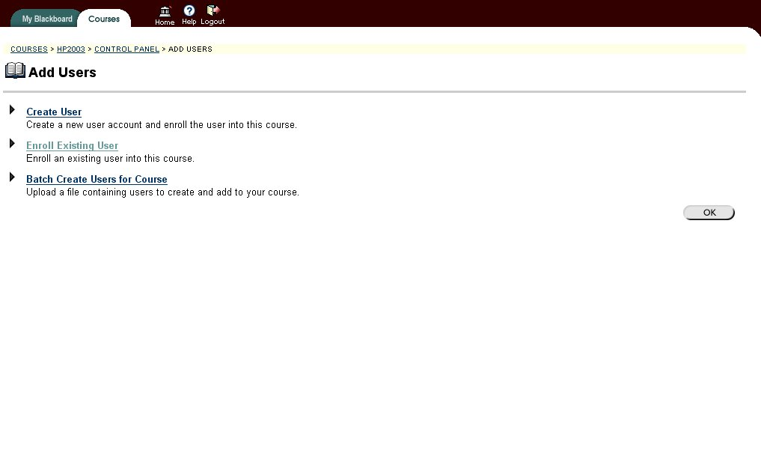

2.51 - Add Users (List of names)

If you searched for the user a list of one or more names will be displayed if they correspond to the search criteria. If you chose to list them or find them alphabetically you will see a list as well. To add one or more users, simply click the box under ADD, so that it has a checkmark in it. Then when you have all the users that you want to add, you can do so by clicking the submit button. Or, you can cancel the whole process by clicking the cancel button.

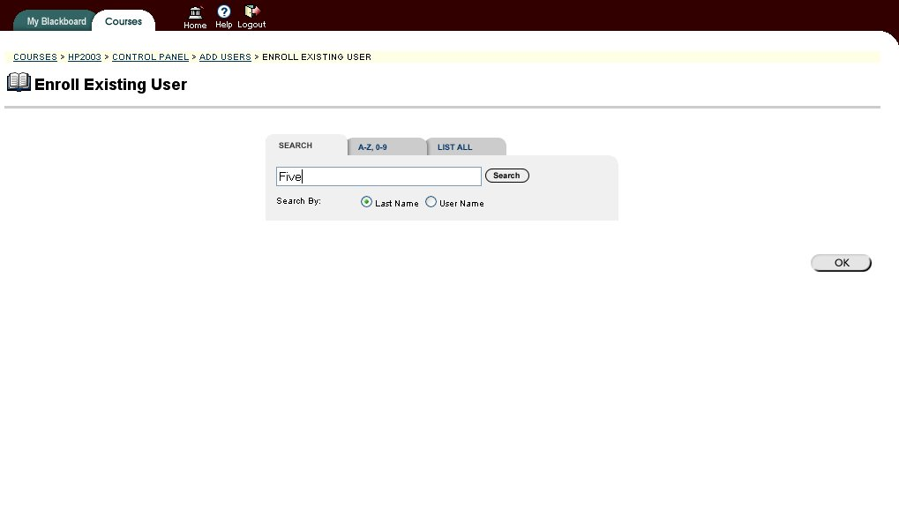

2.52 - Add Users (Enroll Existing User Receipt)

You will get a screen showing Receipt: Success, and a line displaying each user that has been added to the course. It will also display what type of user they have been added as. (Example: student, professor, etc)

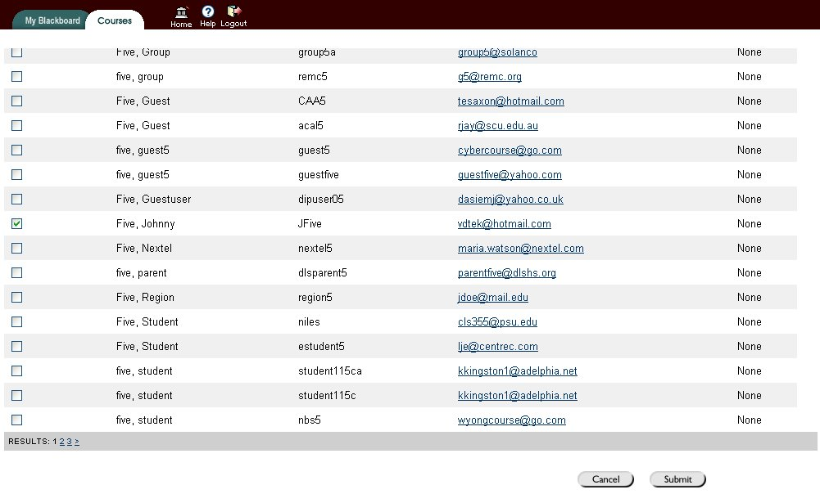

2.53 - Manage groups

This is the instructor only page for managing groups. Here the instructor can come in and add people to the groups and he can also change names of the groups or add new ones. This gives the instructor full control over what happens in the groups to keep organization throughout the system.

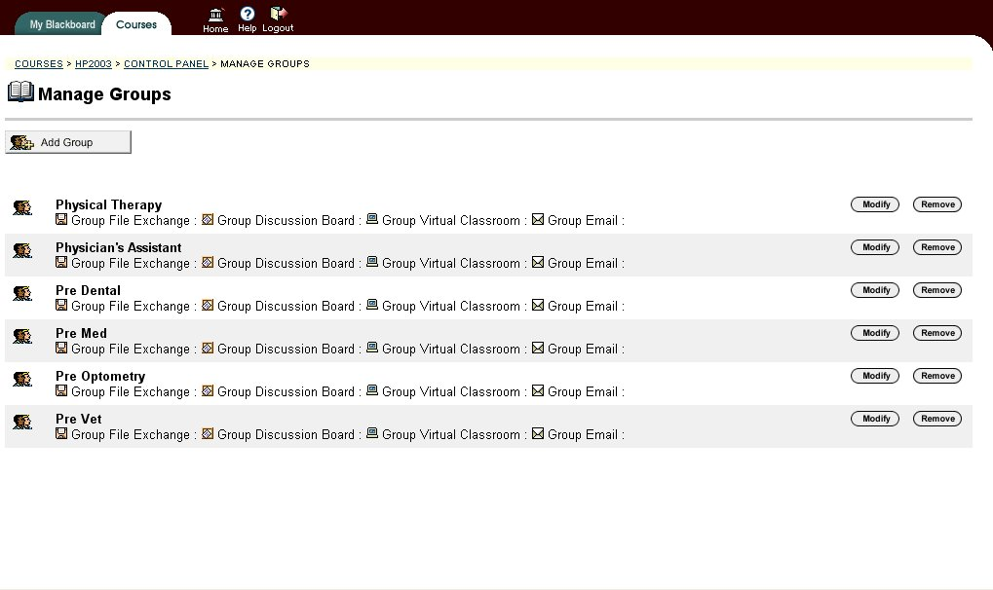

2.54 – Advisor Groups

These are the groups which are to be used by the instructor and student. They are to separate all of the Health professions students into sections where they can be organized. The idea of the groups was something Dr. LaRow wanted to be able to have for separation, email purposes, and other features. Clicking on one of those groups will allow Dr. LaRow to have more options after that screen. As for students, the only group they can go into is the group which they belong to.

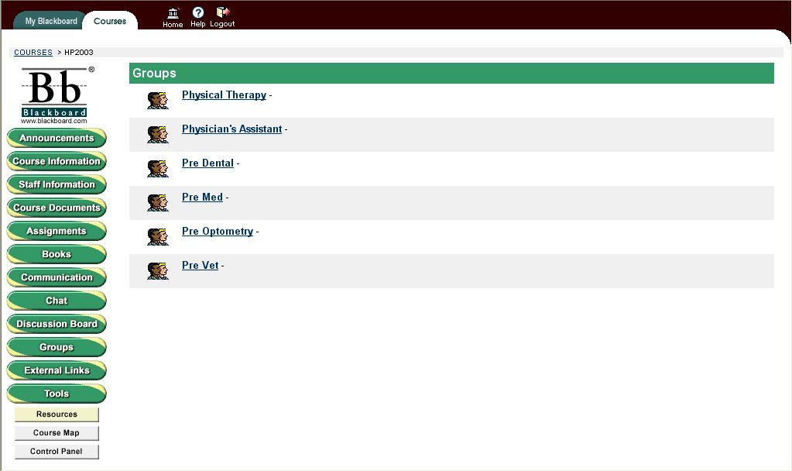

2.55 – Advisors Group 2

When clicking on one of these groups, this is what the user for this group sees and Dr. LaRow. Here are the options which can be accessed by theses students. There is a discussion board, email options, and the group members with email addresses. This is the display of all the people in the group.

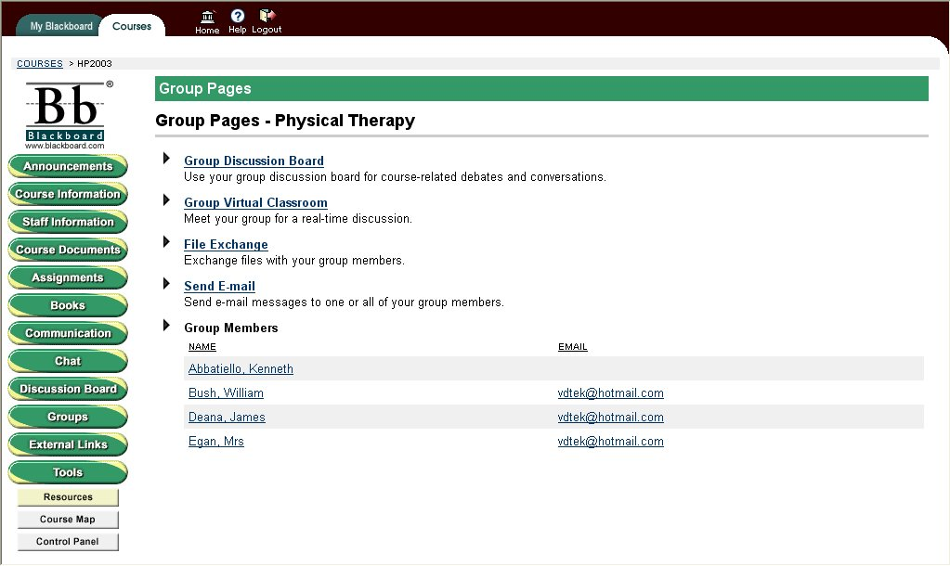

2.56 – Advisors Group 4

Send email screen will allow you to send email to any member of the group. This picture shows the instructor account to where he can send an email to anyone in the group just by clicking the checkbox next to their name. This will allow for faster communication between people in the groups.

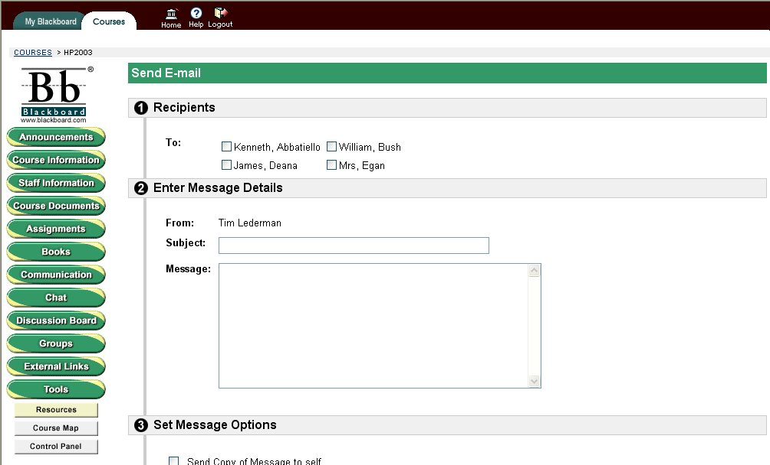

2.57 - Send email 2

When clicking on the send email button in communications, you are shown this screen. Here, you can choose who you want to send emails to with a click of the mouse. In this example, clicking on the Single/Groups will prompt you to add a person you wish to send an email to.

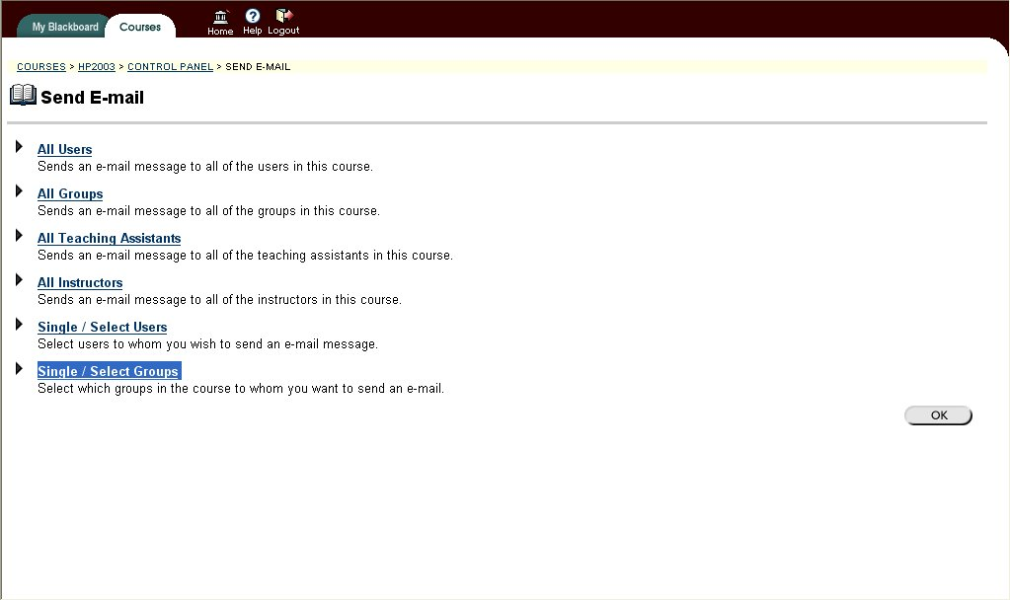

2.58 - Send email 3

At this point, you have clicked on sending an email to groups. Here you can click on any or all of the groups which you would wish to send an email too. This is an option which can be used and will be used by the instructor to send out emails to specific groups for their own information concerning Health Professions.

Here is the rest of the page for sending an email. Fill in your information, then click the submit button

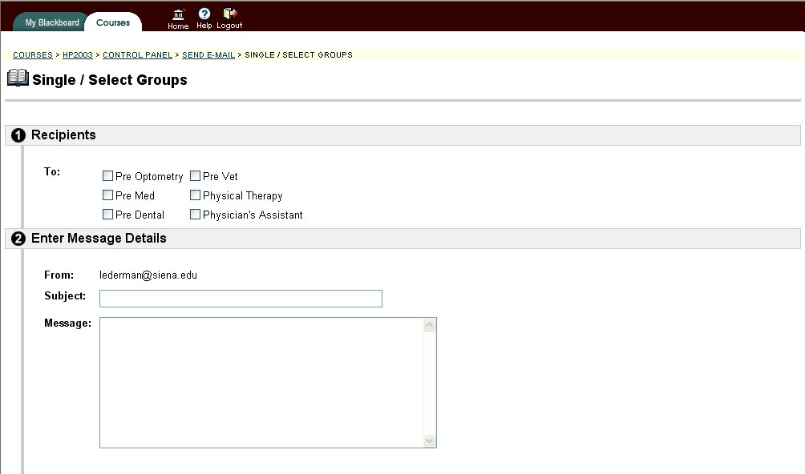

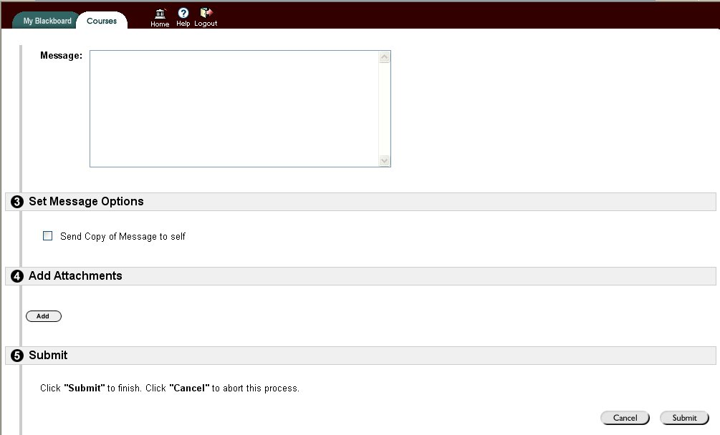
3.0: Modules

3.1 - Processing Narrative

Process for students Login.
The Student will enter user name and password.
The system will authenticate information and login the student.

Process for Instructor Login.
The Instructor will enter user name and pass word.
The system will authenticate information and login the instructor.

Process for Student or Instructor to Choose Process
The student will have 12 processes to choose from. The Instructor will have the same 12 and an additional one.
Process Chooses for Student and Instructor
Course Information
Staff Information
Course Documents
Assignments
Communication
Discussion Board
Groups
External Links
Tools
Resources
Course Map
Announcements
Process Restricted to Instructor
Control Panel

Process for Course Information Course Information
The user will be taken to a screen displaying course information. Then the user may then return to the process list or logout of the system.

Process for Staff Information
The user will be taken to a screen displaying an option to E-mail the instructor. From this screen the user my return to the process list, link to the E-mail instructor process, or logout.

Process for E-mail Instructor

The user may compose e-mail to the instructor. The E-mail will be sent to the instructor. The user may then return to the process list or log out.

Process for Course Documents

The user will be taken to a screen-displaying course. Then the user may then return to the process list or logout of the system.

Process for Assignments
The user will be taken to a screen displaying any assignments. Then the user may then return to the process list or logout of the system

Process for Communication
The user will be taken to a screen displaying any the communication options. Then the user may then return to the process list, choose a communication option, or logout of the system
Communication Options
Send E-Mail
Discussion Board
Roster
Group Pages

Process for Send E-mail
The user may choose form 6 different e-mail options. They will then have the options of choosing whom to s end e-mail to, returning to the process list, or to logout.
Send E-mail Options
All Users
All Groups
All Teaching Assistants
All Instructors
Select Users
Select Groups

Process for Send E-mail Options
The user will be taken to the chosen screen compose their e-mail and it will be sent. The user will now have the option of returning the process list or to logout.

Process for Discussion Board
The user will be taken to a screen displaying any the discussion board. The user may post a message, return to the process list, or logout of the system

Process for Roster
The user will be taken to a screen displaying the current students in the program. The user may return to the process list or logout of the system

Process for Groups
The user will be taken to a screen displaying the current groups. The user may return to the process list or logout of the system

Process for Discussion Board
The user will be taken to a screen displaying any the discussion board. The user may post a message, return to the process list, or logout of the system

Process for Groups
The user will be taken to a screen displaying the current groups. The user may return to the process list or logout of the system

Process for External Links
The user will be taken to a page containing use web links. The user may click on a web link, return to the process list, or logout.

Process for Web Links
The user will be taken to the chosen web page. When the user is done on the web page they will click off of it and return to the External Links Process

Process for Tools
The user will be taken to a page containing the tool options. The user may click on an option, return to the process list, or logout.
Tools Options
Digital Drop Box
Personal Information
Calendar
Check Grade
Manual
Tasks
Address Book
Process for Digital Drop Box
The user will be taken to the digital drop box screen. They then may view information in the digital drop box, post a message for the administrator, return to the process list, or logout.

Process for Personal Information
The user will be taken the personal information screen. From here they may click a link to edit their personal information, change their password, set their cd-rom drive, set their privacy options, return to the process list, or logout.

Process for Editing Information
The user will be at the chosen option screen. Here they will be able to edit their information, return to the process list, or logout.

Process for Calendar
The user will be brought to the calendar screen. They may change the view of the calendar from daily, weekly, monthly, or yearly. They will also have the options of returning to the process list, or to logout.

Process for Check Grade
The user will be at the check grade screen, where they can view their grade. They then have the options of returning to the process list or to log out.

Process for Manual
The user will be at the manual screen, where they can read the manual, return to the process, list or log out.

Process for Tasks
The user will be brought to a screen were they can view a required tasks, returning to the process, list or log out.

Process for Address Book
The address book page will contain links to web addresses that may be useful. The user may click on a link to e-mail a person, return to the process, list or log out.

Process for Resources
The user will be at the resources screen. Here they may link information provided by the Blackboard developers, return to the process, list or log out.

Process for Course Map
By entering this process a pop-up of the process list comes up. The user may link to a process from here or click off of it.

Process for Control Panel
The instructor may login to this area. When at this screen, the instructor will have the following options.

Control Panel Options
Content Areas
Announcements
Assignments
Course Information
Staff Information
External Links
Course Documents

Process for Control Panel Options
Here the instructor will be able to link to the option pages. At these pages they will be able to enter and update the information.
Course Tools
Course Calendar
Discussion Board
Tasks
Chat
Send-Email
Digital Drop Box

Process for Course Tools
Here the instructor will be able to link to the course tool option pages. At these pages they will be able to enter, update, maintain, and monitor the information.

Course Options
Course Settings
Course Utilities
Course Images
Resources

Process for Course Options
Here the instructor will be able to link to the course options pages. At these pages they will be able to enter, update, maintain, and monitor the information. They will also be able to set the preferences for the course, add images, and resources.

User Management
Add Users
Remove Users
List / Modify Users
Manage Groups

Process for User Management
Here the instructor will be able to link to the user management pages, where they will be able to control that can be in the system.
Assessment
Assessment Management
Pool Manager
On-line Grade Book
Course Statistics
Process for Assessment
The instructor will be able to link to pages to enter assessment information.
Assistances
Online Support
Online Manual
Contact Sys Admin
Process for Assistance
The instructor will be able to link to pages to get information and support with any problems or questions they may have about the Blackboard system.

3.2 - Interface Description for Blackboard

Blackboard is a web based course management system. Both the student and instructor must connect to the Blackboard web site at http://www.blackboard.com . Once they have accessed this web site they must enter their login information. If they successfully login they may enter the Health Professions course. After successfully entering the course they will be at the announcements screen. At this point a student may do any of the student processes explained above. The Instructor may responsible do any of the processes listed above. Students will only have access to the information that the instructor has given them permission to view. The instructor will be for controlling who has access to what areas. The instructor will have the ability to set up student accounts and organize them into the proper groups. The students will be responsible for entering their personal information.

Some of the reasons for using the Blackboard course management system are.
A. Cut down on paper work for students and staff.
- Ease of storing information.
- Easy way to contact students in a program.
- Give students access to information that was not easily accessible in the past.
- Allow students to easily contact others in the same program.
- Make the job of the health professions staff easier.
- To make the health professions department more efficient.

3.3 - Health Professions Website Module

The following is the preliminary description of the Health Professions Website. Upon completion, this website will be viewable by anyone with access to the World Wide Web. This page will have a color and design scheme that follows the Siena College style sheet for its websites.

The website has six navigation buttons located at the top of each page. Each button represents a different section (and web page), for each topic of the Health Professions program. By clicking on each button, you will be brought to the corresponding page. Also, by placing the mouse over each button, you will be presented with a drop down menu. These menus will help make the navigation through the site easier. The user can select specific headings from each section they are interested in researching. Below is a breakdown for each button, and its drop down menu items:

I ) Health Professions Office
1. Health Professions Advisor
a) Personal
b) Responsibility
2. Health Professions Recommendations Committee
a) Responsibilities
b) Membership

II ) Professions
1. Medicine
2. Osteopathic Medicine
3. Dentistry
4. Veterinary Medicine
5. Optometry
6. Podiatry
7. Chiropractic
8. Physician Assistant
9. Physical Therapy
10. Occupational Therapy
11. Nursing

III ) Articulations
1. Siena / Albany Medical College Program in Science Humanities and Medicine
2. Albany Medical College Program for Under Graduate Students
3. Upstate Medical University - Early Assurance Program
4. Upstate Medical University / SUNY Cobleskill - Rural Physician Program
5. SUNY Buffalo School of Dental Medicine
6. Goldman School of Dentistry at Boston University
7. Pennsylvania College of Optometry
8. SUNY Optometry
a) Accelerated
9. SUNY Optometry Early Assurance
10. Temple University School of Podiatric Nurses
11. Sage Graduate School - Doctorate of Physical Therapy
12. Sage Graduate School - Masters in Occupational Therapy

IV ) Advisement Manual
- Chapters....

V ) Blackboard Registration

VI ) Statistics
1. Professional School Placement
a) Medicine and dentistry
b) Veterinary, Med and Optometry
2. Professional Schools Attended
3. Medical School Interviews
4. Interviews Granted
a) Medical Schools
b) Dental Schools

3.4 - Health Professions Website Screenshots

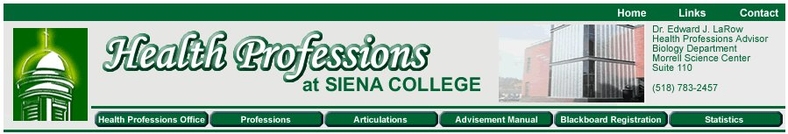

Header of the main page

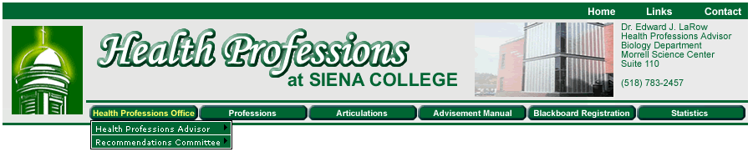

While the mouse is over a button

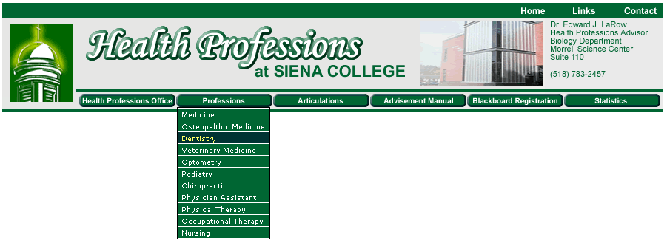

While the mouse is over a drop down menu item

3.5 - Data Organization

Visual Design Technologies will not be providing any data for the Health Profession Project. All of the data will be coming from the Health Professions Department at Siena College. We will be helping them get their data on to the system and the web site. The data for the Blackboard system will be maintained and organized by the Blackboard database which is part of the Blackboard program. The data on the web site will be initially inputted by the Visual Design Technologies team but will be organized and maintained by the Siena College Health Professions Department.

4.0: File Structure and Data

4.1 - External File Structure

For our external file structure, we have encountered a couple of constraints. First of all, we at Visual Design Technologies are not aware of the file system and database schema used by Blackboard. Since they have already pre defined these items and have their file structure already laid out, it prevents us from knowing it and changing anything with respect to it.

Second, we are not the maintainers of the file structures either. Blackboard will be doing the maintenance on the system and they will have full control over what goes on in the database with respect to our Health Professions course.

With these two points described, it gives us freedom to let Blackboard handle the file structure and let us as a team handle our Health Professions course. Our work is hindered slightly due to the fact that we do not have control over our database. However, we are working our system around Blackboard’s.

5.0: Cross Referencing

Cross referencing is the idea that data items are used over and over throughout the different pages of the Blackboard system. In our Health Professions course, we do not have a lot of cross referencing occurring throughout the pages. We do have one instance of it and that is through Personal Information. Viewing the Blackboard System as a Student, the only piece of information which has been saved to the Database which shows up on multiple pages using the same data item is the Email Address. This is shown in a few places throughout the document. It is show in Groups, Roster, and Communication through Email. The information concerning the Email Addresses of Students can be updated through Personal Information which is located in the Tools section.

All of the other data items in the Blackboard system work independently when viewing as a Student.

6.0 Appendix

6.1 Updated Gantt Chart

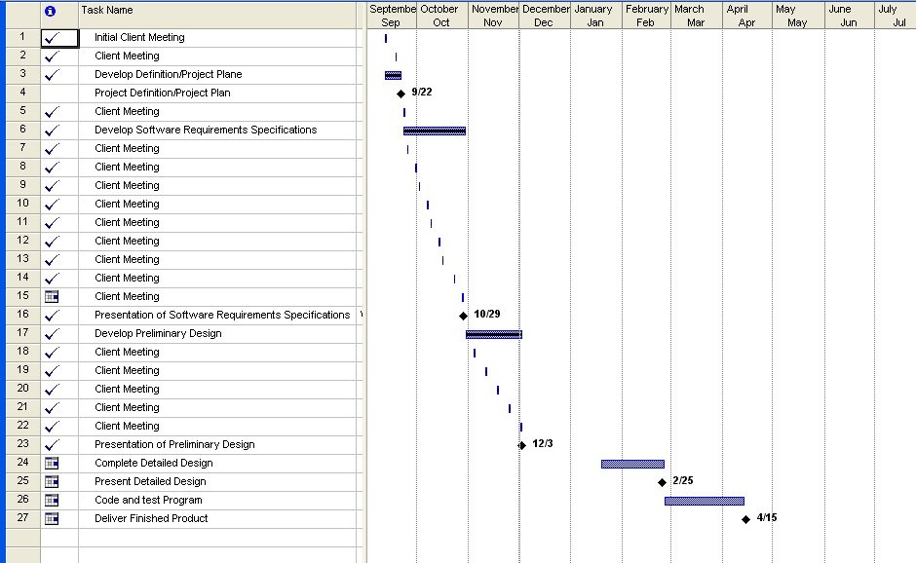

6.2 Glossary

Database: A large, organized collection of information that is accessed via software.

Gantt Chart: A timeline chart that depicts the schedule of the software development process.

Linear Sequential Model: A systematic, sequential approach to software development that begins at the system level and processes through analysis, design, coding, testing, and support. (Also known as waterfall model)

Software: Computer program that when executed provide desire function and performance.

Email: Electronic letters which are sent to people through an internet connection.

Account: A user on the Blackboard system with all personal information stored.+

Information System: An electronic system for storing, editing, and retrieving data.

Security: A website feature included within Blackboard that ensures that all data transmitted into the system will be encrypted and confidential.

User: Person or persons who operate the software

Login: A prompt within Blackboard in which the user inputs a user name and password, and is then permitted to view and edit his or her information.

ITS Department: Information & Technology Services Department at Siena College. This department is in charge of the maintenance, advancement, and troubleshooting of the network on campus.

Blackboard: A web based information system used to create, edit, and store MediTrak.

Student: A type of user for MediTrak.

Instructor: The administrator for MediTrak. The instructor is also a user of MediTrak.

Course Information Screen: A Blackboard screen showing information about the Health Professions Department.

Health Professions: An academic area at Siena College. Students enrolled in the Health Professions department plan on having a career in the field of health or medicine, and often hope to go on to a type of medical school.

Welcome Screen: The screen viewed immediately after login to Blackboard.

Control Panel: Section of Blackboard permitting the Instructor to act as a system administrator and make any changes he sees fit.

Groups: A list showing the students entered into the MediTrak system. This list is divided by class year.

Digital Drop Box: Allows students to exchange files with the instructor.

Data Flow Diagram: A series of diagrams showing the processes and data flow of the project.

Tools: A section in Blackboard which offers the Student or Instructor complete control of Personal Information amongst other things.

