Preliminary Design

Javanet

Clients:

Dr. Darren Lim
Assistant Professor
Department of Computer Science
Siena College

Mrs. Pauline White
Visiting Instructor
Department of Computer Science
Siena College

Phoenix Tech

Prepared By:
Jessica Edmonds
Marc Iuliano
Anthony Torres
Erica Weisgerber

December 2, 2008

Table of Contents:
Javanet

External Design Specifications
1.1 Product Overview and Summary 2
1.2 User Displays and Command Summary 2
1.3 Data Flow Diagrams (see separate document) 35
1.4 Logical Data Dictionary 35

Architectural Design Specifications
2.1 Structure Diagram 40
2.2 Use Case Narratives 45
2.3 Functional Requirements Inventory 48

Testing Requirements
3.1 Testing Overview 52
3.2 Unit Test (see separate document) separate document

Appendix
4.1 Timeline (Gantt Chart) 53
4.2 Glossary of Terms 54

1.1 Product Overview and Summary

Our clients, Dr. Darren Lim and Mrs. Pauline White, have requested a web based application that will allow students enrolled in a Java based course to practice Java programming problems and take Java based quizzes and tests provided by their instructor. Our software program, Javanet, will also help instructors track their students' progress and provide students with a dynamic and interactive way of learning. Here at Phoenix Tech we believe we can offer our clients an efficient solution. A solution that will allow instructors to easily upload, assign and grade Java programming problems. Additionally, student progress will be able to be tracked both immediately and gradually, by both the students themselves and the instructors.

1.2 User Displays and Command Summary

    - Login Page

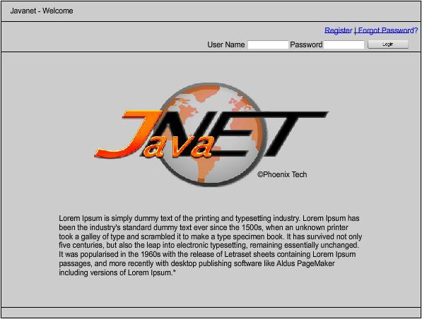

The login page is the first screen the user will see when attempting to login into Javanet. After entering a valid username and password combination, the user will be taken to the appropriate Welcome Page.

1.2.2 Reset Password Page

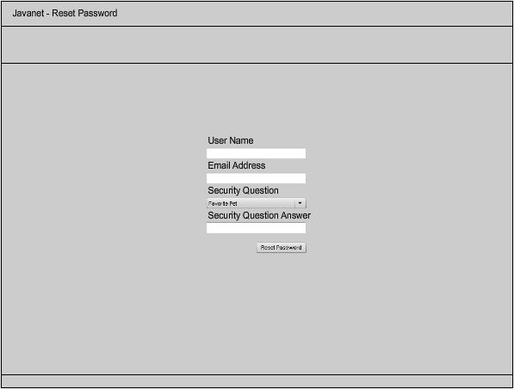

A user will be shown this page if the Forgot Password link is clicked from the Login Page. After entering a user name, email address, and selecting and answering a security question and answer, the user will be emailed a new password.

    - Student - Registration Page

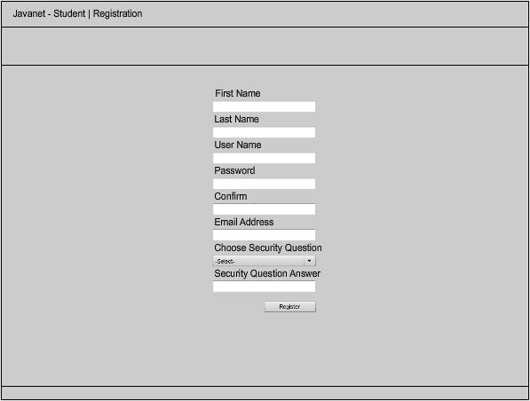

Students are required to self-enroll. The Student Registration Page will be shown after a Student clicks the Register link from the Login Page. The Student will be required to enter a first name, last name, user name, password, confirmed password, email address, and select a security question and enter an answer.

    - Student - Profile Page

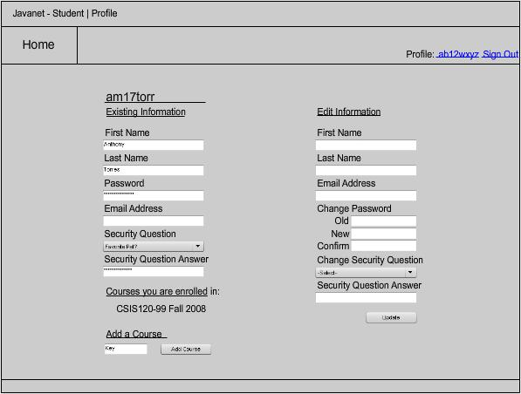

The Student Profile Page will be shown after clicking Register on the Student Registration Page, and anytime the user name link in the upper right corner is clicked. The Student Profile Page will allow a Student to view the existing profile information and edit the information available on this page: first name, last name, password, email address, security question, and security answer. The functionality for adding a course by entering a course key will also be available on this page.

    - Student - Welcome Page

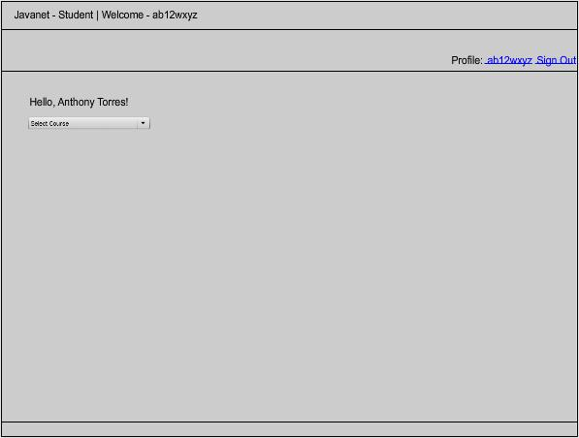

After logging in, a Student will be required to select which course (which they are currently or previously enrolled in) they would like to access.

    - Student - Home Page

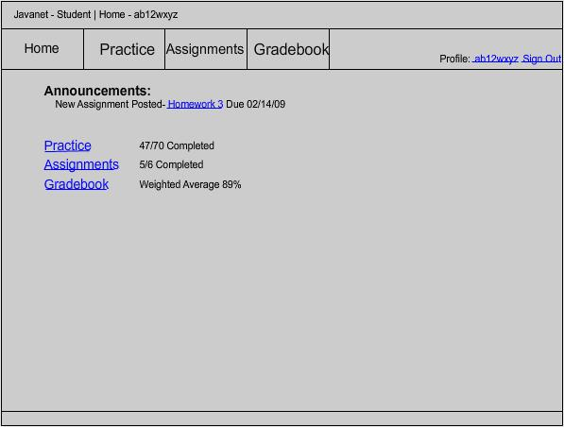

The Student Home page will be shown anytime the Home tab is clicked, or after selecting a course on the Student Welcome Page. A Student user will see announcements that have been posted by the Instructor, the Course Coordinator, or the Administrator. A Student will also be able to click on a Practice link, an Assignments link, or a Gradebook link.

    - Student - Practice Page

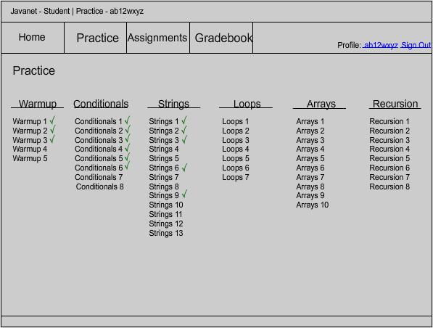

This page can be accessed by a Student either clicking on the Practice tab, or clicking on the Practice link on the Home Page. The Student Practice Page displays the categories of questions available and lists questions sets underneath.

    - Student - Assignment Selection Page

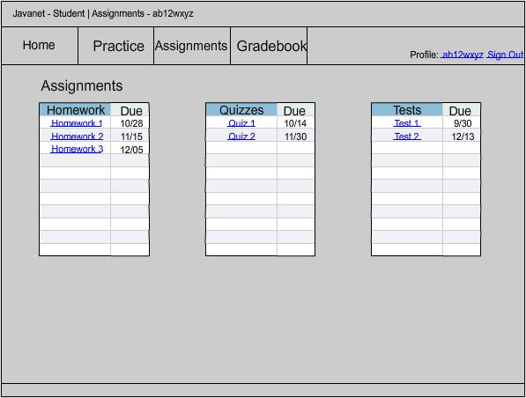

This page can be accessed by a Student either clicking on the Assignments tab, or clicking on the Assignments link on the Home Page. The Student Assignment Selection Page displays three tables: homework, quizzes, and tests. Each assignment is listed with its corresponding due date. Each assignment is also an active link that will redirect to the Student Assignment Page.

    - Student - Assignment Page – for a specific assignment

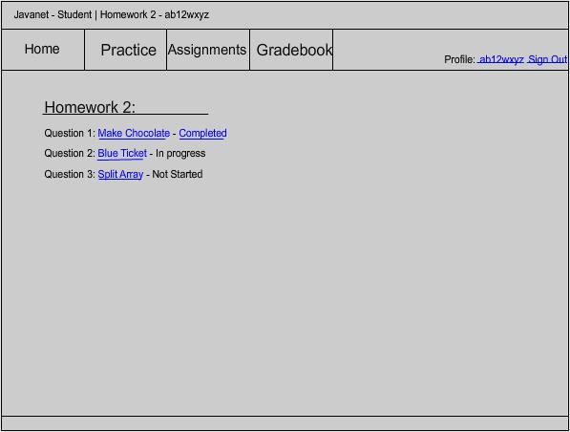

After clicking Homework 2, for example, from the Student Assignment Selection Page, a Student will be brought to this page. There are a list of questions, which are active links that will redirect to the Student Answer Question Page, that make up the assignment and a progress indicator.

1.2.10 Student - Answer Question Page

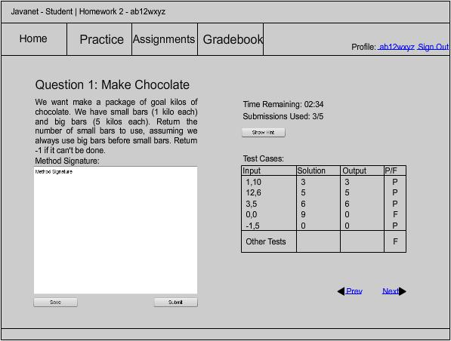

After a question is selected from the Student Assignment Page, the student will see this page. The question will be displayed along with a provided method signature and a text box to write the question solution. In addition, a Student can see how many submissions are remaining and how much time is remaining. A Student may also click Show Hint to view any hints provided by the Instructor. A Student can also Save their source code by clicking on the Save button. Viewable Test Cases are also provided with results.

1.2.11 Student - Solution Page

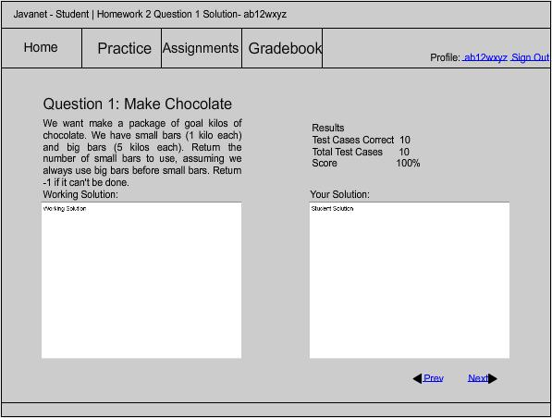

This page can be accessed after an assignment has been completed. This page will provide a Student user with a read only version of his or her solution to the question being viewed. This page will also provide the percentage correct, test cases correct, and the total number of test cases (viewable and non-viewable).

1.2.12 Student - Gradebook Page

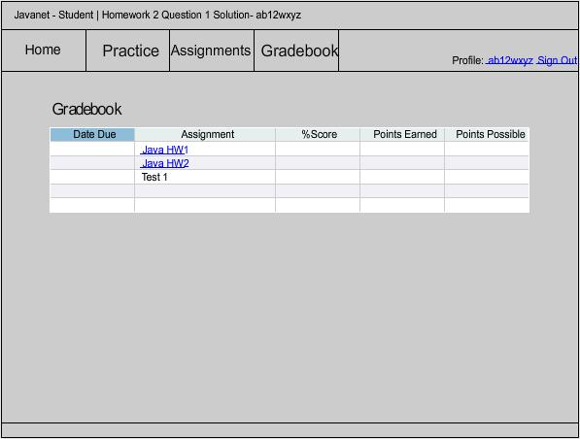

This page can be accessed by a Student either clicking on the Gradebook tab, or by clicking on the Gradebook link on the Student Home Page. In this case, the gradebook is ordered by due date, as displayed by the blue background of the Due Date tab. The gradebook may also be sorted by any of the other columns: assignment, %score, points earned, or points possible, by simply clicking on the heading. The Gradebook will show the percentage, points possible and points earned on each assignment given.

1.2.13 Instructor - Profile Page

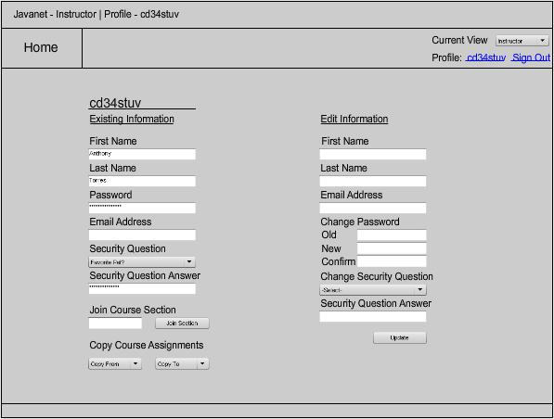

The Instructor Profile Page will be shown anytime the user name link in the upper right corner is clicked. The Instructor Profile Page will allow an Instructor to view the existing profile information and edit the information available on this page: first name, last name, password, email address, security question, and security answer. Additionally, an Instructor has the ability to join a specific course section or to copy course information from a past semester on this page.

1.2.14 Instructor - Welcome Page

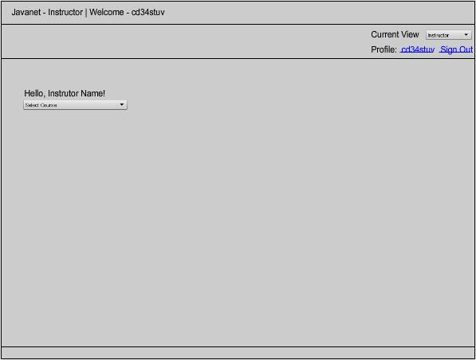

After logging in, an Instructor will be required to select which course they would like to access.

1.2.15 Instructor - Home Page

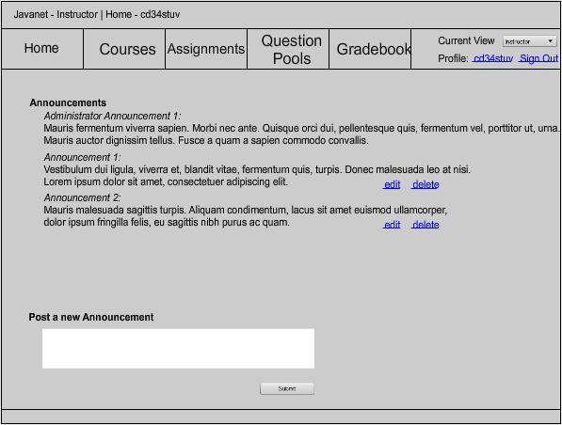

The Instructor Home page will be shown anytime the Home tab is clicked, or after selecting a course on the Instructor Welcome Page. An Instructor user will see the most recent announcements that have been posted by either themselves, the Course Coordinator, or the Administrator. An Instructor will also be able to edit or delete his or her own previous announcements.

1.2.16 Instructor - Create Question Page

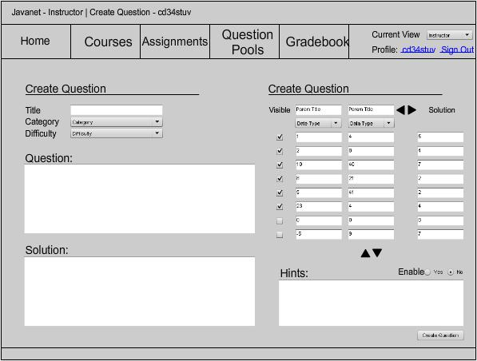

When creating a question, an Instructor will see this page. He or she can select a title, category, and difficulty for the question. An Instructor can then write the question and solution as well. An Instructor will also be able to add parameters for test sets and hints if it is desired. The arrows in the create test set section provide the functionality of creating more test sets and more parameters.

1.2.17 Instructor - Create Question Set Page

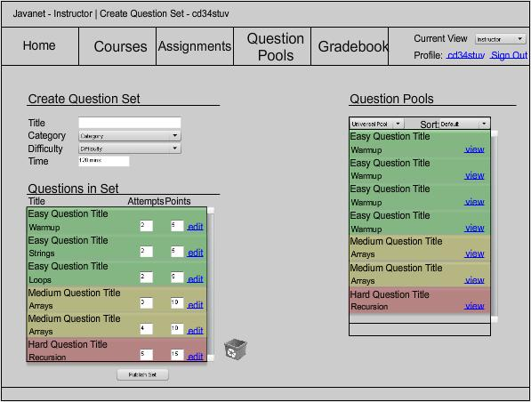

When creating a question set, an Instructor will see this page. An Instructor can create a title, select a category, select a difficulty level, and a time limit for completion. He or she will be able to edit each question in the set, as well as adjust the amount of attempts and, or points available. Instructors are able to build a question set with questions from any of their three pools.

1.2.18 Instructor - Pools Page

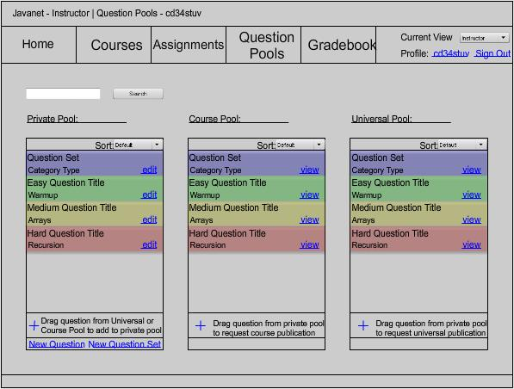

Selecting the Question Pools tab will bring you an Instructor this page. On this page, an Instructor may drag and drop questions to and from certain pools. An Instructor can also search the pools by entering a search string. In addition, he or she can decide to create a new question or question set here.

1.2.19 Instructor - Assignment Listing Page

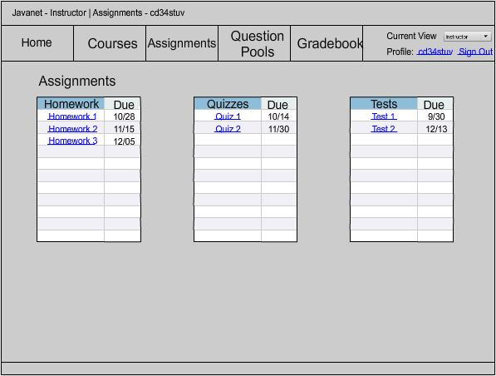

This page can be accessed by an Instructor clicking on the Assignments tab. This page displays three tables: homework, quizzes, and tests. Each assignment is listed with its corresponding due date. Each assignment is also an active link that will redirect to the Gradebook.

1.2.20 Instructor – Gradebook Page – default view

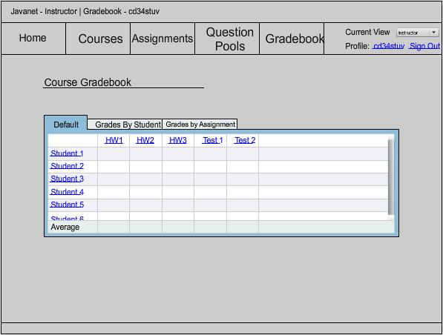

An Instructor can access this page by selecting the Gradebook. This page serves as the default Gradebook. This page will display the students and their averages on each assignment given. Instructors may also choose to view the Gradebook by Student or by Assignment. Each Student name and each assignment are also active links.

1.2.21 Instructor - Gradebook Page - sorted by Students

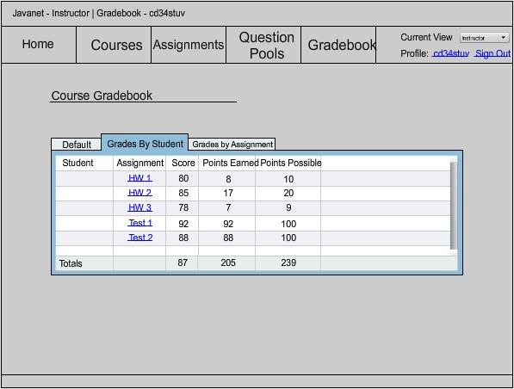

This page can be accessed from the default Gradebook by clicking on a Student name, or by clicking on the Grades By Student tab in the Gradebook. This page shows an Instructor each assignment with its corresponding score, points possible and points earned, for one particular student.

1.2.22 Instructor - Gradebook Page - sorted by Assignments

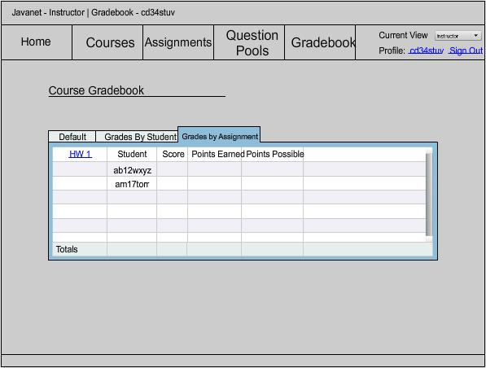

This page can be accessed from the default Gradebook by clicking on a particular assignment, or by clicking on the Grades By Assignment tab in the Gradebook. This page shows an Instructor all of the Students with their corresponding scores, points possible and points earned, for one particular assignment.

1.2.23 Course Coordinator - Profile Page

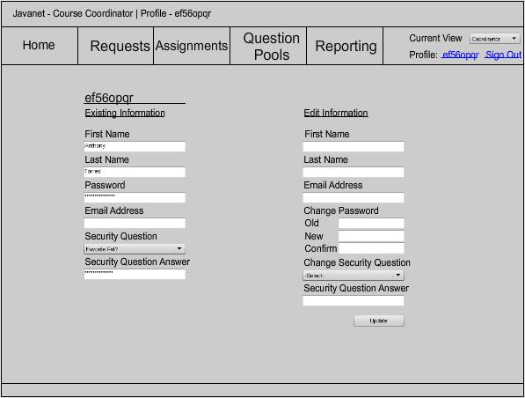

The Course Coordinator Profile Page will be shown anytime the user name link in the upper right corner is clicked. The Course Coordinator Profile Page will allow a Course Coordinator to view his or her existing profile information and edit the information on this page: first name, last name, password, email address, security question, and security answer.

1.2.24 Course Coordinator - Welcome Page

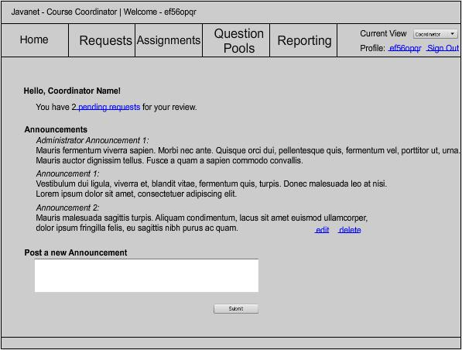

After logging in, the Course Coordinator will be brought to this page. He or she will see any pending requests, the most recent announcements posted and be able to post a new announcement for that course. The Course Coordinator may also edit or delete any announcements that they have posted.

1.2.25 Course Coordinator - Pending Requests Page

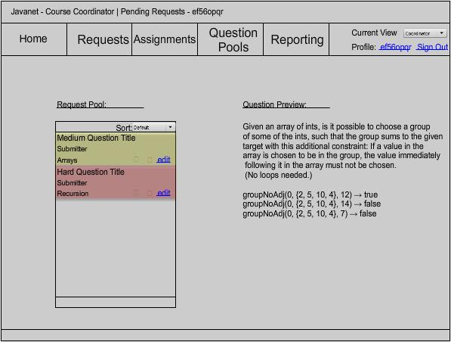

The Pending Requests Page will show the specific pending requests that the Course Coordinator has. He or she can choose to approve, deny, or edit a question or question set.

1.2.26 Course Coordinator - Create Question Page

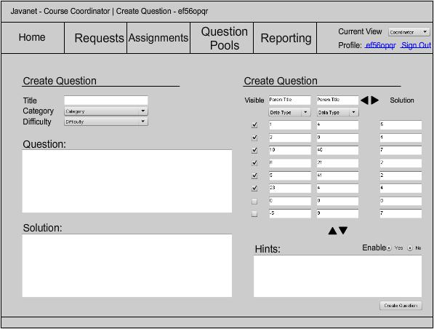

A Course Coordinator will see this page when creating a question. A Course Coordinator can select a title, category, and difficulty for the question. A Course Coordinator can then write the question and solution as well. A Course Coordinator will also be able to add parameters for test sets and hints if it is desired. The arrows in the create test set section provide the functionality of creating more test sets and more parameters.

1.2.27 Course Coordinator - Create Question Set Page

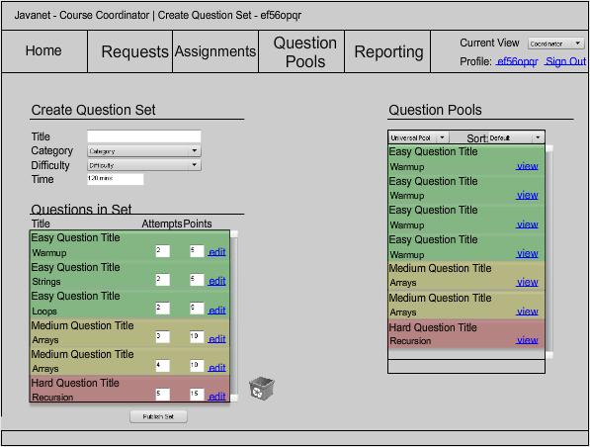

When creating a question set, a Course Coordinator will see this page. A Course Coordinator can create a title, select a category, select a difficulty level, and a time limit for completion. A Course Coordinator will be able to edit each question in the set, as well as adjust the amount of attempts and, or points available. Course Coordinators are able to build a question set with questions from any of their three pools.

1.2.28 Course Coordinator - Pools Page

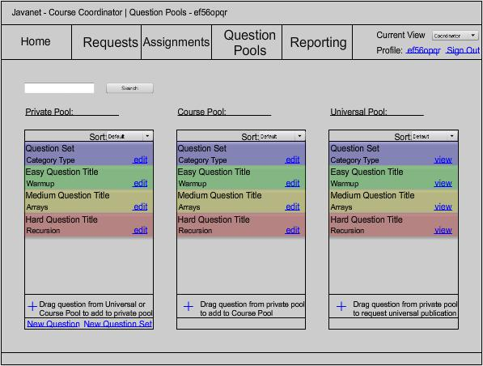

Selecting the Question Pools tab will bring a Course Coordinator to this page. On this page, a Course Coordinator may drag and drop questions to and from certain pools. A Course Coordinator can also search the pools by entering a search string. In addition, a course coordinator can decide to create a new question or question set by clicking links on this page.

1.2.29 Course Coordinator - Assignment Listing Page

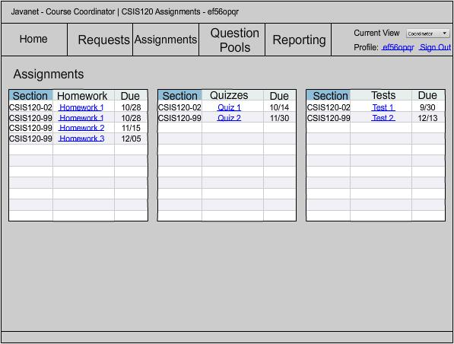

This page can be accessed by clicking the Assignments tab. On this page, a Course Coordinator can view the assignments for a specific course. This page will display three lists: homework, quizzes, and tests. Each list will display the due date and the section for which the assignment has been assigned.

1.2.30 Administrator - Welcome Page

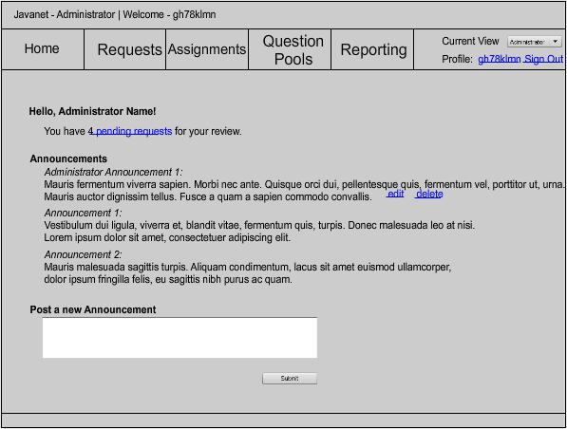

After logging in, the Administrator will be brought to this page. The Administrator will see any pending requests, the most recent announcements posted and be able to post a new announcement for the entire system of Javanet users. The Administrator may also edit or delete any announcements that they have posted.

1.2.31 Administrator - Pending Requests Page

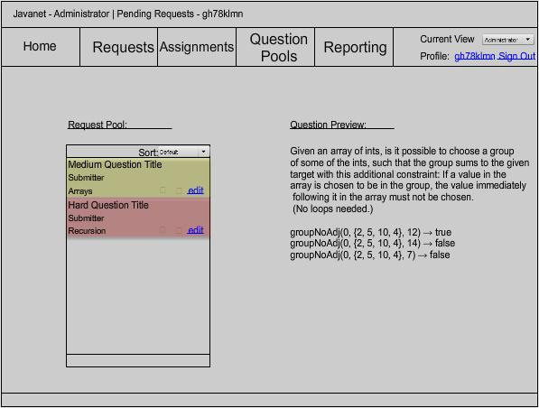

The Pending Requests Page will show the specific pending requests that the Administrator has. The Administrator can choose to approve, deny, or edit a question or question set.

1.2.32 Administrator - Create Question Page

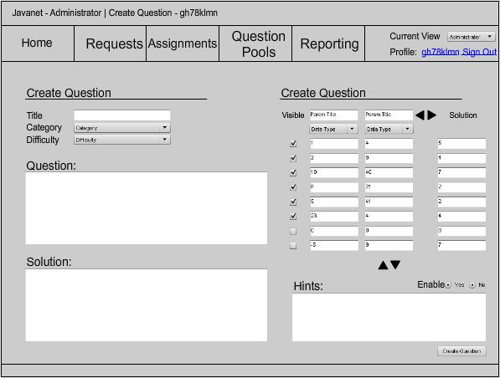

The Administrator will see this page when creating a question. The Administrator can select a title, category, and difficulty for the question. The Administrator can then write the question and solution as well. The Administrator will also be able to add parameters for test sets and hints if desired. The arrows in the create test set section provide the functionality of creating more test sets and more parameters.

1.2.33 Administrator - Create Question Set Page

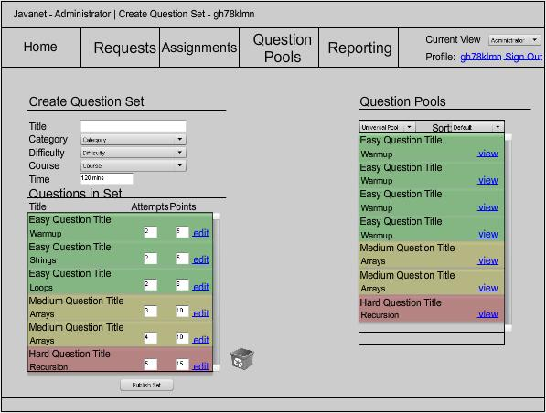

When creating a question set, the Administrator will see this page. The Administrator can create a title, select a category, select a difficulty level, and a time limit for completion. The Administrator will be able to edit each question in the set, as well as adjust the amount of attempts and, or points available. The Administrator is able to build a question set with questions from any of the pools.

1.2.34 Enhancements

We expect to further enhance these prototype screens throughout the Detailed Design phase to ensure that the screens meet the style and functionality requirements of our clients. Additionally, we will create more prototype screens if necessary. One particular instance of this being: functionality for Course Coordinators and the Administrator to generate reports is something that we would like to include, but has not been clearly defined at this time.

  - Data Flow Diagrams

Please refer to the separate Data Flow Diagrams document.

1.4 Logical Data Dictionary

    - Cross Reference Index

This Cross Reference Index serves as an Index to the column in the Data Dictionary that defines where each data entity can be found.

1 | Login Page
2 | Reset Password Page
3 | Student - Registration Page
4 | Student - Profile Page
5 | Student - Welcome Page
6 | Student - Home Page
7 | Student - Practice Page
8 | Student - Assignment Selection Page
9 | Student - Assignment Page - for a specific assignment
10 | Student - Answer Question Page
11 | Student - Solution Page
12 | Student - Gradebook Page
13 | Instructor - Profile Page
14 | Instructor - Welcome Page
15 | Instructor - Home Page
16 | Instructor - Create Question Page
17 | Instructor - Create Question Set Page
18 | Instructor - Pools Page
19 | Instructor - Assignment Listing Page
20 | Instructor - Gradebook Page - default view
21 | Instructor - Gradebook Page - sorted by Students
22 | Instructor - Gradebook Page - sorted by Assignments
23 | Course Coordinator - Profile Page
24 | Course Coordinator - Welcome Page
25 | Course Coordinator - Pending Requests Page
26 | Course Coordinator - Create Question Page
27 | Course Coordinator - Create Question Set Page
28 | Course Coordinator - Pools Page
29 | Course Coordinator - Assignment Listing Page
30 | Administrator - Welcome Page
31 | Administrator - Pending Requests Page
32 | Administrator - Create Question Page
33 | Administrator - Create Question Set Page

    - Data Dictionary Key

The following abbreviations are used in the Data Dictionary:
NN: Not Null
U: Unique

1.4.3 Data Dictionary

Name | Type | Restrictions | Description | Screens it Appears on
announcement | text |  | an announcement posted to all welcome pages of users associated with the author | 6, 15, 24, 30
assignmentAvg | int(4) | numeric | average grade on a specific assignment (question set) for all users | 20
cNumber | varchar(10) | alphaNumeric NN | the course name and number eg. CSIS220 | 14, 15, 16, 17, 18, 19, 20, 21, 22, 24, 25, 26, 27, 28, 29, 30, 31, 32, 33
completedAssign | int(4) | numeric | number of assignments that have been completed by the student | 6
completedPracSets | int(4) | numeric | number of practice sets that have been completed by the student | 6
courseID | varchar(10) | alphaNumeric NN | id used to register for a specific course and section | 4, 13, 29
cSection | varchar(10) | alphaNumeric | course section | 14, 15, 16, 17, 18, 19, 20, 21, 22, 24, 25, 26, 27, 28, 29, 30, 31, 32, 33
cSemester | varchar(6) | alphabetic NN | course semester eg. Fall | 14, 15, 16, 17, 18, 19, 20, 21, 22, 24, 25, 26, 27, 28, 29, 30, 31, 32, 33
cYear | int(4) | numeric NN | year the course was taught | 14, 15, 16, 17, 18, 19, 20, 21, 22, 24, 25, 26, 27, 28, 29, 30, 31, 32, 33
dueDate  Javanet Data Dictionary | date |  | date a question set is due | 6, 8, 12, 19, 29
email | varchar(64) | alphaNumeric U NN | users email address | 2, 3, 4, 13, 23
firstName | varchar(32) | alphabetic NN | users first name | 3, 4, 5, 13, 14, 20, 21, 22, 23
hints | text |  | any hints including urls the instructor wants to add | 10, 16, 26, 32
lastName | varchar(32) | alphabetic NN | users last name | 3, 4, 5, 13, 14, 20, 21, 22, 23
numAttempts | int(2) | numeric | number of submissions allowed for a specific question in the question set | 10, 17, 27, 33
numCorrectCases | int(4) | numeric | number of correct test cases tested against the student code | 11
numPending | int(2) | numeric | number of pending requests for a course coordinator or an administrator | 24, 30
numSubRemaining | int(2) | numeric | number of submissions the student has remaining for a specific question in the question set | 10
pActualOutput | varchar(32) | NN | output of the parameter after being run through student source code | 10, 16, 26, 32
password | varchar(32) | alphaNumeric NN | users password | 1, 3, 4, 13, 23
pDataType | varchar(16) | alphaNumeric NN | expected data type of the parameter eg. Int boolean array string | 16, 26, 32
percentScore | int(4) | numeric | student grade on the question set in the form of a percentage out of 100 | 11, 12, 20, 21, 22
pExpectedOutput | varchar(32) | NN | expected output after the function is called | 10, 25
pName | varchar(16) | alphaNumeric NN | the name of the paramater as its passed to the signature | 16, 25, 26, 31, 32
pointsEarned | int(4) | numeric | total number of points a student has earned on the question set | 12, 21, 22
pointsPossible | int(4) | numeric | number of points possible for a specific question in the question set | 12, 17, 21, 22, 27, 33
practiceStatus  Javanet Data Dictionary | Boolean |  | status of a practice question set | 7
pTestStatus | Boolean | NN | true or false depending on whether the student passed or failed the specific test case | 10
publicationStatus | Boolean |  | true if the question or question set is approved to be published; false if denied | 25, 31
pValue | varchar(32) | NN | value of the parameter | 10, 16, 25, 26, 31, 32
pVisibility | Boolean | NN | Determines whether the parameter is visible to the student users | 16, 25, 26, 31, 32
qCategory | varchar(32) | alphanumeric NN | category of the question eg. Arrays, Loops, Recursion | 16, 17, 18, 25, 26, 27, 28, 31, 32, 33
qDifficulty | varchar(32) | alphabetic NN | question difficulty eg. Easy, Medium, Hard | 16, 17, 18, 25, 26, 27, 28, 31, 32, 33
qsetCategory | varchar(32) | alphaNumeric NN | category of the question set eg. Arrays, Loops Recursion | 17, 18, 25, 27, 28, 31, 33
qsetDifficulty | varchar(32) | alphabetic NN | difficulty of the question set eg. Easy, Medium, Hard | 17, 25, 27, 31, 33
qsetTime | time |  | time allotted for the question set | 17, 27, 33
qsetTitle | varchar(32) | alphaNumeric NN | title of the question set | 8, 9, 12, 17, 18, 19, 25, 27, 28, 29, 31, 33
qSolution | text |  | possible solution provided by instructor | 11, 16, 26, 32
qTitle | varchar(32) | alphanumeric NN | title of the question | 9, 10, 11, 16, 17, 18, 25, 26, 27, 28, 31, 32, 33
questionText | text | NN | description of the problem the student is to solve | 10, 11, 16, 17, 18, 25, 26, 27, 28, 31, 32, 33
searchString | varchar(32) | alphaNumeric | string entered by a non-student user to find a question in a pool | 18, 28
securityA | varchar(64) | alphaNumeric NN | user answer to the security question for identity validation | 2, 3, 4, 13, 23
securityQ | varchar(64) | alphabetic NN | question to be answered by users before resetting a password | 2, 3, 4, 13, 23
showHint | Boolean | NN | are hints available | 16, 26, 32
sourceCode  Javanet Data Dictionary | text |  | student source code | 10, 11
status | varchar(10) | alphabetic NN | status of a question or question set eg. Completed, In Progress | 9
timeRemaining | time |  | time remaining for the question set | 10
totalAssign | int(4) | numeric | total number of assignments | 6
totalPercent | int(4) | numeric | student grade on all question sets in the form of a percentage out of 100 | 6, 12, 21, 22
totalPointsEarned | int(4) | numeric | total number of points a student has earned on all question sets | 12, 21, 22
totalPointsPossible | int(4) | numeric | total number of possible points a student could have earned on all questions | 12, 21, 22
totalPracSets | int(4) | numeric | total number of practice sets | 6
totalTestCases | int(4) | numeric | total number of test cases for a given question | 11
userName | varchar(32) | alphaNumeric U NN | users username | all pages as text or input box

2.1 Structure Diagrams

A structure diagram is the hierarchical representation of how all users, processes, and data flow will take place.
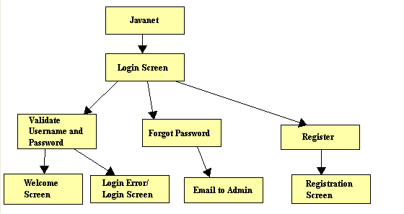

A structure diagram for the Javanet system.

2.1.2 Student

A structure diagram for the Student user.

2.1.3 Instructor

A structure diagram for the Instructor user.

2.1.4 Course Coordinator

A structure diagram for the Course Coordinator user.

2.1.5 Administrator

A structure diagram for the Administrator user.

2.2 Use Case Narratives

Student

The Student user will have the ability to login to and log out of the application through a web interface with a username and password, once they have created an account. When creating an account the Student will be required to create a username and password. The Student will be able to change their password at any time. If the Student forgets their password, they will be able to click a link to an identity validation page to reset the password. The Student will also be able to edit various aspects of their account information at any time. The Student will then be required to enter their name and select what course they are enrolled in. Upon login the Student will be able to select what mode they would like to work in: practice, homework, quiz, or test. In practice mode, the Student will be able to select a category of problems to practice with. In homework mode, the Student will be able to complete the current homework assignment posted by their instructor. In both quiz and test mode, the Student will be able to complete the current quiz or test posted by their instructor. The Student will be required to compile and execute for submission in one step. In all cases, the Student will get instant feedback about their performance, on a category or set of questions, in the form of both a percentage of questions correct and the actual number of questions correct. Students will have the ability to look back at and practice with previous homework assignments, quizzes, and tests with the permission of the Instructor.

Instructor

The Instructor user will have the ability to login to and log out of the application through a web interface with a username and password. The Instructor accounts will be created by the Administrator user. The Instructor users will be given an initial password. The Instructor will have the ability to change their password at anytime. Upon login the Instructor will be able to select what course section page they would like to view. As Student users identify themselves as being enrolled in a specific course, they will appear on the appropriate course page for the corresponding Instructor. The Instructor will have the ability to create new folders/tabs of practice questions, homework assignments, quizzes, and tests. When creating a question, the Instructor will have the following options: including hints for the Students, viewing Student source code, selecting a category for the question, selecting a difficulty level for a question, and selecting the number of compilations allowed for a question or question set. Instructors will have the ability to compile their own private pool of questions. The Instructor may choose to create and publish question sets from their private pool for use by the students enrolled in their course. Instructors may send the Course Coordinator their questions or question sets from their private pool to be published to the Course Pool to share with other Instructors of the course they are teaching. An Instructor may also send the Course Coordinator their questions or question sets to be published to the Universal Pool to be available to all other Instructors. Instructors may also import questions and question sets to their private pool from both the Course and Universal pools. The Instructor will also have the option of how they would like to review results: they can select a Student and scroll through that Student’s assignments, or they can select an assignment and scroll through all of the Students. The Instructor will be able to create a test set for the Student solution to be tested against. The Instructor will also have the ability to override a Student’s grade when they think the automatically generated grade is inappropriate. After an exam is administered and completed, the Instructor will have the ability to see test statistics across all Instructor sections for the corresponding course. The Instructor will also be able to give permission to a particular Student to view previous assignments, quizzes, and tests. Additionally, the Instructor will be able to click to a Student view in order to best assist Students when they are in need of help.

Course Coordinator

The Course Coordinator will be able to log into and log out of the system. The Course Coordinator will be the coordinator of all sections of one specific course. The Course Coordinator will have the ability to submit statistical data to common content of the specific course that they are the coordinator for. This statistical data will be viewable to all Instructors. The Course Coordinator can switch into Instructor or Student view mode.
The Course Coordinator will be able to create questions or question sets to go into the Course Pool. The Course Coordinator will be able to import questions or question sets sent by Instructors to the Course Pool to be shared with other Instructors of the course, and import questions or question sets sent by Instructors to the Universal Pool to be available to all other Instructors. If necessary, the Course Coordinator will have the ability to change the grades of the Students of the course that they coordinate. The Course Coordinator will be able to view the grade book sorted by assignment, or specific Student. Across the course they are coordinating, the Course Coordinator may also view Student progress.

Administrator

The Administrator user will have the ability to login to and log out of the application through a web interface using a username and password provided by the application developers. Once logged into the application, the Administrator will have the ability to create Instructor and Course Coordinator accounts. The Administrator will have the ability to deactivate user accounts, and manage and reset passwords. The Administrator can upload Instructor questions and question sets, upload Instructor test sets, and create questions and question sets to go into the Universal Pool. The Administrator will be able to submit statistical data to common content for all Instructors to see. Administrators will be able to switch into Instructor, Student, or Course Coordinator view mode. The Administrator will have the ability to view the grade book sorted by assignment, specific student, or course. Administrators will be able to view student progress and assignment statistics across all courses. If necessary, the Administrator will be able to change grades. The Administrator will be able to archive student information from the database.

2.3 Functional Requirements Inventory

The following list outlines the required functionality to be included in the final solution.
Javanet will be a web-based application viewable on the four major browsers. These browsers are Internet Explorer 7.0 and 8.0, the latest version of Firefox 2 and 3, and Safari 2.* or better.
- Index page displays a login screen common to all users.
- All other pages display a “logout” option for all users.

The requirements are listed according to user case, as follows:

Student:

- Will be able to self enroll by creating a username (Siena email based) and password.
- Will be able to log in with the confirmed username and password through a web interface:
  - An incorrect log in will display an appropriate error message.
  - A link to an identity validation page will be provided if password is forgotten.
- Will be able to view and edit various account information upon clicking username link.
- Will be able to enroll into their appropriate course.
- Will be able to select a “Practice” tab.
  - Will be able to select practice question sets under given categories.
  - A check mark will be rewarded once the questions in a question set are completed.
  - A smile face will be rewarded once a category is completed.
- Will be able to select an “Assignments” tab.
  - Will be able to choose from chronologically ordered assigned homework.
  - Will be able to choose from chronologically ordered assigned quizzes.
  - Will be able to choose from chronologically ordered assigned tests.
- Will be able to write, compile (or save) and submit solutions to questions.
  - If hints for questions have been enabled, the option to view those hints is available.
  - Test cases and their solutions can be seen on the right-hand side of the screen.
  - A read only version of Students’ question solutions will be available once they have been submitted and graded.
- Will be able to view their grades via a “Gradebook” tab.
  - Links for each assignment will redirect students to a summary page.
- Will be able to log out of the system.

Instructor User:

- Will be able to login to the application through a web interface with a username and password.
- Will be able to select what course section page to view on login.
- Will be able to view and edit various account information upon clicking username link.
- Will be able to post a new announcement for students of that course to see upon login.
- Will be able to select “Courses” tab to switch into another course.
- Will be able to select an “Assignments” tab.
  - Will be able to choose from chronologically ordered assigned homework redirecting to the gradebook.
  - Will be able to choose from chronologically ordered assigned quizzes redirecting to the gradebook.
  - Will be able to choose from chronologically ordered assigned tests redirecting to the gradebook.
- Will be able to select a “Question Pool” tab.
  - A search function will be available to filter through the Universal, Course, and Private pools.
  - Will be able to drag and drop questions from Universal and Course pools to Private pool.
  - Will be able to drag and drop questions from Private pool to Universal or Course pools to request publication from Administrator.
  - Links under private pool will allow creation of a new question and or question set.
- Will have the following options when creating a question set:
  - Creating a title.
  - Selecting a category for the question set.
  - Selecting a difficulty level for a question set.
  - Creating a time limit.
  - Editing each question in the question set or dragging into trash bin for unwanted questions.
  - Adjusting the number of attempts allowed and points for each question.
- Will have the following options when creating a question:
  - Creating a title.
  - Selection a category for the question set.
  - Selecting a difficulty level for a question set.
  - Text box to enter question.
  - Text box to enter solution.
  - Entering and selecting parameter types and their solutions.
  - Enabling hints.
- Will be able to select a “Gradebook” tab.
  - Sub tabs will include: “Default”, “Grades By Student”, and “Grades By Assignment”.
- Will be able to override a Student’s grade when the automatically generated grade is inappropriate.
- Will be able to see statistics across all Instructor sections for the corresponding course after an exam is administered and completed.
- Will be able to see statistics across all Instructor sections for the corresponding course after a homework assignment is administered and completed.
- Will be able to give permission to a particular Student to view previous assignments, quizzes, and tests.
- Will be able to click to a Student view in order to best assist Students when they are in need of help.
- Will be able to log out of the system.

Course Coordinator User:

- Will be able to log into the system.
- Will be able to switch into Instructor and Student view mode.
- Will be able to create questions or question sets to go into the Course pool.
- Will be able to import questions or question sets sent by Instructors to the Course pool to be shared with other Instructors of the course.
- Will be able to import questions or question sets sent by Instructors to the Universal pool to be available to all other Instructors.
- Will be able to change grades for students of the course that they are the coordinator for, if needed.
- Will be able to view grade book sorted by assignment.
- Will be able to view grade book sorted by specific student.
- Will be able to view student progress across the course that they are the coordinator for.
- Will be able to log out of the system.

Administrative User:

- Will be able to log into system.
- Will be able to create Instructor and Course Coordinator accounts.
- Will be able to change current view mode to Course Coordinator, Instructor, or Student.
- Will be able to edit Course Coordinator, Instructor, and Students account information while in their own view mode.
- Will be able to select a “Requests” tab.
  - Will be able to edit, approve, or deny questions pending publication.
  - A question preview will be displayed on the right-hand side.
- Will be able to select a “Question Pool” tab.
  - A search function will be available to filter through the Universal, Course, and Private pools.
  - Will be able to drag and drop questions from Universal and Course pools to Private pool.
  - Will be able to drag and drop questions from Private pool to Universal or Course pools to request publication from Administrator.
  - Links under private pool will allow creation of a new question and or question set.
- Will have the following options when creating a question set:
  - Creating a title.
  - Selecting a category for the question set.
  - Selecting a difficulty level for a question set.
  - Creating a time limit.
  - Editing each question in the question set or dragging into trash bin for unwanted questions.
  - Adjusting the number of attempts allowed and points for each question.
- Will have the following options when creating a question:
  - Creating a title.
  - Selection a category for the question set.
  - Selecting a difficulty level for a question set.
  - Text box to enter question.
  - Text box to enter solution.
  - Entering and selecting parameter types and their solutions.
  - Enabling hints.
- Will be able to create questions and question sets to go into the Universal pool.
- Will be able to change grades, if needed.
  - Switching view modes to either a Course Coordinator or Instructor.
- Will be able to archive student information from the database.
- Will be able to deactivate accounts.
- Will be able to log out of the system.

3.1 Testing Overview

Javanet will undergo extensive unit testing during the Acceptance Test phase of our project. This testing will ensure Javanet meets all functional and non-functional requirements as stated in the functional requirements inventory section of this document, Section 2.3. The acceptance test will be presented to demonstrate our software's
compliance with the needs of the clients. The Unit Test Catalog and accompanying Unit Tests are provided in the accompanying Test Plan Document.

Appendix

4.1 Enlarged Timeline (Gantt Chart)

4.2 Glossary of Terms
All glossary definitions provided by Wikipedia.org.

API

An application programming interface (API) is a set of functions, procedures or classes that an operating system, library or service provides to support requests made by computer programs.

Classic Waterfall Model

The waterfall model is a sequential software development model (a process for the creation of software) in which development is seen as flowing steadily downwards (like a waterfall) through the phases of requirements analysis, design, implementation, testing (validation), integration, and maintenance.

Course Pool

Collection of question sets that an Instructor of the Pool’s specific course has published to the pool. These published questions are then given permission to join the pool of existing question sets in the pool by the Course Pool Administrator.

CSS

Cascading Style Sheets (CSS) is a style sheet language used to describe the presentation of a document written in a markup language. The most common application of CSS is to style web pages written in HTML and XHTML, but the language can be applied to any kind of XML document, include SVG and XUL.

Gantt Chart

A Gantt chart is a type of bar chart that illustrates a project schedule. Gantt charts illustrate the start and finish dates of the terminal elements and summary elements of a project.

GUI

A graphical user interface (GUI) is a type of user interface which allows people to interact with electronic devices like computers, hand-held devices (MP3 Players, Portable Media Players, Gaming devices), household appliances and office equipment.

Hardware

Hardware is a general term that refers to the physical artifacts of a technology. It may also mean the physical components of a computer system,

Java

Java refers to a number of computer software products and specifications from Sun Microsystems that together provide a system for developing application software and deploying it in a cross-platform environment.

Linear Sequential Model

The Linear Sequential Model is a software process model that involves a systematic progression through analysis, design, coding, testing and maintenance phases. It is also referred to as the "waterfall model".

Mac OS X version 10.4 “Tiger” was the fifth major release of Mac OS X, Apple’s desktop and server operating system for Macintosh computers. Tiger was released as the successor to Mac OS X v10.3 “Panther”

MySQL

MySQL is a relational database management system (RDBMS) which has more than 11 million installations. The program runs as a server providing multi-user access to a number of databases.

Operating System

An operating system (commonly abbreviated OS and O/S) is the software component of a computer system that is responsible for the management and coordination of activities and the sharing of the resources of the computer.

PHP

PHP is a computer scripting language. Originally designed for producing dynamic web pages, it has evolved to include a command line interface capability and can be used in standalone graphical applications.

Private Instructor Pool

A specific Instructor’s own personal collection of questions and question sets that they have created/uploaded to their private pool, which Students and other Instructors do not have access to.

Software

Software is a general term used to describe a collection of computer programs, procedures and documentation that perform some tasks on a computer system.

Source Code

In computer science, source code (commonly just source or code) is any sequence of statements or declarations written in some human-readable computer programming language. Source code is written in a programming language, which is usually a simplified form of the English language to reduce ambiguity. Source code allows the programmer to communicate with the computer using a reserved number of instructions.

Universal Pool

The Universal Pool is a collection of question sets that may have been published by any Instructor of any course. The question sets are added to the pool only when they Universal Pool Administrator has granted permission.

Workstation

A workstation, or engineering workstation, is a high-end microcomputer designed for technical or scientific applications. Workstations are intended primarily to be used by one person at a time, although they are commonly connected to a local area network and run multi-user operating systems.

Windows Vista

Windows Vista is a line of operating systems developed by Microsoft for use on personal computers, including home and business desktops, laptops, Tablet PCs, and media center PCs.

XHTML

The Extensible Hypertext Markup Language, or XHTML, is a markup language that has the same depth of expression as HTML, but also conforms to XML syntax.

