Preliminary Design

Requested By: Dr. Scott Hunter
Assistant Professor of Computer Science
Computer Science Department of Siena College

Ms. Jami Cotler
Instructor/Lecturer of Computer Science
Computer Science Department of Siena College

Dr. Tim Lederman
Professor of Computer Science
Computer Science Department of Siena College

Automated Excel Grading System

Oasis Technologies

Prepared By:
Brian Salmon
Jim Dzembo
Vincent Leone
Chris Mahar
Josh Yerkie

Automated Excel Grading System
Preliminary Design

Table of Contents:

Preliminary Design 3
I. Product Overview and Summary 3
II. User Displays, Report Formats, and User Command Summaries 4
Login Views 4
Student Views 8
Lab Instructor Views 14
Lecture Instructor Views 17
Course Administrator Views 19
III. Detailed Data Flow Diagrams 27
Level 0: Context Diagram 27
Level 1: Student 28
Level 2: Lab Instructor 30
Level 3: Lecture Instructor 32
Level 4: Course Administrator 34
IV. Logical Data Dictionary 37
Level 0: Context Diagram 37
Level 1: Student 39
Level 2: Lab Instructor 44
Level 3: Lecture Instructor 49
Level 4: Course Administrator 54
V. Logical Data Stores 65
VI. Logical Format of Data Files and Databases 68
VII. Structure Diagrams 69
VIII. Use Case Narrative 72
IX. Functional Requirements 73
X. Unit Tests 76
Appendices 86
I. Sources of Information 86
II. Gantt Chart 86
III. Glossary of Terms 86
Preliminary Design
I. Product Overview and Summary
Siena College offers two courses in the Computer Science Department that utilize Microsoft Excel. These courses have a required lab where the students create spreadsheets, which then need to be graded by the lab instructor. There is also a pre-lab associated with each lab that the students are required to complete. There are a large number of students that take these courses thus creating a large amount of excel spreadsheets that requiring grading by the lab instructors. As a result of the high quantity of spreadsheets that need grading we have been tasked, by Dr. Scott Hunter and Ms Jami Cotler, with creating a system to grade these labs and pre-labs automatically and report back to the students and instructors the results. The students will have the ability to log in to a web based system and submit these labs and pre-labs and view their grades

II. User Displays, Report Formats, and User Command Summaries
**Note: All screens can be accessed as HTML pages by going to the following link: http://oraserv.cs.siena.edu/~perm_oasis/prototype
Login Views
Login View:
This is a view that all users will see when first loading the website. It is where all users will enter their username and password. If student's have not already set up their account, they can click on the "Register Here" link which will take them to the Register View. They can also recover their password from here if they forgot it.
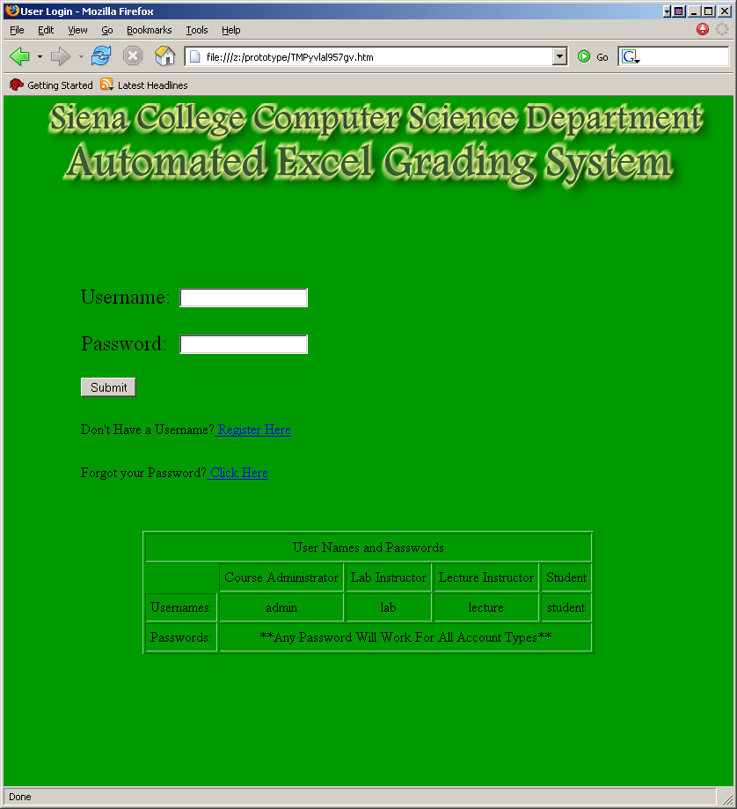

Register View:
This is the view students will see when attempting to create an account. They will fill in their Name, Username, Password twice for verification, Lecture Section, and Lab Section and then click on a "Register" button to finish their registration.
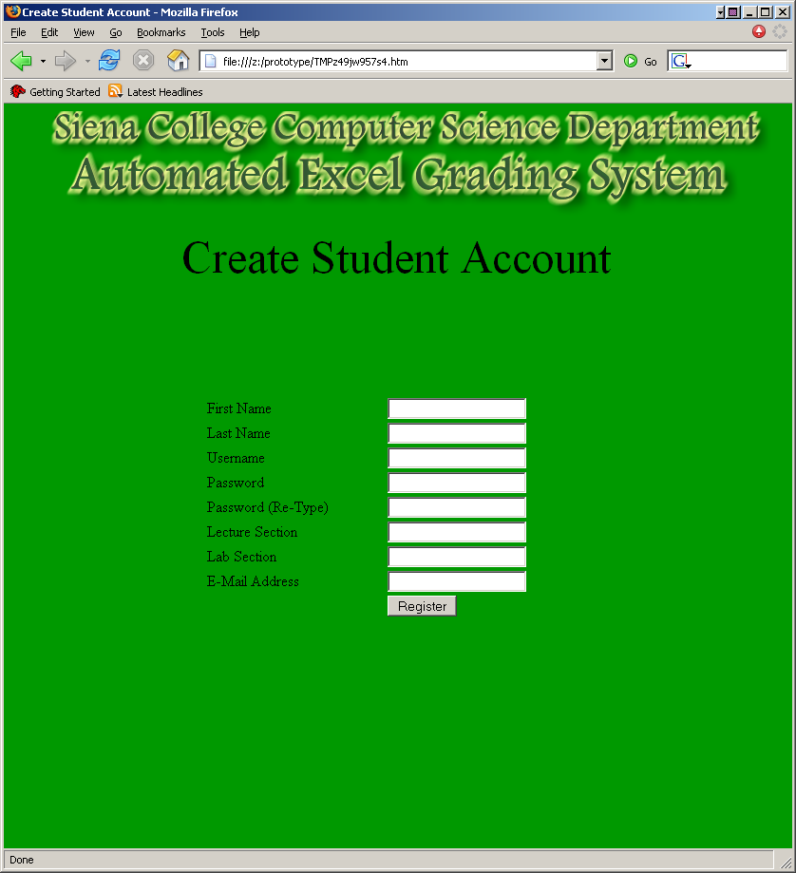

Forgot Password View:
This screen is where you fill out you’re: name, username, and e-mail address. Then an email will be sent to the user with their password.
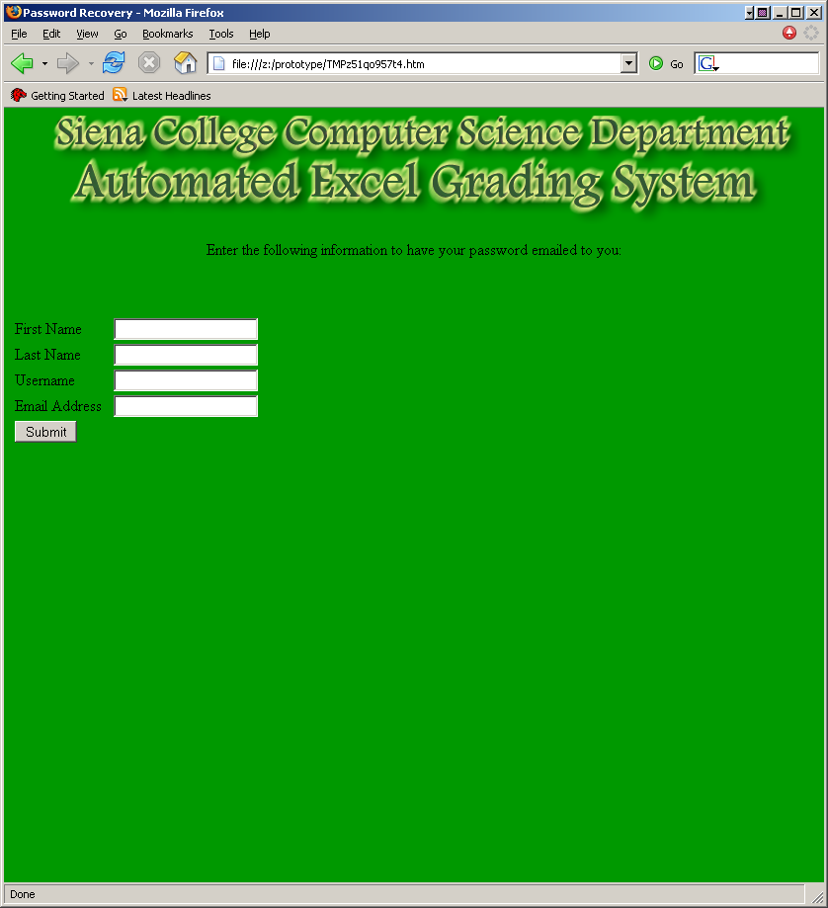

Invalid Login View:
This screen is displayed when you enter an invalid username or password.
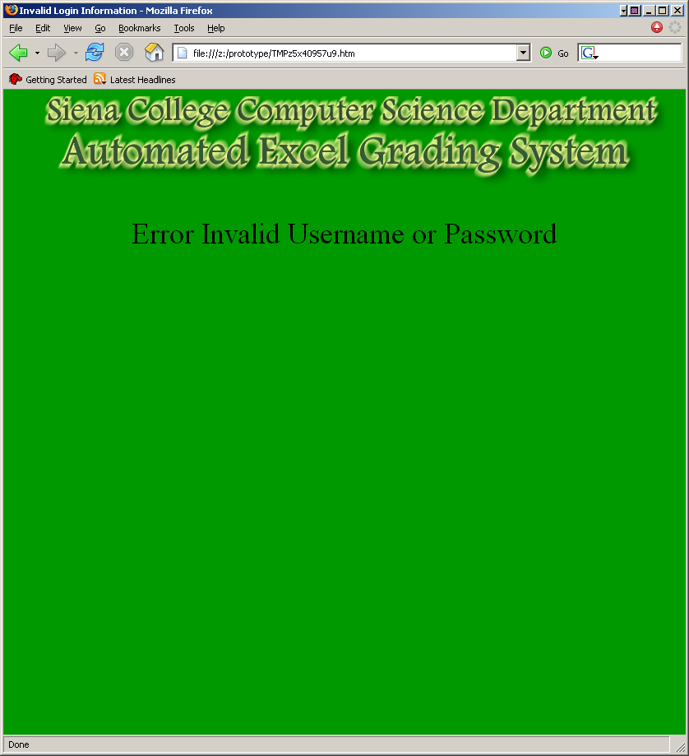

Student Views
Student View:
This is a view of what the students will see when they log into the system. There are two buttons they can click. One will bring them to their pre-labs home page and the other to their labs home page.
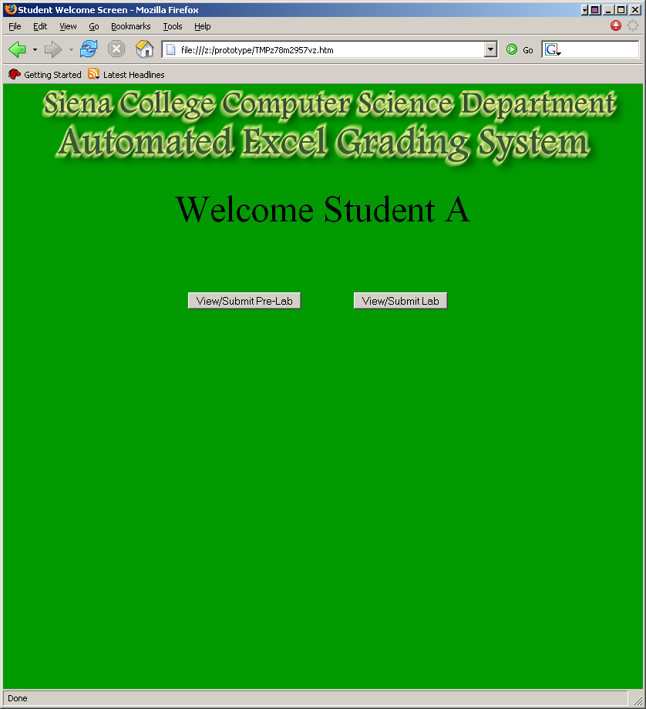

Student View 1:
This screen is where the student views their pre-labs. It will display all pre-lab files associated with each lab and the corresponding grades. It will also display a button to upload new pre-labs and a button to view the errors from the lab.
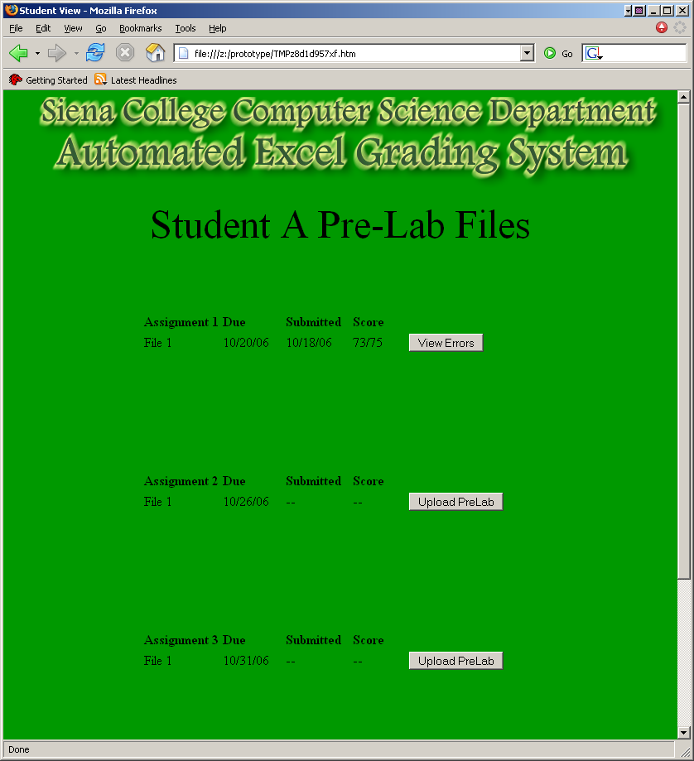

Student View 2:
This screen is where the student views their labs. It will display all lab files associated with each lab and the corresponding grades. It will also display a button to upload new labs and a button to view the errors from the lab.
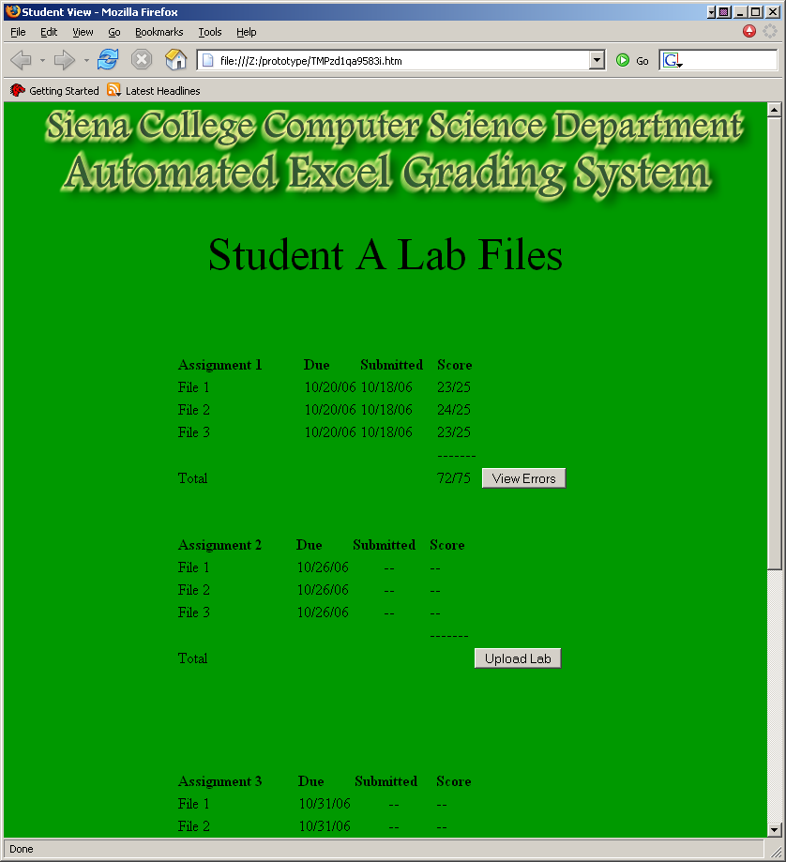

Student View 3:
This screen is where the students can upload their pre-lab files.
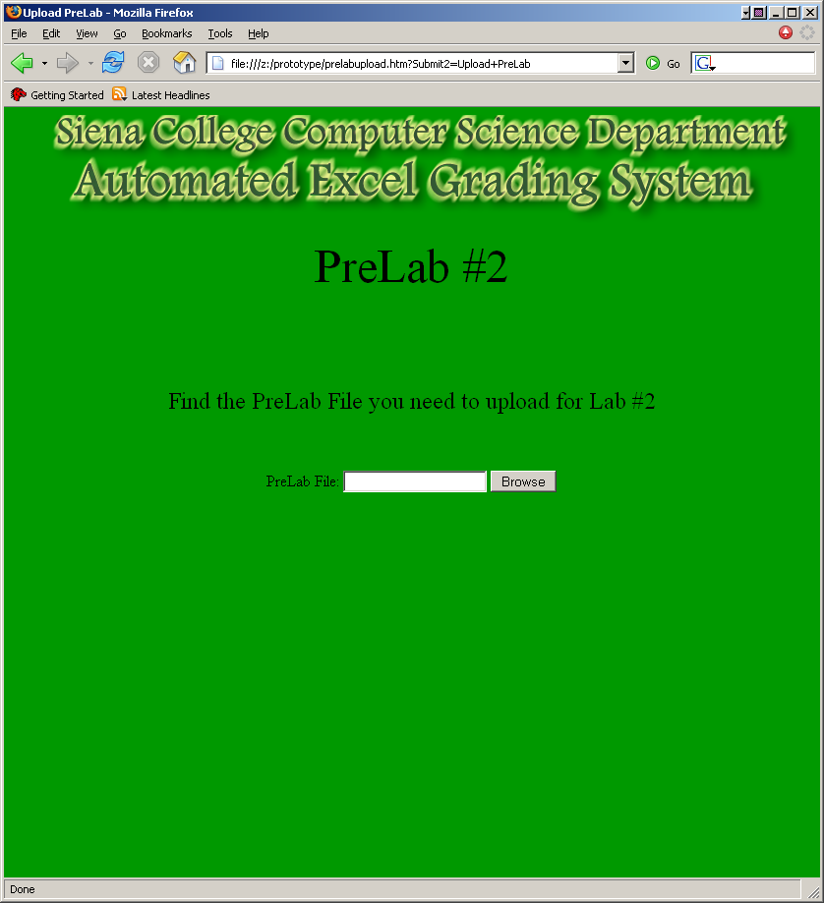

Student View 4:
This screen is where a student can upload their lab files.
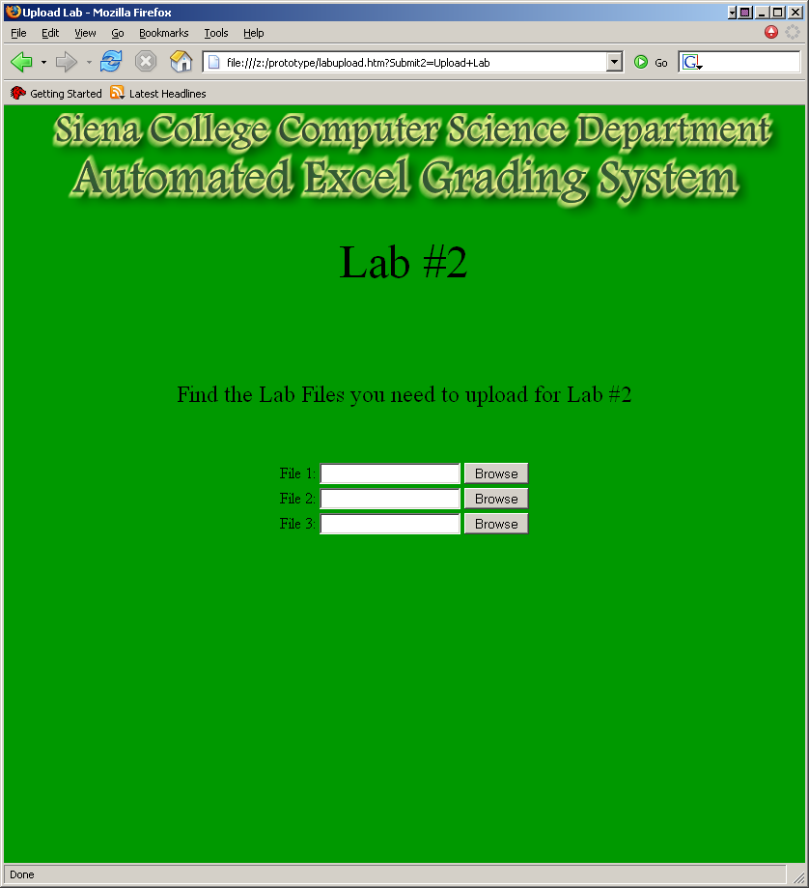

Student View 5:
This is the screen of the HTML error report generated for the student.
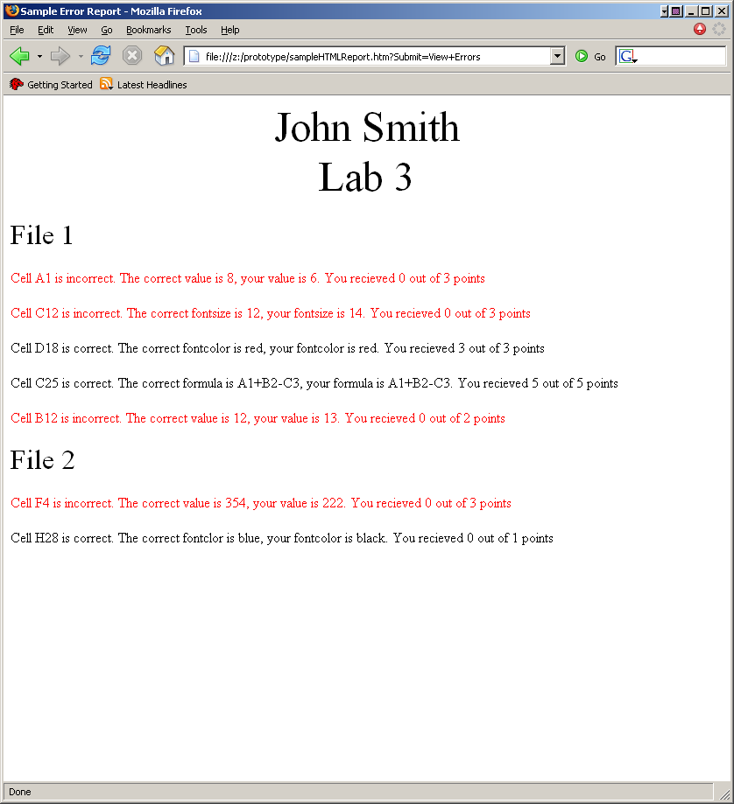

Lab Instructor Views
Lab Instructor View 1:
This is the area where Lab Instructors will be able to decide which grades they want to view. They will first select which students they want to see: either a single lab section or all of their lab sections. Then they will select if they want to view all labs or a specific lab.
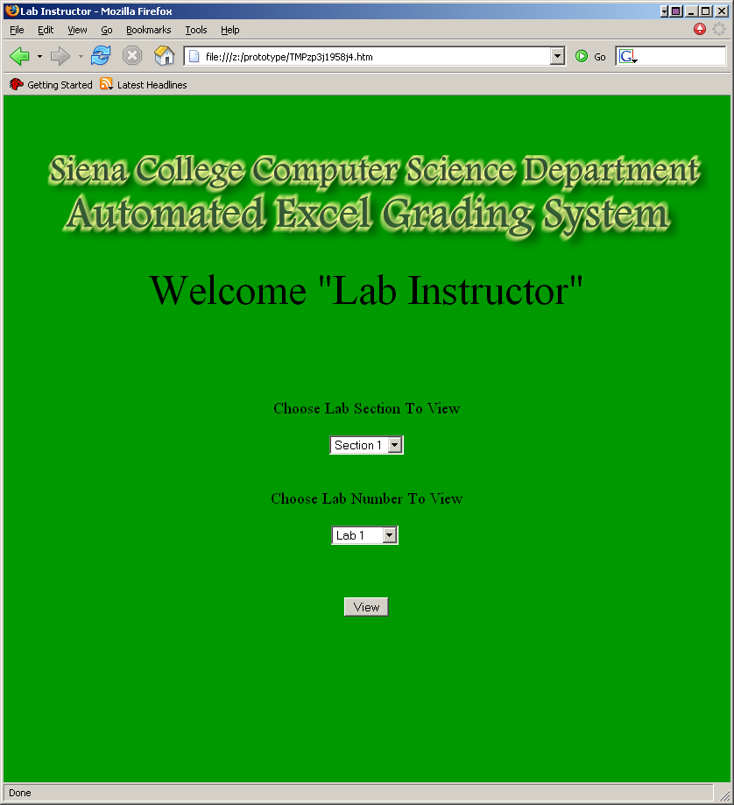

Lab Instructor View 2:
This is where the grades selected in Lab Instructor View 1 are displayed. This is where Lab Instructors can choose to view the graded files, approve the grades and also change the grade if necessary. This screen allows you to see the lab file in excel and also give the instructor and error report.
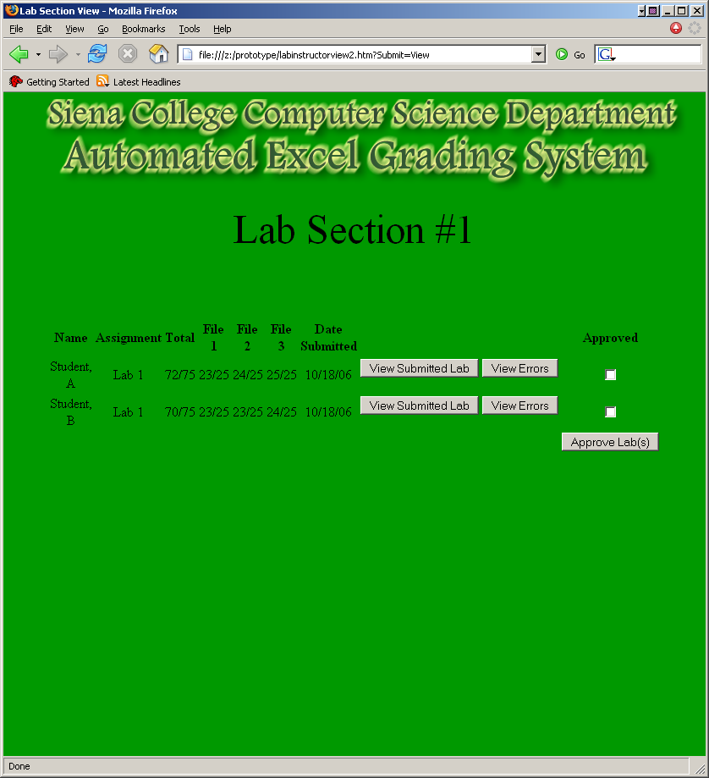

Lab Instructor View 3:
This is the error report that the lab instructor sees. It has everything that was marked incorrect from the excel file. They can edit this report to mark things correct that were marked incorrect by the system but deemed acceptable by the instructor.
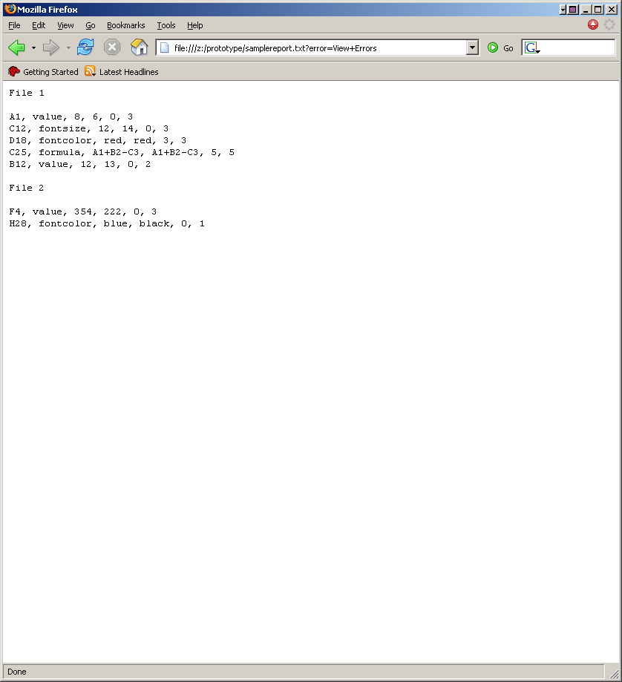

Lecture Instructor Views
Lecture Instructor View 1:
This is the area where Lecture Instructors will be able to decide what they want to view. They will first select which students they want to see: either a single lecture section or all of their lecture sections. Then they will select if they want to view all labs or a specific lab.
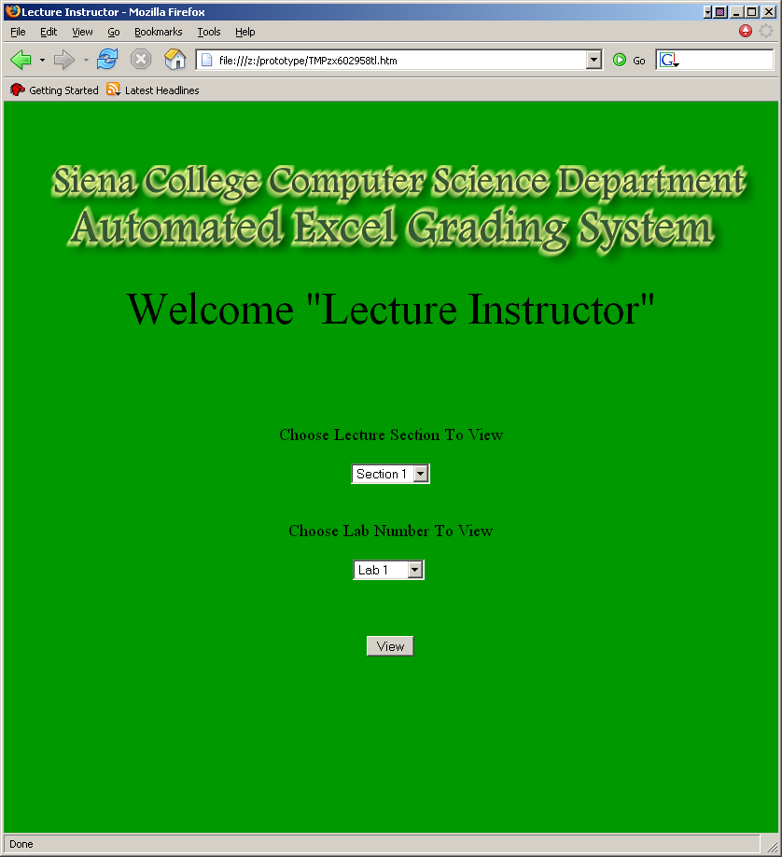

Lecture Instructor View 2:
This is where the grades selected in Lecture Instructor View 1 are displayed. The lecture instructor can view the submitted lab in excel and can also view the error report to the corresponding lab on an HTML page.
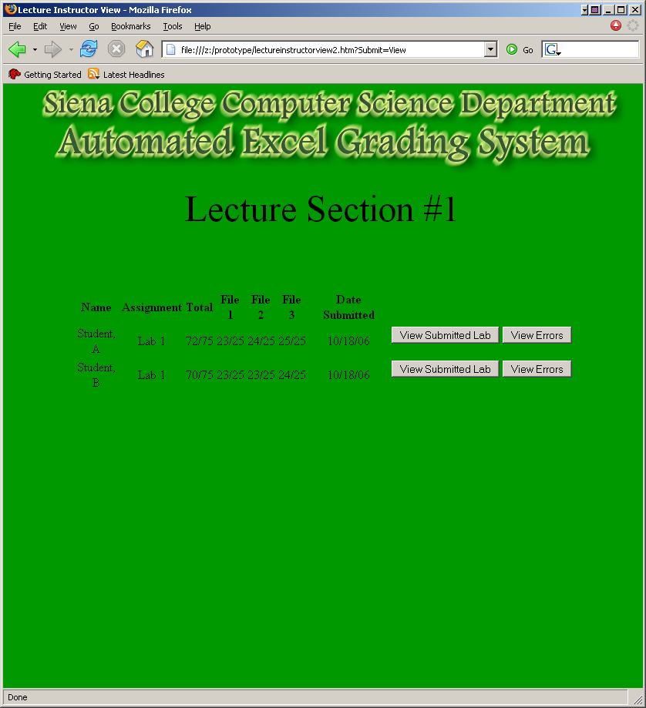

Course Administrator Views
Course Administrator View 1:
This is the area where the Course Administrator will be able to decide what they want to view. They will first select which students they want to see: a single lab section, a single lecture session, or all students. Then they will select if they want to view all labs or a specific lab. They can also edit/delete instructors or register new ones. They have the option of searching for a student by name. They can also view all students or all instructors. Finally, they have the option of uploading answer keys on this page.


Course Administrator View 2:
This is where the grades selected in Course Administrator View 1 are displayed. From this screen they will also be able to launch the excel file or view the error reports. Also they have the option of approving the grades as well.
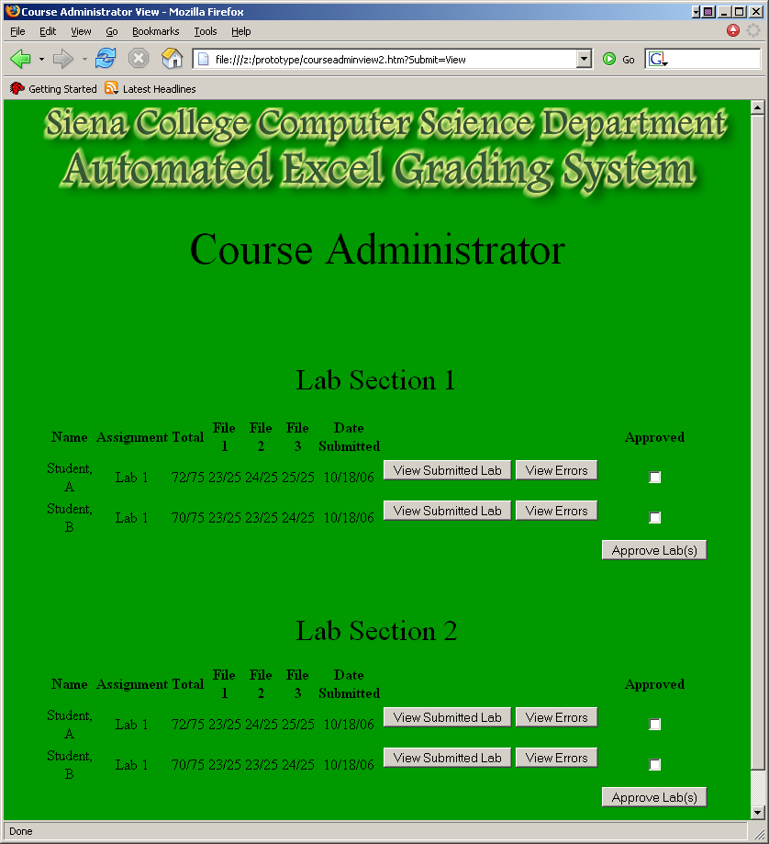

Course Administrator View 3:
This screen is where the Course Administrator can create a new instructor account. You are able to select which type of instructor they are as well as the corresponding sections they teach.
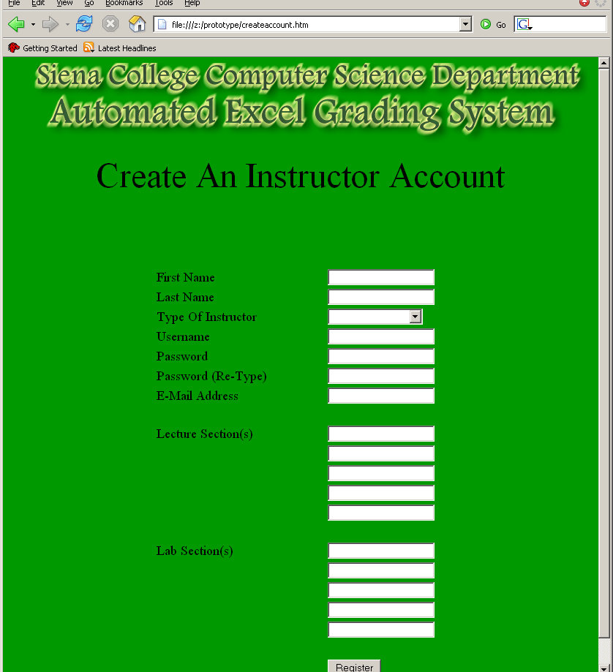

Course Administrator View 4:
This screen is where you are able to view all of the instructors. This screen gives you the option of editing or deleting an instructor. (editing screen is in view 5)
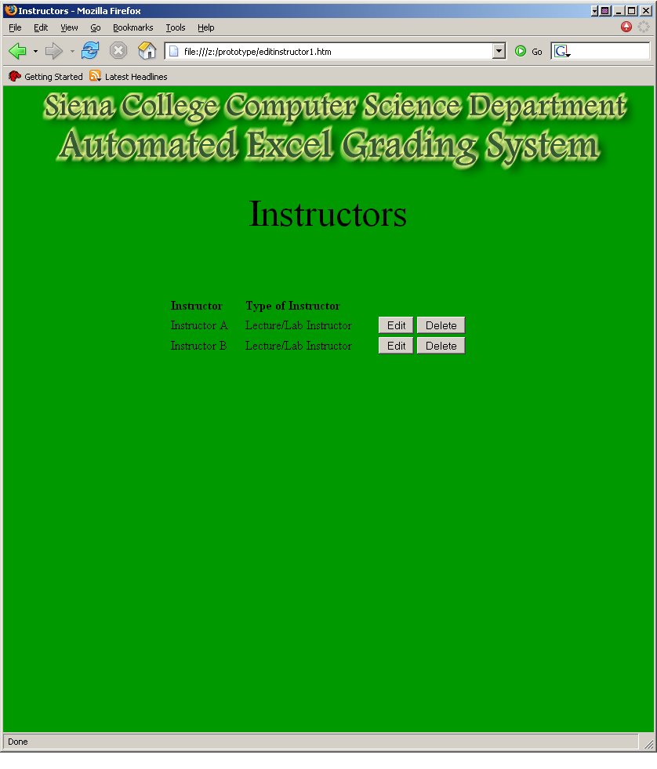

Course Administrator View 5:
This screen allows you to change the instructor’s information including the type of instructor and the lecture/lab sections.
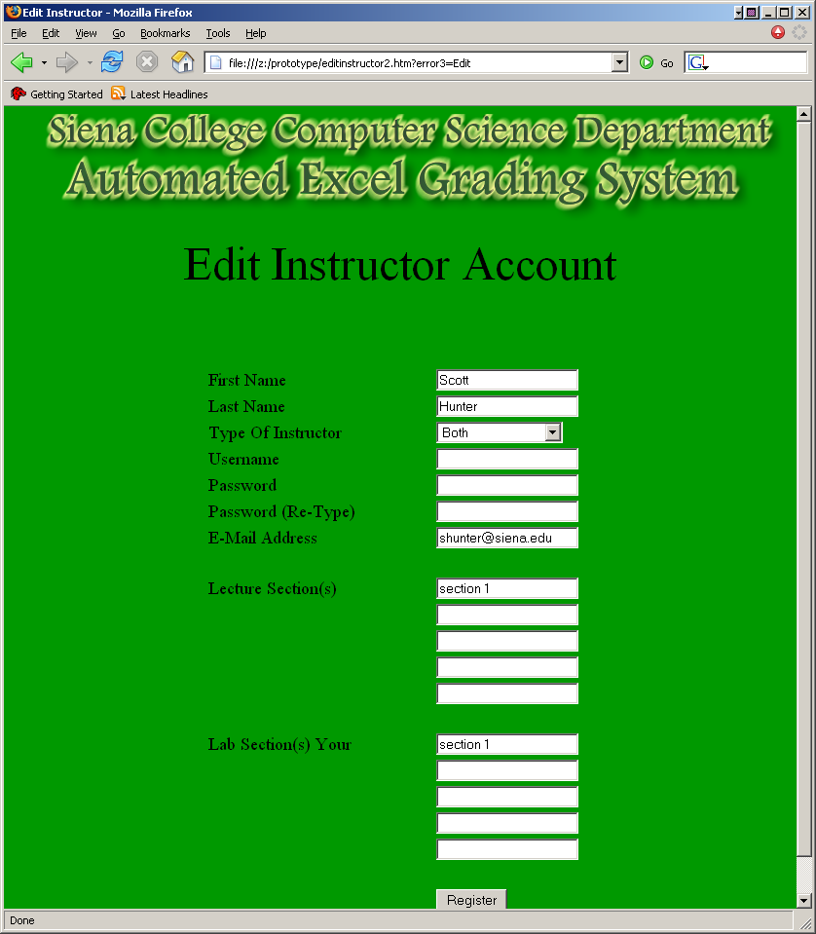

Course Administrator View 6:
This screen allows you to view all the students taking your class. This screen gives you the option of editing their information or deleting their account.(editing screen in view 7)
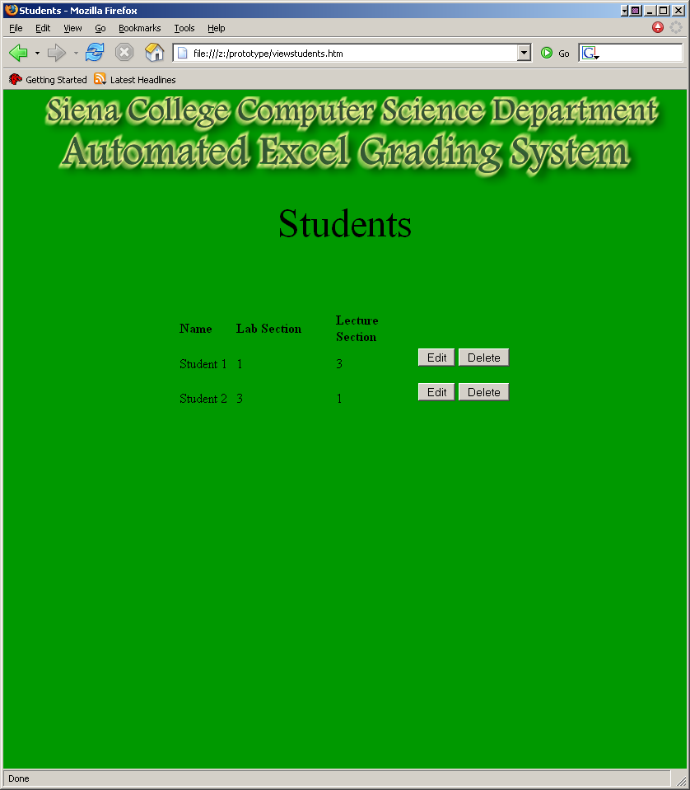

Course Administrator View 7:
When the Course Administrator chooses view all students then clicks the edit button, this screen will show everything stored on this particular students account in separate fields. The Course Administrator will be able to change any of these fields. These fields include name, username, password, lecture section, and lab section.
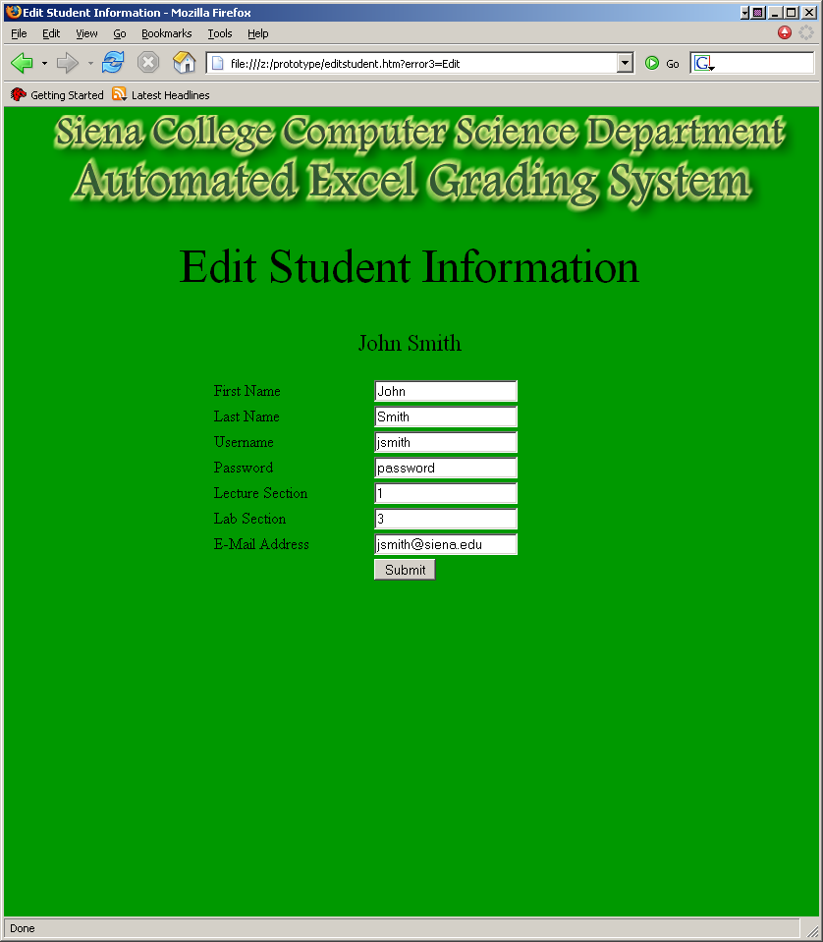

Course Administrator View 8:
This screen is where the Course Administrator can upload their answer keys for the labs. Also this screen allows the Course Administrator to upload sample lab files.
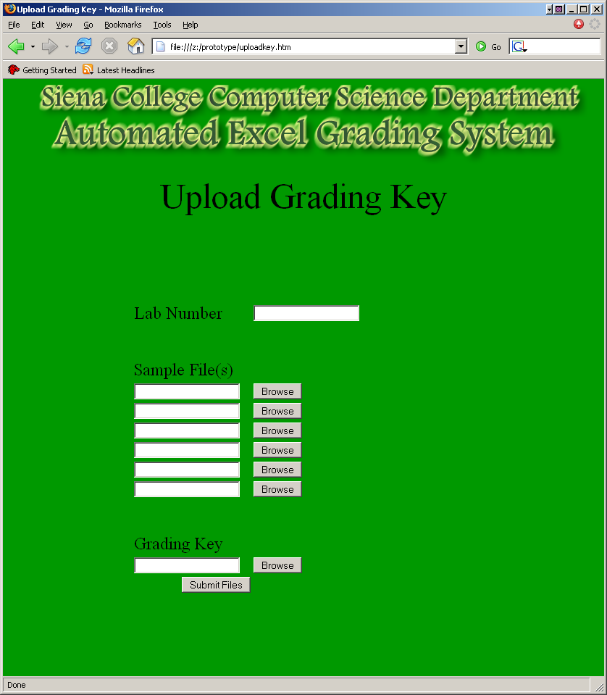

III. Detailed Data Flow Diagrams
Level 0: Context Diagram
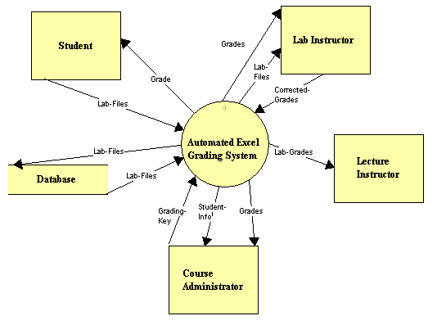

Level 1: Student
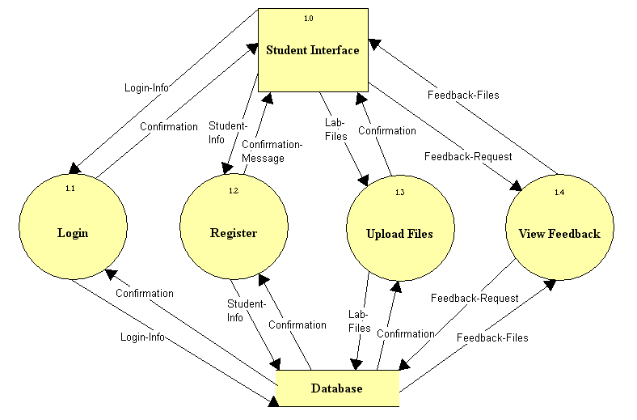

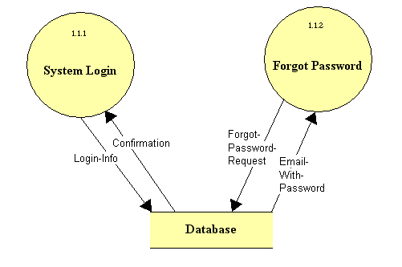

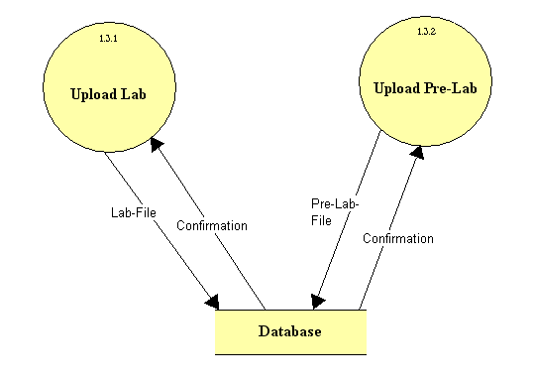

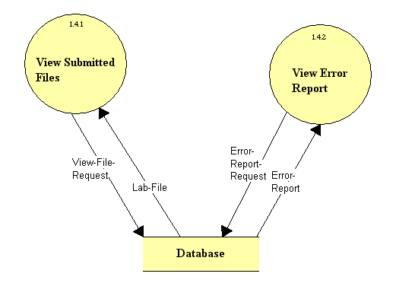

Level 2: Lab Instructor

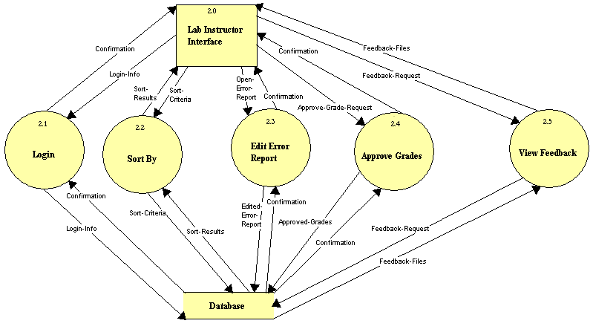

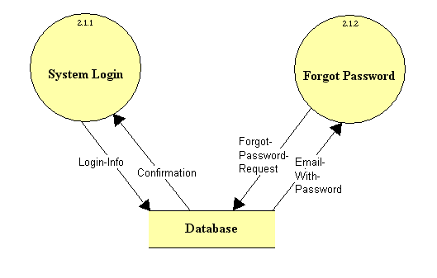
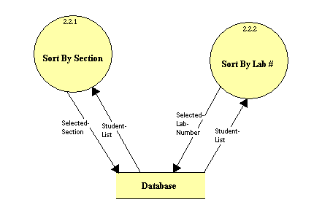
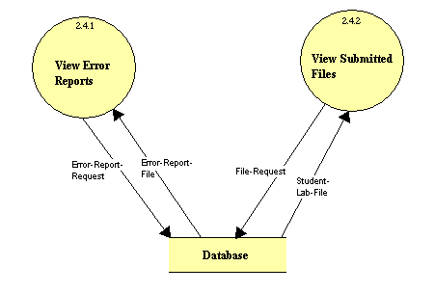

Level 3: Lecture Instructor
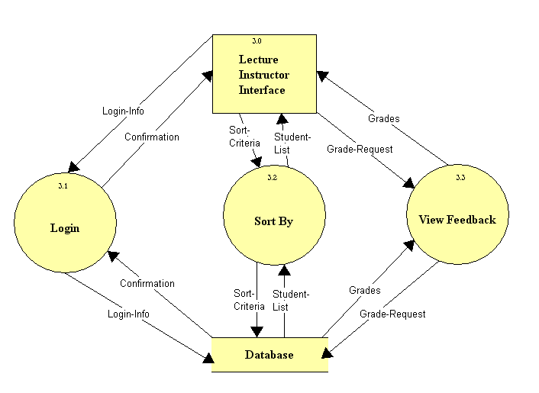

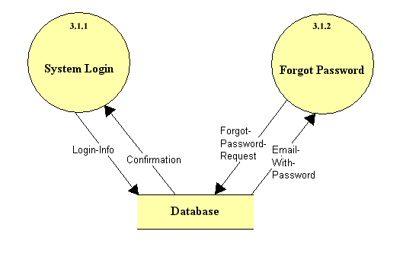

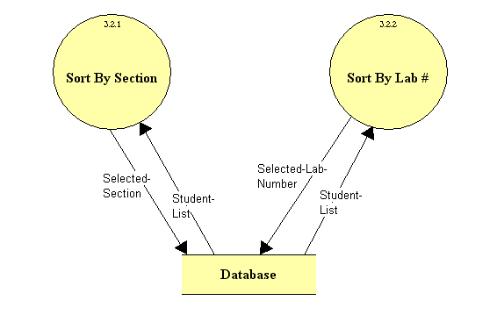
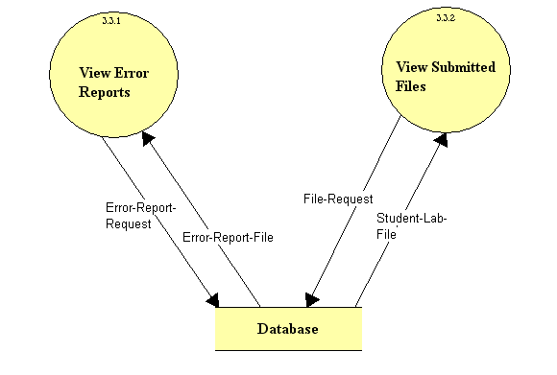

Level 4: Course Administrator

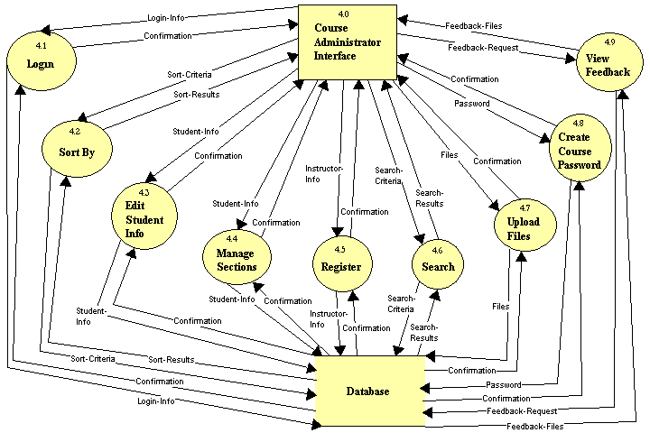

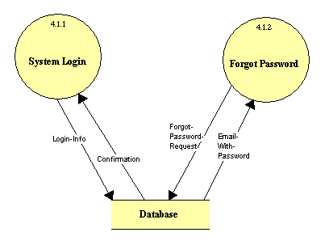

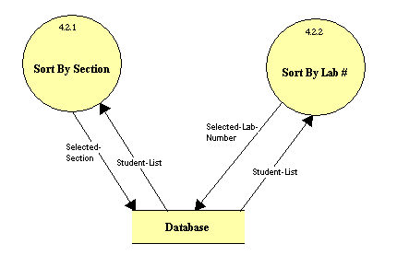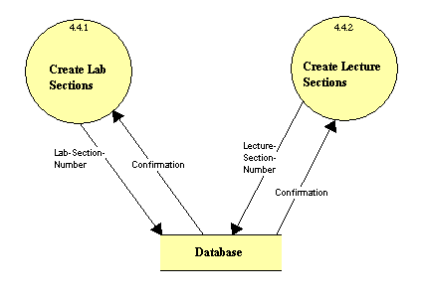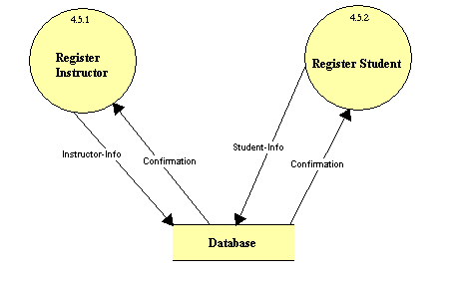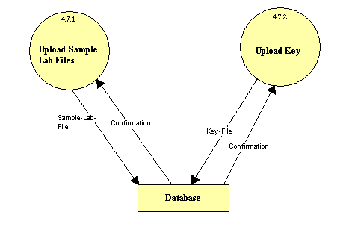

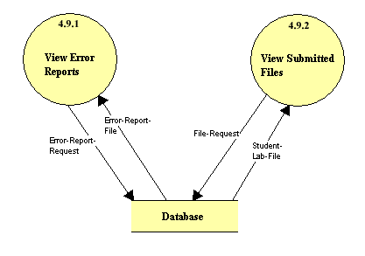

IV. Logical Data Dictionary
Level 0: Context Diagram

Lab Files Data Flow
Source: Student
Destination: Automated Excel Grading System
Description: Lab files will be submitted to the system.

Grade Data Flow
Source: Automated Excel Grading System
Destination: Student
Description: The grades of the lab or pre-labs will be viewed by the student.

Corrected Grades Data Flow
Source: Lab Instructor
Destination: Automated Excel Grading System
Description: The lab instructor will send the verified or corrected grades to the
system.

Grades Data Flow
Source: Automated Excel Grading System
Destination: Lab Instructor
Description: The unverified grades will be viewed by the lab instructor.

Lab Files Data Flow
Source: Automated Excel Grading System
Destination: Lab Instructor
Description: The lab instructor will be able to view the student’s submitted files.

Lab Grades Data Flow
Source: Automated Excel Grading System
Destination: Lecture Instructor
Description: The lecture instructor can view the student’s lab grades.

Grading Key Data Flow
Source: Course Administrator
Destination: Automated Excel Grading System
Description: The course administrator will submit the key for grading.

Student Info Data Flow
Source: Automated Excel Grading System
Destination: Course Administrator
Description: The course administrator can view each student’s information.

Grades Data Flow
Source: Automated Excel Grading System
Destination: Course Administrator
Description: The course administrator can view each student’s grades.

Lab Files Data Flow
Source: Database
Destination: Automated Excel Grading System
Description: The system will retrieve each student’s submitted files from the
database.

Lab Files Data Flow
Source: Automated Excel Grading System
Destination: Database
Description: The system will send all the student’s files to the database when
submitted.

Student Source/Sink
Input Flows: Grade
Output Flows: Lab Files
Description: Student that is enrolled in a lab section.

Lab Instructor Source/Sink
Input Flows: Grade, Lab Files
Output Flows: Corrected Grades
Description: Instructor of one or multiple lab sections. Must verify/correct all
grades, and can view each student’s submitted files.

Lecture Instructor Source/Sink
Input Flows: Lab Grades
Description: Instructor of one or multiple lecture sections. Can view each
student’s grades for labs.

Course Administrator Source/Sink
Input Flows: Student Info, Grades
Output Flows: Grading Key
Description: The administrator of the Excel Course. Can submit the grading key
and view student information and grades.

Database Data Store
Input Flows: Lab Files
Output Flows: Lab Files
Description: Database containing usernames, passwords, submitted lab files,
graded lab files, grading key, and the grading template.

Level 1: Student
Login Info Data Flow
Source: Student Interface
Destination: Login
Description: Username and password for student.

Confirmation Data Flow
Source: Login
Destination: Student Interface
Description: Acceptance or rejection of login info.

Student Info Data Flow
Source: Student Interface
Destination: Register
Description: Student’s registration information.

Confirmation Message Data Flow
Source: Register
Destination: Student Interface
Description: Confirmation sent to the student to confirm registration.

Lab Files Data Flow
Source: Student Interface
Destination: Upload Files
Description: Student’s completed lab file.

Confirmation Data Flow
Source: Upload Files
Destination: Student Interface
Description: Confirmation that lab file has been submitted successfully.

Feedback Request Data Flow
Source: Student Interface
Destination: View Feedback
Description: Request for feedback on the submitted lab files.

Feedback Files Data Flow
Source: View Feedback
Destination: Student Interface
Description: Feedback on lab files after grading system completion and lab
instructor verification.

Login Info Data Flow
Source: Login
Destination: Database
Description: Username and password for student.

Confirmation Data Flow
Source: Database
Destination: Login
Description: Acceptance or rejection of login info.

Student Info Data Flow
Source: Register
Destination: Database
Description: Student’s registration information.

Confirmation Message Data Flow
Source: Database
Destination: Register
Description: Confirmation of successful registration.

Lab Files Data Flow
Source: Upload Files
Destination: Database
Description: Student’s completed lab file.

Confirmation Data Flow
Source: Database
Destination: Upload Files
Description: Confirmation that lab file has been submitted successfully.

Feedback Request Data Flow
Source: View Feedback
Destination: Database
Description: Request for feedback on the submitted lab files.

Feedback Files Data Flow
Source: Database
Destination: View Feedback
Description: Feedback on lab files after grading system completion and lab
instructor verification.

Student Interface Source/Sink
Input Flows: Confirmation, Confirmation Message, Confirmation, Feedback Files
Output Flows: Login Info, Student Info, Lab Files, Feedback Request
Description: Student’s web interface with which they will be able to
login, register, upload files, and view feedback.

Login Process
Input Flows: Login Info, Confirmation
Output Flows: Confirmation, Login Info
Description: This process will check the login info against the database and
determine whether it is correct or incorrect.

Register Process
Input Flows: Student Info, Confirmation
Output Flows: Confirmation Message, Student Info
Description: The student’s will register themselves into the grading system.

Upload Files Process
Input Flows: Lab Files, Confirmation
Output Flows: Confirmation, Lab Files
Description: Student’s will upload their completed lab files into the system for
grading.

View Feedback Process
Input Flows: Feedback Request, Feedback Files
Output Flows: Feedback Files, Feedback Request
Description: Displays student’s feedback on submitted lab files.

Database Data Store
Input Flows: Login Info, Student Info, Lab Files, Feedback Request
Output Flows: Confirmation, Confirmation, Confirmation, Feedback Files
Description: Database containing usernames, passwords, submitted lab files,
graded lab files, grading key, and the grading template.

Location – Student – Login – Level 1.1

Login Info Data Flow
Source: System Login
Destination: Database
Description: Sends student’s login info to database.

Confirmation Data Flow
Source: Database
Destination: System Login
Description: Acceptance or rejection of login info.

Forgot Password Request Data Flow
Source: Forgot Password
Destination: Database
Description: Request for email containing password.

Email With Password Data Flow
Source: Database
Destination: Forgot Password
Description: Email containing student’s password.

System Login Process
Input Flows: Confirmation
Output Flows: Login Info
Description: Confirms or rejects user’s attempt to login with username and
password.

Forgot Password Process
Input Flows: Email with password
Output Flows: Forgot Password Request
Description: Sends user an email containing password.

Database Data Store
Input Flows: Login Info, Forgot Password Request
Output Flows: Confirmation, Email With Password
Description: Database containing usernames, passwords, submitted lab files,
graded lab files, grading key, and the grading template.

Location – Student – Upload Files – Level 1.3

Lab File Data Flow
Source: Upload Lab
Destination: Database
Description: Student’s completed lab file.

Confirmation Data Flow
Source: Database
Destination: Upload Lab
Description: Confirmation that lab file has been submitted successfully.

Pre Lab File Data Flow
Source: Upload Pre Lab
Destination: Database
Description: Student’s completed pre lab file.

Confirmation Data Flow
Source: Database
Destination: Upload Pre Lab
Description: Confirmation that pre lab file has been submitted successfully.

Upload Lab Process
Input Flows: Confirmation
Output Flows: Lab File
Description: Student uploads completed lab file to system for grading.

Upload Pre Lab Process
Input Flows: Confirmation
Output Flows: Pre Lab File
Description: Student uploads completed pre lab file to system for grading.

Database Data Store
Input Flows: Lab File, Pre Lab File
Output Flows: Confirmation, Confirmation
Description: Database containing usernames, passwords, submitted lab files,
graded lab files, grading key, and the grading template.

Location – Student – View Feedback – Level 1.4

View File Request Data Flow
Source: View Submitted Files
Destination: Database
Description: Student’s request view previously submitted lab files.

Lab File Data Flow
Source: Database
Destination: View Submitted Files
Description: Student’s previously submitted lab files.

Error Report Request Data Flow
Source: View Error Report
Destination: Database
Description: Request to view error report generated by grading system.

Error Report Data Flow
Source: Database
Destination: View Error Report
Description: Error Report generated by grading system.

View Submitted Files Process
Input Flows: Lab File
Output Flows: View File Request
Description: Displays student’s submitted lab file from database.

View Error Report Process
Input Flows: Error Report
Output Flows: Error Report Request
Description: Displays student’s error report generated by grading system.

Database Data Store
Input Flows: View File Request
Output Flows: Error Report Request
Description: Database containing usernames, passwords, submitted lab files,
graded lab files, grading key, and the grading template.
Level 2: Lab Instructor

Login Info Data Flow
Source: Lab Instructor Interface
Destination: Login
Description: Username and password for lab instructor.

Confirmation Data Flow
Source: Login
Destination: Lab Instructor Interface
Description: Acceptance or rejection of login info.

Sort Criteria Data Flow
Source: Lab Instructor Interface
Destination: Sort by
Description: The method which the lab instructor would like to sort students
by.

Sort Results Data Flow
Source: Sort by
Destination: Lab Instructor Interface
Description: The resulting list of students determined by the selected sort criteria.

Open Error Report Data Flow
Source: Lab Instructor Interface
Destination: Edit Error Report
Description: Request to open error report generated by the system.

Confirmation Data Flow
Source: Edit Error Report
Destination: Lab Instructor Interface
Description: Confirmation that edited error report has been successfully
submitted.

Approve Grade Request Data Flow
Source: Lab Instructor Interface
Destination: Approve Grades
Description: Request to approve grades generated by the system.

Confirmation Data Flow
Source: Approve Grades
Destination: Lab Instructor Interface
Description: Confirmation that approved grades have been successfully
submitted.

Feedback Request Data Flow
Source: View Feedback
Destination: Lab Instructor Interface
Description: Request to view feedback generated by grading system.

Feedback Files Data Flow
Source: View Feedback
Destination: Lab Instructor Interface
Description: Feedback generated by the grading system.

Login Info Data Flow
Source: Login
Destination: Database
Description: Username and password for lab instructor.

Confirmation Data Flow
Source: Database
Destination: Login
Description: Acceptance or rejection of login info.

Sort Criteria Data Flow
Source: Sort By
Destination: Database
Description: The method which the lab instructor would like to sort students
by.

Sort Results Data Flow
Source: Database
Destination: Sort By
Description: The resulting list of students determined by the selected sort criteria.

Edited Error Report Data Flow
Source: Edit Error Report
Destination: Database
Description: Error report that has been edited by lab instructor.

Confirmation Data Flow
Source: Database
Destination: Edit Error Report
Description: Confirmation that edited error report has been submitted
successfully.

Approved Grades Data Flow
Source: Approve Grades
Destination: Database
Description: Grades that have been approved by Lab Instructor.

Confirmation Data Flow
Source: Database
Destination: Approve Grades
Description: Confirmation that approved grades have been submitted
successfully.

Feedback Request Data Flow
Source: View Feedback
Destination: Database
Description: Request to view feedback generated by grading system.

Feedback Files Data Flow
Source: View Feedback
Destination: Database
Description: Feedback files that have been generated by grading system.

Lab Instructor Interface Source/Sink
Input Flows: Confirmation, Sort Results, Confirmation, Confirmation, Feedback
Files
Output Flows: Login Info, Sort Criteria, Open Error Report, Approve Grade
Request, Feedback Request
Description: Lab instructors web interface with which they will be able to
login, sort students, edit error reports, approve student grades, and
view feedback generated by the grading system.

Login Process
Input Flows: Login Info, Confirmation
Output Flows: Confirmation, Login Info
Description: This process will check the login info against the database and
determine whether it is correct or incorrect.

Sort By Process
Input Flows: Sort Criteria, Sort Results
Output Flows: Sort Results, Sort Criteria
Description: This process will send the sort criteria to the database and take the
resulting student list and send it to the lab instructor interface.

Edit Error Report Process
Input Flows: Open Error Report, Confirmation
Output Flows: Edited Error Report, Confirmation
Description: This process is where the lab instructor will be able to edit the error
report generated by the grading system.

Approve Grades Process
Input Flows: Approve Grade Request, Confirmation
Output Flows: Confirmation, Approved Grades
Description: This process is where the lab instructor will approve the grades
generated by the grading system.

View Feedback Process
Input Flows: Feedback Request, Feedback Files
Output Flows: Feedback Files, Feedback Request
Description: Displays the feedback generated by the grading system to the lab
instructor.

Database Data Store
Input Flows: Login Info, Sort Criteria, Edited Error Report, Approved Grades,
Feedback Request
Output Flows: Confirmation, Sort Results, Confirmation, Confirmation, Feedback
Files
Description: Database containing usernames, passwords, submitted lab files,
graded lab files, grading key, and the grading template.

Location – Lab Instructor – Login – Level 2.1

Login Info Data Flow
Source: System Login
Destination: Database
Description: Sends lab instructor’s login info to database.

Confirmation Data Flow
Source: Database
Destination: System Login
Description: Acceptance or rejection of login info.

Forgot Password Request Data Flow
Source: Forgot Password
Destination: Database
Description: Request for email containing password.

Email With Password Data Flow
Source: Database
Destination: Forgot Password
Description: Email containing lab instructor’s password.

System Login Process
Input Flows: Confirmation
Output Flows: Login Info
Description: Confirms or rejects user’s attempt to login with username and
password.

Forgot Password Process
Input Flows: Email with password
Output Flows: Forgot Password Request
Description: Sends user an email containing password.

Database Data Store
Input Flows: Login Info, Forgot Password Request
Output Flows: Confirmation, Email With Password
Description: Database containing usernames, passwords, submitted lab files,
graded lab files, grading key, and the grading template.

Location – Lab Instructor – Sort By – Level 2.2

Selected Section Data Flow
Source: Sort By Section
Destination: Database
Description: Selection that lab instructor would like to sort by section.

Student List Data Flow
Source: Database
Destination: Sort By Section
Description: Resulting student list when sorted by section.

Selected Lab Number Data Flow
Source: Sort By Lab #
Destination: Database
Description: Selection that lab instructor would like to sort by lab number.

Student List Data Flow
Source: Database
Destination: Sort By Lab #
Description: Resulting student list when sorted by lab #.

Sort By Section Process
Input Flows: Student List
Output Flows: Selected Section
Description: Sorts all students by their assigned section.

Sort By Lab # Process
Input Flows: Student List
Output Flows: Selected Lab Number
Description: Sorts all students by each assigned lab number.

Database Data Store
Input Flows: Selected Section, Selected Lab Number
Output Flows: Student List, Student List
Description: Database containing usernames, passwords, submitted lab files,
graded lab files, grading key, and the grading template.

Location – Lab Instructor – View Feedback – Level 2.5

Error Report Request Data Flow
Source: View Error Reports
Destination: Database
Description: Lab Instructor’s request to view student’s error report.

Error Report File Data Flow
Source: Database
Destination: View Error Reports
Description: Student’s error report after grading by the system.

File Request Data Flow
Source: View Submitted Files
Destination: Database
Description: Lab Instructor’s request to view student’s lab files.

Student Lab File Data Flow
Source: Database
Destination: View Submitted Files
Description: Student’s original lab files that were submitted to the system.

View Error Reports Process
Input Flows: Error Report File
Output Flows: Error Report Request
Description: Displays student’s error reports to the lab instructor.

View Submitted Files Process
Input Flows: Student Lab File
Output Flows: File Request
Description: Displays student’s original lab files that were submitted to the
system.

Database Data Store
Input Flows: Error Report Request, File Request
Output Flows: Error Report File, Student Lab File
Description: Database containing usernames, passwords, submitted lab files,
graded lab files, grading key, and the grading template.

Level 3: Lecture Instructor

Login Info Data Flow
Source: Lecture Instructor Interface
Destination: Login
Description: Username and password for lecture instructor.

Confirmation Data Flow
Source: Login
Destination: Lecture Instructor Interface
Description: Acceptance or rejection of login info.

Sort Criteria Data Flow
Source: Lecture Instructor Interface
Destination: Sort by
Description: The method which the lecture instructor would like to sort students
by.

Student List Data Flow
Source: Sort by
Destination: Lecture Instructor Interface
Description: The resulting list of students determined by the selected sort criteria.

Grade Request Data Flow
Source: Lecture Instructor Interface
Destination: View Feedback
Description: The request to view student’s grades generated by the system.

Grades Data Flow
Source: View Feedback
Destination: Lecture Instructor Interface
Description: The grades generated by the system for viewing by the lecture
instructor.

Grade Request Data Flow
Source: View Feedback
Destination: Database
Description: The request to retrieve student’s grades generated by the system.

Grades Data Flow
Source: Database
Destination: View Feedback
Description: The grades generated by the system for viewing by the lecture
instructor.

Sort Criteria Data Flow
Source: Sort by
Destination: Database
Description: The method which the lecture instructor would like to sort students
by.

Student List Data Flow
Source: Database
Destination: Sort by
Description: The resulting list of students determined by the selected sort criteria.

Login Info Data Flow
Source: Login
Destination: Database
Description: Username and password for lecture instructor.

Confirmation Data Flow
Source: Database
Destination: Login
Description: Acceptance or rejection of login info.

Lecture Instructor Interface Source/Sink
Input Flows: Grades, Confirmation, Student List
Output Flows: Grade Request, Login Info, Sort Criteria
Description: Lecture instructors web interface with which they will be able to
login, view student’s grades, and sort students.

Login Process
Input Flows: Login Info, Confirmation
Output Flows: Confirmation, Login Info
Description: This process will check the login info against the database and
determine whether it is correct or incorrect.

Sort By Process
Input Flows: Sort Criteria, Student List
Output Flows: Student List, Sort Criteria
Description: This process will send the sort criteria to the database and take the
resulting student list and send it to the lecture instructor interface.

View Feedback Process
Input Flows: Grade Request, Grades
Output Flows: Grades, Grade Request
Description: This process will get the requested student grades from the database
and send them to the lecture instructor interface.
Database Data Store
Input Flows: Login Info, Sort Criteria, Grade Request
Output Flows: Confirmation, Student List, Grades
Description: Database containing usernames, passwords, submitted lab files,
graded lab files, grading key, and the grading template.

Location – Lecture Instructor – Login – Level 3.1

Login Info Data Flow
Source: System Login
Destination: Database
Description: Sends lecture instructor’s login info to database.

Confirmation Data Flow
Source: Database
Destination: System Login
Description: Acceptance or rejection of login info.

Forgot Password Request Data Flow
Source: Forgot Password
Destination: Database
Description: Request for email containing password.

Email With Password Data Flow
Source: Database
Destination: Forgot Password
Description: Email containing lecture instructor’s password.

System Login Process
Input Flows: Confirmation
Output Flows: Login Info
Description: Confirms or rejects user’s attempt to login with username and
password.

Forgot Password Process
Input Flows: Email with password
Output Flows: Forgot Password Request
Description: Sends user an email containing password.

Database Data Store
Input Flows: Login Info, Forgot Password Request
Output Flows: Confirmation, Email With Password
Description: Database containing usernames, passwords, submitted lab files,
graded lab files, grading key, and the grading template.

Location – Lecture Instructor – Sort By – Level 3.2

Selected Section Data Flow
Source: Sort By Section
Destination: Database
Description: Selection that lecture instructor would like to sort by section.

Student List Data Flow
Source: Database
Destination: Sort By Section
Description: Resulting student list when sorted by section.

Selected Lab Number Data Flow
Source: Sort By Lab #
Destination: Database
Description: Selection that lecture instructor would like to sort by lab number.

Student List Data Flow
Source: Database
Destination: Sort By Lab #
Description: Resulting student list when sorted by lab #.

Sort By Section Process
Input Flows: Student List
Output Flows: Selected Section
Description: Sorts all students by their assigned section.

Sort By Lab # Process
Input Flows: Student List
Output Flows: Selected Lab Number
Description: Sorts all students by each assigned lab number.

Database Data Store
Input Flows: Selected Section, Selected Lab Number
Output Flows: Student List, Student List
Description: Database containing usernames, passwords, submitted lab files,
graded lab files, grading key, and the grading template.

Location – Lecture Instructor – View Feedback – Level 3.3

Error Report Request Data Flow
Source: View Error Reports
Destination: Database
Description: Lecture Instructor’s request to view student’s error report.

Error Report File Data Flow
Source: Database
Destination: View Error Reports
Description: Student’s error report after grading by the system.

File Request Data Flow
Source: View Submitted Files
Destination: Database
Description: Lecture Instructor’s request to view student’s lab files.

Student Lab File Data Flow
Source: Database
Destination: View Submitted Files
Description: Student’s original lab files that were submitted to the system.

View Error Reports Process
Input Flows: Error Report File
Output Flows: Error Report Request
Description: Displays student’s error reports to the lecture instructor.

View Submitted Files Process
Input Flows: Student Lab File
Output Flows: File Request
Description: Displays student’s original lab files that were submitted to the
system.

Database Data Store
Input Flows: Error Report Request, File Request
Output Flows: Error Report File, Student Lab File
Description: Database containing usernames, passwords, submitted lab files,
graded lab files, grading key, and the grading template.

Level 4: Course Administrator

Login Info Data Flow
Source: Course Administrator Interface
Destination: Login
Description: Username and password for course administrator.

Confirmation Data Flow
Source: Login
Destination: Course Administrator Interface
Description: Acceptance or rejection of login info.

Sort Criteria Data Flow
Source: Course Administrator Interface
Destination: Sort by
Description: The method which the course administrator would like to sort
students by.

Sort Results Data Flow
Source: Sort by
Destination: Course Administrator Interface
Description: The resulting list of students determined by the selected sort criteria.

Student Info Data Flow
Source: Course Administrator Interface
Destination: Edit Student Info
Description: Student’s edited information.

Confirmation Data Flow
Source: Edit Student Info
Destination: Course Administrator Interface
Description: Confirmation that the student’s information has been submitted
successfully.

Student Info Data Flow
Source: Course Administrator Interface
Destination: Manage Sections
Description: Student’s edited section information.

Confirmation Data Flow
Source: Manage Sections
Destination: Course Administrator Interface
Description: Confirmation that student’s edited section information has been
submitted successfully.

Instructor Info Data Flow
Source: Course Administrator Interface
Destination: Register
Description: Instructor’s information for registration as an instructor.

Confirmation Data Flow
Source: Register
Destination: Course Administrator Interface
Description: Confirmation that the instructor has been successfully registered.

Search Criteria Data Flow
Source: Course Administrator Interface
Destination: Search
Description: Criteria that course administrator would like to search for.

Search Results Data Flow
Source: Search
Destination: Course Administrator Interface
Description: Results after search is processed using search criteria.

Key Files Data Flow
Source: Course Administrator Interface
Destination: Upload Files
Description: Key file which will be used for grading by the system.

Confirmation Data Flow
Source: Upload Files
Destination: Course Administrator Interface
Description: Confirmation that key file has been successfully submitted.

Password Data Flow
Source: Course Administrator Interface
Destination: Create Course Password
Description: Password which will be used to register students for the course.

Confirmation Data Flow
Source: Create Course Password
Destination: Course Administrator Interface
Description: Confirmation that password has been successfully created.

Feedback Request Data Flow
Source: Course Administrator Interface
Destination: View Feedback
Description: Request to view feedback generated by the grading system.

Feedback Files Data Flow
Source: View Feedback
Destination: Course Administrator Interface
Description: Feedback generated by the grading system.

Login Info Data Flow
Source: Login
Destination: Database
Description: Username and password for course administrator.

Confirmation Data Flow
Source: Database
Destination: Login
Description: Acceptance or rejection of login info.

Sort Criteria Data Flow
Source: Sort By
Destination: Database
Description: The method which the course instructor would like to sort students
by.

Sort Results Data Flow
Source: Database
Destination: Sort By
Description: The resulting list of students determined by the selected sort criteria.

Student Info Data Flow
Source: Edit Student Info
Destination: Database
Description: Student’s edited information.

Confirmation Data Flow
Source: Database
Destination: Edit Student Info
Description: Confirmation that the student’s information has been submitted
successfully.

Student Info Data Flow
Source: Manage Sections
Destination: Database
Description: Student’s edited section information.

Confirmation Data Flow
Source: Database
Destination: Manage Sections
Description: Confirmation that student’s edited section information has been
submitted successfully.

Instructor Info Data Flow
Source: Register
Destination: Database
Description: Instructor’s information for registration as an instructor.

Confirmation Data Flow
Source: Database
Destination: Register
Description: Confirmation that the instructor has been successfully registered.

Search Criteria Data Flow
Source: Search
Destination: Database
Description: Criteria that course administrator would like to search for.

Search Results Data Flow
Source: Database
Destination: Register
Description: Results after search is processed using search criteria.

Key Files Data Flow
Source: Upload Files
Destination: Database
Description: Key file which will be used for grading by the system.

Confirmation Data Flow
Source: Database
Destination: Upload Files
Description: Confirmation that key file has been successfully submitted.

Password Data Flow
Source: Create Course Password
Destination: Database
Description: Password which will be used to register students for the course.

Confirmation Data Flow
Source: Database
Destination: Create Course Password
Description: Confirmation that password has been successfully created.

Feedback Request Data Flow
Source: View Feedback
Destination: Database
Description: Request to view feedback generated by the grading system.

Feedback Files Data Flow
Source: Database
Destination: View Feedback
Description: Feedback generated by the grading system.

Course Administrator Interface Source/Sink
Input Flows: Confirmation, Sort Results, Confirmation, Confirmation,
Confirmation, Search Results, Confirmation, Confirmation,
Feedback Files
Output Flows: Login Info, Sort Criteria, Student Info, Student Info, Instructor
Info, Search Criteria, Key Files, Password, Feedback Request
Description: Course Administrator’s web interface with which they will be able to
login, sort students, edit student information, manage sections,
register instructors, search, upload files, create the course password,
and view the feedback generated by the grading system.

Login Process
Input Flows: Login Info, Confirmation
Output Flows: Confirmation, Login Info
Description: This process will check the login info against the database and
determine whether it is correct or incorrect.

Sort By Process
Input Flows: Sort Criteria, Sort Results
Output Flows: Sort Results, Sort Criteria
Description: This process will send the sort criteria to the database and take the
resulting student list and send it to the course administrator interface.

Edit Student Info Process
Input Flows: Student Info, Confirmation
Output Flows: Confirmation, Student Info
Description: This is how the course administrator will edit any student info that is
incorrect.

Manage Sections Process
Input Flows: Student Info, Confirmation
Output Flows: Confirmation, Student Info
Description: This is how the course administrator will change any student’s
section in the system if they switch sections

Register Process
Input Flows: Instructor Info, Confirmation
Output Flows: Confirmation, Instructor Info
Description: This is how the course administrator will register the different
instructors for the course at the beginning of the semester.

Search Process
Input Flows: Search Criteria, Search Results
Output Flows: Search Results, Search Criteria
Description: The course administrator can search for a student if they are not sure
where to quickly find a specific student.

Upload Files Process
Input Flows: Key Files, Confirmation
Output Flows: Confirmation, Key Files
Description: The course administrator will upload the files used by the grading
system to grade and provide feedback on the students labs and pre
labs.

Create Course Password Process
Input Flows: Password, Confirmation
Output Flows: Confirmation, Password
Description: The course administrator will create the password used by the
students when they register for a course so that no students can
register that are not enrolled in the course.
View Feedback Process
Input Flows: Feedback Request, Feedback Files
Output Flows: Feedback Files, Feedback Request
Description: The course administrator will be able to view the feedback generated
by the grading system.

Database Data Store
Input Flows: Login Info, Sort Criteria, Student Info, Student Info, Instructor Info,
Search Criteria, Key Files, Password, Feedback Request
Output Flows: Confirmation, Sort Results, Confirmation, Confirmation,
Confirmation, Search Results, Confirmation, Confirmation,
Feedback Files
Description: Database containing usernames, passwords, submitted lab files,
graded lab files, grading key, and the grading template.

Location – Course Administrator – Login – Level 4.1

Login Info Data Flow
Source: System Login
Destination: Database
Description: Sends course administrator’s login info to database.

Confirmation Data Flow
Source: Database
Destination: System Login
Description: Acceptance or rejection of login info.

Forgot Password Request Data Flow
Source: Forgot Password
Destination: Database
Description: Request for email containing password.

Email With Password Data Flow
Source: Database
Destination: Forgot Password
Description: Email containing course administrator’s password.

System Login Process
Input Flows: Confirmation
Output Flows: Login Info
Description: Confirms or rejects user’s attempt to login with username and
password.

Forgot Password Process
Input Flows: Email with password
Output Flows: Forgot Password Request
Description: Sends user an email containing password.

Database Data Store
Input Flows: Login Info, Forgot Password Request
Output Flows: Confirmation, Email With Password
Description: Database containing usernames, passwords, submitted lab files,
graded lab files, grading key, and the grading template.

Location – Course Administrator – Sort By – Level 4.2

Selected Section Data Flow
Source: Sort By Section
Destination: Database
Description: Selection that course administrator would like to sort by section.

Student List Data Flow
Source: Database
Destination: Sort By Section
Description: Resulting student list when sorted by section.

Selected Lab Number Data Flow
Source: Sort By Lab #
Destination: Database
Description: Selection that course administrator would like to sort by lab number.

Student List Data Flow
Source: Database
Destination: Sort By Lab #
Description: Resulting student list when sorted by lab #.

Sort By Section Process
Input Flows: Student List
Output Flows: Selected Section
Description: Sorts all students by their assigned section.

Sort By Lab # Process
Input Flows: Student List
Output Flows: Selected Lab Number
Description: Sorts all students by each assigned lab number.

Database Data Store
Input Flows: Selected Section, Selected Lab Number
Output Flows: Student List, Student List
Description: Database containing usernames, passwords, submitted lab files,
graded lab files, grading key, and the grading template.

Location – Course Administrator – Manage Sections – Level 4.4

Lab Section Number Data Flow
Source: Create Lab Sections
Destination: Database
Description: Lab section numbers for the semester.

Confirmation Data Flow
Source: Database
Destination: Create Lab Sections
Description: Confirmation that lab sections have been created successfully.

Lecture Section Number
Source: Create Lecture Sections
Destination: Database
Description: Lecture section numbers for the semester.

Confirmation Data Flow
Source: Database
Destination: Create Lecture Sections
Description: Confirmation that lecture sections have been successfully created.

Create Lab Sections Process
Input Flows: Confirmation
Output Flows: Lab Section Number
Description: Creates lab sections for the semester.

Create Lecture Sections Process
Input Flows: Confirmation
Output Flows: Lecture Section Number
Description: Creates lecture sections for the semester.

Database Data Store
Input Flows: Lab Section Number, Lecture Section Number
Output Flows: Confirmation, Confirmation
Description: Database containing usernames, passwords, submitted lab files,
graded lab files, grading key, and the grading template.

Location – Course Administrator – Register – Level 4.5

Instructor Info Data Flow
Source: Register Instructor
Destination: Database
Description: Information for instructor of a lecture or lab section for the semester.

Confirmation Data Flow
Source: Database
Destination: Register Instructor
Description: Confirmation that lecture instructor has been registered successfully.

Student Info Data Flow
Source: Register Student
Destination: Database
Description: Information for student needed for registration.

Confirmation Data Flow
Source: Database
Destination: Register Student
Description: Confirmation that student has been registered successfully.

Register Instructor Process
Input Flows: Confirmation
Output Flows: Instructor Info
Description: Registers an instructor in the grading system for the semester.

Register Student Process
Input Flows: Confirmation
Output Flows: Student Info
Description: Registers a student in the grading system.

Database Data Store
Input Flows: Instructor Info, Student Info
Output Flows: Confirmation, Confirmation
Description: Database containing usernames, passwords, submitted lab files,
graded lab files, grading key, and the grading template.

Location – Course Administrator – Upload Files – Level 4.7

Sample Lab File Data Flow
Source: Upload Sample Lab Files
Destination: Database
Description: Sample lab file used for grading by the system.

Confirmation Data Flow
Source: Database
Destination: Upload Sample Lab Files
Description: Confirmation that sample lab files have been uploaded to the system
successfully.

Key File Data Flow
Source: Upload Key
Destination: Database
Description: Key file used for grading by the system.

Confirmation Data Flow
Source: Upload Key
Destination: Database
Description: Confirmation that key file has been uploaded to the key successfully.

Upload Sample Lab Files Process
Input Files: Confirmation
Output Files: Sample Lab File
Description: Uploads sample lab files to the system which are used for grading.

Upload Key Process
Input Files: Confirmation
Output Files: Key File
Description: Uploads key file to the system which is used for grading.

Database Data Store
Input Files: Sample Lab File, Key File
Output Files: Confirmation, Confirmation
Description: Database containing usernames, passwords, submitted lab files,
graded lab files, grading key, and the grading template.

Location – Course Administrator – View Feedback – Level 4.9

Error Report Request Data Flow
Source: View Error Reports
Destination: Database
Description: Course administrator’s request to view student’s error report.

Error Report File Data Flow
Source: Database
Destination: View Error Reports
Description: Student’s error report after grading by the system.

File Request Data Flow
Source: View Submitted Files
Destination: Database
Description: Course administrator’s request to view student’s lab files.

Student Lab File Data Flow
Source: Database
Destination: View Submitted Files
Description: Student’s original lab files that were submitted to the system.

View Error Reports Process
Input Flows: Error Report File
Output Flows: Error Report Request
Description: Displays student’s error reports to the course administrator.

View Submitted Files Process
Input Flows: Student Lab File
Output Flows: File Request
Description: Displays student’s original lab files that were submitted to the
system.

Database Data Store
Input Flows: Error Report Request, File Request
Output Flows: Error Report File, Student Lab File
Description: Database containing usernames, passwords, submitted lab files,
graded lab files, grading key, and the grading template.
V. Logical Data Stores
Table Name: PERSONAL_INFORMATION

username
Type: varchar
Description: The person’s username for the system
Key: yes
Required: yes
Length: 20

first_name
Type: varchar
Description: Persons first name
Key: no
Required: yes
Length: 20

last_name
Type: varchar
Description: Persons last name
Key: no
Required: yes
Length: 20

email
Type: varchar
Description: Persons email address
Key: no
Required: yes
Length: 40

password
Type: varchar
Description: Persons password for the system
Key: no
Required: yes
Length: 20

account_type
Type: varchar
Description: the account type that they are assigned (ex. student, admin, lab and/or lecture instructor
Key: no
Required: yes
Length: 10

Table Name: STUDENT_FILES

username
Type: varchar
Description: The person’s username for the system
Key: yes
Required: yes
Length: 20

lab_num
Type: int
Description: the lab number that corresponds to the submitted file
Key: no
Required: yes
Length: 2

file_path
Type: varchar
Description: the location where the file is stored
Key: no
Required: yes
Length: 50

file_name
Type: varchar
Description: the name of the file submitted
Key: no
Required: yes
Length: 20

file_type
Type: varchar
Description: The type of file- can be lab, prelab or error report
Key: no
Required: yes
Length: 10

date_submitted
Type: Date
Description: the date the file was submitted to the system
Key: no
Required: yes
Length: 20

grade
Type: int
Description: the grade the student was given for this file
Key: no
Required: no
Length: 3

Table Name: SECTIONS

section_number
Type: varchar
Description: the section number that is assigned to this lab/ lecture
Key: yes
Required: yes
Length: 10

section_type
Type: varchar
Description: lab or lecture
Key: no
Required: yes
Length: 10

instructor
Type: varchar
Description: the username of the instructor teaching this section
Key: no
Required: yes
Length: 20

semester
Type: varchar
Description: the semester the section is being taught
Key: no
Required: yes
Length: 10

Table Name: GRADING_KEY_FILES

file_name
Type: varchar
Description: the name of the file submitted
Key: yes
Required: yes
Length: 20

lab_num
Type: int
Description: the lab number that corresponds with the submitted file
Key: no
Required: yes
Length: 2

due_date
Type: Date
Description: the date the file is due to be submitted by the student
Key: no
Required: yes
Length: 20

file_type
Type: varchar
Description: type of file that was submitted- Key file or sample Excel file
Key: no
Required: yes
Length: 10

file_path
Type: varchar
Description: location where the file is stored
Key: no
Required: yes
Length: 50
VI. Logical Format of Data Files and Databases
We will be using either Oracle DBMS or mySQL for our data storage. The files submitted to the system will not be stored in the tables, instead they will be stored in a separate directory and the path to the files will be stored in the database. We will be storing the following types of fields in our database: varchar, Date and int. Each field will have a maximum size as specified in our Logical Data Stores.
VII. Structure Diagrams
This structure diagram is a graphical representation of the structure of the Automated Excel Grading System. The first diagram displays the system itself broken down into each user type’s interface:
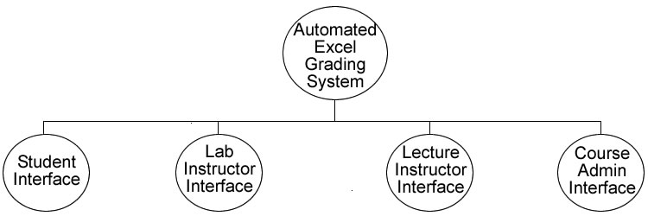

Each of the user interfaces is broken down into the tasks that can be performed by each user:
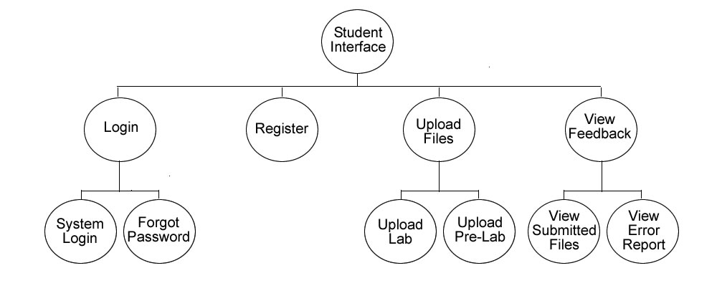
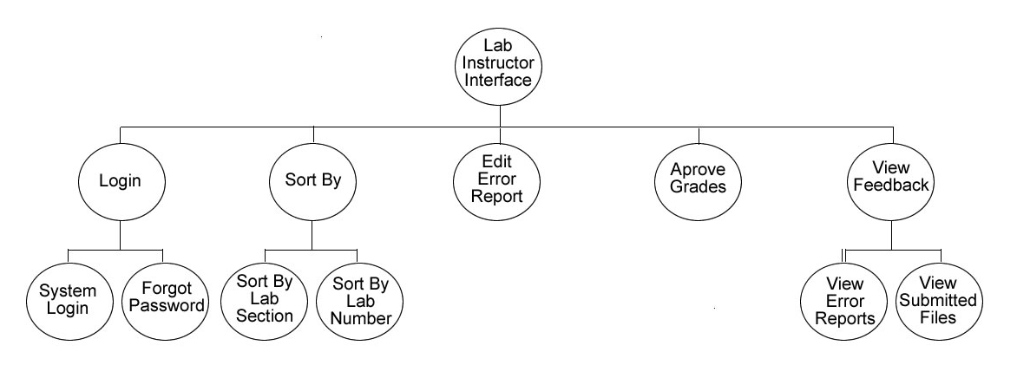
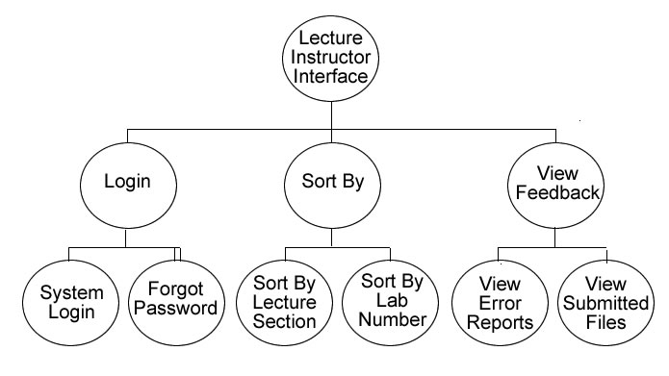

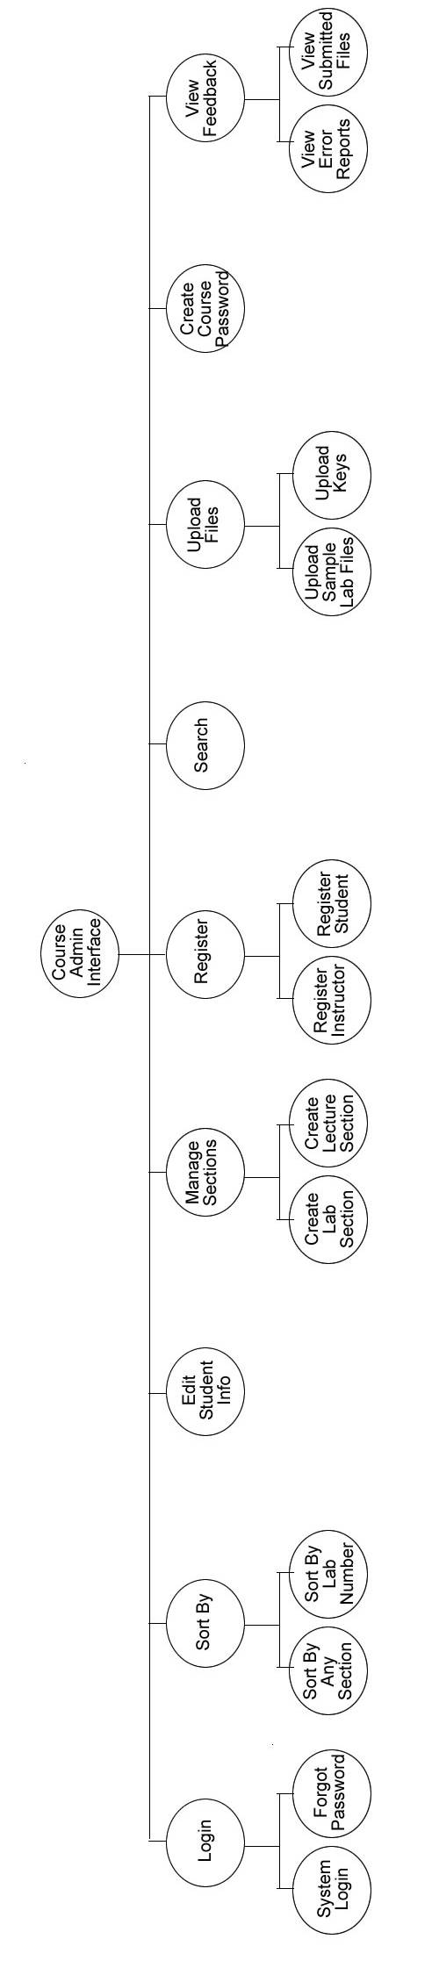
VIII. Use Case Narrative
Student
The Student user will have the ability to login to the system through the website with a username and password, if they do not have an account they must create one. When creating an account the Student will be required to select their lab and lecture section from a drop down menu. Once the Student logs in they will be able to upload their pre-labs and have the system grade them. After the pre-lab is graded it will provide a report to the Student with all of their errors. The students will also be able to submit their labs, which will be graded, and the grade will be displayed to the Student after it is approved by the instructor. The Student can also view their submitted labs.
Lab Instructor
The Lab Instructor will have the ability to log into the system through the website with a username and password. Their account will be created by the Course Administrator. They will be given an initial password by the course administrator which they can change at anytime. Once the system grades the labs it will provide a report to the Lab Instructor telling them what was wrong on the lab. The lab instructors will have the ability to view the errors on each lab and override the grade in the system if what the system classified as an error is deemed acceptable by the instructor. Once they finalize the grades they can be viewed by the Student User. The lab instructors will also be able to sort students by the lab and lecture section that the student attends and the lab number that they wish to view
Lecture Instructor
Lecture Instructors will have the ability to log into the system through the website with a username and password. Their accounts will be created by the Course Administrator. They will be given an initial password which they can change at anytime. Lecture Instructors will have the ability to view student’s lab grades in the system that the lab instructor has approved. They can sort students by their lab and lecture section.
Course Administrator
The Course Administrator will log on to the system using the username and password provided by the developers. Once logged into the system they can create other user accounts, upload grading keys and sample lab files, and edit and delete user accounts. The Course Administrator also needs to be able to set up the lab and lecture sections on the system, so the student user can pick the correct lab and lecture section when creating their account. Since the Course Administrator could also be a lecture and lab instructor they will have the same privileges when it comes to changing the grade on a lab and viewing the student’s lab grades.
IX. Functional Requirements
Course Administrator
- Login
  - The first time the Administrator logs into the system they will use the username and password given to them by the developers.
- Create Accounts
  - The Administrator will create the Lab Instructor and Lecture instructor accounts. When they create these accounts they will specify what user account is being created.
  - They will have the option to create student accounts if needed.
- Edit Accounts
  - If any account needs to be changed for any reason the Course Administrator can do so, including changing a students lab section or lecture section.
- Create Password for Student User
  - The Administrator creates the initial password so the Student user can log into the system for the first time.
- Delete Accounts
  - The Administrator can delete accounts from semester to semester with Student Users leaving the course and Lab and Lecture Instructors not teaching the course.
- Upload Grading Key and Sample Files
  - The Administrator will upload one grading key per lab and pre-lab along with multiple sample files per lab and pre-lab.
  - The grading key specifies what sections of the lab files to grade.
- View Reports
- Course Instructor can view students lab grades based on lab or lecture section.
  - Change Password
    - At any time the Course Administrator can change their password.

Student User
- Login
  - The first time the student logs into the system, he or she will create a username and use the specific password given to them in class by the lecture instructor.
- Upload Labs and Pre-labs
- When the student wants to submit a file they will be able to in their student view after they log into the system. The submit button will bring them to a new screen where they will upload each individual file with a browse button that searches the directories on the computer their on.
- Viewing Pre-Lab Error Reports
  - The student will click on the view Pre-Lab Button on the student view page to view the report
    - Viewing Lab Grades, Files and Report
      - The student can view their graded labs and see what sections they got wrong by clicking on the view Lab Button on the student view page.
      - They can only view these documents once the grades are approved and released by the Lab Instructor.
        - Change Password
  - At any time the Student User can change their password.

Lab Instructor
- Login
- The first time the Lab Instructor logs into the system they will use the username and password created by the Course Administrator.
• Review Lab Grades from System
- Override any mistakes that the system made after viewing the report generated by the system showing what the student got wrong.
- Approve Grades For Student User’s View
- Viewing Student Grades
- They will be able to view the lab grades based on what lab section they want including all their lab sections.
- They can also view the grades based on lab number, including all labs.
  - Change Password
    - At any time the Lab Instructor can change their password.

Lecture Instructor
- Login
  - The first time the Lecture Instructor logs into the system they will use the username and password created by the Course Administrator.
- Viewing Lab Grades
- Once the Lab Instructor has checked to make sure the lab was graded correctly by the system the Lecture Instructor can view the lab grades.
- They will be able to view the lab grades based on what lecture section they want including all their lecture sections.
- They can also view the grades based on lab number, including all labs.
- Change Password
- At any time the Lecture Instructor can change their password.
X. Unit Tests
**Note: All screens can be accessed as HTML pages by going to the following link: http://oraserv.cs.siena.edu/~perm_oasis/miscdocs
These are a few examples of what our Unit Test will look like. The first is a table of contents that breaks up the test into each screen and each of those screens is then broken down into internal tests. For a whole screen to pass, all of its internal tests must also pass.
0. Unit Test Contents
Pass/Fail | Screen Number | Internal Tests |  | Name
 | 1 |  |  | Login Screen
 |  | 1.1 |  |  | Load Page
 |  | 1.2 |  |  | Inadequate Login Attempt
 |  | 1.3 |  |  | Incorrect Login Attempt - Unregistered Account
 |  | 1.4 |  |  | Incorrect Login Attempt - Incorrect Password
 |  | 1.5 |  |  | Correct Student Login
 |  | 1.6 |  |  | Correct Lab Instructor Login
 |  | 1.7 |  |  | Correct Lecture Instructor Login
 |  | 1.8 |  |  | Correct Lab/Lecture Instructor Login
 |  | 1.9 |  |  | Correct Course Administrator Login
 |  | 1.10 |  |  | Forgot Password
 |  | 1.11 |  |  | Register
 | 2 |  |  | Student Homepage
 |  | 2.1 |  |  | Load Page
 |  | 2.2 |  |  | Generate Lab Grades Table
 |  |  | 2.2.1 |  |  | Correct Labs Displayed in Table
 |  |  | 2.2.2 |  |  | Correct Unsubmitted Labs Information in Table
 |  |  | 2.2.3 |  |  | Correct Submitted Pre-Labs Information in Table
 |  |  | 2.2.4 |  |  | Correct Submitted, Ungraded Labs Information in Table
 |  |  | 2.2.5 |  |  | Correct Graded Labs Information in Table
 |  | 2.3 |  |  | Submit Lab
 |  | 2.4 |  |  | View Error Report
 | 3 |  |  | Lab Instructor Homepage
 |  | 3.1 |  |  | Load Page
 |  | 3.2 |  |  | Lab Section Dropdown
 |  | 3.3 |  |  | Lab Number Dropdown
 |  | 3.4 |  |  | View
 | 4 |  |  | Lecture Instructor Homepage
 |  | 4.1 |  |  | Load Page
 |  | 4.2 |  |  | Lecture Section Dropdown
 |  | 4.3 |  |  | Lab Number Dropdown
 |  | 4.4 |  |  | View

1. Login Screen
Num | Name | Description | State Before Test | State After Test | Input | Steps to be Executed | Expected Output | Comments | Pass/Fail
1.1 | Load Page | Page loads properly | Any other webpage | Index.php | None | Load login screen. | Login screen displays all information properly in web browser
1.2 | Inadequate Login Attempt | Login button is clicked w/o all required login information | Index.php | Error1.php | None | Redirect to error page. | Error page loads telling user they did not supply adequate login information
1.3 | Incorrect Login Attempt - Unregistered Account | Login button is clicked with incorrect username | Index.php | Error2.php | Username:  unregistered  Password:  anything | Determine username is not registered.  Redirect to error page | Error page loads telling user they did not supply a valid username or password.
14 | Incorrect Login Attempt - Incorrect Passwoord | Login button is clicked with incorrect password | Index.php | Error2.php | Username:  student_test  Password  incorrect_pword | Determine that password is incorrect for this user.  Redirect to error page. | Error page loads telling user they did not supply a valid username or password.
1.5 | Correct Student Login | Login button is clicked with correct Student Username and password | Index.php | home.php | Username:  student_test  Password:  oasis_s | Determine login is for Student User  Generate Student homepage | Student User homepage is generated.

Num | Name | Description | State Before Test | State After Test | Input | Steps to be Executed | Expected Output | Comments | Pass/Fail
1.6 | Correct Lab Instructor Login | Login button is clicked with correct Lab Instructor username and password | Index.php | home.php | Username:  lab_instructor_test  Password:  oasis_lab | Determine login is for Lab Instructor User  Generate Lab Instructor homepage | Lab Instructor homepage is generated
1.7 | Correct Lecture Instructor Login | Login button is clicked with correct Lecture Instructor username and password | Index.php | home.php | Username:  lecture_instructor_test  Password:  oasis_lec | Determine login is for Lecture Instructor User  Generate Lecture Instructor homepage | Lecture Instructor homepage is generated
1.8 | Correct Lab/Lecture Instructor Login | Login button is clicked with correct Lab/Lecture Instructor username and password | Index.php | home.php | Username:  lab_lectuure_test  Passwoord:  oasis_lablec | Determine login is for Lab/Lecture Instructor User  Generate Lab/Lecture Instructor homepage | Lab/Lecture homepage is generated.
1.9 | Correct Course Administrator Login | Login button is clicked with correct Course Administrator username and password. | Index.php | home.php | Username:  course_admin_test  Password:  oasis_ca | Determine login is for Course Administrator User  Generate Course Administrator homepage | Course Administrator homepage is generated
Num | Name | Description | State Before Test | State After Test | Input | Steps to be Executed | Expected Output | Comments | Pass/Fail
1.10 | Forgot Password | Forgot Password link is clicked | Index.php | forgot_pword.html | None | Load Forgot Password webpage | Forgot Password screen is displayed.
1.11 | Register | Register link is clicked | Index.php | register.php | None | Load Registration webpage | Registration screen is displayed

2. Student Homepage
Num | Name | Description | State Before Test | State After Test | Input | Steps to be Executed | Expected Output | Comments | Pass/Fail
2.1 | Load Page | Page loads properly | index.php | home.php | usernamee:  student_test  Password:  oasis_s | Determine that username is a student User  Generate the student homepage | Homepage screen displays student homepage
2.2 | Generate Lab Grades Table | Table containing this students Lab grades is generated when page is displayed | index.php | home.php | usernamee:  student_test  Password:  oasis_s | Determine that username is a student User  Generate a table of this students Lab grades from the database | Table of students Lab grades displayed in correct format with all grades and information displayed  Requires tests 2.2.1-2.2.5 To pass completely
2.2.1 | Correct Labs Displayed in Table | Table contains correct Labs | index.php | home.php | usernamee:  student_test  Password:  oasis_s | Determine what Labs need to be displayed  Display these Labs and their information in table | Lab's with key associated for both Lab and Pre-Lab are displayed
2.2.2 | Correct Unsubmitted Labs Information in Table | Table contains correct information about unsubmitted Labs | index.php | home.php | usernamee:  student_test  Password:  oasis_s | Determine which Labs and Pre-Labs are ready for submission but have not yet been submitted  Display these Labs and Pre-Labs correctly in table | Unsubmitted Labs and Pre-Labs with key associated display empty rows and Submit link for both Lab and Pre-Lab

Num | Name |  | Description |  | State Before Test |  | State After Test |  | Input | Steps to be Executed | Expected Output |  | Comments | Pass/Fail
2.2.3 | Correct Submitted Pre-Labs Information in Table |  | Table containts correct information about submitted Pre-Labs |  | index.php |  | home.php |  | usernamee:  student_test  Password:  oasis_s | Determine which Pre-Labs have been submitted  Display these Pre-Labs correctly in table | Pre-Labs that have been submitted display Submission Date  Display View Error Report link
2.2.4 | Correct Submitted, Ungraded Labs Information in Table |  | Table contains correct information about Submitted, Ungraded Labs |  | index.php |  | home.php |  | usernamee:  student_test  Password:  oasis_s | Determine which Labs have been submitted, but not yet graded  Display correct information about these Labs | Submitted Labs displayed with Submission Date  Submit Lab link is now gone
2.2.5 | Correct Graded Labs Information in Table |  | Table contains correct information about Graded Labs |  | index.php |  | home.php |  | usernamee:  student_test  Password:  oasis_s | Determine which Labs have been graded  Display correct information about these Labs | Graded Labs displayed with Lab Grades and View Error Report link  Labs that were not submitted, but graded, will receive a 0 grade
2.3 | Submit Lab |  | Submit Lab link is clicked |  | home.php |  | submit_Lab.php |  | None | Determine which Lab is to be submitted  Generate Submit Lab page based on this Lab's criteria | Submit Lab page generated
2.4 | View Error Report |  | View Error Report link is clicked |  | home.php |  | Lab*_report.csv  OR  preLab*_report.csv  * - Fill in number |  | None | Determine which Lab or Pre-Lab Error Report is to be viewed  Displays error report for this Lab or Pre-Lab | Error Report page displayed
3. Lab Instructor Homepage
Num | Name | Description |  | State Before Test |  | State After Test |  | Input |  | Steps to be Executed | Expected Output | Comments |  | Pass/Fail
3.1 | Load Page | Page loads properly |  | index.php |  | home.php |  | Username:  lab_instructor_test  Password:  oasis_lab |  | Determine that Username is a Lab Instructor User  Generate the Lab Instructor homepage | Homepage screen displays Lab instructor homepage
3.2 | Lab Section Dropdown | Choose Lab Section dropdown menu displays |  | index.php |  | home.php |  | Username:  lab_instructor_test  Password:  oasis_lab |  | Determine that Username is a Lab Instructor User  Generate a dropdown menu for choosing from all current Lab Sections | A dropdown menu with all current Lab Sections along with an "All Lab Sections" item is displayed for choosing Lab Section to view
3.3 | Lab Number Dropdown | Choose Lab Number dropdown menu displays |  | index.php |  | home.php |  | Username:  lab_instructor_test  Password:  oasis_lab |  | Determine that Username is a Lab Instructor User  Generate a dropdown menu for choosing all eligible Labs for viewing | A dropdown menu with all viewable Lab Numbers along with an "All Labs" item is displayed for choosing Lab Number to view
3.4 | View | View Button is clicked |  | home.php |  | lab_view.php |  | Item in Lab Section dropdown is selected and Item in Lab Number dropdown is selected |  | Determine the Lab Section and Lab Number criteria  Generate Lab Instructor View Labs page | Lab Instructor View Labs page is displayed

4. Lecture Instructor Homepage
Num | Name | Description | State Before Test | State After Test | Input | Steps to be Executed | Expected Output | Comments | Pass/Fail
4.1 | Load Page | Page loads properly | index.php | home.php | Username:  lecture_instructor_test  Password:  oasis_Lab | Determine that username is a Lecture Instructor User  Generate the Lecture Instructor homepage | Homepage screen displays Lecture Instructor homepage
4.2 | Lecture Section Dropdown | Choose Lecture Section dropdown menu displays | index.php | home.php | Username:  lecture_instructor_test  Password:  oasis_Lab | Determine that username is a Lecture Instructor User  Generate a dropdown menu for choosing from all current Lab Sections | A dropdown menu with all current Lecture Sections along with an "All Lecture Sections" item is displayed for choosing Lab Section to view
4.3 | Lab Number Dropdown | Choose Lab Number dropdown menu displays | index.php | home.php | Username:  lecture_instructor_test  Password:  oasis_Lab | Determine that username is a Lecture Instructor User  Generate a dropdown menu for choosing all eligible Labs for viewing | A dropdown menu with all viewable Lab Numbers along with an "All Labs" item is displayed for choosing Lab Number to view
4.4 | View | View Button is clicked | home.php | lec_view.php | Item in Lecture Section dropdown is selected and Item in Lab Number dropdown is selected | Determine the Lecture Section and Lab Number criteria  Generate Lecture Instructor View Labs page | Lecture Instructor View Labs page is displayed

Appendices

I. Sources of Information
The information in this document was gathered from meetings with our clients, Ms. Jami Cotler and Dr. Scott Hunter, knowledge learned from Dr. Lederman’s Software Engineering lectures, the class textbook Software Engineering: A Practitioner’s Approach by Roger S. Pressman, and team websites from previous years located at: http://www.cs.siena.edu/~lederman/csis410/csis410.html

II. Gantt Chart

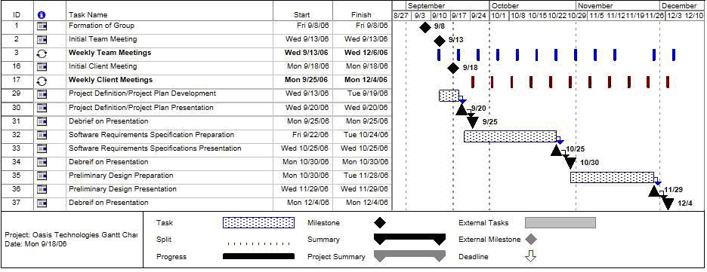

III. Glossary of Terms

Gantt Chart: A popular type of bar chart that illustrates a project schedule including start and finish dates, tasks, and events that are to occur to complete the project

HTML: Hypertext Markup Language (HTML) is programming language used in the creation of Web pages.

Java: A programming language used for developing object oriented programs.

JavaScript: Javascript is a scripting language developed by Netscape that can interact with HTML source code, enabling Web authors to spice up their sites with dynamic content.

MySQL: An open source relational database management system (RDBMS) that uses Structured Query Language (SQL), the most popular language for adding, accessing, and processing data in a database.

PHP: PHP Hypertext Preprocessor is a widely-used, open-source, general-purpose scripting language that is especially suited for web development.

Structure Diagrams: graphical representation of the structure of the Automated Excel Grading System

Student User/Account: The most basic user of this software. Will be able to create their own accounts and use them to upload lab's and pre-lab's and also view their grades

Use Case Narrative: The basic functionality that the system will have for each of the users

