Detailed Design

Requested by: Mr. Eric Crossman
Assistant Systems & Operations Manager
Siena College
School of Science

Mr. Ken Swarner
Systems & Operations Manager
Siena College
School of Science

Virtual Network Device Mapping System

Prepared by:

MAJIK Software Solutions

Amanda Danko
Kevin Johnson
Ian Kost
Mark Riley

March 6, 2007

Table of Contents
-Detailed Design-
Introduction 3
Section 1: External Design Specifications 3
1.1 User Displays 3
1.2 Data Flow Diagrams 16
1.3 Logical Data Dictionary 24
1.4 Logical Data Stores 27
1.5 Entity-Relationship Diagram 29
1.6 Physical Data Structures and Data File Specification 30
Section 2: Architectural Design Specification 31
2.1 Structure Diagram 31
2.2 Use Cases 33
2.3 Functional Requirements 33
2.4 Development Environment Information 40
Section 3: Detailed Design Specification 41
3.1 Documentation Prologue for each Routine 41
3.1.1 login 41
3.1.2 logout 41
3.1.3 displayRoom 41
3.1.4 displayDevice 41
3.1.5 displayRoom_Notes 41
3.1.6 displayDevice_Info 41
3.1.7 search 42
3.1.8 editPassword 42
3.1.9 editPermissions 42
3.1.10 editRoom_Notes 42
3.2 Pseudocode for each Routine 43
3.2.1 login 43
3.2.2 logout 43
3.2.3 displayRoom 43
3.2.4 displayDevice 43
3.2.5 displayRoom_Notes 43
3.2.6 displayDevice_Info 44
3.2.7 search 44
3.2.8 editPassword 44
3.2.9 editPermissions 44
3.2.10 editRoom_Notes 44
Section 4: Testing Requirements 45
4.1 Test Plan 45
4.2 Unit Test 49
4.3 Integration Test 80
4.4 Acceptance Test 81
Section 5: Appendices 87
5.1 Gantt Chart 87
5.2 Glossary of Terms 88

Introduction

The Virtual Network Device Mapping System is being developed at the request of Mr. Eric Crossman and Mr. Ken Swarner. The system will allow for a web-based, graphical organization and easy access to information about the devices on the network in the School of Science at Siena College located in Roger Bacon and the Morrell Science Center. This document outlines the detailed design of our solution system.

Section 1: External Design Specifications

1.1 User Displays
Login Screen:

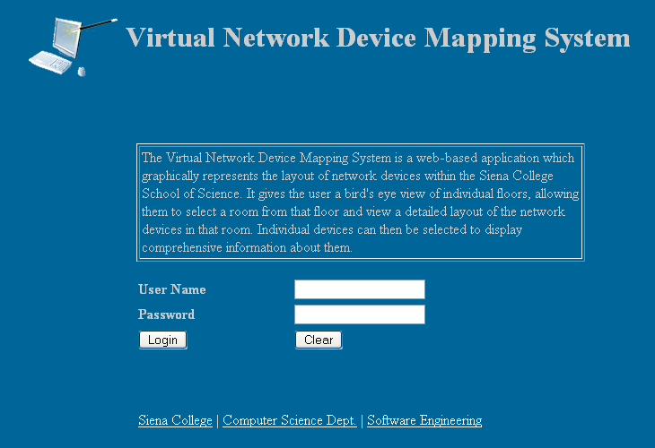

This is the first page that all users see when accessing the program. It gives a short description of the purpose of the program, followed by the login dialogue. This page also links to the websites of Team MAJIK via the team logo link, Siena College, the Computer Science Department, and the Software Engineering course. It is the same for all users.

Failed Login:

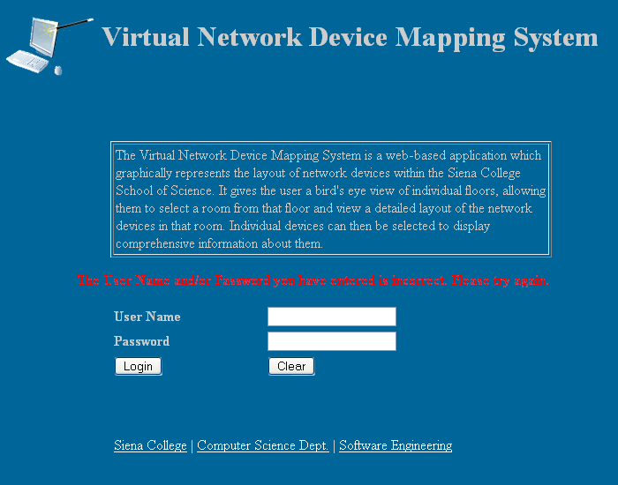

If a user enters an incorrect User Name and/or an incorrect Password, they are presented with a message informing them of their error.

Logged In:

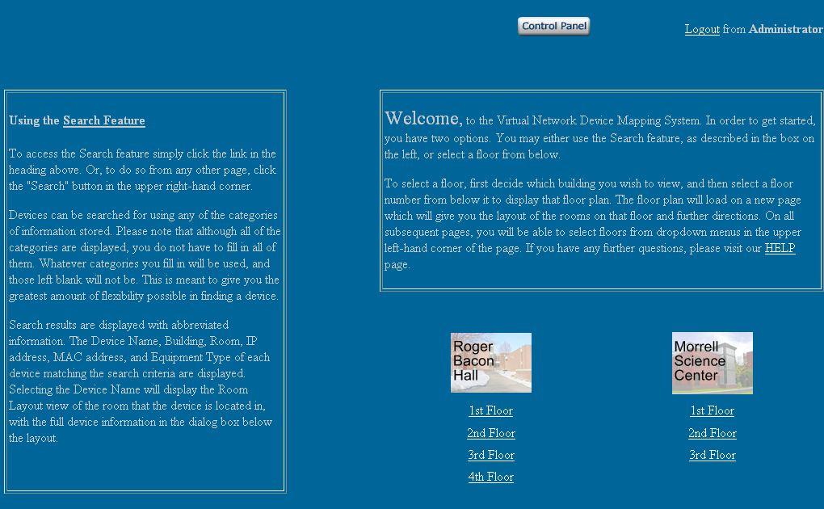

This is the first page a user will see after logging in. On this page, and all others after it, they will have the option to logout. They can do this by clicking the link in the top right hand corner of the page. This area also displays the User Name that they are logged into. Administrative users will see the Control Panel link as displayed, and all other users will not. Otherwise, the page displays the same for all users. Additionally, the page gives directions for use of the program and the option of choosing a floor to view or using the Search feature.

Floor Plan:

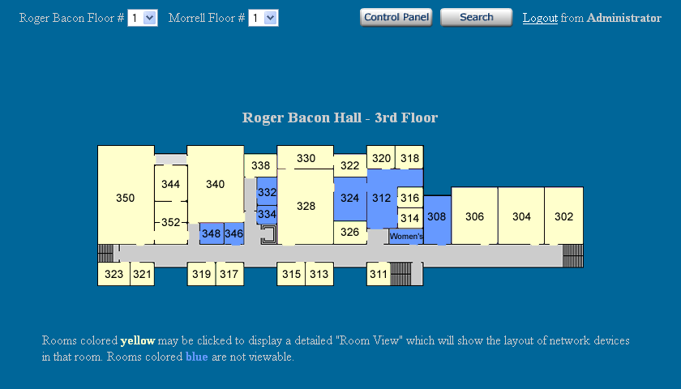

The Floor Plan page indicates the building and floor currently displayed. For the purposes of this prototype it is Roger Bacon Hall, third floor. Immediately below, the physical layout of that floor is graphically displayed. Users can select individual rooms in order to be brought to a closer view. On this, and subsequent pages, there are dropdown menus at the top allowing users to quickly move to different floors in the two buildings. There is also a link to the Search page present.

Room Layout:

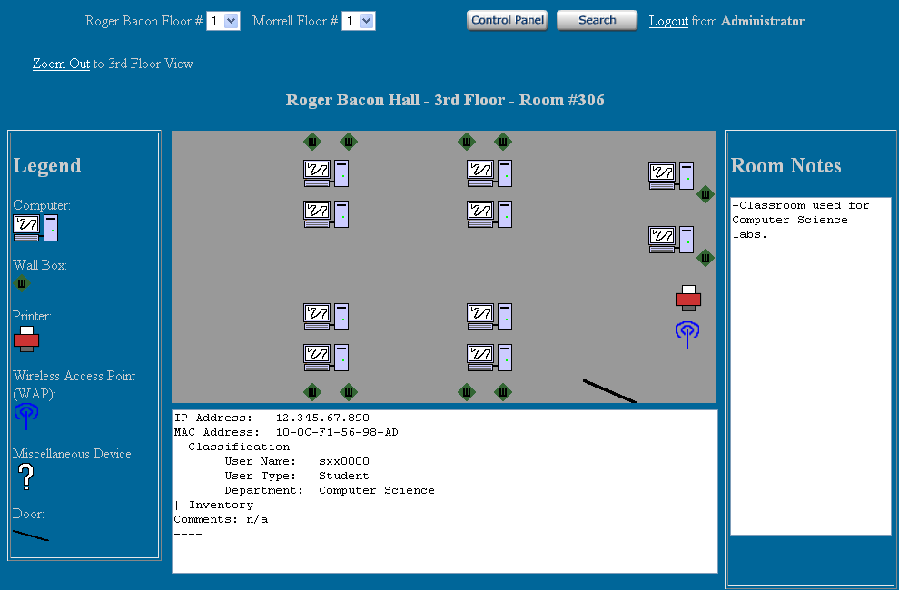

The Room Layout page gives a close-up view of an individual room. It displays the location of all network devices in the room graphically. The devices are displayed as symbols which are defined in a legend to the left of the Room Layout image. Each device can be selected by a user, causing information pertaining to that device to be displayed in a dialogue box at the bottom of the page. The Room Notes that an Administrator user has saved for the room through use of the Control Panel are displayed on the right side. Also, a link is displayed allowing a user to quickly zoom out to the Floor Plan they were viewing before selecting that room.

Detailed Device Information:

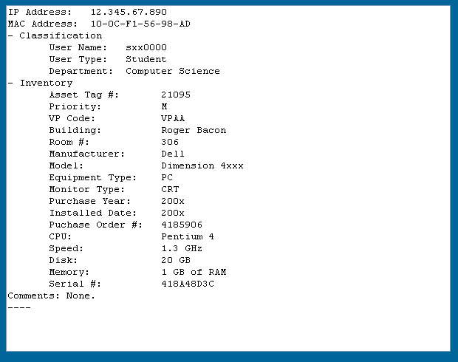

The Room Layout image shows the device info partially abbreviated. This image shows off all information fields possible for a network device. The values given are meant as examples and may not follow the exact format of real data.

Search:

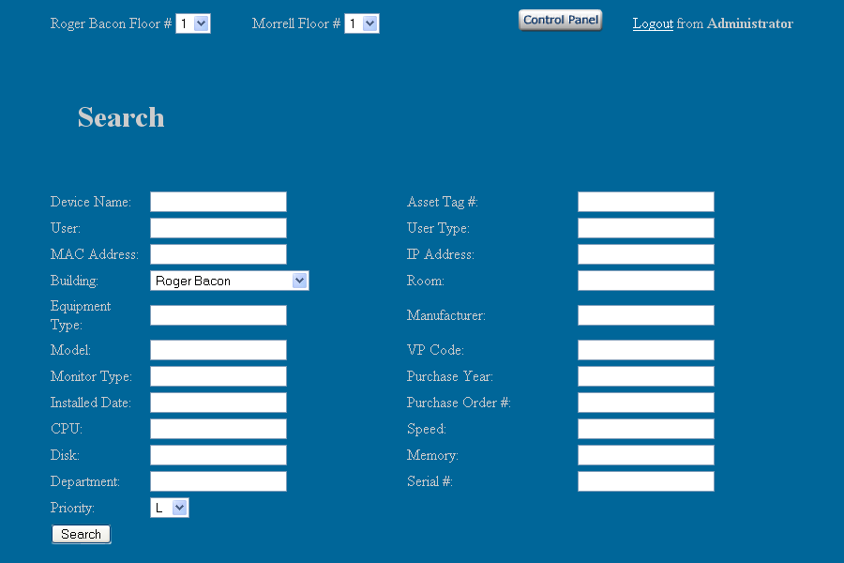

Devices can be searched for using any of the categories of information stored. Although all of the categories are displayed, only one is required to perform a search. Any categories filled in will be factored into the search, and those left blank will not be utilized. This is meant to give the greatest amount of flexibility possible in finding a device.

Search Results:

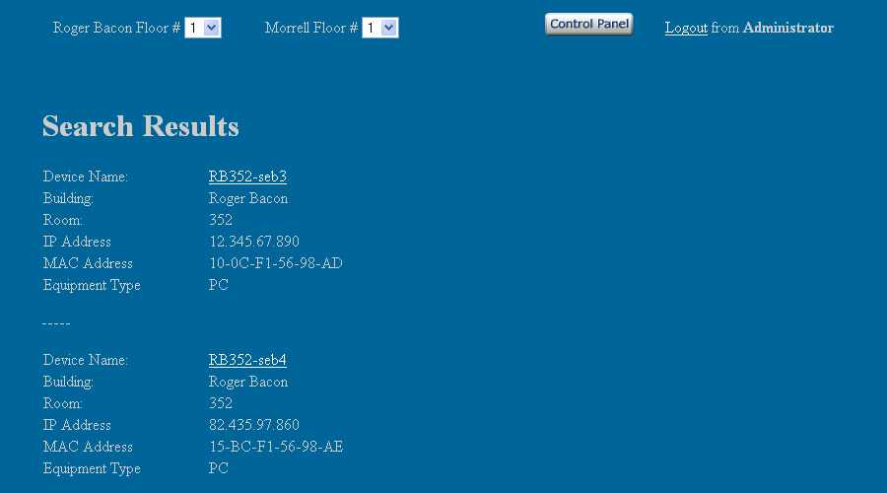

Search results are displayed with abbreviated information. The Device Name, Building, Room, IP address, MAC address, and Equipment Type of each device matching the search criteria are displayed. Selecting the Device Name will display the Room Layout view of the room that the device is located in, with the full device information in the dialog box below the layout. Multiple results are displayed one below the other.

Control Panel:

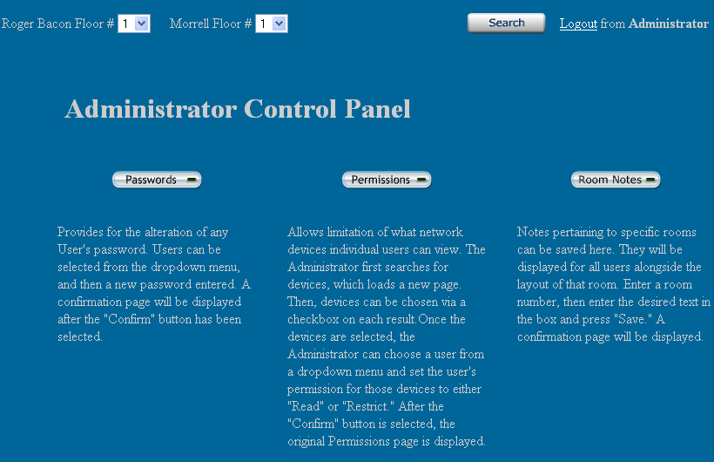

This page contains a menu detailing Administrative tasks. It can only be accessed by an Administrative user. Three Control Panel options are displayed; the ability to change passwords, edit permissions, and add room notes. Below each menu option is a short description and brief directions. Selecting a Control Panel menu item will load a new page.

Passwords:

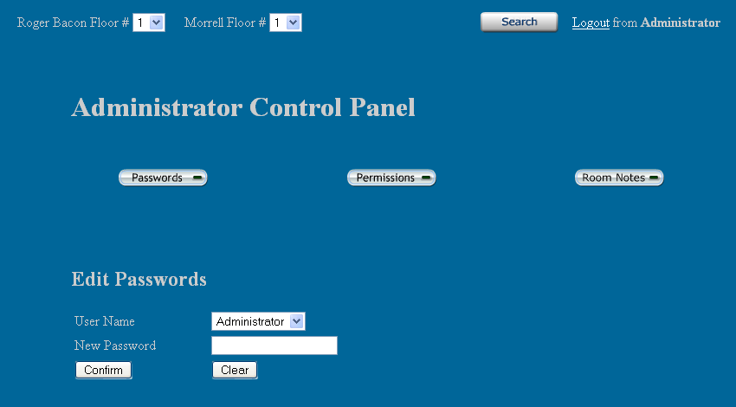

The User Name is selected from a dropdown menu, and a new password is entered. The change is complete when the “Confirm” button is selected. A new page is loaded displaying a confirmation message. That page is displayed below.

Password Change Confirmation:

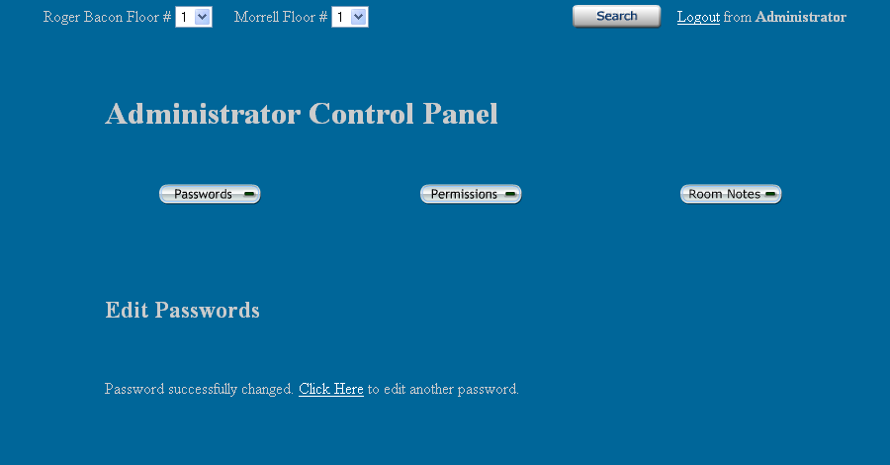

Permissions Device Search:

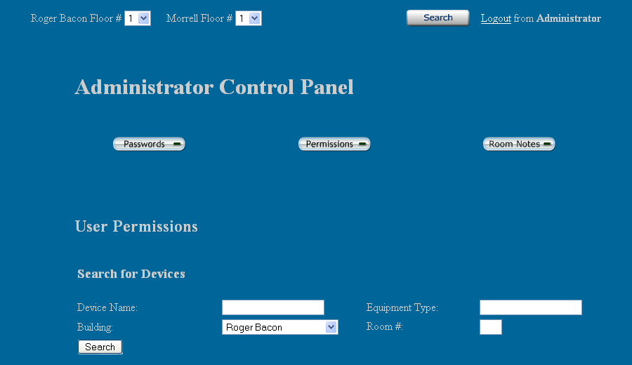

Allows limitation of what network devices individual users can view. The Administrator first searches for devices according to Building, Room, Device Name, or Equipment Type. Generally, the Administrator will be searching for a group of devices. After entering the proper search criteria, the “Search” button is selected and a new page is loaded.

Permissions Selection:

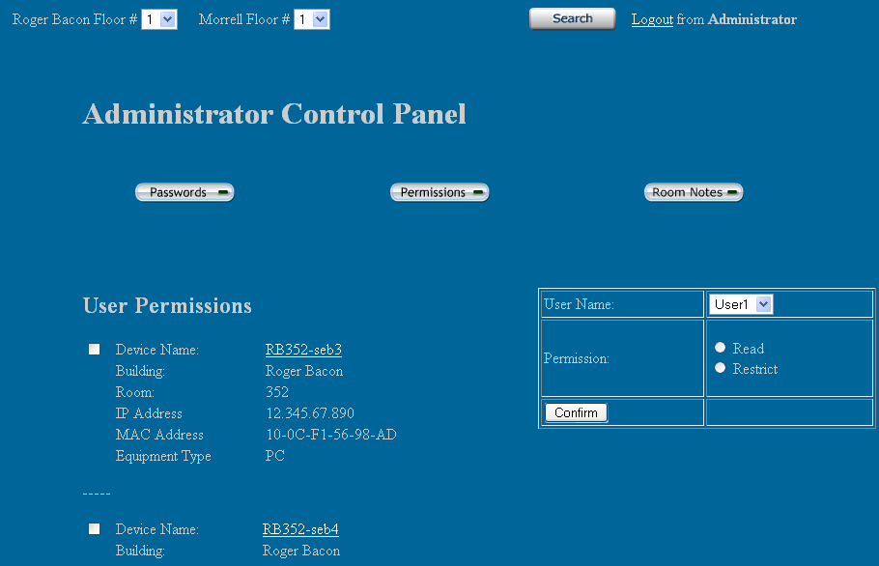

On the left, the search results are displayed. Devices can be chosen via a checkbox on each result. Once the devices are selected, the Administrator can choose a user from the dropdown menu on the right and set the user's permission for those devices to either "Read" or "Restrict." Read will allow the user to see that device and all information regarding it, and Restrict will prevent the user from viewing any information about the device. After the "Confirm" button is selected, the original Permissions page is displayed.

Room Notes:

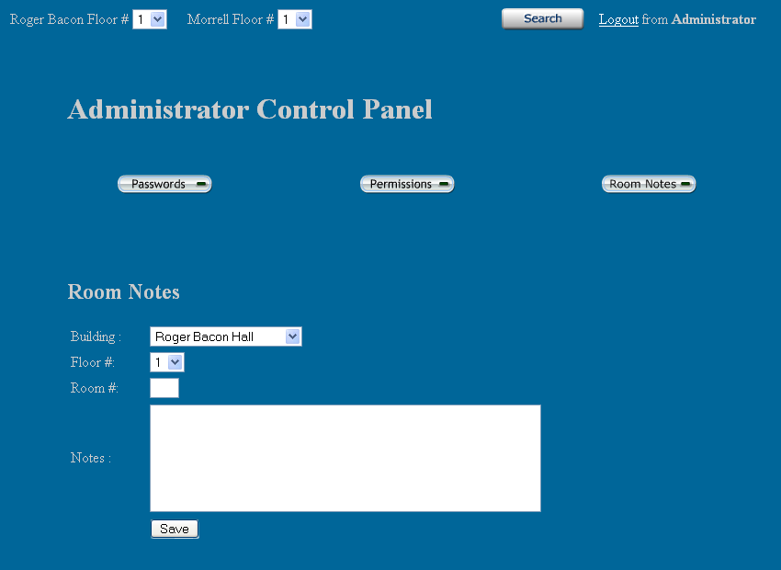

Notes pertaining to specific rooms can be saved here. They will be displayed for all users on the Room Layout screen. The Administrator first selects a building, and a floor within that building. Then, they enter the number of the room they wish to save a note about. Finally, the Administrator types in whatever notes they want saved about the room and selects “Save.” The Room Notes Confirmation page is displayed.

Room Notes Confirmation:

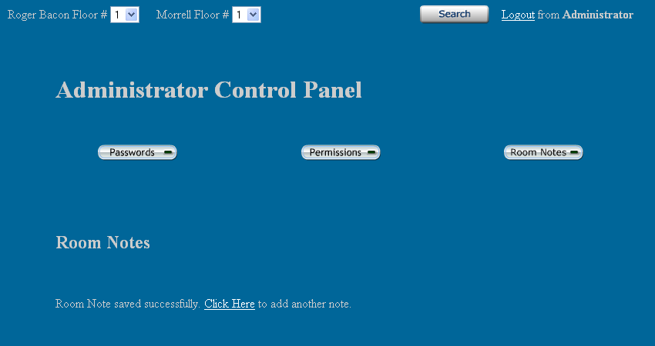

1.2 Data Flow Diagrams
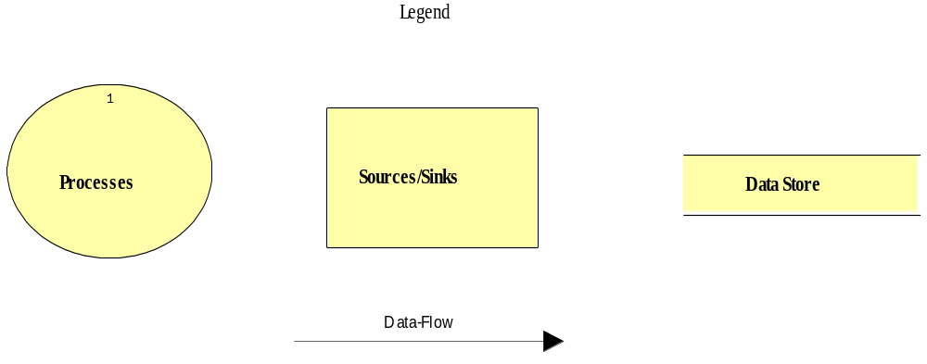
Legend for icons used in the Data Flow Diagrams.

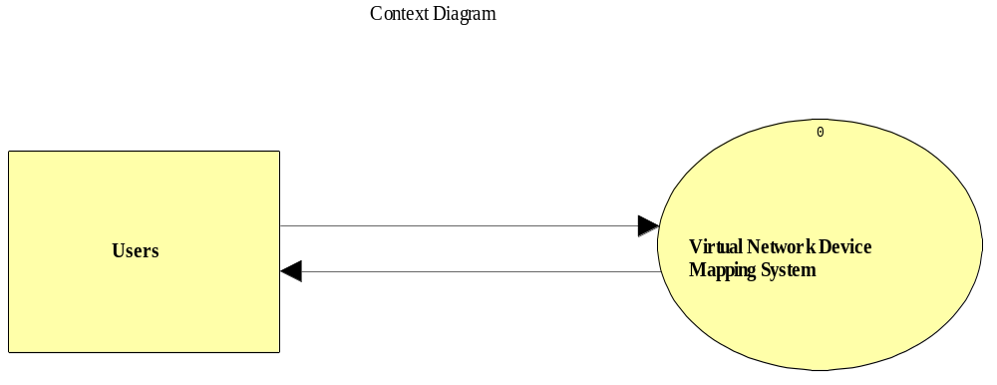

Context Diagram: It is the most basic diagram that shows the interaction between the user and the system.
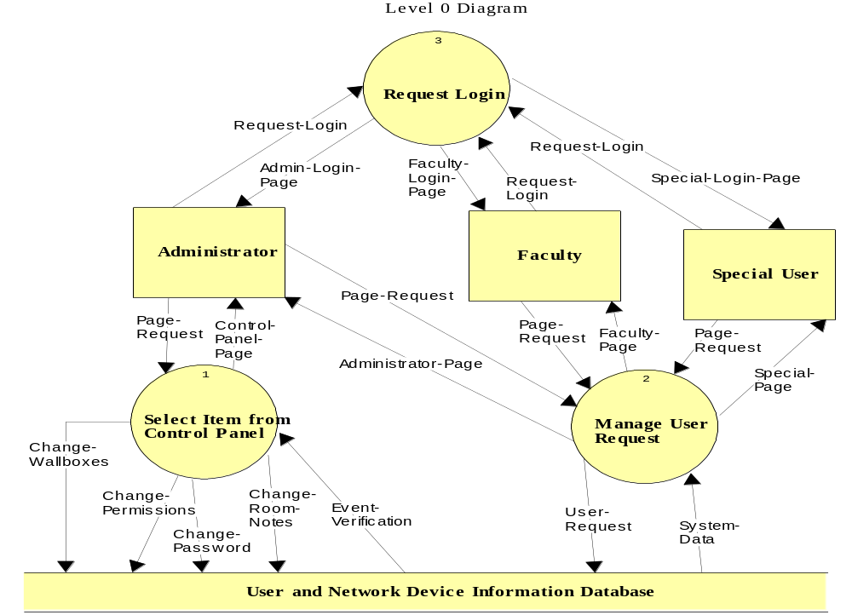
Level 0 Diagram: This is an expansion of the “Virtual Device Network Mapping System” that was shown in the Context Diagram.
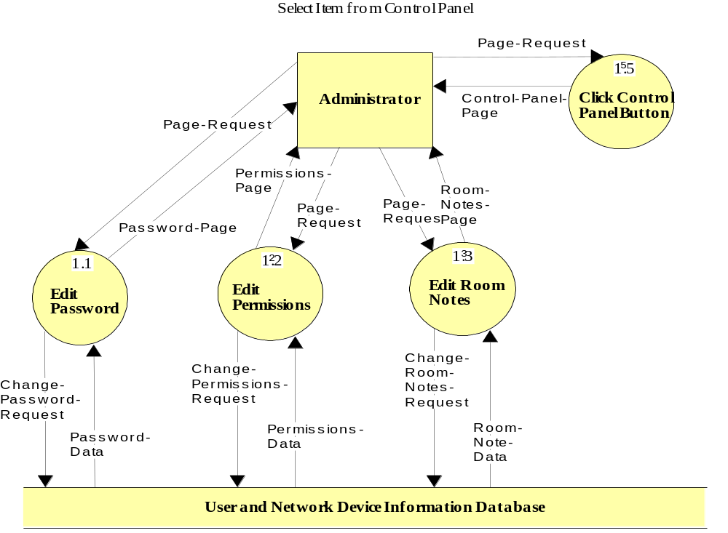

The Select Item from Control Panel diagram is a Level 1 Diagram. It shows the processes an Administrator can perform.
Manage User Request: This is a Level 2 diagram that shows the processes for all the different users.
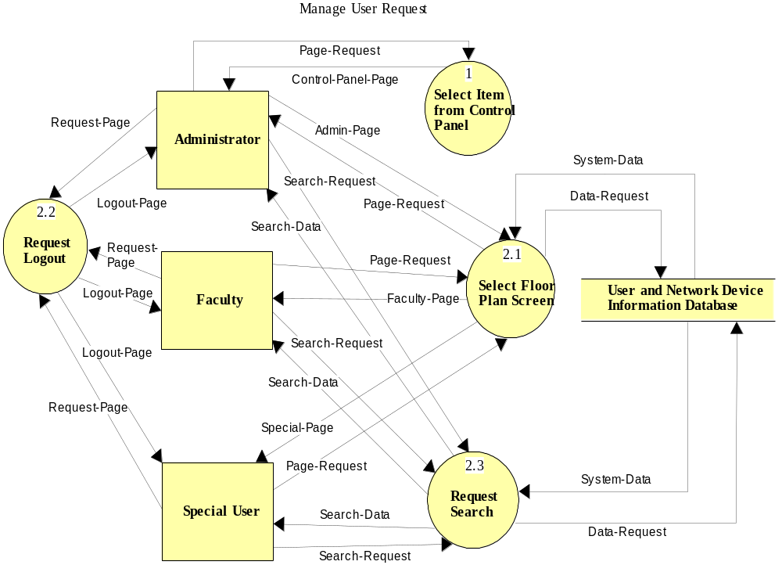
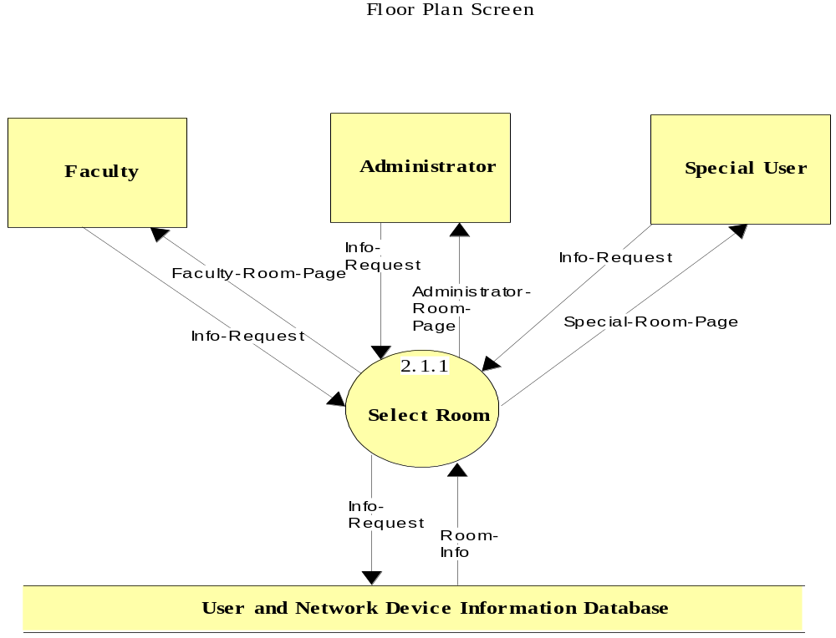
Floor Plan/Permissions Screen: This is shows the process of selecting a room after a floor has been selected.
Room Select Screen: This shows the processes of selecting a device for information or going back to a higher level of display.
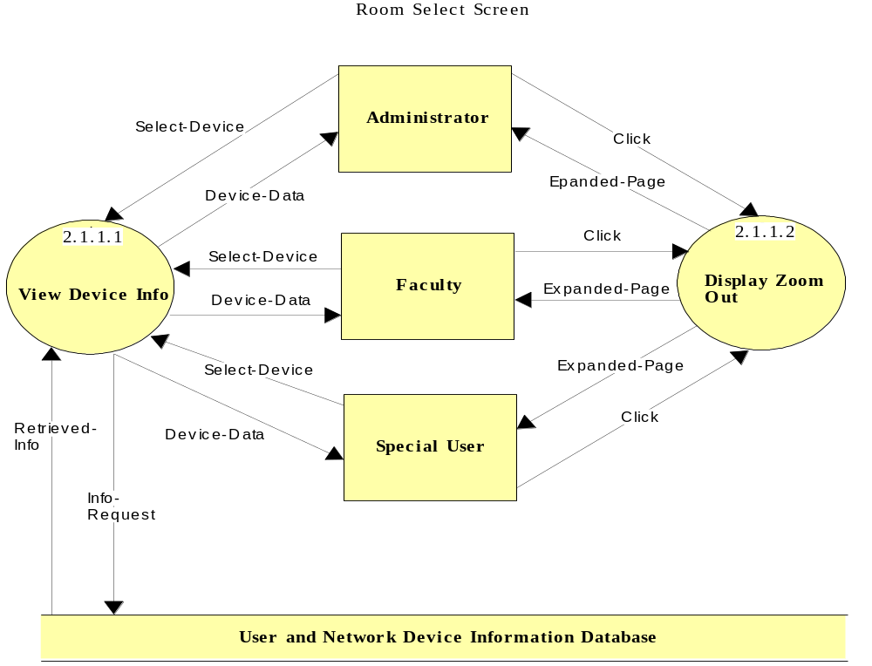

1.3 Logical Data Dictionary
Faculty-Room-Page
Locations:
Level 2.1.1 Destination: Faculty User
Source: User and Network Device Information Database

Administrator-Room-Page
Locations:
Level 2.1.1 Destination: Administrator User
Source: User and Network Device Information Database

Special-Room-Page
Locations:
Level 2.1.1 Destination: Special User
Source: User and Network Device Information Database

Admin-Login-Page
Locations:
Level 0 Destination: Administrator
Source: Request Login

Faculty-Login-Page
Locations:
Level 0 Destination: Faculty
Source: Request Login

Special-Login-Page
Locations:
Level 0 Destination: Special User
Source: Request Login

Special-Page
Locations:
Level 0 Destination: Special User
Source: Manage User Request
Level 2.1 Destination: Special User
Source: Select Floor Plan Screen

Faculty-Page
Locations:
Level 0 Destination: Faculty
Source: Manage User Request
Level 2.1 Destination: Faculty
Source: Select Floor Plan Screen

Administrator-Page
Locations:
Level 0 Destination: Administrator
Source: Manage User Request
Level 2.1 Destination: Administrator
Source: Select Floor Plan Screen

Control-Panel-Page
Locations:
Level 0 Destination: Administrator
Source: Select Item from Control Panel
Level 1.1 Destination: Administrator
Source: Click Control Panel Button
Level 2.1 Destination: Administrator
Source: Select Item from Control Panel

System-Data
Locations:
Level 0 Destination: Manage User Request
Source: User and Network Device Information Database
Level 2.1 Destination: Select Floor Plan Screen Source: User and Network Device Information Database
Level 2.1 Destination: Request Search Source: User and Network Device Information Database

Logout-Page
Locations:
Level 2.1 Destination: Administrator
Destination: Faculty
Destination: Special User
Source: Request-Logout

Search-Data
Locations:
Level 2.1 Destination: Administrator
Destination: Faculty
Destination: Special User
Source: Request Search
Device-Data
Locations:
Level 2.1.1.1 Destination: Administrator
Destination: Faculty
Destination: Special User
Source: View Device Info

Retreived-Info
Locations:
Level 2.1.1.1 Destination: View Device Info
Source: User and Network Device Information Database

Password-Page
Locations:
Level 1.1 Destination: Administrator
Source: Edit Password

Permissions-Page
Locations:
Level 1.1 Destination: Administrator
Source: Edit Permissions

Room-Notes-Page
Locations:
Level 1.1 Destination: Administrator
Source: Edit Room Notes

Page
Locations:
Level 1.1 Destination: Administrator
Source: Edit Wall boxes

Password-Data
Locations:
Level 1.1 Destination: Edit Password
Source: User and Network Device Information Database

Permissions-Data
Locations:
Level 1.1 Destination: Edit Permissions
Source: User and Network Device Information Database

Room-Note-Data
Locations:
Level 1.1 Destination: Edit Room Note
Source: User and Network Device Information Database

Wall box-Data
Locations:
Level 1.1 Destination: Edit Wall box
Source: User and Network Device Information Database

1.4 Logical Data Stores
The following information presents a preliminary description of the data stored in the Virtual Network Device Mapping System database. The data is presented in a layout of the table structure. Primary Keys are underlined.

Table: User
Fields:
Lname: CHAR(12)
-User's last name
Fname: CHAR(12)
-User's first name
Building: CHAR(3)
-name of the building which the user's office or room is located
Room_Num: VARCHAR(5)
-number of the room which the user's office or room is located
login: CHAR(8)
- name given to the user to login under
Password: CHAR(8)
-Password for the login, created by the user
User_type: CHAR(8)
- which class of user a login is classified as (used to specify permissions)
Table: Room
Fields:
Num: VARCHAR(5)
- The room number
Building: CHAR(3)
- The building the room is found in
Department: CHAR(15)
- The department the room is used by
Type: CHAR(10)
- The type of room; i.e. lecture, lab, etc...
EEC: CHAR(1)
- Indicates if the room is an Electronically Enhanced Classroom - Y/N
Table: Machine
Fields:
Id: INTEGER
- A unique identifier
Host_Name: VARCHAR(30)
- The hostname of the machine
IP_Address: VARCHAR(15)
- The IP Address of the machine
MAC_Address: VARCHAR(20)
- The MAC Address of the machine
Asset_Tag: INTEGER
- The IT&S Asset Tag value
Serial_Num: VARCHAR(20)
- The machine's serial number
Department: CHAR(15)
- The department to which the machine belongs (the sub-network)
Building: CHAR(3)
- The building in which the machine is located
Room: VARCHAR(5)
- The room in which the machine is located
CPU: VARCHAR(6)
- The CPU type
Speed: VARCHAR(6)
- The speed of the processor
Disk: VARCHAR(5)
- The disk size
Memory: VARCHAR(5)
- The memory size
User: CHAR(12)
- The name of the primary user
User_Type: CHAR(15)
- The type of primary user; i.e. student, faculty, etc...
Priority: CHAR(1)
- Priority level; L-low; M- medium; H-High
PO_Num: VARCHAR(15)
- Purchase order number
VP_Code: CHAR(4)
- Always VPAA for Vice President of Academic Affairs
Manufacturer: CHAR(15)
- The name of the manufacturing company
Model: VARCHAR(15)
- The model number of the machine
Equipment_Type: CHAR(20)
- The type of equipment; i.e. PC, Mac, Laptop, Wireless Access Point, etc.
Monitor_Type: CHAR(5)
- The type of monitor; i.e. LCD, CRT
Purchase_Year: DATE
- The date the machine/equipment was purchased
Installed_Date: DATE
- The date the machine/equipment was installed
X_coord: VARCHAR(3)
- The X coordinate of the location of the machine/equipment in the room
Y_coord: VARCHAR(3)
- The Y coordinate of the location of the machine/equipment in the room
Comments: VARCHAR(100)
- Comments about the machine/equipment

1.5 Entity-Relationship Diagram
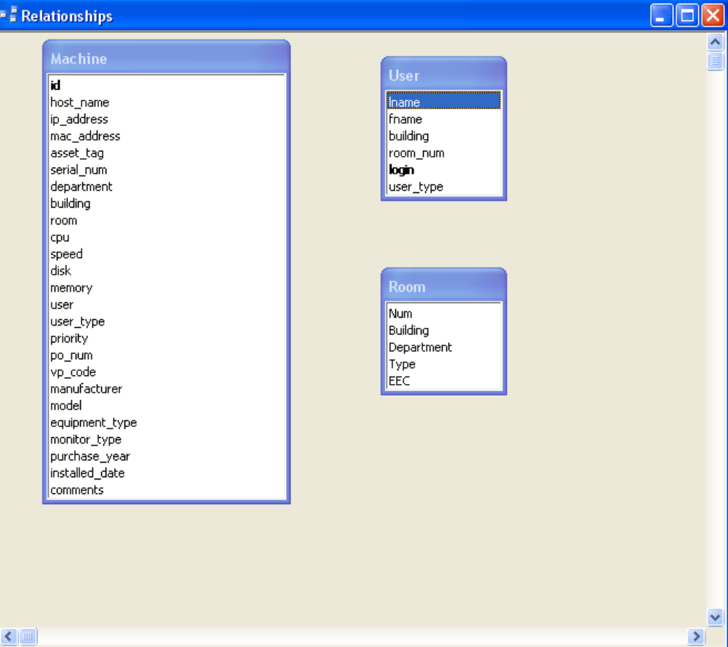

1.6 Physical Data Structures and Data File Specification

The user table is populated with names of users, set by the administrator, and is updated by the administrator

User
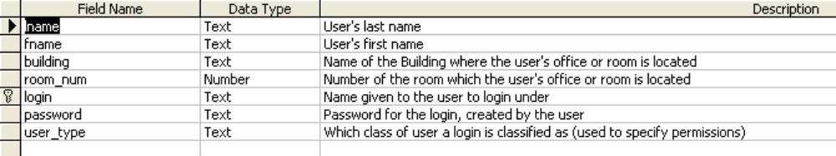

The machine and room tables are populated with information given to us by the clients, and updates will be pushed to these tables by the clients.

Machine
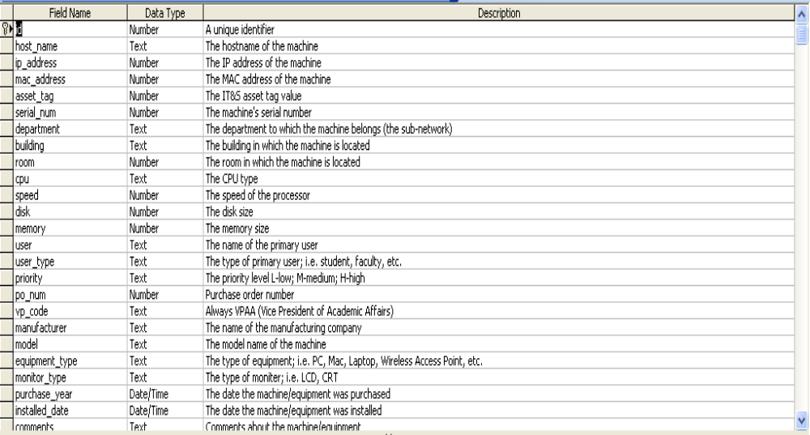

Room
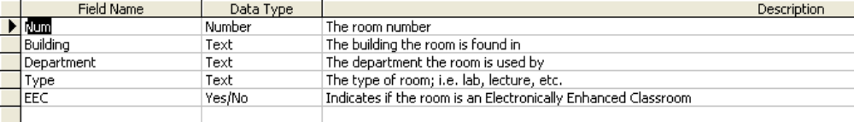

Section 2: Architectural Design Specification

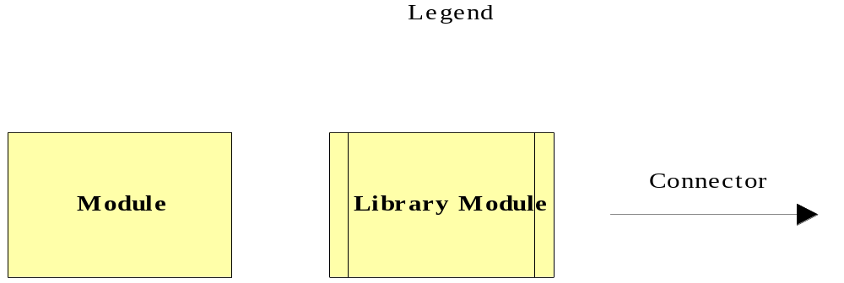
2.1 Structure Diagram

A Module represents an instruction that carries out an operation.
A Library Module behaves in the same manner every time that it is called upon.

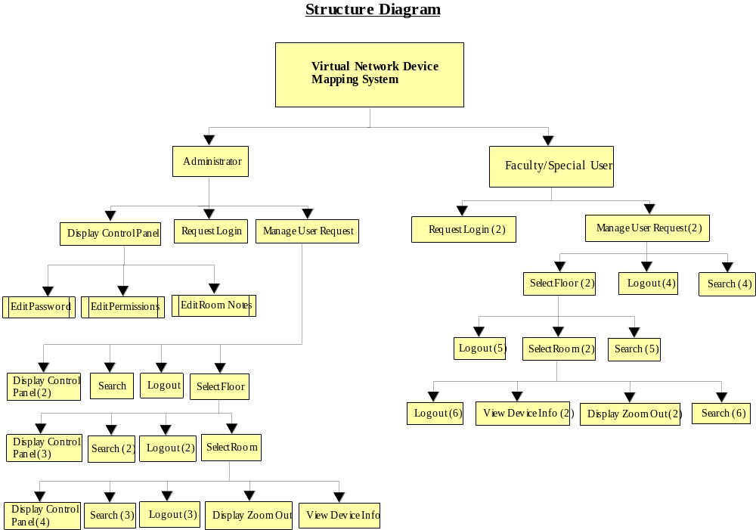

2.2 Use Cases

The Virtual Network Device Mapping System will service three users.

The Administrator user will have full access to all features of the software, including the ability to view and edit all information regarding each device on the network. The Administrator user will manage all other user accounts.

A Faculty/Staff user will only have the option to view information about devices pertaining to them (i.e. their office and/or classrooms, etc.). The Faculty/Staff user will have no editing capability.

The Special user's use of the system will vary. The Special user will be granted use of certain features of the system by the administrator as needed, including extended view of information about devices and possible editing capabilities.

2.3 Functional Requirements

The following list outlines the required functionality to be included in the final solution. The requirements are listed according to user case and then by screens the user will view.

General:
The Virtual Network Device Mapping System is web-based.
Administrator User:
The Administrator user will have an account.

The Administrator user will have a username and password.

The Administrator will establish usernames and passwords for other users.

Login Screen:
The user will log in with correct username and password.

An incorrect login will provide an appropriate error message.

Welcome Screen:
The user will have access to a control panel on the welcome screen.

The user will be able to perform a search for certain devices or a specific device based on indicated search criteria.

The user will be able to select a floor of Roger Bacon Hall from a menu to view a floor plan layout.

The user will be able to select a floor of Morrell Science Center from a menu to view a floor plan layout.

The user will be able to logout from the welcome screen by clicking the "Logout" link.

Control Panel Index Screen:
The user will be able to change user passwords in the control panel.

The user will be able to change user permissions for devices in the control panel.

The user will be able to insert notes pertaining to a specific room or devices within a room.

The user will be able to log out from the control panel index screen.

User Control Panel Screen:
The Administrator user will be able to choose a user for which the password is to be changed.

The Administrator will enter a new password for the chosen user.

The Administrator will submit changes.

A message will appear indicating a that a change has been accepted.

The Administrator user will be able to log out from the user control panel screen.

User Permissions Control Panel Screen:
The Administrator will be able to choose a user for which the permissions are to be set.

The Administrator will be able to search for or choose a device or set of devices for which the user’s permissions are to apply to.

The Administrator will be able to choose the permission level for the user with reference to the chosen device(s): read or restrict.

The Administrator will submit the changes.

A message will appear indicating that a change has been accepted.

The Administrator user will be able to log out from the user permissions control panel screen.

Room Notes Control Panel Screen:
The Administrator user will be able to choose a building and floor for which the room is in.

The Administrator will be able to enter a room number for which to add notes.

The Administrator will be able to add notes into a text box for the chosen room.

The Administrator will submit the changes.

A message will appear indicating that a change has been accepted.

The Administrator user will be able to log out from the room notes control panel screen.

Floor Plan Screen:
A floor plan for the chosen floor will be displayed on the screen.

The building name and floor number will be displayed on the screen.

The Administrator user will be able to access the control panel from this screen.

Administrator user will be able to view information about all rooms and devices on the floor.

The Administrator will be able to choose a room from the floor plan to view a detailed room layout.

The Administrator user will be able to log out from the floor plan screen.

The Administrator user will be able to choose a different floor of either Roger Bacon Hall or Morrell Science Center from a drop down menu.

Room Layout Screen:
A room layout will be displayed for the selected room.

The existence and location of devices within the room will be indicated in the layout.

The building name, floor number, and room number will be displayed on the screen.

The Administrative user will be able to zoom out to the floor level diagram to which the room belongs.

The Administrator user will be able to choose a device within the room to view the information pertaining to that device.

The information for a specific device will appear below the room layout in a text box.

Any available notes for the selected room will be displayed on the screen for easy reference.

A legend will be displayed below the layout to denote the meaning of symbols in the layout.

The Administrator user will be able to log out from the room layout screen.

Search Screen:
The Administrator user will be able to search for a device on the following criteria:
Asset Tag Number
Priority
User
User Type
Department
VP Code
Building
Room
Manufacturer
Model
Equipment Type
Monitor Type
Purchase Year
Installed Date
Purchase Order Number
CPU
Speed
Disk
Memory
MAC Address
Serial Number

Summarized search results will be displayed on the same screen.

Search results will be selectable to view more detailed results.

When selected, detailed search results will be displayed in the room layout view.

Faculty/Staff User:
The Faculty/Staff user will have an account established by the Administrator.

The Faculty/Staff user will have a username and password.

Login Screen:
The user will log in with correct username and password.

An incorrect login will provide an appropriate error message.

Welcome Screen:
The user will be able to perform a search for certain devices or a specific device based on indicated search criteria.

The user will be able to select a floor of Roger Bacon Hall from a menu to view a floor plan layout.

The user will be able to select a floor of Morrell Science Center from a menu to view a floor plan layout.

The user will be able to logout from the welcome screen by clicking the "Logout" link.

Floor Plan Screen:
A floor plan for the chosen floor will be displayed on the screen.

The building name and floor number will be displayed on the screen.

Faculty/Staff user will be able to view information about limited rooms and devices on the floor.

Rooms available for viewing will be highlighted so a Faculty/Staff user is aware of which rooms can be selected.

The Faculty/Staff will be able to choose a room from the floor plan to view a detailed room layout.

The Faculty/Staff user will be able to log out from the floor plan screen.

The Faculty/Staff user will be able to choose a different floor of either Roger Bacon Hall or Morrell Science Center from a drop down menu.

Room Layout Screen:
A room layout will be displayed for the selected room.

The existence and location of devices within the room that will be indicated in the layout.

The building name, floor number, and room number will be displayed on the screen.

The Faculty/Staff user will be able to zoom out to the floor level diagram to which the room belongs.

The Faculty/Staff user will be able to choose certain devices within the room to view the information pertaining to that device.

The information for a specific device will appear below the room layout in a text box.

Any available notes for the selected room will be displayed on the screen for easy reference.

A legend will be displayed below the layout to denote the meaning of symbols in the layout.

The Faculty/Staff user will be able to log out from the room layout screen.

Search Screen:
The Faculty/Staff user will be able to do a search for a device on the following criteria:
Asset Tag Number
Priority
User
User Type
Department
VP Code
Building
Room
Manufacturer
Model
Equipment Type
Monitor Type
Purchase Year
Installed Date
Purchase Order Number
CPU
Speed
Disk
Memory
MAC Address
Serial Number

Search results will be limited to what the user has permissions to view.

Summarized search results will be displayed on the same screen.

Search results will be selectable to view more detailed results.

When selected, detailed search results will be displayed in the room layout view.

Special User:

The Special user will have an account established by the Administrator.

The Special user will have a username and password.

The Special user will have access to any feature the Administrator user grants them, up to and including administrative functions.

2.4 Development Environment Information

The machines we will be using to do our development work, and their specifications, as well as the software that we will be using to develop our programs are listed here.

Server:

Oracle, version 10g
Mysql, version 4.1.14
PHP, version 4.3.11
Apache, version 2.0.46

Browser Environment:

Microsoft Internet Explorer version 6.0.2800.1106
Mozilla Firefox version 1.0 preview release
Mozilla Firefox version 1.0
Apple Safari 1.2

Software:

Adobe Acrobat version 5.0.5
Adobe Reader version 6.0.0
Microsoft Office Word 2000 9.0.4402
Microsoft Office PowerPoint 2000 SR1 9.0.3821
WinSCP version 3.1.0 (Build 165)
Putty Release 0.53b
Macromedia Dreamweaver MX Education Edition 6.0
Macromedia Fireworks MX Education Edition 6.0
Visible Analyst Education Edition version 7.5.5
Microsoft Project 2000 9.0.2001.0219SR1
Microsoft Windows 2000 5.00.2195 Service Pack 3
Microsoft Windows XP Professional Version 2002 Service Pack 2

Systems:

Dell Dimension Dim4550
Intel Pentium 4 2.40 GHz
512 MB of RAM

Macintosh iMac
2.0GHz Intel Core 2 Duo
1GB of RAM

Section 3: Detailed Design Specification

3.1 Documentation Prologue for each Routine

3.1.1 login

This routine takes a user name and a password as input from the user. It connects to the database and verifies the information. If the information is verified it allows access to the rest of the program. Otherwise, an error message is displayed to the screen.

3.1.2 logout

This routine severs the connection to the database and redirects to the index page.

3.1.3 displayRoom

This routine takes as input the room selected on the Floor Plan page. It displays the floor and room numbers in the heading, and the image for that room.

3.1.4 displayDevice

This routine displays the icon for a device in the correct location within the Room Layout image.

3.1.5 displayRoom_Notes

This routine takes as input the selected room number. It retrieves the Room Notes information for that room from the database and displays it to the page.

3.1.6 displayDevice_Info

This routine displays the device information for a selected device in the correct area of the page.

3.1.7 search

This routine takes as input the information entered into search fields. It returns all devices which match the entered criteria.

3.1.8 editPassword

This routine changes the password stored in the database for the selected user.

3.1.9 editPermissions

This routine takes as input a user and one or more selected devices, and sets a flag that determines whether that user can view the information for the selected device(s).

3.1.10 editRoom_Notes

This routine stores entered text into the database for the selected room.

3.2 Pseudocode for each Routine

3.2.1 login

connect to database
if( info is verified )
create Session
load ‘Logged In’ page
else
disconnect from database
output error message

3.2.2 logout

end Session
disconnect from database
load ‘Log In’ page

3.2.3 displayRoom

room_number = input from user
output( building_name “ – “ floor_number “ – Room #” room_number )
room_layout_image = image_array[room_number]

3.2.4 displayDevice

device = input from user
lookup device_type
lookup device_coords
output( image.device_type ) at location device_coords

3.2.5 displayRoom_Notes

room_number = input from user
if( room_number.notes == NULL )
output( “n/a” )
else
output( room_number.notes )

3.2.6 displayDevice_Info

device = user input
output( device.* )

3.2.7 search

search_vars[n] = user input from search fields
x = 0
for( i=1 to n) || n = # of devices
{
compare device to search criteria
if ( device matches search criteria )
{
output( device_name, building, room, ip_address, mac_address, equip_type )
output( newline “------“ newline )
x++
}
}
if( x==0 )
output( “No results found.” )

3.2.8 editPassword

user_name = user input
password = user input
user_name.pass = password

3.2.9 editPermissions

user_name = user input
devices[n] = user selects devices
bool permission = user input || True – read, False – restrict
for ( i=1 to n)
devices[i].perm = permission

3.2.10 editRoom_Notes
room_number = input from user
room_note = input string from user
room_number.notes = room_note

Section 4: Testing Requirements

To test the system, we will perform four testing stages. The first is unit testing where each component is tested individually for errors. The second stage is integration testing where we will ensure that components interact correctly to perform higher functions. System testing, the third stage, involves ensuring that all the features of the system meet the functional requirements previously defined in the Requirements Specification. Finally, acceptance testing will be carried out to ensure that the delivered system meets all of the requirements as specified by our clients.

4.1 Test Plan

4.1.1 Test Plan Identifier:

Virtual Network Device Mapping System Test Plan version 1.1

4.1.2 Introduction

In order to ensure the highest quality product possible, and to be sure that our program adequately meets the needs of our clients, we are utilizing four separate types of testing. First, we will implement Unit Tests to ensure that each module is functioning correctly, including individual test cases. Second, we will perform Integration Tests to be sure that each module is interacting correctly with other modules to perform high level tasks. If changes are made to interdependent modules, Regression Testing will be done as a part of Integration Tests. Third, we will perform a System Test, which verifies that all functional requirements have been met and are operating as defined in the Requirements Specification. Fourth, Acceptance Testing will be carried out to ensure that the delivered system meets all of the requirements as specified by our clients.

4.1.3 Test Items

We will be running our software on a Dell 2550 Server running Red Hat Linux – ES Release 3, with Oracle version 10g, PHP version 4.3.11 and the Apache web server version 2.0.46. Our software will be tested to ensure compatibility with Microsoft Internet Explorer version 6.0, Mozilla Firefox version 1.0, and Apple Safari version 1.2. Also, our software will be designed to be viewed on a monitor set to 1024x768 resolution.

4.1.4 Features Not To Be Tested

It is our plan to test all parts of the project that we have implemented. This does not include the way in which network device information is entered into the database, or the ways in which that data can be edited.

4.1.5 Approach

We have designated two members of our team to specialize in testing. As modules are completed, we will perform our Unit Tests on them. Following that, Integration Testing will occur. When these have been successfully completed, the System Test will be executed. Finally, we will perform the Acceptance Test.

4.1.6 Pass/Fail Criteria

Each Test Case will Pass if it consistently meets all requirements specified in the Unit Test. If a Test Case fails to produce the required results, it will Fail. Criteria used to determine whether a Test Case is passed or failed include:

- Task performs action specified.
- Task performs action in a reasonable amount of time.
- Task performed without errors.
- Task displays output correctly.

- Individual test cases for each GUI will include tests on all links, buttons, text boxes, drop-down menus and any other means of user input in that interface.
- Master Test Plan – The master test plan will be passed if and only if all lower level test plans (Unit Tests) are completed and passed. Any lower level plan that fails will result in a new version of that module which will then be subjected to the original Unit Test. Regression Testing will also be implemented in this case.

4.1.7 Suspension Criteria and Resumption Requirements

Testing activity will be suspended under the following circumstances:

- System failure.
- Excessive Test Case failures.
- Changes made to the Unit being tested.
- A need for Regression Testing to begin which involves the unit being tested.

Testing will resume from the beginning of the Unit Test when it is believed that the problems causing failure have been resolved.

4.1.8 Test Deliverables

The test deliverables include a complete documentation of the Unit Tests and the Integration Tests. A fully completed checklist of the Functional Requirements and the Acceptance Test will also be delivered.

4.1.9 Testing Tasks

The Testing Tasks will be comprised of Unit Tests for each screen that the user will be able to navigate through. There are 3 different types of users and some tests are specific to a certain user. The screens that will be tested that are common to all users are the login page, view floor plan and view office layout. The administrative user will have access to another page called the control panel page. Each of these pages will be tested in a logical order allowing for quick results.

4.1.10 Environmental Needs

-Oracle, version 10g
-Mysql, version 4.1.14
-PHP, version 4.3.11
-Apache, version 2.0.46
-Browsers:
-Microsoft Internet Explorer version 6.0.2800.1106
-Mozilla Firefox version 1.0 preview release
-Mozilla Firefox version 1.0
-Apple Safari 1.2
-Microsoft Windows 2000 5.00.2195 Service Pack 3
-Microsoft Windows XP Professional Version 2002 Service Pack 2

4.1.11 Responsibilities

- Amanda Danko is the Team Leader. She will make sure that all required testing is in place and that all features are tested.
- Mark Riley will be the head tester. He will be in charge of providing the overall strategy for testing.

4.1.12 Staffing and Training Needs

- Mark Riley is in charge of testing and making crucial decisions that will affect what is tested and how it is tested.
- Mark will also work with Amanda Danko in each stage of testing for our software.

4.1.13 Schedule

Scheduled Milestones:
-April 30, 2007: Acceptance Test Deliverables due
-May 1, 2007: Acceptance Test Presentations
-May 4, 2007: Academic Celebration Presentations

4.1.14 Risks and Contingencies

The current status of the project has rendered us unable to anticipate the possible risks and therefore their countermeasures. As the development process continues, we will be able to further assess the possible risks we may encounter.

4.1.15 Approvals

Names and Titles for Approval:

Amanda Danko - MAJIK Software Solutions Team Leader
Kevin Johnson – MAJIK Software Solutions Lead Developer
Ian Kost – MAJIK Software Solutions Developer
Mark Riley – MAJIK Software Solutions Lead Tester

Mr. Eric Crossman - Assistant Systems Administrator
Mr. Ken Swarner - Systems Administrator

4.2 Unit Test

MAJIK Software Solutions
Virtual Network Device Mapping System
Unit Test Catalog
Test Result | Test Number | Unit Test Name
P F | 1 | Login Screen
P F | 2 | Administrator Welcome Screen
P F | 3 | Faculty/Staff Welcome Screen
P F | 4 | Roger Bacon Floor 1 Layout Screen
P F | 5 | Roger Bacon Floor 2 Layout Screen
P F | 6 | Roger Bacon Floor 3 Layout Screen
P F | 7 | Roger Bacon Floor 4 Layout Screen
P F | 8 | Morrell Science Center Floor 1 Layout Screen
P F | 9 | Morrell Science Center Floor 2 Layout Screen
P F | 10 | Morrell Science Center Floor 3 Layout Screen
P F | 11 | Room View Screen
P F | 12 | Administrator Control Panel Index Screen
P F | 13 | Manage Users Control Panel Screen
P F | 14 | Permissions Control Panel Screen
P F | 15 | Room Notes Control Panel Screen
P F | 16 | Search Screen
P = Pass
F = Fail

MAJIK Software Solutions
Virtual Network Device Mapping System
Test Number 1 - Login Screen Test Cases
Number | Test Case Name | Description |  | Input | Expected Result | Actual Result/Comments | TestResult (Pass/Fail)
1.1 | Index Page Loads | Correct page load. |  | N/A | Index page loads and all components are displayed on the screen.
1.2 | Correct Login - Administrator | Log in with valid administrator account and password. |  | Administrator username and password | Welcome screen for administrators loads.
1.3 | Correct Login - Faculty/Staff | Log in with valid faculty/staff account and password |  | Faculty/Staff username and password | Welcome screen for faculty/staff loads.
1.4 | Incorrect Username Login | Login with invalid username. |  | Username | Message generated indicating invalid username.
1.5 | Incorrect Password Login | Log in with invalid password. |  | Password | Message generated indicating invalid password.
1.6 | Login with Empty Fields | Login with username and password fields empty. |  | N/A | Message generated indicating invalid username or password.
1.7 | Click Clear Button | User clicks clear button. |  | N/A | Username and password field are cleared of contents.
1.8 | Click Link to MAJIK Website | User clicks link to the MAJIK website. |  | N/A | MAJIK Team website loads.
1.9 | Click Link to Software Engineering Website | User clicks link to the Software Engineering website. |  | N/A | Software Engineering website loads.
 |  |  |  |  |  | Summary of Tests for this Unit | P

MAJIK Software Solutions
Virtual Network Device Mapping System
Test Number 2 - Administrator Welcome Screen Test Cases
Number | Test Case Name | Description | Input | Expected Result | Actual Result/Comments | TestResult (Pass/Fail)
2.1 | Welcome page loads. | Page loads correctly. | N/A | Page loads and all components are displayed on the screen.
2.2 | Click Control Panel Button. | User clicks the Control Panel button. | N/A | The control panel screen loads.
2.3 | Click logout button. | User clicks the Logout button. | N/A | The user is logged out of the system and returns to the login screen.
2.4 | Click the Roger Bacon Hall 1st Floor link. | A link to the layout of the first floor of Roger Bacon Hall. | N/A | A new page loads displaying the floor plan layout of the first floor of Roger Bacon Hall.
2.5 | Click the Roger Bacon Hall 2nd Floor link. | A link to the layout of the second floor of Roger Bacon Hall. | N/A | A new page loads displaying the floor plan layout of the second floor of Roger Bacon Hall.
2.6 | Click the Roger Bacon Hall 3rd Floor link. | A link to the layout of the third floor of Roger Bacon Hall. | N/A | A new page loads displaying the floor plan layout of the third floor of Roger Bacon Hall.
2.7 | Click the Roger Bacon Hall 4th Floor link. | A link to the layout of the fourth floor of Roger Bacon Hall. | N/A | A new page loads displaying the floor plan layout of the fourth floor of Roger Bacon Hall.
2.8 | Click the Morell Science Center 1st Floor Link | A link to the layout of the first floor of Morrell Science Center. | N/A | A new page loads displaying the floor plan layout of the first floor of Morrell Science Center.
2.9 | Click the Morell Science Center 2nd Floor Link | A link to the layout of the second floor of Morrell Science Center. | N/A | A new page loads displaying the floor plan layout of the second floor of Morrell Science Center.
2.10 | Click the Morell Science Center 3rd Floor Link | A link to the layout of the third floor of Morrell Science Center. | N/A | A new page loads displaying the floor plan layout of the third floor of Morrell Science Center.
 |  |  |  |  | Summary of Tests for this Unit | P
 | Back to Catalog

MAJIK Software Solutions
Virtual Network Device Mapping System
Test Number 3 - Faculty/Staff Welcome Screen Test Cases
Number | Test Case Name | Description | Input | Expected Result | Actual Result/Comments | TestResult (Pass/Fail)
3.1 | Welcome page loads. | Page loads correctly. | N/A | Page loads and all components are displayed on the screen.
3.2 | Click logout button. | A link to logout of the system. | N/A | The user is logged out of the system and is returned to the login screen.
3.3 | Click the Roger Bacon Hall 1st Floor link. | A link to the layout of the first floor of Roger Bacon Hall. | N/A | A new page loads displaying the floor plan layout of the first floor of Roger Bacon Hall.
3.4 | Click the Roger Bacon Hall 2nd Floor link. | A link to the layout of the second floor of Roger Bacon Hall. | N/A | A new page loads displaying the floor plan layout of the second floor of Roger Bacon Hall.
3.5 | Click the Roger Bacon Hall 3rd Floor link. | A link to the layout of the third floor of Roger Bacon Hall. | N/A | A new page loads displaying the floor plan layout of the third floor of Roger Bacon Hall.
3.6 | Click the Roger Bacon Hall 4th Floor link. | A link to the layout of the fourth floor of Roger Bacon Hall. | N/A | A new page loads displaying the floor plan layout of the fourth floor of Roger Bacon Hall.
3.7 | Click the Morell Science Center 1st Floor Link | A link to the layout of the first floor of Morrell Science Center. | N/A | A new page loads displaying the floor plan layout of the first floor of Morrell Science Center.
3.8 | Click the Morell Science Center 2nd Floor Link | A link to the layout of the second floor of Morrell Science Center. | N/A | A new page loads displaying the floor plan layout of the second floor of Morrell Science Center.
3.9 | Click the Morell Science Center 3rd Floor Link | A link to the layout of the third floor of Morrell Science Center. | N/A | A new page loads displaying the floor plan layout of the third floor of Morrell Science Center.
 |  |  |  |  | Summary of Tests for this Unit | P
 | Back to Catalog

MAJIK Software Solutions
Virtual Network Device Mapping System
Test Number 4 - Roger Bacon Floor 1 Layout Screen
Number | Test Case Name | Description | Input | Expected Result | Actual Result/Comments | TestResult (Pass/Fail)
4.1 | Layout Screen loads. | Page loads correctly. | N/A | Page loads and all components are displayed on the screen.
4.2 | Select Roger Bacon Floor 1 and Press Go | A link to the layout of the first floor of Roger Bacon Hall. | N/A | A new page loads displaying the floor plan layout of the first floor of Roger Bacon Hall.
4.3 | Select Roger Bacon Floor 2 and Press Go | A link to the layout of the second floor of Roger Bacon Hall. | N/A | A new page loads displaying the floor plan layout of the first floor of Roger Bacon Hall.
4.4 | Select Roger Bacon Floor 3 and Press Go | A link to the layout of the third floor of Roger Bacon Hall. | N/A | A new page loads displaying the floor plan layout of the second floor of Roger Bacon Hall.
4.5 | Select Roger Bacon Floor 4 and Press Go | A link to the layout of the fourth floor of Roger Bacon Hall. | N/A | A new page loads displaying the floor plan layout of the third floor of Roger Bacon Hall.
4.6 | Select Morell Science Center Floor 1and Press Go | A link to the layout of the first floor of Morrell Science Center. | N/A | A new page loads displaying the floor plan layout of the fourth floor of Roger Bacon Hall.
4.7 | Select Morell Science Center Floor 2 and Press Go | A link to the layout of the second floor of Morrell Science Center. | N/A | A new page loads displaying the floor plan layout of the first floor of Morrell Science Center.
4.8 | Select Morell Science Center Floor 3 and Press Go | A link to the layout of the third floor of Morrell Science Center. | N/A | A new page loads displaying the floor plan layout of the second floor of Morrell Science Center.
4.9 | Click the Control Panel Link | A link to the administrator control planel | N/A | A new page loads displaying the initial options for the control panel
4.10 | Click the Search Link | A link to the search page | N/A | A new page loads displaying the search function
4.11 | Click the Logout Link | A link to the login screen | N/A | The user is logged out, and the login page loads
4.12 | Click a Room | A link to a specific room | N/A | A new page loads, displaying the floor plan of the room clicked
 |  |  |  |  | Summary of Tests for this Unit | P
 | Back to Catalog

MAJIK Software Solutions
Virtual Network Device Mapping System
Test Number 5 - Roger Bacon Floor 2 Layout Screen
Number | Test Case Name | Description | Input | Expected Result | Actual Result/Comments | TestResult (Pass/Fail)
5.1 | Layout Screen loads. | Page loads correctly. | N/A | Page loads and all components are displayed on the screen.
5.2 | Select Roger Bacon Floor 1 and Press Go | A link to the layout of the first floor of Roger Bacon Hall. | N/A | A new page loads displaying the floor plan layout of the first floor of Roger Bacon Hall.
5.3 | Select Roger Bacon Floor 2 and Press Go | A link to the layout of the second floor of Roger Bacon Hall. | N/A | A new page loads displaying the floor plan layout of the first floor of Roger Bacon Hall.
5.4 | Select Roger Bacon Floor 3 and Press Go | A link to the layout of the third floor of Roger Bacon Hall. | N/A | A new page loads displaying the floor plan layout of the second floor of Roger Bacon Hall.
5.5 | Select Roger Bacon Floor 4 and Press Go | A link to the layout of the fourth floor of Roger Bacon Hall. | N/A | A new page loads displaying the floor plan layout of the third floor of Roger Bacon Hall.
5.6 | Select Morell Science Center Floor 1and Press Go | A link to the layout of the first floor of Morrell Science Center. | N/A | A new page loads displaying the floor plan layout of the fourth floor of Roger Bacon Hall.
5.7 | Select Morell Science Center Floor 2 and Press Go | A link to the layout of the second floor of Morrell Science Center. | N/A | A new page loads displaying the floor plan layout of the first floor of Morrell Science Center.
5.8 | Select Morell Science Center Floor 3 and Press Go | A link to the layout of the third floor of Morrell Science Center. | N/A | A new page loads displaying the floor plan layout of the second floor of Morrell Science Center.
5.9 | Click the Control Panel Link | A link to the administrator control planel | N/A | A new page loads displaying the initial options for the control panel
5.10 | Click the Search Link | A link to the search page | N/A | A new page loads displaying the search function
5.11 | Click the Logout Link | A link to the login screen | N/A | The user is logged out, and the login page loads
5.12 | Click a Room | A link to a specific room | N/A | A new page loads, displaying the floor plan of the room clicked
 |  |  |  |  | Summary of Tests for this Unit | P
 | Back to Catalog

MAJIK Software Solutions
Virtual Network Device Mapping System
Test Number 6 - Roger Bacon Floor 3 Layout Screen
Number | Test Case Name | Description | Input | Expected Result | Actual Result/Comments | TestResult (Pass/Fail)
6.1 | Layout Screen loads. | Page loads correctly. | N/A | Page loads and all components are displayed on the screen.
6.2 | Select Roger Bacon Floor 1 and Press Go | A link to the layout of the first floor of Roger Bacon Hall. | N/A | A new page loads displaying the floor plan layout of the first floor of Roger Bacon Hall.
6.3 | Select Roger Bacon Floor 2 and Press Go | A link to the layout of the second floor of Roger Bacon Hall. | N/A | A new page loads displaying the floor plan layout of the first floor of Roger Bacon Hall.
6.4 | Select Roger Bacon Floor 3 and Press Go | A link to the layout of the third floor of Roger Bacon Hall. | N/A | A new page loads displaying the floor plan layout of the second floor of Roger Bacon Hall.
6.5 | Select Roger Bacon Floor 4 and Press Go | A link to the layout of the fourth floor of Roger Bacon Hall. | N/A | A new page loads displaying the floor plan layout of the third floor of Roger Bacon Hall.
6.6 | Select Morell Science Center Floor 1and Press Go | A link to the layout of the first floor of Morrell Science Center. | N/A | A new page loads displaying the floor plan layout of the fourth floor of Roger Bacon Hall.
6.7 | Select Morell Science Center Floor 2 and Press Go | A link to the layout of the second floor of Morrell Science Center. | N/A | A new page loads displaying the floor plan layout of the first floor of Morrell Science Center.
6.8 | Select Morell Science Center Floor 3 and Press Go | A link to the layout of the third floor of Morrell Science Center. | N/A | A new page loads displaying the floor plan layout of the second floor of Morrell Science Center.
6.9 | Click the Control Panel Link | A link to the administrator control planel | N/A | A new page loads displaying the initial options for the control panel
6.10 | Click the Search Link | A link to the search page | N/A | A new page loads displaying the search function
6.11 | Click the Logout Link | A link to the login screen | N/A | The user is logged out, and the login page loads
6.12 | Click a Room | A link to a specific room | N/A | A new page loads, displaying the floor plan of the room clicked
 |  |  |  |  | Summary of Tests for this Unit | P
 | Back to Catalog

MAJIK Software Solutions
Virtual Network Device Mapping System
Test Number 7 - Roger Bacon Floor 4 Layout Screen
Number | Test Case Name | Description | Input | Expected Result | Actual Result/Comments | TestResult (Pass/Fail)
7.1 | Layout Screen loads. | Page loads correctly. | N/A | Page loads and all components are displayed on the screen.
7.2 | Select Roger Bacon Floor 1 and Press Go | A link to the layout of the first floor of Roger Bacon Hall. | N/A | A new page loads displaying the floor plan layout of the first floor of Roger Bacon Hall.
7.3 | Select Roger Bacon Floor 2 and Press Go | A link to the layout of the second floor of Roger Bacon Hall. | N/A | A new page loads displaying the floor plan layout of the first floor of Roger Bacon Hall.
7.4 | Select Roger Bacon Floor 3 and Press Go | A link to the layout of the third floor of Roger Bacon Hall. | N/A | A new page loads displaying the floor plan layout of the second floor of Roger Bacon Hall.
7.5 | Select Roger Bacon Floor 4 and Press Go | A link to the layout of the fourth floor of Roger Bacon Hall. | N/A | A new page loads displaying the floor plan layout of the third floor of Roger Bacon Hall.
7.6 | Select Morell Science Center Floor 1and Press Go | A link to the layout of the first floor of Morrell Science Center. | N/A | A new page loads displaying the floor plan layout of the fourth floor of Roger Bacon Hall.
7.7 | Select Morell Science Center Floor 2 and Press Go | A link to the layout of the second floor of Morrell Science Center. | N/A | A new page loads displaying the floor plan layout of the first floor of Morrell Science Center.
7.8 | Select Morell Science Center Floor 3 and Press Go | A link to the layout of the third floor of Morrell Science Center. | N/A | A new page loads displaying the floor plan layout of the second floor of Morrell Science Center.
7.9 | Click the Control Panel Link | A link to the administrator control planel | N/A | A new page loads displaying the initial options for the control panel
7.10 | Click the Search Link | A link to the search page | N/A | A new page loads displaying the search function
7.11 | Click the Logout Link | A link to the login screen | N/A | The user is logged out, and the login page loads
7.12 | Click a Room | A link to a specific room | N/A | A new page loads, displaying the floor plan of the room clicked
 |  |  |  |  | Summary of Tests for this Unit | P
 | Back to Catalog

MAJIK Software Solutions
Virtual Network Device Mapping System
Test Number 8 - Morell Science Center Floor 1 Layout Screen
Number | Test Case Name | Description | Input | Expected Result | Actual Result/Comments | TestResult (Pass/Fail)
8.1 | Layout Screen loads. | Page loads correctly. | N/A | Page loads and all components are displayed on the screen.
8.2 | Select Roger Bacon Floor 1 and Press Go | A link to the layout of the first floor of Roger Bacon Hall. | N/A | A new page loads displaying the floor plan layout of the first floor of Roger Bacon Hall.
8.3 | Select Roger Bacon Floor 2 and Press Go | A link to the layout of the second floor of Roger Bacon Hall. | N/A | A new page loads displaying the floor plan layout of the first floor of Roger Bacon Hall.
8.4 | Select Roger Bacon Floor 3 and Press Go | A link to the layout of the third floor of Roger Bacon Hall. | N/A | A new page loads displaying the floor plan layout of the second floor of Roger Bacon Hall.
8.5 | Select Roger Bacon Floor 4 and Press Go | A link to the layout of the fourth floor of Roger Bacon Hall. | N/A | A new page loads displaying the floor plan layout of the third floor of Roger Bacon Hall.
8.6 | Select Morell Science Center Floor 1and Press Go | A link to the layout of the first floor of Morrell Science Center. | N/A | A new page loads displaying the floor plan layout of the fourth floor of Roger Bacon Hall.
8.7 | Select Morell Science Center Floor 2 and Press Go | A link to the layout of the second floor of Morrell Science Center. | N/A | A new page loads displaying the floor plan layout of the first floor of Morrell Science Center.
8.8 | Select Morell Science Center Floor 3 and Press Go | A link to the layout of the third floor of Morrell Science Center. | N/A | A new page loads displaying the floor plan layout of the second floor of Morrell Science Center.
8.9 | Click the Control Panel Link | A link to the administrator control planel | N/A | A new page loads displaying the initial options for the control panel
8.10 | Click the Search Link | A link to the search page | N/A | A new page loads displaying the search function
8.11 | Click the Logout Link | A link to the login screen | N/A | The user is logged out, and the login page loads
8.12 | Click a Room | A link to a specific room | N/A | A new page loads, displaying the floor plan of the room clicked
 |  |  |  |  | Summary of Tests for this Unit | P
 | Back to Catalog

MAJIK Software Solutions
Virtual Network Device Mapping System
Test Number 9 - Morell Science Center Floor 2 Layout Screen
Number | Test Case Name | Description | Input | Expected Result | Actual Result/Comments | TestResult (Pass/Fail)
9.1 | Layout Screen loads. | Page loads correctly. | N/A | Page loads and all components are displayed on the screen.
9.2 | Select Roger Bacon Floor 1 and Press Go | A link to the layout of the first floor of Roger Bacon Hall. | N/A | A new page loads displaying the floor plan layout of the first floor of Roger Bacon Hall.
9.3 | Select Roger Bacon Floor 2 and Press Go | A link to the layout of the second floor of Roger Bacon Hall. | N/A | A new page loads displaying the floor plan layout of the first floor of Roger Bacon Hall.
9.4 | Select Roger Bacon Floor 3 and Press Go | A link to the layout of the third floor of Roger Bacon Hall. | N/A | A new page loads displaying the floor plan layout of the second floor of Roger Bacon Hall.
9.5 | Select Roger Bacon Floor 4 and Press Go | A link to the layout of the fourth floor of Roger Bacon Hall. | N/A | A new page loads displaying the floor plan layout of the third floor of Roger Bacon Hall.
9.6 | Select Morell Science Center Floor 1and Press Go | A link to the layout of the first floor of Morrell Science Center. | N/A | A new page loads displaying the floor plan layout of the fourth floor of Roger Bacon Hall.
9.7 | Select Morell Science Center Floor 2 and Press Go | A link to the layout of the second floor of Morrell Science Center. | N/A | A new page loads displaying the floor plan layout of the first floor of Morrell Science Center.
9.8 | Select Morell Science Center Floor 3 and Press Go | A link to the layout of the third floor of Morrell Science Center. | N/A | A new page loads displaying the floor plan layout of the second floor of Morrell Science Center.
9.9 | Click the Control Panel Link | A link to the administrator control planel | N/A | A new page loads displaying the initial options for the control panel
9.10 | Click the Search Link | A link to the search page | N/A | A new page loads displaying the search function
9.11 | Click the Logout Link | A link to the login screen | N/A | The user is logged out, and the login page loads
9.12 | Click a Room | A link to a specific room | N/A | A new page loads, displaying the floor plan of the room clicked
 |  |  |  |  | Summary of Tests for this Unit | P
 | Back to Catalog

MAJIK Software Solutions
Virtual Network Device Mapping System
Test Number 10 - Morell Science Center Floor 3 Layout Screen
Number | Test Case Name | Description | Input | Expected Result | Actual Result/Comments | TestResult (Pass/Fail)
10.1 | Layout Screen loads. | Page loads correctly. | N/A | Page loads and all components are displayed on the screen.
10.2 | Select Roger Bacon Floor 1 and Press Go | A link to the layout of the first floor of Roger Bacon Hall. | N/A | A new page loads displaying the floor plan layout of the first floor of Roger Bacon Hall.
10.3 | Select Roger Bacon Floor 2 and Press Go | A link to the layout of the second floor of Roger Bacon Hall. | N/A | A new page loads displaying the floor plan layout of the first floor of Roger Bacon Hall.
10.4 | Select Roger Bacon Floor 3 and Press Go | A link to the layout of the third floor of Roger Bacon Hall. | N/A | A new page loads displaying the floor plan layout of the second floor of Roger Bacon Hall.
10.5 | Select Roger Bacon Floor 4 and Press Go | A link to the layout of the fourth floor of Roger Bacon Hall. | N/A | A new page loads displaying the floor plan layout of the third floor of Roger Bacon Hall.
10.6 | Select Morell Science Center Floor 1and Press Go | A link to the layout of the first floor of Morrell Science Center. | N/A | A new page loads displaying the floor plan layout of the fourth floor of Roger Bacon Hall.
10.7 | Select Morell Science Center Floor 2 and Press Go | A link to the layout of the second floor of Morrell Science Center. | N/A | A new page loads displaying the floor plan layout of the first floor of Morrell Science Center.
10.8 | Select Morell Science Center Floor 3 and Press Go | A link to the layout of the third floor of Morrell Science Center. | N/A | A new page loads displaying the floor plan layout of the second floor of Morrell Science Center.
10.9 | Click the Control Panel Link | A link to the administrator control planel | N/A | A new page loads displaying the initial options for the control panel
10.10 | Click the Search Link | A link to the search page | N/A | A new page loads displaying the search function
10.11 | Click the Logout Link | A link to the login screen | N/A | The user is logged out, and the login page loads
10.12 | Click a Room | A link to a specific room | N/A | A new page loads, displaying the floor plan of the room clicked
 |  |  |  |  | Summary of Tests for this Unit | P
 | Back to Catalog

MAJIK Software Solutions
Virtual Network Device Mapping System
Test Number 11 - Room View Screen
Number | Test Case Name | Description | Input | Expected Result | Actual Result/Comments | TestResult (Pass/Fail)
11.1 | Layout Screen loads. | Page loads correctly. | N/A | Page loads and all components are displayed on the screen.
11.2 | Select Roger Bacon Floor 1 and Press Go | A link to the layout of the first floor of Roger Bacon Hall. | N/A | A new page loads displaying the floor plan layout of the first floor of Roger Bacon Hall.
11.3 | Select Roger Bacon Floor 2 and Press Go | A link to the layout of the second floor of Roger Bacon Hall. | N/A | A new page loads displaying the floor plan layout of the first floor of Roger Bacon Hall.
11.4 | Select Roger Bacon Floor 3 and Press Go | A link to the layout of the third floor of Roger Bacon Hall. | N/A | A new page loads displaying the floor plan layout of the second floor of Roger Bacon Hall.
11.5 | Select Roger Bacon Floor 4 and Press Go | A link to the layout of the fourth floor of Roger Bacon Hall. | N/A | A new page loads displaying the floor plan layout of the third floor of Roger Bacon Hall.
11.6 | Select Morell Science Center Floor 1and Press Go | A link to the layout of the first floor of Morrell Science Center. | N/A | A new page loads displaying the floor plan layout of the fourth floor of Roger Bacon Hall.
11.7 | Select Morell Science Center Floor 2 and Press Go | A link to the layout of the second floor of Morrell Science Center. | N/A | A new page loads displaying the floor plan layout of the first floor of Morrell Science Center.
11.8 | Select Morell Science Center Floor 3 and Press Go | A link to the layout of the third floor of Morrell Science Center. | N/A | A new page loads displaying the floor plan layout of the second floor of Morrell Science Center.
11.9 | Click the Control Panel Link | A link to the administrator control planel | N/A | A new page loads displaying the initial options for the control panel
11.10 | Click the Search Link | A link to the search page | N/A | A new page loads displaying the search function
11.11 | Click the Logout Link | A link to the login screen | N/A | The user is logged out, and the login page loads
11.12 | Click the Zoom Out Link | A link back to the layout of the current floor | N/A | A new page loads, displaying the layout of the floor clicked
 |  |  |  |  | Summary of Tests for this Unit | P
 | Back to Catalog

MAJIK Software Solutions
Virtual Network Device Mapping System
Test Number 12 - Administrator Control Panel Index Screen
Number | Test Case Name | Description | Input | Expected Result | Actual Result/Comments | TestResult (Pass/Fail)
12.1 | Control Panel Screen loads. | Page loads correctly. | N/A | Page loads and all components are displayed on the screen.
12.2 | Select Passwords | A link to the Change Passwords page | N/A | A new page loads displaying the Control Panel Change Passwords page.
12.3 | Select Permissions | A link to the Change Permissions page | N/A | A new page loads displaying the Control Panel Change Permissions page.
12.4 | Select Room Notes | A link to the Room Notes page | N/A | A new page loads displaying the Control Panel Room Notes page.
12.6 | Click the Search Link | A link to the search page | N/A | A new page loads displaying the search function
12.7 | Click the Logout Link | A link to the login screen | N/A | The user is logged out, and the login page loads
 |  |  |  |  | Summary of Tests for this Unit | P
 | Back to Catalog

MAJIK Software Solutions
Virtual Network Device Mapping System
Test Number 13 - Passwords Control Panel Screen
Number | Test Case Name | Description | Input | Expected Result |  | Actual Result/Comments | TestResult (Pass/Fail)
13.1 | Edit Passwords Screen loads. | Page loads correctly. | N/A | Page loads and all components are displayed on the screen.
13.2 | Select Passwords | A link to the Change Passwords page | N/A | A new page loads displaying the Control Panel Change Passwords page.
13.3 | Select Permissions | A link to the Change Permissions page | N/A | A new page loads displaying the Control Panel Change Permissions page.
13.4 | Select Room Notes | A link to the Room Notes page | N/A | A new page loads displaying the Control Panel Room Notes page.
13.5 | Select User Name from dropdown | Dropdown menu to choose user names | User Name | The selected value is highlighted in the list.
13.6 | Enter text into New Password field and click Confirm | A Function to change Users passwords | New Pasword | A new page loads displaying a confirmation message.
13.7 | Enter text into fields and click Clear | A button to clear the fields | N/A | The User Name and New Password fields are cleared.
13.8 | Click the Search Link | A link to the search page | N/A | A new page loads displaying the search function
13.9 | Click the Logout Link | A link to the login screen | N/A | The user is logged out, and the login page loads
 |  |  |  |  |  | Summary of Tests for this Unit | P
 | Back to Catalog
MAJIK Software Solutions
Virtual Network Device Mapping System
Test Number 14 - Permissions Control Panel Screen
Number | Test Case Name | Description | Input | Expected Result | Actual Result/Comments |  | TestResult (Pass/Fail)
14.1 | Edit Passwords Screen loads. | Page loads correctly. | N/A | Page loads and all components are displayed on the screen.
14.2 | Select Passwords | A link to the Change Passwords page | N/A | A new page loads displaying the Control Panel Change Passwords page.
14.3 | Select Permissions | A link to the Change Permissions page | N/A | A new page loads displaying the Control Panel Change Permissions page.
14.4 | Select Room Notes | A link to the Room Notes page | N/A | A new page loads displaying the Control Panel Room Notes page.
14.5 | Enter text into Device Name field and click Search | Search function by device name | Device Name | A new page loads displaying the search results
14.6 | Enter text into Equiptment Type field and click Search | Search function by equiptment type | Equiptment Type | A new page loads displaying the search results
14.7 | Choose value in Building field and click Search | Search function by Building | Building Name | A new page loads displaying the search results
14.8 | Enter text into Room Number field and click Search | Search function by Room Number | Room Number | A new page loads displaying the search results
14.8.1 | Select Device name | Check Box next to Device name | Device Name | See last subsection.
14.8.2 | Choose value in User Name field | Dropdown menu for User names | User Name | See last subsection.
14.8.3 | Select Read Permission and click Confirm | Function to set permission to users | Permission | A new page loads and data is stored to database
14.8.4 | Select Restrict Permission and click Confirm | Function to set permission to users | Permission | A new page loads and data is stored to database
14.9 | Click the Search Link | A link to the search page | N/A | A new page loads displaying the search function
14.10 | Click the Logout Link | A link to the login screen | N/A | The user is logged out, and the login page loads
 |  |  |  |  | Summary of Tests for this Unit |  | P
 | Back to Catalog

MAJIK Software Solutions
Virtual Network Device Mapping System
Test Number 15 - Room Notes Control Panel Screen
Number | Test Case Name | Description | Input | Expected Result | Actual Result/Comments | TestResult (Pass/Fail)
15.1 | Edit Passwords Screen loads. | Page loads correctly. | N/A | Page loads and all components are displayed on the screen.
15.2 | Select Passwords | A link to the Change Passwords page | N/A | A new page loads displaying the Control Panel Change Passwords page.
15.3 | Select Permissions | A link to the Change Permissions page | N/A | A new page loads displaying the Control Panel Change Permissions page.
15.4 | Select Room Notes | A link to the Room Notes page | N/A | A new page loads displaying the Control Panel Room Notes page.
15.5 | Select Building Name from dropdown | Dropdown menu to choose building | User Name | The selected value is highlighted in the list.
15.5 | Select Floor Number from dropdown | Dropdown menu to choose floor number | Floor Number | The selected value is highlighted in the list.
15.6 | Enter text into Room Number field | Text Field to enter room number | Room Number | See next test field.
15.7 | Enter text into Notes field and click Save | Function to save entered text to database | N/A | A new page loads displaying the confirmation message.
15.7 | Click the Search Link | A link to the search page | N/A | A new page loads displaying the search function
15.8 | Click the Logout Link | A link to the login screen | N/A | The user is logged out, and the login page loads
 |  |  |  |  | Summary of Tests for this Unit | P
 | Back to Catalog

MAJIK Software Solutions
Virtual Network Device Mapping System
Test Number 16 - Search Screen
Number | Test Case Name | Description | Input | Expected Result | Actual Result/Comments | TestResult (Pass/Fail)
16.1 | Layout Screen loads. | Page loads correctly. | N/A | Page loads and all components are displayed on the screen.
16.2 | Select Roger Bacon Floor 1 and Press Go | A link to the layout of the first floor of Roger Bacon Hall. | N/A | A new page loads displaying the floor plan layout of the first floor of Roger Bacon Hall.
16.3 | Select Roger Bacon Floor 2 and Press Go | A link to the layout of the second floor of Roger Bacon Hall. | N/A | A new page loads displaying the floor plan layout of the first floor of Roger Bacon Hall.
16.4 | Select Roger Bacon Floor 3 and Press Go | A link to the layout of the third floor of Roger Bacon Hall. | N/A | A new page loads displaying the floor plan layout of the second floor of Roger Bacon Hall.
16.5 | Select Roger Bacon Floor 4 and Press Go | A link to the layout of the fourth floor of Roger Bacon Hall. | N/A | A new page loads displaying the floor plan layout of the third floor of Roger Bacon Hall.
16.6 | Select Morell Science Center Floor 1and Press Go | A link to the layout of the first floor of Morrell Science Center. | N/A | A new page loads displaying the floor plan layout of the fourth floor of Roger Bacon Hall.
16.7 | Select Morell Science Center Floor 2 and Press Go | A link to the layout of the second floor of Morrell Science Center. | N/A | A new page loads displaying the floor plan layout of the first floor of Morrell Science Center.
16.8 | Select Morell Science Center Floor 3 and Press Go | A link to the layout of the third floor of Morrell Science Center. | N/A | A new page loads displaying the floor plan layout of the second floor of Morrell Science Center.
16.9 | Click the Control Panel Link | A link to the administrator control planel | N/A | A new page loads displaying the initial options for the control panel
16.10 | Click the Logout Link | A link to the login screen | N/A | The user is logged out, and the login page loads
16.11 | Enter Text in the Device Name Field and Click Search | A Search function based upon Device Name | Device name | A new page loads, displaying results of the Device Name Search
16.12 | Enter Text in the User Field and Click Search | A Search function based upon User | User | A new page loads, displaying results of the User Search
16.13 | Enter Text in the MAC Address Field and Click Search | A Search function based upon MAC Address | MAC Address | A new page loads, displaying results of the MAC Address Search
16.14 | Select a Building in the Building Field and Click Search | A Search function based upon Building | Building | A new page loads, displaying results of the building Search
16.15 | Enter Text in the Equipment Type Field and Click Search | A Search function based upon Equipment Type | Equipment Type | A new page loads, displaying results of the Equipment Type Search
16.16 | Enter Text in the Model Field and Click Search | A Search function based upon Model | Model | A new page loads, displaying results of the Model Search
16.17 | Enter Text in the Monitor Type Field and Click Search | A Search function based upon Monitor Type | Monitor Type | A new page loads, displaying results of the Monitor Type Search
16.18 | Enter Text in the Installed Date Field and Click Search | A Search function based upon Installed Date | Installed Date | A new page loads, displaying results of the Installed Date Search
16.19 | Enter Text in the CPU Field and Click Search | A Search function based upon CPU | CPU | A new page loads, displaying results of the CPU Search
16.20 | Enter Text in the Disk Field and Click Search | A Search function based upon Disk | Disk | A new page loads, displaying results of the Disk Search
16.21 | Enter Text in the Department Field and Click Search | A Search function based upon Department | Department | A new page loads, displaying results of the Department Search
16.22 | Select a Priority in the Priority Field and Click Search | A Search function based upon Priority | Priority | A new page loads, displaying results of the Priority Search
16.23 | Enter Text in the Asset Tag Number Field and Click Search | A Search function based upon Asset Tag Number | Asset Tag Number | A new page loads, displaying results of the Asset Tag Number Search
16.24 | Enter Text in the User Type Field and Click Search | A Search function based upon User Type | User Type | A new page loads, displaying results of the User Type Search
16.25 | Enter Text in the IP Address Field and Click Search | A Search function based upon IP Address | IP Address | A new page loads, displaying results of the IP Address Search
16.26 | Enter Text in the Room Field and Click Search | A Search function based upon Room | Room | A new page loads, displaying results of the Room Search
16.27 | Enter Text in the Manufacturer Field and Click Search | A Search function based upon Manufacturer | Manufacturer | A new page loads, displaying results of the Manufacturer Search
16.28 | Enter Text in the VP Code Field and Click Search | A Search function based upon VP Code | VP Code | A new page loads, displaying results of the VP Code Search
16.29 | Enter Text in the Purchase Year Field and Click Search | A Search function based upon Purchase Year | Purchase Year | A new page loads, displaying results of the Purchase Year Search
16.30 | Enter Text in the Purchase Order Number Field and Click Search | A Search function based upon Purchase Order Number | Purchase Order Number | A new page loads, displaying results of the Purchase Order Number Search
16.31 | Enter Text in the CPU Speed Field and Click Search | A Search function based upon CPU Speed | CPU Speed | A new page loads, displaying results of the CPU Speed Search
16.32 | Enter Text in the Memory Field and Click Search | A Search function based upon Memory | Memory | A new page loads, displaying results of the Memory Search
16.33 | Enter Text in the Serial Number Field and Click Search | A Search function based upon Serial Number | Serial Number | A new page loads, displaying results of the Serial Number Search
16.34 | Enter Text in the Field and Click Search | A Search function based upon | Device name | A new page loads, displaying results of the Search
 |  |  |  |  | Summary of Tests for this Unit | P
 | Back to Catalog

4.3 Integration Test

Integration testing is a particularly important phase of software testing. After Unit testing, we will identify which of the units of our software will be linked together. Then these units will be combined and tested as a group. The goal of this phase is to bring together pieces of our system, and resolve any issues that may arise in the process.

Integration Tests are as follows:

MAJIK Software Solutions
Virtual Network Device Mapping System
Integration Tests
Unit Number | Linked Units
1 | 2, 3
2 | 4, 5, 6, 7, 8, 9, 10, 12, 13, 14, 15
3 | 4, 5, 6, 7, 8, 9, 10
4 | 11
5 | 11
6 | 11
7 | 11
8 | 11
9 | 11
10 | 11
11 | 4, 5, 6, 7, 8, 9, 10, 16
12 | 13, 14, 15, 16
13 | 14, 15, 16
14 | 13, 15, 16
15 | 13, 14, 16
16 | 4, 5, 6, 7, 8, 9, 10, 11

Examples of Integration Tests:

- If the user does not provide valid login information, they do not have access to the rest of the program or information in the database.
- If a Faculty member logs in, they are not able to see or access the Control Panel.
- If a Faculty member or Administrator selects a floor in Roger Bacon or the Morrell Science Center from the menus, the page will load the correct floor.
- If a Faculty member or Administrator selects a room from any floor plan view, the page will load the correct room.
- If a Faculty member or Administrator selects a device in a room view, the page will load the correct device information.

4.4 Acceptance Test

The acceptance test will ensure that all features of the functional requirements are met as follows.

General:
The Virtual Network Device Mapping System is web-based.
Administrator User:
The Administrator user will have an account.

The Administrator user will have a username and password.

The Administrator will establish usernames and passwords for other users.

Login Screen:
The user will log in with correct username and password.

An incorrect login will provide an appropriate error message.

Welcome Screen:
The user will have access to a control panel on the welcome screen.

The user will be able to perform a search for certain devices or a specific device based on indicated search criteria.

The user will be able to select a floor of Roger Bacon Hall from a menu to view a floor plan layout.

The user will be able to select a floor of Morrell Science Center from a menu to view a floor plan layout.

The user will be able to logout from the welcome screen by clicking the "Logout" link.

Control Panel Index Screen:
The user will be able to change user passwords in the control panel.

The user will be able to change user permissions for devices in the control panel.

The user will be able to insert notes pertaining to a specific room or devices within a room.

The user will be able to log out from the control panel index screen.

User Control Panel Screen:
The Administrator user will be able to choose a user for which the password is to be changed.

The Administrator will enter a new password for the chosen user.

The Administrator will submit changes.

A message will appear indicating a that a change has been accepted.

The Administrator user will be able to log out from the user control panel screen.

User Permissions Control Panel Screen:
The Administrator will be able to choose a user for which the permissions are to be set.

The administrator will be able to search for or choose a device or set of devices for which the user’s permissions are to apply to.

The Administrator will be able to choose the permission level for the user with reference to the chosen device(s): read or restrict.

The Administrator will submit the changes.

A message will appear indicating that a change has been accepted.

The Administrator user will be able to log out from the user permissions control panel screen.

Room Notes Control Panel Screen:
The Administrator user will be able to choose a building and floor for which the room is in.

The Administrator will be able to enter a room number for which to add notes.

The Administrator will be able to add notes into a text box for the chosen room.

The Administrator will submit the changes.

A message will appear indicating that a change has been accepted.

The Administrator user will be able to log out from the room notes control panel screen.

Floor Plan Screen:
A floor plan for the chosen floor will be displayed on the screen.

The building name and floor number will be displayed on the screen.

The Administrator user will be able to access the control panel from this screen.

Administrator user will be able to view information about all rooms and devices on the floor.

The Administrator will be able to choose a room from the floor plan to view a detailed room layout.

The Administrator user will be able to log out from the floor plan screen.

The Administrator user will be able to choose a different floor of either Roger Bacon Hall or Morrell Science Center from a drop down menu.

Room Layout Screen:
A room layout will be displayed for the selected room.

The existence and location of devices within the room will be indicated in the layout.

The building name, floor number, and room number will be displayed on the screen.

The Administrative user will be able to zoom out to the floor level diagram to which the room belongs.

The Administrator user will be able to choose a device within the room to view the information pertaining to that device.

The information for a specific device will appear below the room layout in a text box.

Any available notes for the selected room will be displayed on the screen for easy reference.

A legend will be displayed below the layout to denote the meaning of symbols in the layout.

The Administrator user will be able to log out from the room layout screen.

Search Screen:
The Administrator user will be able to search for a device on the following criteria:
Asset Tag Number
Priority
User
User Type
Department
VP Code
Building
Room
Manufacturer
Model
Equipment Type
Monitor Type
Purchase Year
Installed Date
Purchase Order Number
CPU
Speed
Disk
Memory
MAC Address
Serial Number

Summarized search results will be displayed on the same screen.

Search results will be selectable to view more detailed results.

When selected, detailed search results will be displayed in the room layout view.

Faculty/Staff User:
The Faculty/Staff user will have an account established by the Administrator.

The Faculty/Staff user will have a username and password.

Login Screen:
The user will log in with correct username and password.

An incorrect login will provide an appropriate error message.

Welcome Screen:
The user will be able to perform a search for certain devices or a specific device based on indicated search criteria.

The user will be able to select a floor of Roger Bacon Hall from a menu to view a floor plan layout.

The user will be able to select a floor of Morrell Science Center from a menu to view a floor plan layout.

The user will be able to logout from the welcome screen by clicking the "Logout" link.

Floor Plan Screen:
A floor plan for the chosen floor will be displayed on the screen.

The building name and floor number will be displayed on the screen.

Faculty/Staff user will be able to view information about limited rooms and devices on the floor.

Rooms available for viewing will be highlighted so a Faculty/Staff user is aware of which rooms can be selected.

The Faculty/Staff will be able to choose a room from the floor plan to view a detailed room layout.

The Faculty/Staff user will be able to log out from the floor plan screen.

The Faculty/Staff user will be able to choose a different floor of either Roger Bacon Hall or Morrell Science Center from a drop down menu.

Room Layout Screen:
A room layout will be displayed for the selected room.

The existence and location of devices within the room that will be indicated in the layout.

The building name, floor number, and room number will be displayed on the screen.

The Faculty/Staff user will be able to zoom out to the floor level diagram to which the room belongs.

The Faculty/Staff user will be able to choose certain devices within the room to view the information pertaining to that device.

The information for a specific device will appear below the room layout in a text box.

Any available notes for the selected room will be displayed on the screen for easy reference.

A legend will be displayed below the layout to denote the meaning of symbols in the layout.

The Faculty/Staff user will be able to log out from the room layout screen.

Search Screen:
The Faculty/Staff user will be able to do a search for a device on the following criteria:
Asset Tag Number
Priority
User
User Type
Department
VP Code
Building
Room
Manufacturer
Model
Equipment Type
Monitor Type
Purchase Year
Installed Date
Purchase Order Number
CPU
Speed
Disk
Memory
MAC Address
Serial Number

Search results will be limited to what the user has permissions to view.

Summarized search results will be displayed on the same screen.

Search results will be selectable to view more detailed results.

When selected, detailed search results will be displayed in the room layout view.

Special User:

The Special user will have an account established by the Administrator.

The Special user will have a username and password.

The Special user will have access to any feature the Administrator user grants them, up to and including administrative functions.

Section 5: Appendices

5.1 Gantt Chart

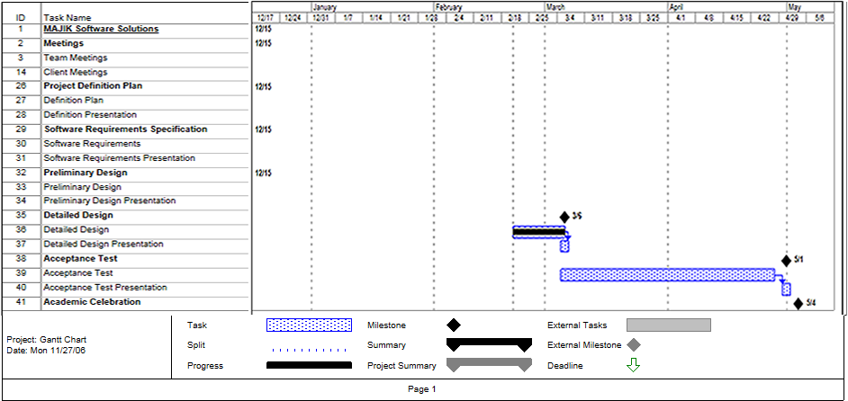

5.2 Glossary of Terms

Apache - an open source web server that runs on most commonly used platforms.
CPU - Central Processing Unit – The processing component of a computer to process data.
Data Flow Diagram - A graphical breakdown of the processes and major flows of data that occur in the system.
Database – A collection of data organized to be readily available for use.
Gantt Chart - A chart that displays progress over time, in this case used to keep track of a project.
IP address – Internet Protocol address, is a unique address that certain electronic devices use in order to identify and communicate with each other on a computer network.
Linear Sequential Model / Classic Waterfall Model – A systematic, sequential approach to software development that progresses from this Software Plan to Requirement Specifications, Preliminary/Detailed, and finally Acceptance Tests.
MAC address - Media Access Control address, given to a device in a network. It consists of a 48-bit hexadecimal number (12 characters). The address is normally assigned to a device, such as a network card, when it is manufactured.
MySql - Open source relational database management system (RDBMS) that uses Structured Query Language (SQL), a popular language for adding, accessing, and processing data in a database.
Network Device - A computer, peripheral or other related communications equipment attached to a network.
Oracle - a relational database management system (RDBMS) developed and copyrighted by the Oracle Corporation.
PHP – A scripting language useful in the creation of dynamic web pages.
Prototype – A rudimentary depiction of the design of the final product.
Virtual - Something which is a representation rather than the ‘real’ thing, thus ‘virtual reality’.

