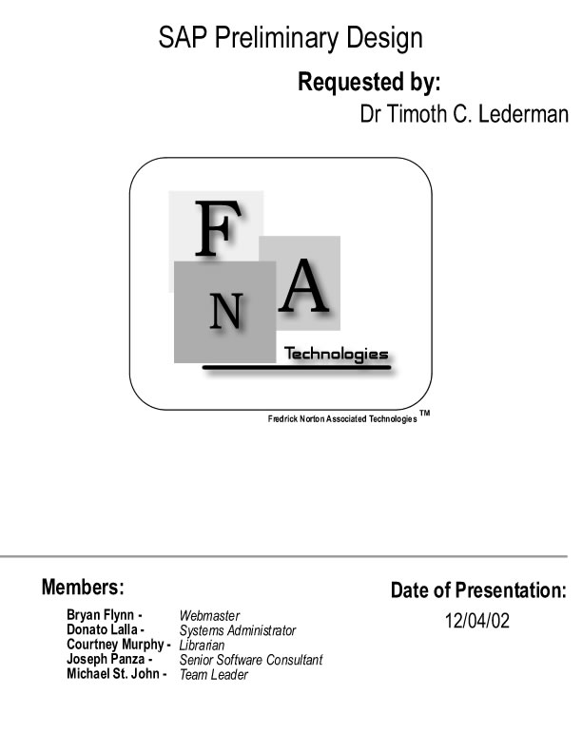
Table of Contents

Project Overview  Section 1: External Design Specifications  User displays and report formats  User command summary  Detailed data flow diagrams  Logical data dictionary  Section 2: Architectural Design Specification  Structure diagrams  Parameter specifications  Logical data structures  Functional descriptions  Section 3: Testing Requirements  Requirements Inventory  Design Inventroy  Glossary | 3  4  21  24  32  86  99  100  102  103  104  105

Project Overview

The SAP system will be a software package that works in conjunction with a Microsoft Access database. This package will allow for information to be easily accessible, data entry to be performed more efficiently, and making point calculations an automated task provided by the system. This system is being developed in cooperation with our client, Dr. Timoth Lederman, on behalf of the Castleton Volunteer EMS Station. Operators of the SAP system will interface with menus, forms, and reports. All of these attributes of the system will be developed through the use of Microsoft Visual C++, the Microsoft Foundation Class (MFC) Library, and Microsoft Access. To summarize, this system will make the management of data much easier then was ever possible before, along with creating a product that will be timely and efficient.
Section 1: External Design Specifications

User Displays and Report Formats

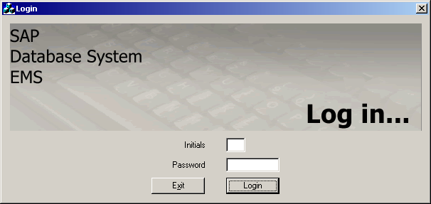

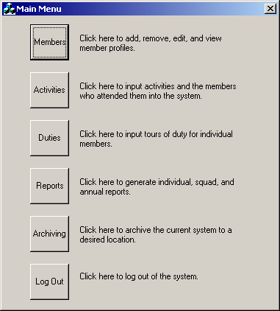

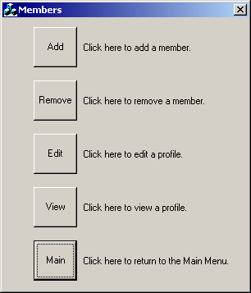

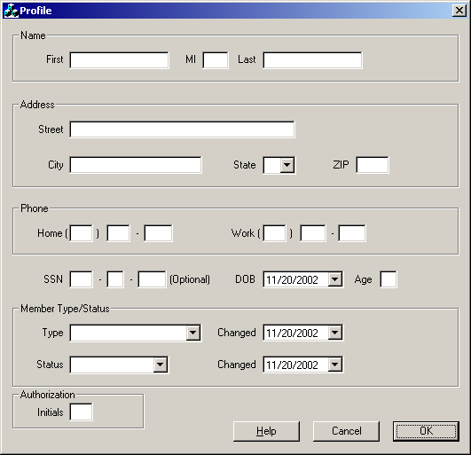

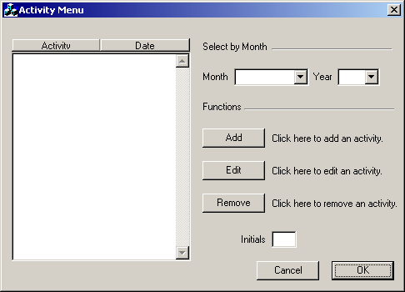

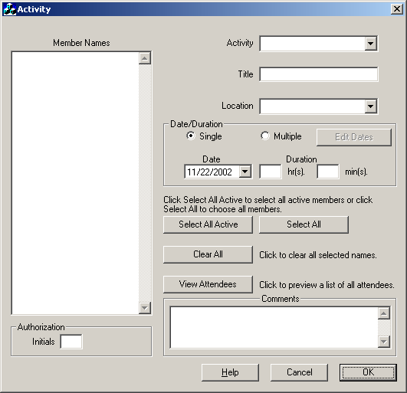

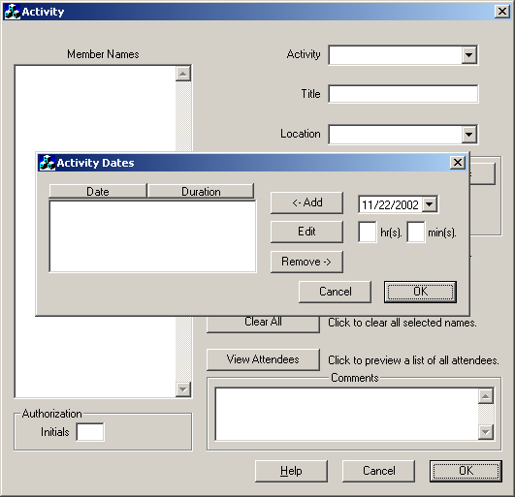

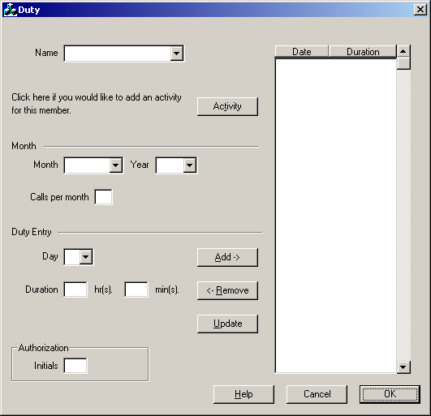

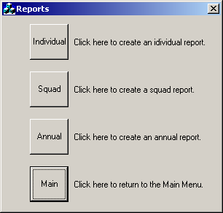

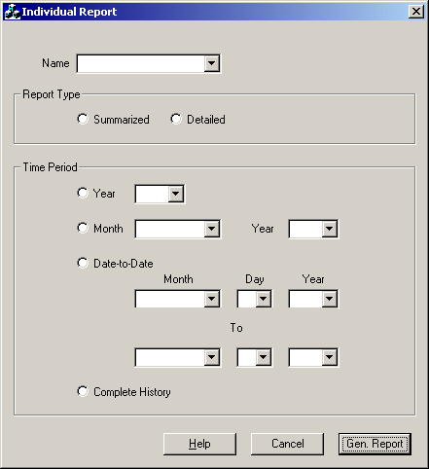

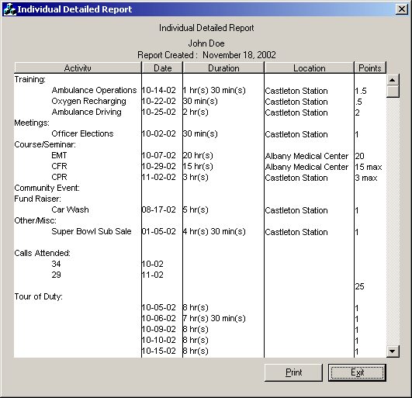

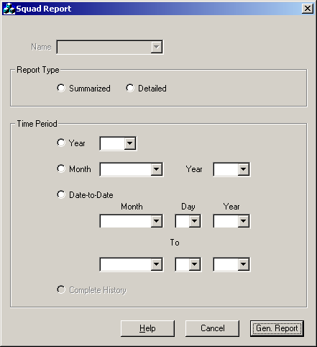

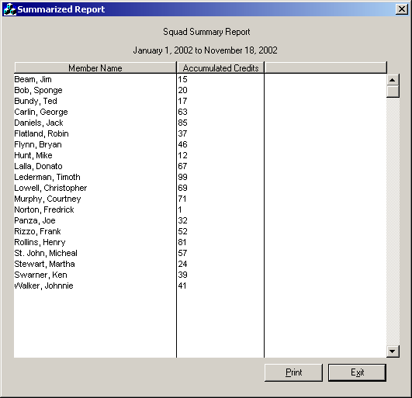

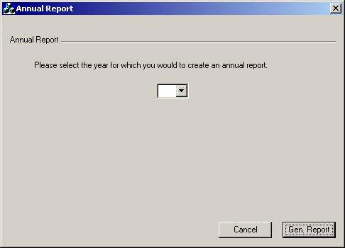

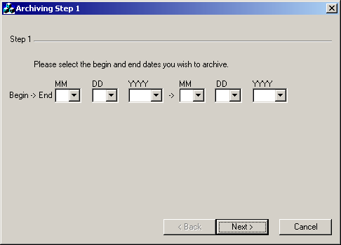

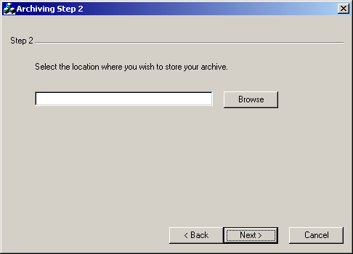

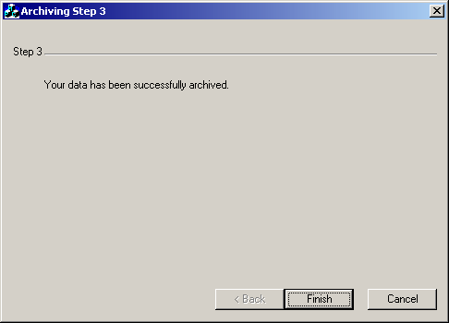

User Command Summary

Log In
The user may enter in his/her initials along with a valid password and then click ok. He/she will then enter the main menu. If the user opts to click the Exit button, the program will then close.

Main Menu
The user is prompted with several options. He/she may click Members which will bring him/her to the Member profile screen. If the user clicks on the Activities button, it will bring him/her to the Activities Menu. If he/she clicks on Duties, it will bring him/her to the Duty Form. By clicking on Reports, the Report Form will be displayed. If he/she clicks on Archiving, it brings the user to the Archiving screen, and if he/she clicks Log Out, it will bring the user back to the log-in screen.

Members
The user can choose to Add, Remove and Edit Members. He/she can also choose to view a member’s profile. If he/she clicks on Add, the user is brought to the add member form. If they click Remove, he/she is brought to the Remove Member screen, and if the user clicks on Edit, he/she will be taken to the Edit User form. The member’s profile can be viewed by clicking on the View button. The user may also choose to return to the Main menu by clicking on Main.

Activity Menu
The user will enter his/her initials. If the activity the user wishes to enter information about is not shown in the column displayed to the left of the screen, which is searchable by month, he/she can then choose to Add a new Activity by clicking Add. A new activity form will be displayed.
If the activity is displayed in the column, the user can edit the activity information by selecting the activity and then clicking Edit. The user will be taken to an Existing Activity Form.
If the user wants to remove an activity from the database, they can select the activity and then click remove. After the user is done making changes, he/she will click ok and return to the Main Menu. The user can choose to return to the Main Menu at any time by clicking Cancel.

New Activity Form
The user enters in the activity type, title and location. He/she then selects whether the activity took place over one day or over several. If the user selects a single date, he/she will then enter in that date. If he/she selects multiple, he/she will then select edit dates and enter in the dates the activity took place. After the dates are entered in both instances, the user will then select the member names. He/she has the option of selecting single users by clicking on each individual name, by selecting all members and selecting all active members by clicking on their respective buttons. There is also the option of clearing all names that have been selected by clicking Clear All. He/she may also view the names that have been selected by clicking on View Attendees. The user then enters his/her initials and when all information has been entered, clicks OK. The user will then be taken back to the Activity Menu. At any point, the user can return to the Activity Menu by clicking Cancel, or receive help by clicking Help.

Existing Activity Form
The user can edit any information pertaining to a specific activity on this form. All steps in the New Activity Form apply to this form as well. At any point, the user can return to the Activity Menu by clicking Cancel, or receive help by clicking Help.

Duties
The user enters in all Duty Data along with his/her initials and then clicks add. The added duty information will be displayed to the user. The user can then enter in more duty data until he/she has entered all the duty for the member. To commit the data to the database, the user will click Update and the database will be updated. The user is sent a verification message and will then return to the duty form. The user can remove any duty data by selecting the duty in the display screen and then clicking Remove. The user will be giving a remove verification and then go back to Duty Data. If the user wants to enter in a full activity, he/she can enter the date in and then select Activity and the user will be taken to the New Activity form.

Reports
The user can request several reports. He/she can request an Individual Report, a Squad Report or an Annual Report. To view an Individual Report, the user will click on Individual and he/she will be taken to the Individual Report Form. If the user would like to request a Squad Report, he/she will click on Squad to be taken to the Squad Report Form. If the user would like an Annual Report, he/she would click on Annual to be taken to the Annual Report Form. The user can return to the Main Menu screen at any time by clicking Main.

Individual Report
The user will enter in all report data and then click Generate Reports to view the Individual Report. After viewing the generated Individual Report, he/she will be brought back to the Generate Reports page. At any time the user can return to Generate Report by clicking Cancel and he/she can also receive help at any time by clicking Help.

Squad Report
The user will enter in all report data and then click Generate Reports to view the Squad Report. After viewing the generated Squad Report, he/she will be brought back to the Generate Reports page. At any time the user can return to Generate Report by clicking Cancel and he/she can also receive help at any time by clicking Help.

Squad Report
The user will select the year in which they wish to generate a report on and then click Generate Reports to view the Annual Report. After viewing the generated Annual Report, he/she will be brought back to the Generate Reports page. At any time the user can return to Generate Report by clicking Cancel.

Archive Date
The user will enter the dates he/she wishes to archive the database and then click next. The user will then be brought to the locations screen. He/she can return to Main Menu by clicking Cancel.

Archive Location
The user can select the location in which he/she wishes to have the archived data stored and then click Next in order to archive. He/she will receive a confirmation screen and then can return to Main Menu. The user can return to the archive date screen by clicking Back or can return to main menu by clicking Cancel.
Detailed Data Flow Diagrams
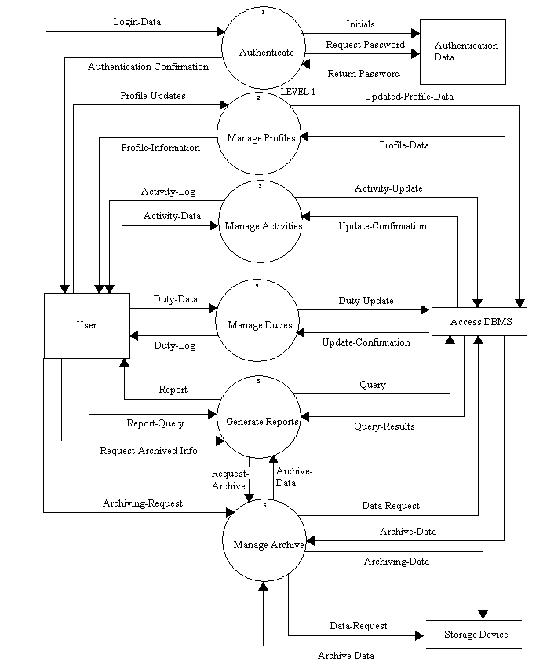
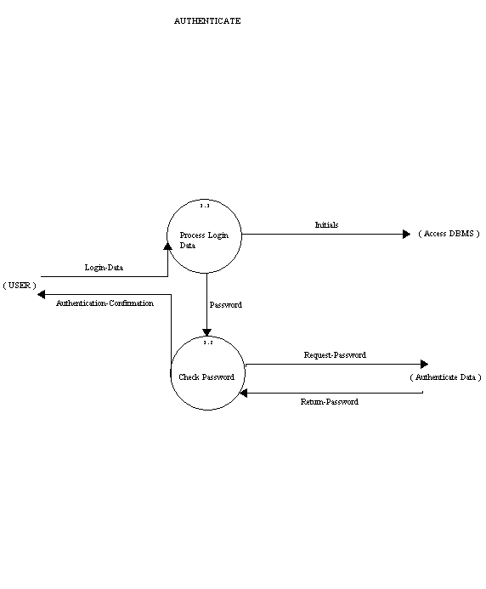
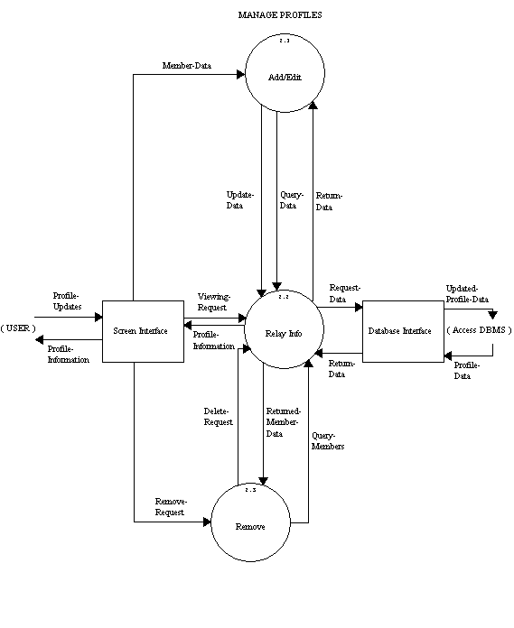
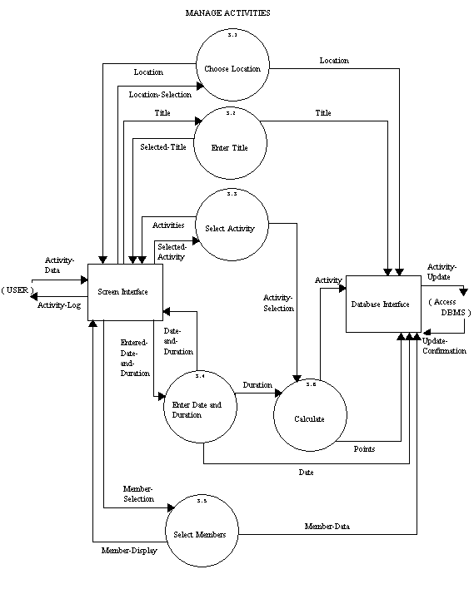
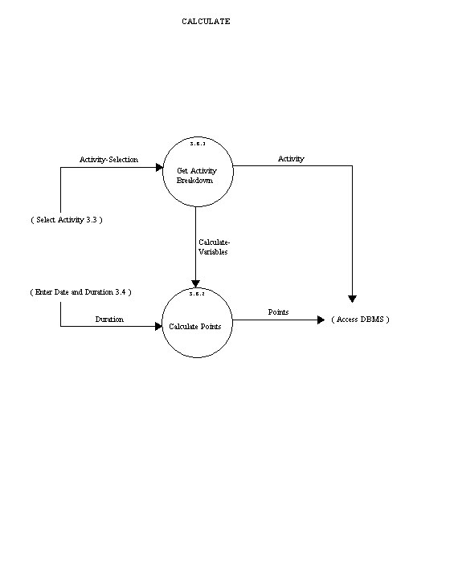
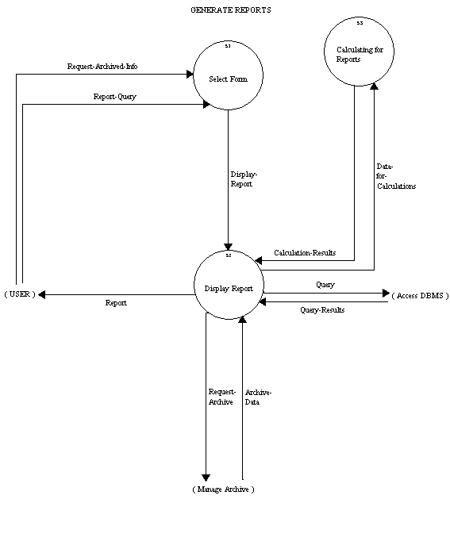
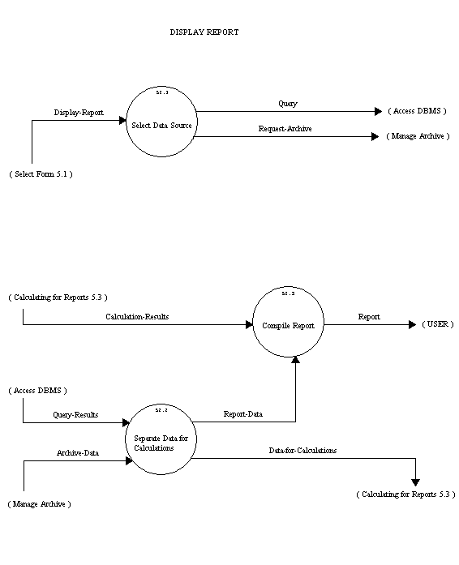
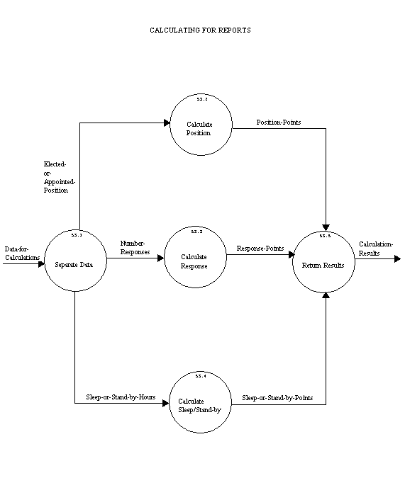
Logical Data Dictionary

LEVEL 1

Authentication Data Source/Sink
Description:
A file holding the information that allows users to access the system.
Location:
level 1 ( 0 )
Input Flows:
Request-Password
Initials
Output Flows:
Return-Password
Date Last Altered:11/24/2002 Date Created:11/24/2002
---------------------------------------------------------------------------------
User Source/Sink
Description:
The person logged in and operating the software.
Location:
level 1 ( 0 )
Input Flows:
Duty-Log
Activity-Log
Report
Authentication-Confirmation
Profile-Information
Authentication-Confirmation
Output Flows:
Activity-DAta
Request-Archived-Info
Archiving-Request
Login-Data
Profile-Updates
Duty-Data
Login-Data
Profile-Updates
Request-Archived-Info
Date Last Altered:11/24/2002 Date Created:11/24/2002
---------------------------------------------------------------------------------
Access DBMS File
Description:
The Microsoft Access Database in which all Member/Activity/Duty data will
be stored.
Composition:
Activity-Update
Archive-Data
Data-Request
Profile-Data
Query
Query-Results
Update-Confirmation
Updated-Profile-Data
Location:
level 1 ( 0 )
Input Flows:
Duty-Update
Activity-Update
Query
Data-Requst
Updated-Profile-Data
Initials
Updated-Profile-Data
Data-Request
Output Flows:
Update-Confirmation
Archive-Data
Profile-Data
Update-Confirmation
Profile-Data
Query-Results
Archive-Data
Date Last Altered:11/24/2002 Date Created:11/24/2002
---------------------------------------------------------------------------------
Storage Device File
Description:
Anything that data will be archived to, such as disk, cd or hard drive, etc.
Location:
level 1 ( 0 )
Input Flows:
Data-Request
Archiving-Data
Data-Request
Output Flows:
Archive-Data
Archive-Data
Date Last Altered:11/24/2002 Date Created:11/24/2002
---------------------------------------------------------------------------------
Authenticate Process
Description:
Secures the system from entry from unwanted users.
Process #: 1
Process Description:
Takes the user entered log in data and sends the password on to be
verified and sends the user's initials to the database. A confirmation is
then sent back to the user.
Location:
level 1 ( 0 )
Input Flows:
Return-Password
Login-Data
Output Flows:
Request-Password
Authentication-Confirmation
Initials
Date Last Altered:11/24/2002 Date Created:11/24/2002
---------------------------------------------------------------------------------
Generate Reports Process
Description:
Allows the user to choose from five different query types from the
database, this includes current information and archived data.
Process #: 5
Process Description:
Takes in a query or archive request from the user and returns the report
from the database or storage device.
Notes:
The five types of queries are: annual report, individual summary,
individual detailed, squad summary and squad detailed.
Location:
level 1 ( 0 )
Input Flows:
Report-Query
Archive-Data
Report-Query
Query-Results
Output Flows:
Request-Archive
Query
Report
Date Last Altered:11/24/2002 Date Created:11/24/2002
---------------------------------------------------------------------------------
Manage Activities Process
Description:
Stores activity information in the database.
Process #: 3
Process Description:
Takes the activities information as inputed by the user and stores them
into the database.
Location:
level 1 ( 0 )
Input Flows:
Activity-DAta
Update-Confirmation
Output Flows:
Activity-Log
Activity-Update
Date Last Altered:11/24/2002 Date Created:11/24/2002
---------------------------------------------------------------------------------
Manage Archive Process
Description:
Archives data from database to a specific storage device.
Process #: 6
Process Description:
Retrieves the requested data from the database as specified by the user
and stores to a storage device.
Location:
level 1 ( 0 )
Input Flows:
Archiving-Request
Request-Archive
Archive-Data
Archive-Data
Output Flows:
Data-Requst
Archiving-Data
Data-Request
Date Last Altered:11/24/2002 Date Created:11/24/2002
---------------------------------------------------------------------------------
Manage Duties Process
Description:
Stores Duty information entered by the user in the database.
Process #: 4
Process Description:
Takes the Duty information as inputed by the user and stores them
into the database.
Location:
level 1 ( 0 )
Input Flows:
Update-Confirmation
Duty-Data
Output Flows:
Duty-Log
Duty-Update
Date Last Altered:11/24/2002 Date Created:11/24/2002
---------------------------------------------------------------------------------
Manage Profiles Process
Description:
Allows the addition, editing, deletion and viewing of member profiles.
Process #: 2
Process Description:
Any changes the user may need to make are modified in the database.
Location:
level 1 ( 0 )
Input Flows:
Profile-Updates
Profile-Data
Output Flows:
Profile-Information
Updated-Profile-Data
Date Last Altered:11/24/2002 Date Created:11/24/2002
---------------------------------------------------------------------------------
Activity-DAta Data Flow
Description:
All the activity data inputted by the user.
Location:
level 1 ( 0 )
Source:User ( Source/Sink )
Dest: Manage Activities ( Process )
Manage Activities ( 3 )
Source:*** Not on Diagram ***
Dest: Screen Interface ( Source/Sink )
Date Last Altered:11/24/2002 Date Created:11/24/2002
---------------------------------------------------------------------------------
Activity-Log Data Flow
Description:
The activity information which needs to be displayed to the user .
Location:
level 1 ( 0 )
Source:Manage Activities ( Process )
Dest: User ( Source/Sink )
Manage Activities ( 3 )
Source:Screen Interface ( Source/Sink )
Dest: *** Not on Diagram ***
Date Last Altered:11/24/2002 Date Created:11/24/2002
---------------------------------------------------------------------------------
Activity-Update Data Flow
Description:
The new activity information to be sent to the database to update it.
Location:
level 1 ( 0 )
Source:Manage Activities ( Process )
Dest: Access DBMS ( File )
Manage Activities ( 3 )
Source:Database Interface ( Source/Sink )
Dest: *** Not on Diagram ***
File --> Access DBMS
Date Last Altered:11/24/2002 Date Created:11/24/2002
---------------------------------------------------------------------------------
Archive-Data Data Flow
Description:
Data that has been archived already and it being inputed from a storage
device.
Location:
level 1 ( 0 )
Source:Manage Archive ( Process )
Dest: Generate Reports ( Process )
Source:Access DBMS ( File )
Dest: Manage Archive ( Process )
Source:Storage Device ( File )
Dest: Manage Archive ( Process )
Generate Reports ( 5 )
Source:*** Not on Diagram ***
Dest: Display Report ( Process )
Manage Archive ( 6 )
Source:*** Not on Diagram ***
Dest: Manage Storage Device ( Process )
Source:Manage Storage Device ( Process )
Dest: *** Not on Diagram ***
Source:Storage Device ( File )
Dest: *** Not on Diagram ***
File --> Access DBMS
Display Report ( 5.2 )
Source:*** Not on Diagram ***
Dest: Separate Data for Calculations ( Process )
Date Last Altered:11/24/2002 Date Created:11/24/2002
---------------------------------------------------------------------------------
Archiving-Data Data Flow
Description:
Data that is being transferred to a storage device to be archived.
Location:
level 1 ( 0 )
Source:Manage Archive ( Process )
Dest: Storage Device ( File )
Manage Archive ( 6 )
Source:*** Not on Diagram ***
Dest: Handle Archiving ( Process )
Source:Manage Archive ( Process )
Dest: *** Not on Diagram ***
Date Last Altered:11/24/2002 Date Created:11/24/2002
---------------------------------------------------------------------------------
Archiving-Request Data Flow
Description:
An index to data that is going to be transferred from a database to a
storage device.
Location:
level 1 ( 0 )
Source:User ( Source/Sink )
Dest: Manage Archive ( Process )
Manage Archive ( 6 )
Source:*** Not on Diagram ***
Dest: Handle Archiving ( Process )
Date Last Altered:11/24/2002 Date Created:11/24/2002
---------------------------------------------------------------------------------
Authentication-Confirmation Data Flow
Description:
The information displayed to the user verifying their sucessful/failed log in
attempt.
Location:
level 1 ( 0 )
Source:Authenticate ( Process )
Dest: User ( Source/Sink )
Generate Reports ( 5 )
Source:*** Not on Diagram ***
Dest: *** Not on Diagram ***
Authenticate ( 1 )
Source:Check Password ( Process )
Dest: *** Not on Diagram ***
Source:Authenticate ( Process )
Dest: User ( Source/Sink )
Date Last Altered:11/24/2002 Date Created:11/24/2002
---------------------------------------------------------------------------------
Data-Request Data Flow
Description:
The archived data requested to be retrieved from the storage device.
Location:
level 1 ( 0 )
Source:Manage Archive ( Process )
Dest: Storage Device ( File )
Manage Archive ( 6 )
Source:Manage Storage Device ( Process )
Dest: *** Not on Diagram ***
Source:Manage Archive ( Process )
Dest: Storage Device ( File )
File --> Access DBMS
Date Last Altered:11/24/2002 Date Created:11/24/2002
---------------------------------------------------------------------------------
Duty-Data Data Flow
Description:
The name, date, duration of duties, and calls per month.
Location:
level 1 ( 0 )
Source:User ( Source/Sink )
Dest: Manage Duties ( Process )
Manage Duties ( 4 )
Source:*** Not on Diagram ***
Dest: Screen Interface ( Source/Sink )
Date Last Altered:11/24/2002 Date Created:11/24/2002
---------------------------------------------------------------------------------
Duty-Log Data Flow
Description:
The duty information which needs to be displayed to the user.
Location:
level 1 ( 0 )
Source:Manage Duties ( Process )
Dest: User ( Source/Sink )
Manage Duties ( 4 )
Source:Screen Interface ( Source/Sink )
Dest: *** Not on Diagram ***
Date Last Altered:11/24/2002 Date Created:11/24/2002
---------------------------------------------------------------------------------
Duty-Update Data Flow
Description:
All new duty data to be inputed into the Access DBMS.
Location:
level 1 ( 0 )
Source:Manage Duties ( Process )
Dest: Access DBMS ( File )
Manage Duties ( 4 )
Source:Database Interface ( Source/Sink )
Dest: *** Not on Diagram ***
Date Last Altered:11/24/2002 Date Created:11/24/2002
---------------------------------------------------------------------------------
Initials Data Flow
Description:
The user's initials that are inputed at the log in screen that will be stored in
the database.
Notes:
2-3 characters in length
Location:
level 1 ( 0 )
Source:Authenticate ( Process )
Dest: Access DBMS ( File )
Source:Authenticate ( Process )
Dest: Authentication Data ( Source/Sink )
Authenticate ( 1 )
Source:Process Login Data ( Process )
Dest: *** Not on Diagram ***
Date Last Altered:11/24/2002 Date Created:11/24/2002
---------------------------------------------------------------------------------
Login-Data Data Flow
Description:
The initials and password inputed by the user at the log-in screen.
Location:
level 1 ( 0 )
Source:User ( Source/Sink )
Dest: Authenticate ( Process )
Generate Reports ( 5 )
Source:*** Not on Diagram ***
Dest: *** Not on Diagram ***
Authenticate ( 1 )
Source:*** Not on Diagram ***
Dest: Process Login Data ( Process )
Source:User ( Source/Sink )
Dest: *** Not on Diagram ***
Date Last Altered:11/24/2002 Date Created:11/24/2002
---------------------------------------------------------------------------------
Profile-Data Data Flow
Description:
Member data requested from the database.
Location:
level 1 ( 0 )
Source:Access DBMS ( File )
Dest: Manage Profiles ( Process )
Manage Profiles ( 2 )
Source:Access DBMS ( File )
Dest: Database Interface ( Source/Sink )
File --> Access DBMS
Date Last Altered:11/24/2002 Date Created:11/24/2002
---------------------------------------------------------------------------------
Profile-Information Data Flow
Description:
The member information to be displayed to the user.
Location:
level 1 ( 0 )
Source:Manage Profiles ( Process )
Dest: User ( Source/Sink )
Manage Profiles ( 2 )
Source:Screen Interface ( Source/Sink )
Dest: *** Not on Diagram ***
Source:Relay Info ( Process )
Dest: Screen Interface ( Source/Sink )
Date Last Altered:11/24/2002 Date Created:11/24/2002
---------------------------------------------------------------------------------
Profile-Updates Data Flow
Description:
Changes made to member profiles.
Location:
level 1 ( 0 )
Source:User ( Source/Sink )
Dest: Manage Profiles ( Process )
Manage Profiles ( 2 )
Source:User ( Source/Sink )
Dest: Manage Profiles ( Process )
Date Last Altered:11/24/2002 Date Created:11/24/2002
---------------------------------------------------------------------------------
Query Data Flow
Description:
The report requested from the database.
Location:
level 1 ( 0 )
Source:Generate Reports ( Process )
Dest: Access DBMS ( File )
Generate Reports ( 5 )
Source:Display Report ( Process )
Dest: *** Not on Diagram ***
File --> Access DBMS
Display Report ( 5.2 )
Source:Select Data Source ( Process )
Dest: *** Not on Diagram ***
Date Last Altered:11/24/2002 Date Created:11/24/2002
---------------------------------------------------------------------------------
Query-Results Data Flow
Description:
The requested report information as queried from the database.
Location:
level 1 ( 0 )
Source:Access DBMS ( File )
Dest: Generate Reports ( Process )
Generate Reports ( 5 )
Source:*** Not on Diagram ***
Dest: Display Report ( Process )
File --> Access DBMS
Display Report ( 5.2 )
Source:*** Not on Diagram ***
Dest: Separate Data for Calculations ( Process )
Date Last Altered:11/24/2002 Date Created:11/24/2002
---------------------------------------------------------------------------------
Report Data Flow
Description:
One of the 5 different forms of data to be displayed to the user.
Location:
level 1 ( 0 )
Source:Generate Reports ( Process )
Dest: User ( Source/Sink )
Generate Reports ( 5 )
Source:Display Report ( Process )
Dest: *** Not on Diagram ***
Display Report ( 5.2 )
Source:Compile Report ( Process )
Dest: *** Not on Diagram ***
Date Last Altered:11/24/2002 Date Created:11/24/2002
---------------------------------------------------------------------------------
Report-Query Data Flow
Description:
Request for one of the 5 types of reports.
Location:
level 1 ( 0 )
Source:User ( Source/Sink )
Dest: Generate Reports ( Process )
Generate Reports ( 5 )
Source:*** Not on Diagram ***
Dest: Select Form ( Process )
Date Last Altered:11/24/2002 Date Created:11/24/2002
---------------------------------------------------------------------------------
Request-Archive Data Flow
Description:
Information requested to be archived from the database.
Location:
level 1 ( 0 )
Source:Generate Reports ( Process )
Dest: Manage Archive ( Process )
Generate Reports ( 5 )
Source:Display Report ( Process )
Dest: *** Not on Diagram ***
Manage Archive ( 6 )
Source:*** Not on Diagram ***
Dest: Manage Storage Device ( Process )
Display Report ( 5.2 )
Source:Select Data Source ( Process )
Dest: *** Not on Diagram ***
Date Last Altered:11/24/2002 Date Created:11/24/2002
---------------------------------------------------------------------------------
Request-Archived-Info Data Flow
Description:
Requested information to be retreived from a storage device.
Location:
level 1 ( 0 )
Source:User ( Source/Sink )
Dest: Generate Reports ( Process )
Generate Reports ( 5 )
Source:*** Not on Diagram ***
Dest: Select Form ( Process )
Date Last Altered:11/24/2002 Date Created:11/24/2002
---------------------------------------------------------------------------------
Request-Password Data Flow
Description:
The password entered by the user to be sent to the authenticate data for
verification.
Location:
level 1 ( 0 )
Source:Authenticate ( Process )
Dest: Authentication Data ( Source/Sink )
Generate Reports ( 5 )
Source:*** Not on Diagram ***
Dest: *** Not on Diagram ***
Authenticate ( 1 )
Source:Check Password ( Process )
Dest: *** Not on Diagram ***
Source:*** Not on Diagram ***
Dest: *** Not on Diagram ***
Date Last Altered:11/24/2002 Date Created:11/24/2002
---------------------------------------------------------------------------------
Return-Password Data Flow
Description:
Returns whether or not the entered password was found in Authenticate
Data.
Location:
level 1 ( 0 )
Source:Authentication Data ( Source/Sink )
Dest: Authenticate ( Process )
Generate Reports ( 5 )
Source:*** Not on Diagram ***
Dest: Authenticate ( Process )
Authenticate ( 1 )
Source:*** Not on Diagram ***
Dest: Check Password ( Process )
Source:*** Not on Diagram ***
Dest: *** Not on Diagram ***
Date Last Altered:11/24/2002 Date Created:11/24/2002
---------------------------------------------------------------------------------
Update-Confirmation Data Flow
Description:
The data sent back to the database interface confirming that an update has
been made to the database.
Location:
level 1 ( 0 )
Source:Access DBMS ( File )
Dest: Manage Duties ( Process )
Source:Access DBMS ( File )
Dest: Manage Activities ( Process )
Manage Duties ( 4 )
Source:*** Not on Diagram ***
Dest: Database Interface ( Source/Sink )
Manage Activities ( 3 )
Source:*** Not on Diagram ***
Dest: Database Interface ( Source/Sink )
File --> Access DBMS
Date Last Altered:11/24/2002 Date Created:11/24/2002
---------------------------------------------------------------------------------
Updated-Profile-Data Data Flow
Description:
Member data that has been edited by the user that is being sent to
update the database
Location:
level 1 ( 0 )
Source:Manage Profiles ( Process )
Dest: Access DBMS ( File )
Manage Profiles ( 2 )
Source:Database Interface ( Source/Sink )
Dest: Access DBMS ( File )
File --> Access DBMS
Date Last Altered:11/24/2002 Date Created:11/24/2002
---------------------------------------------------------------------------------

LEVEL 2

AUTHENTICATE (1)

Check Password Process
Description:
Varifies the user password to allow access to the system.
Process #: 1.2
Process Description:
Takes in the user entered password, sends it to be authenticated and
then sends the user confirmation on the sucessful or failed log in
attempt.
Location:
Authenticate ( 1 )
Input Flows:
Return-Password
Password
Output Flows:
Request-Password
Authentication-Confirmation
Date Last Altered:11/24/2002 Date Created:11/24/2002
---------------------------------------------------------------------------------
Process Login Data Process
Description:
Separates the log in data into initials and password.
Process #: 1.1
Process Description:
Takes the log in information entered by the user and sends the initials to
be stored in the database and the password to be verified.
Location:
Authenticate ( 1 )
Input Flows:
Login-Data
Output Flows:
Initials
Password
Date Last Altered:11/24/2002 Date Created:11/24/2002
---------------------------------------------------------------------------------
Authentication-Confirmation Data Flow
Description:
The information displayed to the user verifying their sucessful/failed log in
attempt.
Location:
level 1 ( 0 )
Source:Authenticate ( Process )
Dest: User ( Source/Sink )
Generate Reports ( 5 )
Source:*** Not on Diagram ***
Dest: *** Not on Diagram ***
Authenticate ( 1 )
Source:Check Password ( Process )
Dest: *** Not on Diagram ***
Source:Authenticate ( Process )
Dest: User ( Source/Sink )
Date Last Altered:11/24/2002 Date Created:11/24/2002
---------------------------------------------------------------------------------
Initials Data Flow
Description:
The user's initials that are inputed at the log in screen that will be stored in
the database.
Notes:
2-3 characters in length
Location:
level 1 ( 0 )
Source:Authenticate ( Process )
Dest: Access DBMS ( File )
Source:Authenticate ( Process )
Dest: Authentication Data ( Source/Sink )
Authenticate ( 1 )
Source:Process Login Data ( Process )
Dest: *** Not on Diagram ***
Date Last Altered:11/24/2002 Date Created:11/24/2002
---------------------------------------------------------------------------------
Login-Data Data Flow
Description:
The initials and password inputed by the user at the log-in screen.
Location:
level 1 ( 0 )
Source:User ( Source/Sink )
Dest: Authenticate ( Process )
Generate Reports ( 5 )
Source:*** Not on Diagram ***
Dest: *** Not on Diagram ***
Authenticate ( 1 )
Source:*** Not on Diagram ***
Dest: Process Login Data ( Process )
Source:User ( Source/Sink )
Dest: *** Not on Diagram ***
Date Last Altered:11/24/2002 Date Created:11/24/2002
---------------------------------------------------------------------------------
Password Data Flow
Description:
The password entered by the user.
Location:
Authenticate ( 1 )
Source:Process Login Data ( Process )
Dest: Check Password ( Process )
Date Last Altered:11/24/2002 Date Created:11/24/2002
---------------------------------------------------------------------------------
Request-Password Data Flow
Description:
The password entered by the user to be sent to the authenticate data for
verification.
Location:
level 1 ( 0 )
Source:Authenticate ( Process )
Dest: Authentication Data ( Source/Sink )
Generate Reports ( 5 )
Source:*** Not on Diagram ***
Dest: *** Not on Diagram ***
Authenticate ( 1 )
Source:Check Password ( Process )
Dest: *** Not on Diagram ***
Source:*** Not on Diagram ***
Dest: *** Not on Diagram ***
Date Last Altered:11/24/2002 Date Created:11/24/2002
---------------------------------------------------------------------------------
Return-Password Data Flow
Description:
Returns whether or not the entered password was found in Authenticate
Data.
Location:
level 1 ( 0 )
Source:Authentication Data ( Source/Sink )
Dest: Authenticate ( Process )
Generate Reports ( 5 )
Source:*** Not on Diagram ***
Dest: Authenticate ( Process )
Authenticate ( 1 )
Source:*** Not on Diagram ***
Dest: Check Password ( Process )
Source:*** Not on Diagram ***
Dest: *** Not on Diagram ***
Date Last Altered:11/24/2002 Date Created:11/24/2002
---------------------------------------------------------------------------------

MANAGE PROFILES (2)

Add/Edit Process
Description:
Allows the user to add or edit members and member information into the
database.
Process #: 2.1
Process Description:
Takes the inputed user updates and sends it to Relay Info which will
send it on to the database interface.
Location:
Manage Profiles ( 2 )
Input Flows:
Member-Data
Return-Data
Output Flows:
Update-Data
Query-Data
Date Last Altered:11/24/2002 Date Created:11/24/2002
---------------------------------------------------------------------------------
Relay Info Process
Description:
Transfers the requested member information to the process in which it is
needed.
Process #: 2.2
Process Description:
It can 1) relay member information to be viewed to user. 2) Allow
member data in the database to be added or edited or 3) Allow member
data stored in the database to be removed.
Location:
Manage Profiles ( 2 )
Input Flows:
Viewing-Request
Query-Members
Delete-Request
Update-Data
Query-Data
Return-Data
Output Flows:
Returned-Member-Data
Return-Data
Request-Data
Profile-Information
Date Last Altered:11/24/2002 Date Created:11/24/2002
---------------------------------------------------------------------------------
Remove Process
Description:
Allows the user to remove a member and their corresponding member
information from the database.
Process #: 2.3
Process Description:
Takes the remove request made by the user and matches it with the
database information and removes all relevant information.
Location:
Manage Profiles ( 2 )
Input Flows:
Remove-Request
Returned-Member-Data
Output Flows:
Query-Members
Delete-Request
Date Last Altered:11/24/2002 Date Created:11/24/2002
---------------------------------------------------------------------------------
Delete-Request Data Flow
Description:
The index of the data to be deleted.
Location:
Manage Profiles ( 2 )
Source:Remove ( Process )
Dest: Relay Info ( Process )
Date Last Altered:11/24/2002 Date Created:11/24/2002
---------------------------------------------------------------------------------
Member-Data Data Flow
Description:
Information regarding a volunteer, as entered by the user.
Notes:
Data to be stored: First Name, Last Name, Middle Initial,SSN, Street,
Street2, City, State, Zip, Home Phone, Work Phone.
Location:
Manage Activities ( 3 )
Source:Select Members ( Process )
Dest: Database Interface ( Source/Sink )
Manage Profiles ( 2 )
Source:Screen Interface ( Source/Sink )
Dest: Add/Edit ( Process )
Date Last Altered:11/24/2002 Date Created:11/24/2002
---------------------------------------------------------------------------------
Profile-Data Data Flow
Description:
Member data requested from the database.
Location:
level 1 ( 0 )
Source:Access DBMS ( File )
Dest: Manage Profiles ( Process )
Manage Profiles ( 2 )
Source:Access DBMS ( File )
Dest: Database Interface ( Source/Sink )
File --> Access DBMS
Date Last Altered:11/24/2002 Date Created:11/24/2002
---------------------------------------------------------------------------------
Profile-Information Data Flow
Description:
The member information to be displayed to the user.
Location:
level 1 ( 0 )
Source:Manage Profiles ( Process )
Dest: User ( Source/Sink )
Manage Profiles ( 2 )
Source:Screen Interface ( Source/Sink )
Dest: *** Not on Diagram ***
Source:Relay Info ( Process )
Dest: Screen Interface ( Source/Sink )
Date Last Altered:11/24/2002 Date Created:11/24/2002
---------------------------------------------------------------------------------
Profile-Updates Data Flow
Description:
Changes made to member profiles.
Location:
level 1 ( 0 )
Source:User ( Source/Sink )
Dest: Manage Profiles ( Process )
Manage Profiles ( 2 )
Source:User ( Source/Sink )
Dest: Manage Profiles ( Process )
Date Last Altered:11/24/2002 Date Created:11/24/2002
---------------------------------------------------------------------------------
Query-Data Data Flow
Description:
The requested data to be edited by the user.
Location:
Manage Profiles ( 2 )
Source:Add/Edit ( Process )
Dest: Relay Info ( Process )
Date Last Altered:11/24/2002 Date Created:11/24/2002
---------------------------------------------------------------------------------
Query-Members Data Flow
Description:
Member information to be matched up with database members for deletion.
Location:
Manage Profiles ( 2 )
Source:Remove ( Process )
Dest: Relay Info ( Process )
Date Last Altered:11/24/2002 Date Created:11/24/2002
---------------------------------------------------------------------------------
Remove-Request Data Flow
Description:
The requested member information to be removed from the database.
Location:
Manage Profiles ( 2 )
Source:Screen Interface ( Source/Sink )
Dest: Remove ( Process )
Date Last Altered:11/24/2002 Date Created:11/24/2002
---------------------------------------------------------------------------------
Request-Data Data Flow
Description:
Information to be retrieved from the database to be viewed by the user.
Location:
Manage Profiles ( 2 )
Source:Relay Info ( Process )
Dest: Database Interface ( Source/Sink )
Date Last Altered:11/24/2002 Date Created:11/24/2002
---------------------------------------------------------------------------------
Return-Data Data Flow
Description:
Member data retrieved from the database to be edited or viewed by the
user.
Location:
Manage Profiles ( 2 )
Source:Relay Info ( Process )
Dest: Add/Edit ( Process )
Source:Database Interface ( Source/Sink )
Dest: Relay Info ( Process )
Date Last Altered:11/24/2002 Date Created:11/24/2002
---------------------------------------------------------------------------------
Returned-Member-Data Data Flow
Description:
Member data from the database to be removed.
Location:
Manage Profiles ( 2 )
Source:Relay Info ( Process )
Dest: Remove ( Process )
Date Last Altered:11/24/2002 Date Created:11/24/2002
---------------------------------------------------------------------------------
Update-Data Data Flow
Description:
Sends the data edited by the user to be updated to Relay Info to be
updated to the database.
Location:
Manage Profiles ( 2 )
Source:Add/Edit ( Process )
Dest: Relay Info ( Process )
Date Last Altered:11/24/2002 Date Created:11/24/2002
---------------------------------------------------------------------------------
Updated-Profile-Data Data Flow
Description:
Member data that has been edited by the user that is being sent to
update the database
Location:
level 1 ( 0 )
Source:Manage Profiles ( Process )
Dest: Access DBMS ( File )
Manage Profiles ( 2 )
Source:Database Interface ( Source/Sink )
Dest: Access DBMS ( File )
File --> Access DBMS
Date Last Altered:11/24/2002 Date Created:11/24/2002
---------------------------------------------------------------------------------
Viewing-Request Data Flow
Description:
The member information requested from the database by the user to be
viewed.
Location:
Manage Profiles ( 2 )
Source:Screen Interface ( Source/Sink )
Dest: Relay Info ( Process )
Date Last Altered:11/24/2002 Date Created:11/24/2002
---------------------------------------------------------------------------------

MANAGE ACTIVITIES (3)

Calculate Process
Description:
Tallies the points in which the members recieve for various
activities/duties performed.
Process #: 3.6
Process Description:
Takes the inputed activity/duty, by using the guidelines the comptroller
has designed, it will calculate the points the member recieves.
Location:
Manage Activities ( 3 )
Input Flows:
Activity-Selection
Duration
Output Flows:
Activity
Points
Date Last Altered:11/24/2002 Date Created:11/24/2002
---------------------------------------------------------------------------------
Choose Location Process
Description:
Allows the user to enter or select the location of an activity and store it in
the database.
Process #: 3.1
Process Description:
Takes the user selected/entered location and stores it in the database
and then displays that information back to the user.
Location:
Manage Activities ( 3 )
Input Flows:
Location-Selection
Output Flows:
Location
Location
Date Last Altered:11/24/2002 Date Created:11/24/2002
---------------------------------------------------------------------------------
Enter Date And Duration Process
Description:
Stores inputed Date and Duration as objects to be entered into the
database and also used for calculations.
Process #: 3.4
Process Description:
User enters the date and duration, they are processed through Calculate
and then stored into the database.
Location:
Manage Activities ( 3 )
Input Flows:
Entered-Date-and-Duration
Output Flows:
Date-and-Duration
Duration
Date
Date Last Altered:11/24/2002 Date Created:11/24/2002
---------------------------------------------------------------------------------
Enter Title Process
Description:
The user selects the activity title.
Process #: 3.2
Process Description:
The title is highlighted from the screen menu.
Location:
Manage Activities ( 3 )
Input Flows:
Title
Output Flows:
Title
Selected-Title
Date Last Altered:11/24/2002 Date Created:11/24/2002
---------------------------------------------------------------------------------
Select Activity Process
Description:
Takes activity selected by the user and sends it to be calculated which is
process 2.5
Process #: 3.3
Location:
Manage Activities ( 3 )
Input Flows:
Selected-Activity
Output Flows:
Activities
Activity-Selection
Date Last Altered:11/24/2002 Date Created:11/24/2002
---------------------------------------------------------------------------------
Select Members Process
Description:
Allows the user to select the members who attended a certain activity.
Process #: 3.5
Process Description:
The user inputs the names of members who were in attendance and then
sends that information to be calculated.
Location:
Manage Activities ( 3 )
Input Flows:
Member-Selection
Output Flows:
Member-Display
Member-Data
Date Last Altered:11/24/2002 Date Created:11/24/2002
---------------------------------------------------------------------------------
Activities Data Flow
Description:
The activity information to be displayed to the user for confirmation.
Location:
Manage Activities ( 3 )
Source:Select Activity ( Process )
Dest: Screen Interface ( Source/Sink )
Date Last Altered:11/24/2002 Date Created:11/24/2002
---------------------------------------------------------------------------------
Activity Data Flow
Description:
The selected activity transferred to the database after calculations take
place.
Location:
Manage Activities ( 3 )
Source:Calculate ( Process )
Dest: Database Interface ( Source/Sink )
Calculate ( 3.6 )
Source:Get Activity Breakdown ( Process )
Dest: *** Not on Diagram ***
Date Last Altered:11/24/2002 Date Created:11/24/2002
---------------------------------------------------------------------------------
Activity-DAta Data Flow
Description:
All the activity data inputted by the user.
Location:
level 1 ( 0 )
Source:User ( Source/Sink )
Dest: Manage Activities ( Process )
Manage Activities ( 3 )
Source:*** Not on Diagram ***
Dest: Screen Interface ( Source/Sink )
Date Last Altered:11/24/2002 Date Created:11/24/2002
---------------------------------------------------------------------------------
Activity-Log Data Flow
Description:
The activity information which needs to be displayed to the user .
Location:
level 1 ( 0 )
Source:Manage Activities ( Process )
Dest: User ( Source/Sink )
Manage Activities ( 3 )
Source:Screen Interface ( Source/Sink )
Dest: *** Not on Diagram ***
Date Last Altered:11/24/2002 Date Created:11/24/2002
---------------------------------------------------------------------------------
Activity-Selection Data Flow
Description:
The user selected activity which is being sent to be calculated.
Location:
Manage Activities ( 3 )
Source:Select Activity ( Process )
Dest: Calculate ( Process )
Calculate ( 3.6 )
Source:*** Not on Diagram ***
Dest: Get Activity Breakdown ( Process )
Date Last Altered:11/24/2002 Date Created:11/24/2002
---------------------------------------------------------------------------------
Activity-Update Data Flow
Description:
The new activity information to be sent to the database to update it.
Location:
level 1 ( 0 )
Source:Manage Activities ( Process )
Dest: Access DBMS ( File )
Manage Activities ( 3 )
Source:Database Interface ( Source/Sink )
Dest: *** Not on Diagram ***
File --> Access DBMS
Date Last Altered:11/24/2002 Date Created:11/24/2002
---------------------------------------------------------------------------------
Date Data Flow
Description:
The date, composed of the day, month and year.
Location:
Manage Activities ( 3 )
Source:Enter Date and Duration ( Process )
Dest: Database Interface ( Source/Sink )
Date Last Altered:11/24/2002 Date Created:11/24/2002
---------------------------------------------------------------------------------
Date-and-Duration Data Flow
Description:
The date of the activity or duty along with the duration.
Location:
Manage Activities ( 3 )
Source:Enter Date and Duration ( Process )
Dest: Screen Interface ( Source/Sink )
Date Last Altered:11/24/2002 Date Created:11/24/2002
---------------------------------------------------------------------------------
Duration Data Flow
Description:
The amount of time spent, in hours and minutes.
Location:
Manage Activities ( 3 )
Source:Enter Date and Duration ( Process )
Dest: Calculate ( Process )
Calculate ( 3.6 )
Source:*** Not on Diagram ***
Dest: Calculate Points ( Process )
Date Last Altered:11/24/2002 Date Created:11/24/2002
---------------------------------------------------------------------------------
Entered-Date-and-Duration Data Flow
Description:
It is the date and duration as inputed by the user.
Location:
Manage Activities ( 3 )
Source:Screen Interface ( Source/Sink )
Dest: Enter Date And Duration ( Process )
Date Last Altered:11/24/2002 Date Created:11/24/2002
---------------------------------------------------------------------------------
Location Data Flow
Description:
The location of the activity as inputed by the user.
Location:
Manage Activities ( 3 )
Source:Choose Location ( Process )
Dest: Screen Interface ( Source/Sink )
Source:Choose Location ( Process )
Dest: Database Interface ( Source/Sink )
Date Last Altered:11/24/2002 Date Created:11/24/2002
---------------------------------------------------------------------------------
Location-Selection Data Flow
Description:
The location to be displayed through the screen interface.
Location:
Manage Activities ( 3 )
Source:Screen Interface ( Source/Sink )
Dest: Choose Location ( Process )
Date Last Altered:11/24/2002 Date Created:11/24/2002
---------------------------------------------------------------------------------
Member-Data Data Flow
Description:
Information regarding a volunteer, as entered by the user.
Notes:
Data to be stored: First Name, Last Name, Middle Initial,SSN, Street,
Street2, City, State, Zip, Home Phone, Work Phone.
Location:
Manage Activities ( 3 )
Source:Select Members ( Process )
Dest: Database Interface ( Source/Sink )
Manage Profiles ( 2 )
Source:Screen Interface ( Source/Sink )
Dest: Add/Edit ( Process )
Date Last Altered:11/24/2002 Date Created:11/24/2002
---------------------------------------------------------------------------------
Member-Display Data Flow
Description:
The information to be displayed regarding a specific member.
Location:
Manage Activities ( 3 )
Source:Select Members ( Process )
Dest: Screen Interface ( Source/Sink )
Date Last Altered:11/24/2002 Date Created:11/24/2002
---------------------------------------------------------------------------------
Member-Selection Data Flow
Description:
The name of the member selected by the user.
Location:
Manage Activities ( 3 )
Source:Screen Interface ( Source/Sink )
Dest: Select Members ( Process )
Date Last Altered:11/24/2002 Date Created:11/24/2002
---------------------------------------------------------------------------------
Points Data Flow
Description:
The calculated points the member recieves towards retirement based on
the activities/duties performed.
Location:
Manage Activities ( 3 )
Source:Calculate ( Process )
Dest: Database Interface ( Source/Sink )
Calculate ( 3.6 )
Source:Calculate Points ( Process )
Dest: *** Not on Diagram ***
Date Last Altered:11/24/2002 Date Created:11/24/2002
---------------------------------------------------------------------------------
Selected-Activity Data Flow
Description:
The activity selected by the user in the screen interface.
Location:
Manage Activities ( 3 )
Source:Screen Interface ( Source/Sink )
Dest: Select Activity ( Process )
Date Last Altered:11/24/2002 Date Created:11/24/2002
---------------------------------------------------------------------------------
Selected-Title Data Flow
Description:
The title that has been highlighted by the user.
Location:
Manage Activities ( 3 )
Source:Enter Title ( Process )
Dest: Screen Interface ( Source/Sink )
Date Last Altered:11/24/2002 Date Created:11/24/2002
---------------------------------------------------------------------------------
Title Data Flow
Description:
The activity title; user will be able to select from a pull down menu.
Location:
Manage Activities ( 3 )
Source:Screen Interface ( Source/Sink )
Dest: Enter Title ( Process )
Source:Enter Title ( Process )
Dest: Database Interface ( Source/Sink )
Date Last Altered:11/24/2002 Date Created:11/24/2002
---------------------------------------------------------------------------------
Update-Confirmation Data Flow
Description:
The data sent back to the database interface confirming that an update has
been made to the database.
Location:
level 1 ( 0 )
Source:Access DBMS ( File )
Dest: Manage Duties ( Process )
Source:Access DBMS ( File )
Dest: Manage Activities ( Process )
Manage Duties ( 4 )
Source:*** Not on Diagram ***
Dest: Database Interface ( Source/Sink )
Manage Activities ( 3 )
Source:*** Not on Diagram ***
Dest: Database Interface ( Source/Sink )
File --> Access DBMS
Date Last Altered:11/24/2002 Date Created:11/24/2002
---------------------------------------------------------------------------------

MANAGE DUTIES (4)

Choose Name Process
Description:
Allows the user to choose a member name to record duty data in the
database.
Process #: 41
Process Description:
The user selects a name and the name is displayed to the user and the
information is updated in the database.
Location:
Manage Duties ( 4 )
Input Flows:
Name-Selection
Return-Names
Output Flows:
Member-Name
Query-Names
Date Last Altered:11/24/2002 Date Created:11/24/2002
---------------------------------------------------------------------------------
Display Info Process
Description:
Displays the member names chosen by the user along with all other
relevent information.
Process #: 42
Process Description:
Takes the member name which has been selected by the user and
retrieves all corresponding data from the database and displays it.
Location:
Manage Duties ( 4 )
Input Flows:
New-Duty-Data
Member-Name
Return-Member-Info
Output Flows:
Display-Member-Data
Query-Member-Info
Date Last Altered:11/24/2002 Date Created:11/24/2002
---------------------------------------------------------------------------------
Enter Duty Info Process
Description:
Takes the inputed duty data and stores it into the database.
Process #: 43
Process Description:
User enters all duty data through the screen interface and as entered,
the display will refresh and show the new data. When the user is done,
the data is committed to the database.
Location:
Manage Duties ( 4 )
Input Flows:
Enter-Duty-Data
Output Flows:
New-Duty-Data
Commit-Data
Date Last Altered:11/24/2002 Date Created:11/24/2002
---------------------------------------------------------------------------------
Commit-Data Data Flow
Description:
The information that the user made which is sent to the database for
update.
Location:
Manage Duties ( 4 )
Source:Enter Duty Info ( Process )
Dest: Database Interface ( Source/Sink )
Date Last Altered:11/24/2002 Date Created:11/24/2002
---------------------------------------------------------------------------------
Display-Member-Data Data Flow
Description:
The member information that is to be displayed to the user.
Location:
Manage Duties ( 4 )
Source:Display Info ( Process )
Dest: Screen Interface ( Source/Sink )
Date Last Altered:11/24/2002 Date Created:11/24/2002
---------------------------------------------------------------------------------
Duty-Data Data Flow
Description:
The name, date, duration of duties, and calls per month.
Location:
level 1 ( 0 )
Source:User ( Source/Sink )
Dest: Manage Duties ( Process )
Manage Duties ( 4 )
Source:*** Not on Diagram ***
Dest: Screen Interface ( Source/Sink )
Date Last Altered:11/24/2002 Date Created:11/24/2002
---------------------------------------------------------------------------------
Duty-Log Data Flow
Description:
The duty information which needs to be displayed to the user.
Location:
level 1 ( 0 )
Source:Manage Duties ( Process )
Dest: User ( Source/Sink )
Manage Duties ( 4 )
Source:Screen Interface ( Source/Sink )
Dest: *** Not on Diagram ***
Date Last Altered:11/24/2002 Date Created:11/24/2002
---------------------------------------------------------------------------------
Duty-Update Data Flow
Description:
All new duty data to be inputed into the Access DBMS.
Location:
level 1 ( 0 )
Source:Manage Duties ( Process )
Dest: Access DBMS ( File )
Manage Duties ( 4 )
Source:Database Interface ( Source/Sink )
Dest: *** Not on Diagram ***
Date Last Altered:11/24/2002 Date Created:11/24/2002
---------------------------------------------------------------------------------
Enter-Duty-Data Data Flow
Description:
Holds the name, year, month, day, duration, minutes and calls per month.
Location:
Manage Duties ( 4 )
Source:Screen Interface ( Source/Sink )
Dest: Enter Duty Info ( Process )
Date Last Altered:11/24/2002 Date Created:11/24/2002
---------------------------------------------------------------------------------
Member-Name Data Flow
Description:
The name of the specific volunteer to be stored in the database.
Location:
Manage Duties ( 4 )
Source:Choose Name ( Process )
Dest: Display Info ( Process )
Date Last Altered:11/24/2002 Date Created:11/24/2002
---------------------------------------------------------------------------------
Name-Selection Data Flow
Description:
The name of the volunteer selected by the user.
Location:
Manage Duties ( 4 )
Source:Screen Interface ( Source/Sink )
Dest: Choose Name ( Process )
Date Last Altered:11/24/2002 Date Created:11/24/2002
---------------------------------------------------------------------------------
New-Duty-Data Data Flow
Description:
The duty information that was entered by the user to be displayed.
Location:
Manage Duties ( 4 )
Source:Enter Duty Info ( Process )
Dest: Display Info ( Process )
Date Last Altered:11/24/2002 Date Created:11/24/2002
---------------------------------------------------------------------------------
Query-Member-Info Data Flow
Description:
Member name sent to the database in order to retrieve the other member
information.
Location:
Manage Duties ( 4 )
Source:Display Info ( Process )
Dest: Database Interface ( Source/Sink )
Date Last Altered:11/24/2002 Date Created:11/24/2002
---------------------------------------------------------------------------------
Query-Names Data Flow
Description:
Name to be matched up with the database.
Location:
Manage Duties ( 4 )
Source:Choose Name ( Process )
Dest: Database Interface ( Source/Sink )
Date Last Altered:11/24/2002 Date Created:11/24/2002
Return-Member-Info Data Flow
Description:
Retrieved duty information from the database to be displayed to the user.
Location:
Manage Duties ( 4 )
Source:Database Interface ( Source/Sink )
Dest: Display Info ( Process )
Date Last Altered:11/24/2002 Date Created:11/24/2002
---------------------------------------------------------------------------------
Return-Names Data Flow
Description:
Names retrieved from the database to be sent to process 1.1
Location:
Manage Duties ( 4 )
Source:Database Interface ( Source/Sink )
Dest: Choose Name ( Process )
Date Last Altered:11/24/2002 Date Created:11/24/2002
---------------------------------------------------------------------------------
Update-Confirmation Data Flow
Description:
The data sent back to the database interface confirming that an update has
been made to the database.
Location:
level 1 ( 0 )
Source:Access DBMS ( File )
Dest: Manage Duties ( Process )
Source:Access DBMS ( File )
Dest: Manage Activities ( Process )
Manage Duties ( 4 )
Source:*** Not on Diagram ***
Dest: Database Interface ( Source/Sink )
Manage Activities ( 3 )
Source:*** Not on Diagram ***
Dest: Database Interface ( Source/Sink )
File --> Access DBMS
Date Last Altered:11/24/2002 Date Created:11/24/2002
---------------------------------------------------------------------------------

GENERATE REPORTS (5)

Calculating for Reports Process
Description:
Determines which members have met the requirements for retirement
benefits.
Process #: 5.3
Process Description:
Takes the calculations for all the activities and duties and then
determines whether or not the members meet the retirement benefits.
Location:
Generate Reports ( 5 )
Input Flows:
Data-for-Calculations
Output Flows:
Calculation-Results
Date Last Altered:11/24/2002 Date Created:11/24/2002
---------------------------------------------------------------------------------
Display Report Process
Description:
Displays the information for report the user has selected.
Process #: 5.2
Process Description:
Displays the information for one of the 5 main reports.
Location:
Generate Reports ( 5 )
Input Flows:
Display-Report
Archive-Data
Query-Results
Calculation-Results
Output Flows:
Report
Request-Archive
Query
Data-for-Calculations
Date Last Altered:11/24/2002 Date Created:11/24/2002
---------------------------------------------------------------------------------
Select Form Process
Description:
Allows the user to select one of the 5 types of forms.
Process #: 5.1
Process Description:
Takes the type of report the user wants to view and sends it on to be
processed by display reports.
Location:
Generate Reports ( 5 )
Input Flows:
Request-Archived-Info
Report-Query
Output Flows:
Display-Report
Date Last Altered:11/24/2002 Date Created:11/24/2002
---------------------------------------------------------------------------------
Archive-Data Data Flow
Description:
Data that has been archived already and it being inputed from a storage
device.
Location:
level 1 ( 0 )
Source:Manage Archive ( Process )
Dest: Generate Reports ( Process )
Source:Access DBMS ( File )
Dest: Manage Archive ( Process )
Source:Storage Device ( File )
Dest: Manage Archive ( Process )
Generate Reports ( 5 )
Source:*** Not on Diagram ***
Dest: Display Report ( Process )
Manage Archive ( 6 )
Source:*** Not on Diagram ***
Dest: Manage Storage Device ( Process )
Source:Manage Storage Device ( Process )
Dest: *** Not on Diagram ***
Source:Storage Device ( File )
Dest: *** Not on Diagram ***
File --> Access DBMS
Display Report ( 5.2 )
Source:*** Not on Diagram ***
Dest: Separate Data for Calculations ( Process )
Date Last Altered:11/24/2002 Date Created:11/24/2002
---------------------------------------------------------------------------------
Calculation-Results Data Flow
Description:
The final information regarding whether or not the member qualifies for
retirement benefits and is displayed to the user.
Location:
Generate Reports ( 5 )
Source:Calculating for Reports ( Process )
Dest: Display Report ( Process )
Calculating for Reports ( 5.3 )
Source:Return Results ( Process )
Dest: *** Not on Diagram ***
Display Report ( 5.2 )
Source:*** Not on Diagram ***
Dest: Compile Report ( Process )
Date Last Altered:11/24/2002 Date Created:11/24/2002
---------------------------------------------------------------------------------
Data-for-Calculations Data Flow
Description:
The total credits obtained by a specific member.
Location:
Generate Reports ( 5 )
Source:Display Report ( Process )
Dest: Calculating for Reports ( Process )
Calculating for Reports ( 5.3 )
Source:*** Not on Diagram ***
Dest: Separate Data ( Process )
Display Report ( 5.2 )
Source:Separate Data for Calculations ( Process )
Dest: *** Not on Diagram ***
Date Last Altered:11/24/2002 Date Created:11/24/2002
---------------------------------------------------------------------------------
Display-Report Data Flow
Description:
Sends the report information to the process Display Report.
Location:
Generate Reports ( 5 )
Source:Select Form ( Process )
Dest: Display Report ( Process )
Display Report ( 5.2 )
Source:*** Not on Diagram ***
Dest: Select Data Source ( Process )
Date Last Altered:11/24/2002 Date Created:11/24/2002
---------------------------------------------------------------------------------
Query Data Flow
Description:
The report requested from the database.
Location:
level 1 ( 0 )
Source:Generate Reports ( Process )
Dest: Access DBMS ( File )
Generate Reports ( 5 )
Source:Display Report ( Process )
Dest: *** Not on Diagram ***
File --> Access DBMS
Display Report ( 5.2 )
Source:Select Data Source ( Process )
Dest: *** Not on Diagram ***
Date Last Altered:11/24/2002 Date Created:11/24/2002
---------------------------------------------------------------------------------
Query-Results Data Flow
Description:
The requested report information as queried from the database.
Location:
level 1 ( 0 )
Source:Access DBMS ( File )
Dest: Generate Reports ( Process )
Generate Reports ( 5 )
Source:*** Not on Diagram ***
Dest: Display Report ( Process )
File --> Access DBMS
Display Report ( 5.2 )
Source:*** Not on Diagram ***
Dest: Separate Data for Calculations ( Process )
Date Last Altered:11/24/2002 Date Created:11/24/2002
---------------------------------------------------------------------------------
Report Data Flow
Description:
One of the 5 different forms of data to be displayed to the user.
Location:
level 1 ( 0 )
Source:Generate Reports ( Process )
Dest: User ( Source/Sink )
Generate Reports ( 5 )
Source:Display Report ( Process )
Dest: *** Not on Diagram ***
Display Report ( 5.2 )
Source:Compile Report ( Process )
Dest: *** Not on Diagram ***
Date Last Altered:11/24/2002 Date Created:11/24/2002
---------------------------------------------------------------------------------
Report-Query Data Flow
Description:
Request for one of the 5 types of reports.
Location:
level 1 ( 0 )
Source:User ( Source/Sink )
Dest: Generate Reports ( Process )
Generate Reports ( 5 )
Source:*** Not on Diagram ***
Dest: Select Form ( Process )
Date Last Altered:11/24/2002 Date Created:11/24/2002
---------------------------------------------------------------------------------
Request-Archive Data Flow
Description:
Information requested to be archived from the database.
Location:
level 1 ( 0 )
Source:Generate Reports ( Process )
Dest: Manage Archive ( Process )
Generate Reports ( 5 )
Source:Display Report ( Process )
Dest: *** Not on Diagram ***
Manage Archive ( 6 )
Source:*** Not on Diagram ***
Dest: Manage Storage Device ( Process )
Display Report ( 5.2 )
Source:Select Data Source ( Process )
Dest: *** Not on Diagram ***
Date Last Altered:11/24/2002 Date Created:11/24/2002
---------------------------------------------------------------------------------
Request-Archived-Info Data Flow
Description:
Requested information to be retreived from a storage device.
Location:
level 1 ( 0 )
Source:User ( Source/Sink )
Dest: Generate Reports ( Process )
Generate Reports ( 5 )
Source:*** Not on Diagram ***
Dest: Select Form ( Process )
Date Last Altered:11/24/2002 Date Created:11/24/2002
---------------------------------------------------------------------------------

MANAGE ARCHIVE (6)

Handle Archiving Process
Description:
Retrieves data to be archived from the database.
Process #: 6.2
Process Description:
Takes the inputed archive request and retrieves the data from the
database and returns it to be sent to the storage device.
Location:
Manage Archive ( 6 )
Input Flows:
Archiving-Request
Output Flows:
Data-Request
Archiving-Data
Date Last Altered:11/24/2002 Date Created:11/24/2002
---------------------------------------------------------------------------------
Manage Storage Device Process
Description:
Both takes the data to be archived and transfers it to the storage device,
and retrieves the storage device for reports.
Process #: 6.1
Process Description:
Takes the requested archive information from Generate Reports and
retrieves the data from the storage device or takes the archiving data
from 4.2 and stores it in the storage device.
Location:
Manage Archive ( 6 )
Input Flows:
Request-Archive
Archive-Data
Archiving-Data
Output Flows:
Archive-Data
Data-Request
Archive-Data
Date Last Altered:11/24/2002 Date Created:11/24/2002
---------------------------------------------------------------------------------
Archive-Data Data Flow
Description:
Data that has been archived already and it being inputed from a storage
device.
Location:
level 1 ( 0 )
Source:Manage Archive ( Process )
Dest: Generate Reports ( Process )
Source:Access DBMS ( File )
Dest: Manage Archive ( Process )
Source:Storage Device ( File )
Dest: Manage Archive ( Process )
Generate Reports ( 5 )
Source:*** Not on Diagram ***
Dest: Display Report ( Process )
Manage Archive ( 6 )
Source:*** Not on Diagram ***
Dest: Manage Storage Device ( Process )
Source:Manage Storage Device ( Process )
Dest: *** Not on Diagram ***
Source:Storage Device ( File )
Dest: *** Not on Diagram ***
File --> Access DBMS
Display Report ( 5.2 )
Source:*** Not on Diagram ***
Dest: Separate Data for Calculations ( Process )
Date Last Altered:11/24/2002 Date Created:11/24/2002
---------------------------------------------------------------------------------
Archiving-Data Data Flow
Description:
Data that is being transferred to a storage device to be archived.
Location:
level 1 ( 0 )
Source:Manage Archive ( Process )
Dest: Storage Device ( File )
Manage Archive ( 6 )
Source:*** Not on Diagram ***
Dest: Handle Archiving ( Process )
Source:Manage Archive ( Process )
Dest: *** Not on Diagram ***
Date Last Altered:11/24/2002 Date Created:11/24/2002
---------------------------------------------------------------------------------
Archiving-Request Data Flow
Description:
An index to data that is going to be transferred from a database to a
storage device.
Location:
level 1 ( 0 )
Source:User ( Source/Sink )
Dest: Manage Archive ( Process )
Manage Archive ( 6 )
Source:*** Not on Diagram ***
Dest: Handle Archiving ( Process )
Date Last Altered:11/24/2002 Date Created:11/24/2002
---------------------------------------------------------------------------------
Data-Request Data Flow
Description:
The archived data requested to be retrieved from the storage device.
Location:
level 1 ( 0 )
Source:Manage Archive ( Process )
Dest: Storage Device ( File )
Manage Archive ( 6 )
Source:Manage Storage Device ( Process )
Dest: *** Not on Diagram ***
Source:Manage Archive ( Process )
Dest: Storage Device ( File )
File --> Access DBMS
Date Last Altered:11/24/2002 Date Created:11/24/2002
---------------------------------------------------------------------------------
Request-Archive Data Flow
Description:
Information requested to be archived from the database.
Location:
level 1 ( 0 )
Source:Generate Reports ( Process )
Dest: Manage Archive ( Process )
Generate Reports ( 5 )
Source:Display Report ( Process )
Dest: *** Not on Diagram ***
Manage Archive ( 6 )
Source:*** Not on Diagram ***
Dest: Manage Storage Device ( Process )
Display Report ( 5.2 )
Source:Select Data Source ( Process )
Dest: *** Not on Diagram ***
Date Last Altered:11/24/2002 Date Created:11/24/2002
---------------------------------------------------------------------------------

LEVEL 3

DISPLAY REPORT (5.2)

Compile Report Process
Description:
Puts together the report to be outputed to the user.
Process #: 5.2.3
Process Description:
Takes in the calculation results from 5.3 and the report data from 5.2.2
and generates the report to be seen by the user.
Location:
Display Report ( 5.2 )
Input Flows:
Calculation-Results
Report-Data
Output Flows:
Report
Date Last Altered:11/24/2002 Date Created:11/24/2002
---------------------------------------------------------------------------------
Select Data Source Process
Description:
Allows the user to choose to access the archive or the database.
Process #: 5.2.1
Process Description:
Provides the link between the user and the Access DBMS or the
Archives.
Location:
Display Report ( 5.2 )
Input Flows:
Display-Report
Output Flows:
Request-Archive
Query
Date Last Altered:11/24/2002 Date Created:11/24/2002
Separate Data for Calculations Process
Description:
Breaks down the data to be sent for calculating.
Process #: 5.2.2
Process Description:
Finds the information needed for calculations from either the Access
DBMS, or an archive.
Location:
Display Report ( 5.2 )
Input Flows:
Query-Results
Archive-Data
Output Flows:
Data-for-Calculations
Report-Data
Date Last Altered:11/24/2002 Date Created:11/24/2002
---------------------------------------------------------------------------------
Archive-Data Data Flow
Description:
Data that has been archived already and it being inputed from a storage
device.
Location:
level 1 ( 0 )
Source:Manage Archive ( Process )
Dest: Generate Reports ( Process )
Source:Access DBMS ( File )
Dest: Manage Archive ( Process )
Source:Storage Device ( File )
Dest: Manage Archive ( Process )
Generate Reports ( 5 )
Source:*** Not on Diagram ***
Dest: Display Report ( Process )
Manage Archive ( 6 )
Source:*** Not on Diagram ***
Dest: Manage Storage Device ( Process )
Source:Manage Storage Device ( Process )
Dest: *** Not on Diagram ***
Source:Storage Device ( File )
Dest: *** Not on Diagram ***
File --> Access DBMS
Display Report ( 5.2 )
Source:*** Not on Diagram ***
Dest: Separate Data for Calculations ( Process )
Date Last Altered:11/24/2002 Date Created:11/24/2002
---------------------------------------------------------------------------------
Calculation-Results Data Flow
Description:
The final information regarding whether or not the member qualifies for
retirement benefits and is displayed to the user.
Location:
Generate Reports ( 5 )
Source:Calculating for Reports ( Process )
Dest: Display Report ( Process )
Calculating for Reports ( 5.3 )
Source:Return Results ( Process )
Dest: *** Not on Diagram ***
Display Report ( 5.2 )
Source:*** Not on Diagram ***
Dest: Compile Report ( Process )
Date Last Altered:11/24/2002 Date Created:11/24/2002
---------------------------------------------------------------------------------
Data-for-Calculations Data Flow
Description:
The total credits obtained by a specific member.
Location:
Generate Reports ( 5 )
Source:Display Report ( Process )
Dest: Calculating for Reports ( Process )
Calculating for Reports ( 5.3 )
Source:*** Not on Diagram ***
Dest: Separate Data ( Process )
Display Report ( 5.2 )
Source:Separate Data for Calculations ( Process )
Dest: *** Not on Diagram ***
Date Last Altered:11/24/2002 Date Created:11/24/2002
---------------------------------------------------------------------------------
Display-Report Data Flow
Description:
Sends the report information to the process Display Report.
Location:
Generate Reports ( 5 )
Source:Select Form ( Process )
Dest: Display Report ( Process )
Display Report ( 5.2 )
Source:*** Not on Diagram ***
Dest: Select Data Source ( Process )
Date Last Altered:11/24/2002 Date Created:11/24/2002
---------------------------------------------------------------------------------
Query Data Flow
Description:
The report requested from the database.
Location:
level 1 ( 0 )
Source:Generate Reports ( Process )
Dest: Access DBMS ( File )
Generate Reports ( 5 )
Source:Display Report ( Process )
Dest: *** Not on Diagram ***
File --> Access DBMS
Display Report ( 5.2 )
Source:Select Data Source ( Process )
Dest: *** Not on Diagram ***
Date Last Altered:11/24/2002 Date Created:11/24/2002
---------------------------------------------------------------------------------
Query-Results Data Flow
Description:
The requested report information as queried from the database.
Location:
level 1 ( 0 )
Source:Access DBMS ( File )
Dest: Generate Reports ( Process )
Generate Reports ( 5 )
Source:*** Not on Diagram ***
Dest: Display Report ( Process )
File --> Access DBMS
Display Report ( 5.2 )
Source:*** Not on Diagram ***
Dest: Separate Data for Calculations ( Process )
Date Last Altered:11/24/2002 Date Created:11/24/2002
---------------------------------------------------------------------------------
Report Data Flow
Description:
One of the 5 different forms of data to be displayed to the user.
Location:
level 1 ( 0 )
Source:Generate Reports ( Process )
Dest: User ( Source/Sink )
Generate Reports ( 5 )
Source:Display Report ( Process )
Dest: *** Not on Diagram ***
Display Report ( 5.2 )
Source:Compile Report ( Process )
Dest: *** Not on Diagram ***
Date Last Altered:11/24/2002 Date Created:11/24/2002
---------------------------------------------------------------------------------
Report-Data Data Flow
Description:
Contains all the report data from either the archive or the database.
Location:
Display Report ( 5.2 )
Source:Separate Data for Calculations ( Process )
Dest: Compile Report ( Process )
Date Last Altered:11/24/2002 Date Created:11/24/2002
---------------------------------------------------------------------------------
Request-Archive Data Flow
Description:
Information requested to be archived from the database.
Location:
level 1 ( 0 )
Source:Generate Reports ( Process )
Dest: Manage Archive ( Process )
Generate Reports ( 5 )
Source:Display Report ( Process )
Dest: *** Not on Diagram ***
Manage Archive ( 6 )
Source:*** Not on Diagram ***
Dest: Manage Storage Device ( Process )
Display Report ( 5.2 )
Source:Select Data Source ( Process )
Dest: *** Not on Diagram ***
Date Last Altered:11/24/2002 Date Created:11/24/2002
---------------------------------------------------------------------------------

CALCULATING FOR REPORTS (5.3)

Calculate Position Process
Description:
Calculates the number of points you get for the position of the member.
Process #: 5.3.2
Process Description:
Takes in the separated data and calculates the number of points that
should be returned based on the members position.
Location:
Calculating for Reports ( 5.3 )
Input Flows:
Elected-or-Appointed-Position
Output Flows:
Position-Points
Date Last Altered:11/24/2002 Date Created:11/24/2002
---------------------------------------------------------------------------------
Calculate Response Process
Description:
Calculates the points to be allotted for the responses the member
responded to.
Process #: 5.3.3
Process Description:
Takes in the number of responses from the separated data and
calculates the number of points to be given for the specific number
responded to.
Location:
Calculating for Reports ( 5.3 )
Input Flows:
Number-Responses
Output Flows:
Response-Points
Date Last Altered:11/24/2002 Date Created:11/24/2002
Calculate Sleep/Stand-by Process
Description:
Calculates the number of points to be given out for sleep and stand-by
time.
Process #: 5.3.4
Process Description:
Takes in the sleep or stand-by hours and uses the calculations to
compute the number of points to be given out.
Location:
Calculating for Reports ( 5.3 )
Input Flows:
Sleep-or-Stand-by-Hours
Output Flows:
Sleep-or-Stand-by-Points
Date Last Altered:11/24/2002 Date Created:11/24/2002
---------------------------------------------------------------------------------
Return Results Process
Description:
Returns the total number of points calculated.
Process #: 5.3.5
Process Description:
Adds together the points found from the members position, calls
responded to, and sleep/stand-by time, and returns them.
Location:
Calculating for Reports ( 5.3 )
Input Flows:
Position-Points
Response-Points
Sleep-or-Stand-by-Points
Output Flows:
Calculation-Results
Date Last Altered:11/24/2002 Date Created:11/24/2002
---------------------------------------------------------------------------------
Separate Data Process
Description:
Breaks the data down into specific variables.
Process #: 5.3.1
Process Description:
The variables that are broken down by this process are the members
position, number of calls responded to, and sleep/stand-by hours.
Location:
Calculating for Reports ( 5.3 )
Input Flows:
Data-for-Calculations
Output Flows:
Elected-or-Appointed-Position
Sleep-or-Stand-by-Hours
Number-Responses
Date Last Altered:11/24/2002 Date Created:11/24/2002
---------------------------------------------------------------------------------
Calculation-Results Data Flow
Description:
The final information regarding whether or not the member qualifies for
retirement benefits and is displayed to the user.
Location:
Generate Reports ( 5 )
Source:Calculating for Reports ( Process )
Dest: Display Report ( Process )
Calculating for Reports ( 5.3 )
Source:Return Results ( Process )
Dest: *** Not on Diagram ***
Display Report ( 5.2 )
Source:*** Not on Diagram ***
Dest: Compile Report ( Process )
Date Last Altered:11/24/2002 Date Created:11/24/2002
---------------------------------------------------------------------------------
Data-for-Calculations Data Flow
Description:
The total credits obtained by a specific member.
Location:
Generate Reports ( 5 )
Source:Display Report ( Process )
Dest: Calculating for Reports ( Process )
Calculating for Reports ( 5.3 )
Source:*** Not on Diagram ***
Dest: Separate Data ( Process )
Display Report ( 5.2 )
Source:Separate Data for Calculations ( Process )
Dest: *** Not on Diagram ***
Date Last Altered:11/24/2002 Date Created:11/24/2002
---------------------------------------------------------------------------------
Elected-or-Appointed-Position Data Flow
Description:
The current position of the member.
Location:
Calculating for Reports ( 5.3 )
Source:Separate Data ( Process )
Dest: Calculate Position ( Process )
Date Last Altered:11/24/2002 Date Created:11/24/2002
---------------------------------------------------------------------------------
Number-Responses Data Flow
Description:
The number of responses a member has responded to.
Location:
Calculating for Reports ( 5.3 )
Source:Separate Data ( Process )
Dest: Calculate Response ( Process )
Date Last Altered:11/24/2002 Date Created:11/24/2002
---------------------------------------------------------------------------------
Position-Points Data Flow
Description:
The points calculated from the members position.
Location:
Calculating for Reports ( 5.3 )
Source:Calculate Position ( Process )
Dest: Return Results ( Process )
Date Last Altered:11/24/2002 Date Created:11/24/2002
---------------------------------------------------------------------------------
Response-Points Data Flow
Description:
The number of points calculated based on the number of calls responded
to.
Location:
Calculating for Reports ( 5.3 )
Source:Calculate Response ( Process )
Dest: Return Results ( Process )
Date Last Altered:11/24/2002 Date Created:11/24/2002
---------------------------------------------------------------------------------
Sleep-or-Stand-by-Hours Data Flow
Description:
The number of hours a member has spent on stand-by or sleeping on call.
Location:
Calculating for Reports ( 5.3 )
Source:Separate Data ( Process )
Dest: Calculate Sleep/Stand-by ( Process )
Date Last Altered:11/24/2002 Date Created:11/24/2002
---------------------------------------------------------------------------------
Sleep-or-Stand-by-Points Data Flow
Description:
The calculated number of points based on sleep or stand-by hours.
Location:
Calculating for Reports ( 5.3 )
Source:Calculate Sleep/Stand-by ( Process )
Dest: Return Results ( Process )
Date Last Altered:11/24/2002 Date Created:11/24/2002
---------------------------------------------------------------------------------

CALCULATE (5.6)

Calculate Points Process
Description:
Calculates the amount of points that should be allotted.
Process #: 3.6.2
Process Description:
Takes in the variables required from activity and calculates the number
of points to enter into the database.
Location:
Calculate ( 3.6 )
Input Flows:
Duration
Calculate-Variables
Output Flows:
Points
Date Last Altered:11/24/2002 Date Created:11/24/2002
---------------------------------------------------------------------------------
Get Activity Breakdown Process
Description:
Breaks down the activity information.
Process #: 3.6.1
Process Description:
Takes the variables needed from activities to be passed on to calculate
the points with.
Location:
Calculate ( 3.6 )
Input Flows:
Activity-Selection
Output Flows:
Activity
Calculate-Variables
Date Last Altered:11/24/2002 Date Created:11/24/2002
---------------------------------------------------------------------------------
Activity Data Flow
Description:
The selected activity transferred to the database after calculations take
place.
Location:
Manage Activities ( 3 )
Source:Calculate ( Process )
Dest: Database Interface ( Source/Sink )
Calculate ( 3.6 )
Source:Get Activity Breakdown ( Process )
Dest: *** Not on Diagram ***
Date Last Altered:11/24/2002 Date Created:11/24/2002
---------------------------------------------------------------------------------
Activity-Selection Data Flow
Description:
The user selected activity which is being sent to be calculated.
Location:
Manage Activities ( 3 )
Source:Select Activity ( Process )
Dest: Calculate ( Process )
Calculate ( 3.6 )
Source:*** Not on Diagram ***
Dest: Get Activity Breakdown ( Process )
Date Last Altered:11/24/2002 Date Created:11/24/2002
---------------------------------------------------------------------------------
Calculate-Variables Data Flow
Description:
The specific data required for point calculations that are taken from
activities.
Location:
Calculate ( 3.6 )
Source:Get Activity Breakdown ( Process )
Dest: Calculate Points ( Process )
Date Last Altered:11/24/2002 Date Created:11/24/2002
---------------------------------------------------------------------------------
Duration Data Flow
Description:
The amount of time spent, in hours and minutes.
Location:
Manage Activities ( 3 )
Source:Enter Date and Duration ( Process )
Dest: Calculate ( Process )
Calculate ( 3.6 )
Source:*** Not on Diagram ***
Dest: Calculate Points ( Process )
Date Last Altered:11/24/2002 Date Created:11/24/2002
---------------------------------------------------------------------------------
Points Data Flow
Description:
The calculated points the member recieves towards retirement based on
the activities/duties performed.
Location:
Manage Activities ( 3 )
Source:Calculate ( Process )
Dest: Database Interface ( Source/Sink )
Calculate ( 3.6 )
Source:Calculate Points ( Process )
Dest: *** Not on Diagram ***
Date Last Altered:11/24/2002 Date Created:11/24/2002
---------------------------------------------------------------------------------

Section 2: Architectural Design Specification

Structure Diagrams

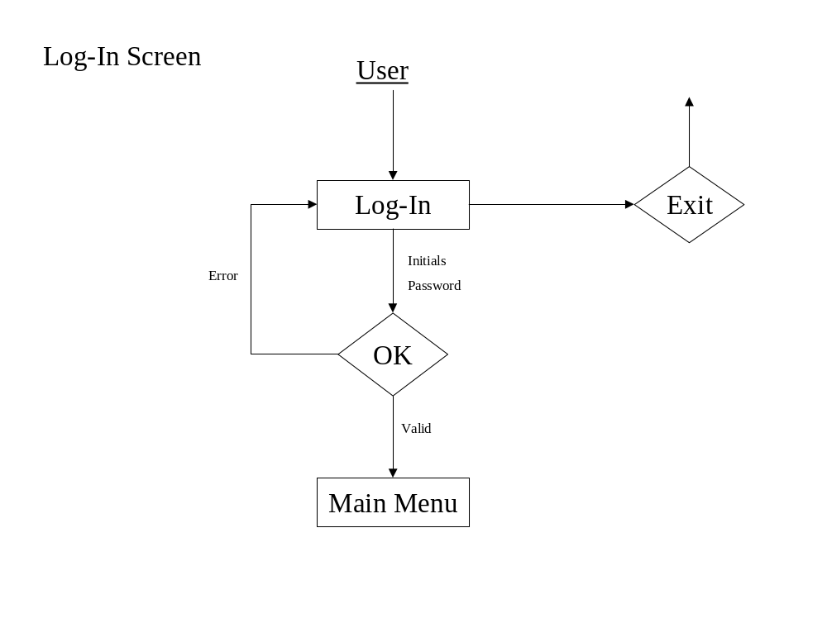

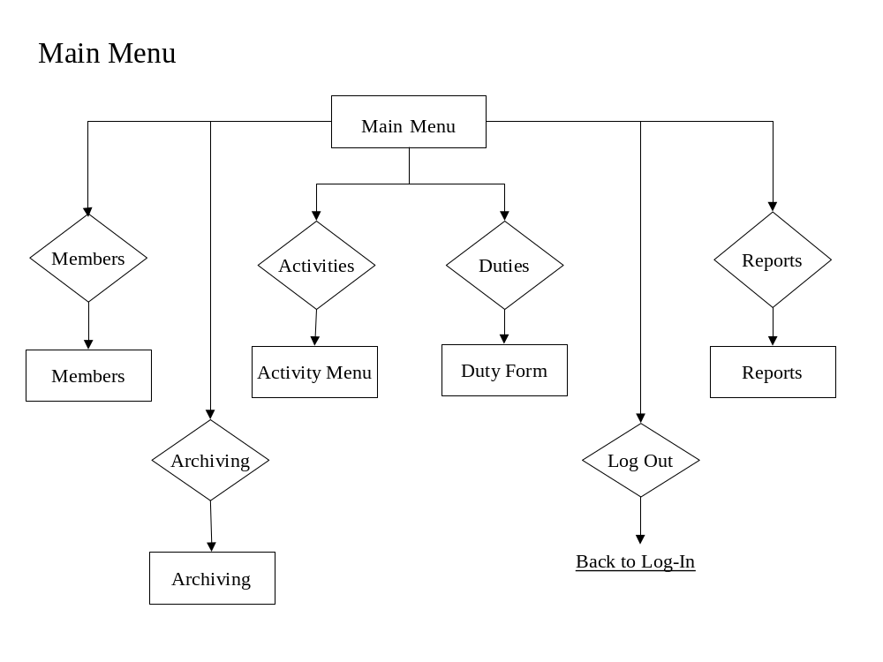

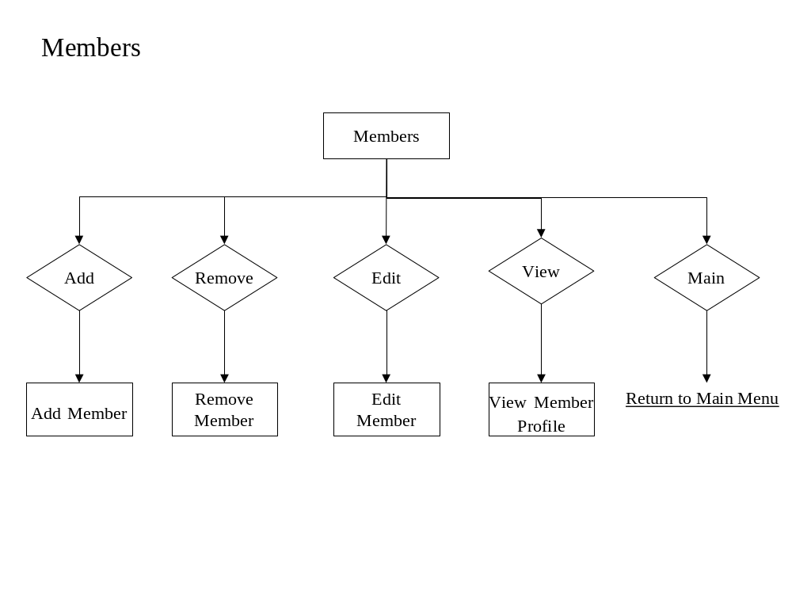

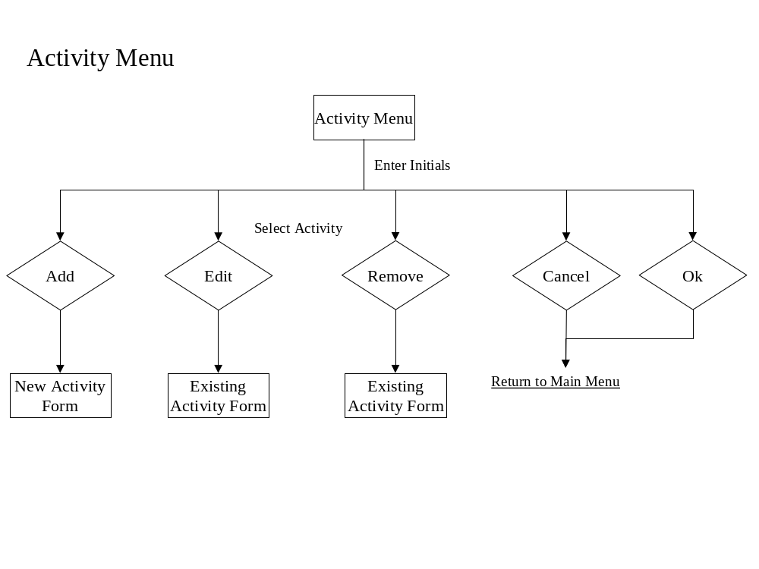

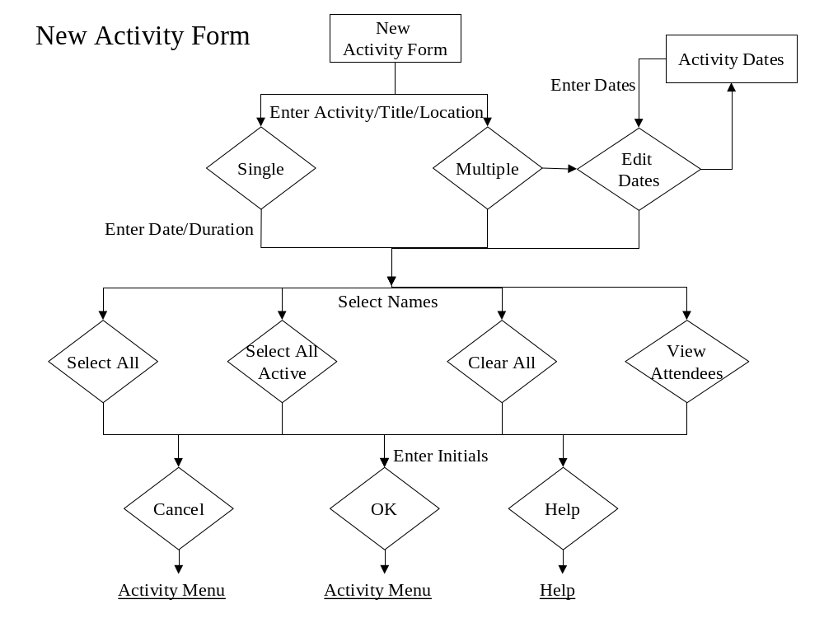

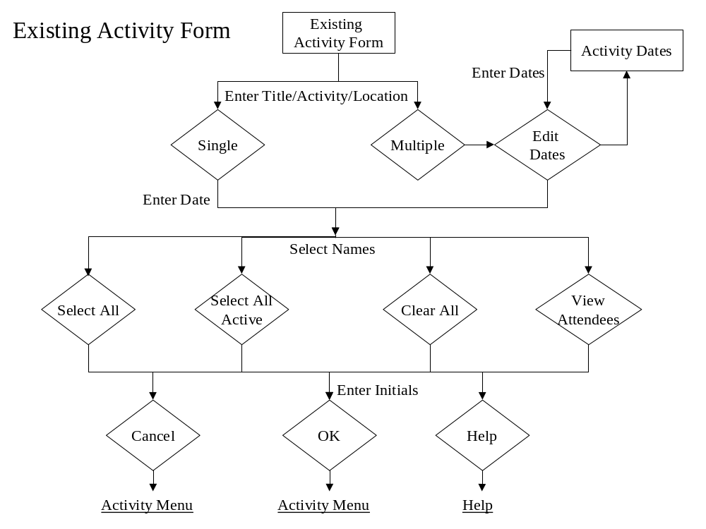

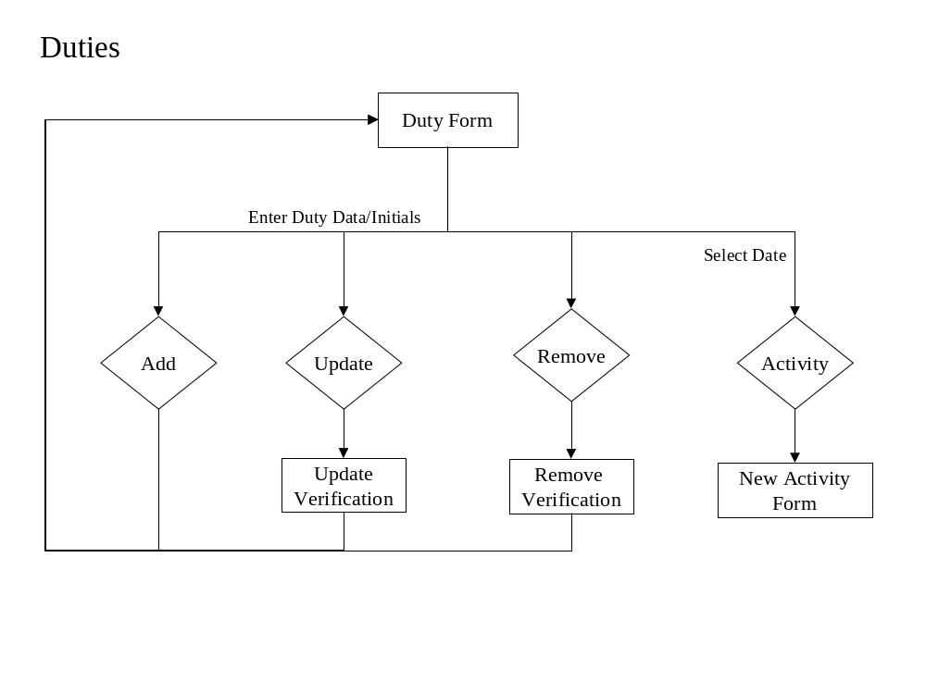

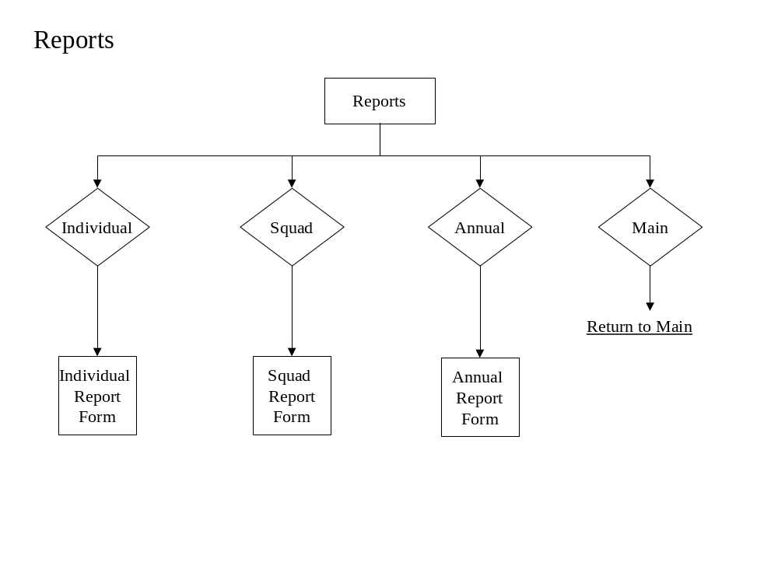

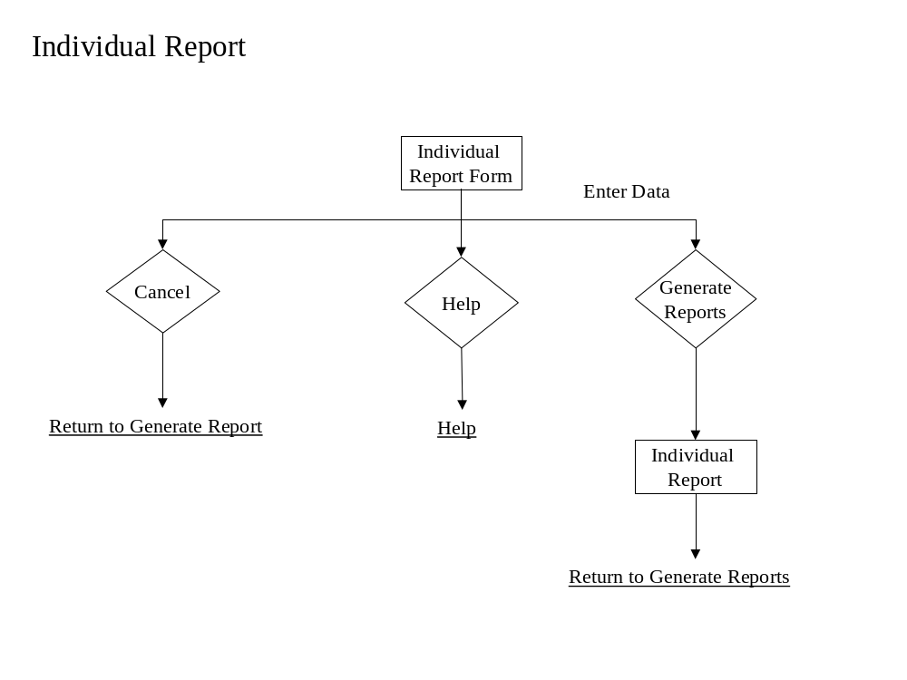

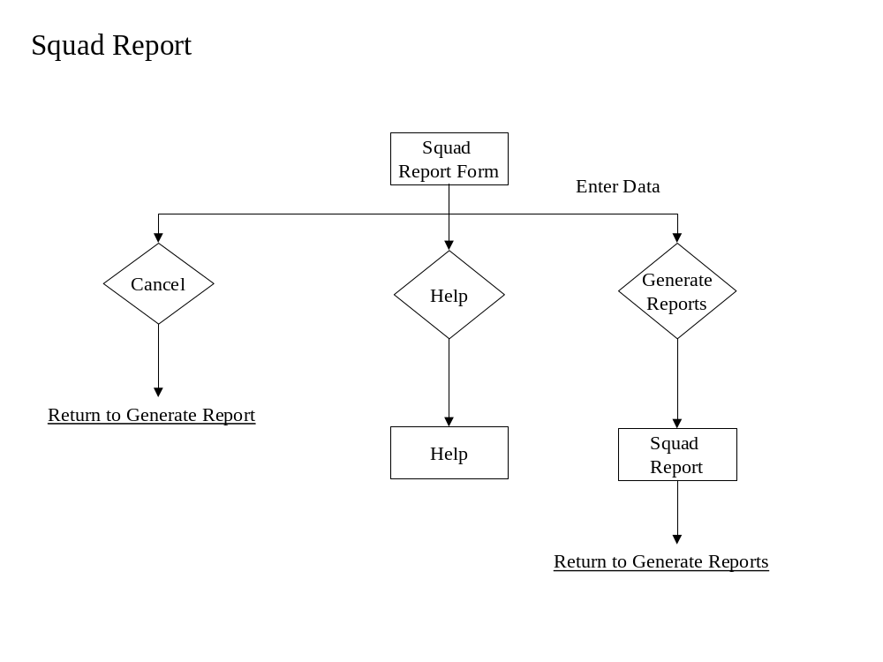

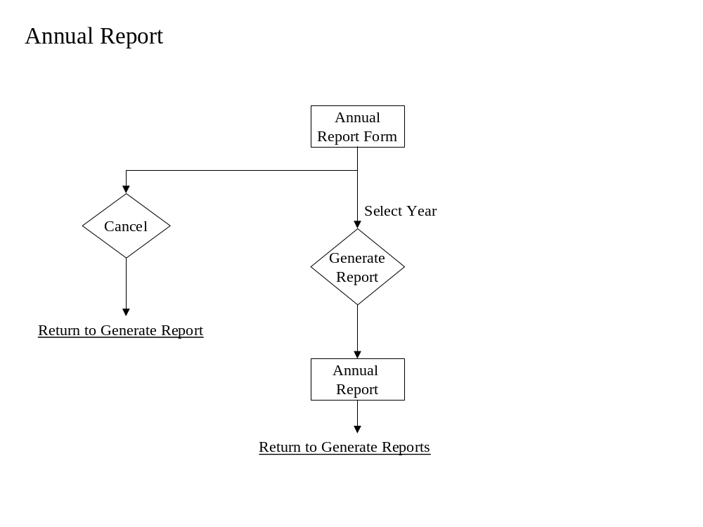

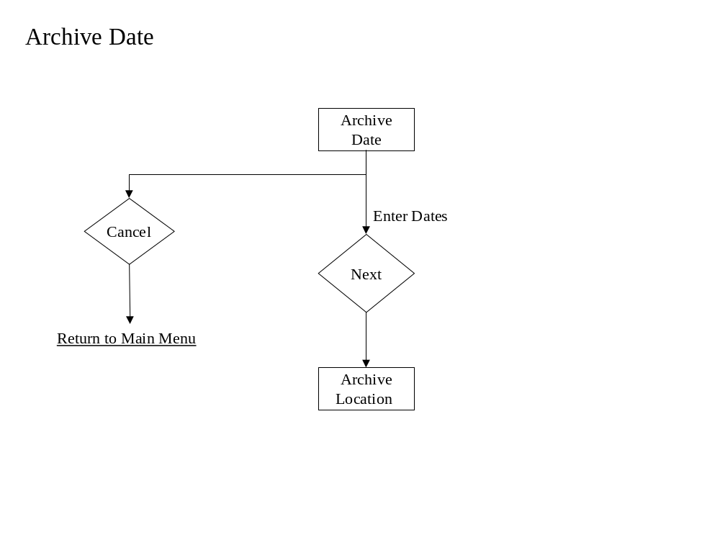

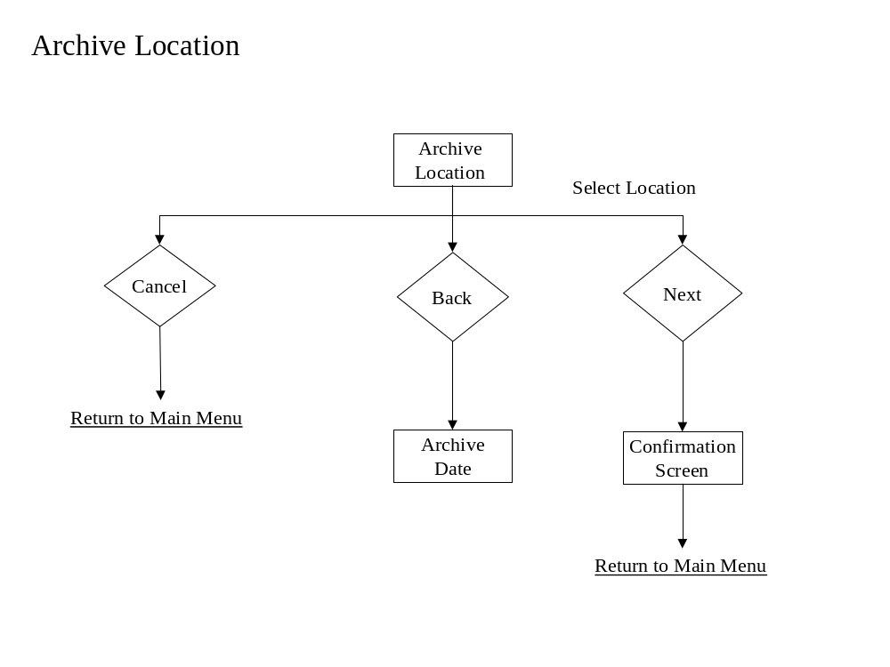
Parameter Specifications

Initials Table: This table will store the initials of the users who enter the system, in which every transaction will be tagged and stored in the transaction log.

Member Profiles Table: This table will store all of the personal information for each member’s profile. Among the items stored will be their name, address, social security number, birth date, age, status, type, and contact information.

Member Type Table: This table will store the different types for each member and keep track of the dates when the member’s type changes.

Member Status Table: This table will store the status of each member, along with storing the date whenever the member’s status changes.

Activity Table: This table will store the relevant activity information, including, the six pre-defined activity types, location of, and the title.

Activity Attendees Table: This table will store all of the members who attend a set activity.

Activity Date/Duration Table: This table will store the date(s) and duration(s) for each activity.

Duty Table: This table will store the tour-of-duty information for each member; keeping track of the dates and durations of duty, along with the number of calls attended per month.
Logical Data Structures

Initials Table
Initial

Member Profiles Table
Member_ID
First_Name
MI
Last_Name
Street
City
State
ZIP
Home_Phone
Work_Phone
SSN
DOB
Age
Member_Type
Member_Status
Type_Date
Status_Date
Initials

Member Type Table
Member_ID
Member_Type
Type_Date

Member Status Table
Member_ID
Member_Status
Status_Date

Activity Table
Member_ID
Member_Name
Activity_Type
Activity_Title
Location
Points
Date
Comments
Initials

Activity Attendees Table
Activity_Type
Activity_Title
Member_ID
Member_Name

Activity Date/Duration Table
Date
Duration_Hours
Duration_Minutes

Duty Table
Member_ID
Member Name
Date
Calls
Duration_Hours
Duration_Minutes
Initials
Functional Descriptions

- Allow for a user to track the activities and tours of duty, in which EMS members have participated in throughout the course of a year.
- The system must have an authentication process that secures the software from entry by unauthorized users.
- The system must allow the user to add, remove, edit or view a specific members’ personal information.
- The activity log includes one of the six predefined activities, the location of the activity, the date on which the activity occurred, and the duration of the activity.
- The duty logs consist of the dates and duration that a specific member was on duty. It will also keep track of the calls a member responded to per month.
- Allow the user to compose various reports based upon the activities and duty log information.
- Allow the user to archive the current database to a specified storage device. Also, retrieve archived data that is requested by the user to generate a report on information within that data.
- Authorized users can easily access the system.
- The response time of the system is dependant upon Microsoft Access’ ability to retrieve and update information in the database, along with the amount of data to be compiled and calculated for the generation of reports.
- Designed for use on a Windows 2000 operating system.
- Screen Interface can be no smaller than 1024 x 768 pixels.

Section 3: Testing Requirements

Testing of the software package can be considered one of the most important phases of the development process. Once the project has passed the design stage, it is important to thoroughly test the system in order to correct any design flaws that were previously overlooked. The testing provisions of this system were established during the requirement specification portion of development, and will be further elaborated upon in the next phase of the project, the Detailed Design.

Requirements Inventory

Requirement: The SAP system must provide an authentication process to secure the system from unwanted users.
Test: FNA will test this requirement through entry of both valid and invalid information into the logon screen.

Requirement: The system must allow the user to add, remove, edit, or view, a specific members’ personal information.
Test: FNA will test this requirement by creating a set of sample data and running it through all of the steps of the system.

Requirement: System should allow the user to archive the current database to a specified storage device.
Test: FNA will test this requirement by archiving test data onto various disk drives.

Requirement: Upon request, the system should be able to retrieve data that is archived on a specified storage device, in order to generate reports.
Test: FNA will test this requirement by retrieving the archived test data and then generating all possible reports for that data set.

Requirement: System should allow the user to compose reports based upon the various activities and duty log information.
Test: Sample data will be inputted into the system, and generated reports will be compared with expected results.

Requirement: The activity logs must include the six predefined activities, the location of the activity, the date on which the activity occurred, the duration of the activity, the title of the activity, and any comments the user would like to associate with the activity.
Test: FNA will test this requirement through viewing the fields of the activity form upon completion.

Requirement: The duty logs must consist of the dates and durations that a specific member was on duty for. Along with, keeping track of the calls a member responded to per month
Test: FNA will test this requirement through viewing the fields of the duty form upon completion.

Requirement: The system should be able to calculate points towards retirement benefits based on the calculation guidelines specified by the NYS Comptroller.
Test: Sample data will be inputted into the system, and generated reports will be compared with expected results.

Requirement: The system should be able to generate reports in the following fields: detailed/summarized individual report, detailed/summarized squad report, and an annual reports for submission to the NYS Comptroller
Test: Sample data will be inputted into the system, and generated reports will be compared with expected results.

Design Inventory

Design Goal: The system should be user-friendly.
Test: FNA will test this design goal through the use of specified test users.

Design Goal: The system should allow quick and easy data entry.
Test: FNA will test this design goal through external consulting.

Design Goal: The system will support multiple menus, created to broaden the user-friendly aspects of the software.
Test: FNA will test this design goal through critique from various potential users of the system.

Glossary

MFC: (Microsoft Foundations Class) A software development tool used in conjunction with the C++ programming language, implemented within Microsoft Visual C++

Microsoft Visual C++: A software development tool that provides an efficient programming environment for the C++ programming language, and all libraries associated with it.

Pixels: Short for picture element. A pixel is the smallest logical unit of visual information that can be used to build an image. Pixels are the little squares that can be seen when a graphics image is enlarged.

SAP: (Service Awards Program) Software package that tracks credits towards benefits for volunteer EMS members.

SQL: (Structured Querying Language) A language used to create, maintain, and query relational databases. SQL uses regular English words for many of its commands, which makes it easy to use. It is often embedded within other programming languages.

Windows: A Microsoft product that provides a platform on which to run software and interact with peripheral hardware on personal computers.

