Software Plan

Let’s Make a Match

Falcon Enterprises

Prepared by:

Rudolph Dussault
Thomas Gentile
Paul E Mahar
Kimberly Milton, Team Leader
Michelle Milton
Kimberly White

Clients:

Mr. Jay Bebb
Director of Residence Life
Siena College

Mr. Brian Peppiatt
Assistant Director for Information Systems (Student Affairs)
Siena College

September 24, 2003

Falcon Enterprises
Let’s Make a Match Software Plan

Table of Contents

System Definition:

1.1: Problem Definition…………………………………………………….1
1.2: System Justification……………………………………………………1
1.3: Goals for the System and on the Project……………………………….1
1.4: Constraints on the System and on the Project………….........................1
1.5: Functions to be Provided (Hardware and Software/People)…………...1
1.6: User Characteristics…………………………………………………....2
1.7: Development/Operating/Maintenance Environments………………… 2
1.8: Solution Strategy……………………………………………………… 2
1.9: Priorities of System Feature……………………………………………3
1.10: System Acceptance Criteria…………………………………………..3
1.11: Sources of Information…………………………….………………….3

Project Plan:

2.1: Life Cycle model (Terminology / Milestones /Products)……………...4
2.2: Org Structure (Management Structure / Team Structure/
Work Breakdown Structure / Statements of Work)…………………....5
2.3: Prelim Staffing and Resource Requirements (Staffing and Resource
Schedule)……………………………………………………………….6
2.4: Prelim Development Schedule (PERT and Gantt Charts)……………...6
2.5: Project Monitoring and Control Mechanisms………………………….6
2.6: Tools and Techniques to be used……………………………………….6
2.7: Programming Languages……………………………………………….6
2.8: Testing Requirements…………………………………………………..6
2.9: Supporting Documents Required ………………………………………6
2.10: Manner of Demonstration and Delivery………………………………7
2.11: Training Schedule and Materials……………………………………...7
2.12: Installation Plan……………………………………………………….7
2.13: Maintenance Consideration…………………………………………...7
2.14: Method and Time of Delivery………………………………………...7
2.15: Sources of Information………………………………………………..7

Appendices:
Appendix A: Gantt Charts
Section 1: Fall Semester……………………………………………..8
Section 2: Fall and Spring Semesters………………………………..9
Appendix B: Glossary of Terms…………………………………………....10
Appendix C: Resumes……………………………………………………....11

System Definition

1.1: Problem Definition

With increasing accessibility on Internet for communication, a system for students to chose their roommate through the Internet is ideal. Currently, incoming students are matched only by gender and their smoking preference. Matching students based on personal preferences may ease the transition to college. It would create a more positive environment that may be less stressful and more enjoyable.

1.2: System Justification

The purpose of the software is to more efficiently match up future roommates for college living situations. It will save time, energy and paperwork for the housing director who would otherwise have to match the students up his/her self. The system will help the roommate matching process flow more smoothly and it will give students a chance to meet other Siena students who have similar interests.

1.3: Goals for the system and on the Project

The goal of the project is to create a software program/database that will reduce the time student affairs puts into matches, and meet the needs of the clients. It will also make a happier and more enjoyable living experience for students.

Our team goals are to learn how to apply the software engineering process to a realistic problem specifically adhering to the steps of the waterfall model to make the process go smoothly and effectively.

1.4: Constraints on the system and on the project

Constraints on the project are all the project stage deadlines, including the final deadline in May. We must also design a solution that is able to be completed by our six member team. Constraints on the system have not yet been determined at this stage of the project.

1.5: Functions to be provided (hard and software/people)

- An online database is needed to store student’s names, contact information and
matching criteria
- An online form for students to fill out and update their personal profiles.
- An algorithm to find appropriate student matches.
- An online form to search for matching students.
- Security system for access to only registered Siena students who have paid their
deposit for housing.

1.6: User Characteristics

The main users are first year student residents and students looking for on campus roommates. Other users are returning students who need additional roommates for the next semester. Users must have access to the Internet and have paid their housing deposit in order to access the system.

1.7: Development / Operating / Maintenance Environments

The Development will occur in the Software Engineering Lab on Siena Campus. The operation of the software will occur on any computer on which students have access to the Internet. Maintenance of the system is undetermined at this time, and will be decided in the future.

1.8: Solution Strategy

The project of matching up students will be approached using the Waterfall Model for Software Development. The model contains the following components:

Software Plan
The team will meet with the clients to determine who will use the product
and any other requirements the software needs to accomplish their goals.

Analysis
The team will meet with the clients on a regular basis to discuss the
requirements and learn the nature of the project to meet the clients
expectations.

Preliminary Design
The team will take the design and requirements of the project and translate
them into software requirements.

Detailed Design
The team will take the preliminary design and discuss with the clients whether or not the design fits their needs. The fine tuning of the design and
additional detailed features will be added. This will take place during the second
semester.

Development and Testing

Our team will then translate the detailed design into code and the actual

software product. Testing will be done throughout the coding process of

the project. Once the team has completed the coding of the design, the

team will test the software with all possible data to make sure the system

has no errors, and meets the needs of our clients. This will also take place

during the second semester.

Acceptance Test
The team will deliver the software and offer help to the clients as needed. If the needs of the client changes after implementation of the software, or errors have been discovered, the team will assist the clients in making any necessary changes.

1.9: Priorities of System Feature

The system features that are important are creating a user-friendly and enjoyable
atmosphere in choosing a roommate. Accurate matching is required for students to be
suitably matched with others who posses similar interests. The system also needs to
be secure so only appropriate users can access the system. Users can access only
their information and information provided to them about potential matches.

1.10: System Acceptance Criteria

The system will allow students to:
- Log in.
- Create and update their profile.
- Submit profile to get a match.
- Get results of matched people and contacts.
- Submit their roommate proposal to student affairs.
- Learn about housing options at the school (smoke free, quiet, dorms, etc.)

1.11: Sources of Information

The majority of information for the software plan was obtained through our clients,
Jay Bebb and Brian Peppiatt. Other significant sources include Dr. Lederman’s
Software Engineering class and the class textbook Software Engineering: A
Practitioner’s Approach by Roger S. Pressman. Previous Software Engineering
projects also helped in providing relevant information our plan.

Project Plan:

2.1: Life Cycle Model
Our project is modeled after the Waterfall Model, which is an example of the Linear
Sequential Model of software development:

Software
Plan

Analysis
Acceptance
Test
Development
and Testing
Detailed
Design
Preliminary
Design

Software Plan
In this phase of development, the basic criteria of the project are gathered.

Analysis
Requirements specification encompasses determining the clients needs, and then using them to determine required software and/or systems to match those needs.

Preliminary Design
In the preliminary design phase, the basic outline of how to solve the problem definition is laid out.

Detailed Design
The detailed design is where the designing of the software, the architecture, interface
representation, and procedural detail are developed.

Development and Testing
The actual coding of the software is completed in this stage. The software is then
tested to be sure that it works properly and its performance matches the clients
expectations.

Acceptance Test
In this stage the product is delivered to the clients, and the clients are given all
instructions needed to implement the software.

2.2: Organizational Structure

Falcon Enterprises is comprised of the following employees:

Name Email Address Phone Number Rudolph Dussault rudolph.dussault@students.siena.edu (518)782-6068
Thomas Gentile thomas.gentile@students.siena.edu (518)782-5879
Paul E Mahar paul.mahar@students.siena.edu (518)447-4760
Kimberly Milton kimberly.milton@students.siena.edu (518)782-5816
Michelle Milton michelle.milton@students.siena.edu (518)782-6265
Kimberly White kimberly.white@students.siena.edu (518)479-7142

We are using the Controlled Decentralized organizational team structure. Our team has a defined leader who is in charge of the group, each of which has responsibility of other specific tasks. Overall we solve problems as a whole.

Rudolph Dussault - Webmaster
Thomas Gentile - System Administrator
Paul Mahar - Librarian
Kimberly Milton - Team Leader
Michelle Milton - Presentation Manager
Kimberly White - Presentation Manager

Webmaster – Duties include setting up and maintaining our company’s website.

Librarian – Duties include documenting all meeting and writing up all necessary reports.

System Administrator – He is charge of setting up and maintaining team members
accounts.

Team Leader – The team leader is in charge of holding all meetings, taking attendance, and making sure that all members are accomplishing their assigned work. The Team Leader is also in charge of setting up and attending client meetings.

Presentation Manager – Duties include designing PowerPoint Presentations and
organizing all presentations the group delivers.

2.3: Preliminary Staffing and Resource Requirements

The clients Mr. Bebb and Mr. Peppiatt are major resources in defining and developing the
Lets Make a Match System. The hardware resources required are Internet connectivity,
computer systems, printers, and other peripherals. The software requirements include a database management system, a web page editor, computer operating systems, and a web
browser.

2.4: Preliminary Development Schedule

See Gantt charts in Appendix A for a time line of the projects progression.

2.5: Project Monitoring and Control Mechanisms

Our project progression will be closely monitored and kept in check with our weekly team meetings as well as the meetings with our clients. If anyone in the group has a discrepancy about where the project is going and if it is still following the criteria set
forth by the clients, the issues will be discussed and resolved before moving on. Through close contact with our clients, we will report all documents to make sure that our work is consistent with the expected results.

2.6: Tools and Techniques to be Used

Tools that our team will use in the development process are computers with necessary software in the software engineering lab, our clients, and our group members. Our group will meet during the week and with the clients to obtain the knowledge necessary to
design and develop the project.

2.7: Programming Languages

Several programming languages will be used throughout the development of the software. Some of the languages may include: Java Script, HTML, SQL and Visual Basic.

2.8: Testing Requirements

Team members, volunteer students, and members of the Residence Life department
will participate in the testing process.

2.9: Supporting Documents Required

- The Project Definition/ Project Plan
- The Software Requirements Specifications
- The Preliminary Design
- Detailed Design Document
- Acceptance Test

2.10: Manner of Demonstration and Delivery

The team will give presentations and documents throughout the development
process to demonstrate our progress. The project parts and dates of presentations
and are as follows:
Project definition/Project Plan Presentation: September 24, 2003
Software Requirements Specification Presentation: October 29, 2003
Preliminary Design Presentation: December 3, 2003
Detailed Design Document: February 25, 2004
Acceptance Test: April 15, 2004

2.11: Training schedule and materials

Members of the team will learn different software and other techniques in order to accomplish the goals of the project. The team will learn throughout the project what is entailed.

2.12: Installation Plan:

The project progress will be demonstrated several times in presentations and in meetings
with the client.

2.13: Maintenance Consideration

The personnel who will perform maintenance on the system will be determined at
a later date.

2.14: Method and Time of Delivery

The expected time of Delivery is April 15, 2004. Details on the delivery of the
Product to Mr. Bebb and Mr. Peppiatt will be determined in the future.

2.15: Sources of information

The majority of information for the software plan was obtained through meetings with
clients Jay Bebb and Brian Peppiatt. Other significant sources include Dr. Lederman’s
Software Engineering class and the class textbook Software Engineering: A practitioner’s
Approach by Roger S. Pressman. Previous Software Engineering projects also helped in
providing relevant information to the project.

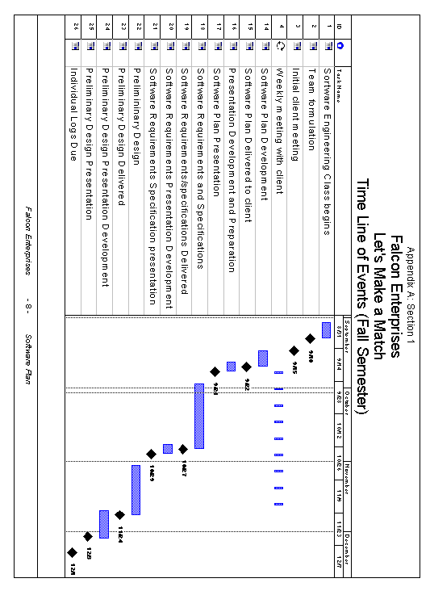

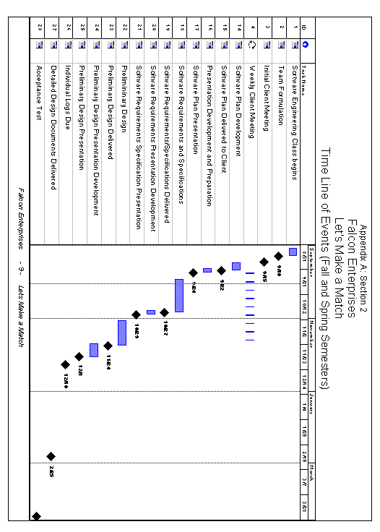

Appendix B:

Glossary of Terms

Access: A relational database running under Microsoft Windows.

Code: A system of symbols and rules used to represent instructions to a computer.

Controlled Decentralized (CD): A software engineering team that has a defined leader
who is in charge of the group, each of which has responsibility of other specific
tasks. Overall we solve problems as a whole.

Database: A collection of data arranged for ease and speed of search and retrieval.

Gantt Chart: A chart that depicts progress in relation to time, often used in planning and
tracking a project.

HTML (Hypertext Markup Language): A markup language used to structure text and
multimedia documents and to set up hypertext links between documents, used extensively on the World Wide Web.

JavaScript: A trademark used for a programming language designed to develop
applications, especially ones for the Internet that can operate on different
platforms.

Linear Sequential Model – Classic Waterfall Model: A systematic, sequential
approach to software development that begins at the system level and progresses
through analysis, design, coding, testing, and support.

Oracle: A relational database management system that runs on most mainframe, micro,
and personal computers.

Relational Database: A database system in which any database file can be a component
of more than one of the database's tables.

SQL: An industry-standard language for creating, updating and, querying relational
database management systems.

Visual Basic: A popular event-driven visual programming system from Microsoft
Corporation for Microsoft Windows.

Rudolph T. Dussault
objective
To secure a rewarding full-time position in the field of Computer Science, utilizing my diverse software development and problem solving skills.
Education
9/2000- Present Siena College Loudonville, NY
- B.A., Computer Science, graduation 5/2004
- Minor in Business
- Courses include C++, Data Structures, Software Engineering
9/1996-5/2000 Rhinebeck High School Rhinebeck, NY
- Focus: Computer Science
Experience
6/2002 – 8/2002 IBM Service Dept. Poughkeepsie, NY
5/2003 – 8/2003 IBM Service Dept. Poughkeepsie NY
Summer Intern
- Developed REXX execs to aid in memory dump analyzation
- Developed application specific programs and Implemented security features for Domino Databases
- Provided technical assistance to other interns.
5/2001–9/2001 IBM Hardware Lab Poughkeepsie, NY
Summer Intern
- Made recruitment web interface utilizing SQL database as backend.
9/1999-5/2000 IBM ATLAS Program Poughkeepsie, NY
Co-op Student
- Twelve top students selected within Dutchess County to participate in advanced course work and onsite co-op experience.
- Developed multiple Web sites for the Poughkeepsie S/390 Briefing Center.
1994–1998 Northern Dutchess Hospital Rhinebeck, NY
Hospital Volunteer
- Provide summer and after school volunteer work
- Assisted in Computer maintenance and Data Entry
Interests
Computer Games, Soccer, Audio Systems, Engines, Running.
Software Knowledge
C++, Scheme, HTML, JavaScript, Visual Basic, PHP, SQL, REXX UNIX, DOS, LINUX, Windows, AIX, Domino
School Phone (518) 782-5729 • e-mail SRD4137@Siena.edu
302 Lake Drive • Rhinebeck, NY 12573 • Home Phone (845) 266-4978

1523 Red Mill Road
Rensselaer, New York 12144
518-436-1677(Home)
518-447-4760(Work)

Paul E. Mahar
Objective
To obtain a challenging position, that will afford me opportunities to utilize my skills/experience in the computer field and expand my knowledge of technology.
Experience
2001-Present NYS Teachers’ Retirement System Albany, NY
Senior Computer Programmer Analyst
- Maintain computer database sytems software on Windows Platforms. Sybase, MS SQL Server, IBM DB2UDB. Other application tools include Lumigent Log Explorer, DBArtisan, Unicenter Database Performance Management.
- Install, Customize, and Test software packages and upgrades from vendors, ensuring that standards are met.
- Test, Implement and Document solutions for Database Server Hardware and/or software problems for future reference.
- Administer DOCS Open document management software. Provide user support and training.
1996–2000 Dormitory Authority - State of New York Albany, NY
Senior Information Services Specialist (1997-2000)
- Install/Implement PC/Network software applications and deployment of PC hardware & peripheral equipment in a TCP/IP Windows NT Environment.
- Maintain knowledgebase of technical problems and solutions for future reference.
- Possess excellent user support skills working in a Windows95/98/NT environment.
- Provide coverage for Network Systems Operations backup for IBM AS/400, Prime, Windows NT Server and Citrix systems.
Records Management Officer (1996-1997)
- Managed the Prime Records Management system and performed systemized record keeping.
- Acted as liason with other Authority units in the implementation of Records Management procedures.

Education
- Siena College Loudonville, NY
Matriculated. Pursuing a Bachelor of Science degree in Computer Science.

- CompTIA A+ certified
- Hudson Valley Community College Troy, NY
Associate Degree in Applied Science.

Kimberly Milton

Present Address Permanent Address
Siena College, SPOB 4121 1205 Five Mile Line Rd.
515 Loudon Rd. Webster, NY 14580
Loudonville, NY 12211 (585) 671-2069
(518) 782-5816, E-mail: Kimberly.Milton@students.siena.edu

OBJECTIVE

To receive a job in the field of Computer Science.

EDUCATION

Siena College, Loudonville, NY
B.S. in Computer Science, May 2004
GPA: 3.7/4.0; President’s List

COMPUTER EXPERIENCE

- Programming in C++ and some Assembly.
- Familiarity with UNIX and Windows Operating Systems.
- Knowledge of Microsoft Excel, PowerPoint, Word, and Internet.
- Database background in Oracle/SQL.

RELEVANT COURSES

Procedural Design-Programming, Data Structures, Object-Oriented Design and Programming, Computer Architecture and Assembly Language, Data Base Management, Analysis of Algorithms, Discrete Structures I & II, Programming Languages, Operating Systems.

EXPERIENCE

Heidelberg Digital, Summer Assistant, Rochester, NY, Summer 2000
- Searched information using SAP software.
- Worked on assembly line and in packaging.

Seabreeze Amusement Park, Water Park Attendant, Rochester, NY, Summers 1999 –
2003
- Assisted guests in the water park.
- Received CPR Certification.

ACTIVITIES

Member, Division I Cross Country Team, Siena College, 2000 - Present
Member, Track Club, Siena College, 2001 - Present
Volunteer, Habitat for Humanity, Siena College, 2000 - 2001

Member, Church Choir, Siena College, 2000 - 2002

Michelle L. Milton
Present Address Permanent Address
Siena College, SPOB 2746 1205 Five Mile Line Rd.
515 Loudon Rd Webster NY 14580
Loudonville NY 12211 (585) 671-2069
(518) 782-6435
Email: Michelle.Milton@students.siena.edu

OBJECTIVE

To obtain a job in the field of computer science.

EDUCATION

Siena College, Loudonville, NY
B.S. Computer Science, May 2004
GPA 3.7/4.0 Presidents List Spring 2001, 2002, 2003, and Fall of 2001 and 2002.

COMPUTER EXPERIENCE

  - Programming in C++ and Assembly.
  - Familiarity with Unix and Windows Operating Systems.
  - Database background in Oracle/SQL.
  - Knowledge of Microsoft Word, Excel, and Internet.

REVELANT COURSES

Procedural Design-Programming, Data Structures, Computer Architecture and Assembly Language, Object-Oriented Design and Programming, Analysis of Algorithms,
Programming Languages, Data Base Management, Operating Systems, Discrete Structures I & II

EXPERIENCE

Heidelberg Digital, Summer Assistant, Rochester, NY, Summer 2000
  - Searched information using SAP software.
  - Worked on an assembly line and packaging.

Seabreeze Amusement Park, Water Park Attendant, Rochester, NY, Summer 1999-
2003
  - Assisted guests onto slides, and enforced the rules.
  - Received CPR Certification.

ACTIVITIES

Member, Siena College Division I Cross Country 2000-present, Captain 2002
Treasurer, Ryan Hall 2000-2001
Vice President, Track Club, 2002
Volunteer, Habitat for Humanity, 2000-2001
Member, Church Choir, 2000-2002

Kimberly A. White
288 Waters Road
East Greenbush, NY 12061
(518) 479-7142
E-Mail: kimberly.white@students.siena.edu

OBJECTIVE
A position in the field of Computer Science; special interest in database management
and design.

EDUCATION
Siena College, Loudonville, NY
BS in Computer Science, May 2004

RELEVANT COURSES
Assembly Language, Database Management, Web Design and Development, C, C++,
Oracle, SQL, Operating Systems

EXPERIENCE
Office Assistant, Becker’s Farm, East Greenbush, NY, May 2003 – present
- Perform all bookkeeping responsibilities, i.e. manage accounts receivable and accounts payable.
- Assist with the development and maintenance of customer database.

Data Entry Clerk, Fleet Libris Information Solutions, Menands, NY, Spring 2003
- Prepared batches for data entry.
- Processed and reconciled Estimated tax returns.

Billing Representative, Albany Medical College, Albany, NY, June 1999 – October 2000
- Performed all billing functions which included medical coding for Primary Care Network and the Department of Medicine.
- Functioned as a User Specialist and assisted with the implementation of the new Signature software system.

ADDITIONAL EXPERIENCE
Front End Support, Capital Care, Ravena, NY, September 2001- March 2003
Waitress, Houlihan’s, Albany, NY, October 2000- April 2001

