Detailed Design

Requested by:
Dr. Darren Lim
Associate Professor of Computer Science
Siena College
Computer Science Department

Competitive Algorithm Calculation Testing in a Unified System
(C.A.C.T.U.S.)

ExoNET Solutions

Prepared by: Paul Amodeo, Interface Expert
Tom Delaney, System Admin./ DBA
Stephanie Del Belso, Team Leader
David Purcell, Lead Programmer
Marco Samaritoni, Testing Manager

February 29th, 2011

C.A.C.T.U.S.

Detailed Design

Table of Contents
Review 4
1.1 Problem Review 4
1.2 User Case Narratives 5
1.3 Data Flow Diagrams 6
1.3.1 Data Flow Diagram Key 6
1.3.2 Context Diagram 7
1.3.3 Level 0 Diagram 8
1.3.4 Process 1 Diagrams 9
1.3.5 Process 2 Diagrams 12
1.3.6 Process 3 Diagrams 15
1.3.7 Process 4 Diagrams 18
1.3.8 Process 5 Diagrams 21
1.4 Structure Diagram 24
1.5 Functional Requirements Inventory 25
Detailed Design 27
1.1 Logical Data Dictionary 27
1.1.1 Logical Data Dictionary Key 27
1.1.2 Logical Data Dictionary Spreadsheet 28
2.1 ER Diagram 36
3.1 Prototype Screens 37
3.1.1 Log in Screen 37
3.1.2 Log in Failed 37
3.1.3 Contestant Screens 38
3.1.3.1 View Clarifications 38
3.1.3.2 Problems List 38
3.1.3.3 Scoreboard View 39
3.1.3.4 Submission Screen 39
3.1.3.5 Submission Screen - Browse for source file 40
3.1.3.6 Submission Screen – No file selected error 40
3.1.4 Judge Screens 41
3.1.4.1 Create Clarification 41
3.1.4.2 View Clarifications 41
3.1.4.3 Judge submissions 42
3.1.4.4 Problems List 42
3.1.4.5 Scoreboard View 43
3.1.5 System Administrator Screens 43
3.1.5.1 Change Admin password 43
3.1.5.2 Change Admin password – Invalid old password error 44
3.1.5.3 Change Admin password – New passwords do not match error 44
3.1.5.4 Upload/ Edit problems 45
3.1.5.5 Upload Problems - Browse for file 45
3.1.5.6 Configure Contest Problems 46
3.1.5.7 Configure Contest Settings 46
3.1.5.8 Configure Contest Settings – Contest started 47
3.1.5.9 Invalid Contest Length Error 47
3.1.5.10 Invalid Selection Error 48
3.1.5.11 Manage Accounts 48
3.1.5.12 Manage Accounts – Contestants 49
3.1.5.13 Manage Accounts – Judges 49
3.1.5.14 Manage Accounts – Spectator 50
3.1.6 Spectator Screens 50
3.1.6.1 Problems List 50
3.1.6.2 Scoreboard View 51
3.1.6.3 View Clarifications 51
4.1 Testing Plan 52
5.1 Development and Production Environments 52
6.1 Appendices 54
6.1.1 Appendix A: Glossary of Terms 54
6.1.2 Appendix B: Project Timeline (Gantt Chart) 56
Testing Plan 57
1.1 Overview and Strategy 57
1.2 Test Plan Description 57
2.1 Pass/Fail Criteria 58
2.1.1 Functional Requirements Inventory 58
2.1.1.1 System Administrator 58
2.1.1.2 Judge 58
2.1.1.3 Contestant 59
2.1.1.4 Spectator 59
2.1.2 Non-Functional Requirements Inventory 59
2.1.3 Exception Handling 59
2.1.4 Testing Approach 60
2.1.5 Acceptance Criteria 60
3.1 Unit Tests 61
3.1.1 Unit Tests and Test Cases 61
3.1.2 Performance Test 61

Review

1.1 Problem Review
The size and complexity of the programming contests held at Siena College has brought about a need for a simple yet powerful solution. Dr. Lim has requested that a system be created to prepare and run programming contests simply and easily. The current contest system lacks the ability to keep a precise record of exactly when a team (consisting 1 to many contestants) submits a solution to a problem, the ability for teams to communicate electronically with judges (i.e. uploading problem solutions, checking ambiguities in the instructions, among any other form of legal correspondence dictated by the administrators of the contest). Also, in the current system, a scoreboard must be updated manually on a whiteboard, and judges lack the ability to run alternate arguments (parameters) on a submission, due to the lack of a way to submit contestants’ code. Our product will solve these problems by:
- Keeping an electronic timestamp of all submissions made to judges for consideration
- Embedding a compiler into our system so that code may be submitted to judges, and also so the judges can run different data sets (arguments) against the contestants’ code
- A digital scoreboard will be created so that all parties involved in the contest can see all teams’ solved problems, and the timestamps for correct problem submissions
- All submissions will be stored in a database (MySQL); also, contestants’ work will be saved periodically, so any system or software failure does not end in a complete loss of information for C.A.C.T.U.S..
- A chat window will be available within C.A.C.T.U.S., so that teams and judges can communicate with each other for ambiguities within contest problem sets, and any other pertinent information that can be shared within a given contest.

1.2 User Case Narratives
The following User Case Narratives describe how users will interact with ExoNET Solutions' Competitive Algorithm Calculations Testing in a Unified System (C.A.C.T.U.S.) system. The narratives provide insight into each user's behavior within C.A.C.T.U.S. and allow ExoNET Solutions to discover user requirements. There are four types of users within C.A.C.T.U.S. The System Administrator configures the programming contest environment and has extensive privileges. Judges answer questions and monitor the scoreboard during the programming contest. Contestants participate in a programming contest and make Problem Submissions to contest problems. Spectators can view public information about a running programming contest.

System Administrator:
The System Administrator will be able to access C.A.C.T.U.S. by using a specific user name and password that will allow them into an administrative account. Within the administrative account, the System Administrator is prompted to input certain information in order to fully configure the contest environment. This information includes the uploading of contest-problems and problem solutions (including test cases), selection of languages (Java and possibly others), editing start and stop times of the competition, adding and dropping of Contestants, and designating the time for freezing the scoreboard during the competition. The System Administrator is also responsible for establishing user names and passwords for the Contestant accounts as well as Judge accounts and Spectator accounts.

Judge:
Each Judge is given a Judge account with a user name and password by the System Administrator. A Judge is allocated one or more Contestants to supervise for the duration of the contest.
When a Judge logs into C.A.C.T.U.S. using his or her Judge account, he or she will have access to a chat window and the contest scoreboard. A Judge can use the chat window to send text-based messages to other Judges and Contestants.
The chat window messages can be sent to all Judges and Contestants, or a subset of the Contestants that the Judge was assigned to supervise. A Judge may receive problem submissions from Contestants along with C.A.C.T.U.S.'s analysis of the submissions. The Judge may then review the problem submissions and can decide to approve or reject the submission. A Judge will be able to take over for another Judge that needs to take a leave of absence for any period of time. In this case, the Judge who is taking over will supervise all of the leaving Judge's Contestants.

Contestant:
Each Contestant is given a Contestant account with a unique user name and password assigned by the System Administrator. After logging into C.A.C.T.U.S. with the assigned Contestant account, the Contestant will be able to familiarize themselves with C.A.C.T.U.S. and get comfortable with the system before a contest is started. Once a contest has begun, a Contestant will have the ability to: submit problem submissions to C.A.C.T.U.S. in the form of source code, message their supervising Judge using a chat window, view the scoreboard and contest problems.

Spectator:
Each Spectator is given a Spectator account with a user name and password assigned by the System Administrator. A Spectator will be able to view the scoreboard at any time during a programming contest. A Spectator will be able to see every Contestant's name, score, and standing. A Spectator will be able to view the contest problems being used in a running programming contest. A Spectator will not be able to communicate with Contestants and Judges. A Spectator will be able to watch a programming contest unfold without interfering with the teams.

1.3 Data Flow Diagrams
The following legend should be used to interpret the Data Flow Diagrams in sections 5.1.2 to sections 5.1.8. ExoNET Solutions’ Data Flow Diagrams have no system boundary and they do not follow some of the standard Data Flow Diagram rules. ExoNET Solutions’ diagrams do not follow standard conventions for the sake of clarity and readability.

1.3.1 Data Flow Diagram Key

External Entity (Data Source/Sink) – External Entities
represent sources of data into the system or destinations of
data sent by the system.

Process – Processes are system functions that transform or manipulate data. Processes receive and send out data.

Data Flow – Data flows represent the movement of data.

Data Store – Data stores contain persistent data that does
not usually move. Data can be saved to and retrieved from Data Stores.

1.3.2 Context Diagram
A Context Diagram represents the actors outside a system that could interact with that system and shows the interaction between them.
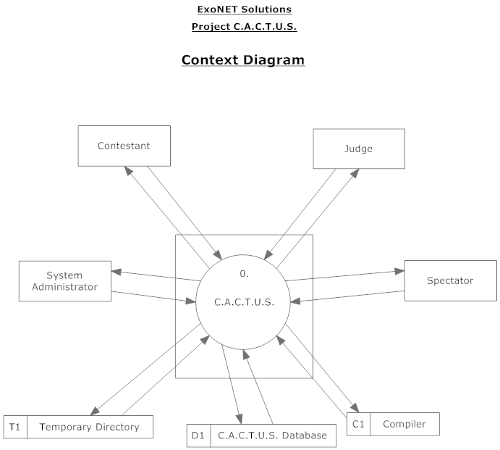

1.3.3 Level 0 Diagram
The Level 0 diagram goes into some detail of the system. It shows how the system is divided into sub-systems, or processes.
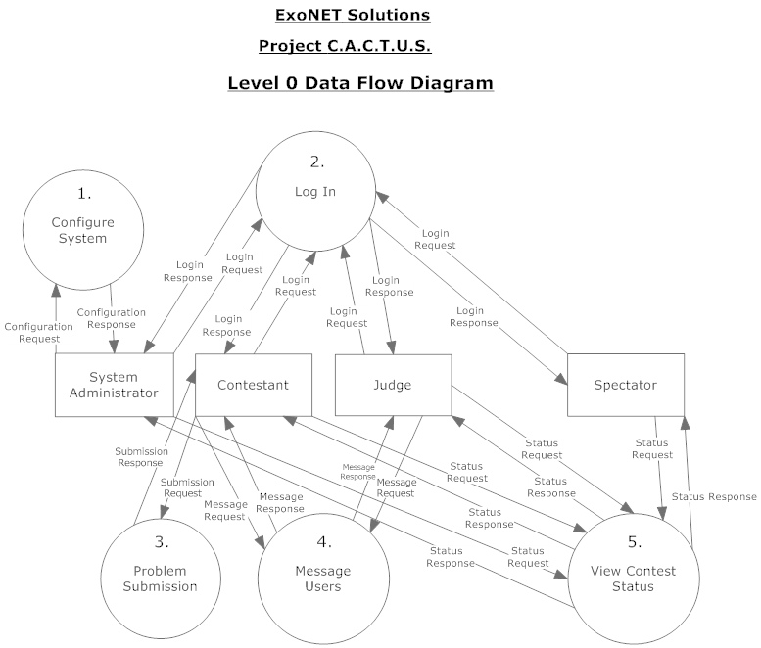

1.3.4 Process 1 Diagrams
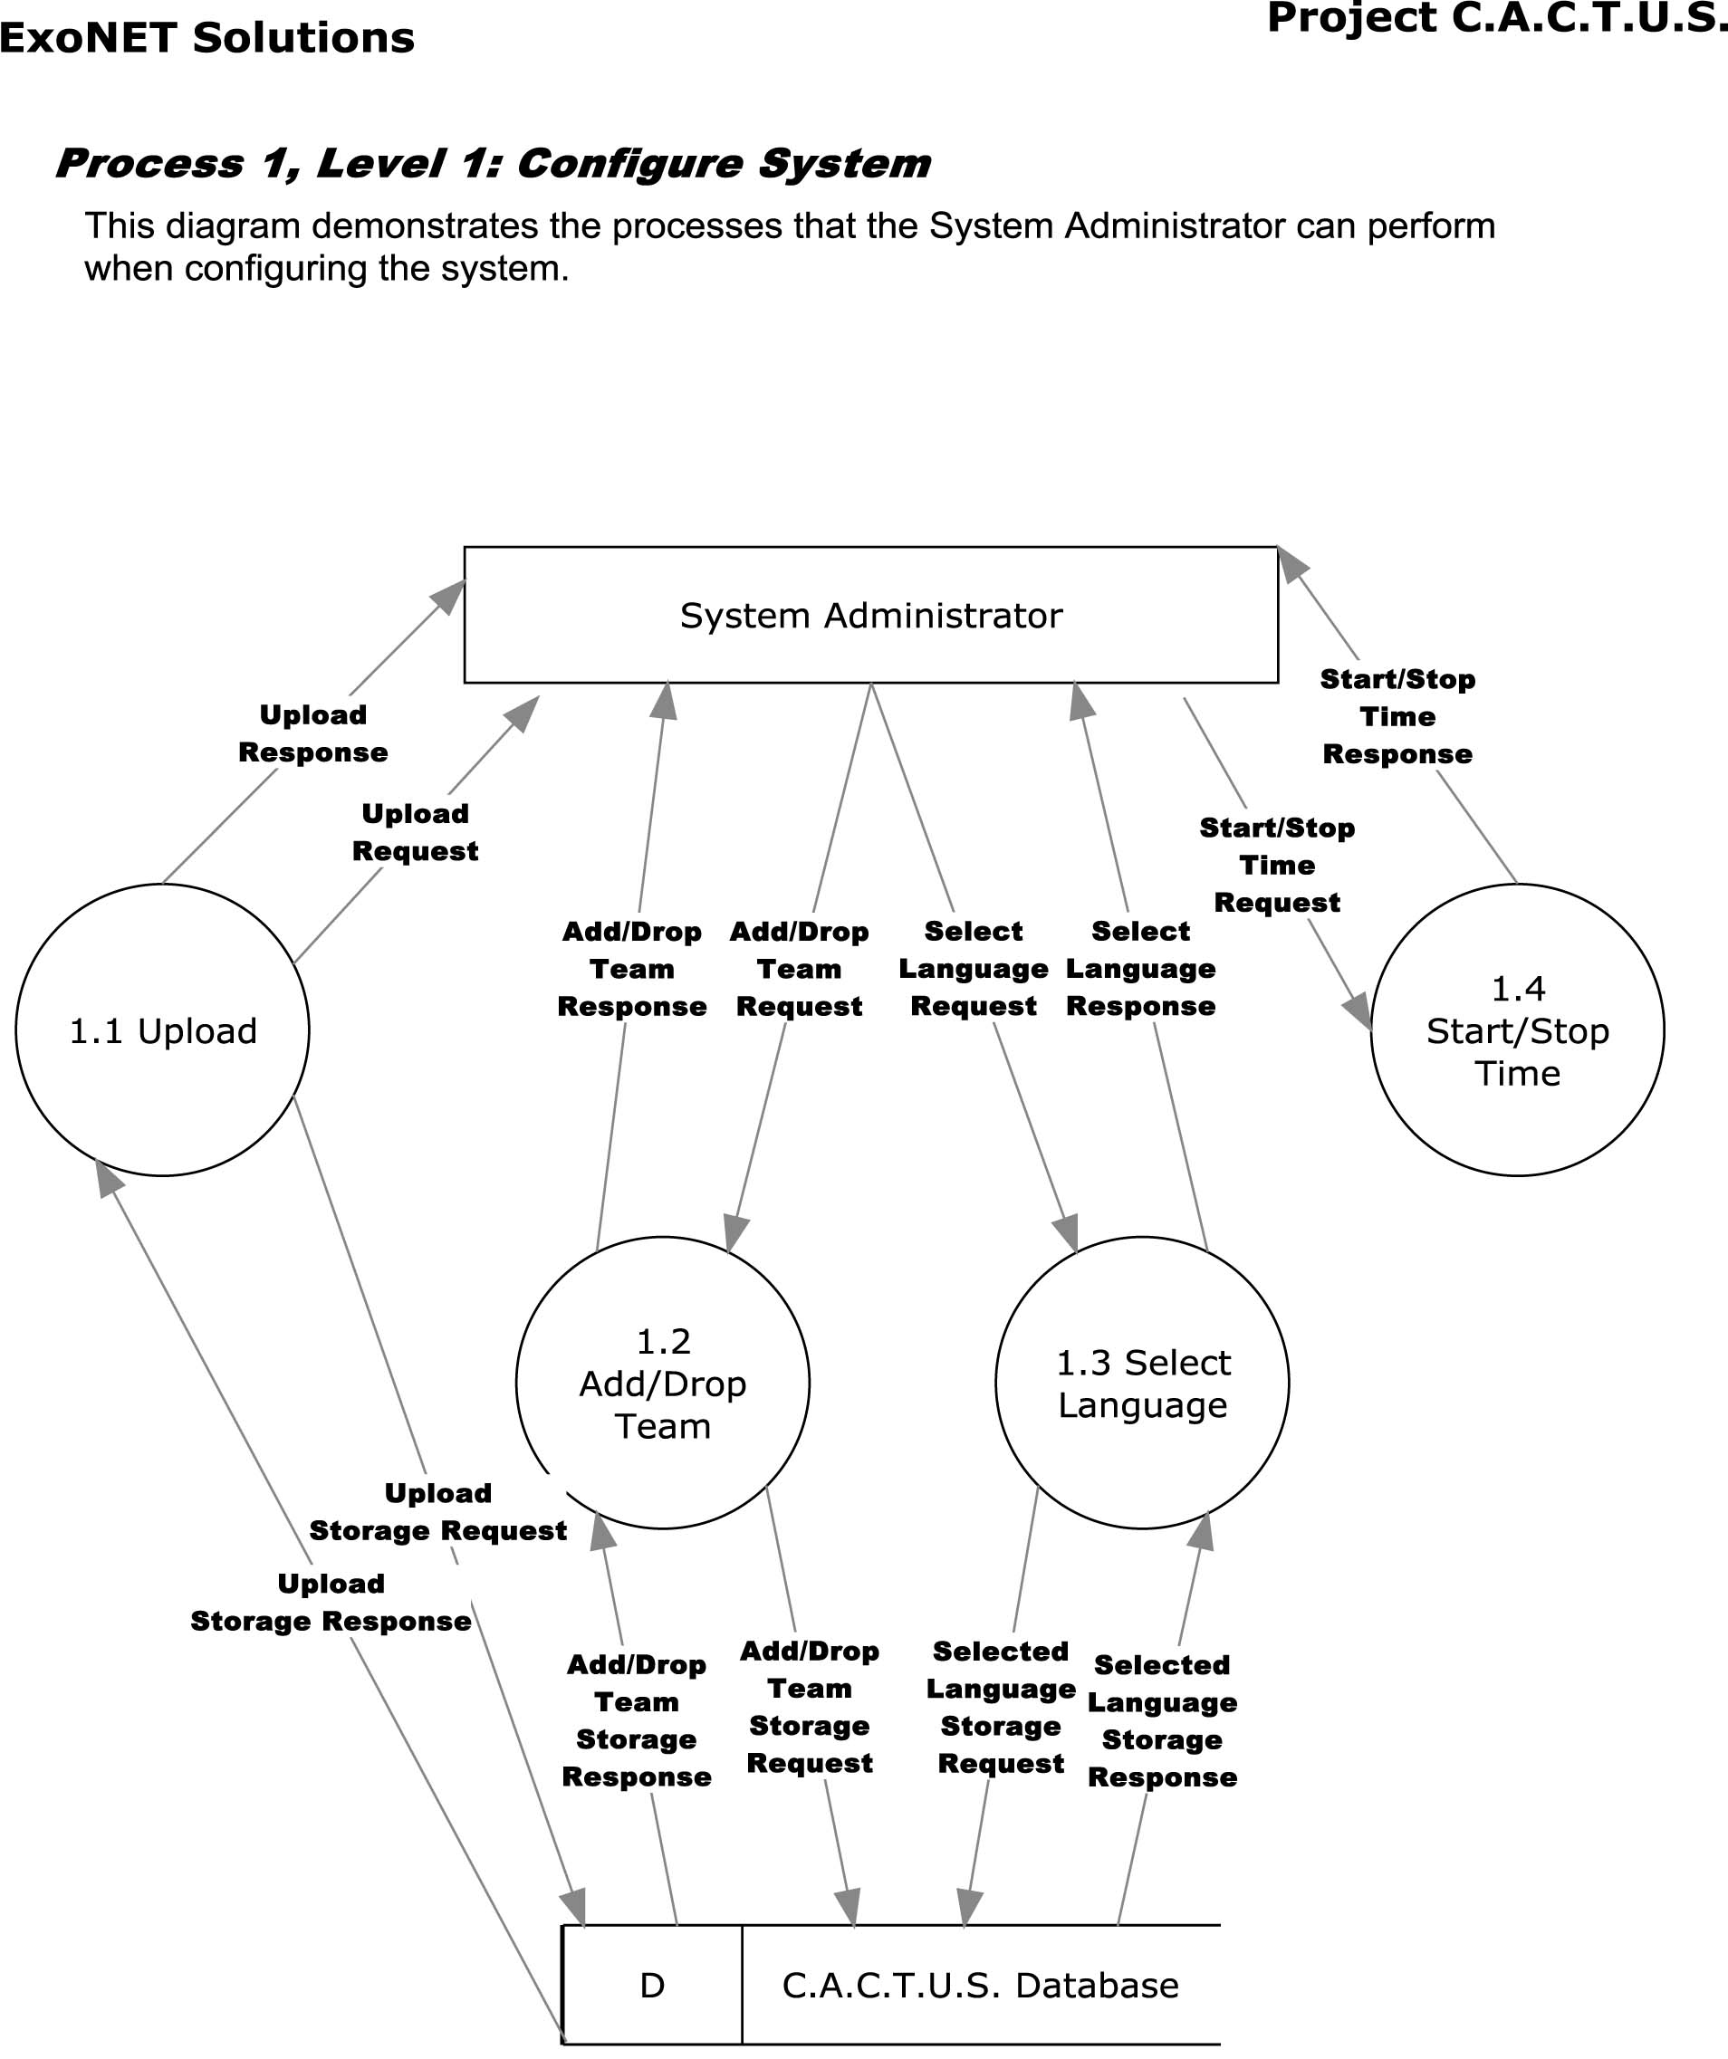
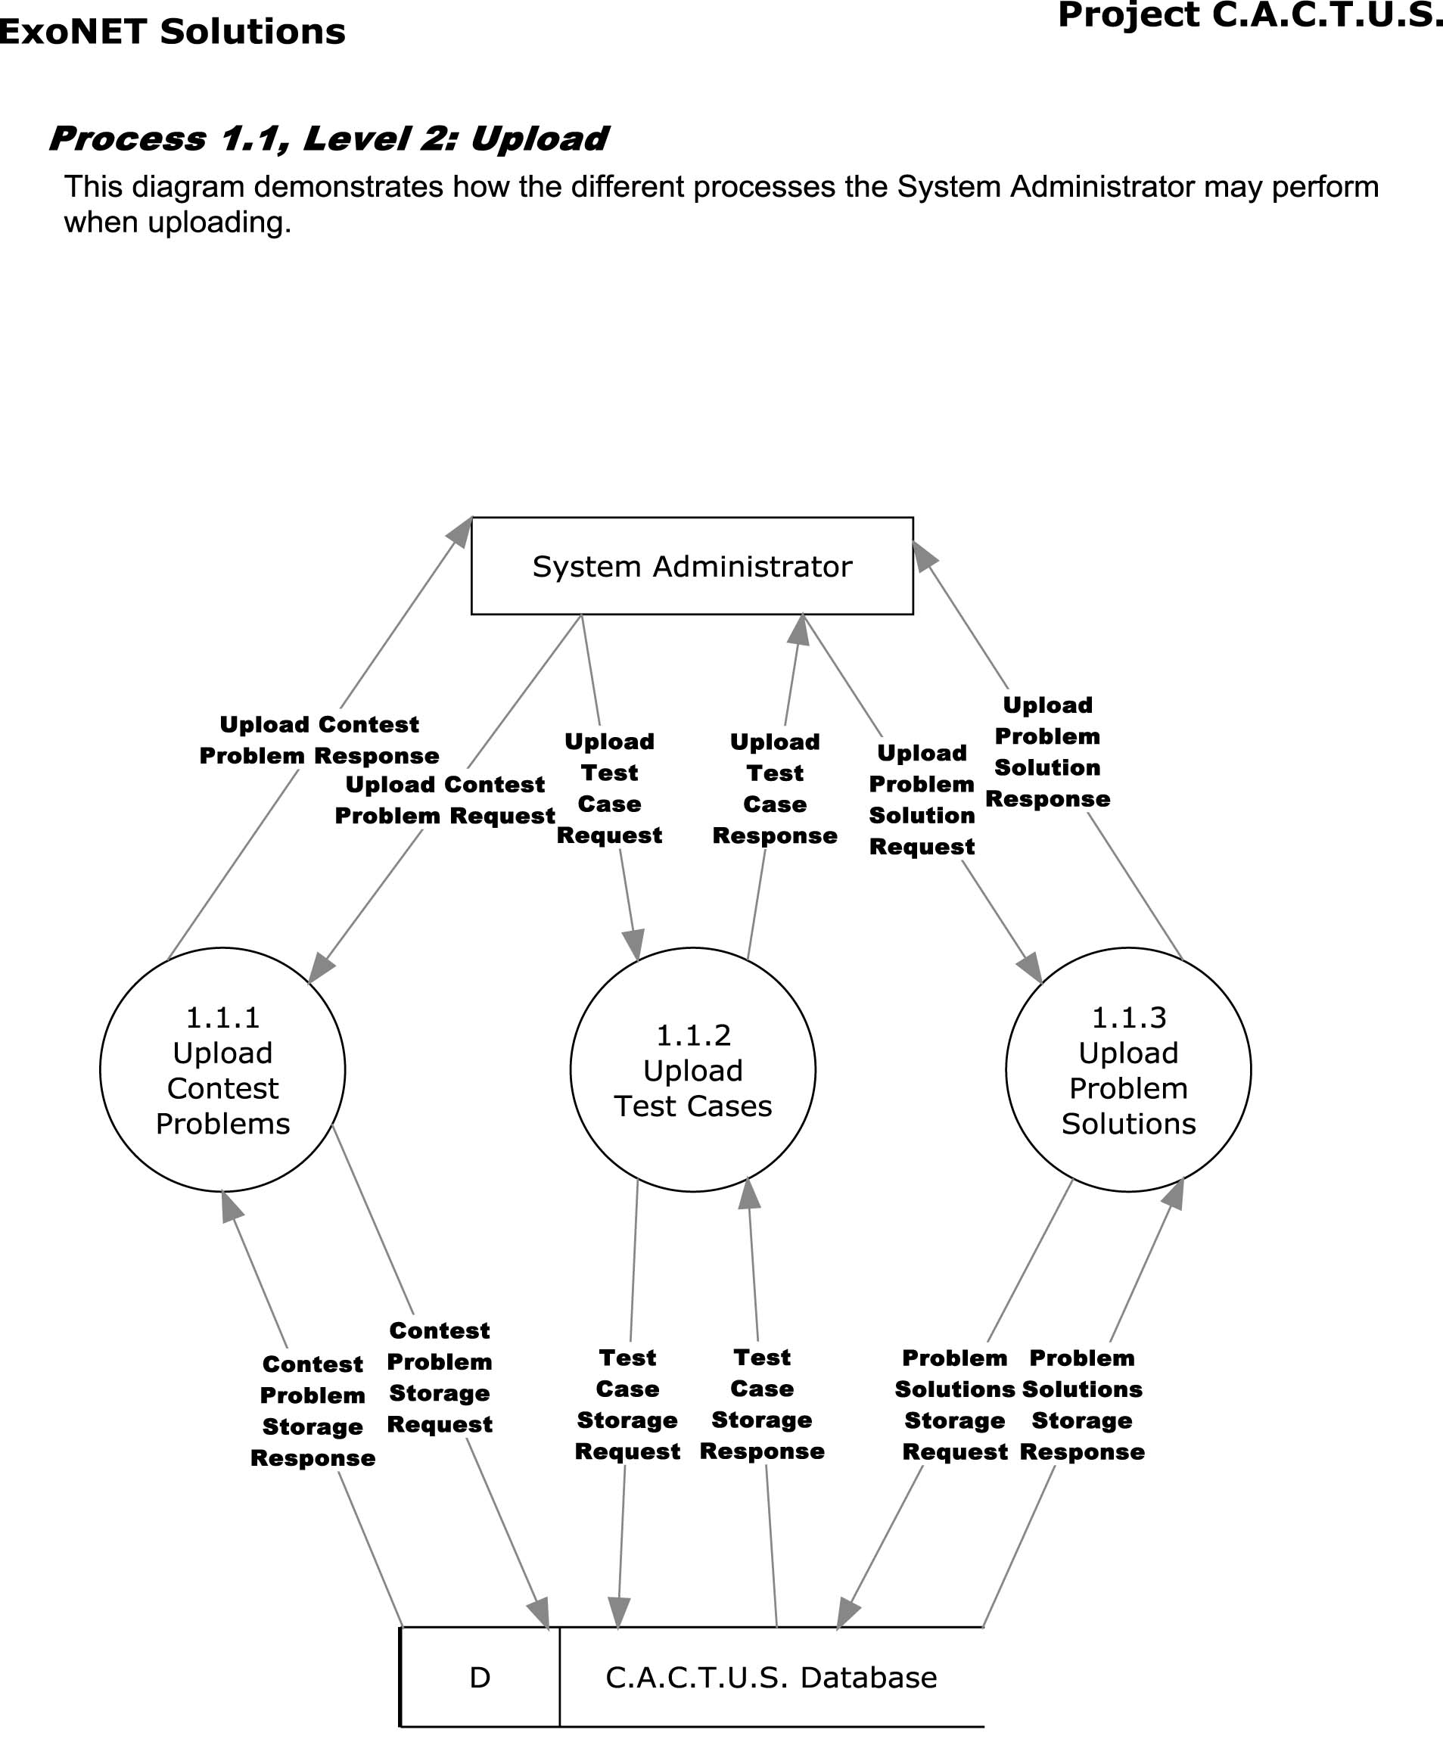
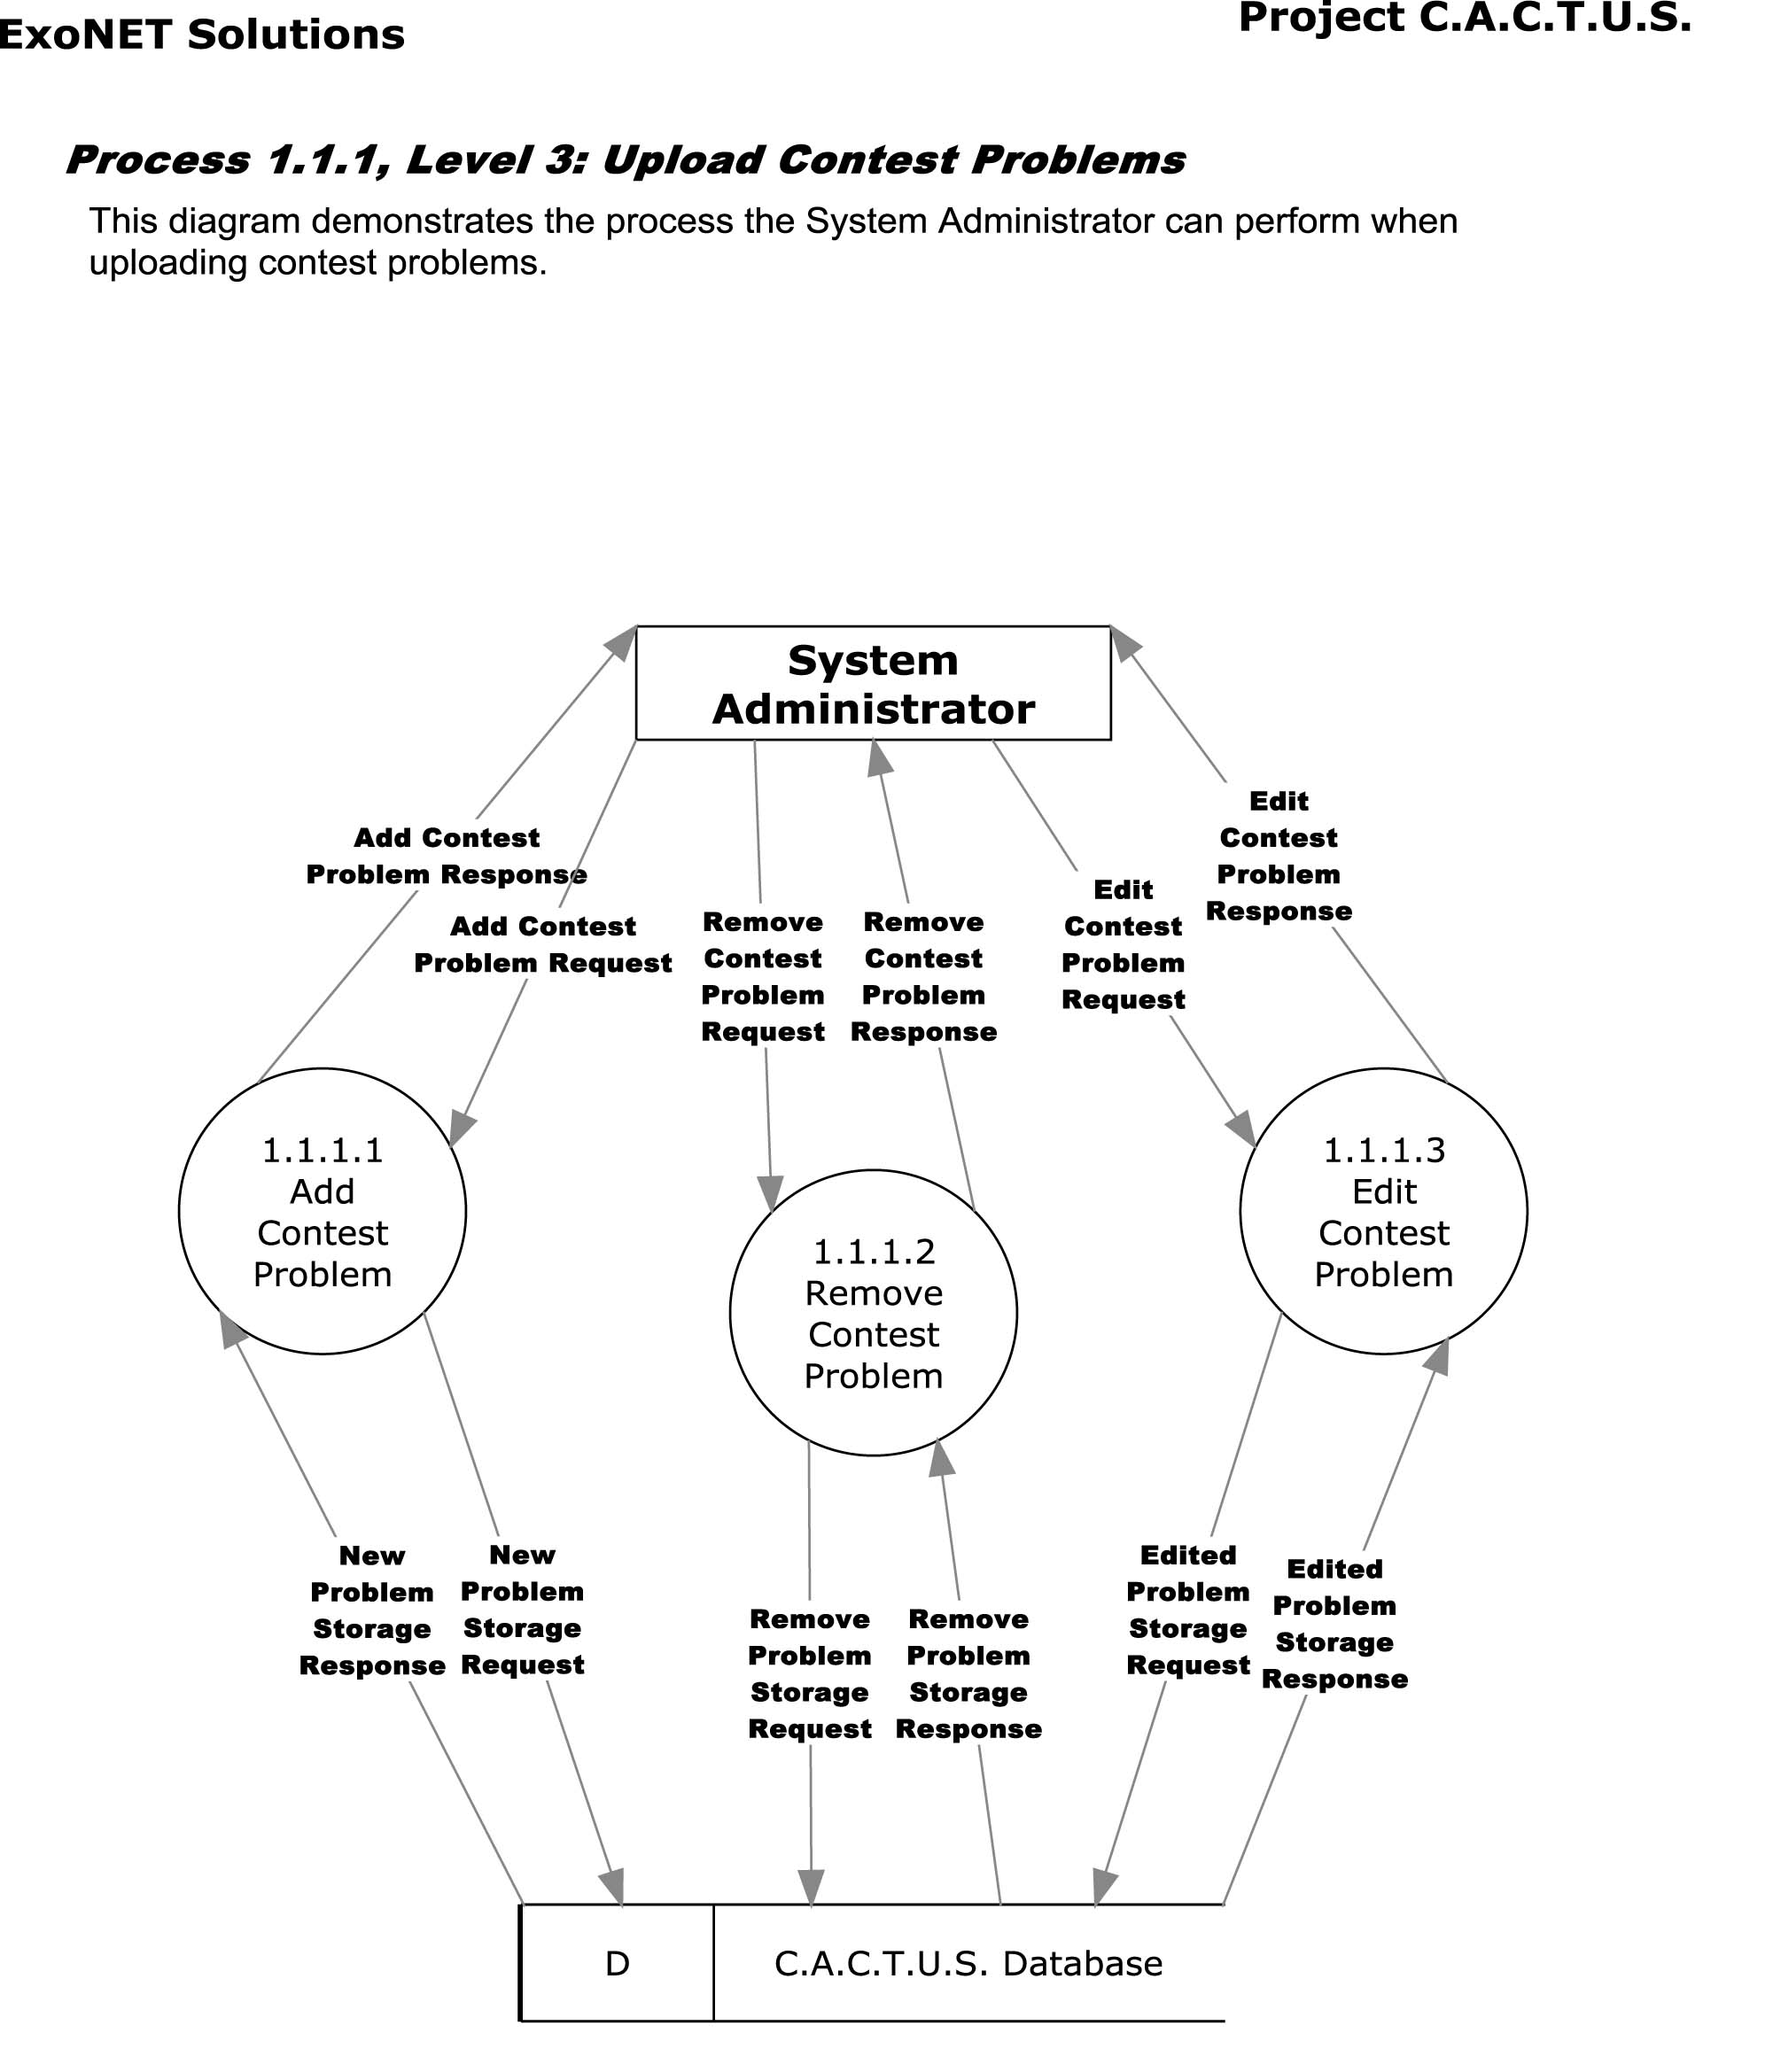

1.3.5 Process 2 Diagrams
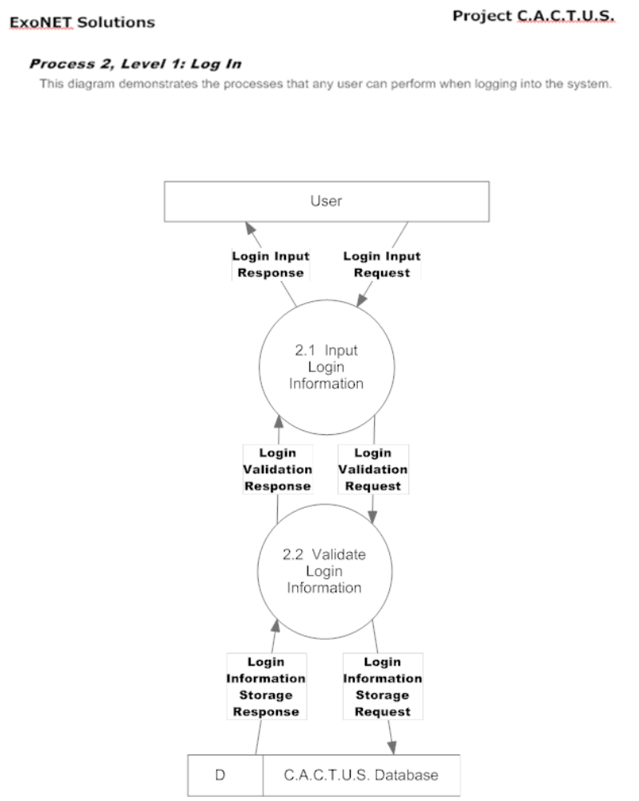
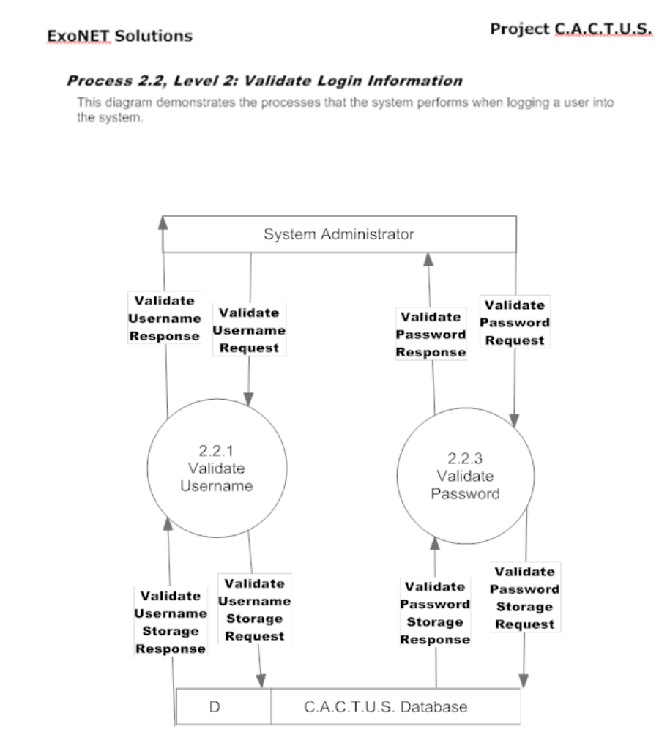
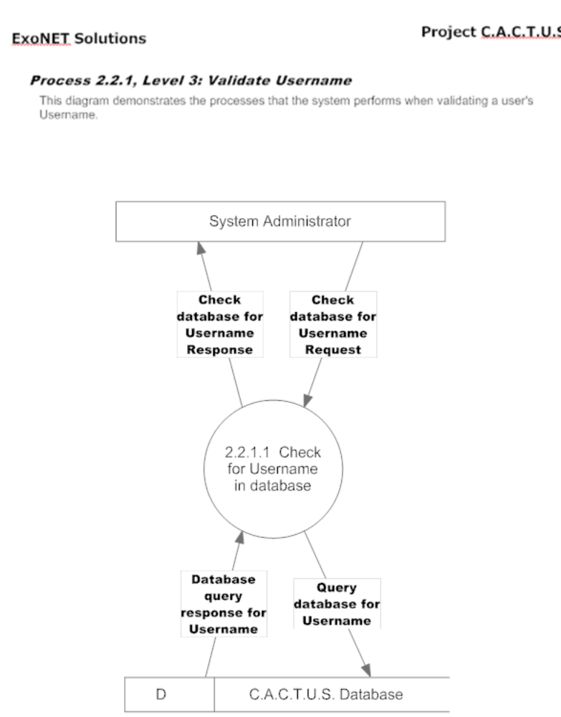

1.3.6 Process 3 Diagrams
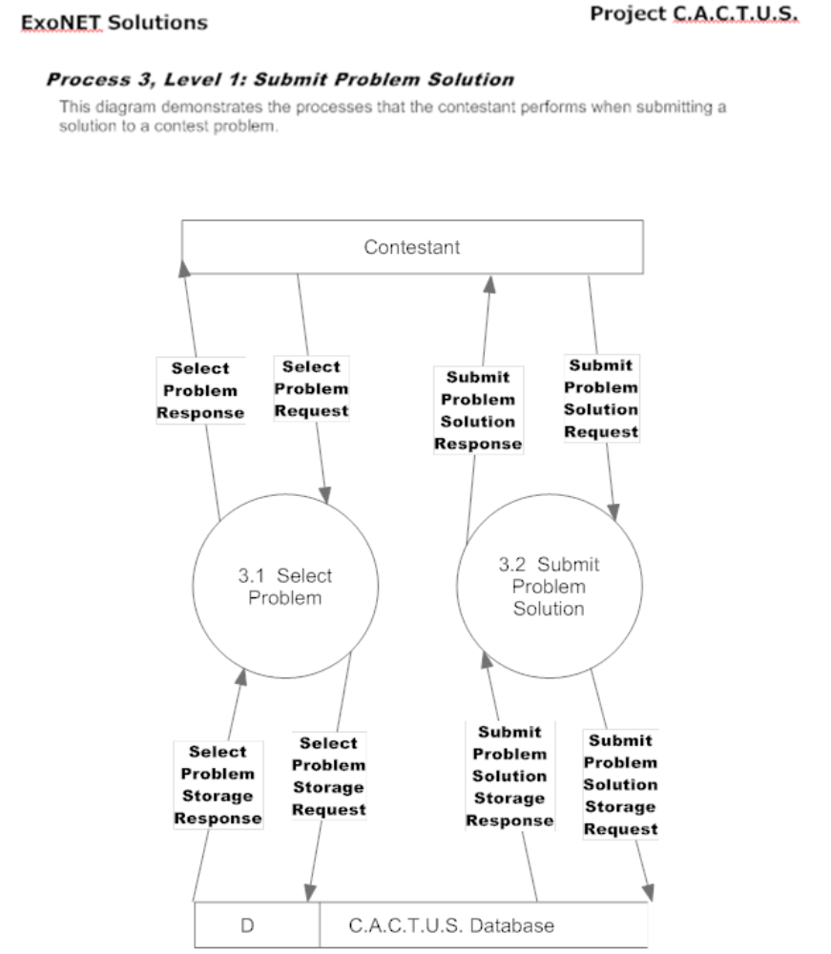
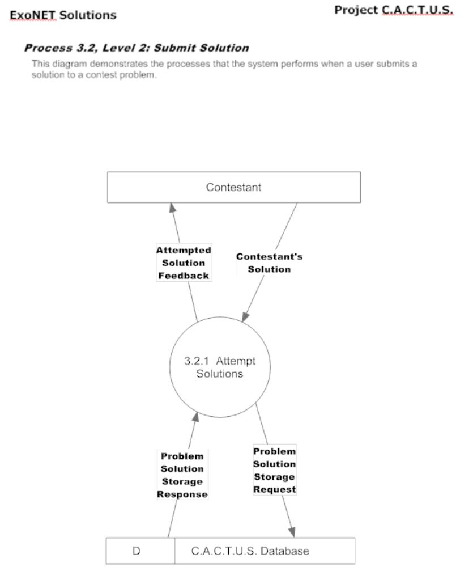
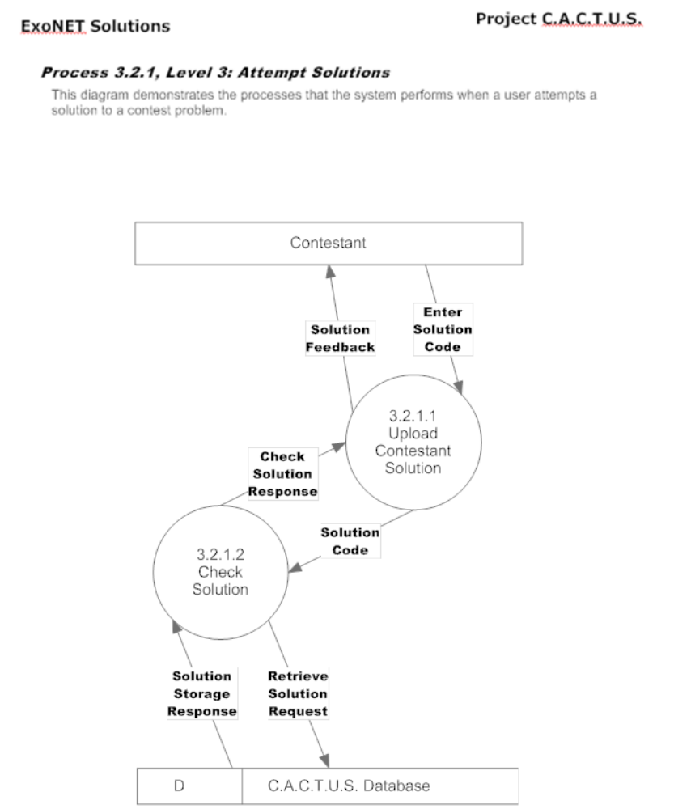

1.3.7 Process 4 Diagrams
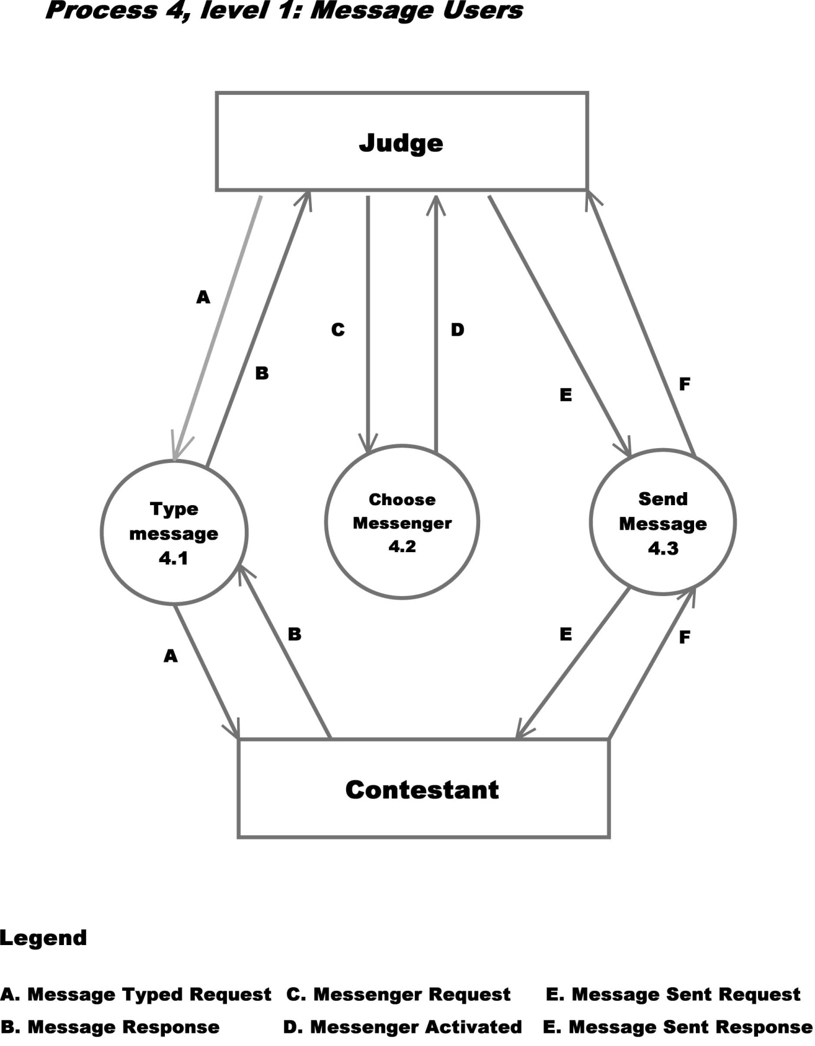
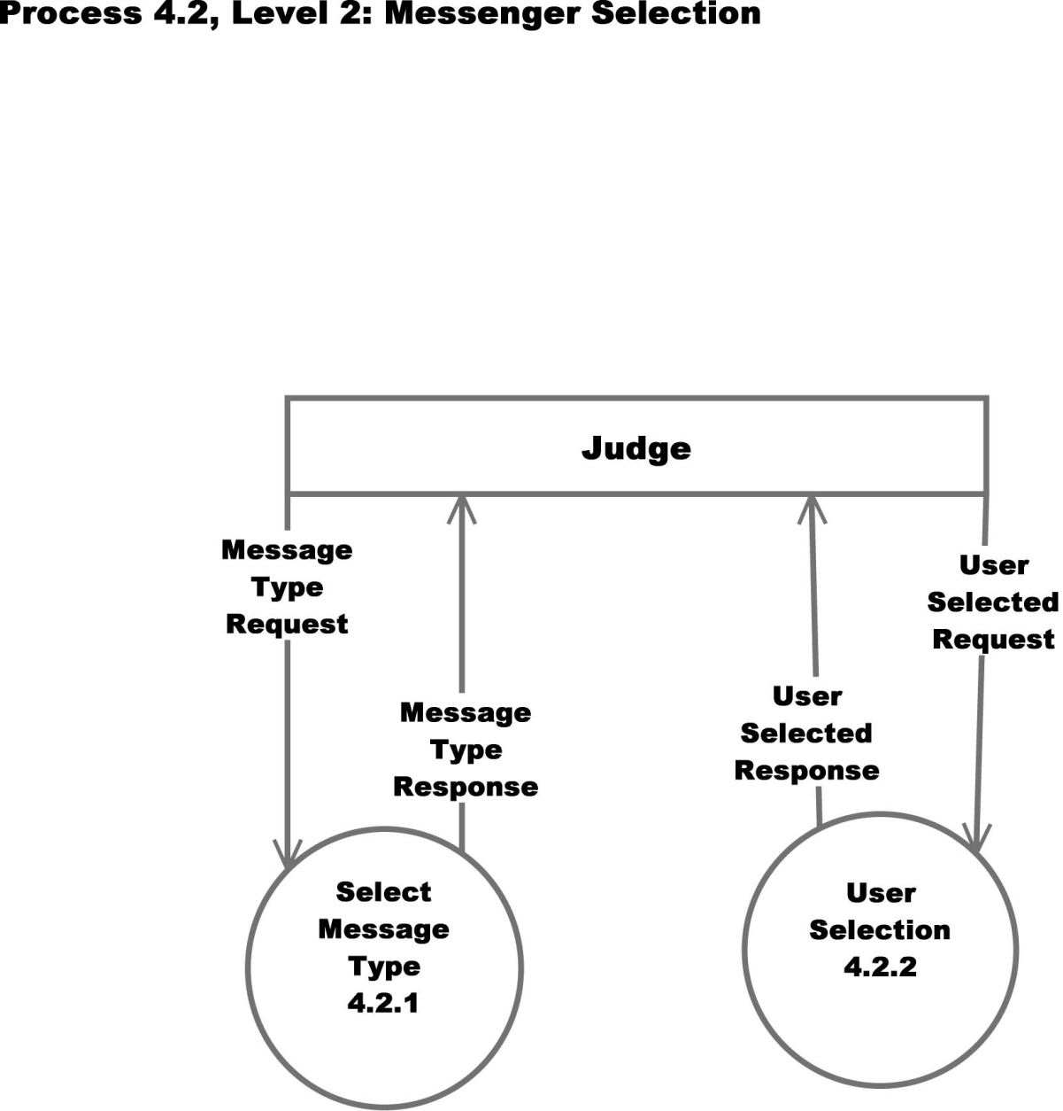
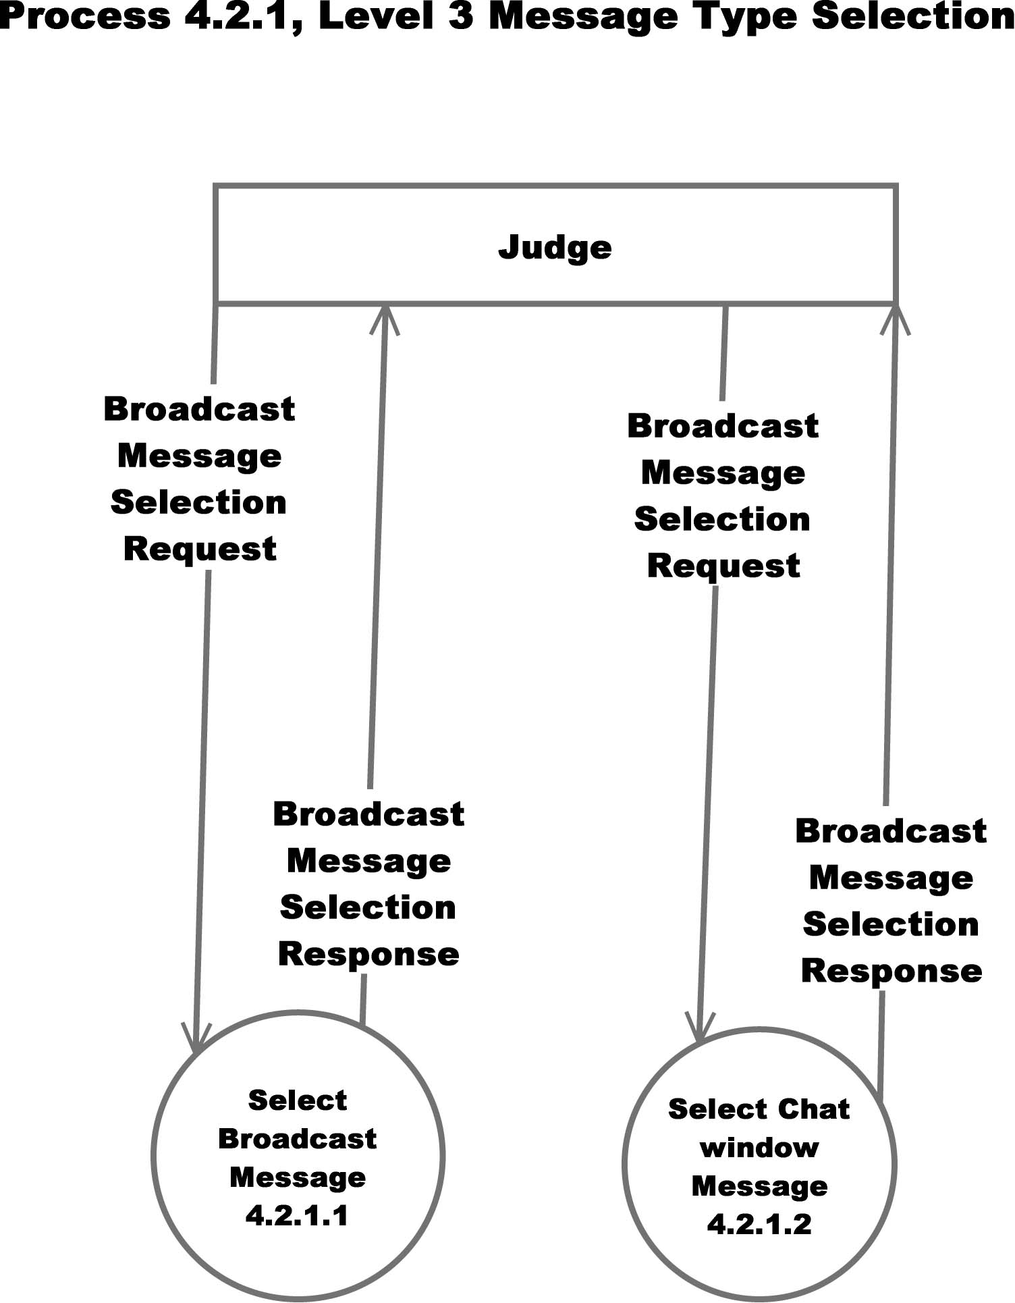

1.3.8 Process 5 Diagrams
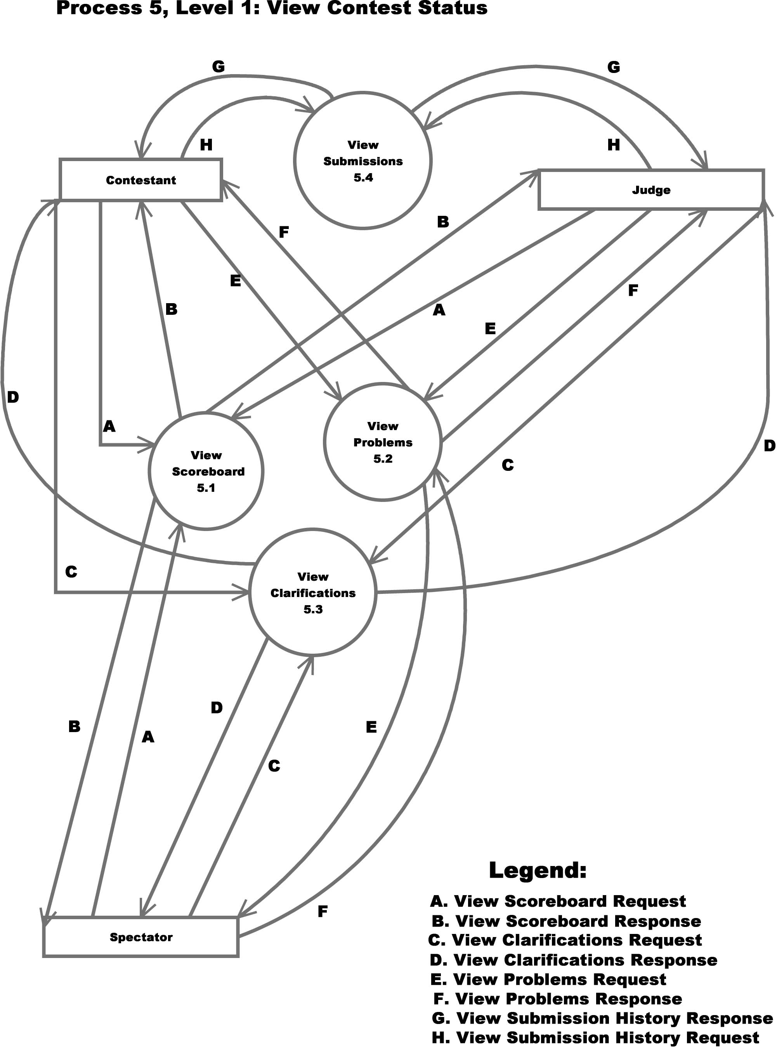
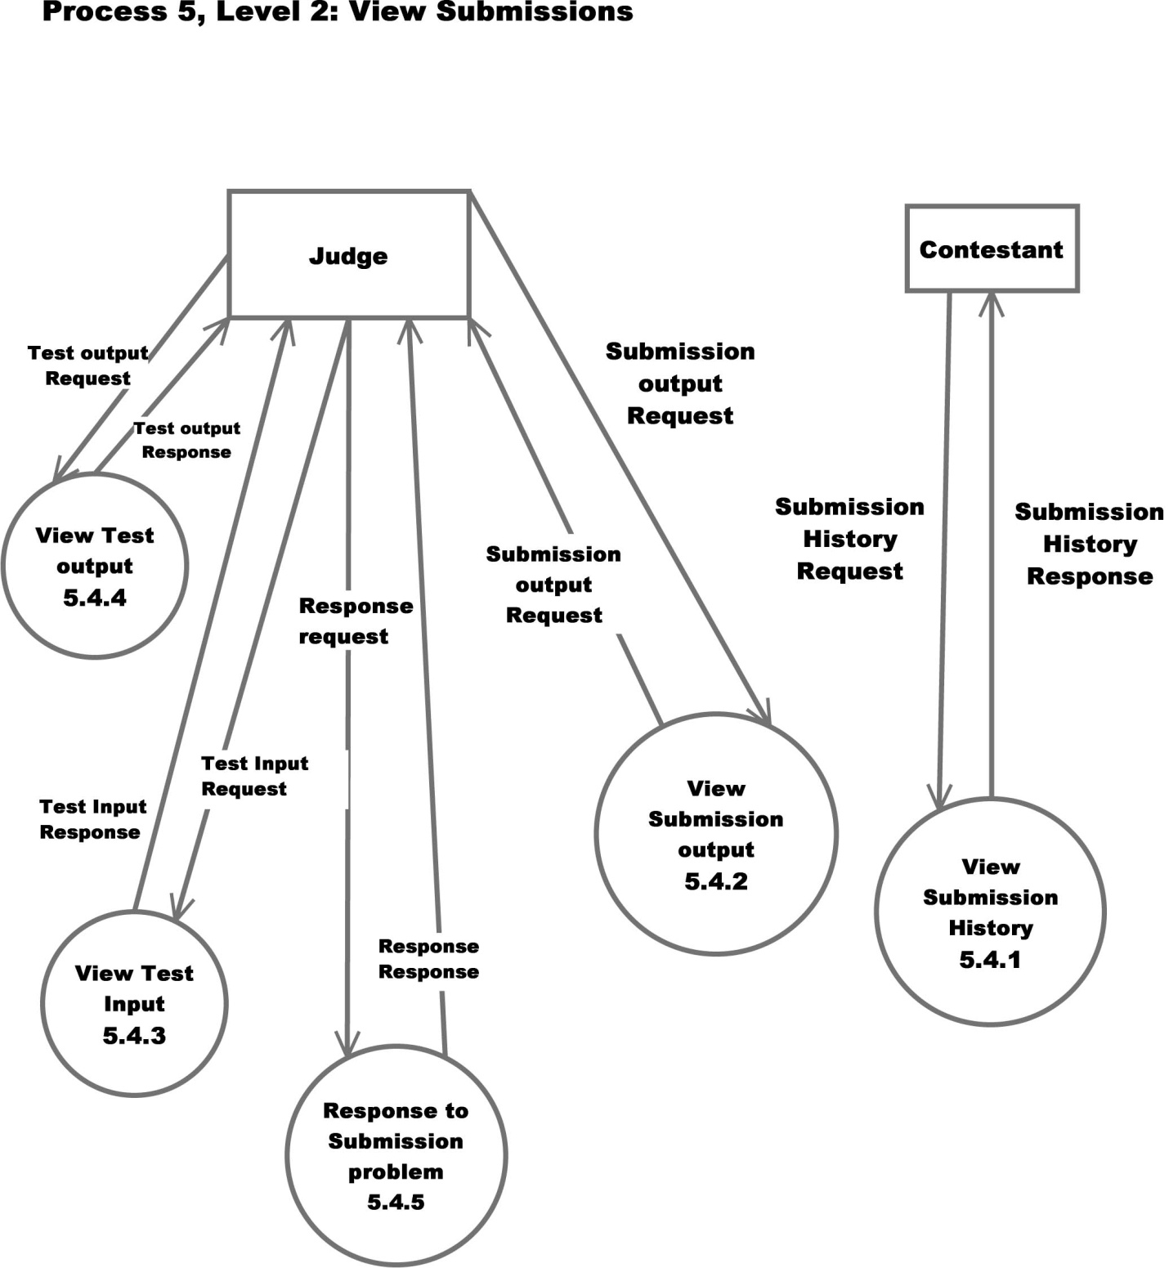
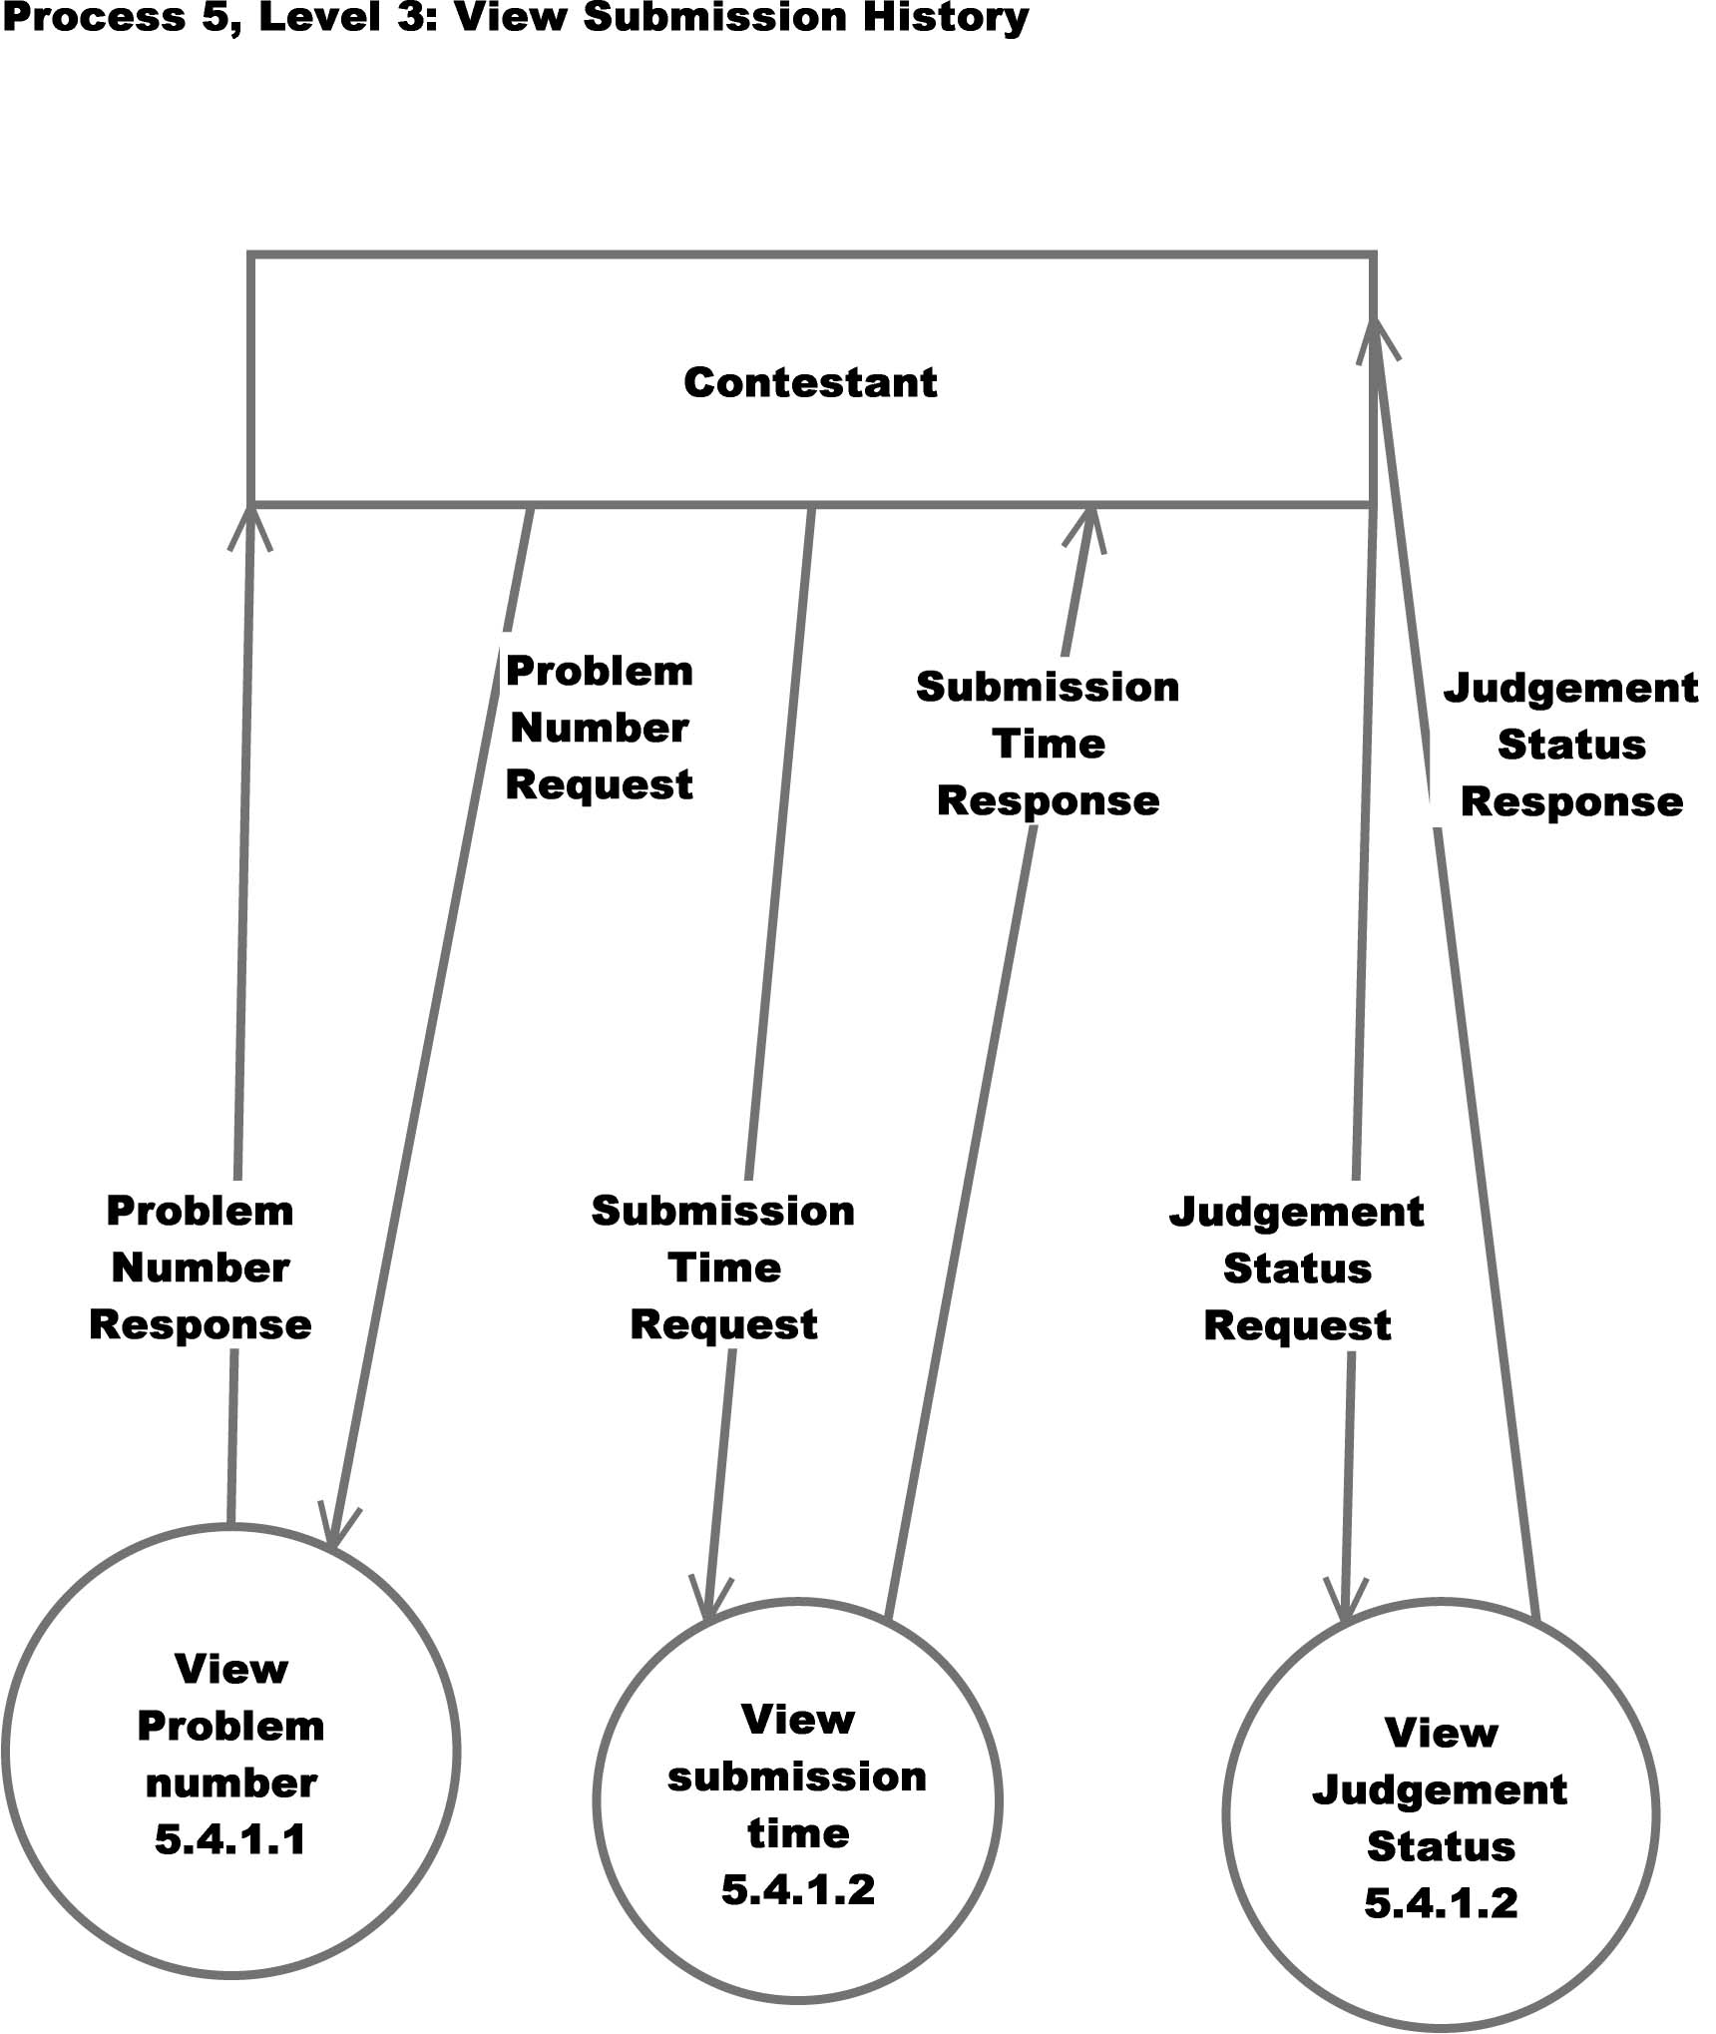

1.4 Structure Diagram
The data structure diagram is a graphical alternative to the composition specifications within such data dictionary entries.
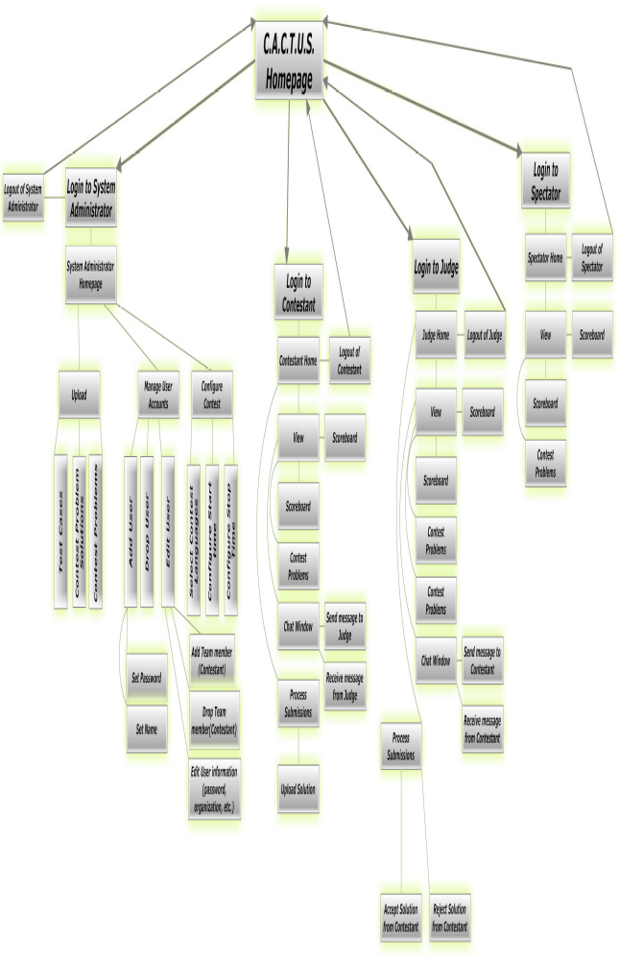

1.5 Functional Requirements Inventory
This is a list of functional requirements. A functional requirement defines a function of a software system or its components. This list is subject to change as ExoNET goes further into the project.
C.A.C.T.U.S (Competitive Algorithm Calculations Testing in a Unified System)-
- Responsiveness(specific ability of a functional unit to complete assigned tasks within a given time)
- Scalability (must be able to operate 30 teams)
- Efficiency (must get responses back within a reasonable time/if infinite loop-time limit exceeded)
- Time limit exceeded – specific time should be determined per contest (decided by system administrator).
- Robustness (if C.A.C.T.U.S. fails or crashes, users should be able to recover successfully)
- Saving option
- System must be secure (user’s should not be able to access other user accounts)
- C.A.C.T.U.S. will be viewable on multiple web browsers
- Web browsers include: Mozilla FireFox, Internet Explorer, Google Chrome
- C.A.C.T.U.S will compile programs during the contest
- C.A.C.T.U.S will maintain a scoreboard during the contest.
- Scoreboard will list all Contestants in decreasing order of standing (determined by # of problems solved and total time)
- For every team, Scoreboard will show the time-stamp of every solved problem and list the total time for all solved problems
- Scoreboard will be able to be "frozen" after a set period of time

System Administrator-
- Securely log in and out of C.A.C.T.U.S.
- Upload problem solutions, contest problems and test cases
- Add/drop Contestants during contest creation
- Delete and create new Judge, Contestant, Spectator accounts
- Administrator will initialize user names and passwords for each user
- Change start and stop time for a contest
- Administrator will set freeze time for scoreboard
- Selecting Languages
- Java will always be a selection choice for the contest
Judge-
- Securely log in and out of C.A.C.T.U.S.
- View contest problems
- Judge will be able to view test cases
- View Scoreboard
- View chat window
- Judge will be able to send broadcast messages to all Contestants
- Judge will be able to send specific messages to their assigned Contestants
- Process submissions
- Judge will be able to ‘accept’ or ‘decline’ submissions sent to them by their specified Contestants

Contestant-
- Securely log in and log out of C.A.C.T.U.S.
- View contest problems
- View Scoreboard
- Contestants will be able to see their time stamp for each problem submitted
- View broad casted messages and chat window
- Contestants will be able to send messages to their assigned Judge
- Submit submissions of source code
- Compile their code

Spectator-
- Securely log in and log out of C.A.C.T.U.S.
- View contest problems
- View Scoreboard
- View only broadcast messages

Detailed Design

1.1 Logical Data Dictionary
As defined by IBM, a data dictionary is “as centralized repository of information about data such as meaning, relationships to other data, origin, usage, and format.” ExoNET’s data dictionary contains: What user this data type is applicable to, the data entity’s name, what the data entity is applicable to in C.A.C.T.U.S., the data type of the entity (such as String, int, etc.), the size of the data type, the data type’s description, the acceptable input format for this data type, examples of good input for this data type, examples of bad input for this data type, and notes regarding this data type (if any are necessary).

1.1.1 Logical Data Dictionary Key
The Key for ExoNET’s Logical Data Dictionary is as follows:
- User Type: What user(s) in our system this data type applies to
- Data Name: This particular data entity’s name
- Applicable to: What Use Case in C.A.C.T.U.S. this data entity pertains to
- Data Type: The type of data this entity represents (such as ‘String’ or ‘int’)
- Data Size: The size that this data entity is going to take up in C.A.C.T.U.S.
- Description: A brief description of what this data entity is going to be used
- Acceptable Input Format: A listing of what input is allowable in C.A.C.T.U.S. for this data entity
- Examples of Good Input: Listing(s) of a properly constructed or executed entry for this data entity
- Examples of Bad Input: Listing(s) of unacceptable input for this data entity
- Notes: Additional information regarding this data entity (if any are necessary)

1.1.2 Logical Data Dictionary Spreadsheet
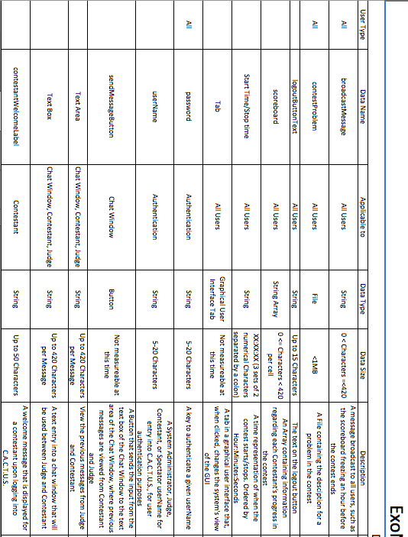
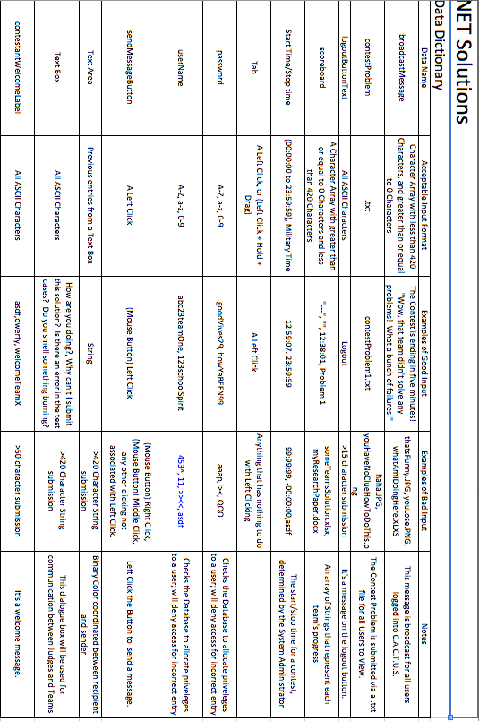
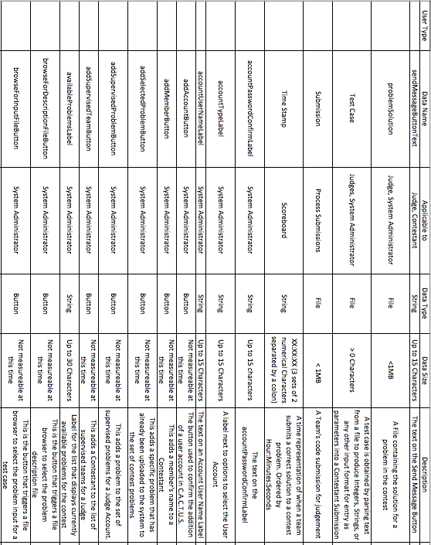
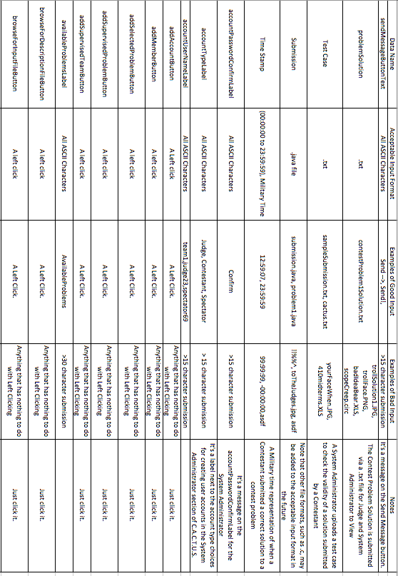
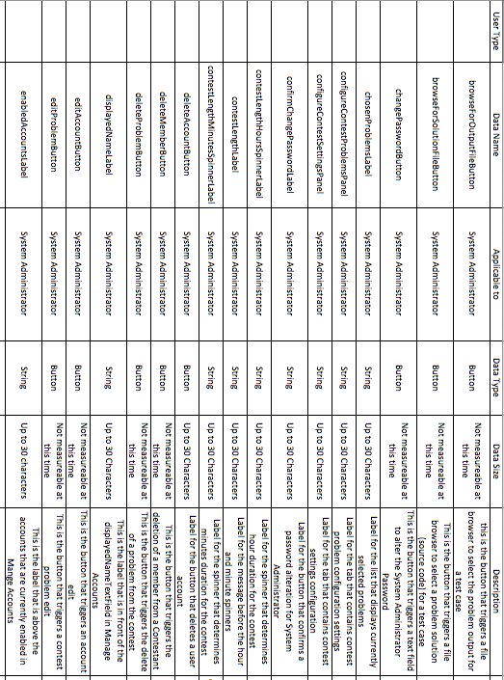
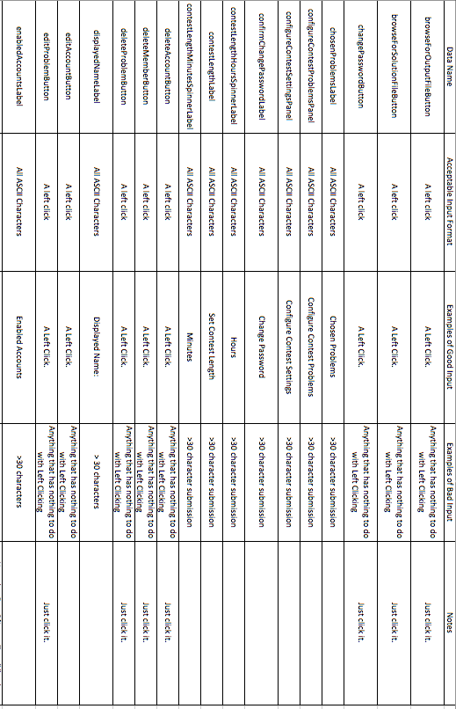
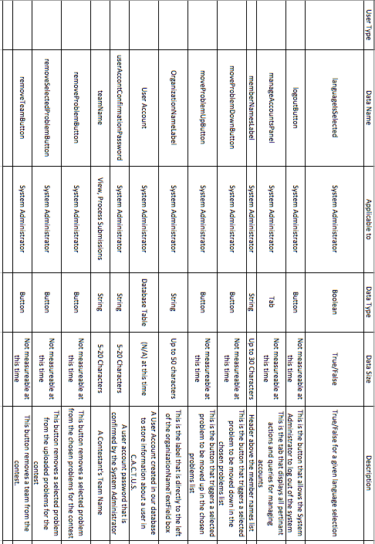
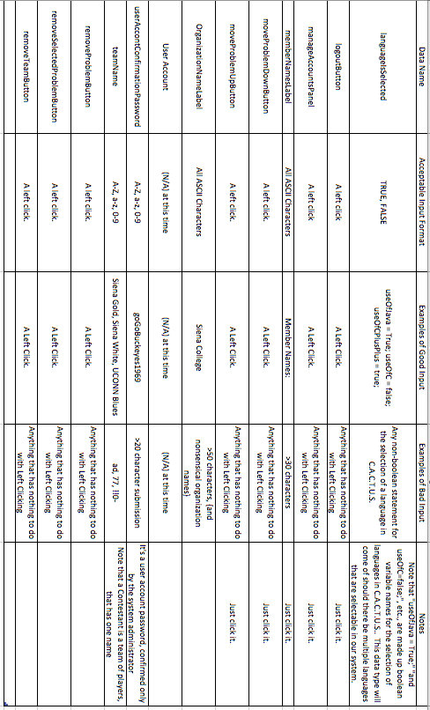

2.1 ER Diagram
An ER diagram is an abstract and conceptual representation of data. It is used to represent the logical format of a database.
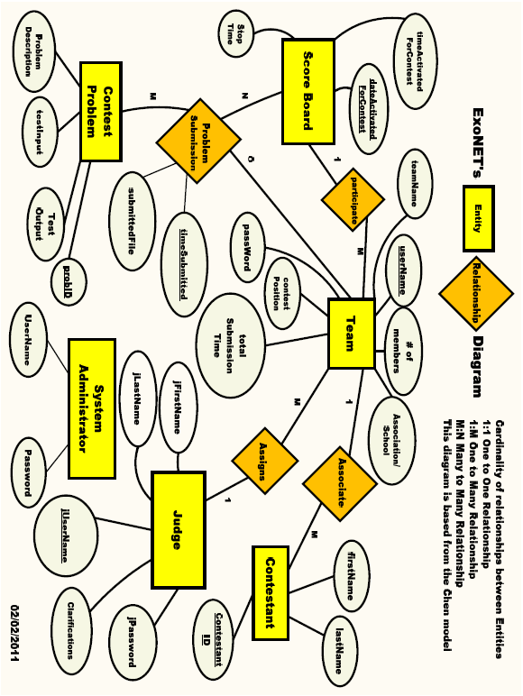

3.1 Prototype Screens

3.1.1 Log in Screen
The login screen allows users to login to C.A.C.T.U.S. using a username and password.
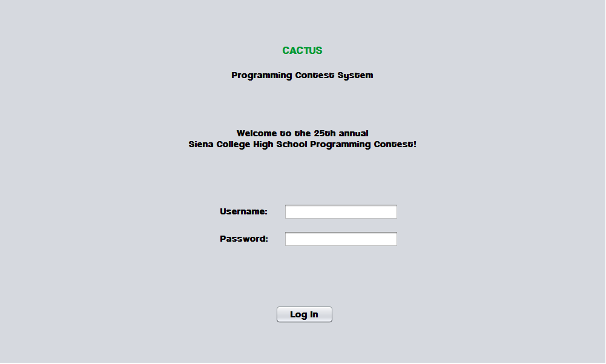

3.1.2 Log in Failed
An error message is displayed when a user enters an invalid username and password combination. 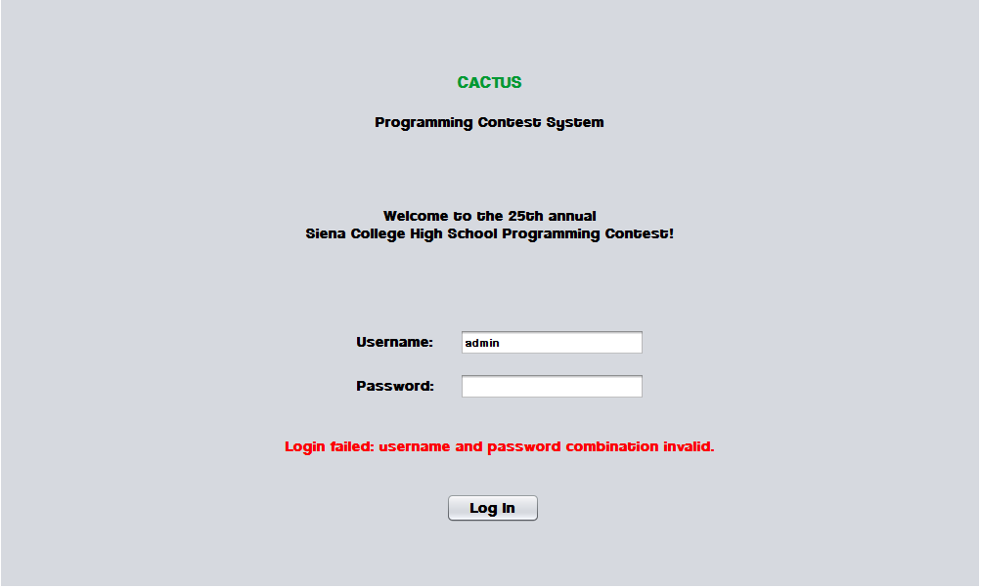

3.1.3 Contestant Screens

3.1.3.1 View Clarifications
Contestants can view all Clarifications sent out by the Judges.
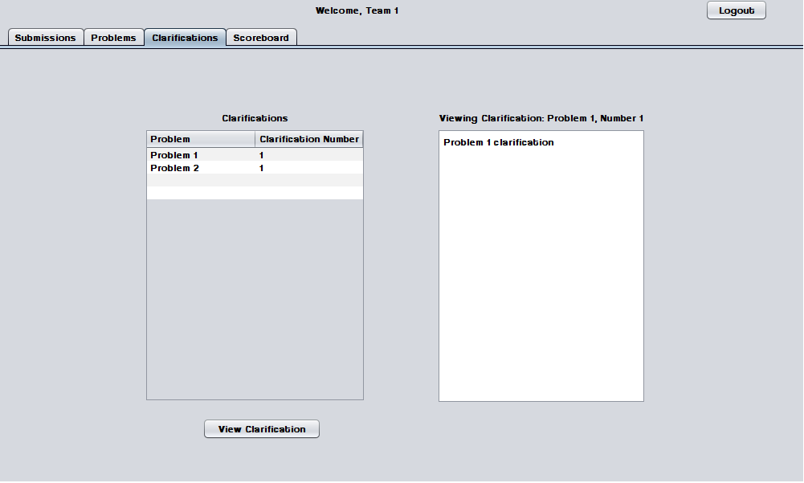

3.1.3.2 Problems List
Contestants may select a contest problem to view in an embedded scroll area.
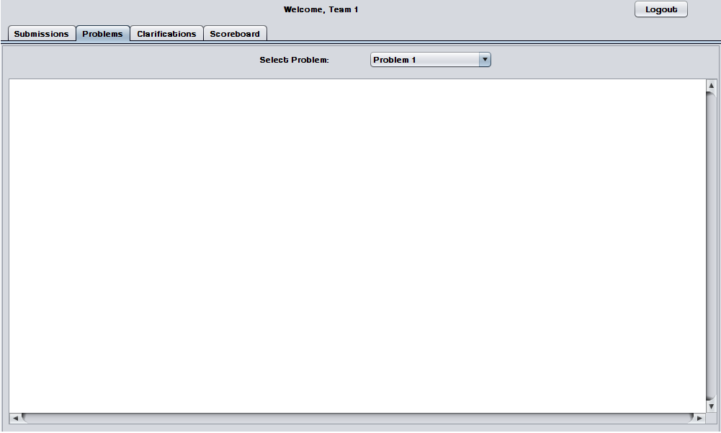

3.1.3.3 Scoreboard View
Contestants may view the contest scoreboard. The scoreboard must be manually refreshed and the scoreboard cannot be refreshed after it has been frozen.
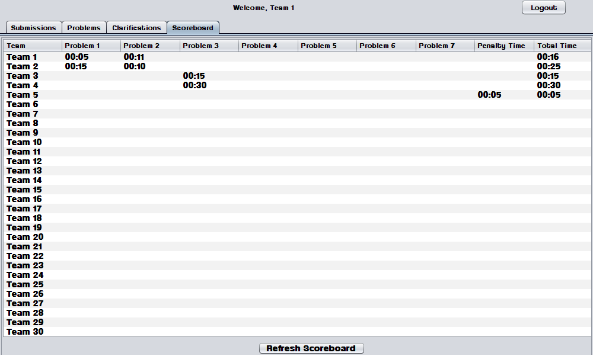

3.1.3.4 Submission Screen
The Submissions Screen allows a Contestant to chat with the Judges, submit Problem Submissions, and view submission history.
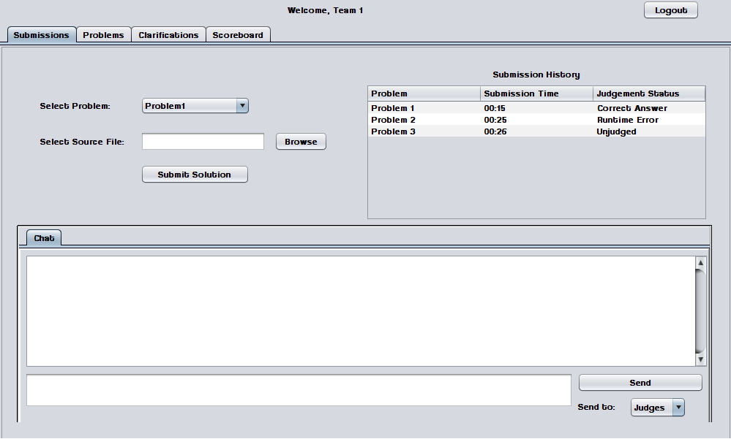

3.1.3.5 Submission Screen - Browse for source file
Contestants use a dialog window to browse for source files.

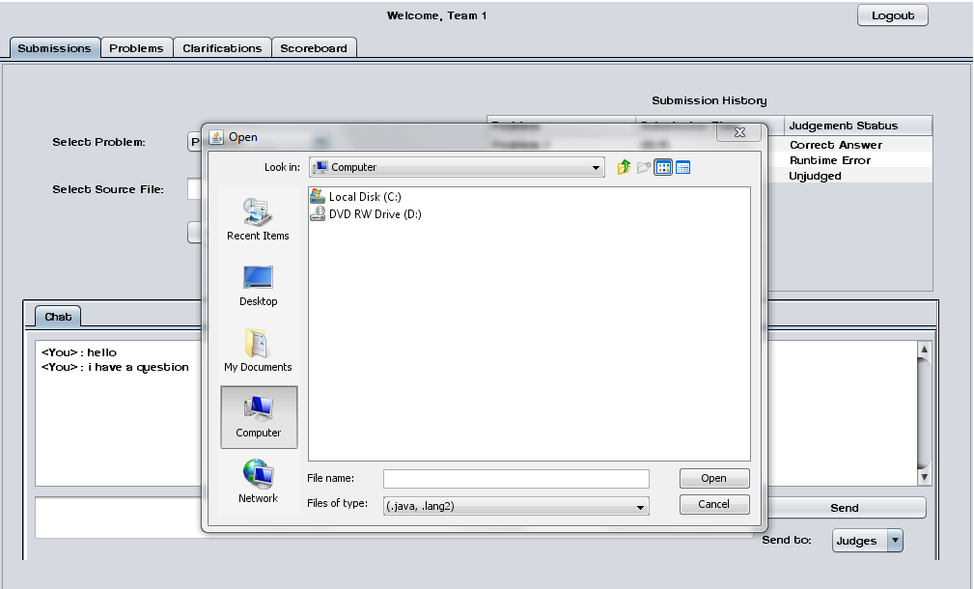

3.1.3.6 Submission Screen – No file selected error
An error message appears when a Contestant attempts to send a Problem Submission without selecting a source file.

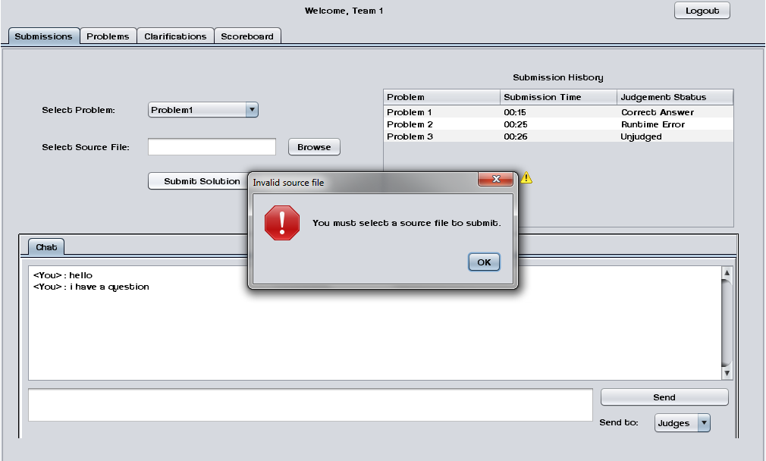

3.1.4 Judge Screens

3.1.4.1 Create Clarification
Judges can create and send out Clarifications to all Contestants, Judges, and Spectators.
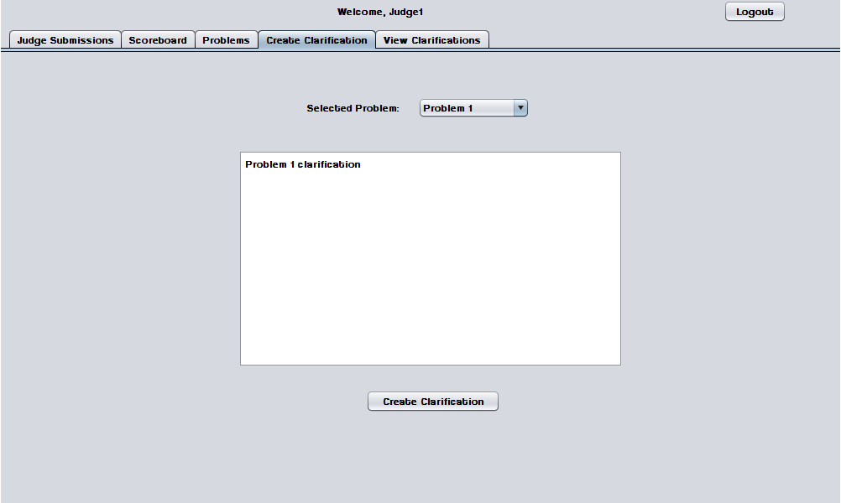

3.1.4.2 View Clarifications
Judges can view all Clarifications that have been sent out by Judges.
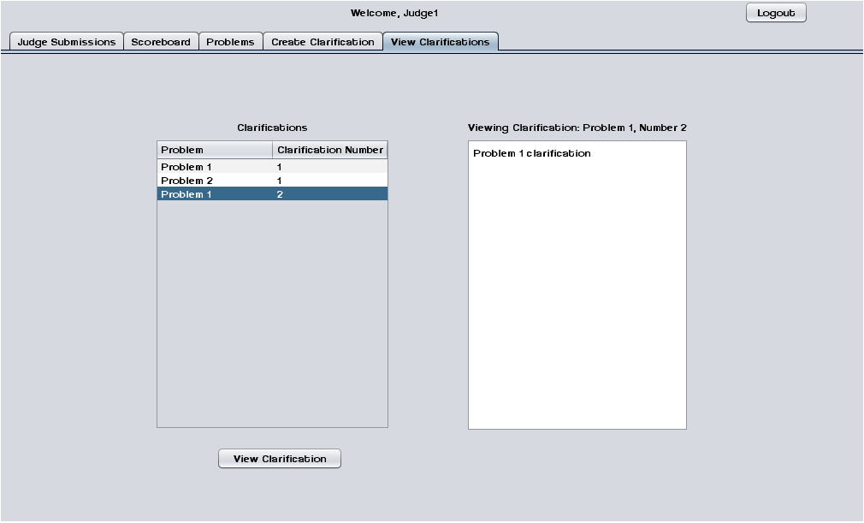

3.1.4.3 Judge submissions
The Judge Submissions screen allows a Judge to chat with Contestants and other Judges. This screen also allows a Judge to view and judge Problem Submissions sent by Contestants.
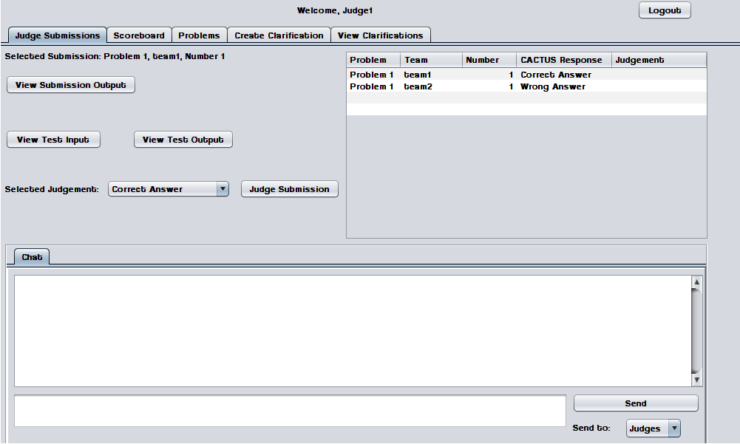

3.1.4.4 Problems List
Judges may select a contest problem to view in an embedded scroll area.
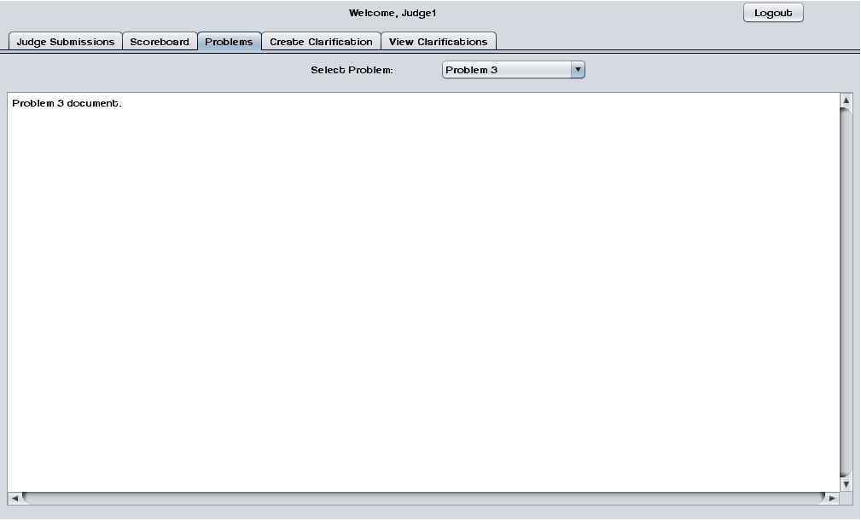

3.1.4.5 Scoreboard View
Judges may view the contest scoreboard. The scoreboard must be manually refreshed.
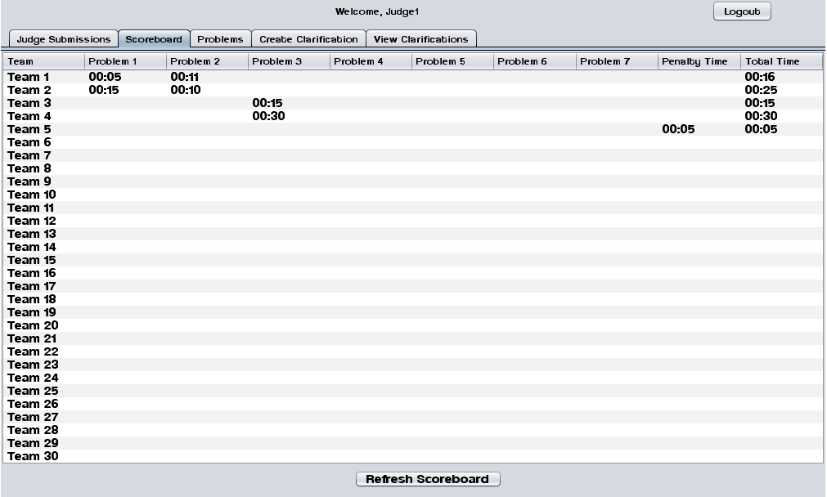

3.1.5 System Administrator Screens

3.1.5.1 Change Admin password
The System Administrator may change the System Administrator Account password.
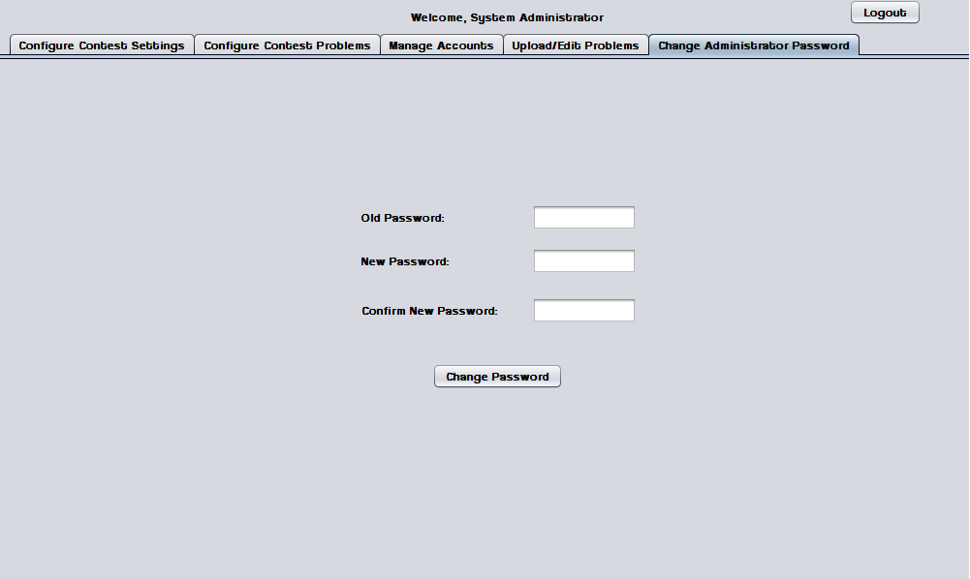

3.1.5.2 Change Admin password – Invalid old password error
This error message appears when the System Administrator enters a password that does not match the old one.
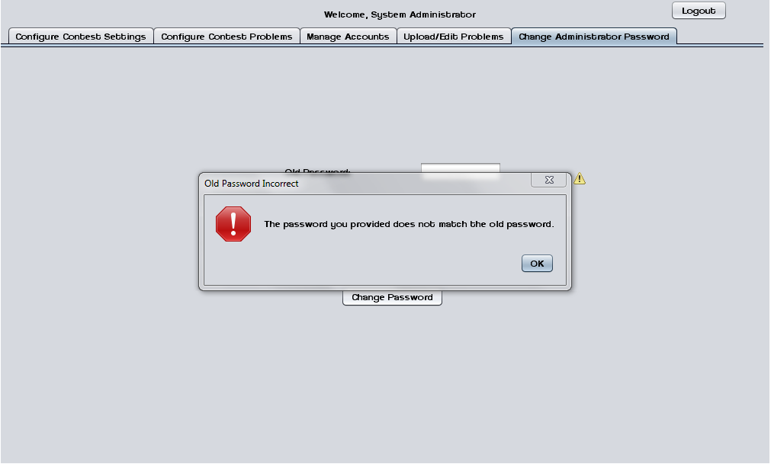

3.1.5.3 Change Admin password – New passwords do not match error
This error message appears when the System Administrator enters two different passwords in the "new password" fields.
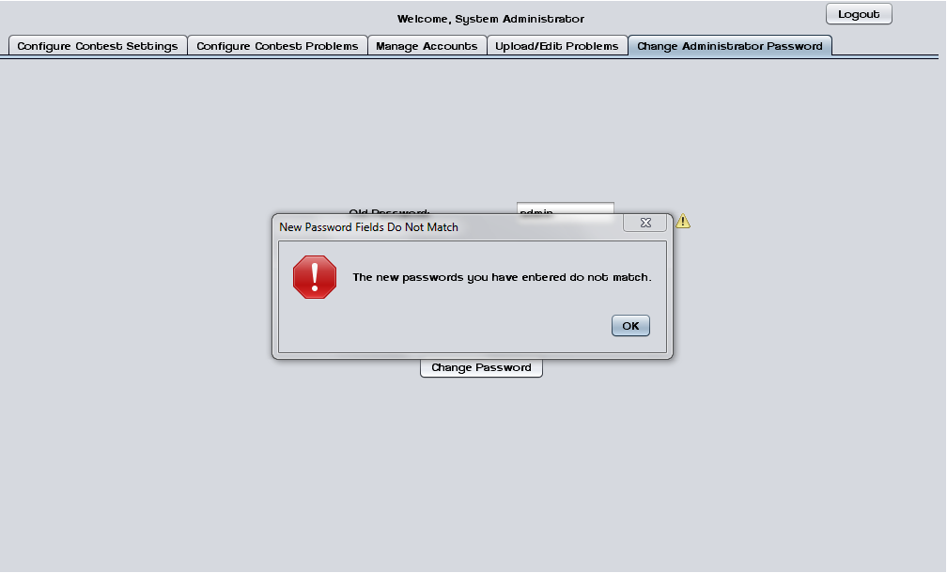

3.1.5.4 Upload/ Edit problems
The System Administrator can upload and edit contest problems into a persistent database.
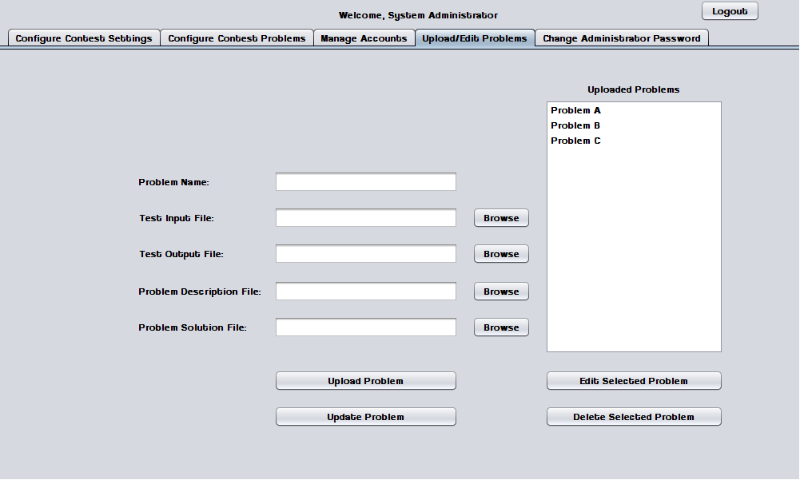

3.1.5.5 Upload Problems - Browse for file
The System Administrator uses a dialog window to browse for test input, test output, problem description, and problem solution files.
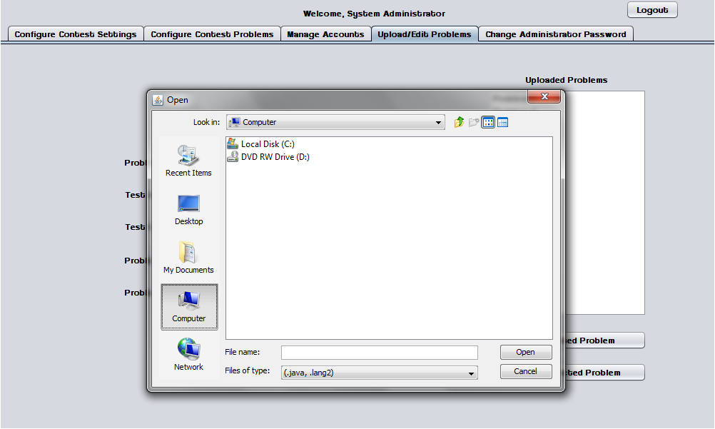

3.1.5.6 Configure Contest Problems
The System Administrator may select a number of problems to use in a contest from a list of available/uploaded problems.
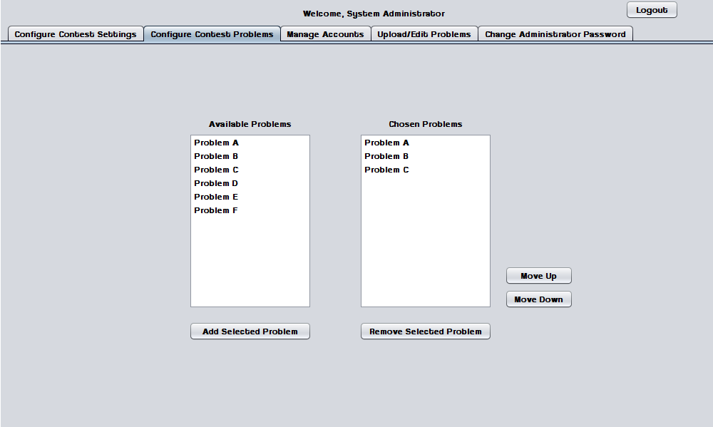

3.1.5.7 Configure Contest Settings
The System Administrator may configure contest settings such as duration, scoreboard freeze time, and acceptable contest languages. The contest may be started and stopped from this screen.
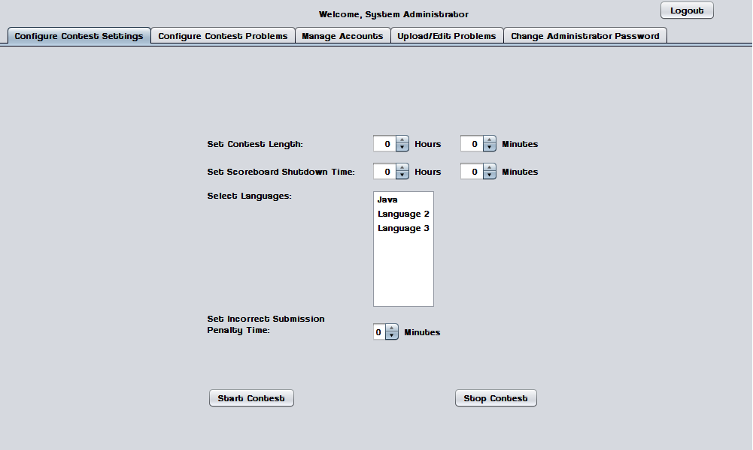

3.1.5.8 Configure Contest Settings – Contest started
When a contest is started many settings cannot be changed until the contest ends or it is stopped by the System Administrator.
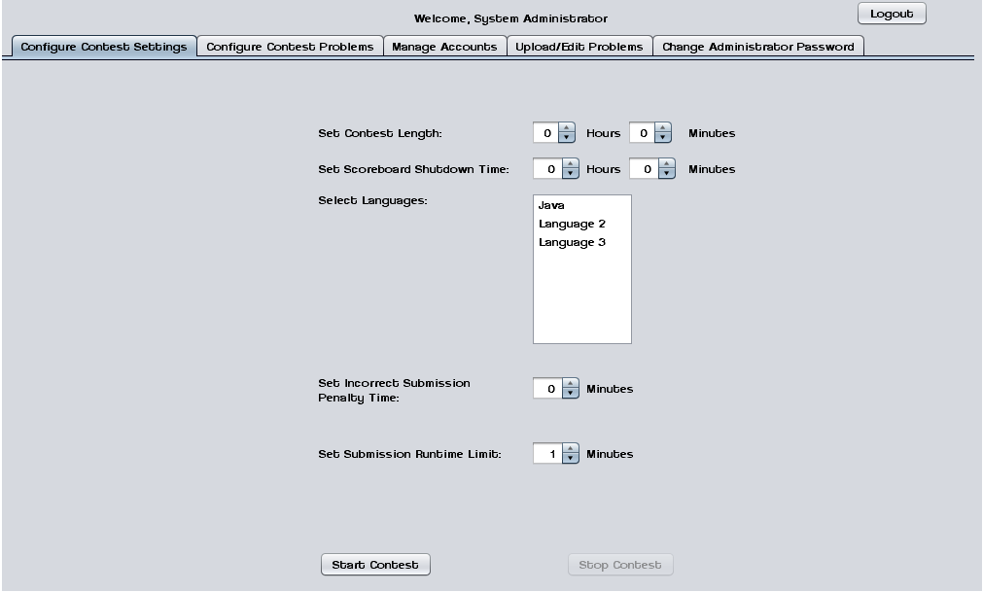

3.1.5.9 Invalid Contest Length Error
This error message appears when the System Administrator tries to start a contest with a duration of less than one minute.
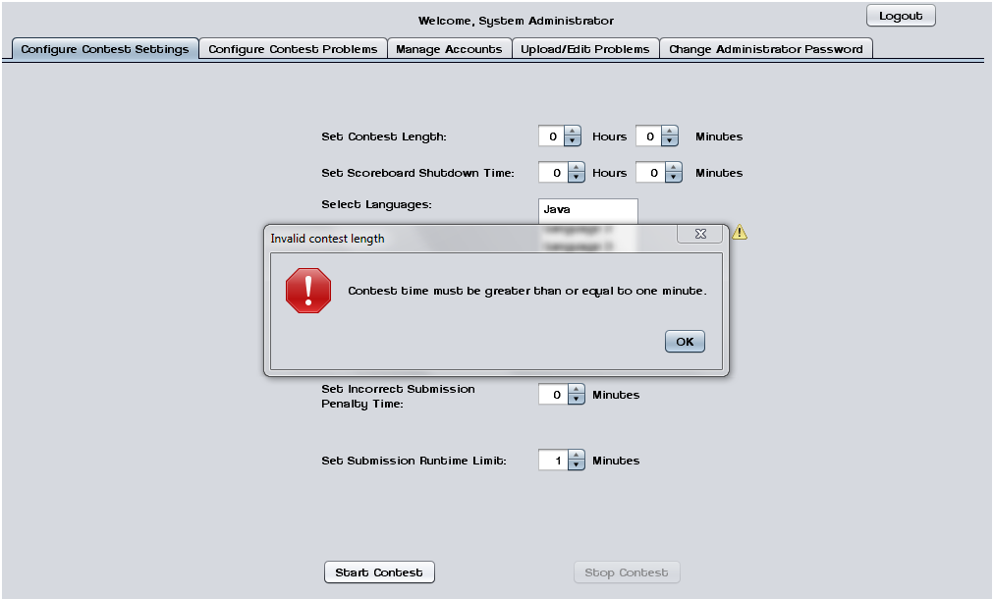

3.1.5.10 Invalid Selection Error
This error message appears when the System Administrator tries to start a contest without any languages selected.
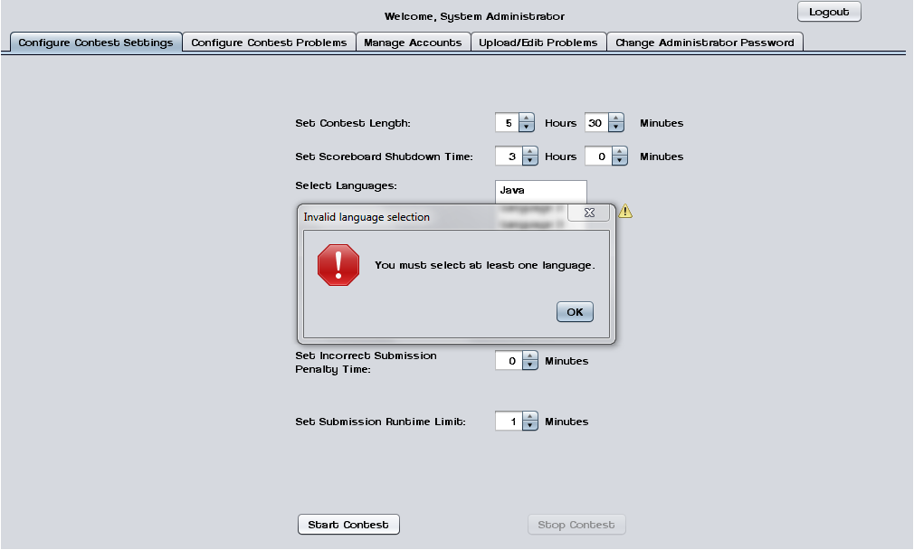

3.1.5.11 Manage Accounts
This screen shows the general interface that the System Administrator uses to manage user accounts.
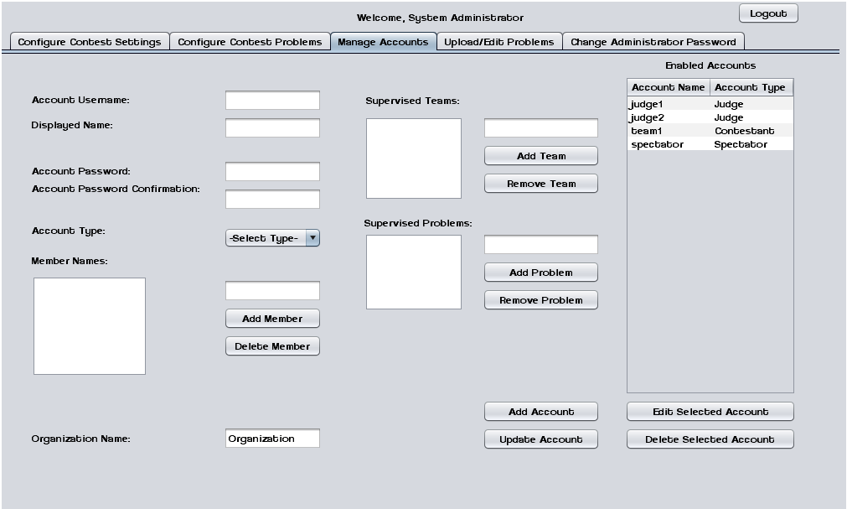

3.1.5.12 Manage Accounts – Contestants
This screen shows the System Administrator managing a Contestant account.
Contestants may have multiple human member names and an organization/school name.
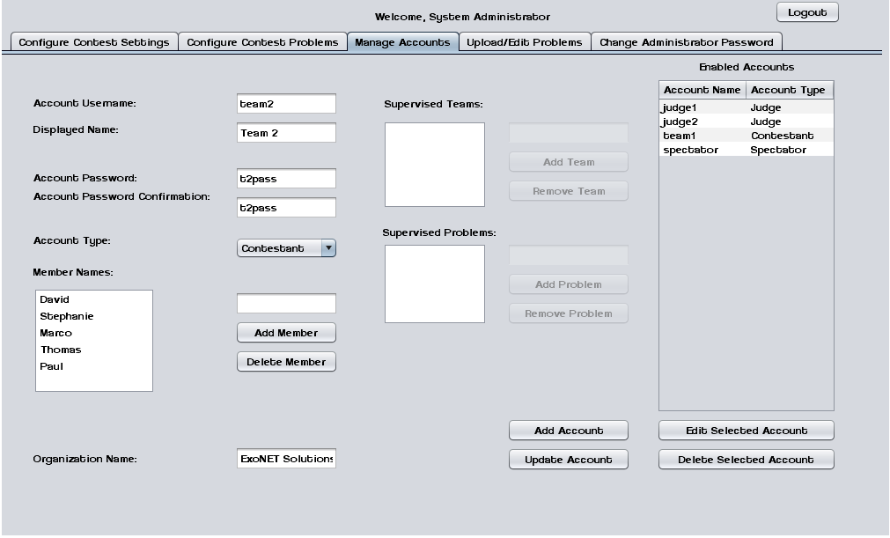

3.1.5.13 Manage Accounts – Judges
This screen shows the System Administrator managing a Judge account. Judges may supervise submissions from specific teams and/or supervise specific problems.
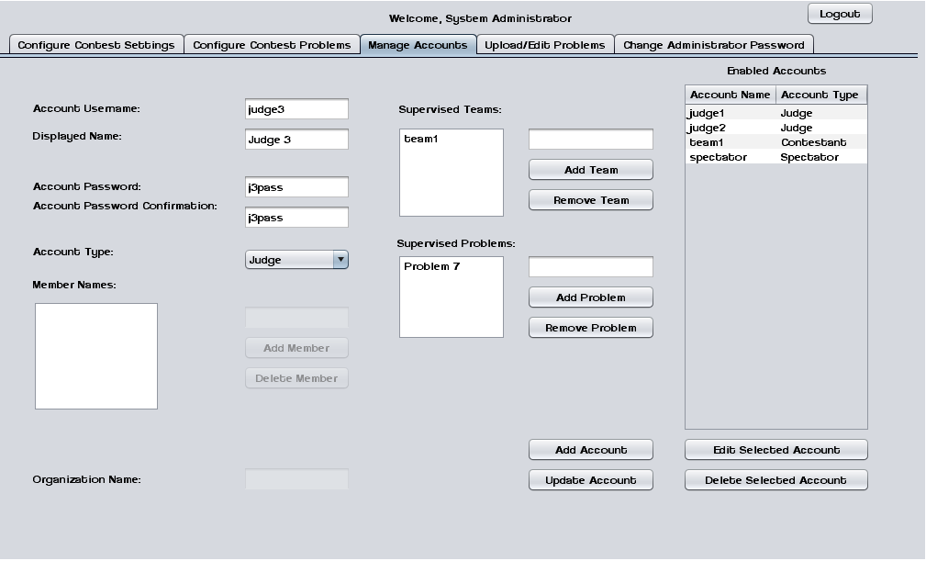

3.1.5.14 Manage Accounts – Spectator
This screen shows the System Administrator managing a Spectator account.
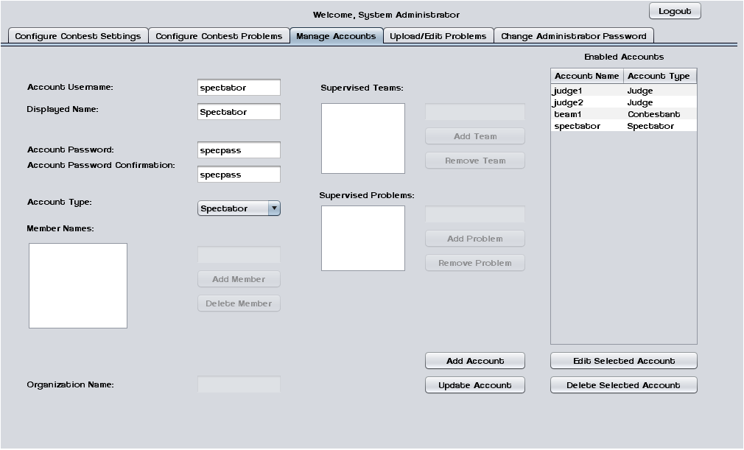

3.1.6 Spectator Screens

3.1.6.1 Problems List
Spectators may select a contest problem to view in an embedded scroll area.
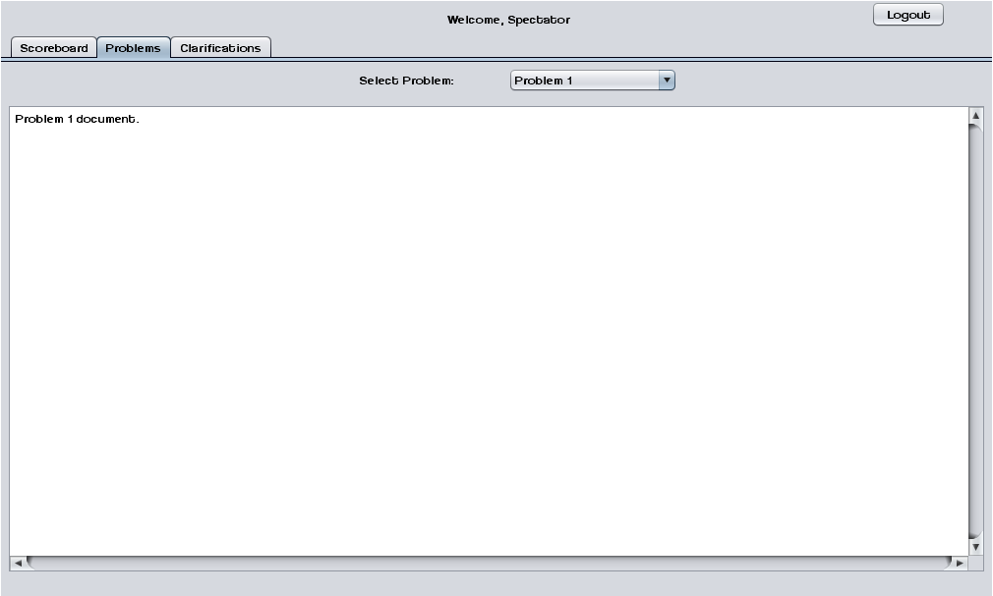

3.1.6.2 Scoreboard View
Spectators may view the contest scoreboard. The scoreboard must be manually refreshed.
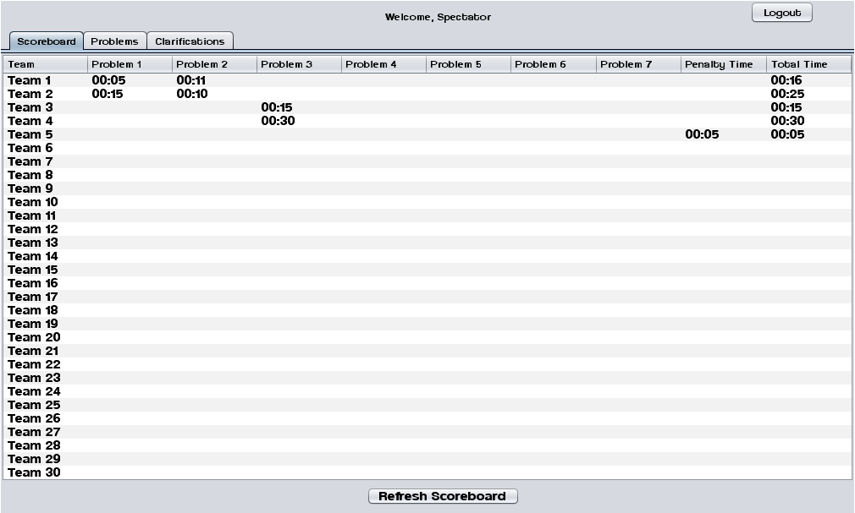

3.1.6.3 View Clarifications
Spectators can view all Clarifications that have been sent out by the Judges.
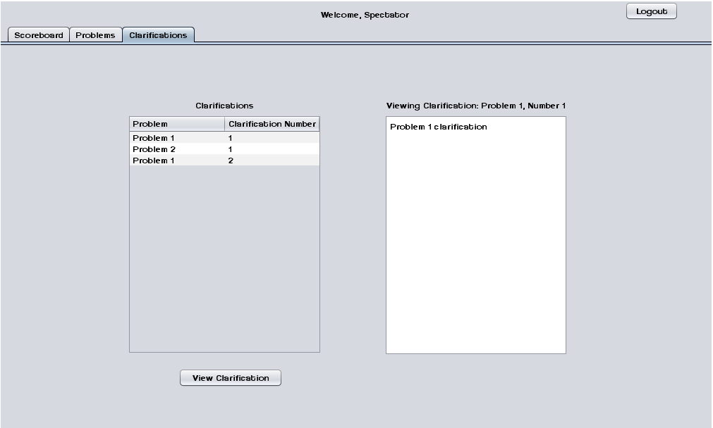

4.1 Testing Plan
A software project test plan is a document detailing a systematic approach to testing a system. It describes the objectives, scope, approach, and focus of a software testing effort. The process of preparing a test plan is a useful way to think through the efforts needed to validate the acceptability of a software product. The completed test plan will serve to help anyone that is not involved in the testing to understand the ‘why’ and ‘how’ of product validation. The test plan documents the approach that will be used to authenticate and make certain that a product or system that is being tested meets the requirements and any other conditions. Software testing can also provide an objective, independent view of the software to allow the business to appreciate and understand the risks of software implementation.

For a detailed description of ExoNET’s testing plan, please see the Test Plan Document.

5.1 Development and Production Environments
Server:
- Operating System: CentOS (Linux) Release 5.2 (Final)
- Server Name: oraserv.cs.siena.edu
- CPU Type: x86_64
- Web Server: Apache Version 2.2.9
- PHP Version: 5.2.6
- Database: MySQL Version 5.0.45; Oracle Version 9.0.1

SE Lab hardware/software specs:
- Dell ACP x86-based PC
- Intel ® Core™ 2 Duo CPU E7500 @ 2.93 Ghz
- Operating System: Windows Vista Enterprise
- Memory: 305.1 GB of total space 258.6 GB free space
- Ram: 4.00 GB
- Network Adapters: Intel(r) 82567LM-3 Gigabit Network Connection
- Display Chip: Intel (R) 4 series Internal Chipset 2.93 GHz
- Browsers: Mozilla FireFox 4.0.1; Internet Explorer 9; Google Chrome; Macromedia Flash, Macromedia Dreamweaver

Marco’s hardware/software specs:
- HDD: 600GB
- Display Adapter: NVIDIA GeForce GTX 285
- DVD/CD ROM:
TSSTcorp CDDVDW SH-S22A SCSI CdRom Device (DVD/CD burner)
ZGFKPUJ 12JKXIR SCSI CdRom Device (DVD/CD burner)
- Logitech HID-Compliant Keyboard
- Logitech HID-Compliant G5 Laser Mouse
- HP 2159 Series Wide LCD Monitor
- Processor: Intel Core i7 CPU 920 @ 2.67 GHz
- Audio: SoundMAX Integrated Digital HD Audio
- Software: Bluej, Netbeans, Microsoft Office, Google Chrome, KompoZer
David’s hardware/software specs:
- Operating System: Windows 7 Home Premium 64-bit (6.1, Build 7601)
System Model: H55M-S2V
- Processor: Intel(R) Core(TM) i3 CPU
- Memory: 4096MB RAM
- Speed: 4 CPUs @ 3.2GHz
- Gimp 2.6
- Paint.NET 3.5.8
- Audacity 1.3
- Netbeans 7.0.1
- Notepad++ 5.9.3
- Google Chrome 14.0.835.163
- Mozilla Firefox 6.0.2
- WinSCP 4.2.9
- PuTTY 0.60

Programming languages used:
- Java
- SQL
- XHTML
- CSS

6.1 Appendices

6.1.1 Appendix A: Glossary of Terms

Actor: An entity in UML Use Case Diagrams and UML Activity Diagrams. It represents the human and non-human external entities (outside the system boundary) that interact with the system.
Apache HTTP Server (Web Server) - Referred to as Apache, it is web server software notable for playing a key role in the initial growth of the World Wide Web.
C++ - (pronounced "see plus plus") is a statically typed, free-form, multi-paradigm, compiled, general-purpose programming language. It is regarded as an intermediate-level language, as it comprises a combination of both high-level and low-level language features.
CACTUS - Java Open Language Toolkit definition project -
A project aimed at providing integrated system for computer programming contests hosted at Siena College.
Cascading Style Sheets (CSS) - A style sheet language used to describe the presentation semantics (the look and formatting) of a document written in a markup language.
Chrome – An Internet browser designed by Google.
Conflict – When an activity can’t be scheduled due to room use, weekend, and one resource being currently in use.
Constraint – When the client specifies that a certain resource must be used, or the project has to be done in a certain way, using certain specifications.
Data Flow Diagram - A graphical representation of the "flow" of data through an information system
Data Flows: A component of a Data Flow Diagram (DFD) that represents the movement of data from an External Entity to a Process or Data Store, and vice versa.
Data Stores: A component of a Data Flow Diagram(DFD) that represents any location in which information or data is stored.
Database - An organized collection of data for one or more uses, typically in digital form.
Dreamweaver – A web development application.
Dropbox - A Web-based file hosting service operated by Dropbox, Inc. which uses cloud computing to enable users to store and share files and folders with others across the Internet using file synchronization.
External Entities: A component of a Data Flow Diagram that represents any human or non-human user of a Software System.
Entity-Relational (ER) Diagram - an abstract and conceptual representation of data; used to represent the logical format of a database
Firefox – An Internet browser designed by Mozilla.
Functional Requirements Inventory: Define what the system will be able to do and what is testable about the system.
Gantt Chart - A type of bar chart that illustrates a project schedule. Gantt charts illustrate the start and finish dates of the terminal elements and summary elements of a project.
HTML (HyperText Markup Language) - The predominant markup language for web pages. It is written in the form of HTML elements consisting of "tags" surrounded by angle brackets within the web page content. It is the building blocks of all basic websites.
HTTP (Hypertext Transfer Protocol) - a protocol used to transfer hypertext requests and information between servers and browsers.
Internet - A global system of interconnected computer networks that use the standard Internet Protocol Suite (TCP/IP) to serve billions of users worldwide. It is a network of networks that consists of millions of private, public, academic, business, and government networks, of local to global scope, that are linked by a broad array of electronic and optical networking technologies.
Internet Explorer (IE) – An Internet browser designed by Microsoft.
Java - a high-level, object-oriented computer programming language used especially to create interactive applications running over the Internet.
JavaScript - An implementation of the ECMAScript language standard and is typically used to enable programmatic access to computational objects within a host environment.
MySQL - A relational database management system that runs as a server providing multi-user access to a number of databases.
PHP (PHP Hypertext Preprocessor) - A widely used, general-purpose “server side” scripting language that was originally designed for web development to produce dynamic web pages.
SQL- structured query language: a computer programming language used for database management
Software: The programs installed on the computer, such as Microsoft Office and Adobe Fireworks.
System: A component of UML Use Case Diagram which represents the Software System.
UML (Unified Modeling Language) Use Case Diagram - a type of behavioral diagram to present a graphical overview of the functionality provided by a system.
Unit Testing – a method by which individual units of source code are tested to determine if they are fit for use. A unit is the smallest testable part of an application.
Use Case: A component of a UML Use Case Diagram which represents any process located within the System that is performable by an Actor.

User Case Narrative: an explanation of the functions and abilities users have for a specific Software System.

Waterfall Model (Classic) - The Classic Waterfall Model is a sequential software development model in which development is seen as flowing steadily downwards (similar to a waterfall) through the phases of requirements analysis, design, implementation, testing, integration, and maintenance.
XHTML (eXtensible Hypertext Markup Language) - A family of XML markup languages that mirror or extend versions of the widely used Hypertext Markup Language (HTML), the language in which web pages are written.
XML (Extensible Markup Language) - A set of rules for encoding documents in machine-readable form. To create a tagging scheme that allows elements of a document to be marked according to their content rather than their format.

6.1.2 Appendix B: Project Timeline (Gantt Chart)
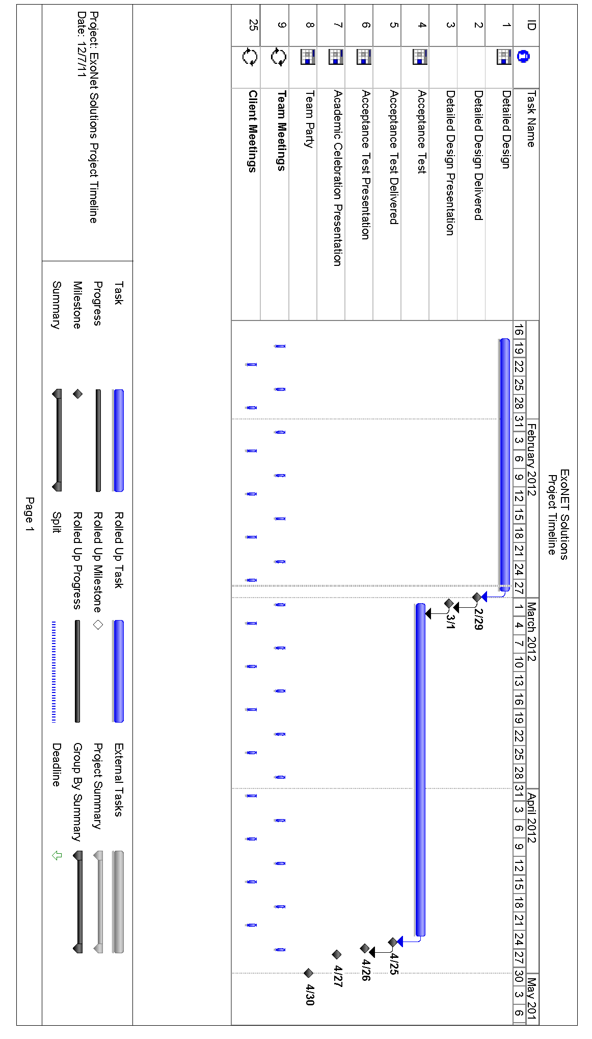

Testing Plan
A software project test plan is a document detailing a systematic approach to testing a system. It describes the objectives, scope, approach, and focus of a software testing effort. The process of preparing a test plan is a useful way to think through the efforts needed to validate the acceptability of a software product. The completed test plan will serve to help anyone that is not involved in the testing to understand the ‘why’ and ‘how’ of product validation. The test plan documents the approach that will be used to authenticate and make certain that a product or system that is being tested meets the requirements and any other conditions. Software testing can also provide an objective, independent view of the software to allow the business to appreciate and understand the risks of software implementation.

1.1 Overview and Strategy
A Test Plan documents the strategy that will be used to verify and ensure that a product meets is design specifications, as well as Functional and Non-functional requirements. The testing will be a multi-step process that consists of activities for validating the software product, from the most primitive elements up to the fully integrated system. This area includes activities such as unit testing, integration testing, system testing, performance testing, and acceptance testing.

Our strategy consists of dividing the project up into separate modules, each with a distinct functionality. Each module has a Unit Test script that is a followed, moving test case by test case to ensure that all parts of the module are thoroughly tested. In order for each unit to be considered ‘passed’ each test case in the unit must pass.

1.2 Test Plan Description
This plan serves as a template for the testing that ExoNET will be performing until the Acceptance Test. Although many of the major aspects are covered in this document, it is by no means finalized; Unit Tests and Test Cases may be added or deleted as necessary to fit the needs of our project, in relation to changes in our software. As tests are performed, the outcome of these tests will be documented to reflect their results. No further alterations will be made after the day of the Acceptance Test.

This Test Plan is the framework for the testing of C.A.C.T.U.S. (Competitive Algorithm Calculation and Testing in a Unified System), by ExoNET Solutions. There are tests for pertaining to all Users in the system; System Administrator, Judge, Contestant, and Spectator user accounts will be the main focus of these tests. There are also a few other Unit Tests that pertain to the overall performance of system. The tests that ExoNET will be managing include:

Unit Test: These will serve as the backbone of our testing plan. Based on testing the functionality of a single action/component of the system, the test serves to check if a particular part of C.A.C.T.U.S. is working as intended (i.e. is free of errors, and fits Acceptance Test Criteria).

Test Case: The Test Case is an individual member of a Unit Test (i.e. many Test Cases make up a Unit Test). Each Test Case tests a specific state of C.A.C.T.U.S., with a specific input and output. Each Test Case has a pass/fail result.

Integration Test: The Integration Test tests combinations of components of C.A.C.T.U.S., with each of these components having a successful Unit Test. The purpose of this test is to ensure that all of the system components work together correctly and efficiently.

System Test: The System Test checks to ensure that the system meets all the Functional Requirements as listed in the Functional Requirements inventory.

Performance Test: The Scalability Test ensures that C.A.C.T.U.S. functions at an acceptable level when a large number of users are using the system concurrently.

Acceptance Test The Acceptance Test validates that the system meets the functional and non-functional requirements as specified in the Requirements Specification (which includes functional and non-functional requirement details).

2.1 Pass/Fail Criteria

2.1.1 Functional Requirements Inventory
The Functional Requirements Inventory will serve as a checklist for our Testing Plan; each of the specifications listed therein will be evaluated by various tests contained in this plan. Each particular test will reflect the intended design specified by Dr. Lim. These tests will have two states: PASSED and FAILED. One of these states will be underlined to reflect the state that each particular requirement is in, displayed to the right of the specified test.

2.1.1.1 System Administrator
- Securely log in and out of C.A.C.T.U.S…………………………….. PASSED/FAILED
- Upload problem solutions, contest problems and test cases………… PASSED/FAILED
- Add/drop Contestants during contest creation……………………… PASSED/FAILED
- Delete and create new Judge, Contestant, Spectator accounts……… PASSED/FAILED
- Administrator will initialize usernames and passwords for each user..PASSED/FAILED
- Change start and stop time for a contest……………………………. PASSED/FAILED
- Administrator will set freeze time for scoreboard………………...... PASSED/FAILED
- Selecting Languages………………………………………………... PASSED/FAILED
- Java will always be a selection choice for the contest……………… PASSED/FAILED

2.1.1.2 Judge
- Securely log in and out of C.A.C.T.U.S……………………………...PASSED/FAILED
- View contest problems……………………………………………….PASSED/FAILED
- Judge will be able to view test cases…………………………………PASSED/FAILED

- View Scoreboard……………………………………………………..PASSED/FAILED
- View chat window…………………………………………………...PASSED/FAILED
- Judge will be able to send broadcast messages to all Contestants…..PASSED/FAILED
- Judge able to accept/decline submissions from Contestants………..PASSED/FAILED

2.1.1.3 Contestant
- Securely log in and log out of C.A.C.T.U.S………………………...PASSED/FAILED
- View contest problems…………………………………………..…..PASSED/FAILED
- View Scoreboard..................................................................................PASSED/FAILED
- View broadcasted messages and chat window……………………..PASSED/FAILED
- Contestants will be able to send messages to assigned Judge………PASSED/FAILED
- Submit and save submissions of source code………………………PASSED/FAILED
- Compile their code…………………………………………………PASSED/FAILED

2.1.1.4 Spectator
- Securely log in and log out of C.A.C.T.U.S……………………….PASSED/FAILED
- View contest problems…………………………………………….PASSED/FAILED
- View Scoreboard………………………………………………….PASSED/FAILED
- View only broadcast messages……………………………………PASSED/FAILED

2.1.2 Non-Functional Requirements Inventory
- Must be easily used (user friendly); not easily measurable at this time.
- Stability; not easily measurable at this time.

2.1.3 Exception Handling
The ultimate goal of project C.A.C.T.U.S. is to create a working system that achieves all of the goals outlined in the Problem Definition of the Software Plan. As part of the system goals, project C.A.C.T.U.S. will include fail-safes that, in the event of an exception error, will handle it without the whole system failing. At this stage of the project, the potential threats to the system are still unknown; however, one of the main issues that will require handling will focus on the loss of data due to an unintentional or unexpected exit of the software. Such an event could be due to error on the part of the system or the user. In either case, C.A.C.T.U.S. will be designed so that the backup of data will be automatic so that it may be recovered in the event of an error.

2.1.4 Testing Approach
C.A.C.T.U.S.’s testing approach will involve a series of various tests to check the system’s compliance with the Functional and Non-Functional Requirements. The first of these will be the Unit Tests, which are displayed below. Each of these tests will challenge each particular portion of C.A.C.T.U.S. that is relevant to the Functional and Non-Functional Requirements. These tests, which are explained in detail in a separate spreadsheet document, will be tested numerous (to be determined) times, in an effort to obtain accurate and reliable test results. These tests will be either passed or failed; there is no “in between”. After all of these Unit Tests are passed satisfactorily, an Integration Test will be put in place to ensure that all of the portions of C.A.C.T.U.S. are meeting the standards put in place by the Functional Requirements Document.

2.1.5 Acceptance Criteria
Acceptance Testing is concerned with knowledge about validating the functional and non- functional requirements of a purchased or acquired system. This unit includes knowledge about techniques for using the contract, the statement of work, the software requirements specification, and the request for proposal to ensure that the delivered system meets all of the requirements (as perceived by the purchasing or acquiring organization).

The Acceptance Criteria will be determined by ExoNET solutions and by the functional requirements inventory listed in section 1.5 of the Detailed Design document. Please keep in mind that these requirements are subject to change and can be added to as more information is gathered. The project will be broken down into units, based on these functional requirements, which will be tested individually. The units will be tested thoroughly until they all pass individual unit testing. Once all the units pass testing they will be brought back together and will be tested as one system.

3.1 Unit Tests
The following is a list of units that will be tested in C.A.C.T.U.S. After all of these tests pass, an Integration Test will follow. Should the Integration Test pass, a System Test will be put in place to ensure that the Functional and Non-Functional Requirements have been met.

Unit Tests are as follows:
Submission
Scoreboard
Authenticate
Database
Chat Window
Configure Contest Settings
Upload

For a more in depth view of these Unit Tests, please refer to Exhibits 1 – 7 of C.A.C.T.U.S. Unit Tests.

3.1.1 Unit Tests and Test Cases
Each Test Case is pertinent to a particular Unit Test. There are many Test Cases for each Unit Test; they are constructed as follows:
- Pass/Fail Status
- Test Number
- Description
- Action to Perform (input)
- Steps to be executed
- State before Test
- Expected Result
- Observed Result
- Comments
- Tested By
- Test Date

At the bottom of each Excel Spreadsheet, there is a Unit Summary, describing the number of tests in the Unit Test, the percentile of passing tests, the number of passed tests, the number of failed tests, and the date of the last test performed.

3.1.2 Performance Test
The Performance Test is used to determine whether or not the system’s performance and responsiveness are acceptable when it is being used by many users at the same time. ExoNET Solutions has communicated with P=NP Solutions regarding a potential Performance Test in the future. This test would entail 40+ users logging into C.A.C.T.U.S., and attempting to run a contest to validate the responsiveness and robustness of the system (S.L.I.C.E. will also be tested on the same day).
The current plan is to obtain enough users on a chosen day to simulate a full scale contest. Currently, this date is tentatively set for sometime in April, 2012. Should this plan commence, a series of tests will be facilitated to effectively run a stability/performance check on C.A.C.T.U.S. Things such as multiple login attempts and multiple submission attempts (within seconds of each other) will be performed in an attempt to ensure that the system’s functionality is unaffected by high traffic (slight lag is acceptable). Chat Window performance and Compiler performance will be evaluated in a similar manner.

