Requirements Specification

Requested by:

Mr. Ken Swarner
System Administrator
Siena College
Computer Science Department

Dr. Tim Lederman
Professor
Siena College
Computer Science Department

RAEMS
Remote Access Environmental Monitoring System

EIN Systems
Environmental Intelligence Network Systems

Prepared by:

Ybelka Brito
Michael Devanandan
Joseph Halvey
Michael Jakubowski
Vernell Mitchell
Anthony Ruotolo

October 25, 2005

Remote Access Environmental Monitoring System

Requirements Specification

Table of Contents

Section 1.1: Product Overview and Summary 2

Section 1.2: Development, Operating, and Maintenance Environments 2

Section 1.3: External Interfaces and Data Flows 2

Section 1.4: Functional Requirements 2

Section 1.5: Performance Requirements 3

Section 1.6: Exception Handling 4

Section 1.7: Early Subsets and implementation Priorities 4

Section 1.8: Foreseeable Modifications and Enhancements 4

Section 1.9: Acceptance Criteria 5

Section 1.10: Testing Requirements 5

Section 1.11: Design Hints and Guidelines 5

Section 1.12: Sources of Information 5

Section 2.1: Mock-Ups 7-13

Section 2.2: Data Flow Diagrams 14-18

Section 2.3 Gantt Chart 19

Section 2.4 Glossary 20

1.1: Product Overview and Summary

With the extreme weather that has ripped through our country recently, people want to make sure their houses are secure when they are not at home. Mr. Swarner and Dr. Lederman have asked EIN Systems to design software which will allow them to access and monitor sensor devices located at their home or office computers. The program will allow a user to check on their devices from a remote location by logging into a website, which will feature a profile of their account and devices. The website will also contain a process for registering new users and setting up their systems. In addition, we will feature automated responses when a user’s sensor enters a user specified danger level. Through the use of our software, users will be able to feel safe and secure that their property is protected when they are not able to ensure it themselves.

1.2: Development, Operating, and Maintenance Environments

The Environmental Monitoring System will be developed for the three major operating systems, Windows, Linux, and Mac OSX, on the Siena College Software Engineering workstations. The web interface will be designed using PHP, and security will be maintained through the use of HTTPS and SSL. The website will be hosted on an Apache Web Server, and device communication will use SNMP. The entire system will be accessible from any internet access point, through all major web browsers. The system will be maintained by two separate administrators, a web administrator and a system administrator.

1.3: External Interfaces and Data Flows

Screen shot mock-ups can be found in Appendix 2.1. Data flow diagrams are located in Appendix 2.2.

1.4: Functional Requirements

The system will serve four users, including the regular or sensored user, the “read only” or remote users, the web administrator, and the system administrator. The following functions are required for our system:

- The system will have a login screen for all authorized users, including regular users, “read only” users, web site administrator and system administrators. The login will also include a link to the registration page for new users.
- The system will have an authentication process to restrict unauthorized people.
- A registration page will take in a new user’s personal and sensor information in order to authenticate them as a regular user with at least a single sensored location.
- Once logged in, regular users will be allowed the ability to access the data from their various sensored locations. They will also be able to make any changes to the settings of their system as well as their profile including:
  - Adding or deleting a sensor for a location.
  - Adding or deleting a location.
  - Changing the warning level for a particular device.
  - Adding or deleting a new regular user account.
  - Adding or deleting a new “read only” user account.
  - Changing their E-mail/Username.
  - Changing their password.
  - Changing their contact information
  - Changing types of events to log
- A guest user, after logging in, will also be allowed to check any data from their sensored locations. However, they will be unable to make any changes to the systems settings.
- An administrator, after being logged in, will have the ability to manage the web site and maintain it.
- The System Administrator will access the database to monitor and maintain the other users’ information from their sensors, their settings, and their profile information, in order to make sure that the system is running smoothly.

1.5: Performance Requirements

In order for our Environmental Monitoring System to perform properly, several constraints and requirements are necessary.

- Our system must be secure. Only authorized personnel can have the ability to
read from and write to our database. Reading and writing privileges will be provided to regular users from the website administrator through the use of usernames and passwords. Reading only privileges will be provided to “read only” users through the same method as regular users. The system must prevent unauthorized users from viewing or tampering with the information stored in our database.

• Our system must be efficient. Working with databases can be difficult if one does not know what they are doing. Our system must be able to quickly access the sensor data needed for each user, which in turn will allow them to check on the sensored location, as well as make any necessary changes.

• Our system must be reliable. We must make sure that everyone that is supposed to have access to the data has the proper access and is able to change the information that they have the ability to change. This reliability function will be looked at during our testing phase, when we make sure that there is an ease of use on any user’s end as well as the code for

1.6: Exception Handling

At times, a user may experience unexpected problems when using our system. To prepare for this, our program will try to resolve the issues if they occur. Exceptions that the system must handle are:

- User does not provide enough information during registration of accounts or devices.
The user must complete all required fields. Required fields will contain necessary information to monitor their system. Failure to complete required fields will result in the program asking them to resubmit their information again with the proper data.
- User forgets username/password
If the user forgets his/her username, verification of the user’s identity will have to be made through use of contacting the website administrator directly before the username can be given out.
If the user forgets his/her password, on-screen information will direct the user in recovering his/her password through means of various security measures.
- Login attempts fail repeatedly
If a user fails to enter the correct login information five times in a row within a short period of time, then the system will recognize this as a possible attempt to breach security. The user will be informed that an e-mail alert about failed logins has been sent to the specified user’s account, and that the IP address where the failed attempts came from will be blocked for an hour.

1.7: Early Subsets and implementation Priorities

The most importable priorities of the system are:

- Being a web-based program
- Accessible by both the FireFox and Internet Explorer web browsers
- Accessible by the Linux, Macintosh OS X and Windows XP operating systems.
- Viewable at 1024 X 768 screen resolution
- Easily adaptable for future development, specifically the incorporation of new devices.
- A client side program to process the data

1.8: Foreseeable Modifications and Enhancements

Future Developments include creating a way for the software to run as a background process in the User’s computer. This would be done in order to eliminate the requirement of having to change the users default web browser home page to our site. Another development may include the addition of new sensoring devices, such as a Carbon monoxide detector or power sensoring device which would require a battery backup for the users computer, but would allow system to send a warning that the power had gone out in the users sensored location.

1.9: Acceptance Criteria

The Environmental Monitoring System will, at minimum, provide the following services to its users:

- Log into the system securely via a log in screen
- Allow new users to register into the system
- Allow regular or sensored users to:
  - Access sensor data
  - Change sensor settings
  - Register or delete sensors
  - Edit their profile
- Allow for an administrator to access, monitor and maintain the web site
- Allow the system administrator to access the database to maintain the users’ data, and make sure the system runs correctly

1.10: Testing Requirements

All functional operations of the website and monitoring software will be tested using major web browsers, on computers running each of the major operating systems. The testing protocol will be developed by EIN Systems with the input and criteria of our clients. Members of our team will be responsible for on-going testing, as we complete sections of development which are necessary to build upon for future development.

1.11: Design Hints and Guidelines

The Environmental Monitoring System will be designed to work with specific monitoring devices that we will be purchased in the near future. Software will be developed and tested with these specific devices, and then expanded to include others. Development will also be specific to the operating system the user has.

1.12: Sources of Information

The majority of information about our software development was acquired through meetings with our clients, Mr. Swarner and Dr. Lederman, as well as through team members’ internet research and group meetings. The main source of information for this document was gleaned from previous years Software Engineering teams including Spartacus Computing Solutions, and Edgetech Development. Additional sources of information include Dr. Lederman’s class lectures and the Software Engineering class textbook Software Engineering: A Practitioner’s Approach 10th Ed by Roger S. Pressman.
2.1: Mock-Ups
SEEN BY: All Users
Home page for site.
Home | Registration | Login | FAQ | About


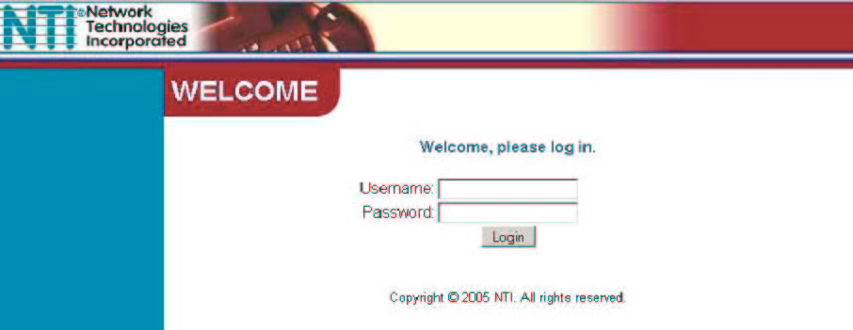
Forgotten Password? Click Here
New User? Click Here

User Testimonials  - Stupendous product! I’ve never felt safer!  Click for more… | Important Information  - Minimum system requirement have been posted here.  - Check FAQ for supported devices before using our service.  News Updates  - Supported devices have been updated. Check the FAQ

Contact Us | Revised 10/18/05 | Policies | Disclaimers

Already have an ID? Sign In.

Fields marked with an asterisk * are required.

Top of Form

Account Setup
* First name: |  | 
* Last name:
* Gender:
* ID (your E-mail address):
* Password:
 |  | Six characters or more; capitalization matters!
* Host Location:

If You Forget Your Password...
* Security question:
* Your answer:
 |  | Four characters or more. Make sure your answer is memorable for you but hard for others to guess!
* Birthday: |  | 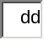 , 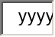
* ZIP/Postal code: |  | 

Seen by: New Users

Description: The page where new users will register for their accounts.

Home | Registration | Login | FAQ | About
Account Home Page

Welcome Mr. Swarner,

Location: Office
Sensors: Reading Status
Thermometer Temp 72 C Enabled
Water Sensor Dry Enabled

Location: Home
Sensors: Reading Status
Motion Detector No Motion Enabled

For additional Device information click here for Monitor Summary page.
Click here to add a new device.
Click here to remove a current device.
Adjust warnings for a device on the Events to Log page.

Contact Us | Revised 10/18/05 | Policies | Disclaimers

SEEN BY: Returning Users
Quick profile of Users account including easy access to locations and devices.
Screen is reached after login and contains links for the majority actions that user will regularly use.

Home | Registration | Login | FAQ | About
Monitor Summary

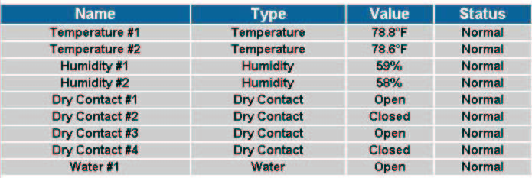

Contact Us | Revised 10/18/05 | Policies | Disclaimers

SEEN BY: Regular or Read-Only Users
In depth monitor summary…a separate page will be available for quick reference of devices grouped by location.

Allows user reference of all devices and their status.

Home | Registration | Login/Logout | FAQ | About
Log

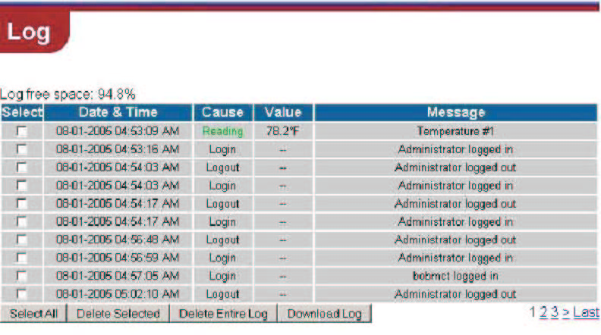

Contact Us | Revised 10/18/05 | Policies | Disclaimers

SEEN BY: All Users
Allows user to reference login/logout information about their account. Includes who logged in, as well as user specified (available on user management page) device logs.

Home | Registration | Login/Logout | FAQ | About
Events to Log

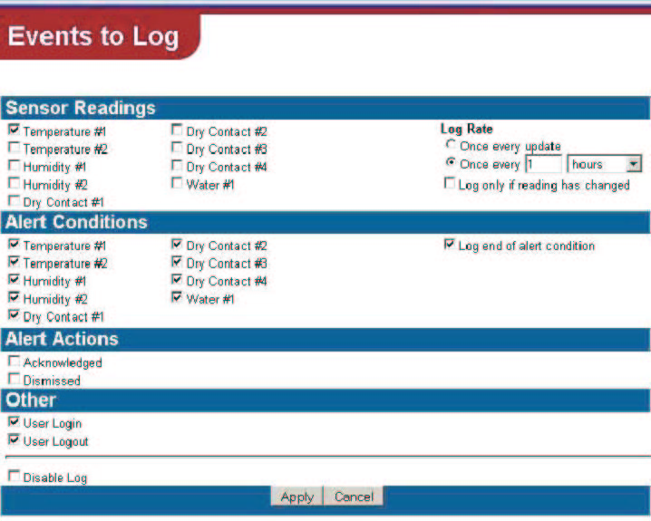

Contact Us | Revised 10/18/05 | Policies | Disclaimers

SEEN BY: Returning User
Allows user to choose device and set the parameters for automated warnings.
Allows for times when automatic log is made of attached devices, or to turn the
log on/off.

Home | Registration | Login/Logout | FAQ | About
User Account Management

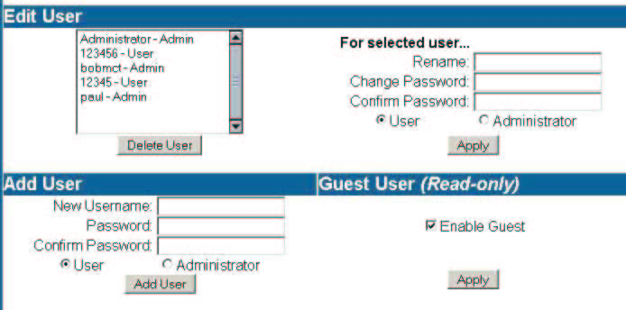

Contact Us | Revised 10/18/05 | Policies | Disclaimers

SEEN BY: Returning Regular User
Lists details of Users personal profile.
Allows for regular user to edit and change their profile.
Allows for regular user to set up account and information for a read-only user.

2.2 Data Flow Diagrams

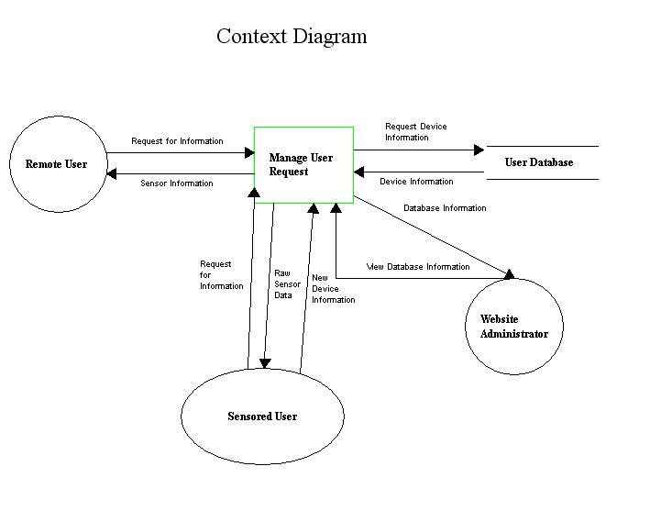

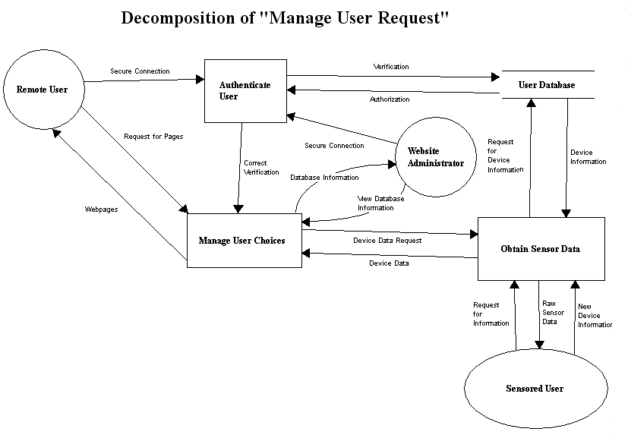
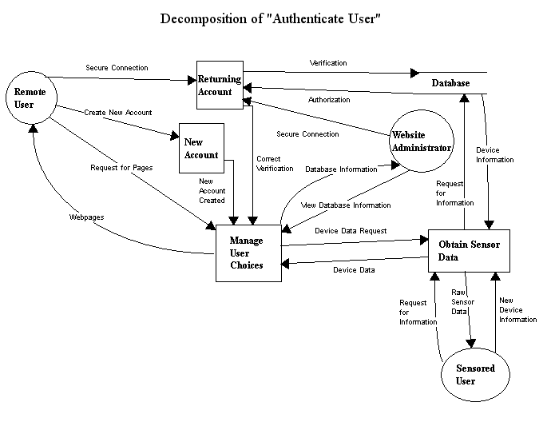

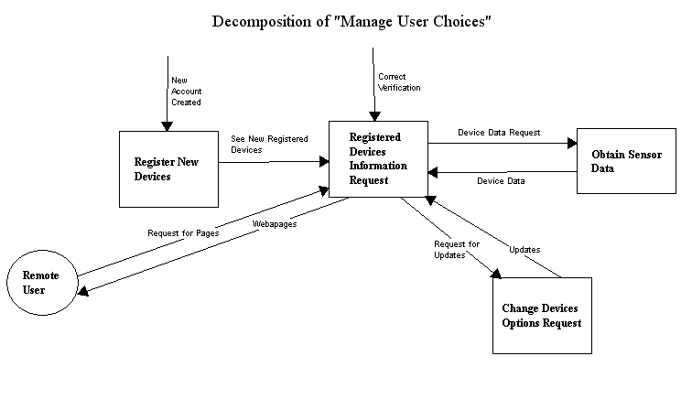

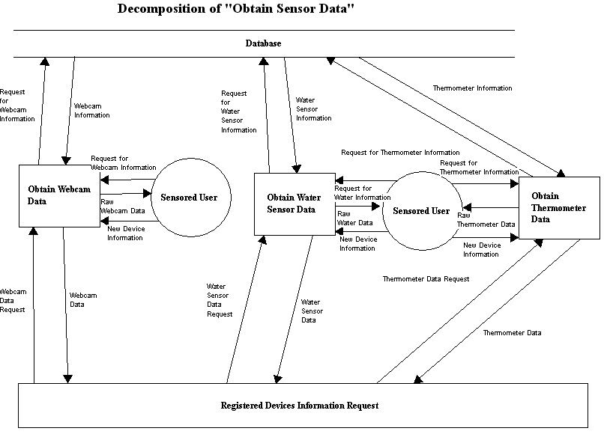
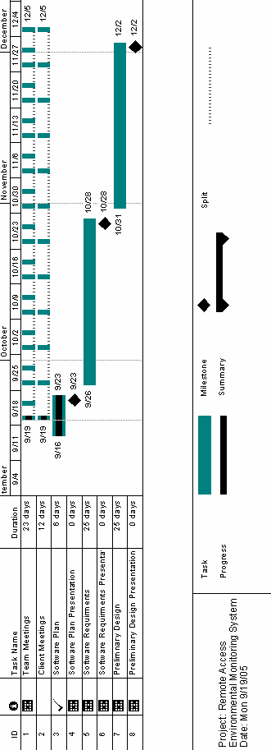
2.3 Gantt Chart
2.4: Glossary

Code – The symbolic arrangement of data or instructions in a computer program or the set of such instructions.

C++ – A compiled object oriented programming language.

Database – A collection of data arranged for ease and speed of search and retrieval.

EIN – Environmental Intelligence Network – Our team name for the six software engineers who will design and implement a home environmental regulation system available over the internet.

Gantt Chart – A chart that depicts progress in relation to time, of ten used in planning and tracking a project.

GUI – Graphical User Interface – An interface, which uses text box’s and buttons to allow easy access of information by a mouse or other input device.

HTML – Hypertext-markup language – HTML is a markup language used to structure text and offers hypertext links between documents. It is the standard of the World Wide Web.

HTTP – Hypertext Transfer Protocol –

HTTPS – Hypertext Transfer Protocol Secure – This is a more secure version of HTTP. It is often used for credit card transactions over the web.

Internet – An interconnected system of networks that connects computers around the world via the TCP/IP protocol.

Java – An object oriented programming language.

PHP – PHP Hypertext Preprocessor – PHP is a widely-used server-sided scripting language and can be embedded into HTML.

SNMP – Simple Network Management Protocol – A protocol which can support monitoring of network-attached devices for any conditions that warrant administrative attention.

SSL – Secure Socket Layer –A cryptographic protocol which provides secure communications on the internet.

