Acceptance Test

Requested by:

Mr. Ken Swarner
System Administrator
Siena College
Computer Science Department

Dr. Tim Lederman
Professor
Siena College
Computer Science Department

RAEMS
Remote Access Environmental Monitoring System

EIN Systems
Environmental Intelligence Network Systems

Prepared by:

Ybelka Brito
Michael Devanandan
Joseph Halvey
Vernell Mitchell
Anthony Ruotolo

May 1, 2006
Environmental Intelligence Network Systems
Remote Access Environmental Monitoring System

Table of Contents
1. Product Overview and Summary...……………………………………….2
2. Deliverables………………………………………………………………2
3. Functional Requirements……………………………………………….2-6
4. User Displays (screenshots)…………………………………….……..6-20
5. User Command Summary ………………….………….......................20-22
6. Environment and Performance Requirements…………………………...22
7. Actual test results……………………………………………………..22-34
Appendices:
Appendix A: Glossary of Terms………………………………………..35-37
Appendix B: Gantt Charts………………………………………………….38

1. Product overview and summary

Our product is a remote access monitoring system, which will allow a user to check the status of many different aspects of the environment in a given location. Our system will use a monitoring device, known as a weather goos, which will have many different sensors which can check for the status of these aspects. These sensoring devices will include a camera with a microphone, thermometer, water sensor, and humidity and door movement detector. The user will be able to check the status of the sensors from a web browser online, by navigating to our website and logging in. The user will receive an email notifying the user of an alert, when one of the devices receives a value that is not within the given thresholds.

2. Deliverables

Our deliverables include a compact disc and a hard copy of the acceptance test document, which is going to be delivered on May 1st, 2006. Included on the compact disc are the executable, source code and any needed data files. Also included on the compact disc is the complete website, with all links to the past documents as well as a README.TXT file that explains what files are where.
.

3. Functional Requirements

Guest User
User with a guest account.
Guest User | Met | Not Met
A guest user’s Web browser is set to the EIN Homepage by default if at a monitored location. | X
A guest user has to open the guest user’s Web browser and navigate to the EIN homepage, if the guest user is at a remote location. | X
A guest user logs into the guest user’s account using the guest user’s username and password. | X
A guest user’s username is the guest user’s E-mail. | X
A guest user’s password consists of 6-12 characters, and includes at least one number, one uppercase letter, one lowercase letter, and at least one of eight recognized special characters shown here within double quotes “#$%^!&*=”. | X
After the guest user has been authenticated, a guest user homepage comes up with a welcome message, as well as a message informing the guest user that the guest user is at a recognized, monitored location if the guest user is at a recognized monitored location. | X
If the guest user is at a remote location, after being authenticated the guest user will be sent to a similar guest user homepage. However, this homepage includes a welcome message, as well as a message informing the guest user that the guest user is at an unrecognized location. | X
On the bottom of the guest user logged-in page for the guest user are the registered locations, the devices associated with each location and the status and the reading for each. | X
The guest user is able to check on the previous status of each device at each location by clicking on the Logs button. | X
The Account, Device, Profile Settings, and New Location buttons are displayed on the navigation bar, however, the buttons will all be grayed out and the guest user is unable to click on any of the buttons. | X

Remote User
Sensored user who is traveling and will be able to check on the status of devices when away from home.
Remote User | Met | Not Met
The remote user opens a web browser and navigates to the EIN homepage. | X
The login page is shown and the remote user’s email address is entered for the username. | X
The remote user also must enter the remote user’s password which is between 6-12 characters long, features at least one number, one capital letter, one lowercase letter, and at least one of eight recognized special characters shown here within double quotes “#$%^!&*=”. | X
After authentication a logged-in page is shown, which welcomes the remote user and states the remote user is at an unknown or unregistered location, | X
At the remote user logged-in page, the remote user is also shown the status of the remote user’s devices, grouped by Location. | X
The New Location button is enabled, allowing the remote user to navigate to a page which will allow the remote user to add a new location, if they have a new device to add at that location. | X
At this New Location page, the remote user must go through a registration process, which after completion will turn them into a sensored user. | X
The remote user cannot make any changes to device or alert settings from an unregistered location. | X
The Account and Device buttons are all displayed on the navigation bar, however the buttons are grayed out and the remote user is unable to click on the buttons. |  | X
The Profile Settings button navigates the remote user to a page that allows the remote user to change the settings associated with the remote user’s online account, including changing the remote user’s E-mail or password. | X

Sensored User
Registered user who is at a monitored location.
Sensored | Met | Not Met
A sensored user’s Web browser is set to the EIN Homepage by default. | X
A sensored user logs into the sensored user’s account using the sensored user’s username and password. | X
A sensored user’s username is the user’s E-mail. | X
A sensored user’s password consists of 6-12 characters, and includes at least one number, one uppercase letter, one lowercase letter, and at least one of eight recognized special characters shown here within double quotes “#$%^!&*=”. | X
After the sensored user has been authenticated, a logged-in screen comes up with a welcome message, as well as a message informing the sensored user that the user is at a recognized, monitored location. | X
Displayed at the bottom of the sensored user’s logged in screen, are the sensored user’s registered locations with the current “at” location highlighted, the devices associated with each location and the status for each. | X
A sensored user also has a navigation bar with buttons that take the sensored user to the different pages on the website which allow the sensored user to change various aspects of the user’s account. | X
The Account button navigates the sensored user to a page that allows the sensored user to add or delete an account, a regular account or a “guest” account. | X
The Device button navigates the sensored user to a page that allows the sensored user to add or delete a device as well as to check the alert status of each device and change the settings of the devices which are associated with the location the sensored user is currently at. | X
The Profile Settings button navigates the sensored user to a page that allows the sensored user to change the settings associated with the sensored user’s online account, including changing the sensored user’s E-mail or password. | X
The Logs button navigates the sensored user to a page that displays the entire alert and event logs in each device’s history. | X
The New Location button, which normally navigates the sensored user to the Web page that allows the user to add a new location, will be grayed out and unable to be selected. |  | X

Site Administrator
Site Administrator | Met | Not Met
The site administrator is responsible for maintaining the database of sensored users as well as for the upkeep and troubleshooting for a sensored user’s software interactions and devices. | X
The site administrator turns on a computer whose IP address is recognized by the EMS system, and opens a Web browser, which has the EIN webpage as its homepage. | X
The login page is shown and the site administrator enters the site administrator’s email address for the username. | X
The site administrator also enters the site administrator’s password which is between 6-12 characters long, features at least one number, one capital letter, one lowercase letter, and at least one of eight recognized special characters shown here within double quotes “#$%^!&*=”. | X
The site administrator page is displayed, including a welcome statement and a message informing the site administrator of the current location. | X
The site administrator page also displays the last 10 lines of recent account events by remote or sensored users, as well as, the last 10 alerts, each displayed with the most recent at the top. | X
The site administrator page also includes a "More" button to view expanded logs of events and alerts. | X
The bottom of the site administrator page has a navigation bar that allows the site administrator to move to a complete list of sensored users, devices, or alerts. | X
The site administrator can click on the Sensored User button on the site administrator navigation bar and arrive at a page where the site administrator can select a sensored user’s account and see the sensored user’s information including locations, devices, system events, account information, and alerts. |  | X
The site administrator can disable user accounts or devices as necessary via the User Information pages. | X
The site administrator can click on the Devices button on his or her navigation bar and navigate to a page where the site administrator can filter the devices by either sensored user’s that have the devices or by the names of the devices. |  | X
The site administrator can click on the Alerts button on the site administrator navigation bar and navigate to a page where the site administrator can view all of the alerts reported for any sensored user to the EMS with most recent displayed at the top. |  | X
The site administrator can filter the alerts by sensored user location, or sensored user device. | X

4. User Displays
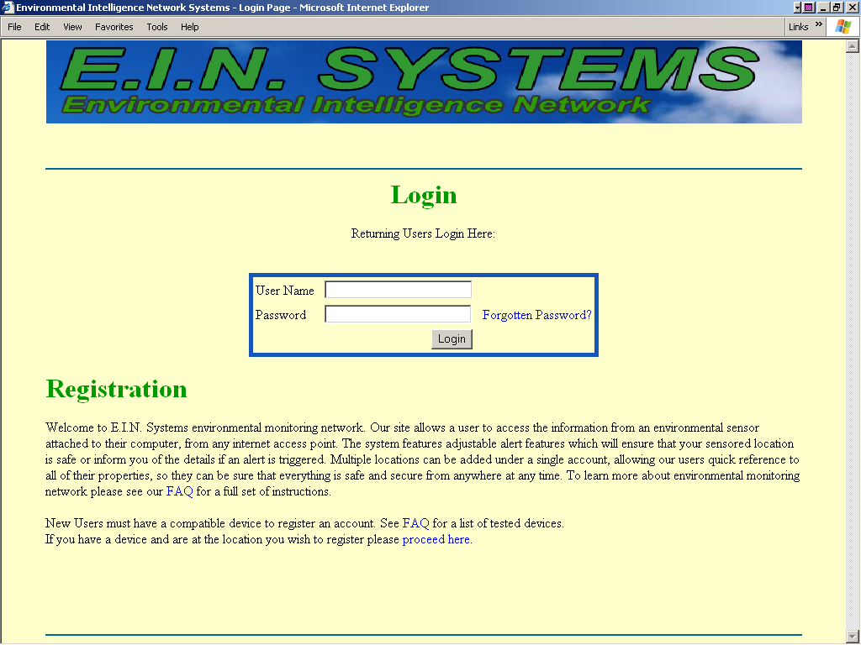
This is the login screen which the user will see after navigating to our website.
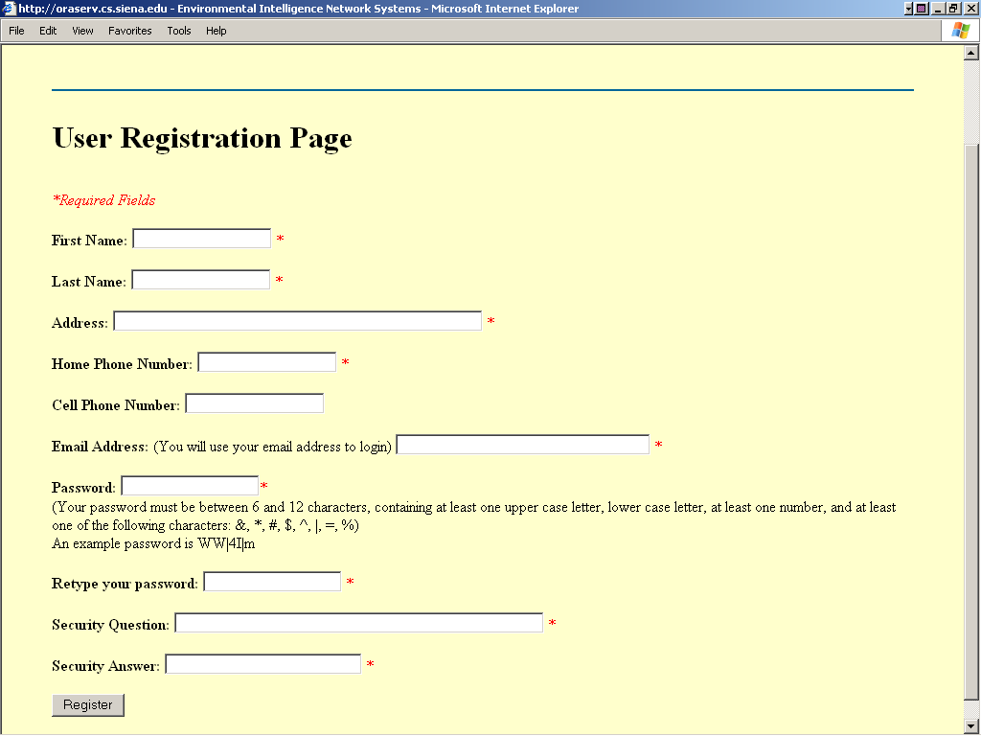
If a user is new, the user will go to the registration page to make an account.
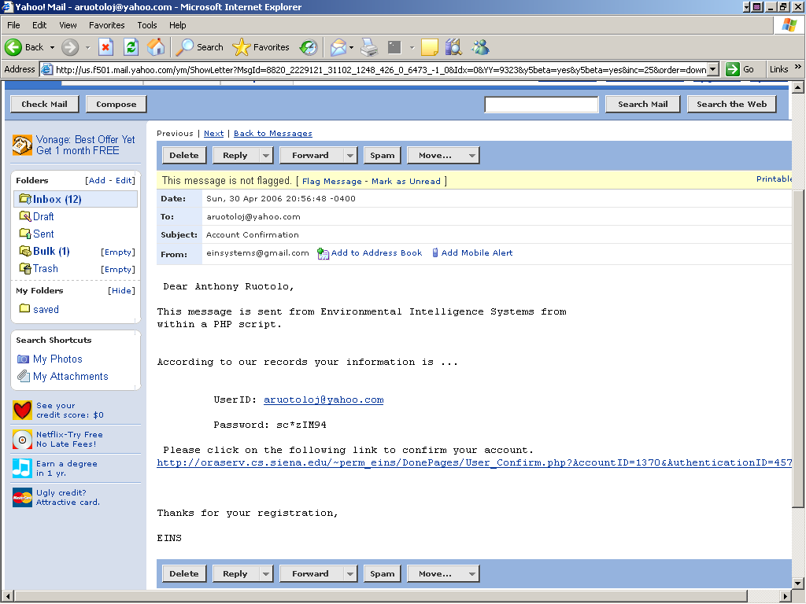
A new user will then be sent an e-mail with a link to activate the user’s account.
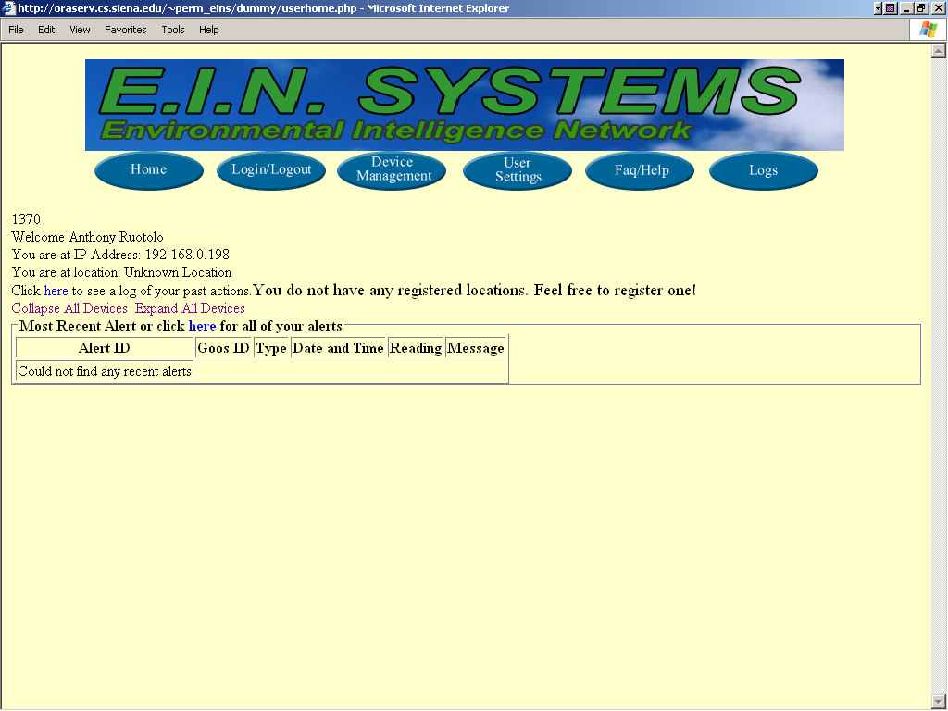
After a new user logs in, the user will be sent to the user home page, where the user’s name and current IP address will be displayed along with a message asking them if the user wishes to register the current location, which is necessary before the user may register any peripherals. The user will however be able to update the user’s information as well as add a guest user to the user’s account.

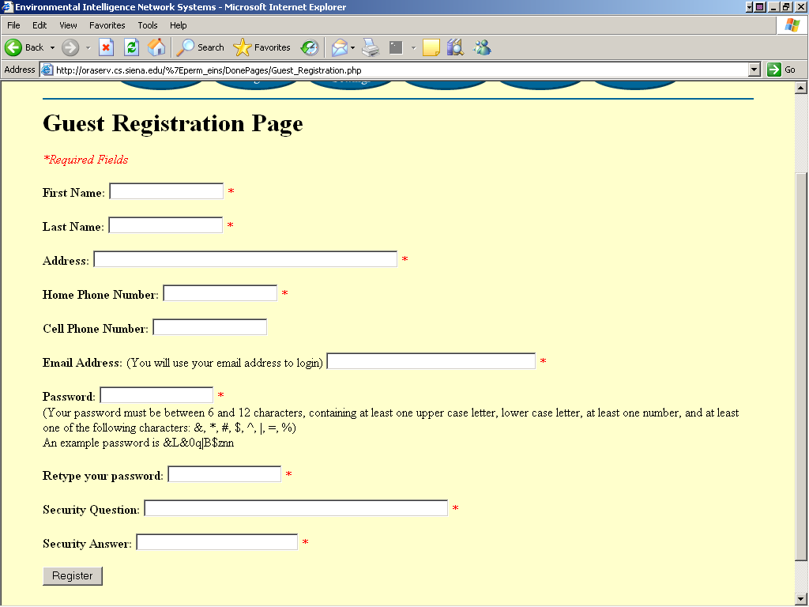

The guest user registration page. A guest user will be able to see the alerts of all of the associated user’s peripherals, but will not be able to change any of the peripheral’s settings.

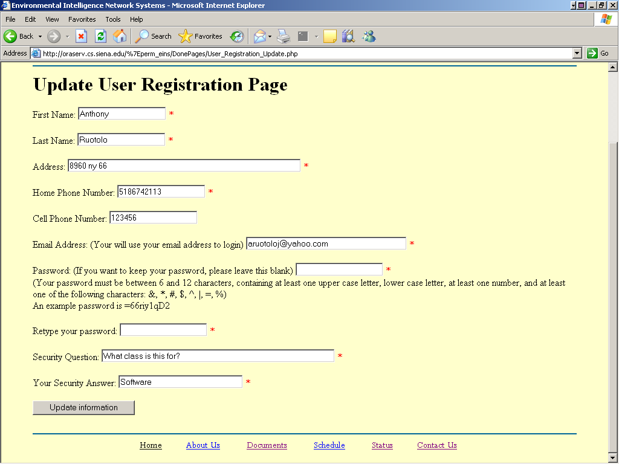
The update user information page

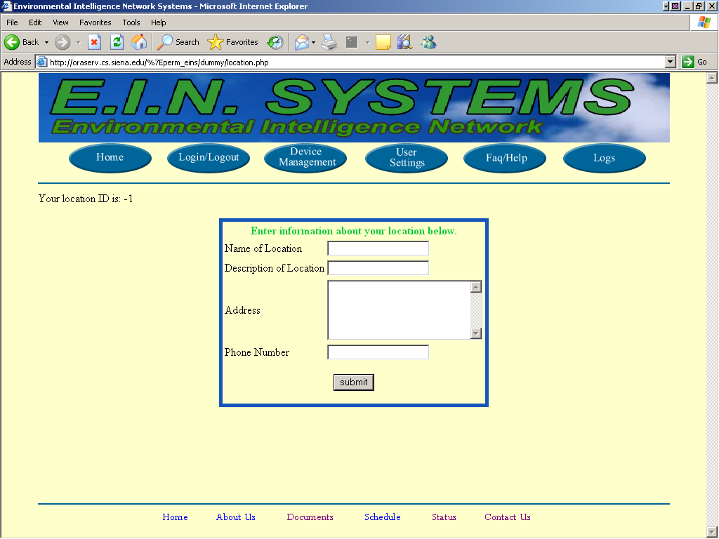
The user will then have to register the user’s current location, in order to add a new Goos and peripherals.

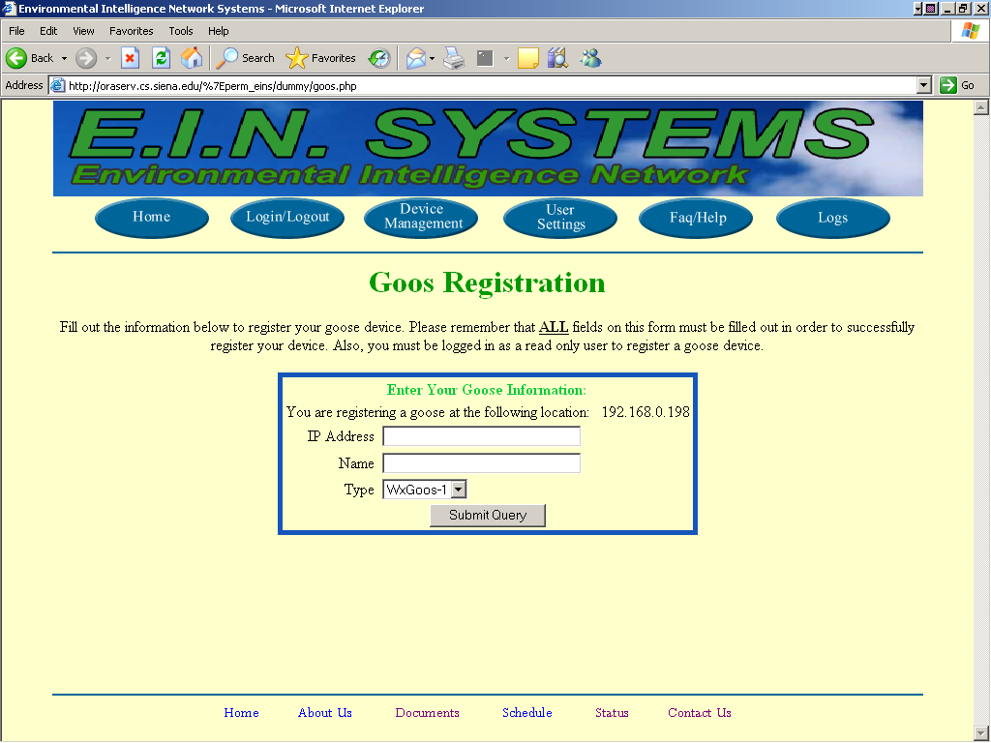
The user will then have to register a Goos, which will have the various peripherals attached to it

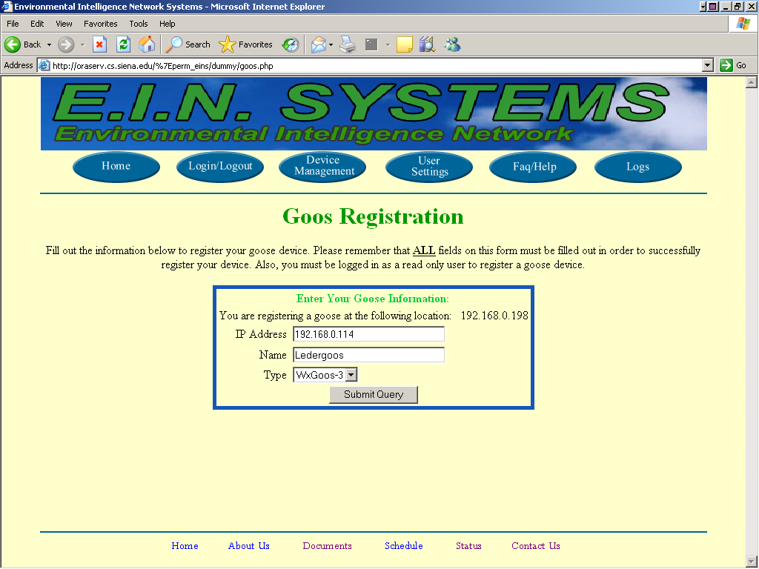
After registering a goos, a user will be able to now register a peripheral.

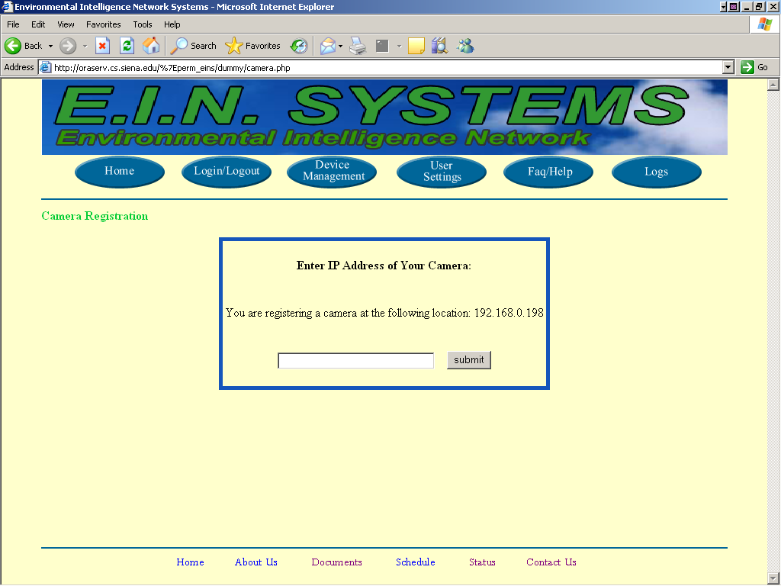
The user will also now be able to register a camera to the user’s account.

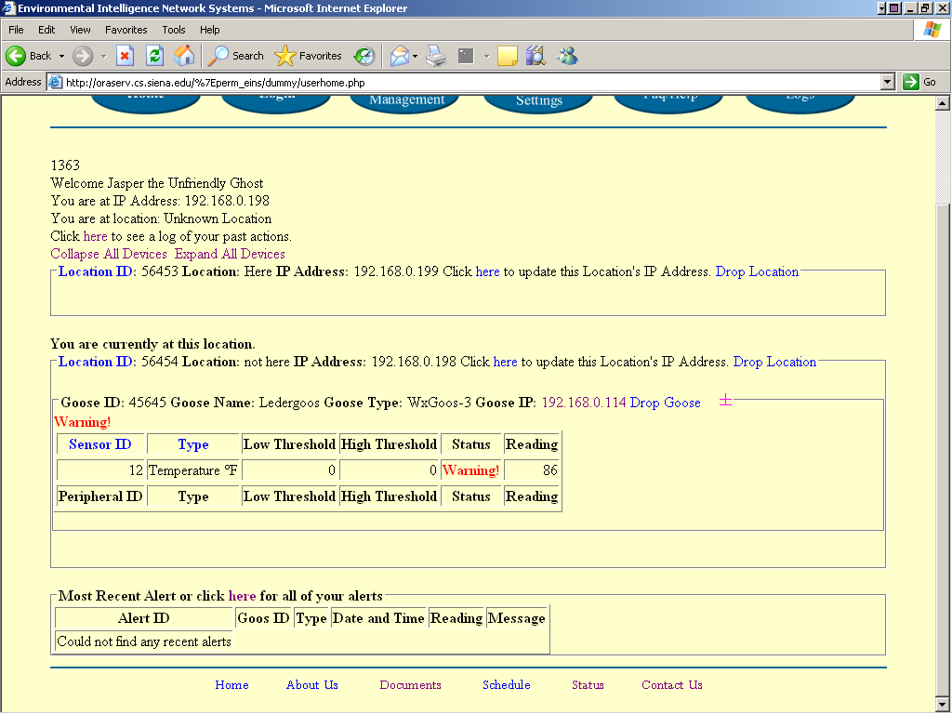
Once a user has registered peripherals, the user will be able to see the user’s readings on the user’s homepage

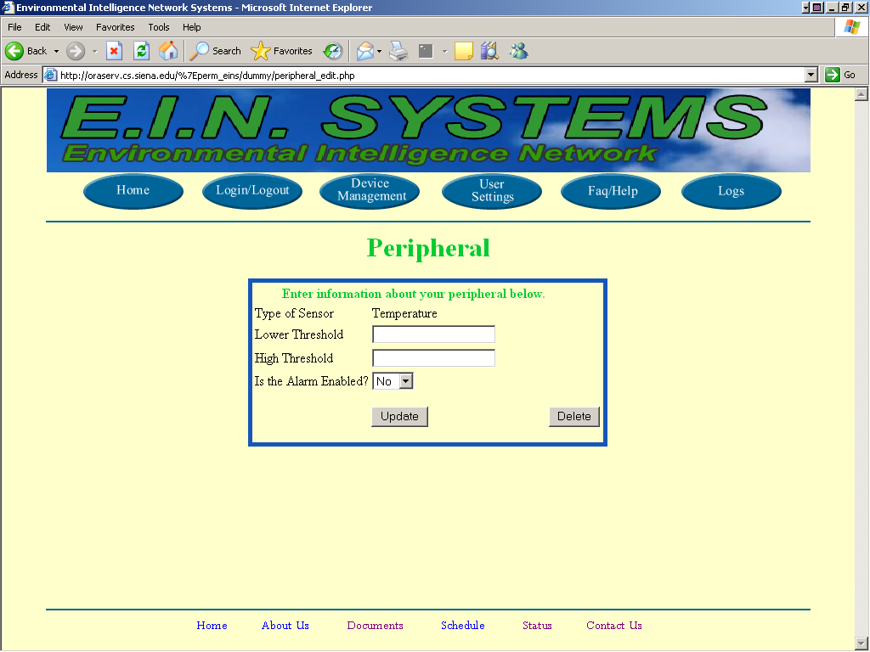
The user can then edit or delete the user’s peripherals from the peripheral editing page.
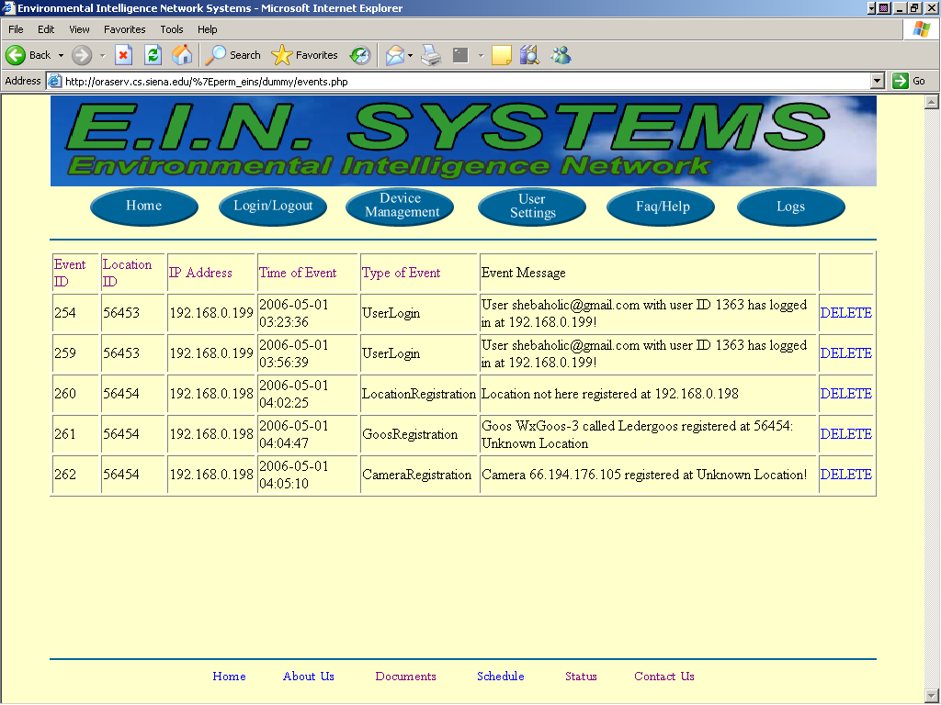
The user can see all of the user’s events at the event logs page.

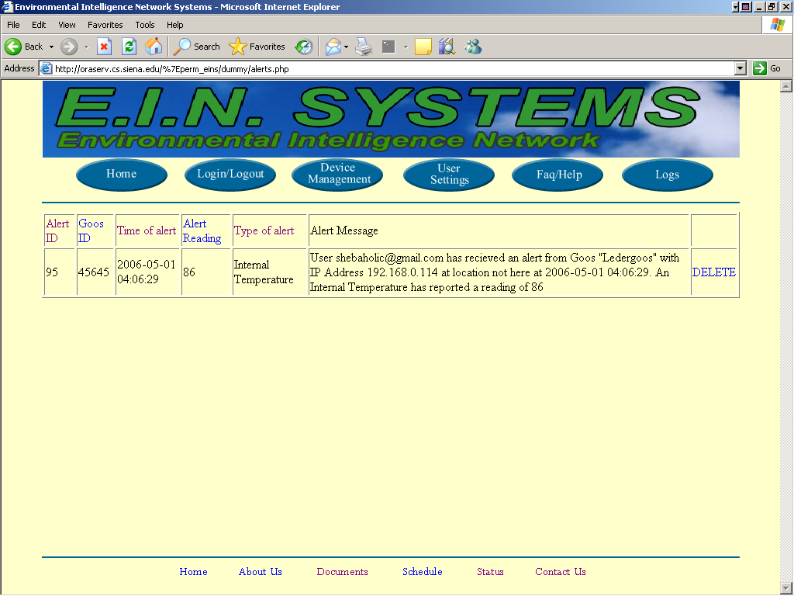
The user will also be able to see a log of all of the user’s alerts at the user alert page.

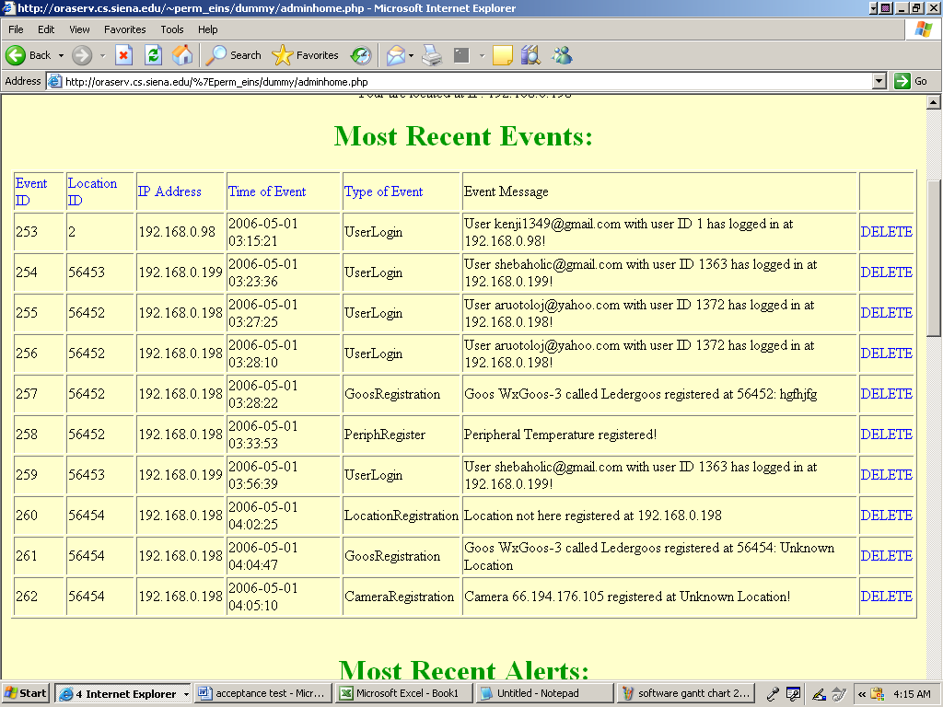
When the Administrator logs on, he is greeted with the Administrator home page.

5. User Command Summary

--Guest User--
A guest user begins by opening the user’s Web browser and navigating to the EIN homepage. The login page will appear asking the guest user to enter the user’s E-mail address for the user’s login and the user’s password which consists of 6-12 characters, and includes at least one number, one uppercase letter, one lowercase letter, and at least one of eight recognized special characters. After being authenticated, the guest user will be sent to the user logged-in screen, which will include a welcome message, as well as a message informing the guest user that the user is at an unrecognized location. Displayed below for the guest user are the registered locations, the devices associated with each location and the status for each. However, a guest user will be unable to access any of the buttons on the navigation toolbar and will only be able to check the status of the devices.

--Remote User--
A remote user is a sensored user who is traveling and will be able to check on the status of devices when away from home. The remote user opens a web browser and navigates to the EIN homepage. The login page is shown and the remote user’s email address is entered for the username followed by the user’s password which is between 6-12 characters long, features at least one number, one capital letter, one lowercase letter, and at least one of eight recognized special characters. After authentication, a logged-in screen is displayed, which welcomes the remote user and states the user is at an unknown or unregistered location. The remote user is also shown the status of the user’s devices, grouped by location. If the remote user has a device and wants to add a new location, the remote user can click on register a new location, and follow the registration process, which will change the remote user to a sensored user. The remote user cannot make any changes to devices or change alert settings from an unregistered location.

--Sensored User--
A sensored user’s Web browser will be set by default to the EIN homepage. Once the web browser is opened, the login page appears and the sensored user will enter the user’s E-mail address for the username followed by the user’s password, which will consist of 6-12 characters, and includes at least one number, one uppercase letter, one lowercase letter, and at least one of eight recognized special characters. Once the sensored user is authenticated, a logged-in screen comes up with a welcome message, as well as a message informing the sensored user that the user is at a recognized, monitored location. Displayed below for the sensored user, are the user’s registered locations, with the current “at” location highlighted, the devices associated with each location and the status for each. A sensored user will have a navigation bar with buttons that will take the sensored user to the different pages on the website which will allow the user to change various aspects of the user’s account. The Account button will take the sensored user to a page that will allow the sensored user to add or delete an account, a regular account or a “guest” account. The Device button will navigate the sensored user to a page, which will allow the sensored user to add or delete a device as well as check the alert status of each device. A sensored user can also change the settings of the devices that are associated with the user's current location. The Profile settings button will navigate the sensored user to a page which will allow the sensored user to change the settings associated with the user’s online account, including changing the sensored user’s E-mail or password. A sensored user may also click on the Logs button that will send the user to a page that will display the entire alert and event logs in each device’s history. However, a sensored user is unable to select the New Location button. This button will send the user to the Web page that would allow the user to add a new location.

--Site Administrator--
The site administrator is responsible for maintaining the database of sensored users as well as upkeep and troubleshooting for a sensored user’s software interaction and devices. The site administrator turns on a computer whose IP address is recognized by the EMS system, and opens a browser that has the EIN webpage as its homepage. The login page is shown and the site administrator enters the site administrator email address for the username followed by an administrator password which is between 6-12 characters long, features at least one number, one capital letter, one lowercase letter, and at least one of eight recognized special characters. The site administrator screen is displayed, including a welcome statement and a message informing the site administrator of the current location. It displays the last 10 lines of recent account activity by remote or sensored users, as well as the last 10 alerts, each displayed with the most recent at the top, and includes a more button to view expanded logs of activity and alerts. The bottom of the page features a navigation bar that allows the site administrator to move to a complete list of sensored users or devices or alerts. The site administrator can click on the Sensored User button on the administrator navigation bar and arrive at a page where the administrator can select a sensored user’s account and see the sensored user’s information including locations, devices, system activity, account information, and alerts. The site administrator can disable user accounts or devices as necessary via the User Information pages. The site administrator can click on the Devices button on the administrator navigation bar and navigate to a page where the administrator can filter the devices by either sensored user’s that have them or by the names of the devices. The site administrator can click on the Alerts button on the administrator navigation bar and navigate to a page where the administrator can view all of the alerts reported for any sensored user to the EMS with most recent displayed at the top. The site administrator can filter the alerts by sensored user location, or sensored user device.

6. Environment and Performance Requirements
The production environment is the environment in which the software will be produced, tested, and implemented. Oraserv is also the name of the machine that is our production environment. Its operation system is Red Hat Enterprise Linux ES release.

7. Actual test results
User Home Page (userhome.php)
Num | Name | ID | Description | State Before Test | State After Test | Input/Test Values | Steps to be Executed | Expected Results | Pass/Fail | Comments
1 | Home Page Link Clicked | Link | Home Page Link is Clicked | userhome.php | userhome.php | None | Load webpage | userhome.php page is loaded automatically | P
2 | Login Link Clicked | Link | Login Link is Clicked | userhome.php | login.php | None | Load webpage | login.php page is loaded automatically | P
3 | Alerts Link Clicked | Link | Alerts Link is Clicked | userhome.php | alerts.php | None | Load webpage | alerts.php page is loaded automatically | P
4 | Events Link Clicked | Link | Events Link is Clicked | userhome.php | user.php | None | Load webpage | events.php page is loaded automatically | P
5 | Reigistration Link Clicked | Link | Registration Link is Clicked | userhome.php | registration.php | None | Load webpage | registration.php page is loaded automatically | P
6 | Faq Link Clicked | Link | Faq Link is Clicked | userhome.php | faq.php | None | Load webpage | faq.php page is loaded automatically | P
7 | Help Link Clicked | Link | Help Link is Clicked | userhome.php | help.php | None | Load webpage | help.php page is loaded automatically | P
8 | Events Link Clicked | Link | Events Link is Clicked | userhome.php | events.php | None | Load webpage | events.php page is loaded automatically | P
9 | Collapse All Link Clicked | Link | Collapse All Link is Clicked | userhome.php | userhome.php | None | Collapses everything on page that can be collapsed | All items that can be collapsed are collapsed on the page | P
10 | Expand All Link Click | Link | Expand All Link is Clicked | userhome.php | userhome.php | None | Expands everything on page that can be expanded | All items that can be expanded are expanded on the page | P
11 | Update Location Link Clicked | Link | Upload Location Link is Clicked | userhome.php | userhome.php | None | Updates IP Address of your location to the one that you are currently at if you need to update it | Updates Location's IP Address to IP Address that you are currently at | P
12 | Drop Goos Link Clicked | Link | Drop Goos Link is Clicked | userhome.php | userhome.php | None | Drops Goos device from your database | Drops Goos device is dropped from your database | P
13 | Toggle Goos Device | Link | Toogle Goos Device | userhome.php | userhome.php | None | Collapses & Expands Visibility of Goos table | Goos Table Collapses & Expands | P
14 | Goos IP Link | Link | Goos IP Link is Clicked | userhome.php | IP Address/Web Site of the Goos Device | None | Shows website of Goos device | Website of Goos device is shown | P
15 | Drop Camera Link Clicked | Link | Drop Camera Link is Clicked | userhome.php | userhome.php | None | Drops camera device from your database | camera device dropped from your database | P
13 | Toggle Camera Device | Link | Toogle Camera Device | userhome.php | userhome.php | None | Collapses & Expands Visibility of Camera table | Camera Table Collapses & Expands | P
14 | Camera IP Link | Link | Camera IP Link is Clicked | userhome.php | IP Address/Web Site of the Camera Device | None | Shows website of Camera device | Website of Camera device is shown | P
15 | Logout Link Clicked | Link | Logout Link is Clicked | userhome.php | screen w/ link to login page | None | User is Logged Out | User is logged out | P
Login Page (login.php)
Num | Name | ID | Description | State Before Test | State After Test | Input/Test Values | Steps to be Executed | Expected Results | Pass/Fail | Comments
7 | Enter User Name | User Name | User enter his/her user name in the user name text box | login.php | login.php | user name | Enter text into User Name text box | User Name text box displays the name that the user has entered | P
8 | Enter Password | Password | User enter his/her password in the password text box | login.php | login.php | password | Enter text into Password text box | Password text box displays the encrypted password that the user has entered | P
9 | Forgotten Password Link Clicked | Link | Forgotten Password Link is Clicked | login.php | Lost_Password_Home.php | None | Load webpage | Lost_Password_Home.php webpage is loaded automatically that helps instructs user how to get a new password | P
10 | Incorrect User Name | User Name | valid, incorrect user name is entered | login.php | Error page | user name, password | Load error webpage | webpage is loaded automatically telling user that his/her authentication attempt was incorrect | P
11 | Incorrect Password | Password | valid, correct user name is entered and valid, incorrect password is entered | login.php | Error page | user name, password | Load error webpage | webpage is loaded automatically telling user that his/her authentication attempt was incorrect | P
12 | Invalid Password | Password | An invalid password is entered | login.php | Error page | user name, password | Load error webpage | webpage is loaded automatically telling user that his/her authentication attempt was incorrect | P
13 | Correct Login | login | valid, correct user name and password is entered | login.php | userhome.php | user name, password | Load webpage | userhome.php page is loaded automatically | P
14 | Login Button Clicked | Button | Login Button is Clicked | login.php | login_action.php | user name, password | Load webpage, submits variables w/in form | login_action.php page is loaded automatically | P
15 | Faq Link Clicked | Link | Faq Link is Clicked | login.php | faq.php | None | Load webpage | faq.php page is loaded automatically | P
16 | New User Registration Link Clicked | Link | New User Registration Link is Clicked | login.php | User_Registration.php | None | Load webpage | User_Registration.php page is loaded automatically for a new user can create a new account | P
User Alerts Page (alerts.php)
Num | Name | ID | Description | State Before Test | State After Test | Input/Test Values | Steps to be Executed | Expected Results | Pass/Fail | Comments
1 | Home Page Link Clicked | Link | Home Page Link is Clicked | alerts.php | userhome.php | None | Load webpage | userhome.php page is loaded automatically | P
2 | Login Link Clicked | Link | Login Link is Clicked | alerts.php | login.php | None | Load webpage | login.php page is loaded automatically | P
3 | Alerts Link Clicked | Link | Alerts Link is Clicked | alerts.php | alerts.php | None | Load webpage | alerts.php page is loaded automatically | P
4 | Events Link Clicked | Link | Events Link is Clicked | alerts.php | user.php | None | Load webpage | events.php page is loaded automatically | P
5 | Reigistration Link Clicked | Link | Registration Link is Clicked | alerts.php | registration.php | None | Load webpage | registration.php page is loaded automatically | P
6 | Faq Link Clicked | Link | Faq Link is Clicked | alerts.php | faq.php | None | Load webpage | faq.php page is loaded automatically | P
7 | Help Link Clicked | Link | Help Link is Clicked | alerts.php | help.php | None | Load webpage | help.php page is loaded automatically | P
8 | Alert ID Link | Link | Alert ID link is Clicked | alerts.php | alerts.php | None | Sorts Table by Alert ID | Alerts table is sorted by Alert ID | P
9 | Goos ID Link | Link | Goos ID link is Clicked | alerts.php | alerts.php | None | Sorts Table by Goos ID | Goos table is sorted by Goos ID | P
10 | Time Of Alert Link | Link | Time of Alert link is Clicked | alerts.php | alerts.php | None | Sorts Table by Time of Alert | Alerts table is sorted by Time of Alert | P
11 | Alert Reading Link | Link | Alert Reading link is Clicked | alerts.php | alerts.php | None | Sorts Table by Alert Reading | Alerts table is sorted by Alert Reading | P
12 | Type of Alert Link | Link | Type of Alert link is Clicked | alerts.php | alerts.php | None | Sorts Table by Type of Alert | Alerts table is sorted by Type of Alert | P
13 | Delete Alert Link Clicked | Link | Delete Alert Link is Clicked | alerts.php | alerts.php | None | Deletes Alert | Alert is deleted from the database | P
14 | Logout Link Clicked | Link | Logout Link is Clicked under its location | alerts.php | alerts.php | None | Load webpage | logout.php page is loaded automatically | P
User Events Page (events.php)
Num | Name | ID | Description | State Before Test | State After Test | Input/Test Values | Steps to be Executed | Expected Results | Pass/Fail | Comments
1 | Home Page Link Clicked | Link | Home Page Link is Clicked | events.php | userhome.php | None | Load webpage | userhome.php page is loaded automatically | P
2 | Login Link Clicked | Link | Login Link is Clicked | events.php | login.php | None | Load webpage | login.php page is loaded automatically | P
3 | Alerts Link Clicked | Link | Alerts Link is Clicked | events.php | events.php | None | Load webpage | alerts.php page is loaded automatically | P
4 | Events Link Clicked | Link | Events Link is Clicked | events.php | events.php | None | Load webpage | events.php page is loaded automatically | P
5 | Reigistration Link Clicked | Link | Registration Link is Clicked | events.php | events.php | None | Load webpage | registration.php page is loaded automatically | P
6 | Faq Link Clicked | Link | Faq Link is Clicked | events.php | events.php | None | Load webpage | faq.php page is loaded automatically | P
7 | Help Link Clicked | Link | Help Link is Clicked | events.php | events.php | None | Load webpage | help.php page is loaded automatically | P
8 | Event ID Link | Link | Event ID link is Clicked | events.php | events.php | None | Sorts Table by Event ID | Events table is sorted by Event ID | P
9 | Location ID Link | Link | Location ID link is Clicked | events.php | events.php | None | Sorts Table by Location ID | Location table is sorted by Location ID | P
10 | IP Address Link | Link | IP Address link is Clicked | events.php | events.php | None | Sorts Table by IP Address | Events table is sorted by IP Address | P
11 | Time of Event Link | Link | Time of Event link is Clicked | events.php | events.php | None | Sorts Table by Time of Event | Events table is sorted by Time of Event | P
12 | Type of Event Link | Link | Type of Event link is Clicked | events.php | events.php | None | Sorts Table by Type of Event | Events table is sorted by Type of Event | P
13 | Delete Event Link Clicked | Link | Delete Event Link is Clicked | events.php | events.php | None | Deletes Event | Event is deleted from the database | P
14 | Logout Link Clicked | Link | Logout Link is Clicked under its location | events.php | screen w/ link to login.php | None | User is Logged out | logout.php page is loaded automatically logging the user out | P
FAQ Page (faq.php)
Num | Name | ID | Description | State Before Test | State After Test | Input/Test Values | Steps to be Executed | Expected Results | Pass/Fail | Comments
1 | Home Page Link Clicked | Link | Home Page Link is Clicked | faq.php | userhome.php | None | Load webpage | userhome.php page is loaded automatically | P
2 | Login Link Clicked | Link | Login Link is Clicked | faq.php | login.php | None | Load webpage | login.php page is loaded automatically | P
3 | Alerts Link Clicked | Link | Alerts Link is Clicked | faq.php | alerts.php | None | Load webpage | alerts.php page is loaded automatically | P
4 | Events Link Clicked | Link | Events Link is Clicked | faq.php | user.php | None | Load webpage | events.php page is loaded automatically | P
5 | Reigistration Link Clicked | Link | Registration Link is Clicked | faq.php | faq.php | None | Load webpage | registration.php page is loaded automatically | P
6 | Faq Link Clicked | Link | Faq Link is Clicked | faq.php | faq.php | None | Load webpage | faq.php page is loaded automatically | P
7 | Help Link Clicked | Link | Help Link is Clicked | faq.php | help.php | None | Load webpage | help.php page is loaded automatically | P
Help Page (help.php)
Num | Name | ID | Description | State Before Test | State After Test | Input/Test Values | Steps to be Executed | Expected Results | Pass/Fail | Comments
1 | Home Page Link Clicked | Link | Home Page Link is Clicked | help.php | userhome.php | None | Load webpage | userhome.php page is loaded automatically | P
2 | Login Link Clicked | Link | Login Link is Clicked | help.php | login.php | None | Load webpage | login.php page is loaded automatically | P
3 | Alerts Link Clicked | Link | Alerts Link is Clicked | help.php | alerts.php | None | Load webpage | alerts.php page is loaded automatically | P
4 | Events Link Clicked | Link | Events Link is Clicked | help.php | user.php | None | Load webpage | events.php page is loaded automatically | P
5 | Reigistration Link Clicked | Link | Registration Link is Clicked | help.php | faq.php | None | Load webpage | registration.php page is loaded automatically | P
6 | Faq Link Clicked | Link | Faq Link is Clicked | help.php | faq.php | None | Load webpage | faq.php page is loaded automatically | P
7 | Help Link Clicked | Link | Help Link is Clicked | help.php | help.php | None | Load webpage | help.php page is loaded automatically | P
8 | Logout Link Clicked | Link | Logout Link is Clicked under its location | help.php | logout.php | screen w/ login.php link | user is logged out | user is logged out | P
Camera Registration Page (camera.php)
Num | Name | ID | Description | State Before Test | State After Test | Input/Test Values | Steps to be Executed | Expected Results | Pass/Fail | Comments
1 | Home Page Link Clicked | Link | Home Page Link is Clicked | camera.php | userhome.php | None | Load webpage | userhome.php page is loaded automatically | P
2 | Login Link Clicked | Link | Login Link is Clicked | camera.php | login.php | None | Load webpage | login.php page is loaded automatically | P
3 | Alerts Link Clicked | Link | Alerts Link is Clicked | camera.php | alerts.php | None | Load webpage | alerts.php page is loaded automatically | P
4 | Events Link Clicked | Link | Events Link is Clicked | camera.php | user.php | None | Load webpage | events.php page is loaded automatically | P
5 | Reigistration Link Clicked | Link | Registration Link is Clicked | camera.php | faq.php | None | Load webpage | registration.php page is loaded automatically | P
6 | Faq Link Clicked | Link | Faq Link is Clicked | camera.php | faq.php | None | Load webpage | faq.php page is loaded automatically | P
7 | Help Link Clicked | Link | Help Link is Clicked | camera.php | help.php | None | Load webpage | help.php page is loaded automatically | P
8 | Logout Link Clicked | Link | Logout Link is Clicked | camera.php | logout.php | None | Load webpage | logout.php page is loaded automatically | P
9 | Camera IP Entered | Camera IP | IP Address of User's Camera is entered in text box | camera.php | camera.php | IP of User's Camera | Enter Camera IP Address into text box | IP Address of user's camera is shown in the text box as entered | P
10 | Submit Button Clicked | Button | Submit Button is Clicked | camera.php | camera_action.php | user name, password | Load webpage, submits variables w/in form | camera_action.php page is loaded automatically | P
Add Location Page (location.php)
Num | Name | ID | Description | State Before Test | State After Test | Input/Test Values | Steps to be Executed | Expected Results | Pass/Fail | Comments
1 | Home Page Link Clicked | Link | Home Page Link is Clicked | location.php | userhome.php | None | Load webpage | userhome.php page is loaded automatically | P
2 | Login Link Clicked | Link | Login Link is Clicked | location.php | login.php | None | Load webpage | login.php page is loaded automatically | P
3 | Alerts Link Clicked | Link | Alerts Link is Clicked | location.php | alerts.php | None | Load webpage | alerts.php page is loaded automatically | P
4 | Events Link Clicked | Link | Events Link is Clicked | location.php | user.php | None | Load webpage | events.php page is loaded automatically | P
5 | Reigistration Link Clicked | Link | Registration Link is Clicked | location.php | faq.php | None | Load webpage | registration.php page is loaded automatically | P
6 | Faq Link Clicked | Link | Faq Link is Clicked | location.php | faq.php | None | Load webpage | faq.php page is loaded automatically | P
7 | Help Link Clicked | Link | Help Link is Clicked | location.php | help.php | None | Load webpage | help.php page is loaded automatically | P
8 | Logout Link Clicked | Link | Logout Link is Clicked | location.php | logout.php | None | Load webpage | logout.php page is loaded automatically | P
9 | Location Name Entered | Location Name | Name of User's Location is entered in text box | location.php | location.php | name of location | Enter text into Location Name text box | name of user's new location is shown in the text box as entered | P
9 | Location Description Entered | Location Description | Description of User's Location is entered in text box | location.php | location.php | description of location | Enter text into Location Description text box | description of user's new location is shown in the text box as entered | P
10 | Address Entered | Address | Address of User's Location is entered in text box | location.php | location.php | address of location | Enter text into address text box | address of user's new location is shown in the text box as entered | P
11 | Phone Number Entered | Location Phone Number | Phone # of User's Location is entered in text box | location.php | location.php | phone # of location | Enter text into Location phone # text box | phone # of user's new location is shown in the text box as entered | P
12 | Submit Button Clicked | Button | Submit Button is Clicked | location.php | location_action.php | name, description, address, phone number | Load webpage, submits variables w/in form | location_action.php page is loaded automatically | P
Goos Registration Page (goos.php)
Num | Name | ID | Description | State Before Test | State After Test | Input/Test Values | Steps to be Executed | Expected Results | Pass/Fail | Comments
1 | Home Page Link Clicked | Link | Home Page Link is Clicked | goos.php | userhome.php | None | Load webpage | userhome.php page is loaded automatically | P
2 | Login Link Clicked | Link | Login Link is Clicked | goos.php | login.php | None | Load webpage | login.php page is loaded automatically | P
3 | Alerts Link Clicked | Link | Alerts Link is Clicked | goos.php | alerts.php | None | Load webpage | alerts.php page is loaded automatically | P
4 | Events Link Clicked | Link | Events Link is Clicked | goos.php | user.php | None | Load webpage | events.php page is loaded automatically | P
5 | Reigistration Link Clicked | Link | Registration Link is Clicked | goos.php | faq.php | None | Load webpage | registration.php page is loaded automatically | P
6 | Faq Link Clicked | Link | Faq Link is Clicked | goos.php | faq.php | None | Load webpage | faq.php page is loaded automatically | P
7 | Help Link Clicked | Link | Help Link is Clicked | goos.php | help.php | None | Load webpage | help.php page is loaded automatically | P
8 | Logout Link Clicked | Link | Logout Link is Clicked | goos.php | logout.php | None | Load webpage | logout.php page is loaded automatically | P
9 | IP Address Entered | Location Description | IP Address of User's Goos is entered in text box | goos.php | goos.php | IP of Goos device | Enter text into IP Address text box | IP Address of user's new goos is shown in the text box as entered | P
9 | Goos Name Entered | Location Name | Name of User's Goos is entered in text box | goos.php | goos.php | name of goos | Enter text into Location Name text box | name of user's new goos is shown in the text box as entered | P
10 | Type of Goos Selected | Drop Down Menu | Type of User's Goos is selected | goos.php | goos.php | type of goos | Select type of goos | goos selected is highlighted | P
11 | Submit Button Clicked | Button | Submit Button is Clicked | goos.php | goos_action.php | name, type, ip address, phone number | Load webpage, submits variables w/in form | goos_action.php page is loaded automatically | P
Peripheral Registration Page (peripheral.php)
Num | Name | ID | Description | State Before Test | State After Test | Input/Test Values | Steps to be Executed | Expected Results | Pass/Fail | Comments
1 | Home Page Link Clicked | Link | Home Page Link is Clicked | peripheral.php | userhome.php | None | Load webpage | userhome.php page is loaded automatically | P
2 | Login Link Clicked | Link | Login Link is Clicked | peripheral.php | login.php | None | Load webpage | login.php page is loaded automatically | P
3 | Alerts Link Clicked | Link | Alerts Link is Clicked | peripheral.php | alerts.php | None | Load webpage | alerts.php page is loaded automatically | P
4 | Events Link Clicked | Link | Events Link is Clicked | peripheral.php | user.php | None | Load webpage | events.php page is loaded automatically | P
5 | Reigistration Link Clicked | Link | Registration Link is Clicked | peripheral.php | faq.php | None | Load webpage | registration.php page is loaded automatically | P
6 | Faq Link Clicked | Link | Faq Link is Clicked | peripheral.php | faq.php | None | Load webpage | faq.php page is loaded automatically | P
7 | Help Link Clicked | Link | Help Link is Clicked | peripheral.php | help.php | None | Load webpage | help.php page is loaded automatically | P
8 | Logout Link Clicked | Link | Logout Link is Clicked | peripheral.php | logout.php | None | Load webpage | logout.php page is loaded automatically | P
10 | Type of Sensor Selected | Drop Down Menu | Type of User's Sensor is selected | peripheral.php | peripheral.php | type of Sensor | Select type of Sensor | Sensor selected is highlighted | P
10 | Low Threshold Entered | Low Threshold | Low Threshold Temp of Goos is selected | peripheral.php | peripheral.php | low threshold of goos | low threshold of peripheral is entered | low threshold of peripheral is entered | P
10 | High Threshold Entered | High Threshold | High Threshold Temp of Goos is selected | peripheral.php | peripheral.php | high threshold of goos | high threshold of peripheral is entered | high threshold of peripheral is entered | P
10 | Enable Alam | Drop Down Menu | Determines if User's Peripheral alarm is enabled | peripheral.php | peripheral.php | type of goos | Alarm status is entered | Alarm status is entered | P
11 | Submit Button Clicked | Button | Submit Button is Clicked | peripheral.php | peripheral_action.php | type, low thresh, high thresh, | Load webpage, submits variables w/in form | peripheral_action.php page is loaded automatically | P
Guest User Registration page (Guest_Registration.php)
Num | Name | ID | Description | State Before Test | State After Test | Input/Test Values | Steps to be Executed | Expected Results | Pass/Fail | Comments
1 | Home Page Link Clicked | Link | Home Page Link is Clicked | Guest_Registration.php | userhome.php | None | Load webpage | userhome.php page is loaded automatically | P
2 | Login Link Clicked | Link | Login Link is Clicked | Guest_Registration.php | login.php | None | Load webpage | login.php page is loaded automatically | P
3 | Alerts Link Clicked | Link | Alerts Link is Clicked | Guest_Registration.php | alerts.php | None | Load webpage | alerts.php page is loaded automatically | P
4 | Events Link Clicked | Link | Events Link is Clicked | Guest_Registration.php | user.php | None | Load webpage | events.php page is loaded automatically | P
5 | Reigistration Link Clicked | Link | Registration Link is Clicked | Guest_Registration.php | faq.php | None | Load webpage | registration.php page is loaded automatically | P
6 | Faq Link Clicked | Link | Faq Link is Clicked | Guest_Registration.php | faq.php | None | Load webpage | faq.php page is loaded automatically | P
7 | Help Link Clicked | Link | Help Link is Clicked | Guest_Registration.php | help.php | None | Load webpage | help.php page is loaded automatically | P
8 | User First Name Entered | User First Name | User's Guest's First Name is entered in text box | Guest_Registration.php | Guest_Registration.php | first name of user | Enter text into User First Name text box | first name of user is shown in the text box as entered | P
9 | User's Guest's Last Name Entered | User Last Name | User Last Name is entered in text box | Guest_Registration.php | Guest_Registration.php | last name of user | Enter text into User Last Name text box | last name of user is shown in the text box as entered | P
10 | User Address is Entered | Address | User Address is entered in text box | Guest_Registration.php | Guest_Registration.php | user address | Enter text into User's Address text box | address of user is shown in the text box as entered | P
11 | Home Phone Number is Entered | Home Phone Number | User Home Phone Number is entered in text box | Guest_Registration.php | Guest_Registration.php | user home phone number | Enter text into User's Home Phone Number text box | home phone number of user is shown in the text box as entered | P
11 | Cell Phone Number is Entered | Cell Phone Number | User Cell Phone Number is entered in text box | Guest_Registration.php | Guest_Registration.php | user cell phone number | Enter text into User's Cell Phone Number text box | cell phone number of user is shown in the text box as entered | P
12 | User Email is Entered | User Email | User Email is entered in text box | Guest_Registration.php | Guest_Registration.php | user email | Enter text into User's email text box | email of user is shown in the text box as entered | P
13 | User Password is Entered | User Password | User Password is entered in text box | Guest_Registration.php | Guest_Registration.php | user password | Enter text into User's Password text box | password of user is shown in the text box as entered | P
13 | Retype Password is Entered | User Password | User's Retyped Password is entered in text box | Guest_Registration.php | Guest_Registration.php | user password | Enter text into User's Retype Password text box | retyped password of user is shown in the text box as entered | P
14 | User Security Question is Entered | User Security Question | User Security Question is entered in text box | Guest_Registration.php | Guest_Registration.php | user security question | Enter text into User's Security Question text box | security question of user is shown in the text box as entered | P
15 | User Security Answer is Entered | User Security Answer | User Security Answer is entered in text box | Guest_Registration.php | Guest_Registration.php | user security answer | Enter text into User's Security Answer text box | security answer of user is shown in the text box as entered | P
16 | Register Button Clicked | Link | Register Button is Clicked | Guest_Registration.php | Guest_Registration_Redirect.php | variables from form | variables sent to Guest_Registration_Redirect.php | variables in form are processed and an email is sent for successful registration | P
Guest User Registration Redirect page (Guest_Registration_Redirect.php)
Num | Name | ID | Description | State Before Test | State After Test | Input/Test Values | Steps to be Executed | Expected Results | Pass/Fail | Comments
1 | Email Sent | Email | Email Sent to Registering User | Guest_Registration_Redirect.php | Guest_Registration_Redirect.php | none | Send an Email | Email is sent to user telling he/she that they have registered | P
User Registration page (User_Registration.php)
Num | Name | ID | Description | State Before Test | State After Test | Input/Test Values | Steps to be Executed | Expected Results | Pass/Fail | Comments
1 | Home Page Link Clicked | Link | Home Page Link is Clicked | User_Registration.php | userhome.php | None | Load webpage | userhome.php page is loaded automatically | P
2 | Login Link Clicked | Link | Login Link is Clicked | User_Registration.php | login.php | None | Load webpage | login.php page is loaded automatically | P
3 | Alerts Link Clicked | Link | Alerts Link is Clicked | User_Registration.php | alerts.php | None | Load webpage | alerts.php page is loaded automatically | P
4 | Events Link Clicked | Link | Events Link is Clicked | User_Registration.php | user.php | None | Load webpage | events.php page is loaded automatically | P
5 | Reigistration Link Clicked | Link | Registration Link is Clicked | User_Registration.php | faq.php | None | Load webpage | registration.php page is loaded automatically | P
6 | Faq Link Clicked | Link | Faq Link is Clicked | User_Registration.php | faq.php | None | Load webpage | faq.php page is loaded automatically | P
7 | Help Link Clicked | Link | Help Link is Clicked | User_Registration.php | help.php | None | Load webpage | help.php page is loaded automatically | P
8 | User First Name Entered | User First Name | User's Guest's First Name is entered in text box | User_Registration.php | User_Registration_Redirect.php | first name of user | Enter text into User First Name text box | first name of user is shown in the text box as entered | P
9 | User's Guest's Last Name Entered | User Last Name | User Last Name is entered in text box | User_Registration.php | User_Registration_Redirect.php | last name of user | Enter text into User Last Name text box | last name of user is shown in the text box as entered | P
10 | User Address is Entered | Address | User Address is entered in text box | User_Registration.php | User_Registration_Redirect.php | user address | Enter text into User's Address text box | address of user is shown in the text box as entered | P
11 | Home Phone Number is Entered | Home Phone Number | User Home Phone Number is entered in text box | User_Registration.php | User_Registration_Redirect.php | user home phone number | Enter text into User's Home Phone Number text box | home phone number of user is shown in the text box as entered | P
11 | Cell Phone Number is Entered | Cell Phone Number | User Cell Phone Number is entered in text box | User_Registration.php | User_Registration_Redirect.php | user cell phone number | Enter text into User's Cell Phone Number text box | cell phone number of user is shown in the text box as entered | P
12 | User Email is Entered | User Email | User Email is entered in text box | User_Registration.php | User_Registration_Redirect.php | user email | Enter text into User's email text box | email of user is shown in the text box as entered | P
13 | User Password is Entered | User Password | User Password is entered in text box | User_Registration.php | User_Registration_Redirect.php | user password | Enter text into User's Password text box | password of user is shown in the text box as entered | P
13 | Retype Password is Entered | User Password | User's Retyped Password is entered in text box | User_Registration.php | User_Registration_Redirect.php | user password | Enter text into User's Retype Password text box | retyped password of user is shown in the text box as entered | P
14 | User Security Question is Entered | User Security Question | User Security Question is entered in text box | User_Registration.php | User_Registration_Redirect.php | user security question | Enter text into User's Security Question text box | security question of user is shown in the text box as entered | P
15 | User Security Answer is Entered | User Security Answer | User Security Answer is entered in text box | User_Registration.php | User_Registration_Redirect.php | user security answer | Enter text into User's Security Answer text box | security answer of user is shown in the text box as entered | P
16 | Register Button Clicked | Link | Register Button is Clicked | User_Registration.php | User_Registration_Redirect.php | variables from form | variables sent to Guest_Registration_Redirect.php | variables in form are processed and an email is sent for successful registration | P
Lost Password page (Lost_Password_Home.php)
Num | Name | ID | Description | State Before Test | State After Test | Input/Test Values | Steps to be Executed | Expected Results | Pass/Fail | Comments
1 | User Email is Entered | User Email | User Email is entered in text box | Lost_Password_Home.php | Lost_Password_Home.php | user email | Enter text into User's email text box | email of user is shown in the text box as entered | P
16 | Go Button Clicked | Link | Go Button is Clicked | Guest_Registration.php | Lost_Password.php | user email | email sent to Lost_Password.php | email are processed and an email is sent for successfully recover their password | P
Lost Password page (Lost_Password.php)
Num | Name | ID | Description | State Before Test | State After Test | Input/Test Values | Steps to be Executed | Expected Results | Pass/Fail | Comments
1 | Security Answer is Entered | Security Answer is Entered | Security Answer is Entered | Lost_Password.php | Lost_Password_Home.php | user user security answer | Enter text into User's security answer text box | security answer of user is shown in the text box as entered and submitted for processing | P
16 | Go Button Clicked | Link | Go Button is Clicked | Guest_Registration.php | Guest_Registration_Redirect.php | user email | email sent to Lost_Password.php | email are processed and an email is sent for successfully recover their password | P
Lost User Registration Redirect page (Lost_Password_Redirect.php)
Num | Name | ID | Description | State Before Test | State After Test | Input/Test Values | Steps to be Executed | Expected Results | Pass/Fail | Comments
1 | Email Sent | Email | Email Sent to Registering User | Guest_Registration_Redirect.php | Guest_Registration_Redirect.php | none | Send an Email | Prints a message saying Email is sent to user telling he/or's email | P
User Registration Redirect page (User_Registration_Redirect.php)
Num | Name | ID | Description | State Before Test | State After Test | Input/Test Values | Steps to be Executed | Expected Results | Pass/Fail | Comments
1 | Email Sent | Email | Email Sent to Registering User | User_Registration_Redirect.php | User_Registration_Redirect.php | none | Send an Email | Email is sent to user telling he/she that they have registered | P
User Registration Update page (User_Registration_Update.php)
Num | Name | ID | Description | State Before Test | State After Test | Input/Test Values | Steps to be Executed | Expected Results | Pass/Fail | Comments
1 | Home Page Link Clicked | Link | Home Page Link is Clicked | User_Registration_Update.php | userhome.php | None | Load webpage | userhome.php page is loaded automatically | P
2 | Login Link Clicked | Link | Login Link is Clicked | User_Registration_Update.php | login.php | None | Load webpage | login.php page is loaded automatically | P
3 | Alerts Link Clicked | Link | Alerts Link is Clicked | User_Registration_Update.php | alerts.php | None | Load webpage | alerts.php page is loaded automatically | P
4 | Events Link Clicked | Link | Events Link is Clicked | User_Registration_Update.php | user.php | None | Load webpage | events.php page is loaded automatically | P
5 | Registration Link Clicked | Link | Registration Link is Clicked | User_Registration_Update.php | faq.php | None | Load webpage | registration.php page is loaded automatically | P
6 | Faq Link Clicked | Link | Faq Link is Clicked | User_Registration_Update.php | faq.php | None | Load webpage | faq.php page is loaded automatically | P
7 | Help Link Clicked | Link | Help Link is Clicked | User_Registration_Update.php | help.php | None | Load webpage | help.php page is loaded automatically | P
8 | User First Name Entered | User First Name | User's Guest's First Name is entered in text box | User_Registration_Update.php | User_Registration_Update.php | first name of user | Enter text into User First Name text box | first name of user is shown in the text box as entered | P
9 | User's Guest's Last Name Entered | User Last Name | User Last Name is entered in text box | User_Registration_Update.php | User_Registration_Update.php | last name of user | Enter text into User Last Name text box | last name of user is shown in the text box as entered | P
10 | User Address is Entered | Address | User Address is entered in text box | User_Registration_Update.php | User_Registration_Update.php | user address | Enter text into User's Address text box | address of user is shown in the text box as entered | P
11 | Home Phone Number is Entered | Home Phone Number | User Home Phone Number is entered in text box | User_Registration_Update.php | User_Registration_Update.php | user home phone number | Enter text into User's Home Phone Number text box | home phone number of user is shown in the text box as entered | P
11 | Cell Phone Number is Entered | Cell Phone Number | User Cell Phone Number is entered in text box | User_Registration_Update.php | User_Registration_Update.php | user cell phone number | Enter text into User's Cell Phone Number text box | cell phone number of user is shown in the text box as entered | P
12 | User Email is Entered | User Email | User Email is entered in text box | User_Registration_Update.php | User_Registration_Update.php | user email | Enter text into User's email text box | email of user is shown in the text box as entered | P
13 | User Password is Entered | User Password | User Password is entered in text box | User_Registration_Update.php | User_Registration_Update.php | user password | Enter text into User's Password text box | password of user is shown in the text box as entered | P
13 | Retype Password is Entered | User Password | User's Retyped Password is entered in text box | User_Registration_Update.php | User_Registration_Update.php | user password | Enter text into User's Retype Password text box | retyped password of user is shown in the text box as entered | P
14 | User Security Question is Entered | User Security Question | User Security Question is entered in text box | User_Registration_Update.php | User_Registration_Update.php | user security question | Enter text into User's Security Question text box | security question of user is shown in the text box as entered | P
15 | User Security Answer is Entered | User Security Answer | User Security Answer is entered in text box | User_Registration_Update.php | User_Registration_Update.php | user security answer | Enter text into User's Security Answer text box | security answer of user is shown in the text box as entered | P
16 | Register Button Clicked | Link | Register Button is Clicked | User_Registration_Update.php | User_Registration_Redirect.php | variables from form | variables sent to Guest_Registration_Redirect.php | variables in form are processed and an email is sent for successful registration | P
AdministratorHome Page (adminhome.php)
Num | Name | ID | Description | State Before Test | State After Test | Input/Test Values | Steps to be Executed | Expected Results | Pass/Fail | Comments
1 | Admin Home Page Link Clicked | Link | Admin Home Page Link is Clicked | adminhome.php | adminhome.php | None | Load webpage | adminhome.php page is loaded automatically | P
2 | Login Link Clicked | Link | Login Link is Clicked | adminhome.php | login.php | None | Load webpage | login.php page is loaded automatically | P
3 | Alerts Link Clicked | Link | Alerts Link is Clicked | adminhome.php | adminalerts.php | None | Load webpage | adminalerts.php page is loaded automatically | F | Page not yet completed
4 | Events Link Clicked | Link | Events Link is Clicked | adminhome.php | adminevents.php | None | Load webpage | adminevents.php page is loaded automatically | F | Page not yet completed
5 | Registration Link Clicked | Link | Registration Link is Clicked | adminhome.php | registration.php | None | Load webpage | registration.php page is loaded automatically | P
6 | Faq Link Clicked | Link | Faq Link is Clicked | adminhome.php | faq.php | None | Load webpage | faq.php page is loaded automatically | P
7 | Help Link Clicked | Link | Help Link is Clicked | adminhome.php | help.php | None | Load webpage | help.php page is loaded automatically | P
8 | Alert ID Link | Link | Alert ID link is Clicked | adminhome.php | alerts.php | None | Sorts Table by Alert ID | Alerts table is sorted by Alert ID | P
9 | Goos ID Link | Link | Goos ID link is Clicked | adminhome.php | alerts.php | None | Sorts Table by Goos ID | Goos table is sorted by Goos ID | P
10 | Time Of Alert Link | Link | Time of Alert link is Clicked | adminhome.php | adminhome.php | None | Sorts Table by Time of Alert | Alerts table is sorted by Time of Alert | P
11 | Alert Reading Link | Link | Alert Reading link is Clicked | adminhome.php | adminhome.php | None | Sorts Table by Alert Reading | Alerts table is sorted by Alert Reading | P
12 | Type of Alert Link | Link | Type of Alert link is Clicked | adminhome.php | adminhome.php | None | Sorts Table by Type of Alert | Alerts table is sorted by Type of Alert | P
13 | Delete Alert Link Clicked | Link | Delete Alert Link is Clicked | adminhome.php | adminhome.php | None | Deletes Alert | Alert is deleted from the database | P
14 | Logout Link Clicked | Link | Logout Link is Clicked under its location | adminhome.php | alerts.php | None | Load webpage | logout.php page is loaded automatically | P
15 | Event ID Link | Link | Event ID link is Clicked | adminhome.php | adminhome.php | None | Sorts Table by Event ID | Events table is sorted by Event ID | P
16 | Location ID Link | Link | Location ID link is Clicked | adminhome.php | adminhome.php | None | Sorts Table by Location ID | Location table is sorted by Location ID | P
17 | IP Address Link | Link | IP Address link is Clicked | adminhome.php | adminhome.php | None | Sorts Table by IP Address | Events table is sorted by IP Address | P
18 | Time of Event Link | Link | Time of Event link is Clicked | adminhome.php | adminhome.php | None | Sorts Table by Time of Event | Events table is sorted by Time of Event | P
19 | Type of Event Link | Link | Type of Event link is Clicked | adminhome.php | adminhome.php | None | Sorts Table by Type of Event | Events table is sorted by Type of Event | P
20 | Delete Event Link Clicked | Link | Delete Event Link is Clicked | adminhome.php | adminhome.php | None | Deletes Event | Event is deleted from the database | P
Administrator Alerts Page (adminalerts.php)
Num | Name | ID | Description | State Before Test | State After Test | Input/Test Values | Steps to be Executed | Expected Results | Pass/Fail | Comments
 |  |  |  |  |  |  |  |  | F | Page not yet completed
Administrator Events Page (adminevents.php)
Num | Name | ID | Description | State Before Test | State After Test | Input/Test Values | Steps to be Executed | Expected Results | Pass/Fail | Comments
 |  |  |  |  |  |  |  |  | F | Page not yet completed
Lost Password Page (logout.php)
Num | Name | ID | Description | State Before Test | State After Test | Input/Test Values | Steps to be Executed | Expected Results | Pass/Fail | Comments
1 | Home Page Link Clicked | Link | Home Page Link is Clicked | lostpassword.php | userhome.php | None | Load webpage | userhome.php page is loaded automatically | P
2 | Login/Logout Link Clicked | Link | Login/Logout Link is Clicked | lostpassword.php | login.php | None | Load webpage | login.php page is loaded automatically | P
3 | Device Manangement Link Clicked | Link | Device Management Link is Clicked | lostpassword.php | device.php | None | Load webpage | device.php page is loaded automatically | P
4 | User Settings Link Clicked | Link | User Settings Link is Clicked | lostpassword.php | user.php | None | Load webpage | user.php page is loaded automatically | P
5 | Faq/Help Link Clicked | Link | Faq/Help Link is Clicked | lostpassword.php | faq.php | None | Load webpage | faq.php page is loaded automatically | P
6 | Logs Link Clicked | Link | Logs Link is Clicked | lostpassword.php | logs.php | None | Load webpage | logs.php page is loaded automatically | P
7 |  | Link | Device Link is Clicked based on its location | remoteuserhome.php | device.php | None | Load webpage | device.php webpage is loaded giving the device's description and information | P

8. Appendices
Appendix A: Glossary of Terms

Access – Program being used to help build the database design.

Alert Log - A sequential data record of alerts.

Authenticate - The process by which a computer, computer program, or another user attempts to confirm that the computer, computer program, or user from whom the second party has received some communication is, or is not, the claimed first party.

Axis 211A Network Camera – The web camera currently used to monitor the client

Code – The symbolic arrangement of data or instructions in a computer program or the set of such instructions.

Context Diagram - The most abstract view of a system showing the system as a whole. Its inputs and outputs from/to external systems.

C++ – A compiled object oriented programming language.

Database – A collection of data arranged for ease and speed of search and retrieval.

Data Flow Diagram (DFD) - A data flow diagram (DFD) is a graphical representation of the "flow" of data through an information system. A data flow diagram can also be used for the visualization of data processing (structured design). It is common practice for a designer to first draw a context-level DFD first which shows the interaction between the system and outside entities. This context-level DFD is then "exploded" to show more detail of the system being modeled.

Data Repository - A data repository is a central place where data is stored and maintained. A data repository can be a place where multiple databases or files are located for distribution over a network, or a data repository can be a location that is directly accessible to the user without having to travel across a network.

EIN – Environmental Intelligence Network – Our team name for the six software engineers who will design and implement a home environmental regulation system available over the internet.

EMS – Environmental Monitoring System – Name for our project consisting on monitoring environmental devices.

Event - A software message that indicates something has happened. This action can be initiated either by the user or the computer.

Event Log - A sequential data record of events.

Functional Decomposition Diagram – Diagram that shows the breaking down of a process into non-redundant operations. It provides a hierarchical breakdown of the program into the individual operations, or routines, that are required.
Gantt Chart – A chart that depicts progress in relation to time, of ten used in planning and tracking a project.

GUI – Graphical User Interface – An interface, which uses text box’s and buttons to allow easy access of information by a mouse or other input device.

HTML – Hypertext-markup language – HTML is a markup language used to structure text and offers hypertext links between documents. It is the standard of the World Wide Web.

HTTP – Hypertext Transfer Protocol – The foundation protocol of the World Wide Web. It sets the rules for exchanges between browser and server. It provides for the transfer of hypertext and hypermedia, for recognition of file types, and other functions.

HTTPS – Hypertext Transfer Protocol Secure – This is a more secure version of HTTP. It is often used for credit card transactions over the web.

Internet – An interconnected system of networks that connects computers around the world via the TCP/IP protocol.

Java – An object oriented programming language.

Mini Goos – A smaller system of devices used to monitor the client.

Monitored Location – Registered and known location found in the database. Has a sensor installed at the location.

PHP – PHP Hypertext Preprocessor – PHP is a widely-used server-sided scripting language and can be embedded into HTML.

Reading - An action performed by computers, to acquire data from a source and place it into their volatile memory for processing.

Guest User – User at an unrecognized location who will only have access to check the status of the devices. The Guest user will only be able to see the registered locations, the devices associated with each location and the status for each.

Registered User – A user who has gone through the registration process and currently has a sensored location.

Remote User – Sensored user at an unknown or unregistered location who will be able to check on the status of devices when away from home. From an unregistered location, the remote user can not make any changes to the devices or alert settings. The Remote User is able to add new locations which will make the user a sensored user.

Remote Location – An unknown or unregistered location not found in the database.

Peripheral – A device that obtains and transmits environmental readings.

Sensored – An attribute indicating an installed sensor.

Sensored Location - Registered and known location found in the database. Has a sensor installed at the location.

Sensored User – Person at a monitored location who is able to add or delete devices and update other key elements such as alerts, passwords, etc. A sensored may not add a new location.

Site Administrator - The site administrator is responsible for maintaining the database of sensored users as well as upkeep and troubleshooting for a sensored user’s software interaction and devices. The site administrator can disable user accounts or devices.

SNMP – Simple Network Management Protocol – A protocol which can support monitoring of network-attached devices for any conditions that warrant administrative attention.

SSL – Secure Socket Layer –A cryptographic protocol which provides secure communications on the internet.

Status – Current state of the device.

Structured Chart – See Functional Decomposition Diagram.

Weather Goos – The system of devices used to monitor the client

Web Browser - A software application that enables a user to display and interact with HTML documents hosted by web servers or held in a file system.

Appendix B: Gantt Chart


