Acceptance Test

Requested by: Dr. Timoth Lederman

Professor of Computer Science

Siena College

Computer Science Department

**oldGMCTrucks Mapper**



Prepared by: Dustin Clark – Team Leader

Devin Hurley – Lead Developer

Joshua Tomaszewski – Database Admin.

Chan Tran – Data Analyst

Zachary Witter – Web Developer

**April 28, 2014**

**oldGMCTrucks Mapper**

**Acceptance Test**

Contents

1. Product Overview and Summary 4

2. User Case Narratives 4

2.1 non-oldGMCtrucks Forum Member 4

2.2 oldGMCtrucks Mapper Member 4

2.3 System Administrator 5

3. Functional Requirements Inventory 5

9.1 General User Interface Functional Requirements 5

9.2 Random Actor 6

9.3 oldGMCtrucks Mapper Member Actor 6

9.4 oldGMCtrucks Mapper administrator 6

4. Non-Functional Requirements Inventory 6

5. Future Enhancements 7

6. User Displays 8

6.1 Admin Home page 8

6.2 Member Home Page 8

6.3 Profile Login Tab 9

6.10 Directions Entered 17

6.11 Profile Tab 18

6.12 Admin 19

6.13 Admin Search Members 20

6.14 Admin Edit Members 21

7. Logical Data Dictionary 22

8. Database ER Diagram 23

8.1 ER Legend 23

8.2 ER Diagram 24

8.3 Relational Schema 25

9. Database Tables 26

9.1 Attends 26

9.2 Event 26

9.3 Member 27

9.4 Phone Number 28

9.5 Picture 28

9.6 URL 28

10. UML Deployment Diagram 29

11. Development and Production Environments 30

11.1 Development Environment 30

11.2 Operating Environment 31

11.3 Maintenance Environment 31

12. Deliverables 31

13. Source Code 31

14. Test Requirements & Results 32

14.1 Overview & Strategy 32

14.2 Acceptance Test 32

14.3 Unit Tests 32

14.4 Test Cases 32

14.5 Exception Handling 32

15. Appendix 33

16. Appendix A: Dataflow Diagrams 34

16.1 Legend 34

16.2.1 Context Diagram 35

16.2.2 Level 0 Diagram 36

16.2.3 Level 1 - Confirm Account 36

16.2.4 Level 2 - Confirm Account - Email User 37

16.2.5 Level 2 – Confirm Account - Add User to Database 38

16.2.6 Level 2 – Confirm Account - Create Mapper Account 39

16.2.7 Level 1 - Log in 40

16.2.8 Level 1 - Modify Profile 41

16.2.9 Level 2 - Modify Profile - Create Profile 42

16.2.10 Level 2 - Modify Profile – Edit Profile 43

16.2.11 Level 2 - Modify Profile – Modify Shoutout 44

16.2.12 Level 1 - Modify Event 45

16.2.13 Level 2 – Modify Event - Create Event 46

16.2.14 Level 2 – Modify Event - Edit Event 47

16.2.15 Level 1 - Interact with Map 48

16.2.16 Level 1 - Request Account 49

16.2.17 Level 1 - Manage Map Data 51

17. Appendix B: Test Results 52

17.1 Directory 52

17.2 Log On 53

17.3 Interact With Map 54

17.4 Members Tab 56

17.5 Events Tab 57

17.6 Directions Tab 58

17.7 Profile Tab 59

17.8 Admin Tab 61

17.8 Functional Requirements 62

18. Appendix C: Glossary of Terms 64

19. Appendix D: GANTT 65

20. Appendix E: Data Dictionary 66

# Product Overview and Summary

For many people who take joy and pride in their classic automobiles, it is difficult to find others to enjoy their cruising experience with. People with an interest in a more specific vehicle may even have a harder time finding people that understand their passion. Dr. Timoth Lederman, an active participant and administrator of an antique GMC truck forum, has expressed the interest in an easy to use web based mapping system for finding people with common interests in antique GMC trucks. The purpose of this system is to provide an intuitive map based interface that allows for GMC truck owners to arrange meetings, gatherings, and cruises with fellow forum members. Such a system would assist in the organization of social events, provide for cruising route suggestions, and even insure them that there would be someone around with the tools to help if they were to break down.

# User Case Narratives

## 2.1 non-oldGMCtrucks Forum Member

This is a user who comes to our system from a link outside of the oldGMCtrucks.com forum. This user must create an account on the oldGMCtrucks.com site in order to be able to register for an account on the oldGMCtrucks Mapper system. Without an account on oldGMCtrucks.com, this user will be unable to access the map’s information.

## 2.2 oldGMCtrucks Mapper Member

This is a user who is a member of our system, the oldGMCtrucks Mapper. When this user reaches the site, they will be able to login if their cookie has expired, or they will be able to view all the information on the map if their cookie is still valid. The oldGMCtrucks Mapper Member will be able to perform maintenance on their own profile. This includes managing what information is visible in the user’s “shout-out”. The shout-out is a pin on a map which, when clicked, displays a little summary of that user’s (or an event’s) associated information. oldGMCtrucks Mapper Members also have the ability to create an event. Any oldGMCtrucks Mapper Member can edit any event on a map for the purpose of fixing incorrect information or updating information. oldGMCtrucks Mapper Members can also plan a trip using the oldGMCtrucks Mapper system.

## 2.3 System Administrator

The System Administrator (admin) is responsible for the inspection of user data entered into the system as well as for maintaining users’ data.

The admin is able to perform all the actions an oldGMCtrucks Mapper Member is able to. This includes editing his or her personal profile, editing event information and planning a trip. The admin also has privileges that an oldGMCtrucks Mapper Member does not. These include the ability to access all member information. The admin can modify any user’s personal information, including information displayed in the shout-out.

# Functional Requirements Inventory

The functional requirements inventory serves to define each function the system will provide for each different actor. Each function will include a set of inputs, the behavior (data transformation etc…) and outputs.

## 9.1 General User Interface Functional Requirements

* Map with pins representing member and event locations
  + Upon click, each pin displays with a “shoutout” containing member or event information
* At least two distinct pins for users and events
* Will have a slide-out right aligned panel with the following tabs
  + Members
    - Will have a search bar to search for members via the members’ first or last name first name, last name, username, or address.
  + Events
  + Directions
    - Will have the ability to create a trip between member’ locations and events
  + Profile
  + Admin
    - Will only exist for Administrators

## 9.2 Random Actor

* Will not be able to see anything. Redirected to create an account on the oldGMCtrucks forum.
* Will see blank map
* Will have the ability to sign up for an account on oldGMCtrucks forum.

## 9.3 oldGMCtrucks Mapper Member Actor

* Will have the ability to log in.
* Will have the ability to update information in their profile.
  + Update First name
  + Update Last name
  + Update Home address
  + Update Phone numbers
  + Update e-Mails
  + Update “about me”
  + Update Pictures
* Members can derive directions to an event or to another member’s location.
* Members can create events.
* Members can update any events.

## 9.4 oldGMCtrucks Mapper administrator

* Will have a profile with the same functionality as an oldGMCtrucks Mapper Member.
* Admin will also be able to modify any member’s data.
* Admin will be able to create user accounts.

# Non-Functional Requirements Inventory

Non-functional requirements are non-specific behaviors of a system used to judge the overall quality of the operation of that system. For the oldGMCtrucks Mapper (the system), we have judged the following to be our non-functional requirements:

1. *The system will run efficiently on the following browsers.* 
   1. Internet Explorer 6.0+
   2. Firefox 2.0+
   3. Safari 3.1+
   4. Chrome
2. *The system will be compliant with the Google Terms of Service.*
3. *Interactions with the system will be intuitive for non-tech savvy people.*
4. *The system will be well documented.*
5. *The system will be extensible.*
6. *The system will be reliable.*
7. *The system will be secure.*

Because non-functional requirements are non-specific behaviors, running acceptance tests on non-functional requirements is near impossible, and can really only be tested through user testing.

# Future Enhancements

Backwards compatibility across as many old browser versions as possible in a worthwhile enhancement. Additionally it would be beneficial to accommodate different browser sizes better. This includes the user who may be trying to view this on a phone or a tablet.

Additionally it would be good to have a more interactive map that shows more about the user. Addition pins could be added by each user to represent one for each of their prized cars. Each car pin could have its own description and picture set. Other map interaction features include ability to move and fine-tune the location of your own pin, along with your car pins.

The mapper could use more of a social site appeal also. This would allow user to send messages or comment on others cars. Additionally events could have attendee lists, and better descriptions of what that event will be like or tie to similar events.

Also, any failing test could be implemented properly to pass. That would enhance many aspects of the site.

# User Displays

To better show the design idea for the product consider the following pictures of various functions of our system.

## 6.1 Admin Home page

What the admin will see when the panel is hidden

## 6.2 Member Home Page

What the member sees when the panel is hidden

## 6.3 Profile Login Tab

What the anonymous user sees in regards to the panel

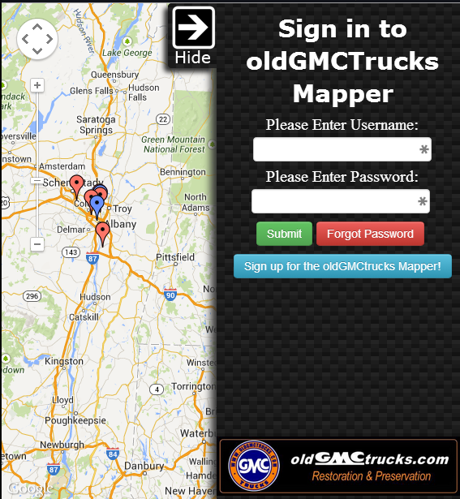6.4 Event Prototype

What the event panel tab will look like

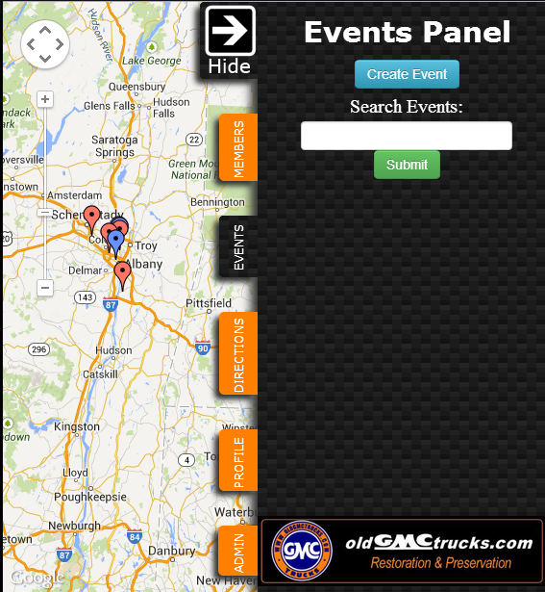

6.5 Create Event

What the event panel turns into when creating an event

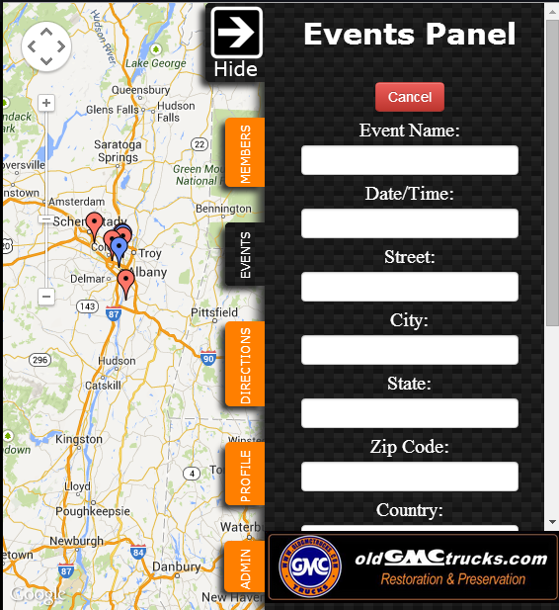6.6 Members Tab

What the member tab will look like

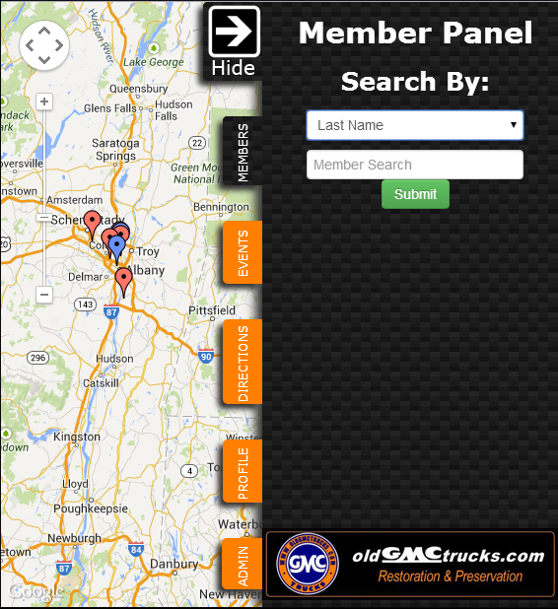6.7 Search Members Options

## 

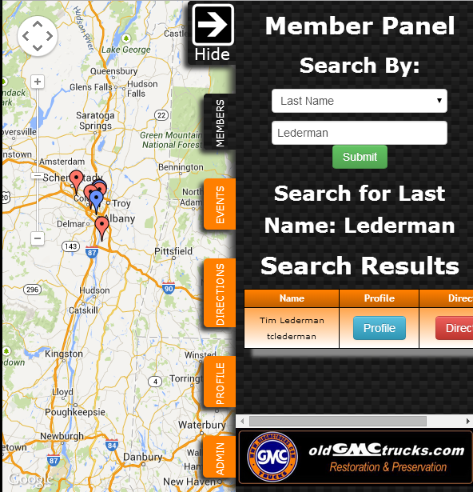6.8 Directions Tab

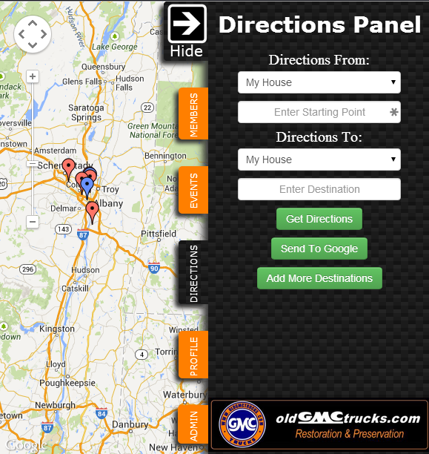6.9 Multiple Directions

After ‘Add more destinations’ is clicked.

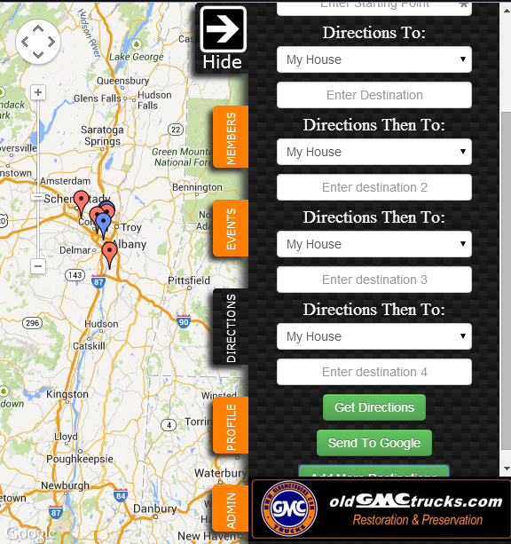

## 6.10 Directions Entered

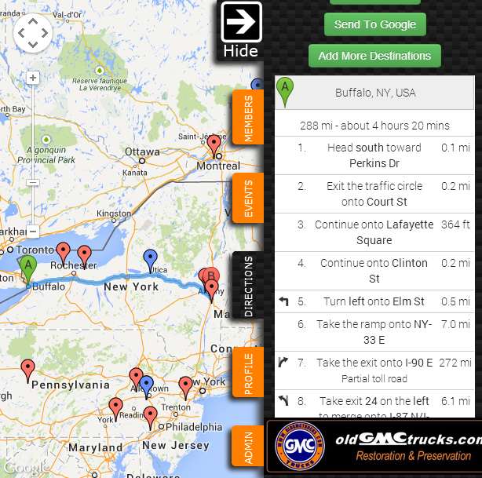

## 6.11 Profile Tab

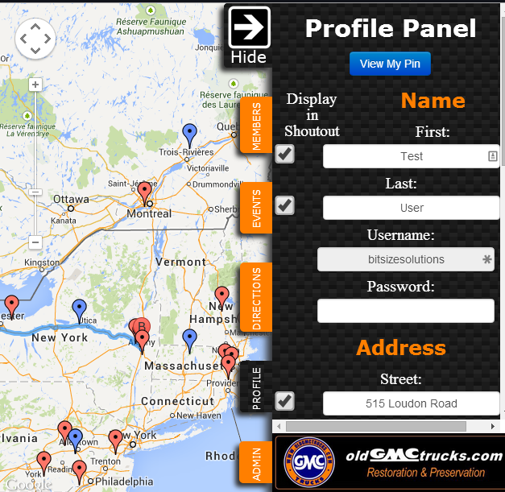

## 6.12 Admin

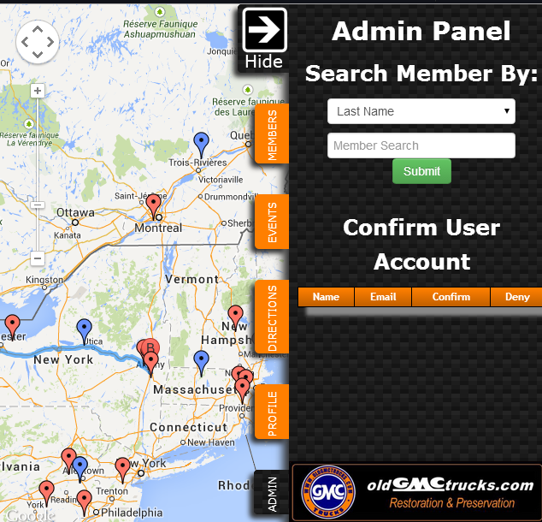

## 6.13 Admin Search Members

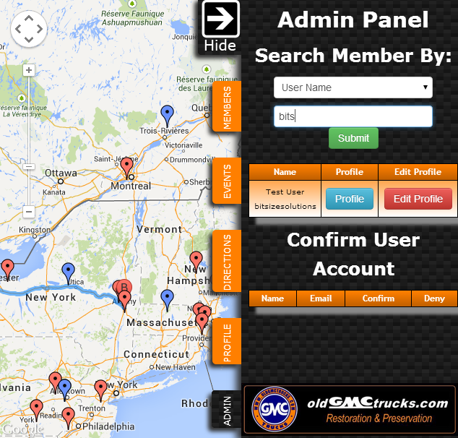

## Admin Edit Members

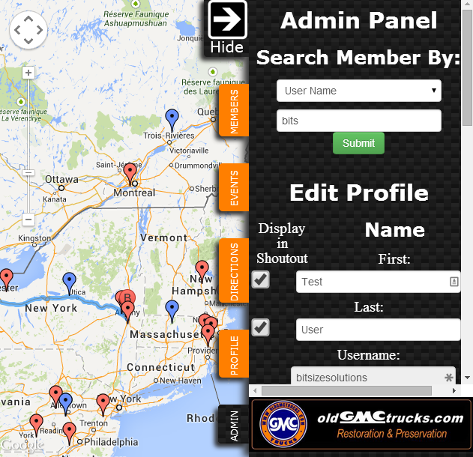

# Logical Data Dictionary

The data dictionary is a repository that shows information about the data within the oldGMCtrucks Mapper system, including format, usage, and examples of correct and incorrect input.

Please see the attached document to view the data dictionary. A Microsoft Excel file of the data dictionary is also available on the BitSize Solutions website.

|  |  |  |
| --- | --- | --- |
| A data dictionary defined in the IBM Dictionary of Computing as a "centralized repository of information about data such as meaning, relationships to other data, origin, usage, and format." | | |
|  |  |  |
| Key | |  |
| **Name** | **Definition** |  |
| Data Name | The name of the data |  |
| Data Type | The type/class of data |  |
| What is it? | Alias/ What the data includes |  |
| How is it used? | How the data is used in the system |  |
| Example | Example of what the data could look like |  |
| Comments | An additional information |  |

See Appendix E.

# Database ER Diagram

* 1. ER Legend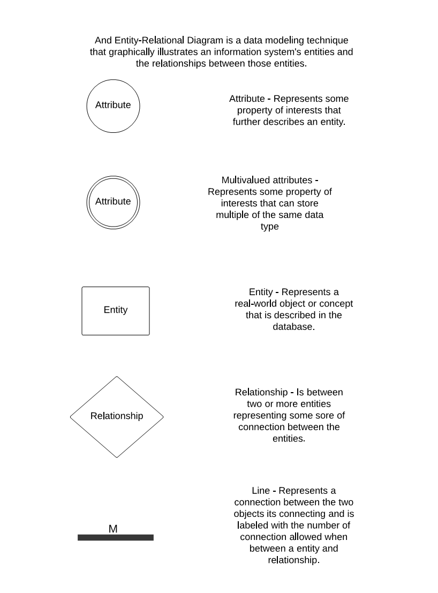
  2. 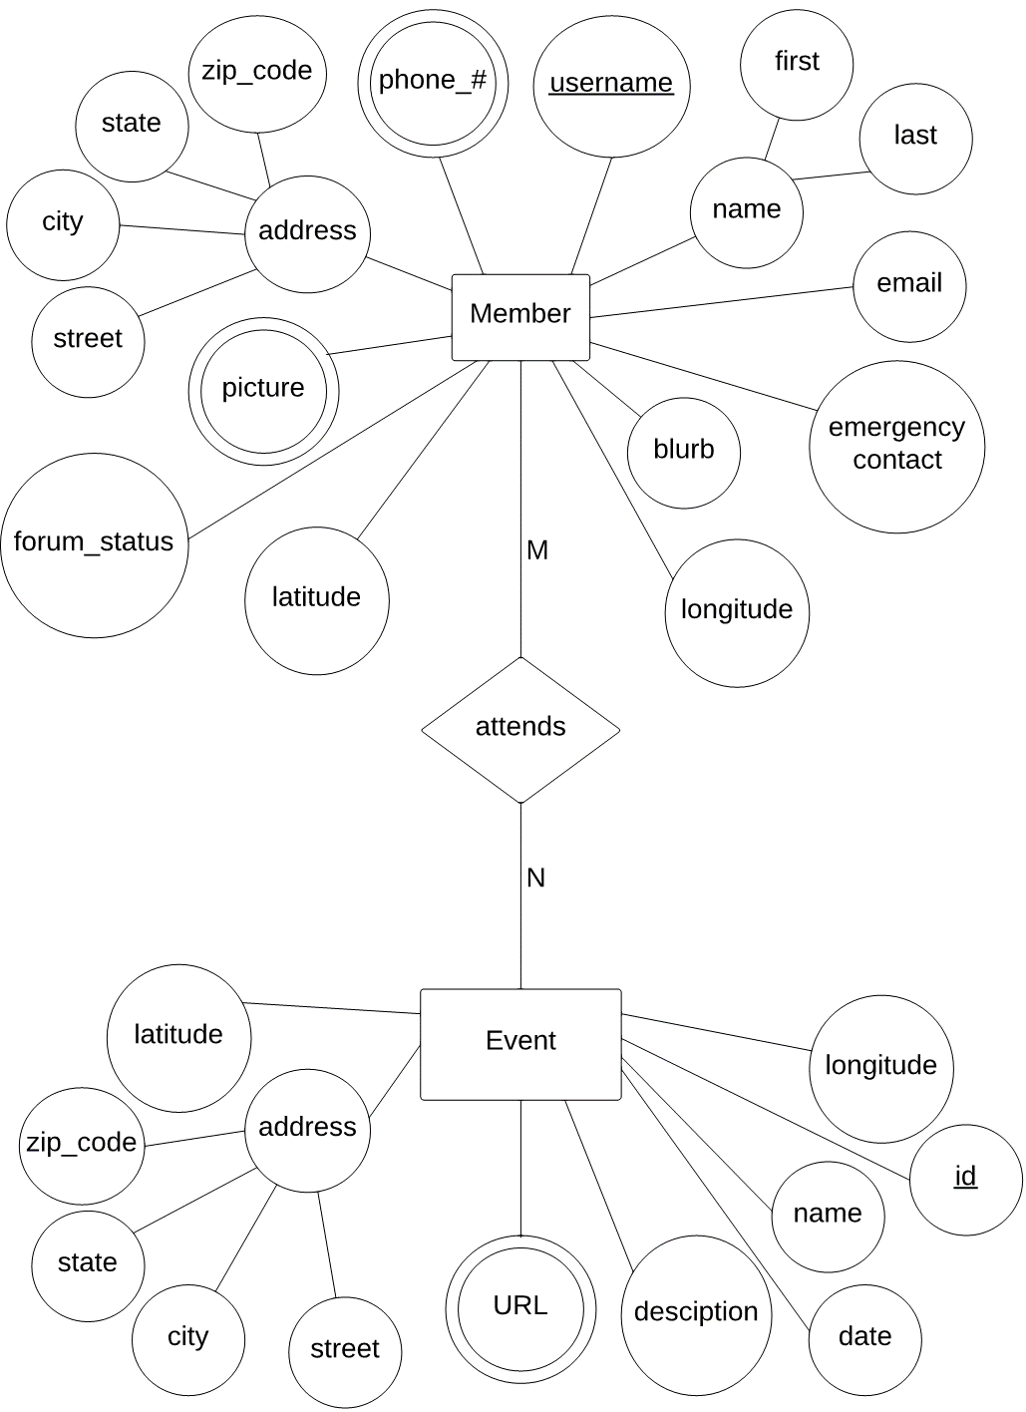ER Diagram

## Relational Schema

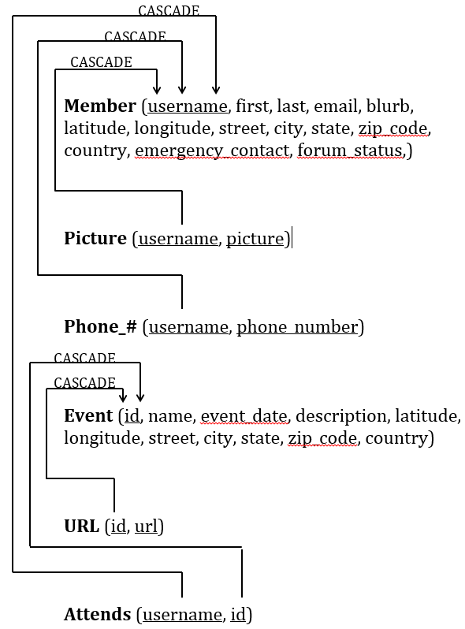

# Database Tables

## Attends

|  |  |  |
| --- | --- | --- |
| **Column** | **Type** | **Can Be Null** |
| username (PK and FK to Member) | varchar(50) | No |
| id (PK and FK to Event) | int(11) | No |

## Event

|  |  |  |
| --- | --- | --- |
| **Column** | **Type** | **Can Be Null** |
| id (PK) | int(11) | No |
| name | varchar(100) | Yes |
| event_date | varchar(50) | Yes |
| description | varchar(250) | Yes |
| latitude | number | Yes |
| longitude | number | Yes |
| street | varchar(50) | Yes |
| city | varchar(50) | Yes |
| state | varchar(50) | Yes |
| zip_code | varchar(5) | Yes |
| country | varchar(50) | Yes |

## Member

|  |  |  |
| --- | --- | --- |
| **Column** | **Type** | **Cab Be Null** |
| username (PK) | varchar(50) | No |
| first_name | varchar(50) | Yes |
| last_name | varchar(50) | Yes |
| email | varchar(50) | No |
| blurb | varchar(500) | Yes |
| latitude | number | Yes |
| longitude | number | Yes |
| street | varchar(50) | Yes |
| city | varchar(50) | Yes |
| state | varchar(50) | Yes |
| zip_code | varchar(50) | Yes |
| country | varchar(50) | Yes |
| emergency_contact | varchar(50) | Yes |
| forum_status | int(11) | No |

## Phone Number

|  |  |  |
| --- | --- | --- |
| **Column** | **Type** | **Can Be Null** |
| username (PK and FK to Member) | varchar(50) | No |
| phone_number (PK) | varchar(15) | No |

## Picture

|  |  |  |
| --- | --- | --- |
| **Column** | **Type** | **Can Be Null** |
| username (PK and FK to Member) | varchar(50) | No |
| picture (PK) | varchar(100) | No |

## URL

|  |  |  |
| --- | --- | --- |
| **Column** | **Type** | **Can Be Null** |
| id (PK and FK to Event) | int(11) | No |
| url (PK) | varchar(100) | No |

# UML Deployment Diagram

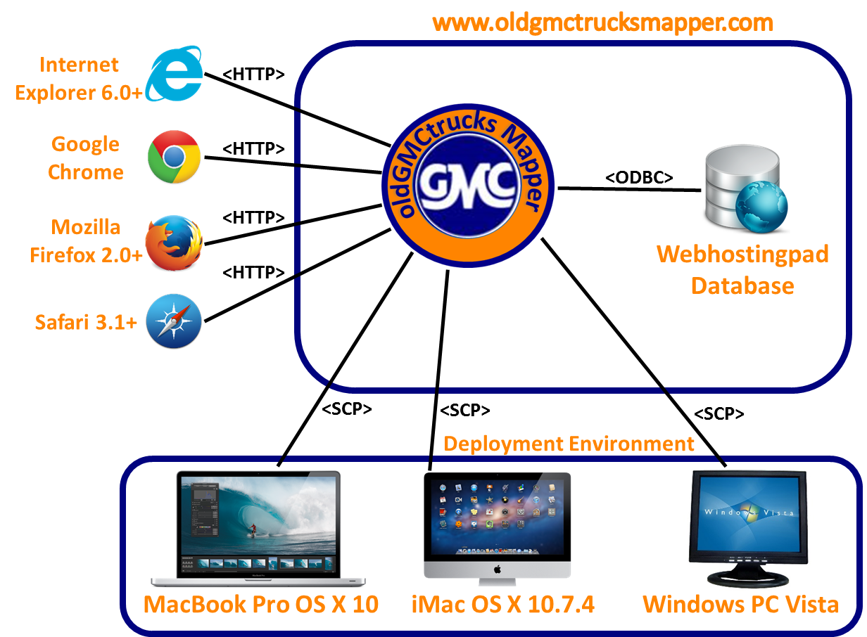 A UML Deployment Diagram models the execution architecture of systems by representing each system as a node. Each node is connected by communication paths to develop a network of systems. The following diagram is a deployment diagram for oldGMCtrucks Mapper.

# Development and Production Environments

## Development Environment

***Server***

Operating System: CentOS 5.2, Kernal 2.6.18-92e15

Server Name: oraserv.cs.siena.edu

CPU: Intel Xeon 2.66 GHz

RAM: 8GB

***Macintosh Computer***

Operating System: OSX Version 10.7.4

Proc: Intel Core i5 @ 2.5GHz

Ram: 4GB 133 MHz DDR3

HDD: 500GB

***Windows Computer***

Operating System: Windows Vista

Proc: Intel Core 2 Duo E7500 @ 2.93 GHz

Ram: 4GB

HDD: 297GB

## Operating Environment

The solution will be a web-based application by Web Hosting Pad. The web-based application will be accessible by oldGMCtrucks.com forum members.

## Maintenance Environment

There should be minimal if any maintenance of the solution, however, if needed, the maintenance environment will include all the same software and hardware used in the Development Environment.

# Deliverables

The following list of items will be delivered over the next week of April 27th – May 5th 2014

1. A CD-ROM (or DVD) with the following (these deliverable/specs may change/increase by the end of the semester):
   1. A full copy of your team files from your team directory, including, of course, all website files (all folders, files, images, etc).
   2. The above team files should, of course, include all files associated with your project.
   3. The website files should reference all “local” URLs as relative links. You could have one subdirectory named team-public_html (for the team website files) and other subdirectory named project-public_html (for the project website files).
   4. There should be a README.TXT file that explains what files are where (this README.TXT should be at the highest level directory.
   5. Be sure to provide any needed usernames/passwords (and database names) and documentation related to gaining access to any database(s) that you use as part of your project.
   6. The lyrics to your team song; a copy of a sound/music file for your team song; and, an audio/video recording of your team song. Place these in a subdirectory named SONG.
2. This document.
3. PowerPoint presentation of this document.
4. All past documents and this one present at Academic Celebration with 2 team members

# Source Code

As mentioned in the deliverables, the source code will be all on a CD-Rom delivered at the end-of-year-party.

# Test Requirements & Results

## 14.1 Overview & Strategy

The oldGMCtrucks Mapper system will be tested on all four major browsers, including IE 6,7, and 8 as stated in the functional requirements. BitSize Solutions will test all the functional requirements of the oldGMCtrucks Mapper system. The functional requirements will be broken into modules and each module will be tested separately. Once a module is considered functional, the module will be tested via interactions with other modules. When this testing is complete, all the modules of the oldGMCtrucks Mapper system will be tested together as a whole system. The results are in the Appendix.

BitSize Solutions will also test the non-functional requirements of the oldGMCtrucks Mapper system. The system will be tested for user-friendliness by reviewing new user interactions in the system. This will allow BitSize Solutions to examine how users go about performing tasks within the system.

## 14.2 Acceptance Test

The system will be considered acceptable under the auspices that the system will meet all of the functional and non-functional requirements. This current document is the final document.

## 14.3 Unit Tests

Unit tests will be tested separately. After each unit passes it’s corresponding tests, BitSize solutions will run a test on the system that encompasses those units to make sure they interact appropriately. Please see the attached sheets for the unit tests for Login, View Map and Member List. The excel file containing the status of the unit tests is also available for download from the BitSize solutions website.

## 14.4 Test Cases

Each test case will be numbered and contain a description of; the unit involved, the action to be performed, the input entered by the user, the state before the test, and the expected result. Results of the tests will be recorded once testing has begun.

## 14.5 Exception Handling

BitSize Solutions will perform checks for all system exceptions and common user errors. System errors include database read and write errors, database connection errors and JavaScript errors. User errors are errors thrown by common invalid entries into the system. All errors will be handled to the furthest extent possible in oldGMCtrucks Mapper system. All errors conceived by BitSize Solutions will be tested in the unit tests, which will be expanded as BitSize Solutions develops the system.

# Appendix

* Appendix A: Dataflow Diagrams………......………..……..34
* Appendix B: Test Results ………………………...………..52
* Appendix C: Glossary of Terms……………………………64
* Appendix D: GANTT Chart………………………………..65
* Appendix E: Data Dictionary……………………………....66

# Appendix A: Dataflow Diagrams

Data flow diagram show the movement of data throughout a system. The following diagrams show the flow of data within oldGMCtrucks Mapper. The data moving within oldGMCtrucks Mapper will allow users to create, edit, and browse profiles and event amount other actions a user can take. There are multiple levels, each breaking down the previous process into more detail.

Context diagrams show the data flow between external entities and the system.

Level 0 diagrams show the main processes in the system and the data flow between the main processes and the entities.

Level 1 diagrams go into more detail, expanding the parent processes shown in the level 0 diagram.

Level 2 diagrams go into even more detail, expanding the level 1 processes further.

## Legend

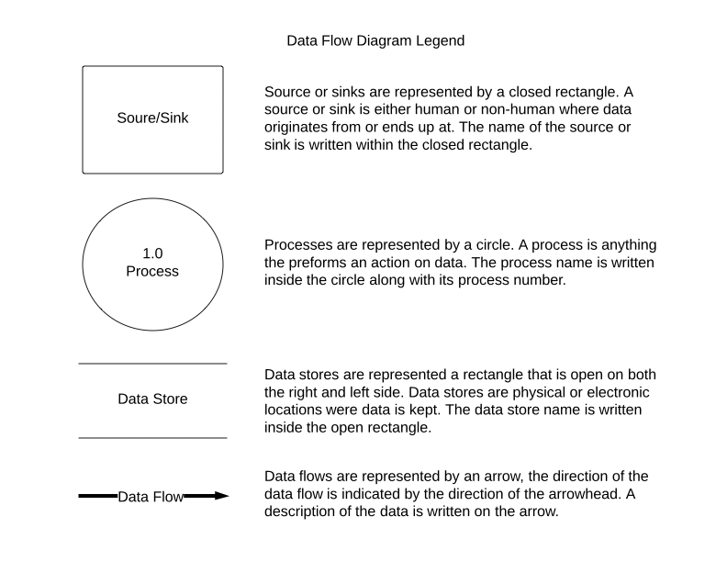16.2 Dataflow Diagrams

### 16.2.1 Context Diagram

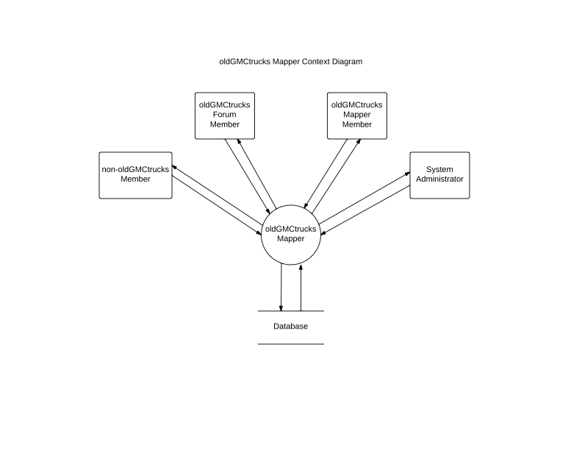

### 16.2.2 Level 0 Diagram

### Data Flow Diagram.pdf16.2.3 Level 1 - Confirm Account

### Data Flow Diagram.pdf16.2.4 Level 2 - Confirm Account - Email User

### Data Flow Diagram.pdf16.2.5 Level 2 – Confirm Account - Add User to Database

### Data Flow Diagram.pdf16.2.6 Level 2 – Confirm Account - Create Mapper Account

### Data Flow Diagram.pdf16.2.7 Level 1 - Log in

### Data Flow Diagram.pdf16.2.8 Level 1 - Modify Profile

### Data Flow Diagram.pdf16.2.9 Level 2 - Modify Profile - Create Profile

### Data Flow Diagram.pdf16.2.10 Level 2 - Modify Profile – Edit Profile

### Data Flow Diagram.pdf16.2.11 Level 2 - Modify Profile – Modify Shoutout

### Data Flow Diagram.pdf16.2.12 Level 1 - Modify Event

### Data Flow Diagram.pdf16.2.13 Level 2 – Modify Event - Create Event

### Data Flow Diagram.pdf16.2.14 Level 2 – Modify Event - Edit Event

### Data Flow Diagram.pdf16.2.15 Level 1 - Interact with Map

### Data Flow Diagram.pdf16.2.16 Level 1 - Request Account

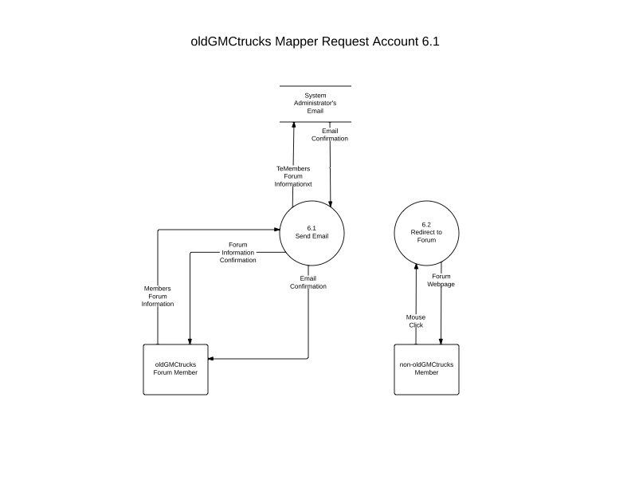

### 16.2.17 Level 1 - Manage Map Data

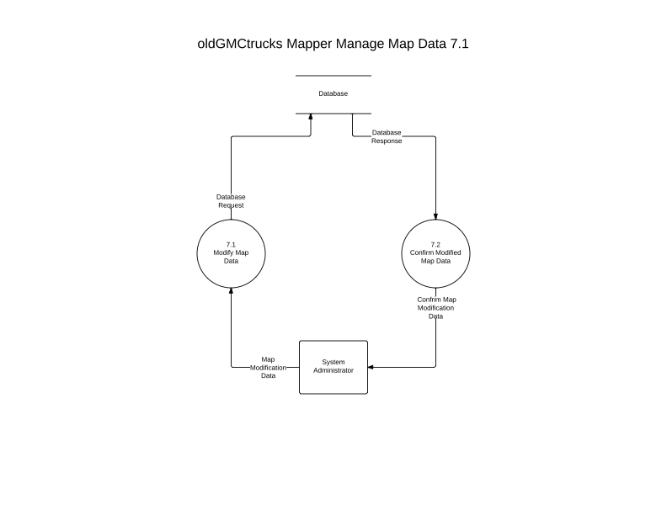

# 

# Appendix B: Test Results

## 17.1 Directory



## 17.2 Log On



## 17.3 Interact With Map



Interact With Map Test (cont.)



## 17.4 Members Tab



## 17.5 Events Tab



## 17.6 Directions Tab



## 17.7 Profile Tab



Profile Tab Test (cont.)



## 17.8 Admin Tab



## 17.8 Functional Requirements

|  |  |  |
| --- | --- | --- |
| Met |  | Map with pins representing member and event locations |
| Met |  | Upon click, each pin displays with a “shoutout” containing member or  event information |
| Met |  | At least two distinct pins for users and events |
| Met |  | Will have a slide-out right aligned panel with a Members tab, Events tab, Directions tab, Profile tab, Admin tab (visible only to admin) |
|  | Unmet | Random Actor will not be able to see anything. Redirected to create an account on the oldGMCtrucks forum. |
|  | Unmet | Will see blank map |
| Met |  | Will have the ability to sign up for an account on oldGMCtrucks forum. |
|  | Unmet | oldGMCtrucks Forum Member Actor will have the ability to access the site through the oldGMCtrucks forum. |

Functional Requirements (cont.)

|  |  |  |
| --- | --- | --- |
| Met |  | Will have the ability to view a map with user information on the map. |
| Met |  | Will have the ability to create an account on the oldGMCtrucks Mapper site. |
| Met |  | oldGMCtrucks Mapper Member Actor will have the ability to log in.  Will have the ability to update information in their profile. |
| Met |  | Update First name |
| Met |  | Update Last name |
| Met |  | Update Home address |
| Met |  | Update Phone numbers |
| Met |  | Update e-Mails |
| Met |  | Update “about me” |
|  | Unmet | Update Pictures |
| Met |  | Members can derive directions to an event or to another member’s location. |
| Met |  | Members can create events. |
| Met |  | Members can update any events. |
| Met |  | oldGMCtrucks Mapper administrator will have a profile with the same functionality as an oldGMCtrucks Mapper Member |
| Met |  | Admin will also be able to modify any member’s data. |
| Met |  | Admin will be able to create user accounts. |

# Appendix C: Glossary of Terms

**API** – **A**pplication **P**rogramming **I**nterface specifies how some software components should interact with each other.

**Browser-** Software application for retrieving, presenting and traversing information resources on the World Wide Web.

**Extensible**- a system design principle where the implementation takes future growth into consideration.

**Gantt** – a chart in which a series of horizontal lines shows the amount of work done or production completed in certain periods of time in relation to the amount planned for those periods.

**HTML** – **H**yper**T**ext **M**arkup **L**anguage is the main markup language for creating web pages and other information that can be displayed in a web browser.

**Input**- Term denoting either an entrance or changes which are inserted into a system and which activate or  modify a process.

**Javascript** – an interpreted computer programming language using client side web pages.

**MySQL** – the world's most widely used open-source relational database management system (RDBMS) that runs as a server providing multi-user access to a number of databases.

**Shout-Out**- Google Inc. has dubbed their onscreen pop up panels as “Shout-Outs”.

**Web Hosting Pad** – a web hosting site with support for server-side programming and front-facing web pages.

# Appendix D: GANTT

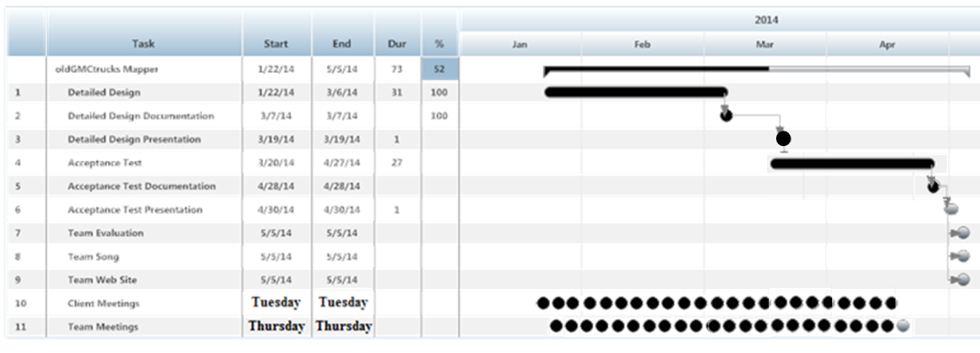

# Appendix E: Data Dictionary

|  |  |  |  |  |  |  |
| --- | --- | --- | --- | --- | --- | --- |
| **Data Name** | **Data Type** | **What is it?** | **How is it used?** | **Acceptable Input** | **Example** | **Comments** |
| userName | String | Username of member | To login to the site. | A-Z, a-z, 0-9 | gmctrucksRULE57 | Is imported from forum. Can be in shoutout |
| password | String | Password of member | To login to the site. | ASCII Chars from Decimal 32 to Decimal 126 inclusive, allowed | aw830bvf7p9 | Is imported from forum. Can be changed |
| isAdmin | boolean | Speicifies if a member is an admin | If true then member has access to admin panel | true, false | TRUE |  |
| isForumMember | boolean | Specifies whether user is forum member | Determines whether this user can see pins on the map | true, false | FALSE | Only matters when not signed in |
| email | String | Email of member | In profile or shoutout | email Field must be in the normal form (i.e. name@siena.edu) | john63@gmail.com | Can be in shoutout |
| firstName | String | First name of member | In profile or shoutout | ASCII Chars from Decimal 32 to Decimal 126 inclusive, allowed | John | Can be in shoutout |
| lastName | String | Last name of member | In profile or shoutout | ASCII Chars from Decimal 32 to Decimal 126 inclusive, allowed | Smith | Can be in shoutout |
| phoneNumber | String | Phone number of member | In profile or shoutout | Series of ints including "()" surrounding the first three error code digits | (518) 867-5309 | Can be in shoutout |
| streetAddress | String | Street address of member or event | In profile or shoutout | ASCII Chars from Decimal 32 to Decimal 126 inclusive, allowed | 12 Main Street | Can be in shoutout |
| city | String | City of event or member | In profile or shoutout | ASCII Chars from Decimal 32 to Decimal 126 inclusive, allowed | Chicago | Can be in shoutout |
| state | String | State of member or event | In profile or shoutout | ASCII Chars from Decimal 32 to Decimal 126 inclusive, allowed | Illinois | Can be in shoutout |
| zipCode | String | Zipcode of member or event | In profile or shoutout | series of numbers | 60652 | Can be in shoutout |
| blurb | String | Description about member or event | In profile or shoutout | ASCII Chars from Decimal 32 to Decimal 126 inclusive, allowed | Stop by anytime! | Can be in shoutout |
| isEvent | boolean | Specifices whether a marker is an event or not, i.e. a member. | To determine marker icon and whether it is included in member or event search | true, false | FALSE |  |
| eventID | int | Unique identification for an event | To ensure each event has a unique reference | int 0-9 for however many digits desired | 2568 |  |
| eventName | String | Name of an Event | To identify the event with a coherent name | ASCII Chars from Decimal 32 to Decimal 126 inclusive, allowed | Car Show |  |
| createdBy | String | Username of member who created event | To specify the creator of each event | ASCII Chars from Decimal 32 to Decimal 126 inclusive, allowed | gmctrucksRULE57 | One per event |
| editedBy | String | Username of member who has edited an event | To track anyone who has edited the event | ASCII Chars from Decimal 32 to Decimal 126 inclusive, allowed | jimmy32 | There could be more than one of these per event |
| shoutOut | String | Information visible when a marker is clicked | Contains all information the member wants to appear when their pin is clicked. Events also have a shoutout containing all event information. | ASCII Chars from Decimal 32 to Decimal 126 inclusive, allowed | gmctrucksRULE57  John Smith  Illinois 60652 Stop By Anytime! |  |
| marker | Marker(opts?: MarkerOptions) | A clickable pin on the map | Used to show where a member or event is located. Clicking on a marker show details about the member or event |  |  |  |
| position | LatLng(lat:number, lng:number, noWrap?:boolean) | Coordinates for a marker | To specify where on the map a marker is placed | Coordinates including (double,double) | (47.584651617, 58.189734948) |  |
| isDraggable | boolean | Determines whether a marker can be dragged | Allows members to drag their own marker, or an event marker | true, false | TRUE |  |
| img | File | Image a user wishes to upload | An image that a user would like to upload and display to other forum members. Most likely pictures of their trucks | an image file in the jpg form | myTruck.jpg |  |
| profileImg | File | image shown at the top of the user profile | The image that the user would like to use to characterize themselves | an image file in the jpg form | secondTruck.jpg |  |
| toDisplay | boolean | a boolean flag to decide if something should be viewable to other users | to allow the user to alter what values can be displayed | true, false | TRUE | This should probably be apart of every table involving the user profile data |
| attatchment1 | File | A file that can be attached to the posting of an event | A User can attach directions, invites, site maps etc. | file type | Directions.doc | Event Content |
| attatchment2 | File | A file that can be attached to the posting of an event | A User can attach directions, invites, site maps etc. | file type | Directions.doc | Event Content |
| attatchment3 | File | A file that can be attached to the posting of an event | A User can attach directions, invites, site maps etc. | file type | Directions.doc | Event Content |
| eventTime | String | Date and time of event | In event shoutout | ASCII Chars from Decimal 32 to Decimal 126 inclusive, allowed | 11/20/13 @ 12:00 PM | Necessary event information |