Detail Design
Client: Dr. Darren Lim, Assistant Professor



Project: Java Online Learning Tool (J.O.L.T.)

Delivered by: 518 Interactive
Team Members:
Erik Stegmann
Lawrence Gregory
Connor Vander Bogart
Jedidiah Turnbull
Christopher Hughto

Revision: 1.0
Date: 3/08/2010
Contents
1 Introduction 1
1.1 Purpose 1
1.2 Scope 2
1.3 Audience 2
1.4 Product Overview and Summary 2
2 Requirements Specification 3
2.1 Introduction 3
2.2 Functional Requirements Inventory 4
2.2.1 Functional Requirements: Student: 4
2.2.2 Functional Requirements: Faculty: 5
2.2.3 Functional Requirements: Course Coordinator: 6
2.2.4 Functional Requirements: Administrator: 7
2.2.5 Java SDK: 7
2.3 Non-Functional Requirements 8
3 Architectural Design Specification 9
3.1 Development, Operating, and Maintenance Environments 9
3.2 Production Environment 11
3.3 UML Deployment Diagram 12
3.4 Web Site Map 13
3.4.1 Context Web Site Map 14
3.4.2 Student Web Site Map 15
3.4.3 Faculty Web Site Map 16
3.4.4 Course Coordinator Web Site Map 17
3.4.5 Administrator Web Site Map 18
4 External & Internal Design Specification 19
4.1 User Screens with respective User Command Summaries 19
4.2 Student User 20
4.2.1 Student User Narrative 20
4.2.2 J.O.L.T Login Page 21
4.2.3 Student Registration Page 22
4.2.4 Student Registration Page (Error Message – Invalid Fields) 23
4.2.5 Student Registration Page (Error Message – Invalid Email) 24
4.2.6 Student Registration Page (Completed) 25
4.2.7 Invalid Login Screen 26
4.2.8 Invalid Login Screen 27
4.2.9 Account Lockout Screen 28
4.2.10 Common Header 29
4.2.11 Student Home Page 29
4.2.12 Course Enrollment (Invalid PIN) 30
4.2.13 Course Enrollment (Completed) 31
4.2.14 Section Home Page 32
4.2.15 Student Section Home (Populated) 33
4.2.16 Problem Set Overview 34
4.2.17 Solve Problem 35
4.2.18 Student Solution Attempt (Compile Error) 36
4.2.19 Student Solution Attempt (Incorrect Output) 37
4.2.20 Student Solution Attempt (Timeout) 38
4.2.21 Updated Problem Set Overview Screen (Navigate Away) 39
4.2.22 Student Solution Attempt (Completed) 40
4.2.23 Updated Problem Set Screen 41
4.2.24 View Gradebook 42
4.2.25 View Profile 43
4.2.26 Edit Profile 44
4.2.27 View Announcement 45
4.2.28 Logout 46
4.3 Faculty User 47
4.3.1 Faculty User Case Narrative 47
4.3.2 Faculty Screens 48
4.3.3 J.O.L.T Login 48
4.3.4 Faculty Home Page 49
4.3.5 Section Home Page 50
4.3.6 Create Problem 51
4.3.7 Create Problem (Invalid Field) 52
4.3.8 Create Problem Compiler Error 53
4.3.9 Faculty Sandbox (Unpopulated) 54
4.3.10 Faculty Sandbox (Populated) 54
4.3.11 Edit Problem 55
4.3.12 Create Problem Set 56
4.3.13 Create Problem Set (Error) 57
4.3.14 Create Problem Set (No Problems Added Error) 58
4.3.15 Create Problem Set (Completed) 59
4.3.16 Edit Problem Set (Completed) 60
4.3.17 Activate/Assign Problem Set 61
4.3.18 Create Announcement 62
4.3.19 Create Announcement (Add Recipients) 63
4.3.20 Create Announcement (Missing Field) 64
4.3.21 Create Announcement (Complete) 65
4.3.22 View Gradebook 66
4.3.23 Edit Gradebook (Editing) 67
4.3.24 Manage Pools 68
4.3.25 View Profile 69
4.3.26 Edit Profile 70
4.3.27 Logout 71
4.4 Course Coordinator User 72
4.4.1 Course Coordinator User Case Narrative 72
4.4.2 Course Coordinator User Screens 73
4.4.1 J.O.L.T Login 73
4.4.2 Course Coordinator Home Page 74
4.4.3 Create Faculty Account 75
4.4.4 Edit Faculty Account 76
4.4.5 Create Course Section 77
4.4.6 Create Course Section (Error) 78
4.4.7 Edit Course Section 79
4.4.1 View Gradebook 80
4.4.2 Edit Gradebook (Editing) 81
4.4.1 Create Problem 82
4.4.2 Create Problem (Invalid Field) 83
4.4.3 Create Problem Compiler Error 84
4.4.1 Course Coordinator Sandbox (Unpopulated) 85
4.4.2 Course Coordinator Sandbox (Populated) 85
4.4.3 Edit Problem 86
4.4.4 Create Problem Set 87
4.4.5 Create Problem Set (Error) 88
4.4.6 Create Problem Set (No Problems Added Error) 89
4.4.7 Create Problem Set (Completed) 90
4.4.8 Edit Problem Set (Completed) 91
4.4.9 Activate/Assign Problem Set 92
4.4.10 Create Announcement 93
4.4.11 Create Announcement (Add Recipients) 94
4.4.12 Create Announcement (Missing Field) 95
4.4.13 Create Announcement (Complete) 96
4.4.14 Manage Pools 97
4.4.15 Accept Private Problems to Course Pool 98
4.4.16 Create Announcement 99
4.4.17 Create Announcement (Add Recipients) 100
4.4.18 Create Announcement (Missing Field) 101
4.4.19 Create Announcement (Complete) 102
4.4.1 View Profile 103
4.4.2 Edit Profile 104
4.4.3 Sample Report Format 105
4.4.4 Logout 106
4.5 Administrator User 107
4.5.1 Administrator User Case Narrative 107
4.5.2 Administrator User Screens 107
4.5.3 J.O.L.T Login 108
4.5.4 Administrator Home Page 109
4.5.5 Manage Users 110
4.5.6 Create Course Coordinator 111
4.5.7 Create Faculty Account 112
4.5.8 Create Student Account 113
4.5.9 Edit User Account 114
4.5.10 Course Management 115
4.5.11 Create Course 116
4.5.12 View Gradebook 117
4.5.13 Edit Gradebook (Editing) 118
4.5.14 Create Problem 119
4.5.15 Create Problem (Invalid Field) 120
4.5.16 Create Problem Compiler Error 121
4.5.17 Course Coordinator Sandbox (Unpopulated) 122
4.5.18 Course Coordinator Sandbox (Populated) 122
4.5.19 Edit Problem 123
4.5.20 Create Problem Set 124
4.5.21 Create Problem Set (Error) 125
4.5.22 Create Problem Set (No Problems Added Error) 126
4.5.23 Create Problem Set (Completed) 127
4.5.24 Edit Problem Set (Completed) 128
4.5.25 Activate/Assign Problem Set 129
4.5.26 Create Announcement 130
4.5.27 Create Announcement (Add Recipients) 131
4.5.28 Create Announcement (Missing Field) 132
4.5.29 Create Announcement (Complete) 133
4.5.30 Manage Pools 134
4.5.1 Accept Private/Course Problems to Global Pool 135
4.5.2 View Profile 136
4.5.3 Edit Profile 137
4.5.4 Logout 138
4.6 Logical Data Stores 139
4.6.1 Announcement Table 139
4.6.2 Assignment Table 140
4.6.3 Course Table 141
4.6.4 Enrolled Students Table 142
4.6.5 Grade Log Table 143
4.6.6 Pool Table 144
4.6.7 Problem Table 145
4.6.8 Problem Location Table 146
4.6.9 Problem Set Table 147
4.6.10 Section Table 149
4.6.11 Set Location Table 149
4.6.12 Solution Attempt Table 150
4.6.13 Test Case Table 150
4.6.14 User Table 151
4.6.15 Graphical Representation Key 152
4.6.16 Graphical Representation (Entity Relationship Diagram) 1
4.7 Packaging Specification 1
5 Appendices 2
5.1 Appendix 1: Sources of Information 2
5.2 Appendix 2: Glossary of Terms 3
5.3 Appendix 4: Current Timeline 5
5.4 Data Flow Diagrams 6
5.5 Activity Diagrams 6
5.6 Data Dictionary 6
5.7 Test Plan 7

Introduction

Purpose
This document finalizes the software requirements identified for the Java Online Learning Tool (J.O.L.T) for the client, Dr. Darren Lim, Assistant Professor of the Computer Science Department of Siena College. The software requirements have been previously defined in the Software Requirements Specification (SRS) document as well as the Preliminary Design document; however, the requirements defined within this document supersede those of the previous documents.
This document also formally defines the final user interface for J.O.L.T. The interface is organized by user type, starting with Student, then progressing to Faculty, then Course Coordinator, and finally Administrator. The user-specific interfaces are laid out in a sequential manner, starting with the first task a user completes to the last task a user completes.
This document serves these main purposes:
- To provide a finalized interface design for all users of J.O.L.T.
- To provide a complete Requirements Inventory.

There are several supplementary documents to this design document, which are available under the “Documents” menu of the 518 Interactive Website. These documents include:

- Data Flow Diagram Document: Provides a graphical representation of how data is transmitted and manipulated within J.O.L.T.
- Activity Diagram Document: Provides a graphical representation of how specific tasks are accomplished within J.O.L.T.
- Data Dictionary: Provides a repository of all the data entities that J.O.L.T utilizes.
- Test Plan Document: The Test Plan Document outlines the testing that is to be done to see if J.O.L.T meets all requirements.

NOTE: All screenshots provided in this document are intended to be final in design and functionality, however, 518 Interactive reserves the right to modify the actual user interface of the final product (J.O.L.T) on an as-needed basis, with consent of the client, Dr. Lim. Such changes shall be documented on the 518 Interactive website.
NOTE: All references to Source Code imply Java™ Source Code, made to work with Java™ Version 1.6

Scope
The requirements and screen designs in this document comprise the scope of J.O.L.T’s requirements and interface. This Detailed Design document supersedes any prior documents as the descriptor of J.O.L.T’s requirements and interface design.

Audience
This document is intended for 518 Interactive, Dr. Lim, members of the Spring 2010 Software Engineering II class, and the other clients, Dr. Lederman and Dr. Breimer.

Product Overview and Summary
The proposed Java Online Learning Tool (J.O.L.T) is a comprehensive web application designed to enhance the experience of learning the Java programming language. J.O.L.T shall allow for students enrolled in programming courses to solve programming problems, which are created and entered by the Computer Science faculty. J.O.L.T shall provide a personal gradebook for all students, as well as a course gradebook for Computer Science faculty members which will be used to track progress.

Requirements Specification

Introduction
The following list outlines the required functionality to be included in the final solution.
Java Online Learning Tool will be a web-based application viewable on the major browsers. Browsers included will be Internet Explorer 8, Mozilla Firefox, Safari, and Google Chrome.
All references to Source Code imply Java™ Source Code, made to work with Java™ Version 1.6
The requirements are listed according to User Type, as follows:

Functional Requirements Inventory

Functional Requirements: Student:
- Will be able to register online with the system
  - Will receive email confirmation following registration
- Will be able to log into system.
  - A failed log in will display an appropriate error message.
  - A link to an identity validation page will be provided if password is forgotten.
  - 3 Failed login attempts will lead to system lockout.
- Will be able to enroll into courses they are currently taking
  - PIN number provided by instructor required to enroll into course on the system
- Will be able to view announcements sent to them.
  - Will be able to delete their announcements
- Will be able to view problem sets for each course they are in enrolled in
  - Will be able to view each individual problem within the problem set
  - Will be able to view hints and solutions to individual problems, if provided by problem creator.
- Will be able to submit solutions to individual problems within active problem sets in the form of Java™ source code
  - Code will be compiled by the system online
  - Student will receive immediate, automatic feedback on compile errors, if any
  - Student will receive immediate, automatic feedback on how their solution compares to the test cases
- Will be able to complete problem sets
  - Will be able to navigate to individual problems in a problem set without completing them in a specific order
  - Will be able to save any progress made for a problem or problem set
- Will be able to view grades for each assignment in each class they are enrolled in.
- Will be able to view all previously submitted solutions
  - Will have access to their solutions and grades for all prior classes they were enrolled in.
- Will be able to log out

Functional Requirements: Faculty:
- Will be able to log into system.
  - A failed log in will display an appropriate error message.
  - A link to an identity validation page will be provided if password is forgotten.
  - 3 Failed login attempts will lead to system lockout.
- Will be able to create individual problems
  - Individual problems that are partially completed by faculty are saved to a sandbox area, until they are complete.
    - Once complete, problem gets transferred to private pool.
- Will be able to create problem sets
  - Will be able to import previously created problems to a problem set
  - Will be able to import problems from the course pool to a problem set
  - Will be able to import problems from the global pool to a problem set
  - Will be able to individually create each problem for a problem set
- Will be able to assign problems they create to a category
- Will be able to assign a grading scheme to problem sets
  - Will be able to assign a point value to specific problems within the problem set
- Will be able to assign problem sets to the sections they teach
  - Will be able to set activation date and time of problem set
  - Will be able to set expiration date and time of problem set
- Will be able to submit problems to a Course Pool
- Will be able to search a Course Pool for problems
- Will be able to search the Global Pool for problems
- Will be able to view a grade book for each of the courses
- Will be able to modify grades for all students in each of the courses they are currently teaching
- Will be able to post announcements to students in their courses
- Will be able to view announcements sent to them.
- Will be able to log out

Functional Requirements: Course Coordinator:
- Will be able to log into system.
  - A failed log in will display an appropriate error message.
  - A link to an identity validation page will be provided if password is forgotten.
  - 3 Failed login attempts will lead to system lockout.
- Will be able to create faculty accounts
- Will be able to assign faculty to a section
- Will be able to create problems and problem sets for courses they are in charge of
  - Individual problems that are partially completed by Course Coordinators are saved to a sandbox area, until they are complete.
    - Once complete, problem gets transferred to private pool.
- Will have access to course tools which will provide statistics on problems and grades for a course
  - Will be able to create reports over multiple sections of a course involving all problems and problem sets or any subset thereof.
  - Reports may include general statistics such as number of participants, average score, median, low score, and high score.
- Will be able to manage the course pool for each course they are in charge of
  - Will be able to add, modify, or delete any problem in their course pool
  - Will be able to submit problems to the global pool
- Will be able to modify grades for all students currently enrolled in a course they currently manage
  - Will be able to keep track of all grades and any adjustments that are made
- Will be able to create announcement for all faculty and students of courses they manage or any subset thereof
- Will be able to log out

Functional Requirements: Administrator:
- Will be able to log into system.
  - A failed log in will display an appropriate error message.
  - A link to an identity validation page will be provided if password is forgotten.
- Will be able to manage all accounts on the system
- Will be able to create course coordinator and faculty accounts
  - Will be able to assign courses to course coordinators
- Will have the same abilities as a course coordinator
- Will be able to manage the global pool of problems
- Will have access to tools for management of all accounts
  - Will be able to modify all account information for any user
  - Will be able to delete accounts
  - Will be able reset locked accounts
- Will be able to create announcements for all course coordinators, faculty and students, or any subset thereof
- Will be able to log out

Java SDK:
- Will accept and attempt to compile all Java™ source code submitted by students
  - Will output compile errors, when applicable
  - Will create Java™ Byte Code upon a successful compilation
- Will execute all successfully compiled Java™ solutions
  - Will monitor students’ submissions while they are running for runtime errors
  - Will kill a student’s submission if it takes too long to run (Timeout)
- Will record the output generated from the students’ submissions

Non-Functional Requirements
A non-functional requirement is a requirement that specifies criteria that can be used to judge the operation of a system, rather than specific behaviors. They are typically used to describe the qualities of a system. Given this definition, there is no concrete way to measure whether or not a non-functional requirement has been met.
Non-Functional requirements have not been formally defined for J.O.L.T.

Architectural Design Specification

Development, Operating, and Maintenance Environments
J.O.L.T will be developed in Siena College’s Software Engineering Lab, located in Roger Bacon, third floor. The members of 518 Interactive will be using the following resources:

Windows Machine:
- Operating System: Microsoft Windows Vista Enterprise
    - Build: 6002
    - Revision: 18005
    - Service Pack 2
- Processor: Intel® Core™2 Duo CPU
    - Model: E7500
    - Speed 2.93 GHz
- Memory (RAM): 4.00 GB
- System Type: 32-bit
- Dual Monitor Setup
- Software Installed:
    - Microsoft Office 2007 (Including Microsoft Project)
    - Macromedia Dreamweaver, Fireworks, Flash , Freehand, Studio (2004 Versions)
    - Internet Explorer, Mozilla Firefox, Google Chrome
Macintosh Machine:
- Operating System: Apple Mac OS X
      - Version 10.4.11
      - Model: iMac5
- Processor: Intel Core2 Duo
    - Speed: 2 GHz
- Memory (RAM): 1.00 GB
- Dual Monitor Setup
- Software Installed:
      - Microsoft Office 2004 for Mac
      - Macromedia Dreamweaver, Fireworks, Flash, Freehand, Studio (2004 Versions)
      - Safari, Mozilla Firefox

J.O.L.T will be implemented, and designed to run on the following specifications:
- Operating System: CentOS (Linux) Release 5.2 (Final)
- Server Name: oraserv.cs.siena.edu
- CPU Type: x86_64
- Web Server: Apache Version 2.2.9
- PHP Version: 5.2.6
- Database: MySQL Version 5.0.45; Oracle Version 9i
- Java™ Version: 1.6.0_10-rc
- Java™ SE Runtime Environment: Build 1.6.0_10-rc-b28
- Java HotSpot™ 64-Bit Server VM: Build 11.0-b15, mixed mode)

Users of J.O.L.T will be able to access the web application through an Internet connection, with any of the following browsers (of the latest version):
- Microsoft Internet Explorer
- Mozilla Firefox
- Apple Safari
- Google Chrome
- Opera Software’s Opera Browser

Production Environment
The production environment is the set of hardware, software, and tools that a system will run on. J.O.L.T is planned to be run on Siena’s oraserv server (oraserv.cs.siena.edu), which has the following characteristics.
- Operating System: CentOS (Linux) Release 5.2 (Final)
- Server Name: oraserv.cs.siena.edu
- CPU Type: x86_64
- Web Server: Apache Version 2.2.9
- PHP Version: 5.2.6
- Database: MySQL Version 5.0.45;
- Java™ Version: 1.6.0_10-rc
- Java™ SE Runtime Environment: Build 1.6.0_10-rc-b28
- Java HotSpot™ 64-Bit Server VM: Build 11.0-b15, mixed mode)

UML Deployment Diagram
Deployment Diagrams are a Unified Modeling Language (UML) based diagram used to show devices and execution environments for a system. It represents the physical layout of the System. The Deployment Diagram for J.O.L.T below shows the different browsers connecting via HTTP to J.O.L.T. It also shows the Development Environment connecting via SCP. Finally J.O.L.T is using various components and devices such as a database, and temporary directory.
Dropbox is a file sharing utility that 518 Interactive uses as a source control mechanism during development. It stores the ‘Test’ version of the site, which automatically synchronizes all connected computers. This ensures that all developers have the most up-to-date source code at all times.
PHPMyAdmin is a web-based database manager. It allows the development team to easily view and alter the contents of the J.O.L.T database through a web browser using a graphical interface. There is currently a version of PHPMyAdmin installed on oraserv.cs.siena.edu under 518 Interactive’s account.

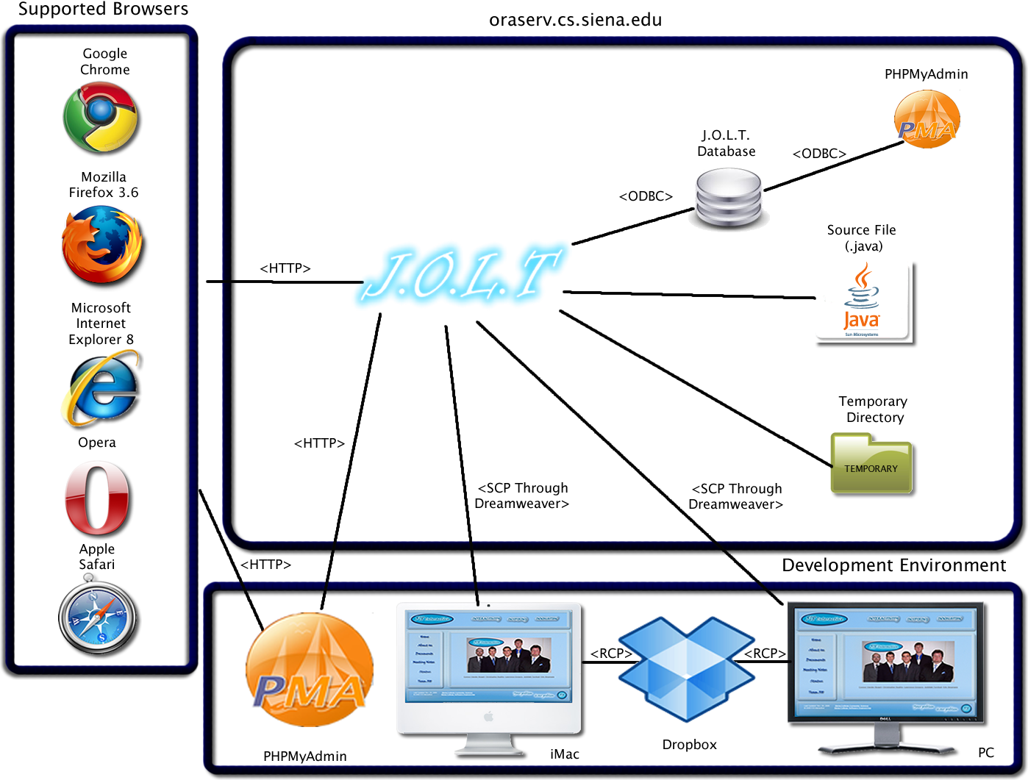

Web Site Map
A Web Site Map is a diagram that shows the structure of a website. It allows the user to see the functionality available at any part of the site. The following elements are used to build a Web Site Map:
Home Page: Denotes the main page for each user within J.O.L.T.
Home: Denotes the initial page that all users see when navigating to J.O.L.T.
Overlay/Dialog: Denotes a window that appears within the current page (Not blocked by popup blockers)
Web Page: Denotes a generic page within J.O.L.T.
Page Redirect: Denotes a forced change (by J.O.L.T) in where the user is within the system.
Link: Shows links on a given Web Page.
Possible Page Result Link: Denotes a page that a user *may* see, depending on conditions within the page they are currently on.
Part of Common Header: Denotes pages that are common to all users, regardless of position within the diagram.

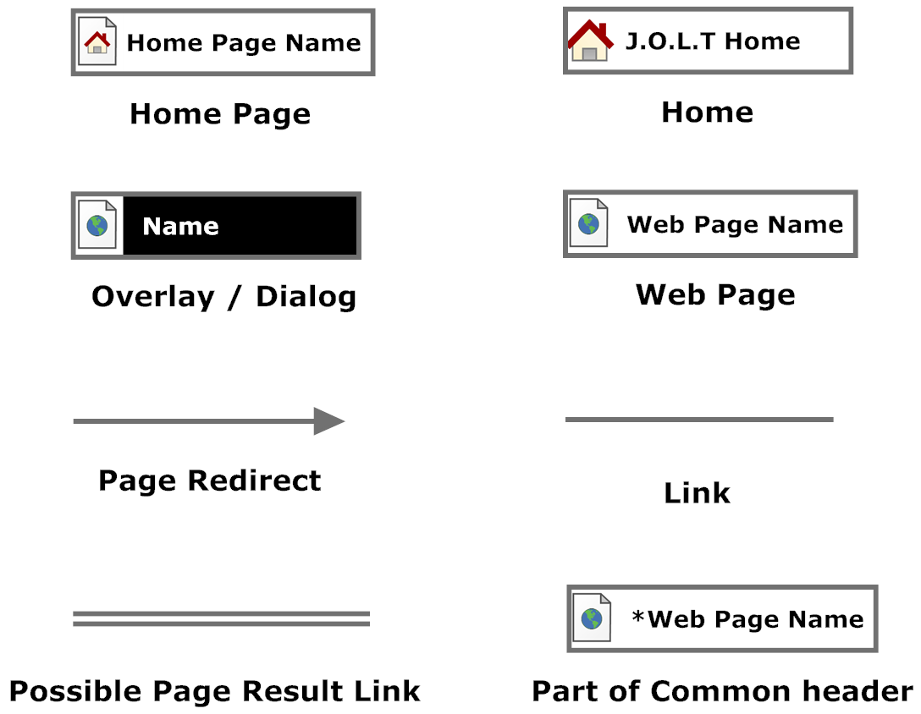

Context Web Site Map
This shows the initial pages for J.O.L.T. All subsequent Web Site Map diagrams show the User Home Pages broken down.
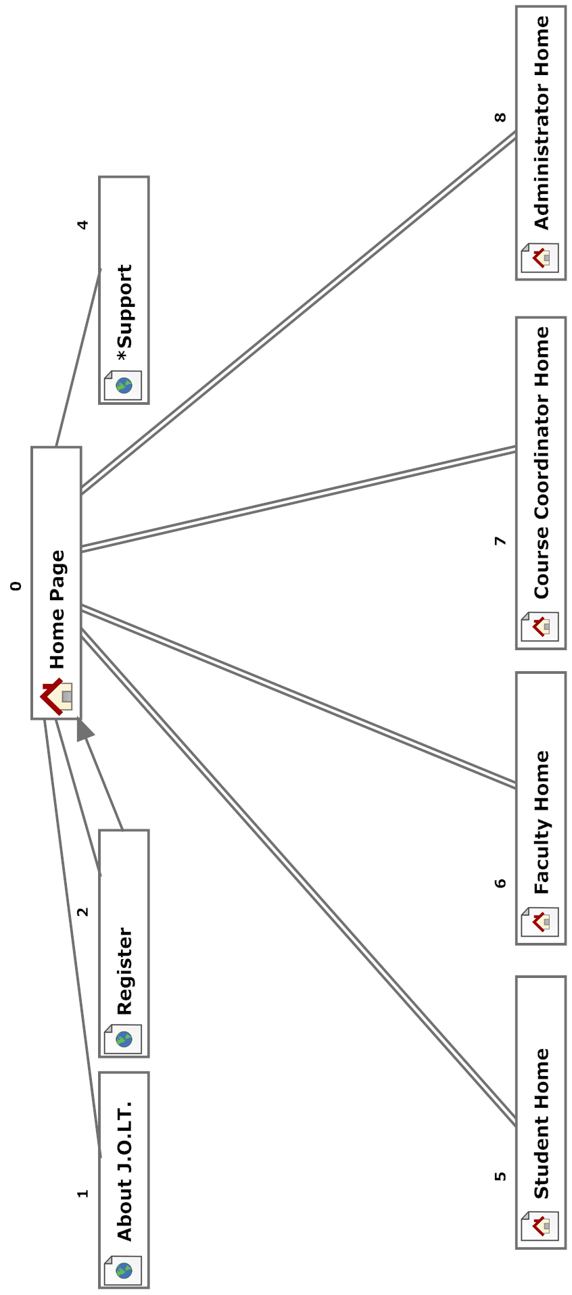

Student Web Site Map
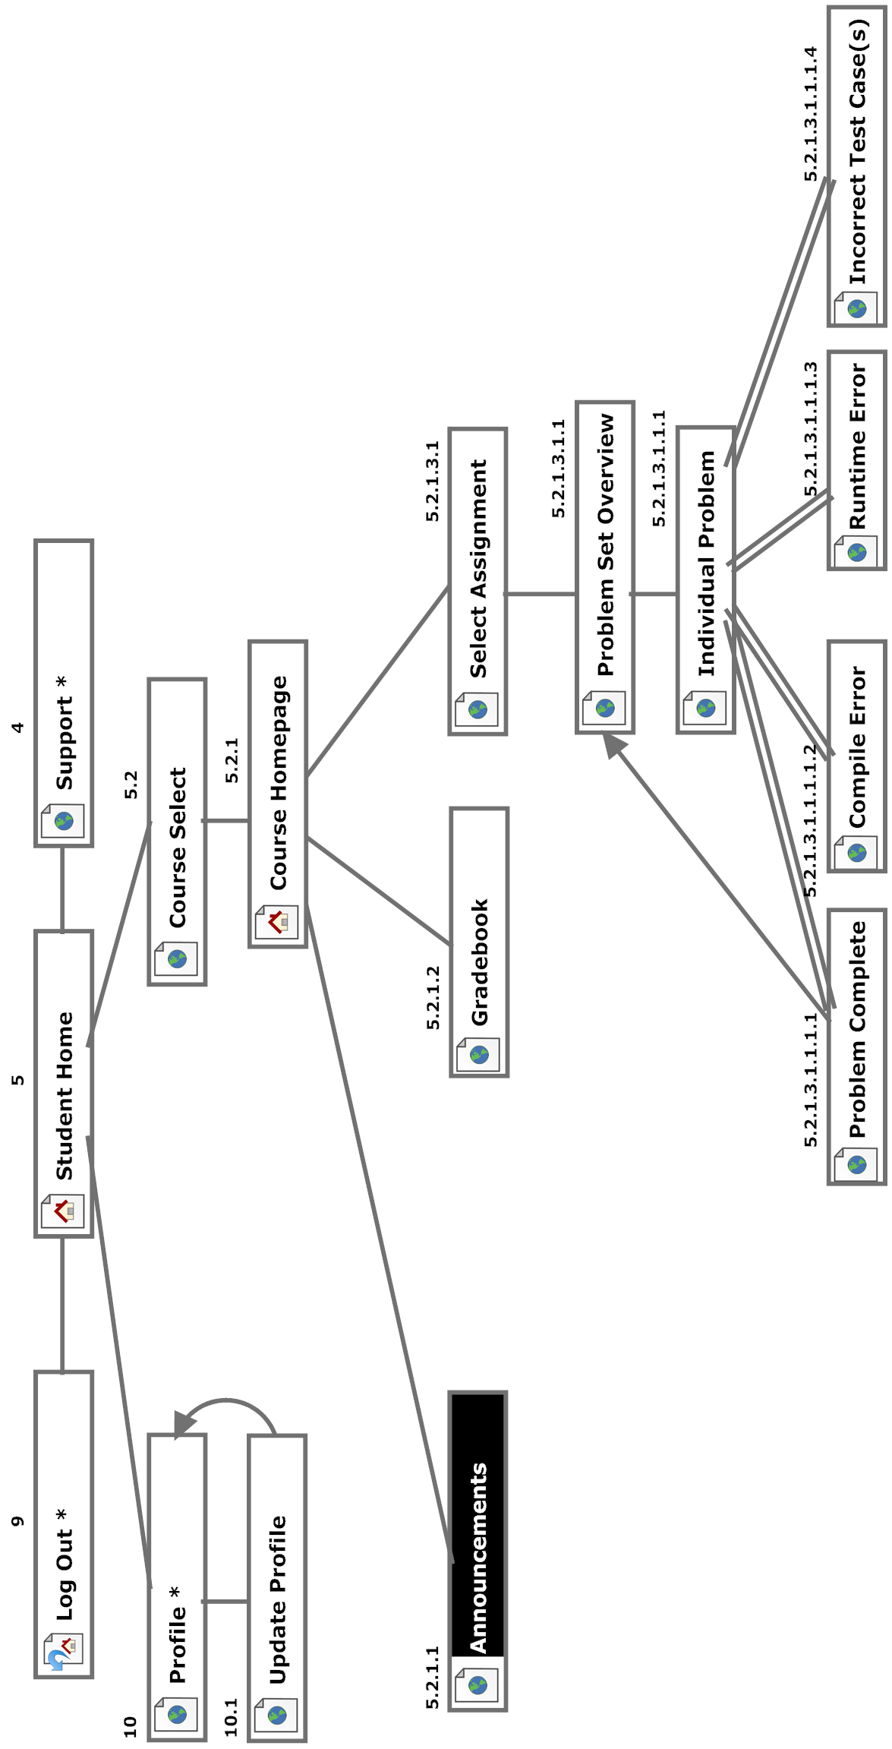

Faculty Web Site Map
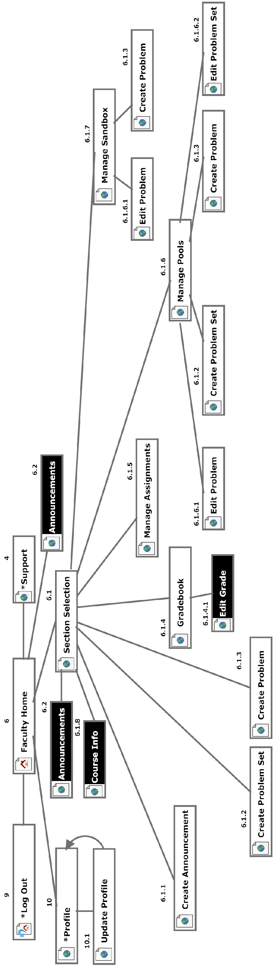

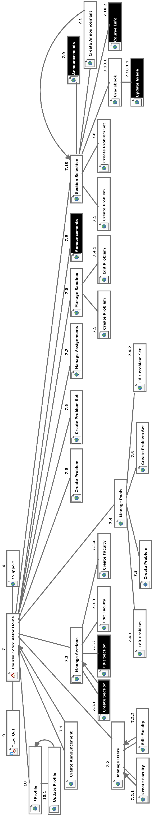
Course Coordinator Web Site Map

Administrator Web Site Map
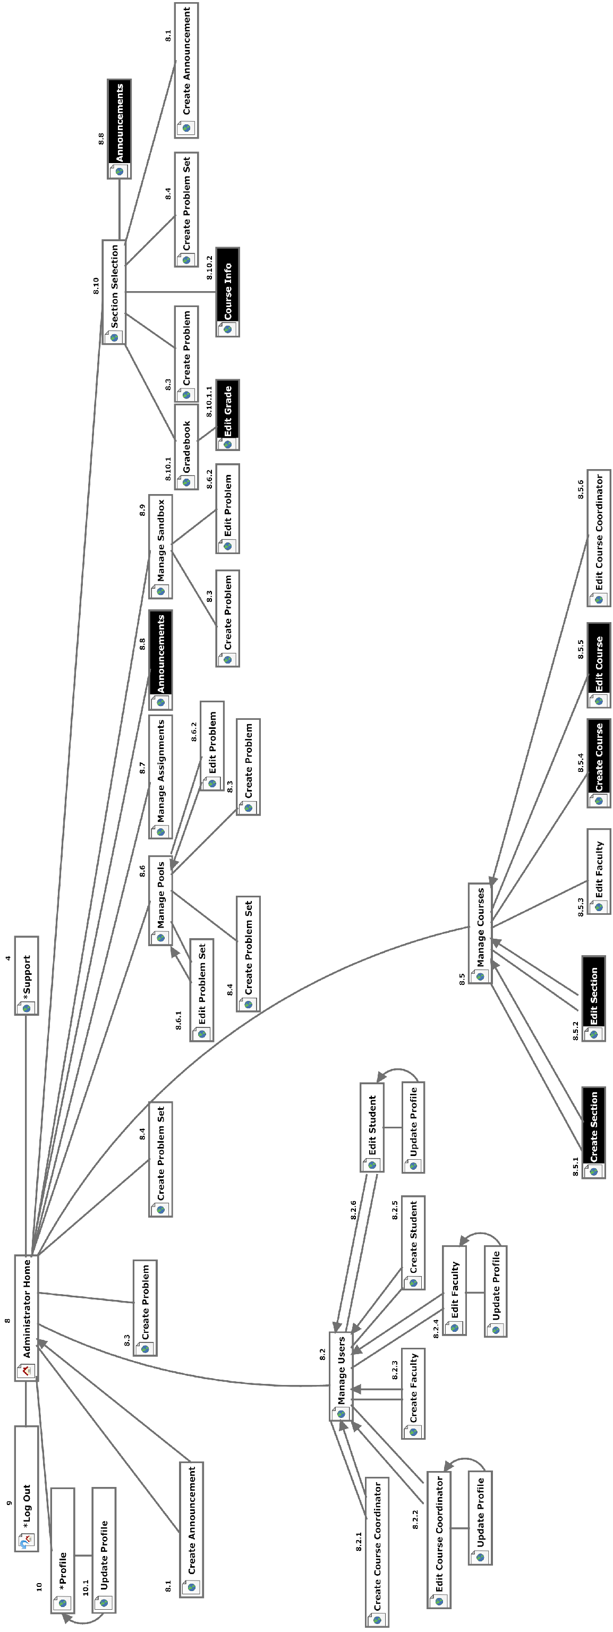

External & Internal Design Specification

User Screens with respective User Command Summaries

Unless otherwise specified, all screenshots which are depicted in browsers are taken with Mozilla Firefox Version 3.60
The screens provided within this document are intended to be final in terms of appearance and functionality, however, 518 Interactive reserves the right to modify the appearance and/or functionality of any screen as long as:
- All functional and non functional requirements are met by the System as a whole.
  - Exception: If it is determined by the client, Dr. Lim, that a requirement is no longer needed, desired, or feasible, than the requirement can be removed from the specifications and associated tests.
- An agreement between 518 Interactive and the client, Dr. Lim, is reached regarding the change.

Note: User Command Summaries appear under each screenshot in this section.

Student User

Student User Narrative
Students shall have the ability to register an account with the System. Once registered, students will be able to log into the system via their unique username and password. Once logged in, students will be able to enroll in only the courses they are currently taking. Students will have the ability to view problems in a categorized manner. Students will also be able to take exams and solve individual problems created by their instructor. Students will be able to solve problems by submitting Java source code, which the system will compile and run against provided test data. While solving a set of problems, students will be able to navigate from problem to problem without completing them in a specific order. Students will be able to save their progress for any individual problem and work on it again during a later session.
Students will have a report card view which will allow them to view their own grades and progress in all current and past courses. Students will be able to browse all of their own solutions as well.

J.O.L.T Login Page

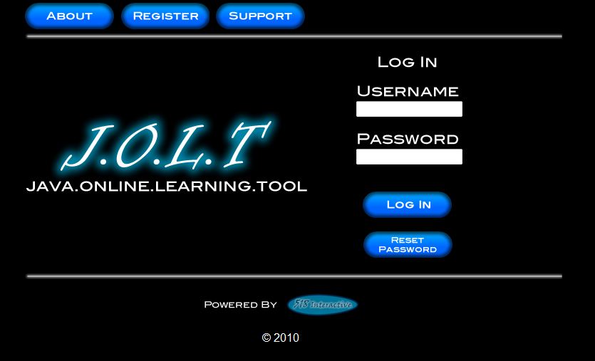
This is the initial screen that Students will be presented with when they navigate to J.O.L.T. It prompts for a username and password, and provides a link for registration and forgotten password. As well as links to the “About” and “Support” pages.

Student Registration Page

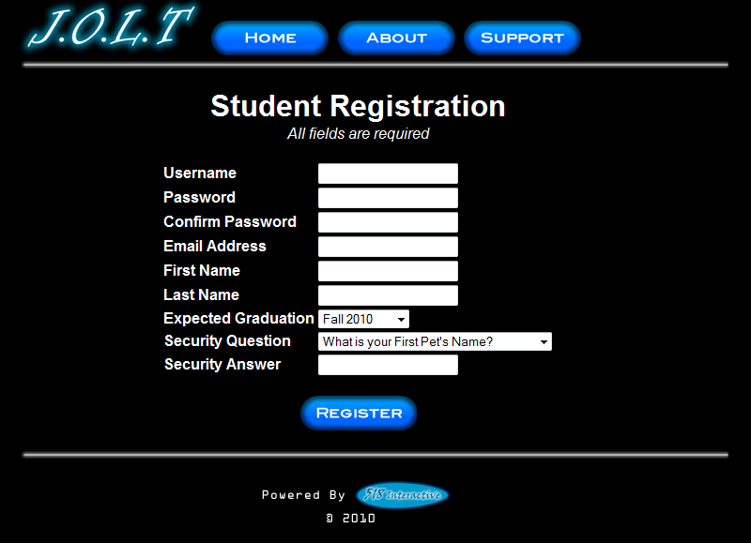

This is the screen that Students will be presented with when they click the “Register” link on the Login Page. Students are asked to provide information that is required to register with J.O.L.T. By clicking on “Register” with all of the correct fields the user ‘s account will be created in the database. At the top, Home will take the non-logged in user back to the home Log in Page. The “About” button will allow the user to view information pertaining to the objectives of J.O.L.T and its creators. Clicking the “Support” button will provide the user with information if they are encountering any difficulties.

Student Registration Page (Error Message – Invalid Fields)

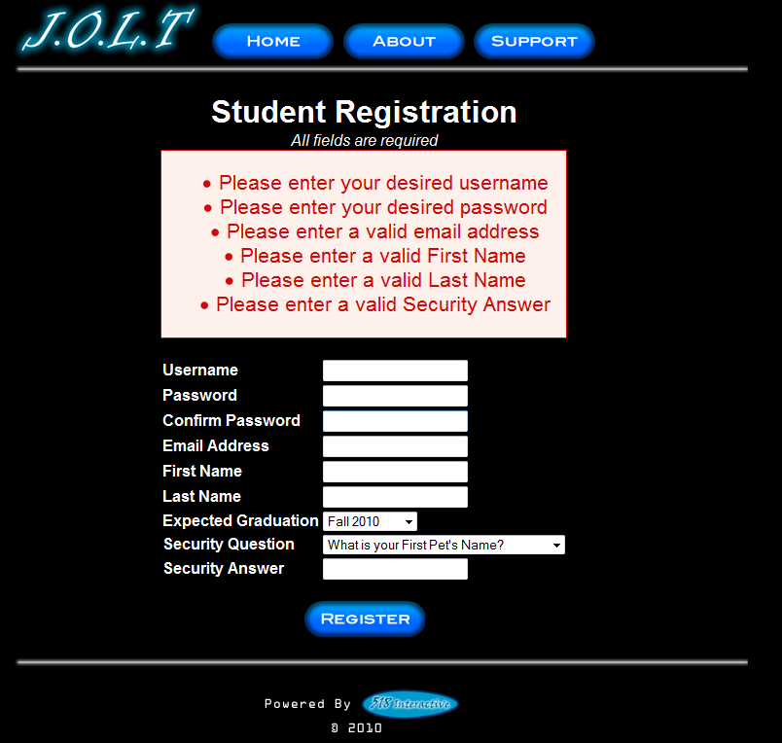

This is an example of an error message that Students would see if they fail to fill out all fields for registration. All functionality remains the same as the original registration page.

Student Registration Page (Error Message – Invalid Email)

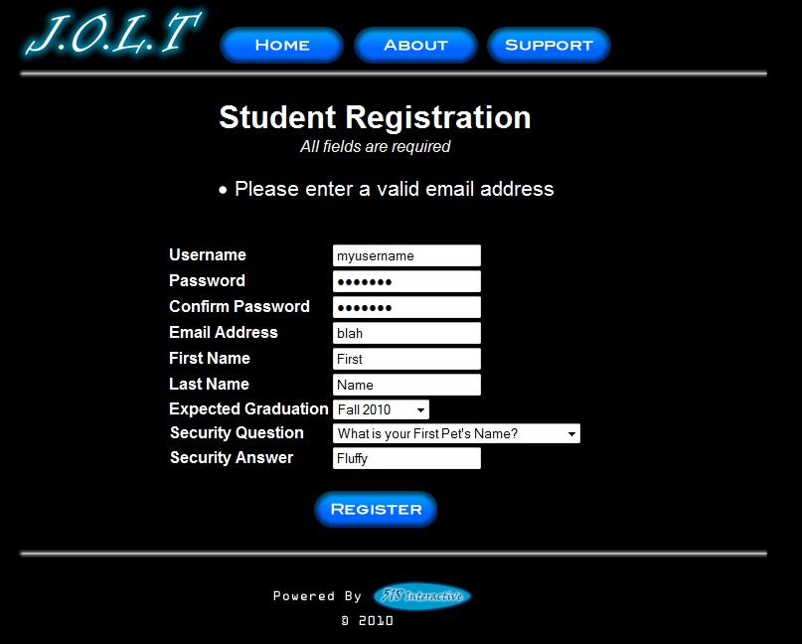

This is an example of an error message that Students would see if they fail to provide a valid email address. All functionality remains the same as the original registration page.

Student Registration Page (Completed)

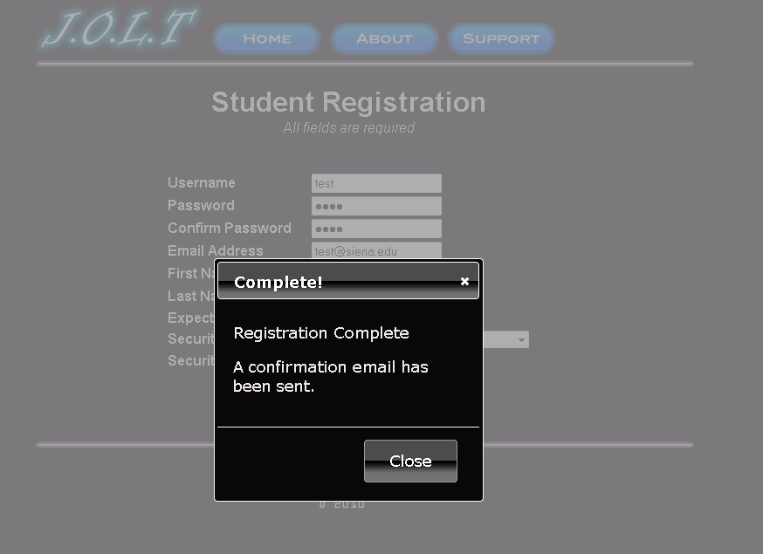

This is a confirmation overlay that is displayed to Students when they successfully provide all required fields for registration. A confirmation email is sent to the email address that they provided.

Invalid Login Screen
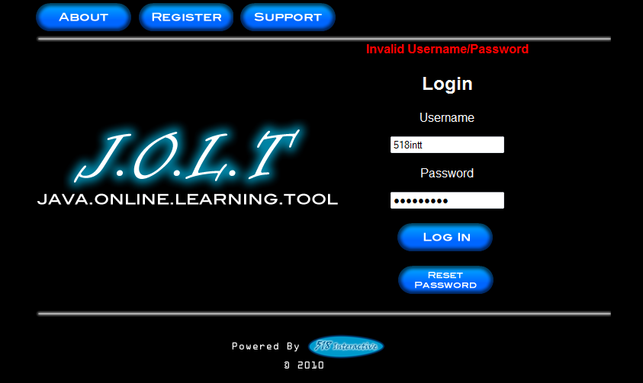
This error message will appear when a Student user enters an incorrect Username.

Invalid Login Screen
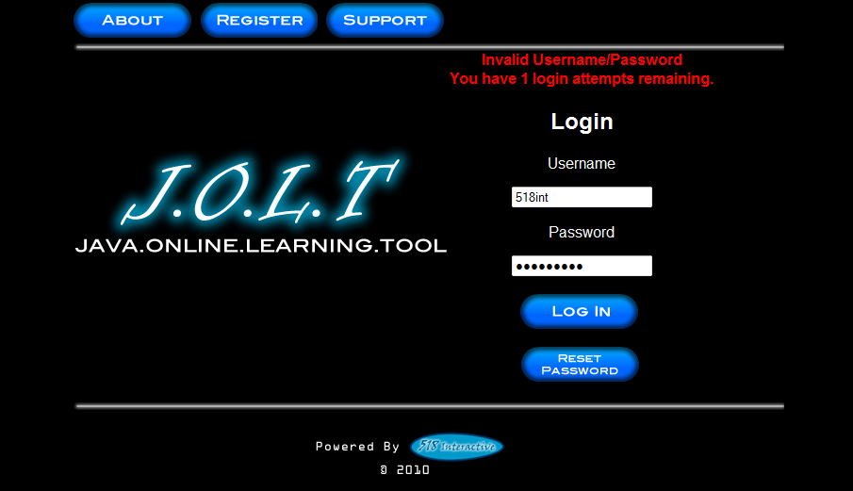
This is what the Student will see after entering a valid username and invalid password. This screen indicates that the Student has 1 more login attempts before their account is locked out.

Account Lockout Screen
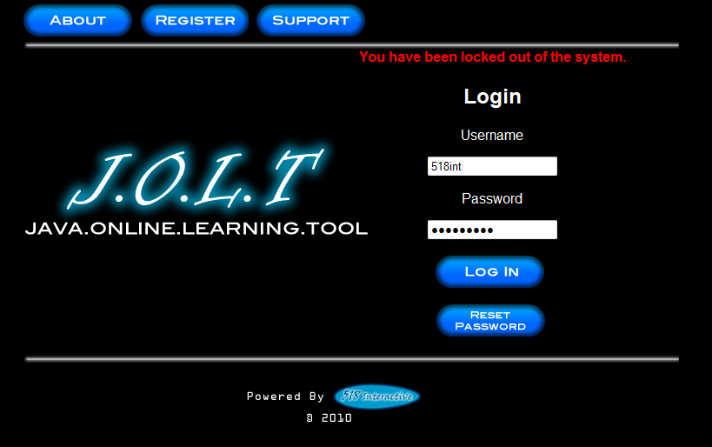
This screen appears when a Student user has too many incorrect login attempts for a particular username, and is locked out of the system.

Common Header
This header appears on all pages that the user has. The “Home” button brings the user to their homepage, the “Profile” button brings them to their profile page, the “Support” button brings them to a support page where they can get assistance, and “Log Out” will terminate the user’s session with J.O.L.T. This header functionality is common to all user types in J.O.L.T. The “(S)” on the right indicates user type. (S = student, F = Faculty, CC = Course Coordinator, and A = Administrator).

Student Home Page
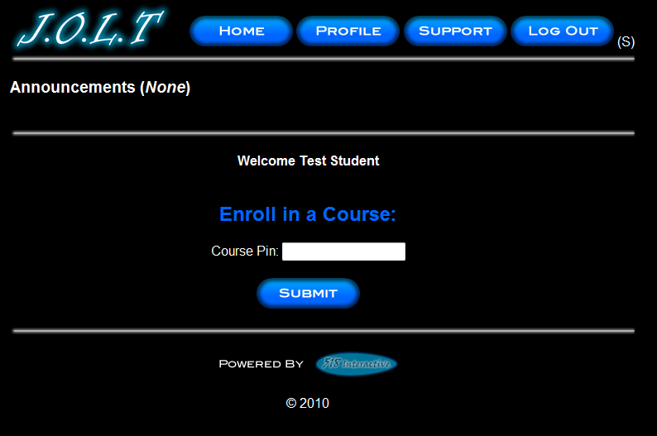
This screen appears once a Student user successfully authenticates with J.O.L.T. This screen indicates that the Student is not enrolled in any courses. Using the inline form, the student can enter a course pin to register for a section.

Course Enrollment (Invalid PIN)
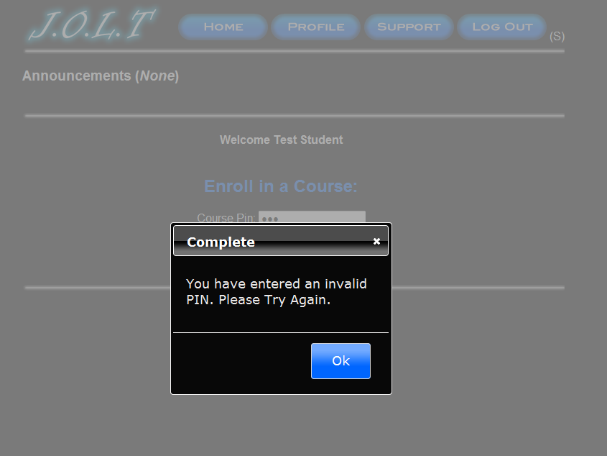
This overlay is displayed when a user attempts to enter an incorrect PIN to enroll in a course. Clicking “OK” brings the user back to the student homepage.

Course Enrollment (Completed)
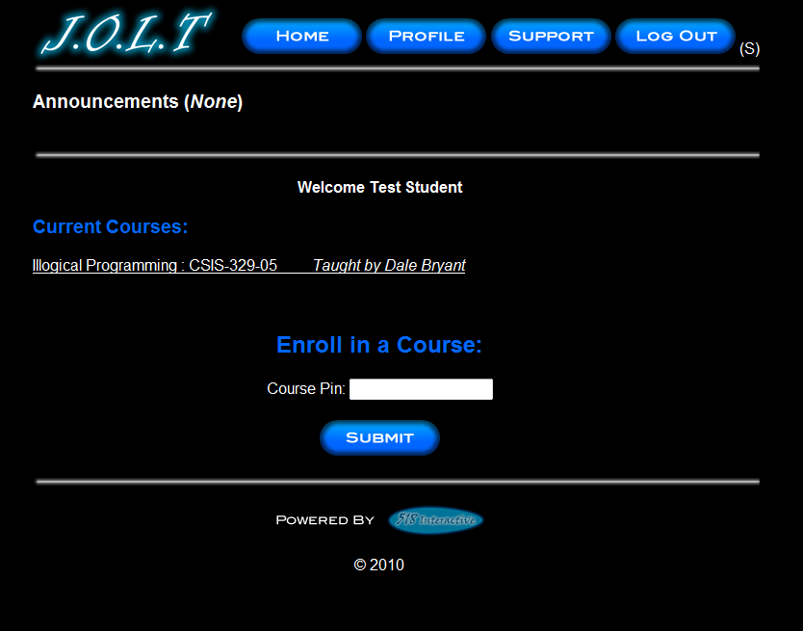
This screen is shown when a Student user enters a correct PIN to register for a course. The newly added course is displayed on the screen. Clicking on the course name will bring the student to the section homepage. Clicking on the “Home” button brings the user back to this page.

Section Home Page
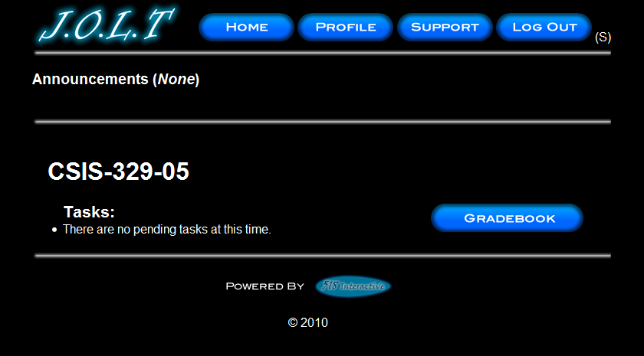
This is an example Section Home Page that a Student user would see once selecting a Section on their Home Page. This screen indicates that there are no tasks pending, and no announcements. The “Gradebook” button brings the student to their grade book.

Student Section Home (Populated)

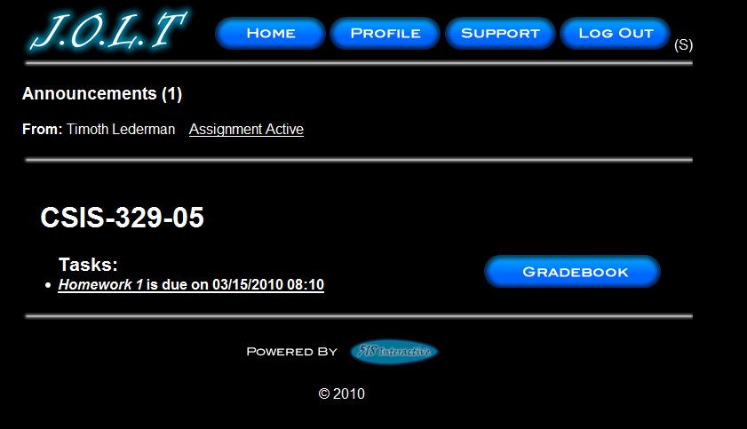
This is the section homepage with an active assignment as well as an announcement. Clicking the task brings the student to the Problem Set Overview screen. Clicking the announcement opens the announcement in a dialog.

Problem Set Overview
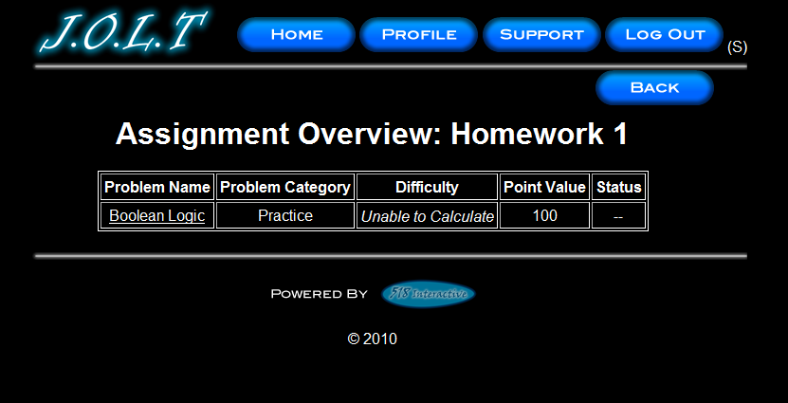
This is an example Problem Set Overview Screen. This screen shows each problem within the problem set, as well as each problem’s category, difficulty point value, and completion status.

Solve Problem
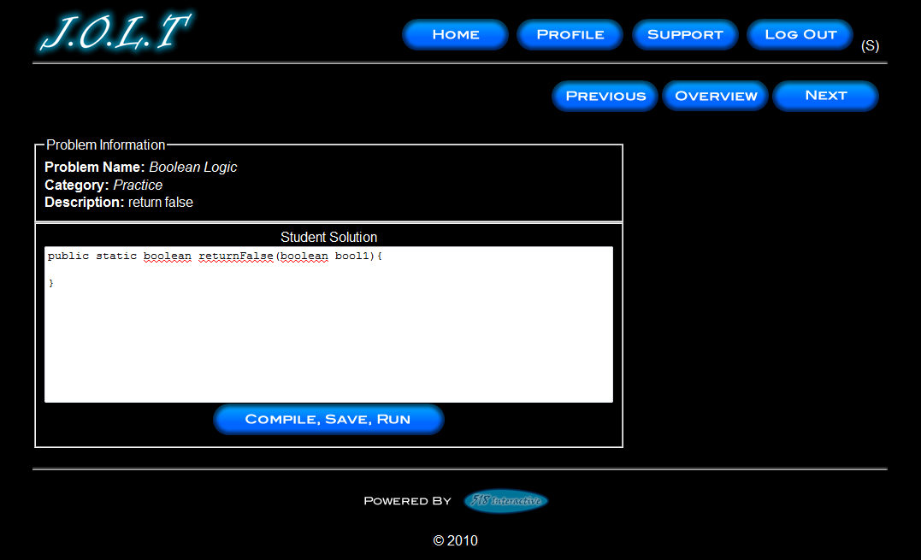
This is an example Solve Problem screen. The Student User is presented with the Problem Name, Description, and a text area for inputting Java™ Source Code. The text area is pre-populated with a method signature. Clicking on the “Previous” and “Next” buttons brings the user to a different problem in the problem set. The “Overview” button brings the user back to the problem set overview screen.

Student Solution Attempt (Compile Error)
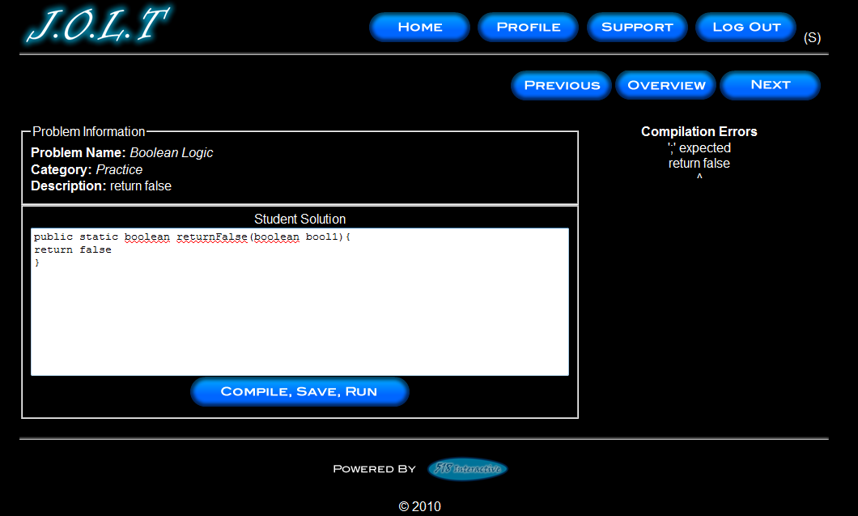
This is the Solve Problem Screen with an example Compile Error. This is shown when a Student enters Java™ Source Code that is not syntactically correct, and then pushes the “Compile, Save, Run” Button.

Student Solution Attempt (Incorrect Output)
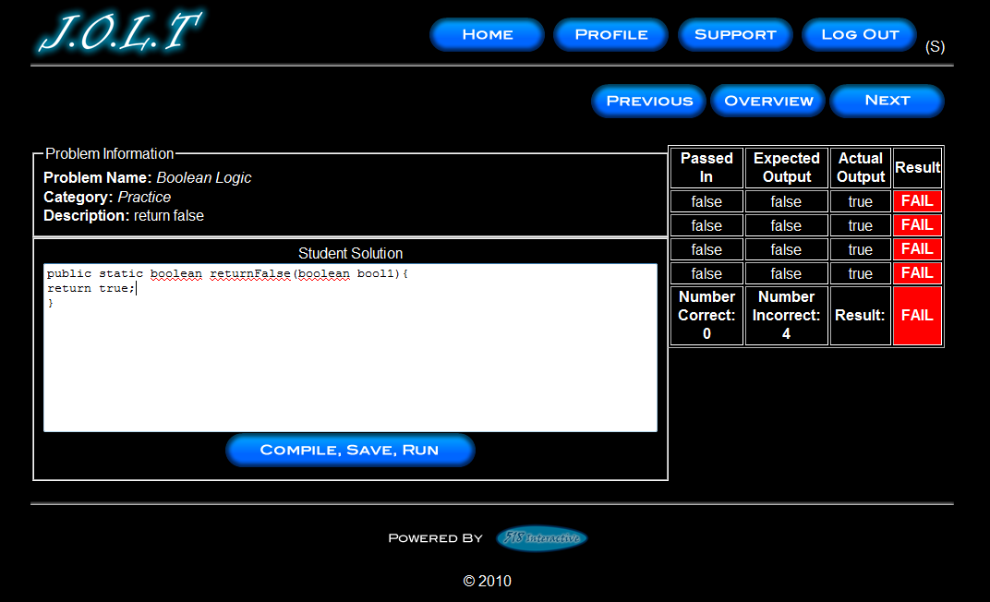
This is the Solve Problem Screen with incorrect output. This is shown when a Student clicks the “Compile, Save, Run” button after entering Java™ Source Code that is syntactically correct, but produces the wrong output.

Student Solution Attempt (Timeout)
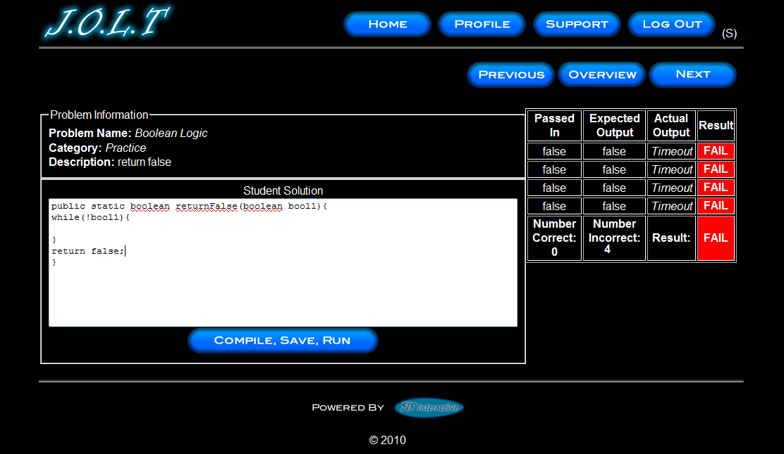
This is the Solve Problem Screen with a timeout error. This is shown when a Student clicks the “Compile, Save, Run” button after entering Java™ Source Code that is syntactically correct, but fails to complete execution within a reasonable amount of time.

Updated Problem Set Overview Screen (Navigate Away)
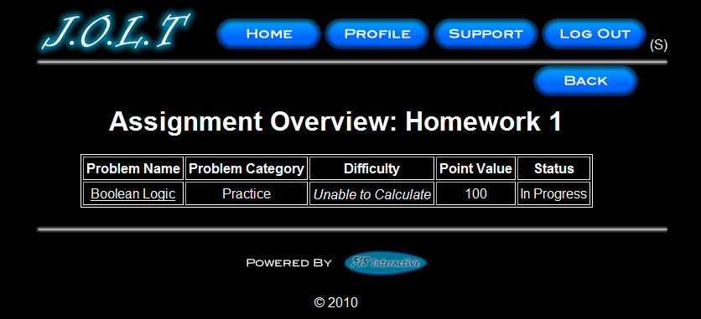
This is an example Problem Set Overview screen with an incomplete problem. This occurs when a student navigates away from a problem once attempting (unsuccessfully) to solve it.

Student Solution Attempt (Completed)
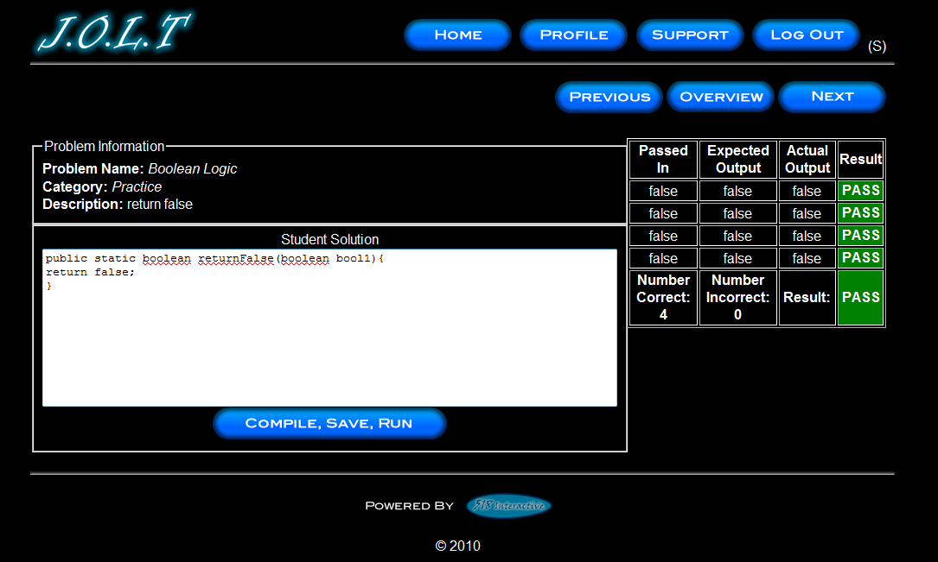
This screen appears when the Student enters a Java™ solution that passes all of the provided test cases.

Updated Problem Set Screen
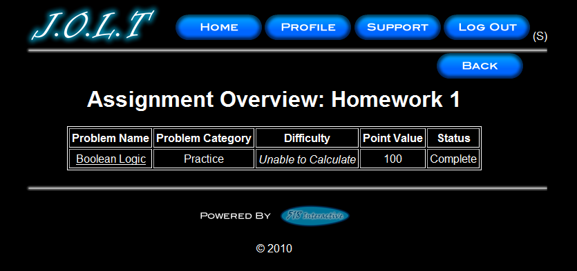
This is an example Problem Set Overview Screen showing a completed problem.

View Gradebook
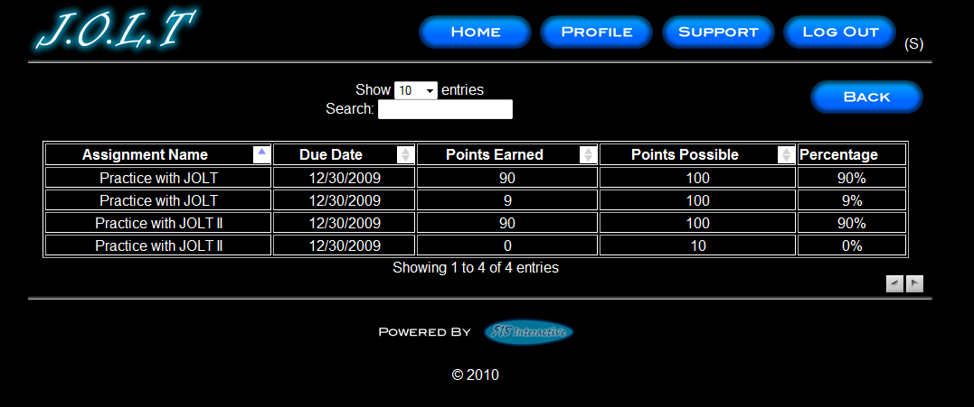
This is an example of the Student gradebook for a particular section. This screen is sortable by name, due date, and grade. The Assignment Name fields are clickable, with each link bringing you to the respective Problem Set Overview.

View Profile
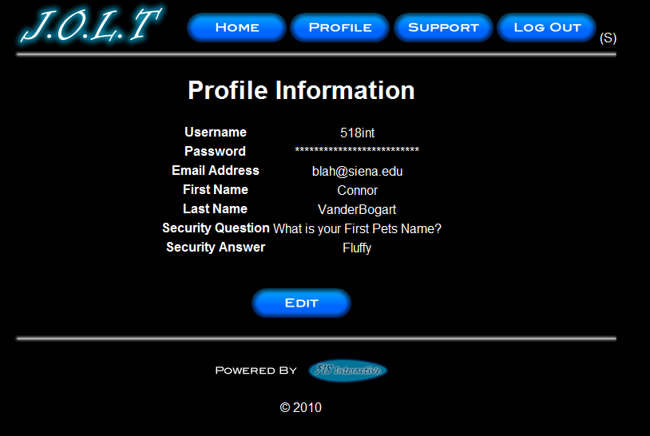
This screen appears when the Student clicks the “Profile” button in the header of any page. It shows the Student’s profile information.

Edit Profile
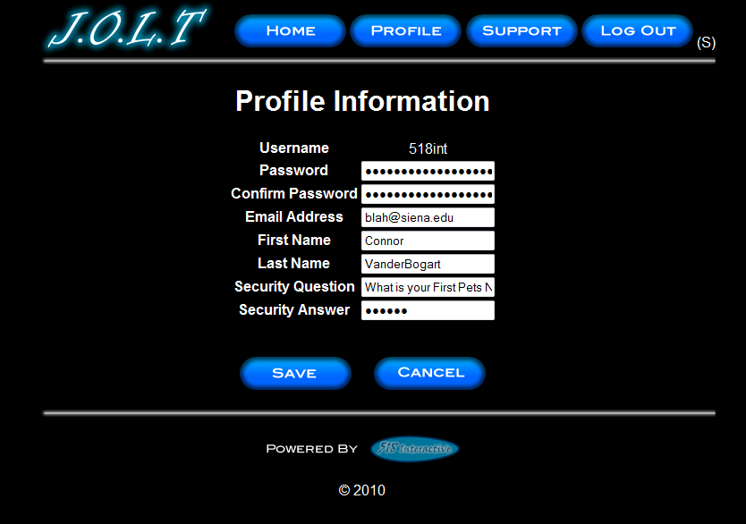
This screen allows a Student user to edit their profile information. The Students gets here by clicking the “Edit Profile” button on the Student Profile Page. All error checking in the registration page applies to this page.

View Announcement
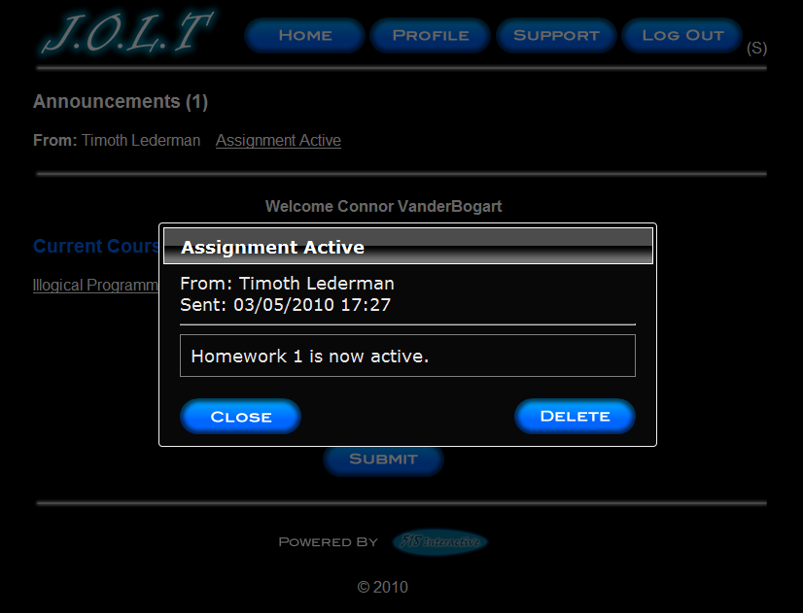
This overlay appears when a user clicks the announcement title on their homepage or section homepage. Clicking “Close” removes the overlay and keeps the announcement in the system. Clicking “Delete” will remove the announcement from the system.

Logout
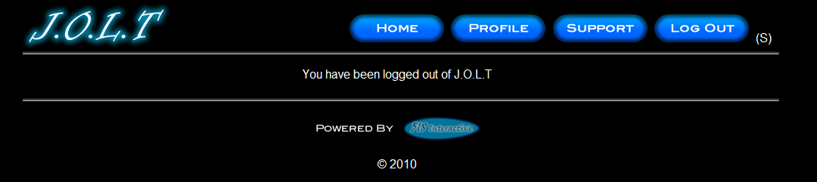
This screen shows a Student who has just logged out of J.O.L.T by clicking the Logout button in the header.

Faculty User

Faculty User Case Narrative
Faculty shall have the ability to log into the system via a unique username and password. Once logged in, Faculty will be able to select a course and then create individual problems as well as problem sets for that course. Each problem will be categorized based on type and difficulty. Faculty will be able to assign a grading scheme to problems and problem sets. Each problem created will have the ability to be modified; however, all changes will be recorded into the System as a new problem. This will allow users to view problems and problem sets in a temporal manner. Problems that are partially completed will be saved to a “sandbox” where they may finish it at a later date.
Faculty will have the ability to submit their problems and problem sets to a “Course Pool”, which will allow other faculty members who teach the same course access to their problems and problem sets. Faculty will have the ability to search a Course Pool or the Global Pool.
Faculty will have a grade book view which will allow them to see the progress of each student that they instruct or have previously instructed. Faculty will have the ability to alter any grade that was assigned to a student in their course. Faculty will have the ability to send a broadcast message to students that they instruct.

Faculty Screens
The Faculty User shall have the following screens available.

J.O.L.T Login

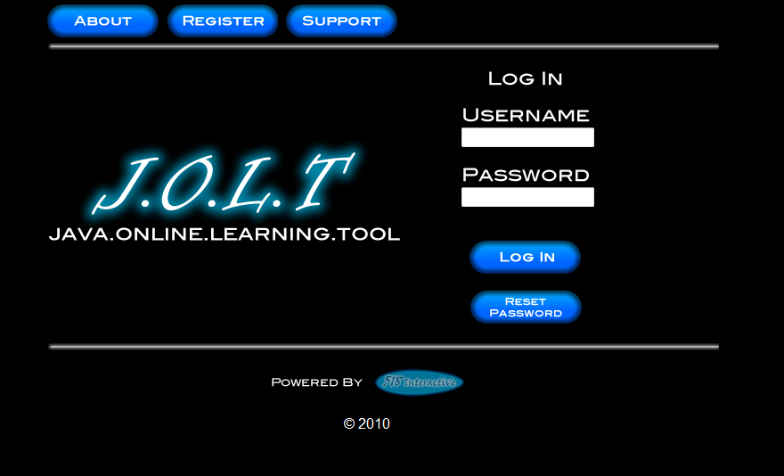
This is the initial screen that Faculty will be presented with when they navigate to J.O.L.T. It prompts for a username and password, and provides a link for forgotten password. Note that faculty accounts are created by Course Coordinators and/or the Administrator. No self-registration is allowed.
Note: All validation that appears on the student screens applies to this page for Faculty.

Faculty Home Page
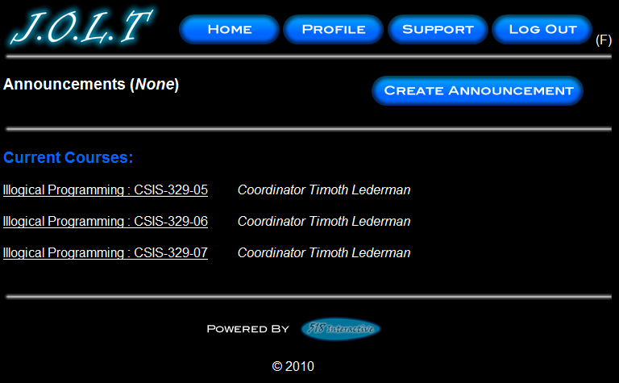
This is the Faculty Home Page. This page is pre-populated with their courses by the Course Coordinator. From here, the Faculty can select a course, or create an announcement.

Section Home Page
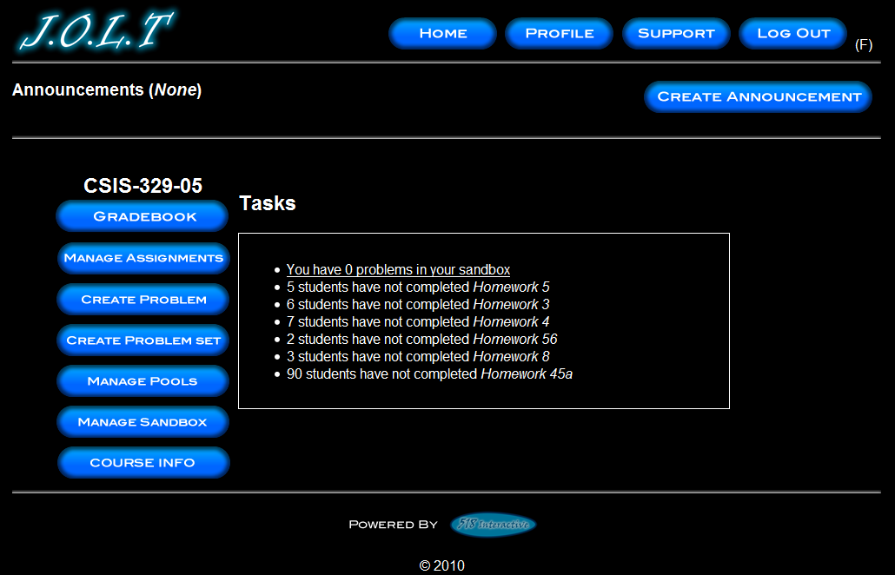
This is the Section home page for a Faculty member. From here, they can manage the gradebook, assignments, sandbox and pools. They can also create a problem or problem set, and view the course information.

Create Problem
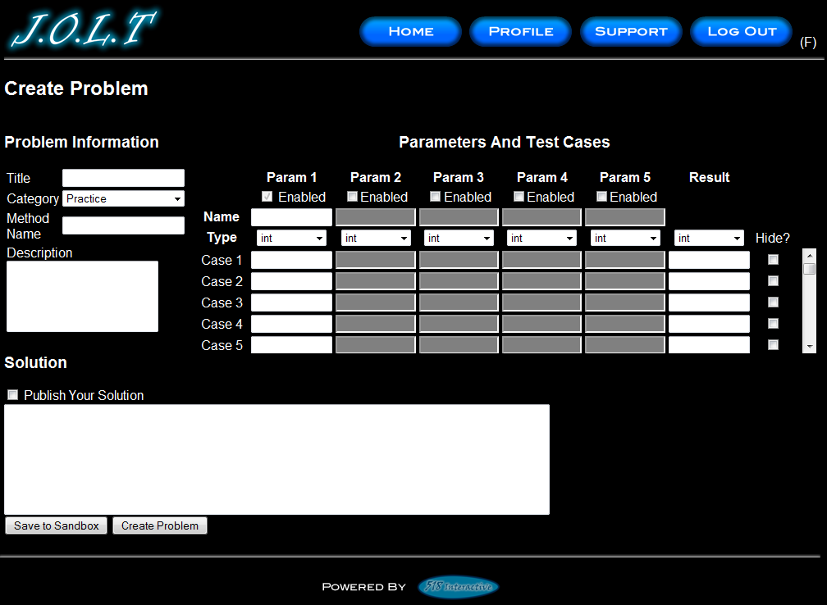
This is the Create Problem page for a faculty member. From here, the faculty enters all information about a problem.

Create Problem (Invalid Field)
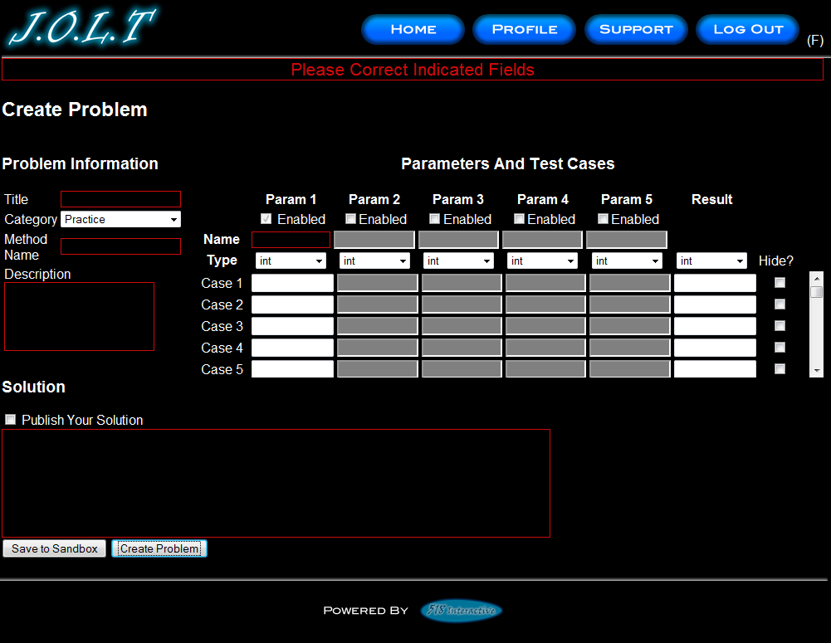
This screen shows an error message indicating an invalid field is present on the Create Problem Screen.

Create Problem Compiler Error
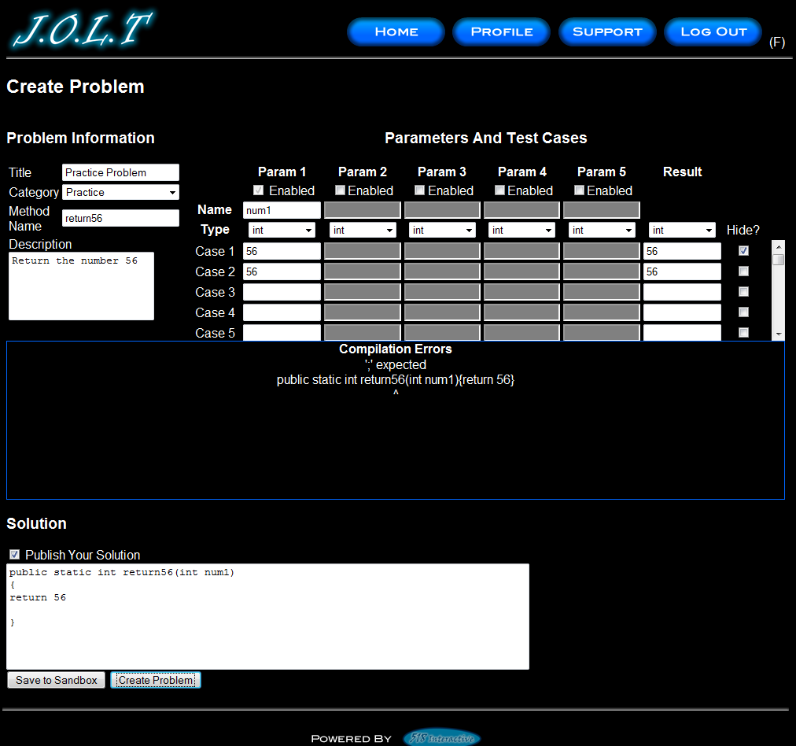
This screen shows an error message pertaining to a compiler error in the Faculty member’s solution code.

Faculty Sandbox (Unpopulated)
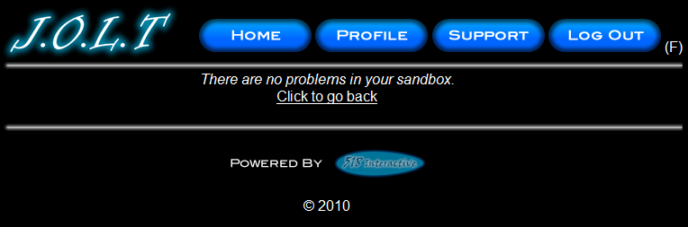

This is the Faculty sandbox. The sandbox stores all problems that are not completed and ready for the pool.

Faculty Sandbox (Populated)
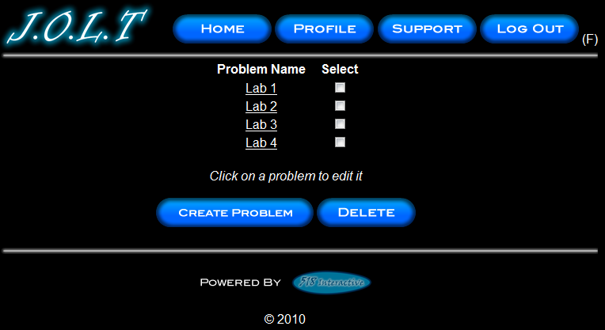
Clicking a problem name in the sandbox will bring up a window to edit the problem. The user can also select a problem to and click ”Delete” to remove it from their sandbox. The user can also Create Problems from this page (The problems created from that create problem screen do not necessarily mean that they will be saved in the sandox.

Edit Problem
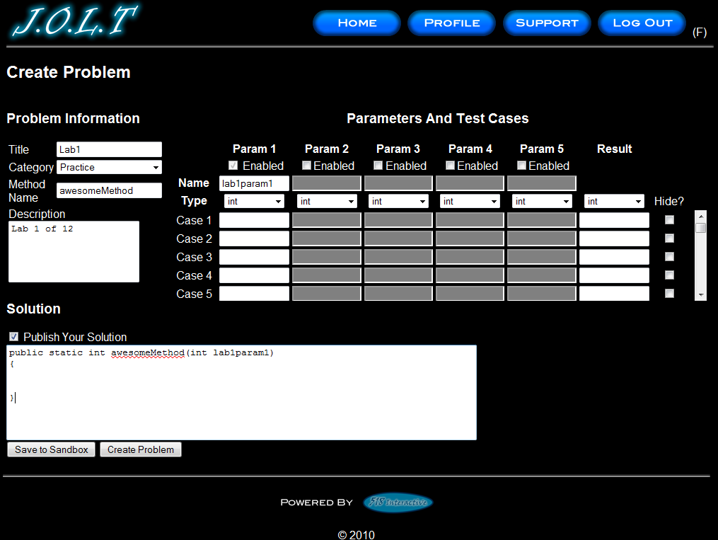
This is the edit problem screen that the Faculty user will see when they choose to edit a problem from their private pool, the course pool, the global pool, or the sandbox. It is simply the create problem screen populated with the information the user provided. All error checking on the Create Problem screen exists on the edit problem screen as well.

Create Problem Set
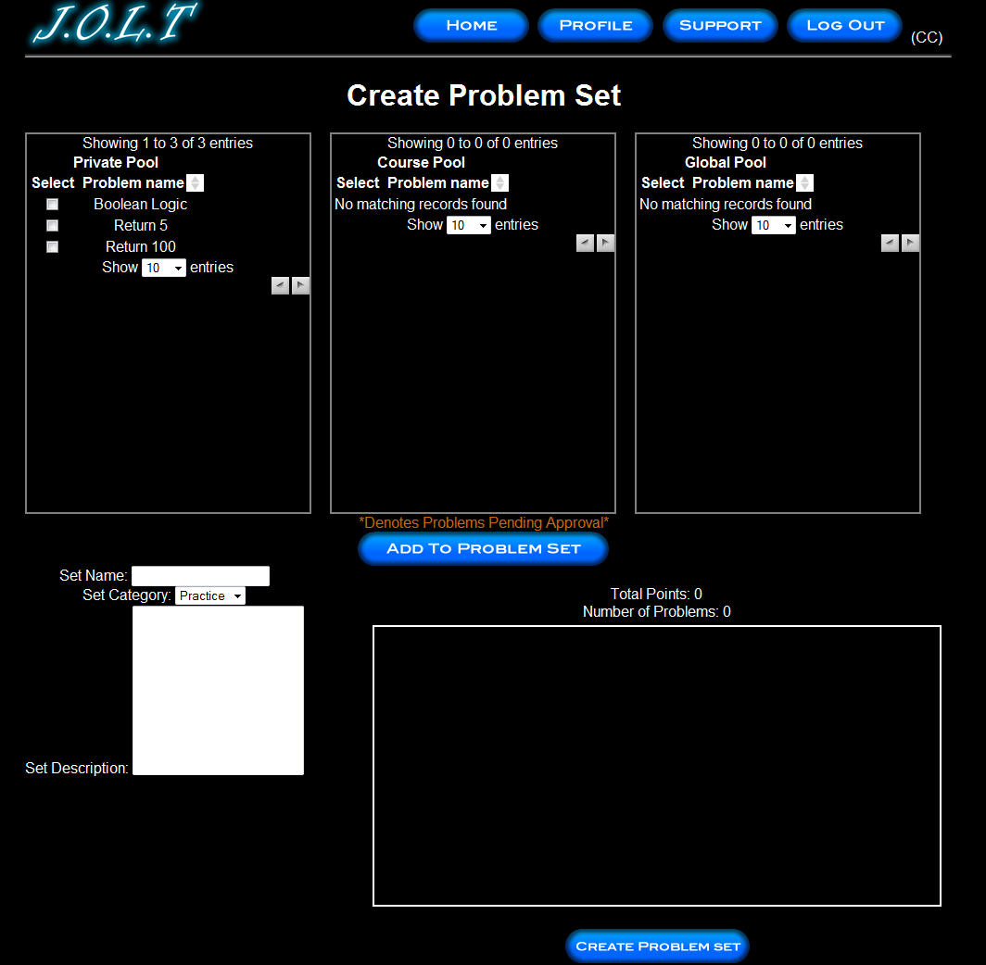
This is an example of the Create Problem Set Screen. Faculty can use problems from their own pool, the course pool, or the global pool when creating a Problem Set. Clicking on a problem in the problem set area will allow the faculty user to edit the problem. Point values can be assigned to each problem.

Create Problem Set (Error)
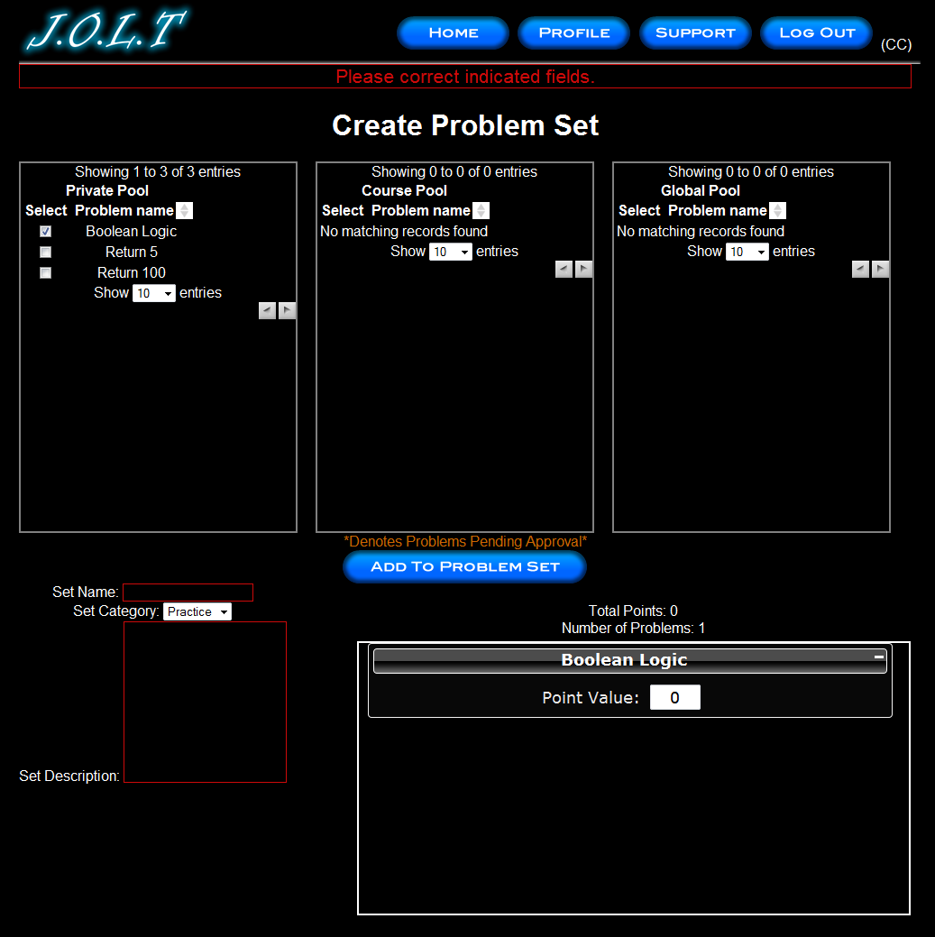
This is an example error message showing invalid fields on the Create Problem Set Screen.

Create Problem Set (No Problems Added Error)
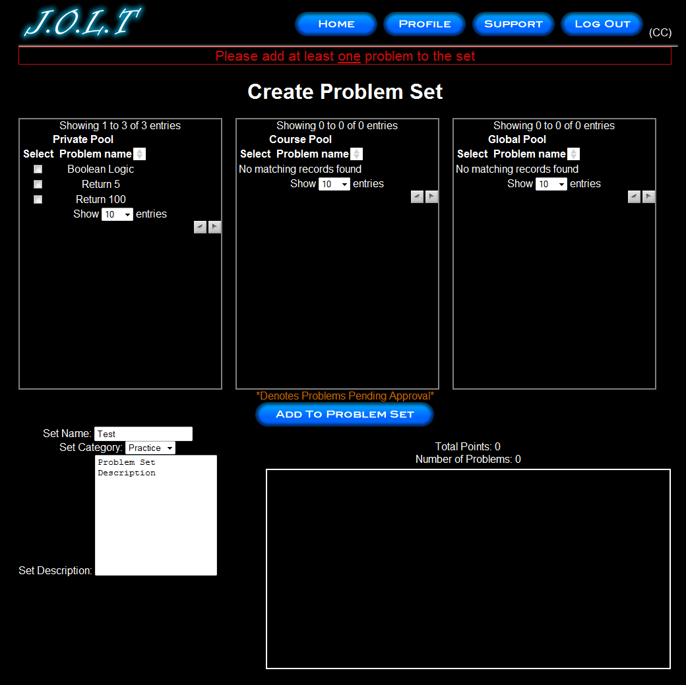
This is an example error message showing a Problem Set with no problems added to it.

Create Problem Set (Completed)
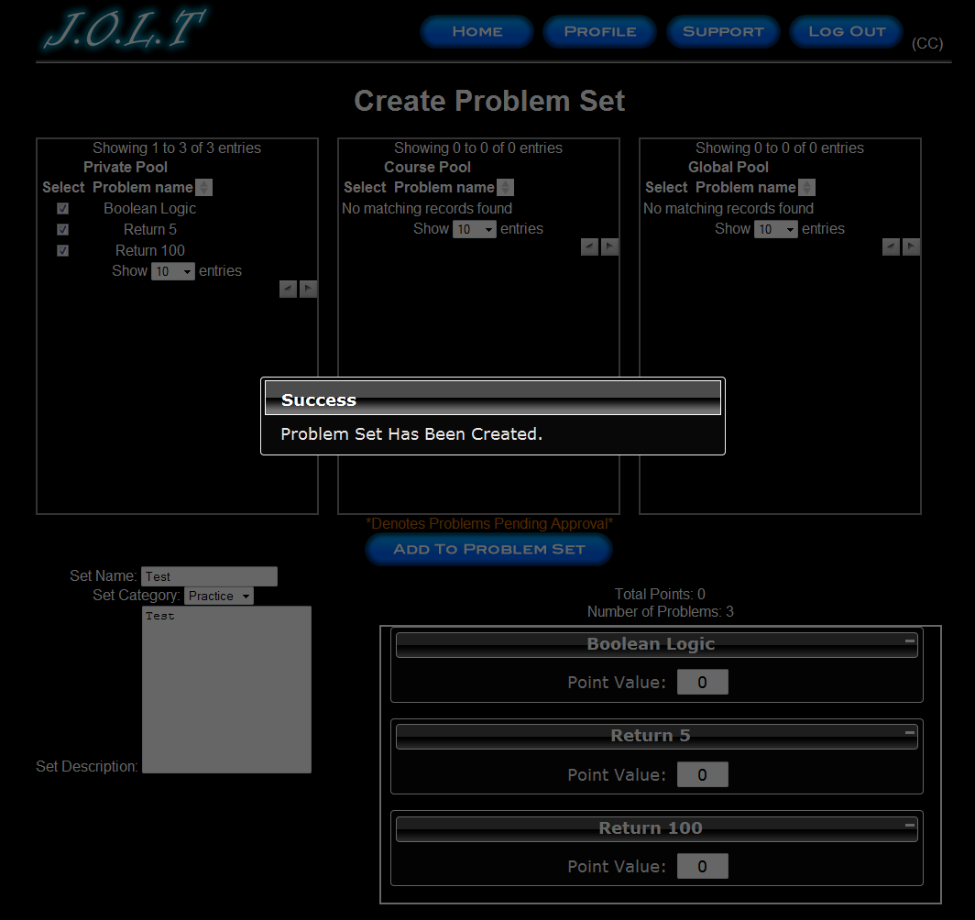
This is a confirmation message showing a created Problem Set. This is an overlay dialog that will redirect to their pool management screen.

Edit Problem Set (Completed)
This is the screen for Editing an existing Problem Set. The format of the screen is identical to the Create Problem Set screen. All error screens for Edit Problem Set are identical to the ones for Create Problem Set.

Activate/Assign Problem Set
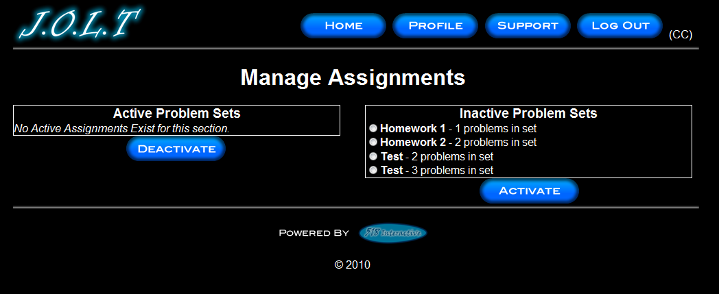
This is the screen to activate a Problem Set for a specific course. Problem Sets can either be activated instantly, or set to be active at a later date. Problem Set Deactivation is also accomplished on this screen. Note that this screen is only used for manual deactivation. J.O.L.T will automatically deactivate problem sets once the expiration date and time have been passed.

Create Announcement
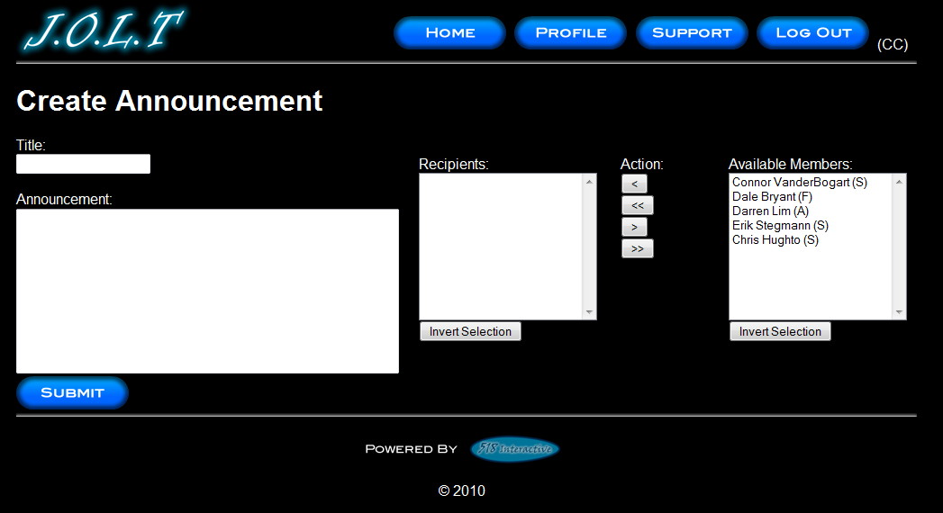
This is the screen to create an announcement to be broadcast to users. Users select recipients of the announcement, and provide a title and announcement text.

Create Announcement (Add Recipients)
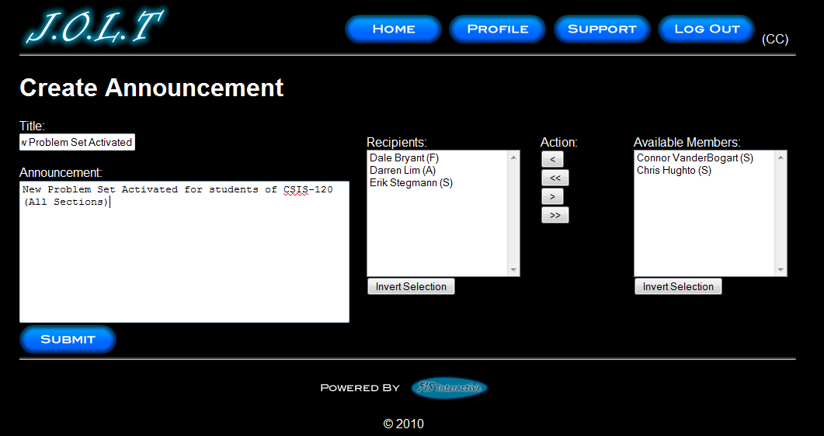
This screen shows an announcement with populated data and selected recipients. Using the left and right arrow buttons add and remove users from the recipient list.

Create Announcement (Missing Field)
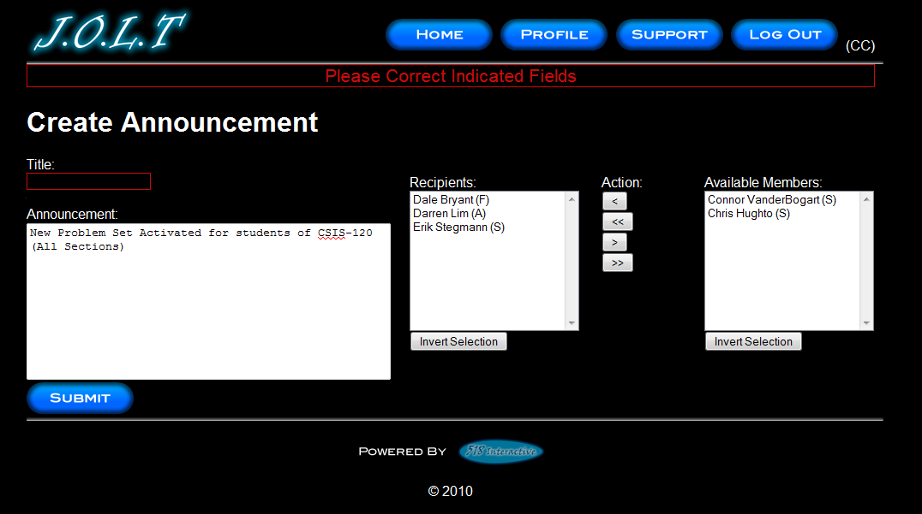
This shows an error message for a missing field when creating an announcement. This appears once the user selects the “Submit” button.

Create Announcement (Complete)
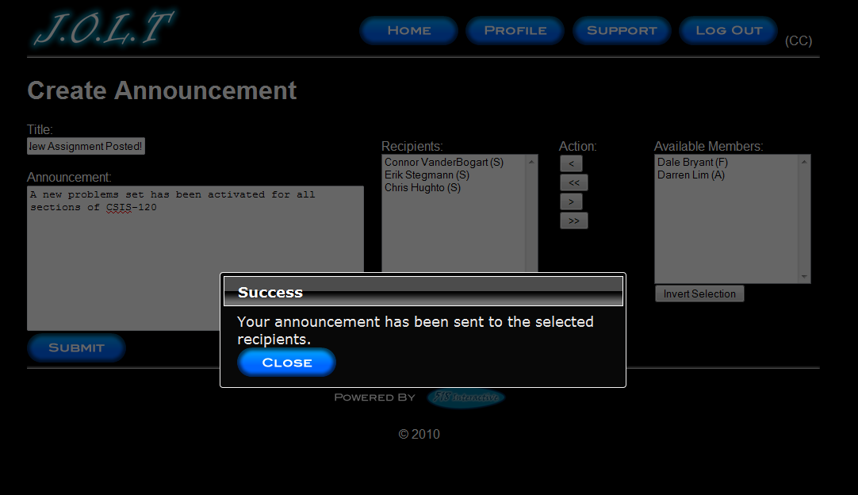
This shows a successfully created announcement. This appears once the user selects the “Submit” button. Clicking on “Close” removes the overlay, but keeps the user at the announcement screen in case they wish to send another announcement.

View Gradebook
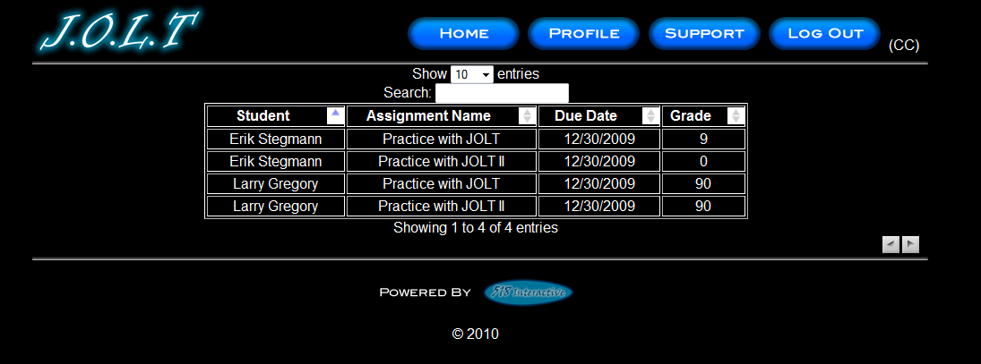
This is the gradebook view for a specific course for a faculty user. Clicking on an Assignment Name brings the user to the Problem Set Overview screen. Clicking on the grade allows the user to change the grade.

Edit Gradebook (Editing)
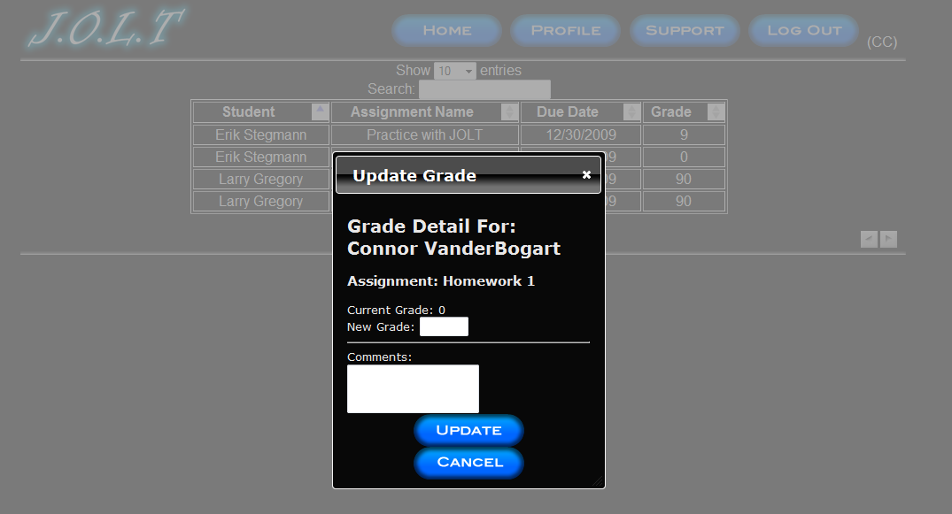
This shows a user editing a student’s grade. Clicking the grade opens an overlay dialog where a new grade may be entered. A comment field is also provided, but not required.

Manage Pools
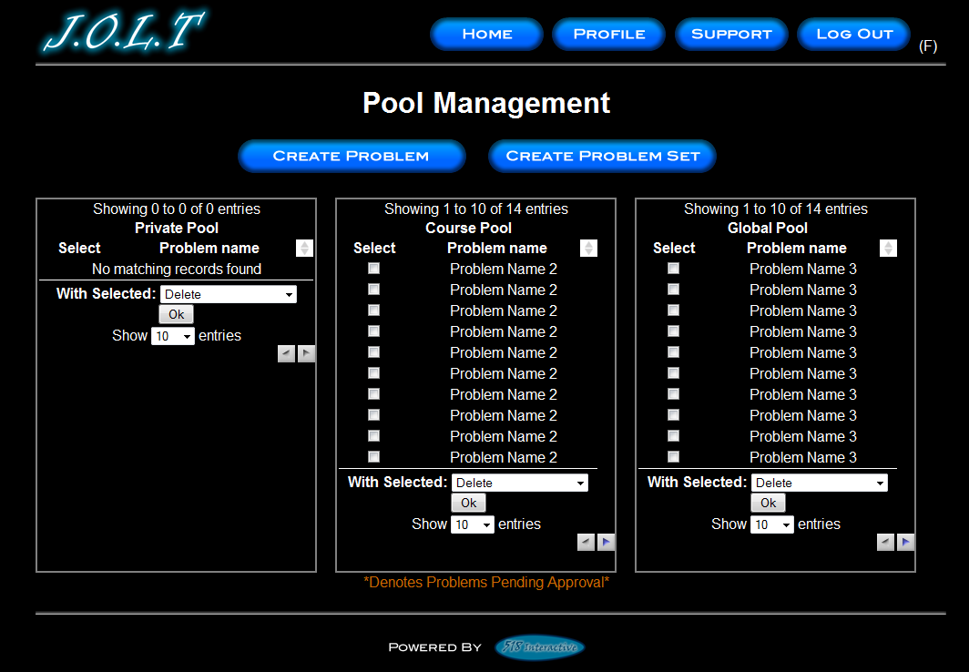
Clicking the “Manage Pools” button on the Section Home Page brings the user to this screen. Multiple problems can be selected at once. Problems in the private pool can be copied to the course pool. Problems in the private pool can also be removed from the pool. Note that deleting a problem from a pool does NOT remove the problem from the database.

View Profile
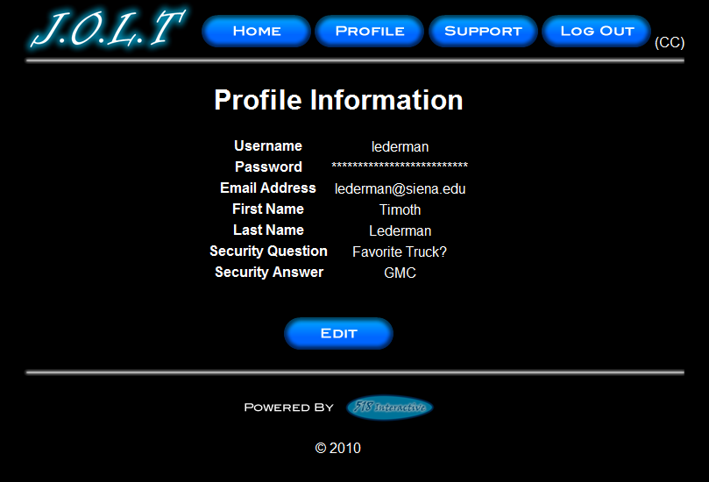
Clicking the “Profile” button in the header will bring faculty members to this screen, where they can view their profile information. There is a button to update their information as well.

Edit Profile
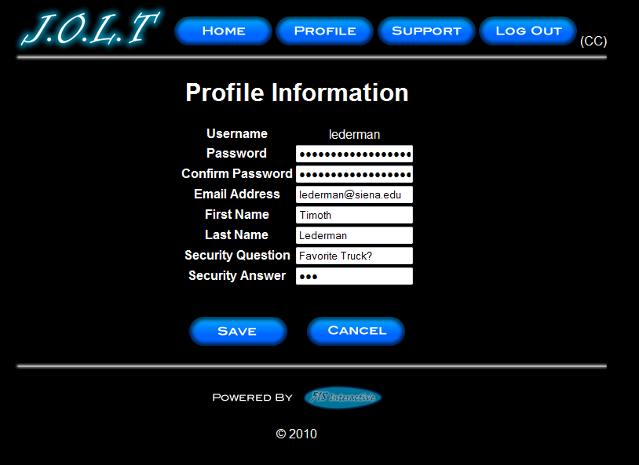
This screen allows a Faculty user to edit their profile information. The Faculty user gets here by clicking the “Edit Profile” button on the Faculty Profile Page. All error checking that the student user has also exists on this screen.

Logout
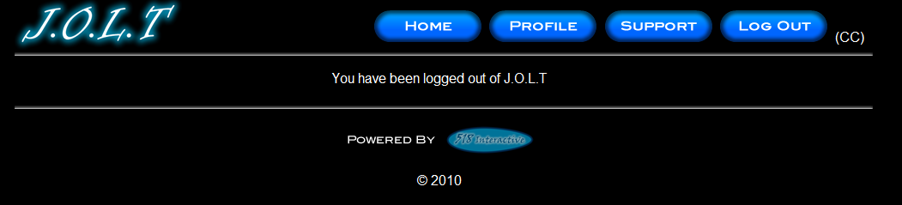
This screen shows a Faculty who has just logged out of J.O.L.T by clicking the Logout button in the header.

Course Coordinator User

Course Coordinator User Case Narrative
The Course Coordinator shall have the ability to log into the System via a unique username and password. Once logged in, the Course Coordinator will be able to create Faculty accounts. The Course Coordinator will also be able to create courses and assign the courses to specific Faculty members. The Course Coordinator will have access to course-wide reporting tools, which will allow for statistical analysis of problems and problem sets.
The Course Coordinator will be able to manage the “Course Pool” for each course they manage. The Course Coordinator will be responsible for adding, modifying, and deleting problems and problem sets from the pool. The Course Coordinator submits problems and problem sets to the “Global Pool” for use by all faculty members. Problems that are partially completed will be saved to a “sandbox” where they may finish it at a later date.
The Course Coordinator will be able to send broadcast messages to faculty members and students that participate in the courses that the Course Coordinator manages, or a subset thereof.

Course Coordinator User Screens
The Course Coordinator shall have the following screens available.

J.O.L.T Login

This is the initial screen that Course Coordinator will be presented with when they navigate to J.O.L.T. It prompts for a username and password, and provides a link for forgotten password. Note that Course Coordinator accounts are created by the Administrator. No self-registration is allowed.
Note: All validation that appears on the student screens applies to this page for Course Coordinator.

Course Coordinator Home Page
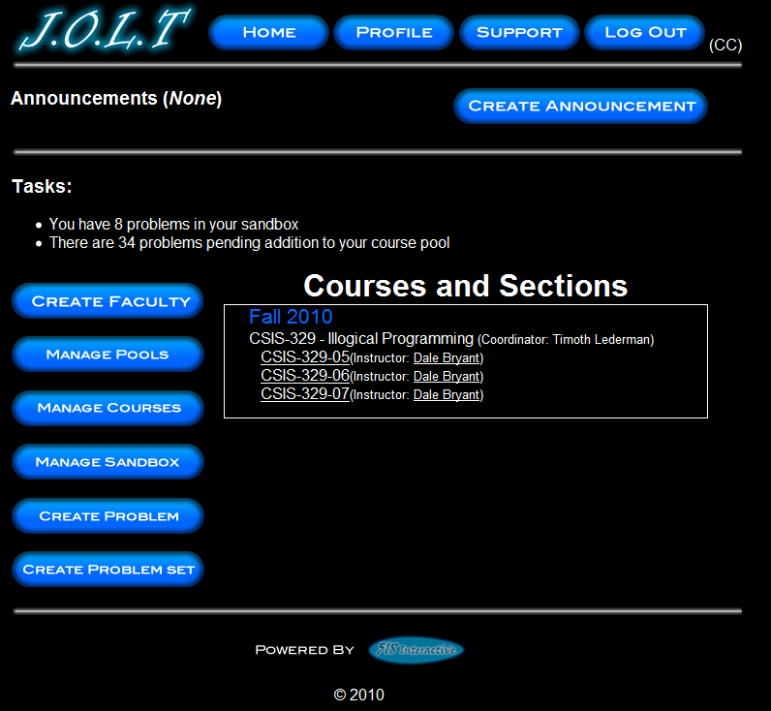
This is the screen that the Course Coordinator is presented with after they successfully log in. From here, they can Manage Pools, Manage Courses (that they coordinate), Manage their Sandbox, Create a Problem, Create a Problem Set, and Create an Announcement. They can also manage the faculty accounts that teach the courses that the course coordinator manages.

Create Faculty Account
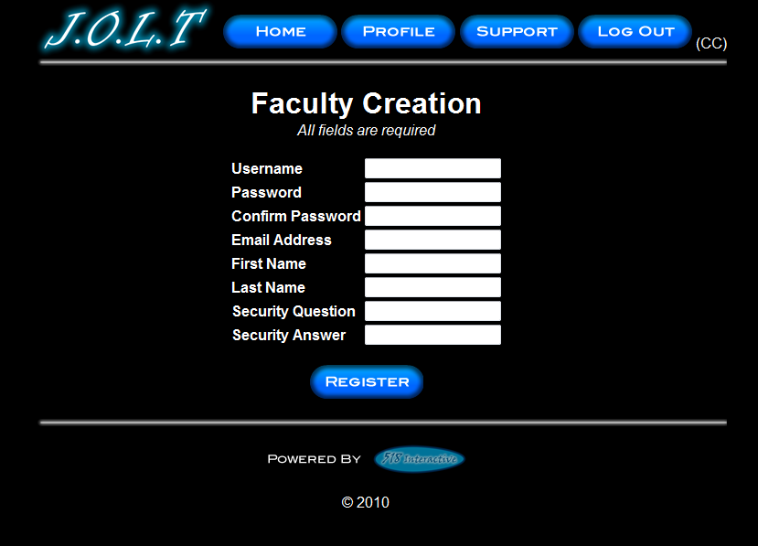
This screen is used by the Course Coordinator to create a Faculty account. All error checking on the registration screen applies to this screen.

Edit Faculty Account
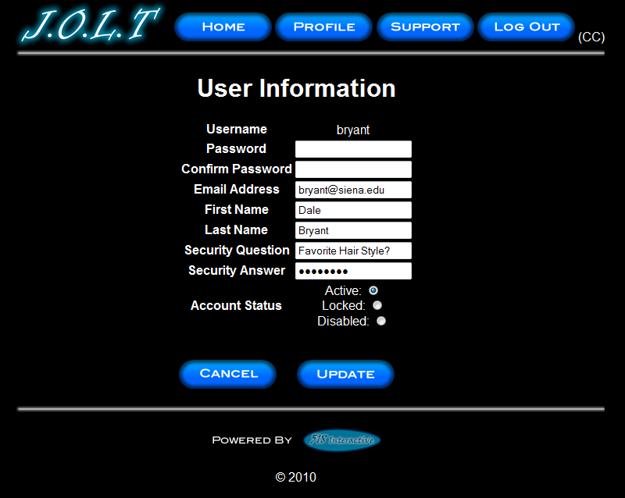
This screen allows a Course Coordinator to edit a faculty member’s account. Entering a value in the password fields will update the user’s password.

Create Course Section
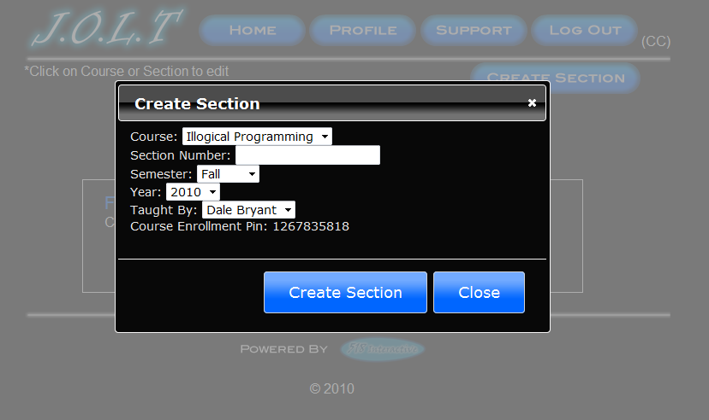
From the Manage Courses button, the “Create Section” button will show this overlay dialog, which will allow the course coordinator to create a section for any course that they manage. Note the Course Enrollment Pin is automatically generated by the system. The Pin can be later changed, if necessary.

Create Course Section (Error)
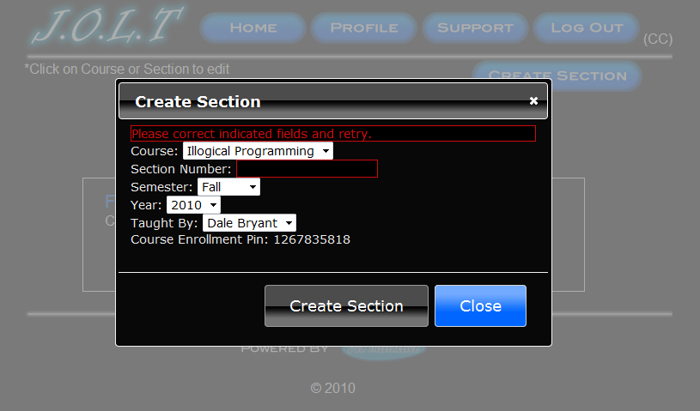
This screen indicates an error in one or more fields while creating a new section. This appears after clicking the “Create Section” Button.

Edit Course Section
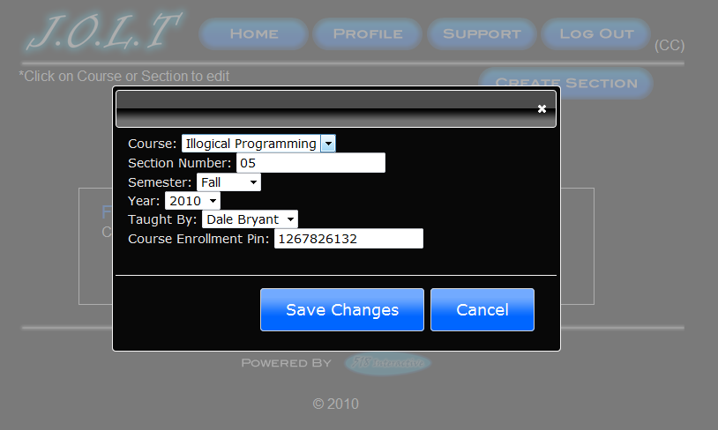
This overlay allows a Course Coordinator to edit an existing Course Section. Clicking on the course name under the “Manage Courses” screen will bring the user to this overlay. All error checking applies to the edit screen as the create course screen.

View Gradebook
This is the gradebook view for a specific course for a Course Coordinator user. Clicking on an assignment name brings the user to the Problem Set Overview screen. Clicking on the grade allows the user to change the grade.

Edit Gradebook (Editing)
This shows a user editing a student’s grade. Clicking the grade opens an overlay dialog where a new grade may be entered. A comment field is also provided, but not required.

Create Problem
This is the Create Problem page for a Course Coordinator member. From here, the user enters all information about a problem.

Create Problem (Invalid Field)
This screen shows an error message indicating an invalid field is present on the Create Problem Screen.

Create Problem Compiler Error
This screen shows an error message pertaining to a compiler error in the Course Coordinator member’s solution code.

Course Coordinator Sandbox (Unpopulated)

This is the Course Coordinator sandbox. The sandbox stores all problems that are not completed and ready for the pool.

Course Coordinator Sandbox (Populated)
Clicking a problem name in the sandbox will bring up a window to edit the problem. The user can also select a problem to and click “Delete” to remove it from their sandbox. The user can also Create Problems from this page (The problems created from that create problem screen do not necessarily mean that they will be saved in the sandbox.)

Edit Problem
This is the edit problem screen that the Course Coordinator user will see when they choose to edit a problem from either their private pool, the course pool, the global pool, or the sandbox. It is simply the create problem screen populated with the information the user provided. All error checking on the Create Problem screen exists on the edit problem screen as well.

Create Problem Set
This is an example of the Create Problem Set Screen. Course Coordinators can use problems from their own pool, the course pool, or the global pool when creating a Problem Set. Clicking on a problem in the problem set area will allow the user to edit the problem. Point values can be assigned to each problem. By selecting problems in the pools using the checkboxes and clicking the “Add to Problem Set” button the problems in the pool are added to the problem set area located underneath the “Total Points” and “Number of Problems” fields.

Create Problem Set (Error)
This is an example error message showing invalid fields on the Create Problem Set Screen.

Create Problem Set (No Problems Added Error)
This is an example error message showing a Problem Set with no problems added to it.

Create Problem Set (Completed)
This is a confirmation message showing a created Problem Set. This is an overlay dialog that will redirect to their pool management screen.

Edit Problem Set (Completed)
This is the screen for Editing an existing Problem Set. The format of the screen is identical to the Create Problem Set screen. All error screens for Edit Problem Set are identical to the ones for Create Problem Set.

Activate/Assign Problem Set
This is the screen to activate a Problem Set for a specific course. Problem Sets can either be activated instantly, or set to be active at a later date. Problem Set Deactivation is also accomplished on this screen. Note that this screen is only used for manual deactivation. J.O.L.T will automatically deactivate problem sets once the expiration date and time have been passed.

Create Announcement
This is the screen to create an announcement to be broadcast to users. Users select recipients of the announcement, and provide a title and announcement text.

Create Announcement (Add Recipients)
This screen shows an announcement with populated data and selected recipients. Using the left and right arrow buttons add and remove users from the recipient list.

Create Announcement (Missing Field)
This shows an error message for a missing field when creating an announcement. This appears once the user selects the “Submit” button.

Create Announcement (Complete)
This shows a successfully created announcement. This appears once the user selects the “Submit” button. Clicking on “Close” removes the overlay, but keeps the user at the announcement screen in case they wish to send another announcement.

Manage Pools
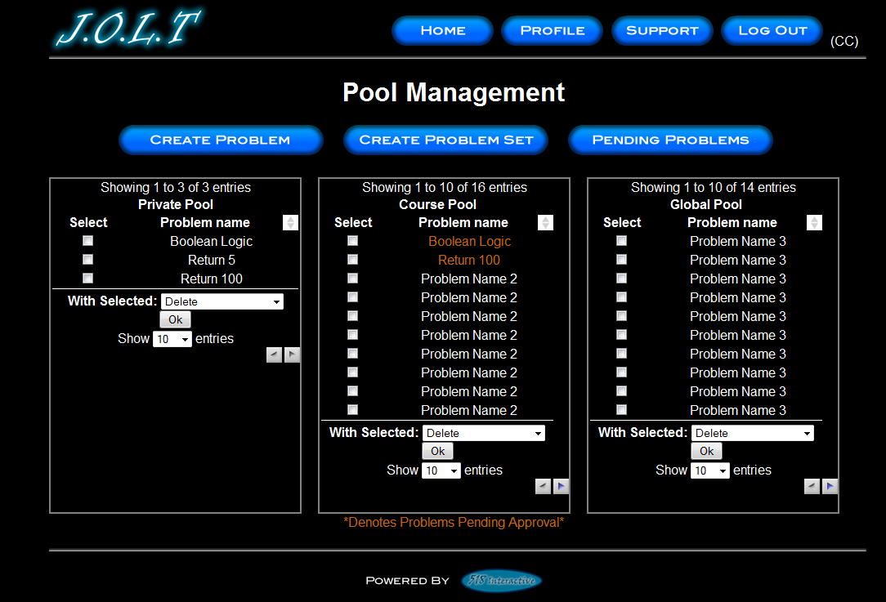
This is the Pool Management screen for Course Coordinators. Clicking the “Manage Pools” button on the Section Home Page brings the user to this screen. Multiple problems can be selected at once. Problems in the private pool can be copied to the course pool. Problems in the private pool can also be removed from the pool. Note that deleting a problem from a pool does NOT remove the problem from the database.

Accept Private Problems to Course Pool
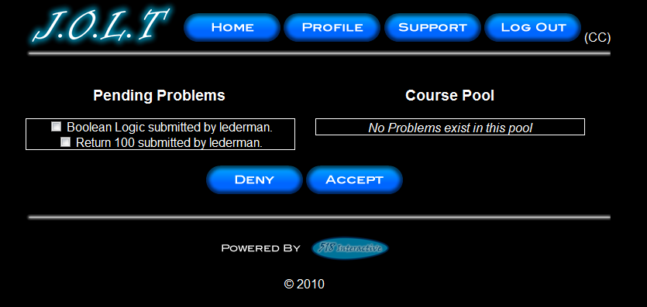
Clicking the “Pending Problems” button brings the Course Coordinator to this screen. From here, the Course Coordinator has the ability to approve or reject problems to the Course Pool. Clicking the problem name allows the Course Coordinator to view the problem details.

Create Announcement
This is the screen to create an announcement to be broadcast to users. Users select recipients of the announcement, and provide a title and announcement text.

Create Announcement (Add Recipients)
This screen shows an announcement with populated data and selected recipients. Using the left and right arrow buttons add and remove users from the recipient list.

Create Announcement (Missing Field)
This shows an error message for a missing field when creating an announcement. This appears once the user selects the “Submit” button.

Create Announcement (Complete)
This shows a successfully created announcement. This appears once the user selects the “Submit” button. Clicking on “Close” removes the overlay, but keeps the user at the announcement screen in case they wish to send another announcement.

View Profile
Clicking the “Profile” button in the header will bring course coordinators members to this screen, where they can view their profile information. There is a button to update their information as well.

Edit Profile
This screen allows a Course Coordinator user to edit their profile information. The user gets here by clicking the “Edit Profile” button on the Course Coordinator Profile Page. All error checking that the student user has also exists on this screen.

Sample Report Format

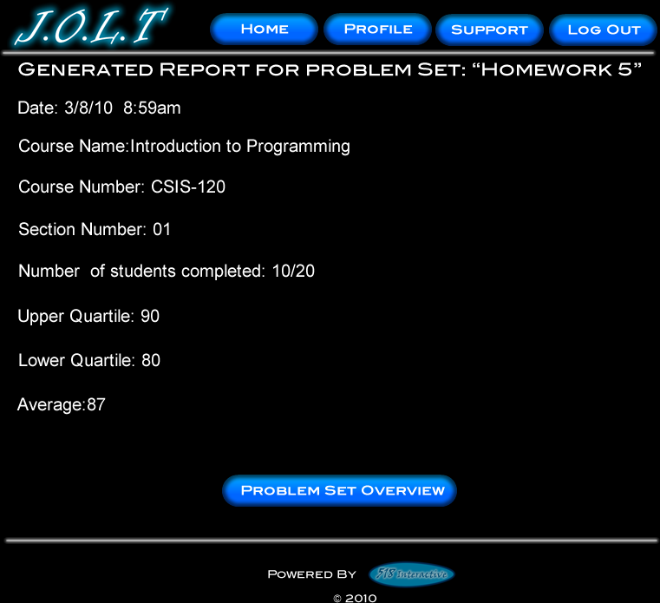
This is a sample report format that the course coordinator will see. Various statistics will be available on a per-problem basis. Statistics are tracked across multiple classes.

Logout
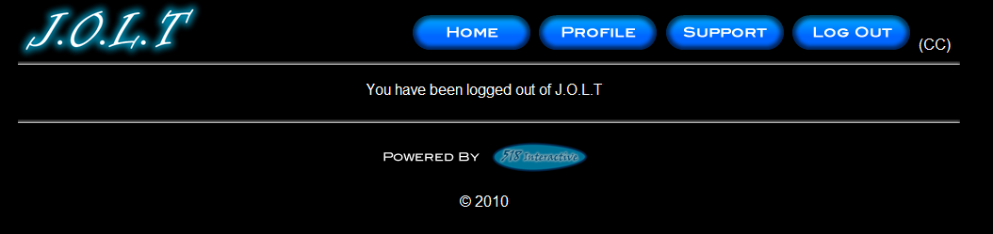
This screen shows a Course Coordinator who has just logged out of J.O.L.T by clicking the Logout button in the header.

Administrator User

Administrator User Case Narrative
The Administrator shall be able to log into the System via a unique username and password. Once logged in, the Administrator will be able to create and manage Course Coordinator, Faculty, and Student accounts. The Administrator has the same abilities as a Course Coordinator. The Administrator will be able to send broadcast messages to all users, or a subset thereof. The Administrator will manage the “Global Pool” of problems and problem sets.

Administrator User Screens
The Administrator shall have the following screens available.

J.O.L.T Login

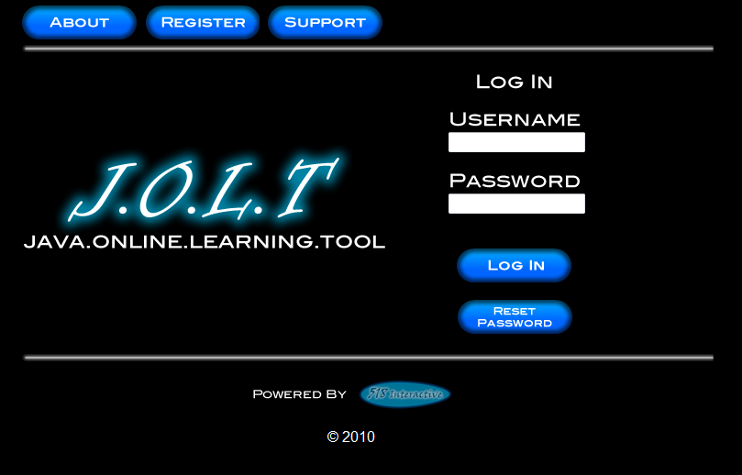
This is the initial screen that the Administrator will be presented with when they navigate to J.O.L.T. It prompts for a username and password, and provides a link for forgotten password.
Note: All validation that appears on the student screens applies to this page for the Administrator. Note that the administrator account cannot get locked out.

Administrator Home Page
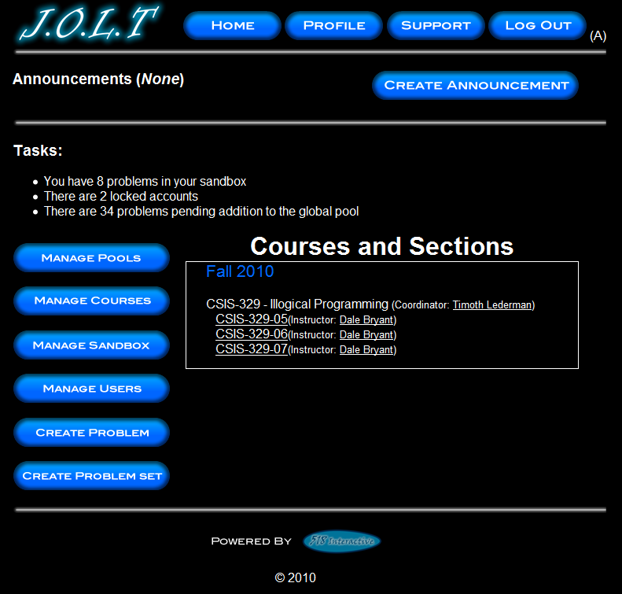
This is the home page for the Administrator. From here, they can Manage Pools, Manage Courses, Manage their Sandbox, Create a Problem, Create a Problem Set, and Create an Announcement. They can also manage all user accounts, and Create Courses and Sections.

Manage Users
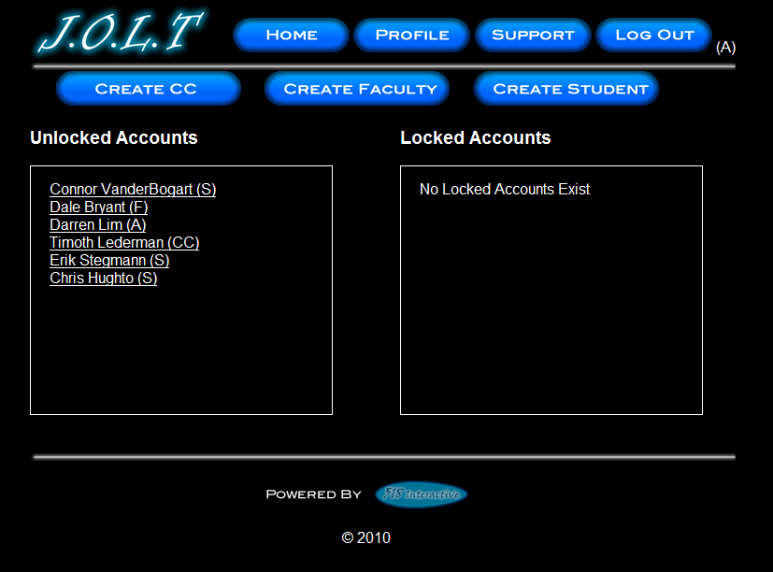
This screen is reached from the “Manage Users” button on the Administrator home page. This screen allows the Administrator to edit and add user accounts.

Create Course Coordinator
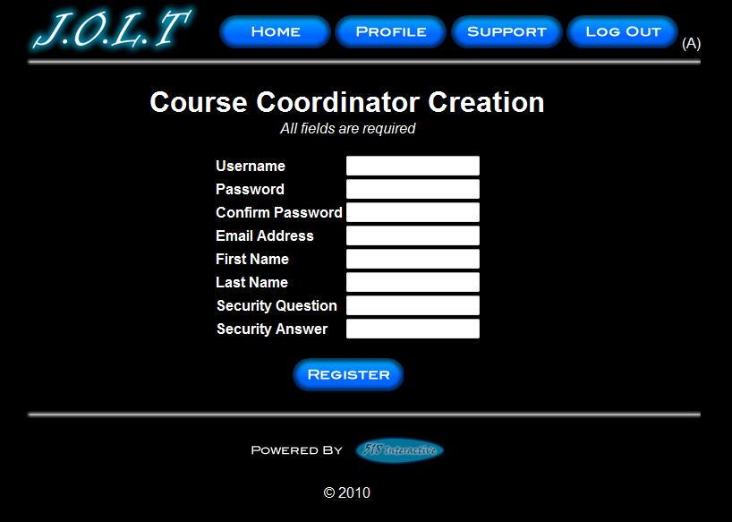
This is the screen the Administrator uses to create a Course Coordinator account. All fields are verified for correct values.

Create Faculty Account
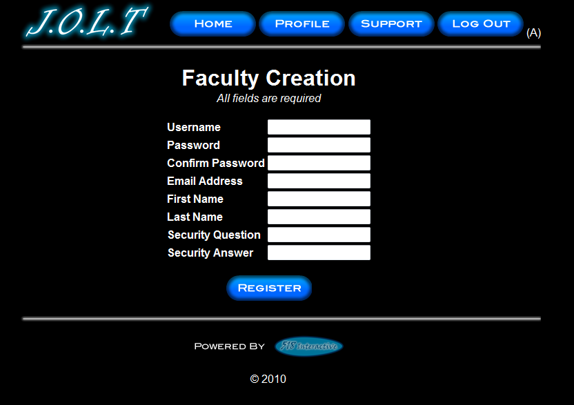
This is the screen the Administrator uses to create a Faculty account. All fields are verified for correct values.

Create Student Account
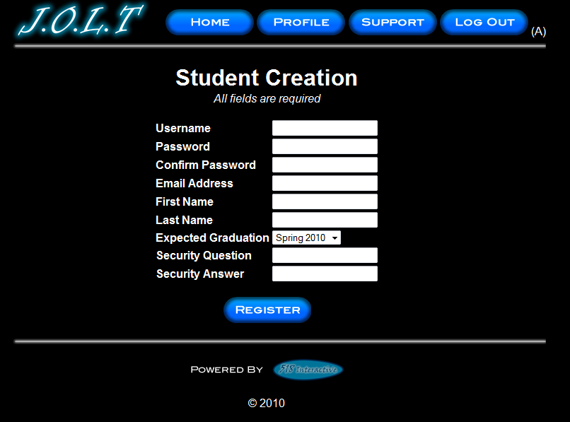
This is the screen the Administrator uses to create a Student account. All fields are verified for correct values.

Edit User Account
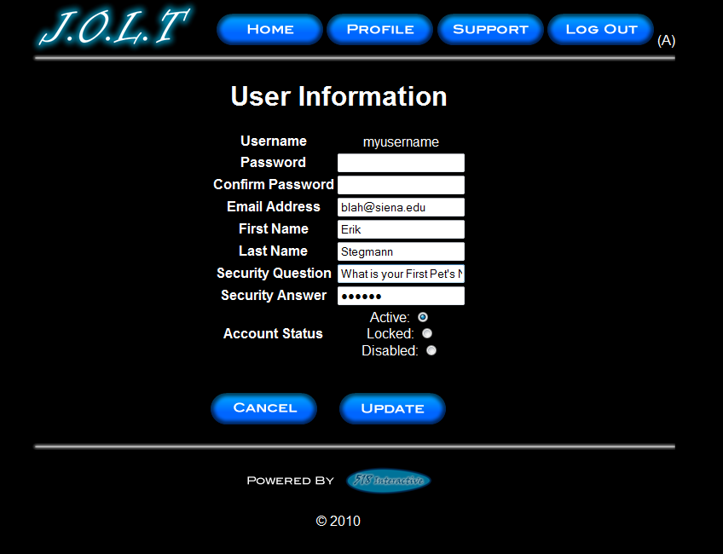
This screen is the same for all user types. The administrator has the ability to update all fields for user account management.

Course Management
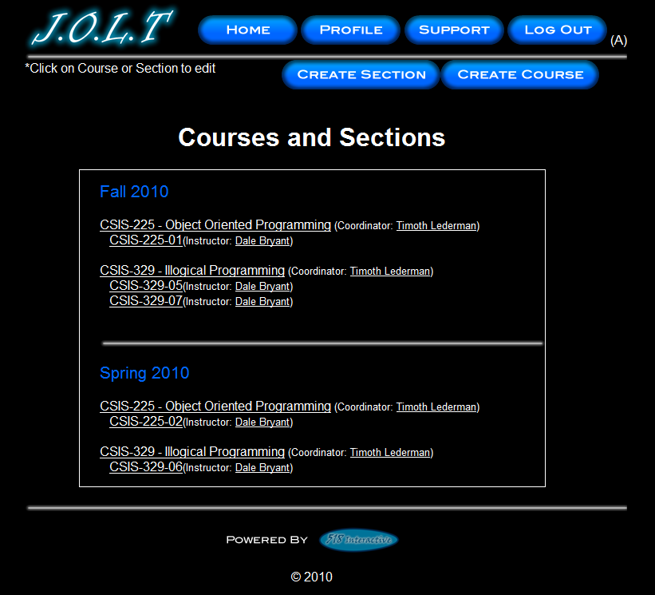
Clicking on the “Manage Courses” button brings the administrator to this screen, where they can create sections, create courses, and manage existing sections and courses (by clicking on them).

Create Course
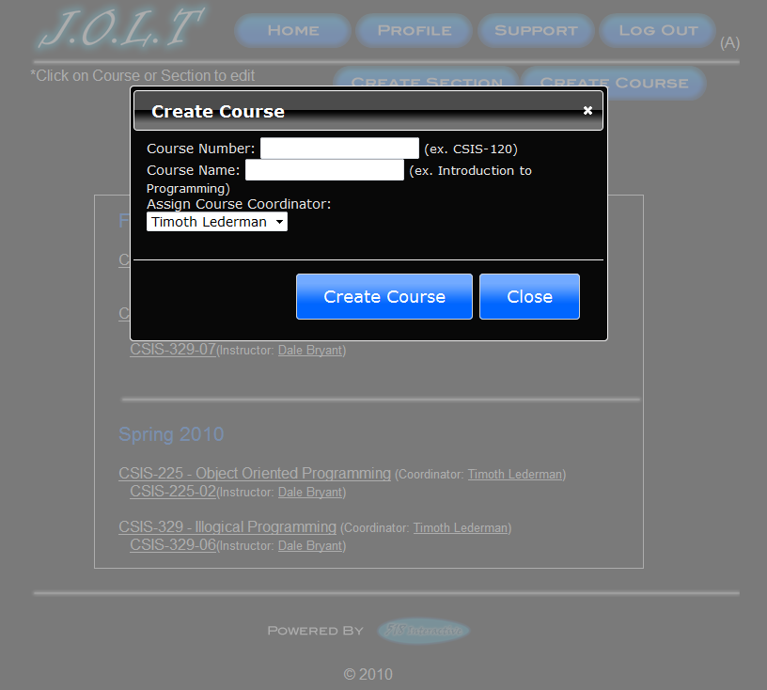
This overlay allows the Administrator to create a course from the “Manage Courses” screen. The Administrator can also create sections as seen in the course coordinator screen “ Create Course Section/” All error checking applies.

View Gradebook
This is the gradebook view for a specific course for the Administrator user. Clicking on an Assignment Name brings the user to the Problem Set Overview screen. Clicking on the grade allows the user to change the grade.

Edit Gradebook (Editing)
This shows a user editing a student’s grade. Clicking the grade opens an overlay dialog where a new grade may be entered. A comment field is also provided, but not required.

Create Problem
This is the Create Problem page for the Administrator. From here, the user enters all information about a problem.

Create Problem (Invalid Field)
This screen shows an error message indicating an invalid field is present on the Create Problem Screen.

Create Problem Compiler Error
This screen shows an error message pertaining to a compiler error in the Administrator member’s solution code.

Course Coordinator Sandbox (Unpopulated)

This is the Administrator sandbox. The sandbox stores all problems that are not completed and ready for the pool.

Course Coordinator Sandbox (Populated)
Clicking a problem name in the sandbox will bring up a window to edit the problem. The user can also select a problem to and click “Delete” to remove it from their sandbox. The user can also Create Problems from this page (The problems created from that create problem screen do not necessarily mean that they will be saved in the sandbox.)

Edit Problem
This is the edit problem screen that the Administrator user will see when they choose to edit a problem from their private pool, the course pool, the global pool, or the sandbox. It is simply the create problem screen populated with the information the user provided. All error checking on the Create Problem screen exists on the edit problem screen as well.

Create Problem Set
This is an example of the Create Problem Set Screen. Administrators can use problems from their own pool, the course pool, or the global pool when creating a Problem Set. Clicking on a problem in the problem set area will allow the faculty user to edit the problem. Point values can be assigned to each problem.

Create Problem Set (Error)
This is an example error message showing invalid fields on the Create Problem Set Screen.

Create Problem Set (No Problems Added Error)
This is an example error message showing a Problem Set with no problems added to it.

Create Problem Set (Completed)
This is a confirmation message showing a created Problem Set. This is an overlay dialog that will redirect to their pool management screen.

Edit Problem Set (Completed)
This is the screen for editing an existing Problem Set. The format of the screen is identical to the Create Problem Set screen. All error screens for Edit Problem Set are identical to the ones for Create Problem Set.

Activate/Assign Problem Set
This is the screen to activate a Problem Set for a specific course. Problem Sets can either be activated instantly, or set to be active at a later date. Problem Set deactivation is also accomplished on this screen. Note that this screen is only used for manual deactivation. J.O.L.T will automatically deactivate problem sets once the expiration date and time have been passed.

Create Announcement
This is the screen to create an announcement to be broadcast to users. Users select recipients of the announcement, and provide a title and announcement text.

Create Announcement (Add Recipients)
This screen shows an announcement with populated data and selected recipients. Using the left and right arrow buttons add and remove users from the recipient list.

Create Announcement (Missing Field)
This shows an error message for a missing field when creating an announcement. This appears once the user selects the “Submit” button.

Create Announcement (Complete)
This shows a successfully created announcement. This appears once the user selects the “Submit” button. Clicking on “Close” removes the overlay, but keeps the user at the announcement screen in case they wish to send another announcement.

Manage Pools
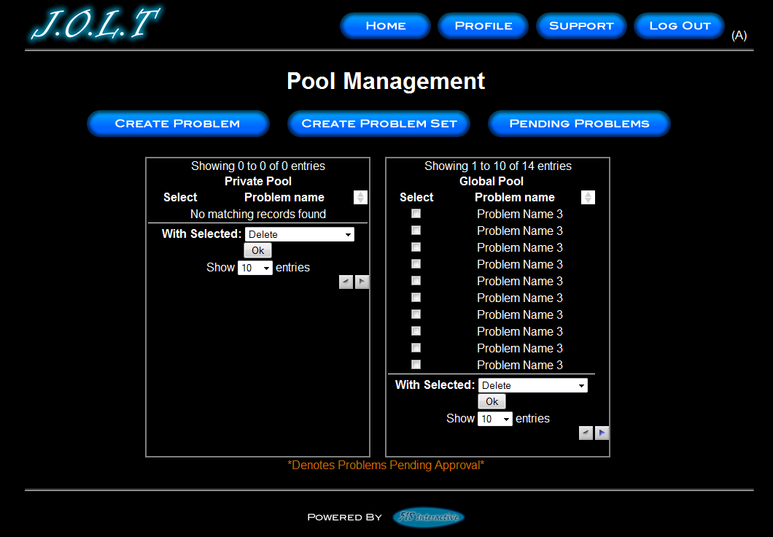
This is the pool management screen for the administrator user. Clicking the “Manage Pools” button on the Section Home Page brings the user to this screen. Multiple problems can be selected at once. Problems in the private pool can be copied to the global pool. Problems in the private pool can also be removed from the pool. Note that deleting a problem from a pool does NOT remove the problem from the database.

Accept Private/Course Problems to Global Pool
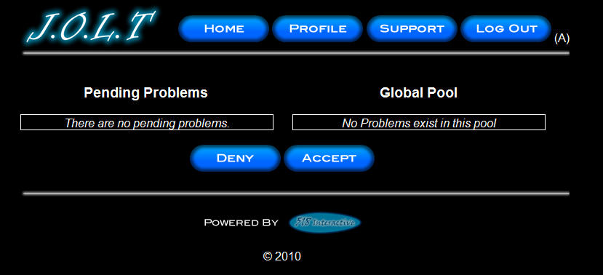
Clicking the “Pending Problems” button brings the Administrator to this screen. From here, the Administrator has the ability to approve or reject problems to the Global Pool. Clicking the problem name allows the Administrator to view the problem details.

View Profile
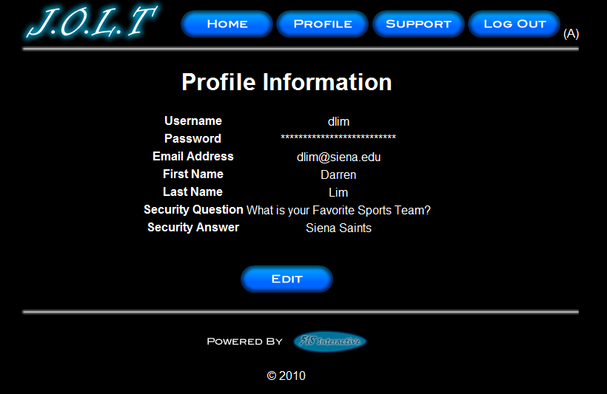
Clicking the “Profile” button in the header will bring the Administrator member to this screen, where they can view their profile information. There is a button to update their information as well.

Edit Profile
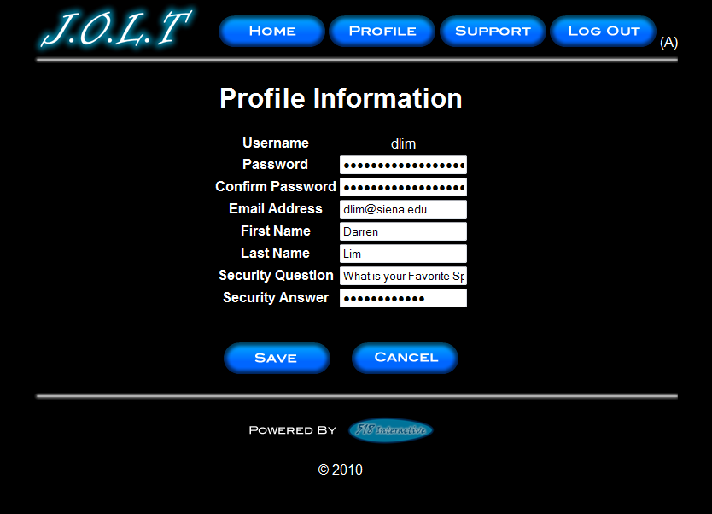
This screen allows the Administrator user to edit their profile information. The Administrator user gets here by clicking the “Edit Profile” button on the Administrator Profile Page.
All error checking for previous users for this screen applies to the Administrator.

Logout
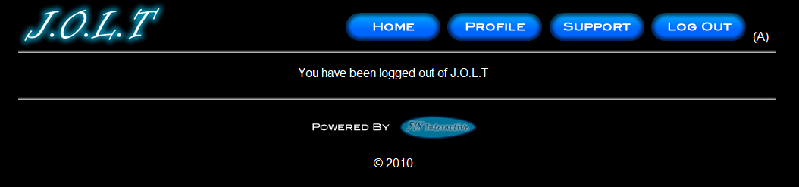
This screen shows the Administrator who has just logged out of J.O.L.T by clicking the Logout button in the header.

Logical Data Stores
The logical data stores are a set of tables that represent the different fields for the MySQL database. The first part of this is a tabular, text-based description, followed by a graphical representation of the tables.

Announcement Table
This table stores all information regarding announcements within the system.
announcement
Field | Type | Null | Default | Comments
announcementId | int(5) | No |  | unique ID for each announcement
fromUser | varchar(30) | Yes | NULL | username of announcement sender
toUser | varchar(30) | Yes | NULL | username of announcement receiver
sendDate | int(20) | Yes | NULL | Timestamp of announcement
subject | varchar(50) | Yes | NULL | Subject of announcement
message | varchar(1000) | Yes | NULL | Announcement Text

Assignment Table
This table lists all assignments (past and current) for all courses in the system.
assignment
Field | Type | Null | Default | Comments
assignmentId | int(9) | No |  | Unique id for each assignment
assignmentName | varchar(30) | Yes | NULL | Name of Assignment
beginOn | int(20) | Yes | NULL | timestamp of when problem should be activated
endOn | int(20) | Yes | NULL | timestamp of when problem should be deactivated
problemSet | int(9) | Yes | NULL | id of problem set that the assignment refers to
assignedTo | int(9) | Yes | NULL | Section id that assignment is assigned to

Course Table
This table stores course information for the system.
course
Field | Type | Null | Default | Comments
courseId | int(9) | No |  | Unique course id for each course
courseName | varchar(30) | Yes | NULL | Course Name (i.e. Intro To Programming)
courseNumber | varchar(10) | Yes | NULL | Course Number (i.e. CSIS-010)
createdBy | varchar(30) | Yes | NULL | Username that created the course
managedBy | varchar(30) | Yes | NULL | The Course Coordinator that manages the course
poolId | int(9) | Yes | NULL | Id of the pool that belongs to the course

Enrolled Students Table
This table shows which students are enrolled in which section it also shows past and current enrollment information.
enrolledStudents
Field | Type | Null | Default | Comments
username | varchar(30) | No |  | username of student enrolled in section
sectionId | int(9) | No | 0 | section id of section that student is enrolled in

Grade Log Table
This table shows all grade adjustments made by Faculty, Course Coordinators, and Administrators.
gradeLog
Field | Type | Null | Default | Comments
assignment | int(9) | No |  | Assignment Id of changed grade
faculty | varchar(30) | No |  | Username of individual who modified grade
student | varchar(30) | No |  | Student whose grade was changed
timestamp | int(10) | No |  | Date/Time of Grade Modification
oldGrade | int(9) | No |  | Original grade for student.
newGrade | int(9) | No |  | New grade for student.
comment | varchar(100) | Yes | NULL | Comment of grade change (Optional, viewable by student if set)

Pool Table
This table contains the information for all pools in the system.
pool
Field | Type | Null | Default | Comments
poolId | int(9) | No |  | unique id for each pool
poolType | int(1) | Yes | NULL | type of pool (0=sandbox, 1=private, 2=course, 3=global)
poolOwner | varchar(30) | Yes | NULL | userid of pool owner

Problem Table
This table stores all information regarding each problem of the system.
problem
Field | Type | Null | Default | Comments
problemId | int(9) | No |  | unique id for each problem
problemName | varchar(30) | No |  | Name of Problem
problemCategory | varchar(30) | No |  | Category of problem
problemDescription | varchar(500) | No |  | description of problem
problemActive | int(1) | No | 0 | field indicating that problem is active (i.e., that it passes all checks, a valid solution is specified, etc) and can be used in a problem set.
totalAttempts | int(9) | No | 0 | number of times this problem has been attempted to be solved.
correctAttempts | int(9) | No | 0 | number of times this problem has been sucessfully solved.
createdOn | int(10) | No |  | timestamp of when the problem was created.
createdBy | varchar(30) | No |  | username if problem creator
methodSignature | varchar(100) | No |  | method signature of problem
methodName | varchar(40) | No |  | name of method of problem
numParameters | int(1) | No | 1 | number of parameters the method contain
parameters | varchar(60) | No |  | parameter types, in object format (Integer, Boolean, Character, etc)
numTestCases | int(2) | No |  | number of test cases for this problem
parm1Name | varchar(20) | Yes | NULL | Name of first parameter of problem
parm1Type | varchar(10) | Yes | NULL | Data type of first parameter of problem
parm2Name | varchar(20) | Yes | NULL | Name of second parameter of problem
parm2Type | varchar(10) | Yes | NULL | Data type of second parameter of problem
parm3Name | varchar(20) | Yes | NULL | Name of third parameter of problem
parm3Type | varchar(10) | Yes | NULL | Data type of third parameter of problem
parm4Name | varchar(20) | Yes | NULL | Name of fourth parameter of problem
parm4Type | varchar(10) | Yes | NULL | Data type of fourth parameter of problem
parm5Name | varchar(20) | Yes | NULL | Name of fifth parameter of problem
parm5Type | varchar(10) | Yes | NULL | Data type of fifth parameter of problem
resultType | varchar(10) | Yes | NULL | Data type of result of problem
solution | varchar(1000) | No |  | Faculty provided solution
publishSolution | int(1) | No | 0 | Field indicating that the solution should be published for the students to see.

Problem Location Table
This table links problems to pools in the system. Problems may exist in more than one pool.
problemLocation
Field | Type | Null | Default | Comments
problemId | int(9) | No |  | Problem ID identifying a unique problem in the Problem table
poolId | int(9) | No |  | Pool ID identifying the pool that the problem resides in
status | int(1) | No | 0 | Status of problem (0=pending approval, 1=approved)

Problem Set Table
This table shows data regarding the problem sets.
problemSet
Field | Type | Null | Default | Comments
setId | int(9) | No |  | Unique id for each problem set
setName | varchar(30) | Yes | NULL | Name of Problem Set
setCategory | varchar(30) | Yes | NULL | Category of Problem Set
setDescription | varchar(500) | Yes | NULL | Description of Problem Set
numProblems | int(2) | Yes | NULL | Number of Problems in problem set
problem1Id | int(9) | Yes | NULL | Id of Problem #1 in Problem set
problem1Point | int(9) | Yes | NULL | Point value for this problem
problem2Id | int(9) | Yes | NULL | Id of Problem #2 in Problem set
problem2Point | int(9) | Yes | NULL | Point value for this problem
problem3Id | int(9) | Yes | NULL | Id of Problem #3 in Problem set
problem3Point | int(9) | Yes | NULL | Point value for this problem
problem4Id | int(9) | Yes | NULL | Id of Problem #4 in Problem set
problem4Point | int(9) | Yes | NULL | Point value for this problem
problem5Id | int(9) | Yes | NULL | Id of Problem #5 in Problem set
problem5Point | int(9) | Yes | NULL | Point value for this problem
problem6Id | int(9) | Yes | NULL | Id of Problem #6 in Problem set
problem6Point | int(9) | Yes | NULL | Point value for this problem
problem7Id | int(9) | Yes | NULL | Id of Problem #7 in Problem set
problem7Point | int(9) | Yes | NULL | Point value for this problem
problem8Id | int(9) | Yes | NULL | Id of Problem #8 in Problem set
problem8Point | int(9) | Yes | NULL | Point value for this problem
problem9Id | int(9) | Yes | NULL | Id of Problem #9 in Problem set
problem9Point | int(9) | Yes | NULL | Point value for this problem
problem10Id | int(9) | Yes | NULL | Id of Problem #10 in Problem set
problem10Point | int(9) | Yes | NULL | Point value for this problem
problem11Id | int(9) | Yes | NULL | Id of Problem #11 in Problem set
problem11Point | int(9) | Yes | NULL | Point value for this problem
problem12Id | int(9) | Yes | NULL | Id of Problem #12 in Problem set
problem12Point | int(9) | Yes | NULL | Point value for this problem
problem13Id | int(9) | Yes | NULL | Id of Problem #13 in Problem set
problem13Point | int(9) | Yes | NULL | Point value for this problem
problem14Id | int(9) | Yes | NULL | Id of Problem #14 in Problem set
problem14Point | int(9) | Yes | NULL | Point value for this problem
problem15Id | int(9) | Yes | NULL | Id of Problem #15 in Problem set
problem15Point | int(9) | Yes | NULL | Point value for this problem
problem16Id | int(9) | Yes | NULL | Id of Problem #16 in Problem set
problem16Point | int(9) | Yes | NULL | Point value for this problem
problem17Id | int(9) | Yes | NULL | Id of Problem #17 in Problem set
problem17Point | int(9) | Yes | NULL | Point value for this problem
problem18Id | int(9) | Yes | NULL | Id of Problem #18 in Problem set
problem18Point | int(9) | Yes | NULL | Point value for this problem
problem19Id | int(9) | Yes | NULL | Id of Problem #19 in Problem set
problem19Point | int(9) | Yes | NULL | Point value for this problem
problem20Id | int(9) | Yes | NULL | Id of Problem #20 in Problem set
problem20Point | int(9) | Yes | NULL | Point value for this problem
problem21Id | int(9) | Yes | NULL | Id of Problem #21 in Problem set
problem21Point | int(9) | Yes | NULL | Point value for this problem
problem22Id | int(9) | Yes | NULL | Id of Problem #22 in Problem set
problem22Point | int(9) | Yes | NULL | Point value for this problem
problem23Id | int(9) | Yes | NULL | Id of Problem #23 in Problem set
problem23Point | int(9) | Yes | NULL | Point value for this problem
problem24Id | int(9) | Yes | NULL | Id of Problem #24 in Problem set
problem24Point | int(9) | Yes | NULL | Point value for this problem
problem25Id | int(9) | Yes | NULL | Id of Problem #25 in Problem set
problem25Point | int(9) | Yes | NULL | Point value for this problem

Section Table
This table shows information about each section in the system.
section
Field | Type | Null | Default | Comments
sectionId | int(9) | No |  | Unique id for each section
semester | varchar(6) | Yes | NULL | Semester that section is active for
year | int(4) | Yes | NULL | Year that section is active for
courseId | int(9) | Yes | NULL | ID of course section belongs to
sectionName | varchar(30) | Yes | NULL | Name of section
sectionNumber | varchar(30) | Yes | NULL | Number of Section
faculty | varchar(30) | Yes | NULL | Faculty username in charge of section
coordinator | varchar(30) | Yes | NULL | Coordinator for course that section lies in.
enrollPin | varchar(10) | No |  | PIN for section that students use to enroll in course

Set Location Table
This table links problems sets to pools in the System. Problems sets may exist in more than one pool.
setLocation
Field | Type | Null | Default | Comments
setId | int(9) | No |  | Problem Set ID identifying a unique problem in the Problem Set table
poolId | int(9) | No |  | Pool ID identifying the pool that the problem set resides in
status | int(1) | No | 0 | Status of problem (0=pending approval, 1=approved)

Solution Attempt Table
This table stores the most recent attempt for each student at solving a problem in the system.
solutionAttempt
Field | Type | Null | Default | Comments
assignmentId | int(9) | No | 0 | Assignment ID that soluition attempt belongs to.
problemId | int(9) | No | 0 | Problem ID that is being solved
student | varchar(30) | No |  | Username of student attempting a solution
timestamp | int(20) | Yes | NULL | Timestamp of last submission
code | varchar(1000) | Yes | NULL | Java Source that student used
numAttempts | int(9) | Yes | NULL | Number of attempts student has used for this particular solution
score | int(9) | Yes | NULL | Grade that student received (NULL indicates unsucessful attempt)
comment | varchar(100) | Yes | NULL | Comment field for faculty to explain a grade change.

Test Case Table
This table stores a single test case for a problem in the system.

testCase
Field | Type | Null | Default | Comments
problemId | int(9) | No | 0 | Id of problem that test case belongs to
testCaseNumber | int(2) | No | 0 | The test case number (1 – 25)
param1 | varchar(100) | Yes | NULL | Data for first parameter of test case.
param2 | varchar(100) | Yes | NULL | Data for second parameter of test case.
param3 | varchar(100) | Yes | NULL | Data for third parameter of test case.
param4 | varchar(100) | Yes | NULL | Data for fourth parameter of test case.
param5 | varchar(100) | Yes | NULL | Data for fifth parameter of test case.
result | varchar(100) | Yes | NULL | Data for result of test case.
hidden | int(1) | Yes | NULL | Indicates that this is a hidden test case.

User Table
This table stores the information for all users in the system.
user
Field | Type | Null | Default | Comments
username | varchar(30) | No |  | username of user
password | varchar(32) | No |  | md5 hash of user password
firstname | varchar(30) | No |  | user first name
lastname | varchar(30) | No |  | user last name
email | varchar(30) | No |  | user email address
squestion | varchar(50) | No |  | security question for password reset
sanswer | varchar(100) | No |  | security answer for password reset
gradSemester | varchar(6) | Yes | NULL | Graduation Semester (Spring/Fall) - Only used for students
gradYear | int(4) | Yes | NULL | Graduation year (20XX) - Only used for students
loginAttempts | int(1) | No | 0 | number of incorrect login attempts
userType | int(1) | No | 0 | type of user (0=student, 1=faculty, 2=course coordinator, 3=administrator)
confirmed | varchar(32) | No |  | This is a md5 hash of the username field concatenated with the email field. When user successfully registers, the field changes to "true"
bornOn | varchar(20) | No |  | timestamp of when the account was registered.
active | int(1) | No | 1 | field indicating status of account (1=active, 0=inactive).

Graphical Representation Key

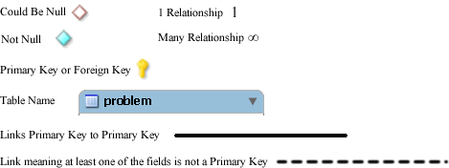

Graphical Representation (Entity Relationship Diagram)
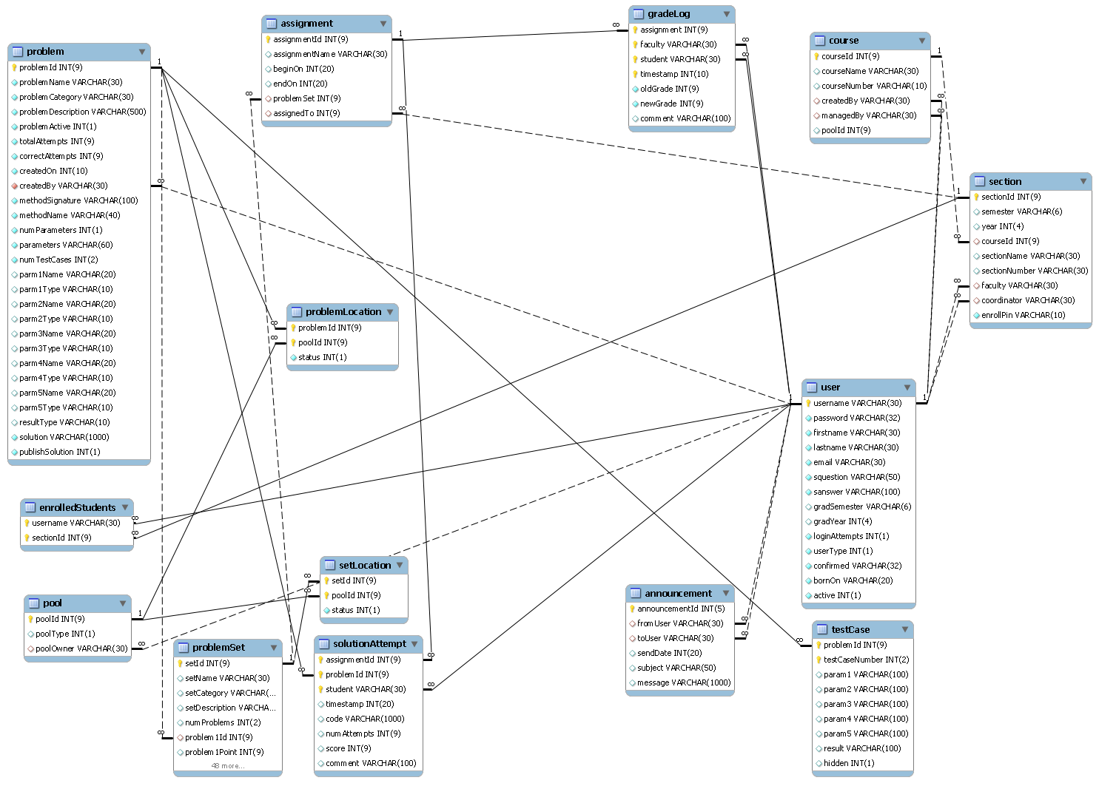

Packaging Specification
518 Interactive will provide all required source files and setup scripts (such as database create table statements) to the client, Dr. Lim, on a portable media device, such as a CD or DVD. Instructions on installation, setup, and configuration will also be provided.

Appendices

- Appendix 1: Sources of Information
- Appendix 2: Glossary of Terms
- Appendix 3: Current Timeline
- Appendix 4: Data Flow Diagrams
- Appendix 5: Activity Diagrams
- Appendix 6: Data Dictionary
- Appendix 7: Test Plan

Appendix 1: Sources of Information
Information found within this Requirement Specification document has been obtained through meetings with our client, Dr. Darren Lim. Information was also obtained through Dr. Lederman’s Software Engineering lectures. Information has also been collected from various internet resources, as well as requirement specification documents from previous years.

Appendix 2: Glossary of Terms
The following are a list of technical terms used within the document. This section is provided to clarify their meaning.
Actor: An entity in UML Use Case Diagrams and UML Activity Diagrams. It represents the human and non-human external entities (outside the system boundary) that interact with the system.
Activity Diagram: A diagram based on the Unified Model Language (UML). This represents the processes that comprise a certain activity within the system. These diagrams are generally created with the perspective of an actor in mind.
Client: Used to refer to Dr. Darren Lim, the client of 518 Interactive who requested J.O.L.T.
Compiler: A program that reads in source code and generates an executable.
CSS: Cascading Style Sheets – Used within HTML documents in order to control the presentation of web pages.
DFD: Data Flow Diagrams are used to show how data moves and is processed within a system. There are various levels to DFDs, with each subsequent level providing more detail than the previous.
Hardware: The tangible components of a computer and server. Examples include monitors, disk drives, printers, keyboard, processor, and memory.
HTML: Hypertext Markup Language is the scripting language used to describe the information contained on a website. HTML utilizes Cascading Style Sheets (CSS) to generate the style of the page. HTML and CSS are parsed by web browsers, such as Internet Explorer and Firefox, to render the websites for users.
Java: A programming language which the System will be able to compile and execute. This language will be used by the students to solve the assigned problems.
Java Byte Code: The output of the Java™ compiler upon successful compilation of Java™ source code. Java Byte Code is read by the Java™ runtime environment, which in turn executes the proper machine-level commands.
Java SDK: Software Development Kit for Java – a collection of tools used by developers to aid in the creation of programs. The Java SDK includes the Java™ (V. 1.6) compiler. The Java™ SDK also includes the Java™ (V. 1.6) runtime environment, which allows for Java™ Byte Code to be executed.
J.O.L.T: Java Online Learning Tool is the name of the system being developed for Dr. Lim, the client of 518 Interactive.
MySQL: A free implementation of a Relational Database Management System. Used to store and retrieve information relevant to the website, such as usernames, passwords, problems, solutions, and scores. Accessing information within the database is achieved by submitting a “query” in the Structured Query Language (SQL) form.
PHP: PHP Hypertext Processor is a programming language used to create dynamic web sites. Has the ability to interact with a database.
Software: The intangible components of a computer and server. It is a set of machine-level instructions that is run from within the memory, and is used to perform a specific set of functions. Examples include Microsoft Word, Adobe Photoshop, and Mozilla Firefox.
Source Code: A document that a compiler parses to generate machine code (which the computer can run directly), or code that gets interpreted by a third-party application, which then gets executed.
Source/Sink: This is a term used within Data Flow Diagrams to represent an entity that either provides (source) or receives (sink) data.
System: Used within this document to describe the Java Online Learning Tool (J.O.L.T).
UML: Unified Modeling Language is the industry-standard language for the specification, visualization, construction, and documentation of the components of software systems.
Use Case Diagram: Represents the high-level functions of the system. It also depicts how actors interact with each of those functions.

Appendix 4: Current Timeline
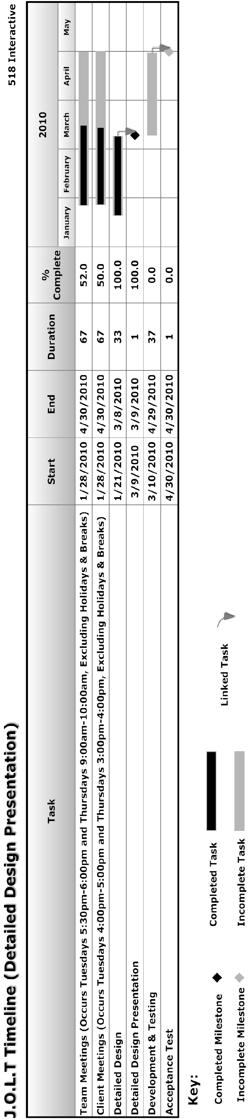

Data Flow Diagrams
The Data Flow Diagrams (DFDs) are used for structure analysis and design. DFDs show the flow of data from external entities into the system. DFDs also show how the data moves and is transformed from one process to another, as well as its logical storage.
Data Flow Diagrams are in an accompanied document titled “Data Flow Diagrams”, which can be found under the “Documents” link of the 518 Interactive Website.

Activity Diagrams
Activity Diagrams are a UML (Unified Modeling Language) specified diagram which shows workflows of stepwise activities and actions, with support for choice, iteration, and concurrency. It outlines the process that Actors (both human and non-human) go through while interacting with the System to accomplish a specific task.
Activity Diagrams are in an accompanied document titled “Activity Diagrams”, which can be found under the “Documents” link of the 518 Interactive Website.

Data Dictionary
The Data Dictionary lists all data entities within J.O.L.T.
The Data Dictionary is in an accompanied document titled “Data Dictionary”, which can be found under the “Documents” link of the 518 Interactive Website.

Test Plan
The Test Plan describes the testing that will take place to verify that all the functional requirements have been met.
The Test Plan is in an accompanied document titled “Test Plan”, which can be found under the “Documents” link of the 518 Interactive Website.

