Preliminary Design

Requested By: Mr. Ken Swarner
Systems Administrator
Computer Science Department of Siena College

Dr. Tim Lederman
Professor of Computer Science
Computer Science Department of Siena College

Environmental Monitoring System

SaintSoft

Prepared By: Daniel Schuldt – Team Leader
Christian Damberg
David Moore
Hannah Palmer

Lioubov Mikhailova

Tina Ting

November 29, 2005

Table Of Contents

1. External Design Specifications 3
1.1 User Displays 3
1.2 User Summary 25
1.3 Detailed Data Flow Diagrams 33
1.4 Functional Decomposition Diagram 40
1.5 Logical Data Dictionary 42
1.6 Logical Data Stores 56
1.7 Functional Requirements 58
1.8 Production/Development Environments 62
2. Testing Requirements 63
2.1 Acceptance Test 63
2.2 Unit Test Example 68
3. Appendices 70
3.1 Gantt Chart 70
3.2 Glossary of Terms 71

1. External Design Specifications

1.1 User Displays
Login Screen:
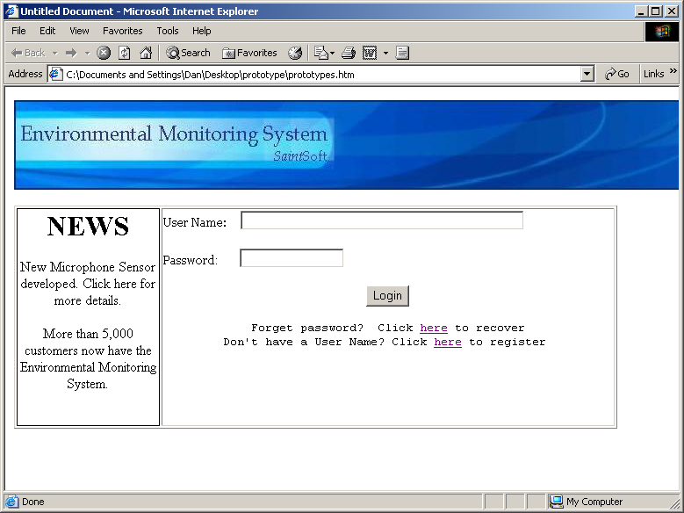

Password Recover Screen:
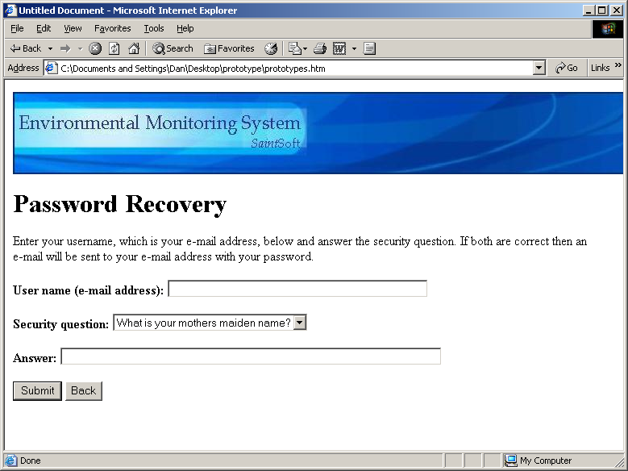

Confirmation Pop-up for Password Recovery:
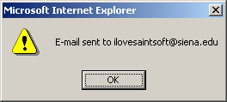

Welcome and First Register Screen (Account Information):
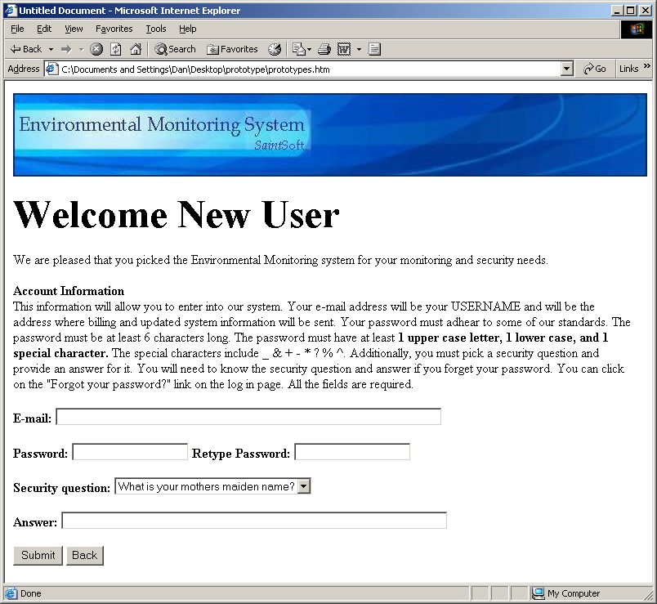

Second Register Screen (Contact Information):
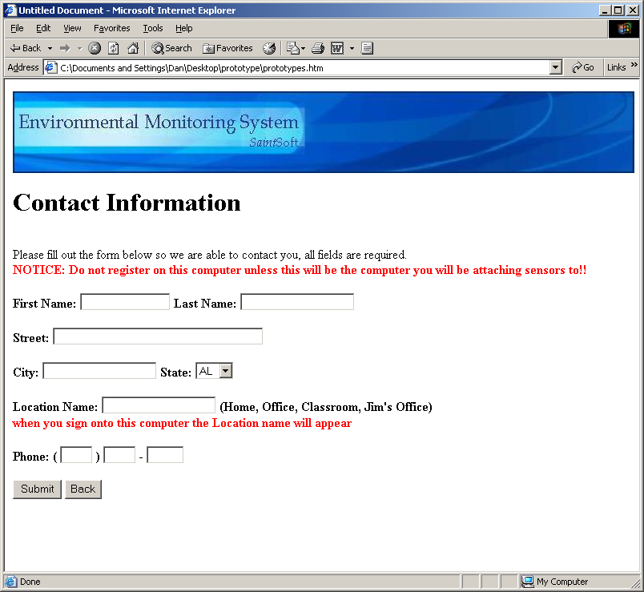

Third Registration Screen (Notification Information):
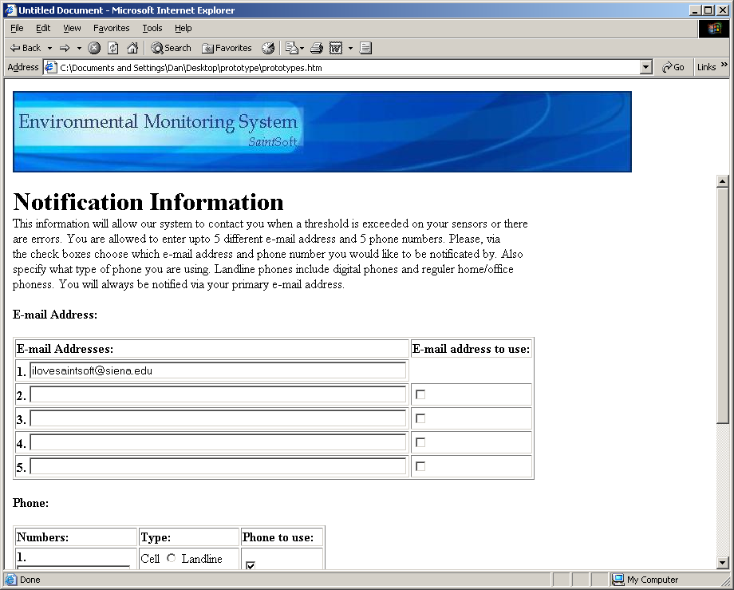
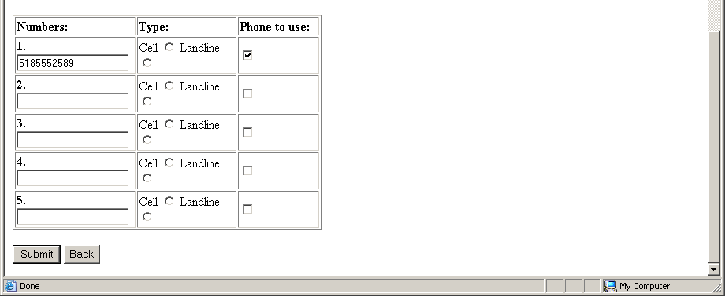

Initial Sensored User Screen:
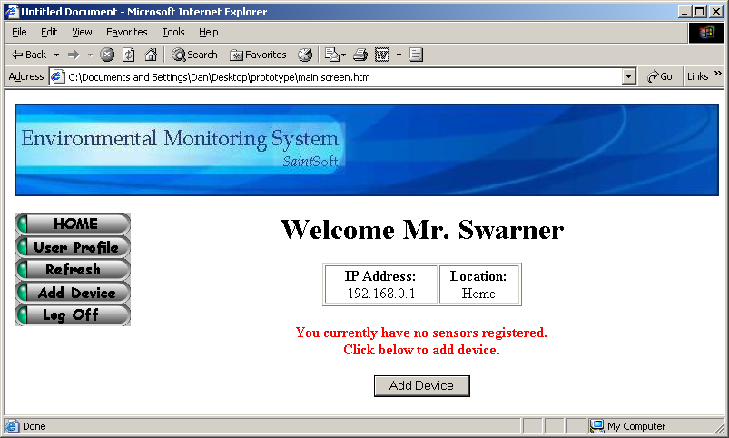

Register Sensors Screen:
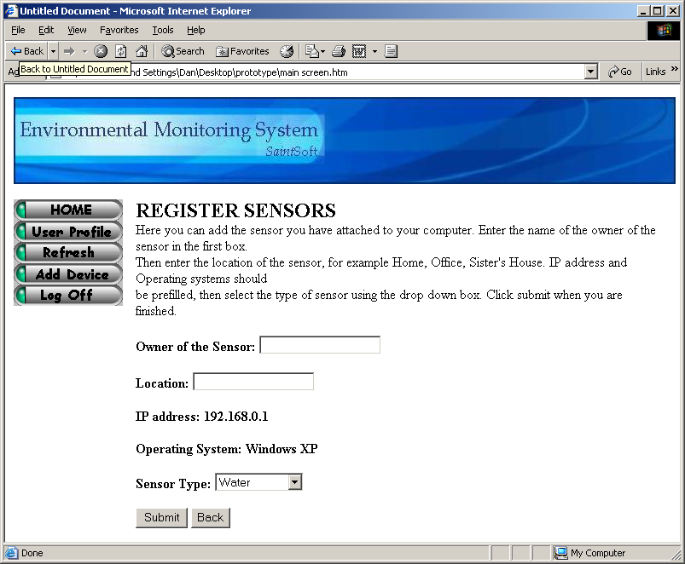

Regular Sensored User Screen:
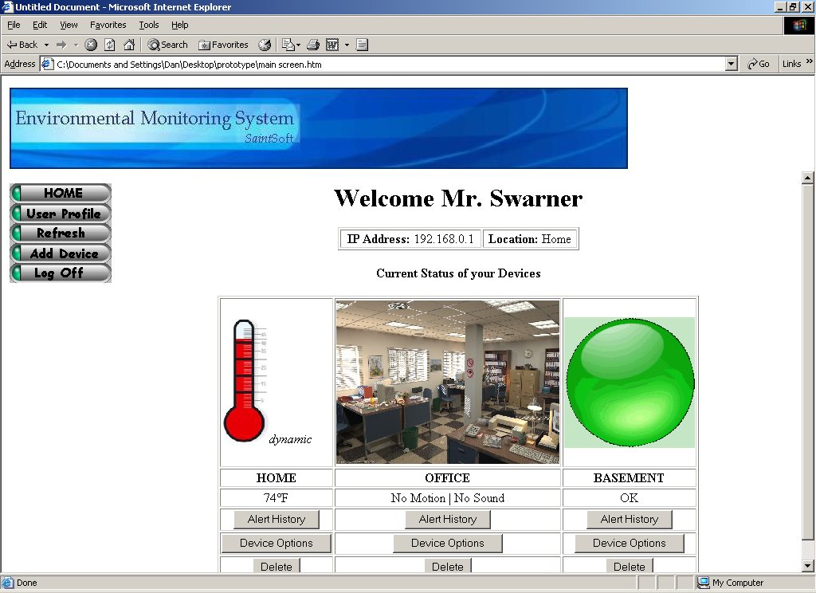

User Profile Screen:
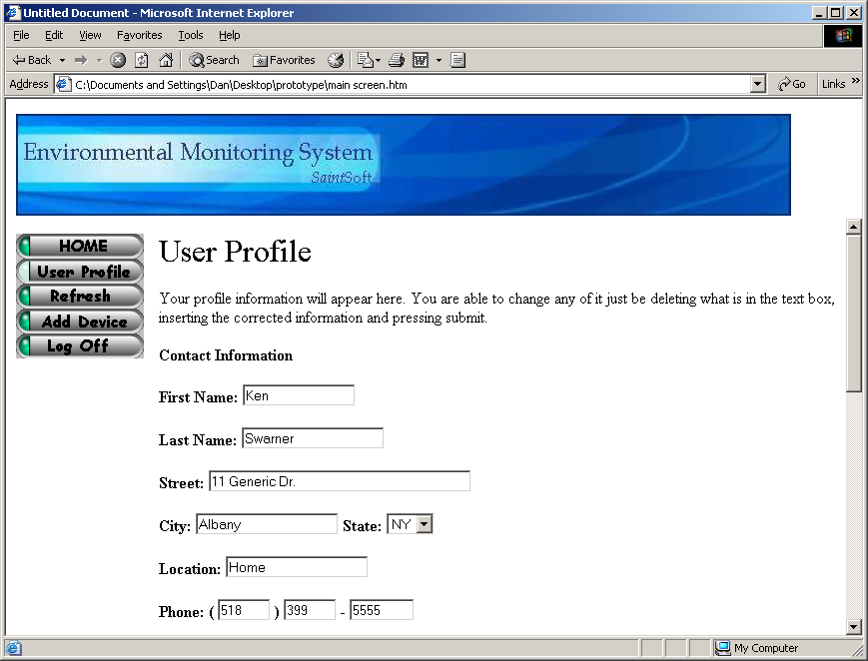
User Profile Screen Cont.
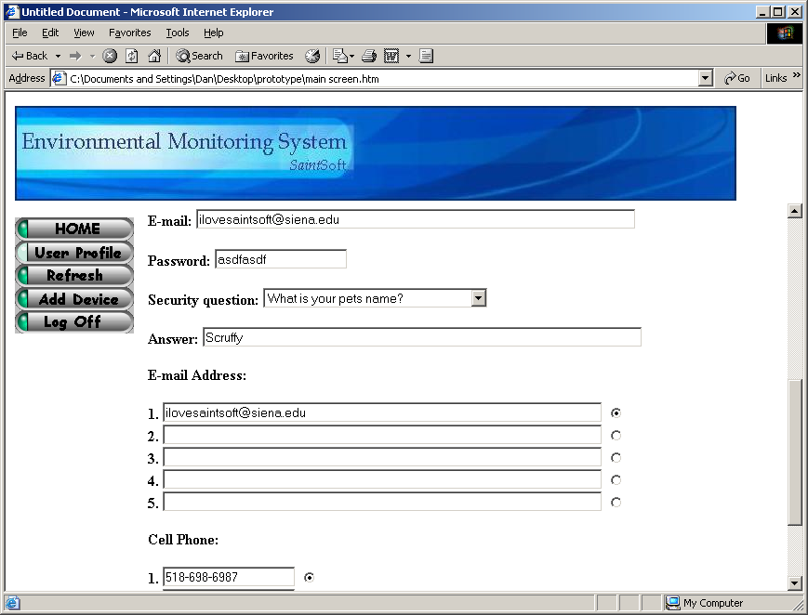

Sensor Alert Screens:
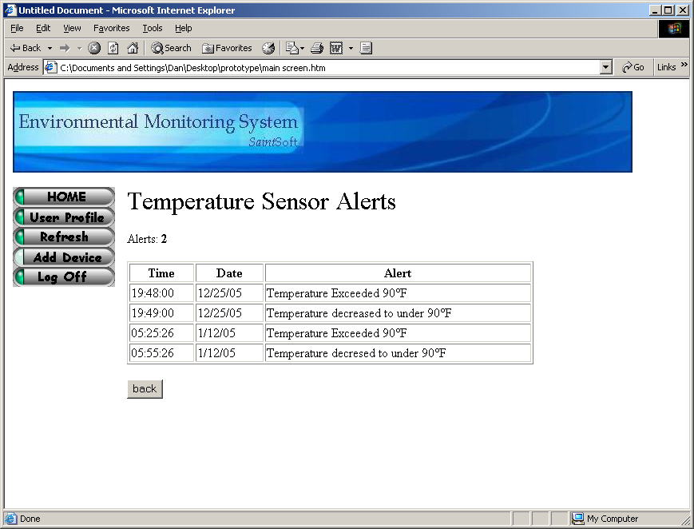
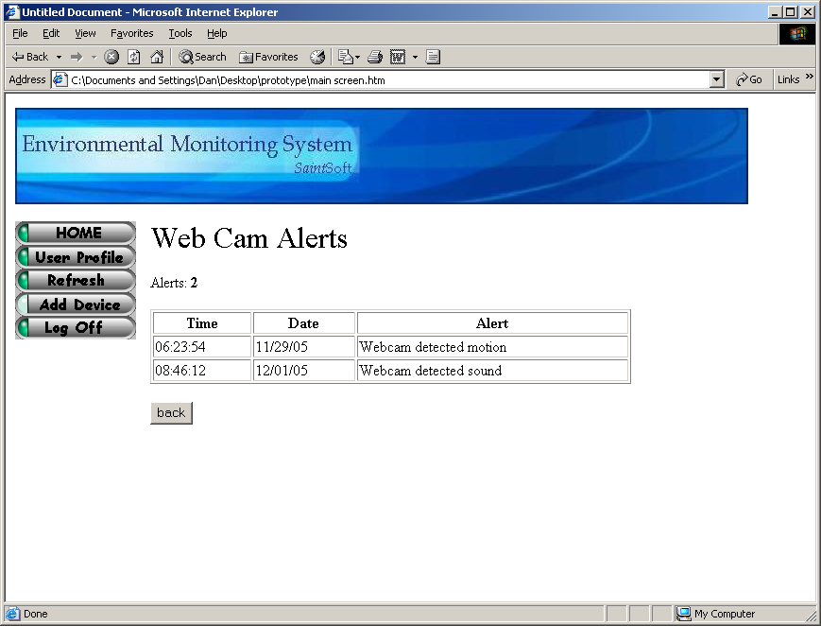
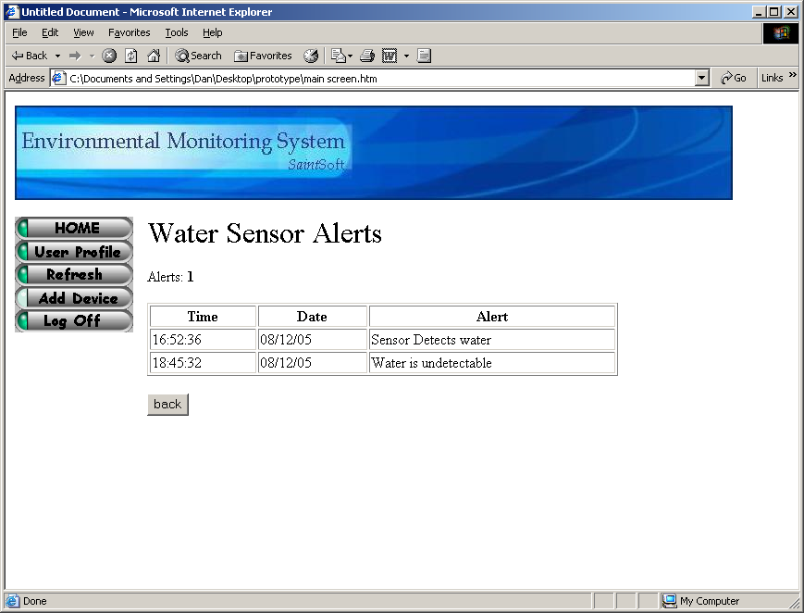
Device Option Screens;
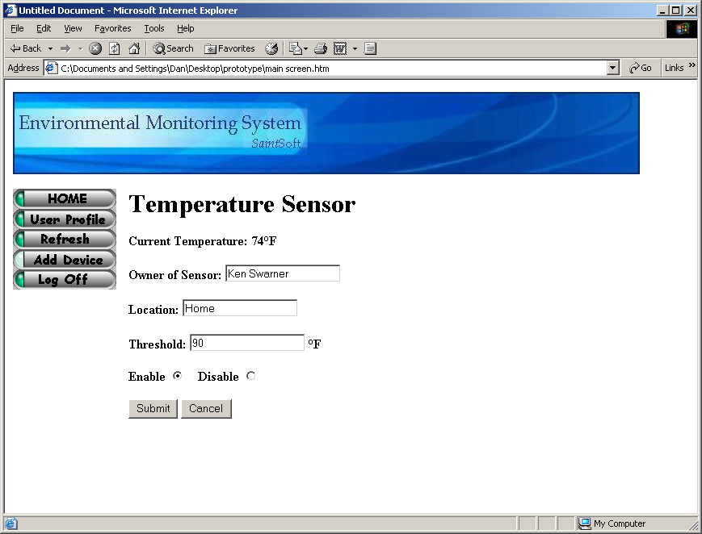
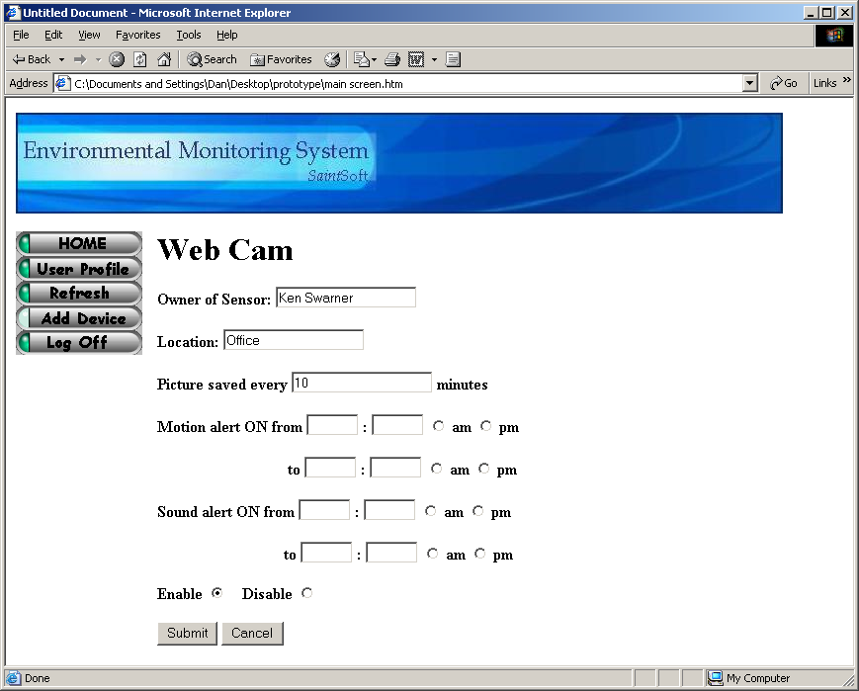
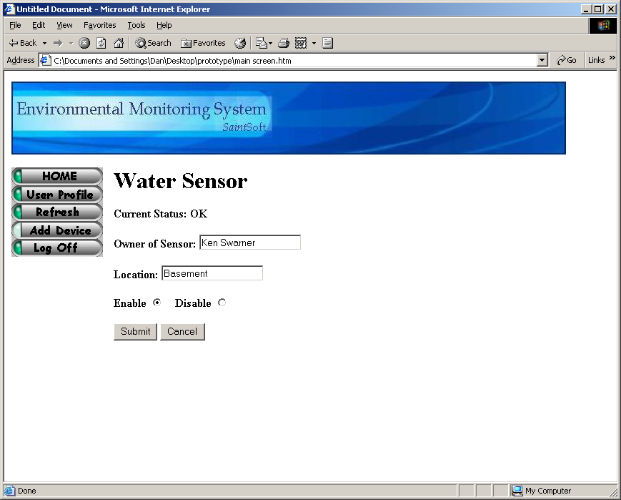

Delete Sensor Pop-Up:
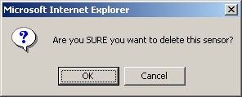

Remote User Screen:
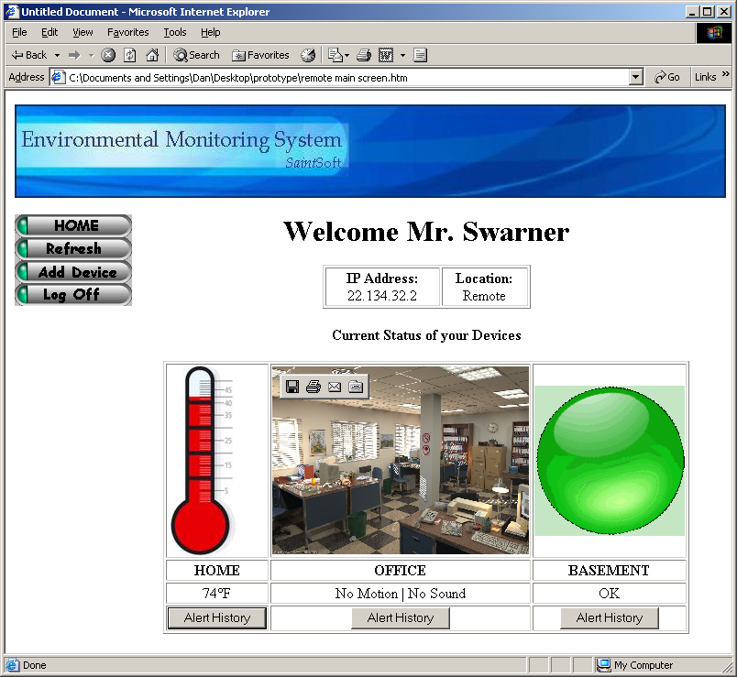

Administrator Screen:
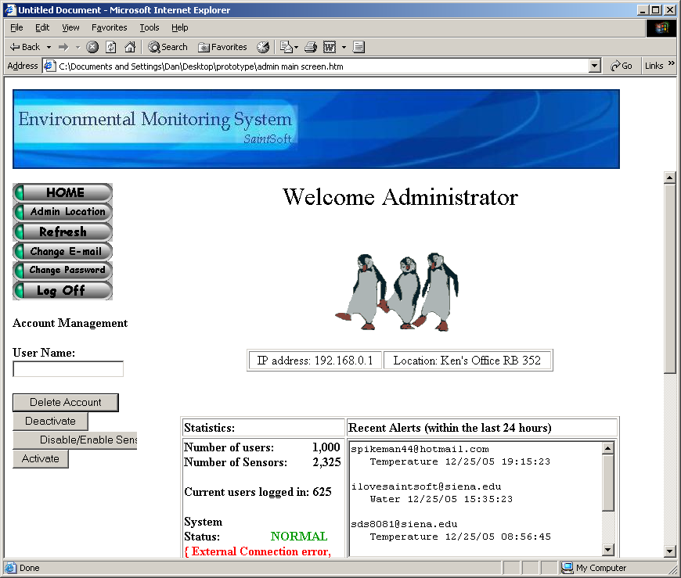

Administrator Screen Cont:
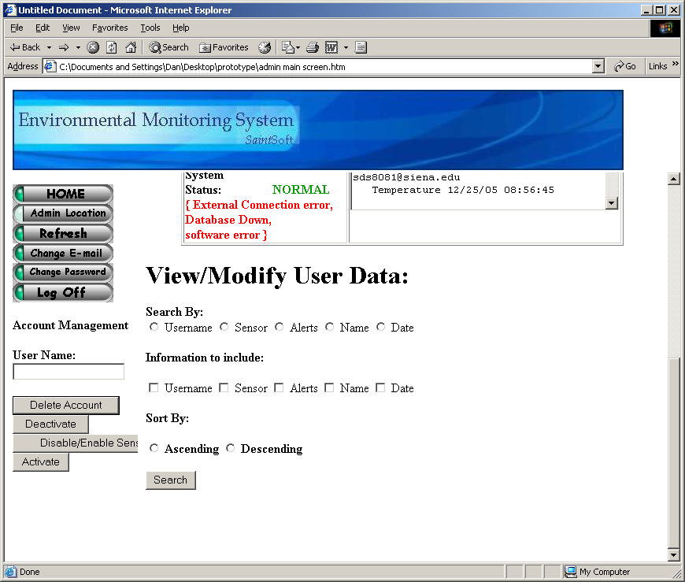

Admin Location Screen:
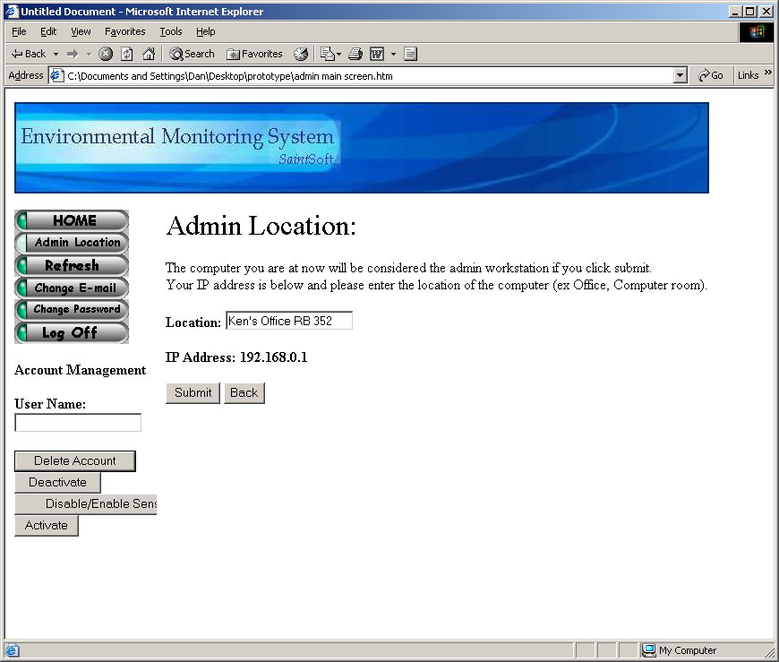
Change E-mail Screen:
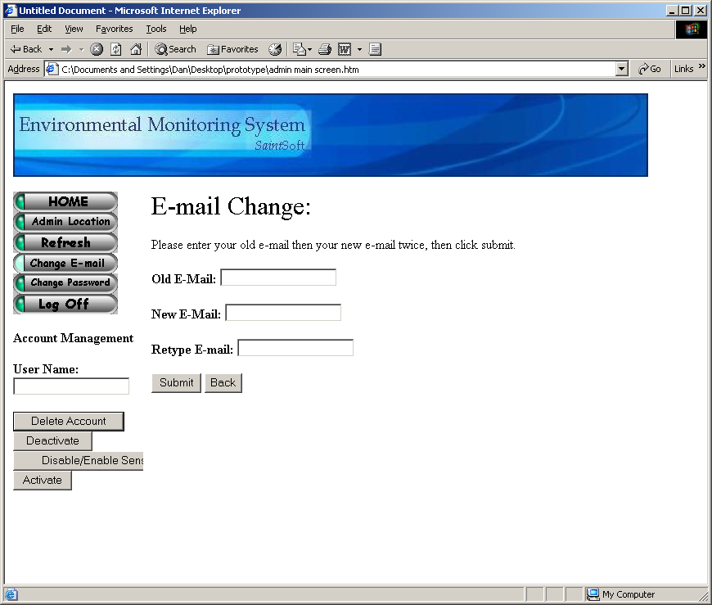
Change Password Screen:
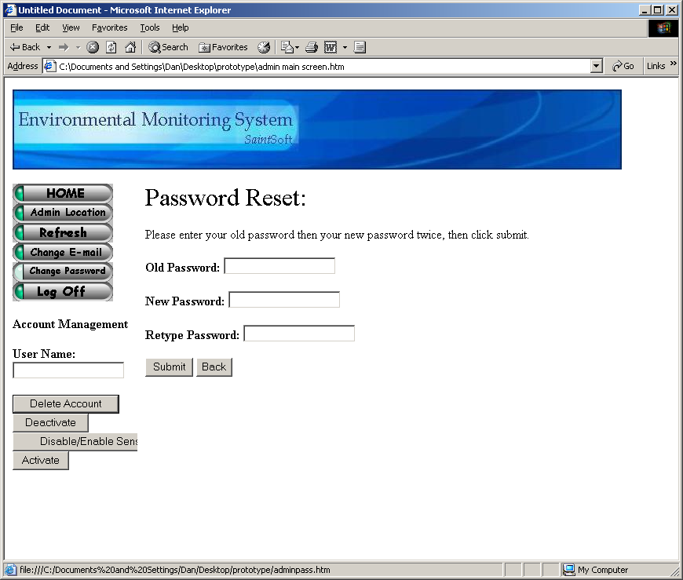
Disable/Enable Sensor Screen:
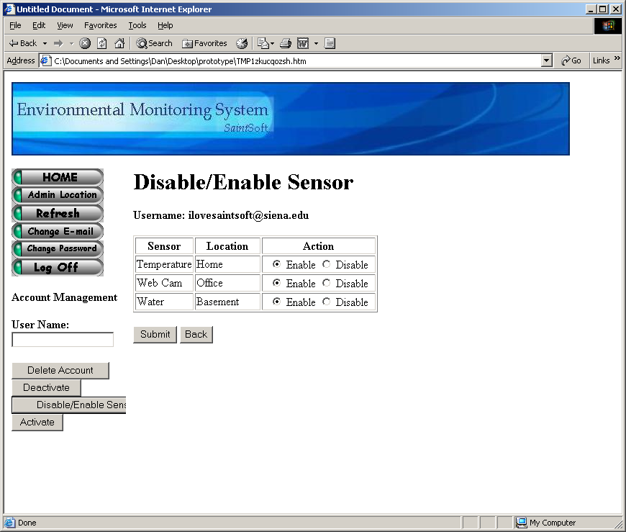
Activate Account Pop-Up:
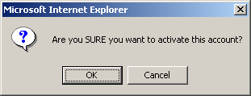

Deactivate Account Pop-Up:
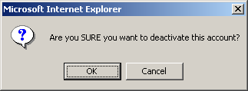

Delete Account Pop-Up:
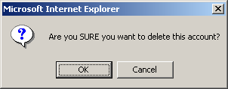
Query Result Screen:
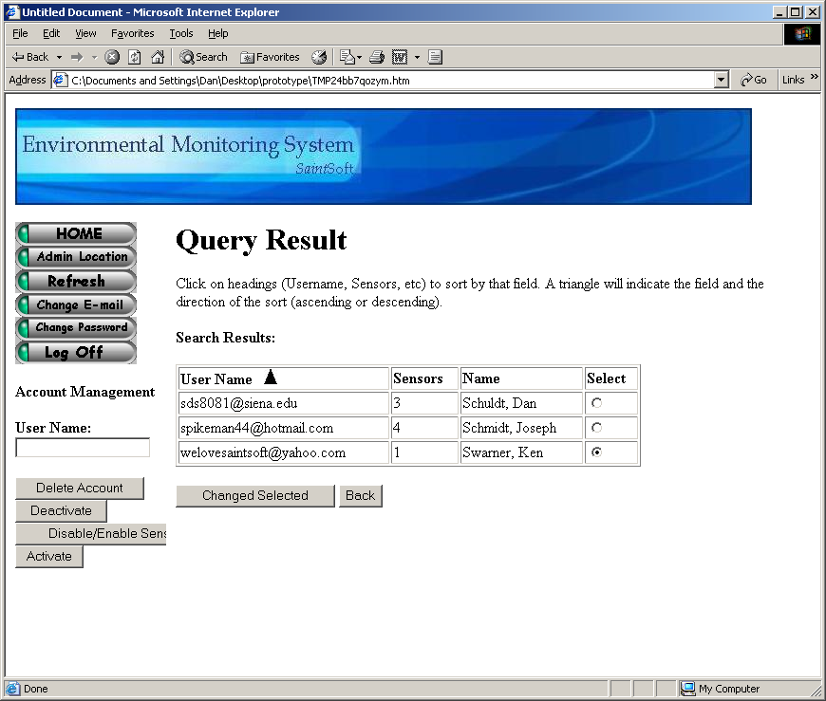

User Summary

Login Screen:
The Login Screen is the first screen that a user is faced with upon access to the system. This screen contains a section in which current news is displayed. Such news could include upgrades to the system, new sensors available to users or a simple system status. The screen also contains two entry fields. The first field is for the user name, the second for the user’s password. Upon correctly completing the specified information, the user is then directed to the corresponding user welcome screen. The initial login screen also provides the user with two links. The first link allows the user to retrieve a lost password. Upon clicking the link, the user is directed to the password recover screen. The second link allows a new user to create a new account and when clicked, directs the user to the first register screen.

Password Recover Screen:
The Password Recover Screen allows a user to retrieve a lost or forgotten password. This screen contains 3 fields. After being directed to this screen from the Login Screen, the user is prompted for the user name (e-mail address) in the first entry field. In addition, the user must select a security question from a drop down menu and provide the correct answer to that question in the last entry field. The information is entered into the system when the user clicks the provided submit button. Both the question and answer must match those specified by the user during the registration process. Upon confirmation of both the question and answer, the user will receive a pop-up message confirming the delivery of the user’s password to the specified e-mail address. At anytime during the password recovery process the user can click on the “Back” button to return to the initial Login Screen.

Confirmation Pop-up for Password Recovery:
The Confirmation Pop-up box is a simple pop-up stating that a password has been sent to a user’s e-mail address. The box contains one line stating: “E-mail has been sent to username@domain.com”. The user is provided with a button to exit the pop up box. Upon completion of the password recovery, the user is directed back to the Password Recover Screen.

Welcome and First Register Screen (Account Information):
This screen is the first of a series of screens that the user must complete during the registration process. The First Register Screen contains five entry fields. The user is first provided with a summary of the screen, informing them of the rules and restrictions applying to the information the user must supply. The first entry field is the E-mail filed. The user is given notice that this e-mail address will serve as the username from that point on. The second entry field prompts the user for a password to associate with the account. The user is then able to enter a password that must meet the specified restrictions in order to be considered valid. The third entry field prompts the user to re-enter the password for verification. The fourth field is a drop down menu that provides the user with a list of possible security questions and the fourth entry field provides the user to enter an answer to the selected security question. As described in the summary at the top of the screen, the user is to choose a security question that will be used in the future for password recovery purposes. When all fields are complete the user can click the “Submit” button to submit the information to the system. Upon the submission of information, the user is directed to the next screen prompting the user for information, the Second Register Screen. At any time during the process the user is able to click on the “Back” button to return to the initial Login Screen.

Second Register Screen (Contact Information):
The Second Register Screen is accessed from the previous register screen. This screen provides the user with seven entry fields. The screen informs the user that the screen, as well as registration process, should only be completed on the computer in use if the user plans on attaching sensors to it. The user is then prompted for their personal information. The first and second entry fields allow the user to enter their First Name and Last Name respectively. The user is then prompted for the address, Street, City and State in the third, fourth and fifth entry fields respectively. The sixth entry field prompts the user for a Location Name. The user is provided with a brief explanation, stating that this name will be used as a label or title for the login location, as well as a few examples. Finally, the user is prompted for a telephone number for notification purposes. When the user has completed the requested information the “Submit” button can be clicked, submitting the information to the system. Upon submission, the user is directed to the Third Registration Screen. At any time in the process, the user can click on the “Back” button to go to the previous page.

Third Registration Screen (Notification Information):
The Third Registration Screen provides the user with a brief explanation of the screen, stating that the information provided will be used in the case of an alert or error in the system or with a device. The user is prompted to enter up to five different e-mail addresses in which notification or error information will be sent. The user is also able to enter up to five telephone numbers for the same purpose. The user is able to specify whether the telephone number is a cellular number or a landline for notification purposes. Upon completing the screen, the user is able to click the “Submit” button to submit the information to the system. Upon submitting the information, the user is directed to the Initial Sensored User Screen. At any time during the process, the user can click the “Back” button to return to the previous screen.

From this point on, the user is provided with five different buttons that appear on the left side bar of the screen. The first of these five buttons entitled “Home” will direct the user to their initial welcome screen. The second button, “User Profile”, will direct them to the User Profile Screen in which the user can view and change personal information. The third button, “Refresh”, will refresh the users current page, updating any displayed sensor information. The fourth button, “Add Device”, will direct the user to the Register Sensors Screen, allowing the user to add a new sensor to the account from the computer in which they are located. The fifth and final button, “Log Off” will log the user out of the system and direct them to the Login Screen.

Initial Sensored User Screen:
The user is directed to this screen upon the completion of the registration process or by clicking on the “Home” button on the left side bar. The Initial Sensored User Screen provides the user with a welcome message as well as the current IP address of the computer in which the user is accessing the system. If this IP address is recognized by the system, the screen will also display the location name specific to that IP address. The user is informed that they do not currently have sensors registered to the account and are given the option to add a device by clicking in either of two places, the first being a button below the message, “Add Device”, or the button on the left side toolbar. Both buttons will direct the user to the Register Sensors Screen.

Register Sensors Screen:
The Register Sensors Screen, first, provides the user with a brief explanation of the screen and its functionality. The Screen has three entry fields in which the user must complete in order to register a sensor to their computer. The first of the three prompts the user for the owner’s name that will be associated with the sensor. The second field prompts the user for the location label associated with the sensor. The system will auto-fill the IP Address field as well as the Operating System field. The third entry field provides the user with a drop down menu allowing the user to choose the type of sensor they will be registering to the system. Upon completion of the fields, the user can click the “Submit” button, submitting the information to the system. Upon the submission of information the user is directed to the Regular Sensored User Screen. At any time during the process, the user is able to click on the “Back” button to return to the previous page.

Regular Sensored User Screen:
The Regular Sensored User Screen is much like the Initial Sensored User Screen in that it provides the user with the current IP address of the computer in which the user is located as well as the location label of that computer. Like the Initial Sensored User Screen, the user is able to add a new device to the account. This screen however, provides the user with a graphical display representing information received from the account’s registered devices. The information pertaining to each sensor is displayed including the sensor location as well as the sensor’s current status. The user is also able to make changes to each of the devices. For each device displayed, each of three buttons are displayed. First, the “Alert History” button allows the user to view the history of the alerts that the pertaining device produced. Upon clicking this button, the user is directed to the appropriate Sensor Alert Screen. Secondly, the user can click on the “Device Options” button allowing the user to make changes to the device information. Upon clicking the Device Options button, the user is directed to the appropriate Device Option Screen. The last button, “Delete”, will allow the user to delete the appropriate sensor from their account. Upon clicking this button, the user is faced with a pop-up screen assuring the action.

User Profile Screen:
The User Profile Screen is accessed through the “User Profile” button on the left side bar. The screen allows the user to view and/or change any of the given information including name, address, location label, phone number, e-mail address, password, security question and answer as well as the contact e-mail addresses and phone numbers. By clicking the “Submit” button, the user can submit all (if any) changes made to the information. Upon submitting the new information, the user is directed back to the Regular Sensored User Screen where the location and sensor information is displayed. At any time during the process of changing or viewing profile information the user can click the “Back” button to return to the previous screen without saving any changes.

Sensor Alert Screens:
A Sensor Alert Screen is accessed by clicking on the “Alert History” button provided for each of the registered sensors. The user is provided with a Sensor Alert Screen specific to the device that the user selected. The screen allows the user to view a history of alerts generated by the corresponding sensor. The time, date and a description of the alert are provided for each instance. In addition to the alert, the user is provided with the logged entry of when the sensor falls below the specified threshold to provide the user with complete information. At any time the user can click the “Back” button to return to the Sensored User Screen.

Device Option Screens:
A Device Option Screen is accessed by clicking on the “Device Option” button provided for each of the registered sensors. The user is provided with a Device Option Screen specific to the device that the user selected. The screen allows the user view the current status of the specified device. The user is also able to change information pertaining to that device including the owner’s name, location label as well as a threshold point for the sensors in which it applies. The user is able to either enable or disable any of the registered sensors as well. The user can click the “Submit” button to submit all (if any) changes made to the device options. Upon submitting the changes, the user is directed to the Sensored User Screen. At any time the user can click the “Cancel” button to return to the Sensored User Screen.

Delete Sensor Pop-Up:
The Delete Sensor Pop-up appears after the user has clicked the “Delete” button specific to one of the registered sensors. This pop-up ensures that the user wishes to perform the requested action and minimizes mistakes. The pop-up provides the user with a simple message stating “Are you SURE you want to delete this sensor?”. The user is then provided with two buttons. The first button, “OK”, confirms the user’s action and proceeds by deleting the specified sensor. Following the deletion, the user is directed back to an updated Sensored User Screen. The second button, “Cancel”, cancels the action and directs the user back to the Sensored User Screen.

Remote User Screen:
The Remote User Screen is much like the Sensored User Screen in that it provides the user with the current IP Address of the computer in which the user is accessing the system from as well as stating that the user is accessing the system from a “Remote” location. The user is able to view a graphical representation of the current status of all devices registered to the account as well as view an alert history pertaining to the specified device. From this point, the user can not make any changes to the account other than add an addition device.

Administrator Screen:
The Administrator Screen is accessed from the login screen only after entering a special username and password. From this point, the System Administrator is faced with a welcome screen that displays the current IP Address of the computer accessing the system as well as the location label of that computer. The user is also provided with a set of statistics specific to the system, including the number of users, the number of sensors, the number of users logged into the system as well as the current system status. In addition, the user is provided with the most recent alerts generated by the system. This section will allow the user to view the username (e-mail address) of the user whose sensor generated an alert, the type of sensor as well as the date and time specific to the alert. The user is also provided with a section in which the database containing user and sensor information can be searched. The Administrator will also be provided with a unique left side bar including additional options. The left sidebar includes six buttons as well as an area for account management. The first of the six buttons, “Home”, will direct the user to the Initial User Screen. The second button, “Admin Location”, will direct the user to a new screen allowing the user to change the location label associated with the IP Address specific to that computer. The third button, “Refresh”, will allow the user to refresh the current page, updating and re-displaying current information related to the system. The fourth button, “Change E-mail”, directs the user to a new screen allowing the user to change the registered e-mail address specific to the account. The fifth button, “Change Password”, allows the user to change the password specific to the account by directing the user to a new screen. The sixth and final button, “Log Off”, will log the user out of the system and re-direct back to the Login Screen.
The View/Modify User Data section of the screen allows the Administrator to search the databases containing both user and sensor information. This search allows the user to search by a single key (username, sensor, alerts, name, date, etc) and allows the user to include specific and additional information in the search. An order in which the information will be displayed can be specified by the user at this point as well. By clicking the “Search” button, the user submits the specified query and will be faced with the results.
The Account Management Section of the left side bar enables the Administrator to search the database for a single user and make changes specific to that account. From this point the user is able to delete the account by clicking the provided “Delete Account” button, deactivate the account by clicking the “Deactivate” button, disable or enable sensors specific to that account by clicking the “Disable/Enable Sensors” button or activate a user’s account by clicking the “Activate” button. These options allow the Administrator to have control over the system and be able to troubleshoot within.

Admin Location Screen:
The Administrator Location Screen is accessed from the “Admin Location” button on the left side bar. This screen enables the user to change the location label specific to the computer accessing the system. To do this, the user enters the new label into the provided entry field. By clicking the “Submit” button, the changes are submitted to the system and the user is directed back to the Administrator Main Screen. At any point, the user can click on the “Back” button to return to the previous page without submitting any changes to the account.

Change E-mail Screen:
The Change E-mail Screen is accessed from the left side toolbar by clicking the “Change E-mail” button provided. The user is provided with three entry fields in which the user first enters the old e-mail address, next enters the desired new e-mail address and finally confirms the new e-mail address. By clicking the “Submit” button, the user submits the changed information to the system and is directed to the Administrator Main Screen. At any time, the user can click the “Back” button to return to the previous page without submitting any changes to the account.

Change Password Screen:
The Change Password Screen is accessed from the left side toolbar by clicking the “Change Password” button provided. The user is provided with three entry fields in which the user first enters the old password, next enters the desired new password and finally confirms the new password, adhering to the specified restrictions. By clicking the “Submit” button, the user submits the changed information to the system and is directed to the Administrator Main Screen. At any time, the user can click the “Back” button to return to the previous page without submitting any changes to the account.

Disable/Enable Sensor Screen:
The Disable/Enable Sensor Screen is accessed through the Account Management Section of the left side toolbar and by clicking on the “Disable/Enable Sensors” button. After entering an e-mail address in the entry field the user can click any of four buttons. By clicking the Disable/Enable Sensor button, the user can view all of the sensors registered to the account specified. From here, the user can view the type of each sensor, location of each sensor and choose to either enable or disable that specific sensor. The user can then submit changes by clicking on the “Submit” button. After submitting updated information, the user is directed to the Administrator Main Screen, changes complete. At any time the user can click on the “Back” button to return to the Administrator Main Screen without submitting any changes to the specified account.

Activate Account Pop-Up:
The Activate Account Pop-up appears after the user has clicked the “Activate” button specific to the entered user e-mail address. This pop-up ensures that the user wishes to perform the requested action and minimizes mistakes. The pop-up provides the user with a simple message stating “Are you SURE you want to activate this account?”. The user is then provided with two buttons. The first button, “OK”, confirms the user’s action and proceeds by activating the specified account. Following the addition, the user is directed back to an updated Administrator Main Screen. The second button, “Cancel”, cancels the action and directs the user back to the Administrator Main Screen.

Deactivate Account Pop-Up:
The Deactivate Account Pop-up appears after the user has clicked the “Deactivate” button specific to the entered user e-mail address. This pop-up ensures that the user wishes to perform the requested action and minimizes mistakes. The pop-up provides the user with a simple message stating “Are you SURE you want to deactivate this account?”. The user is then provided with two buttons. The first button, “OK”, confirms the user’s action and proceeds by deactivating the specified account. Following the addition, the user is directed back to an updated Administrator Main Screen. The second button, “Cancel”, cancels the action and directs the user back to the Administrator Main Screen.

Delete Account Pop-Up:
The Delete Account Pop-up appears after the user has clicked the “Delete” button specific to the entered user e-mail address. This pop-up ensures that the user wishes to perform the requested action and minimizes mistakes. The pop-up provides the user with a simple message stating “Are you SURE you want to delete this account?”. The user is then provided with two buttons. The first button, “OK”, confirms the user’s action and proceeds by deleting the specified account. Following the addition, the user is directed back to an updated Administrator Main Screen. The second button, “Cancel”, cancels the action and directs the user back to the Administrator Main Screen.

Query Result Screen:
The Query Result Screen is accessed after the user submits a query into the system. The user is provided with a screen displaying the information requested (username, sensor, alerts, name, date, etc) in the order requested (ascending, descending). At the end of each line the user is able to select any of the query results to make changes to those accounts. To do so, the user selects a query result followed by the “Change Selected” button. This action will direct the user to a screen allowing the Administrator to edit the user information. At any point the user can click on the “Back” button to return to the Administrator Main Screen without submitting any changes.

Detailed Data Flow Diagrams

Symbols:

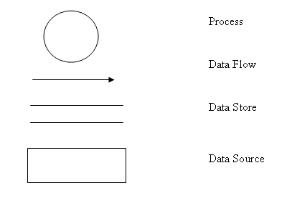

Context Diagram:

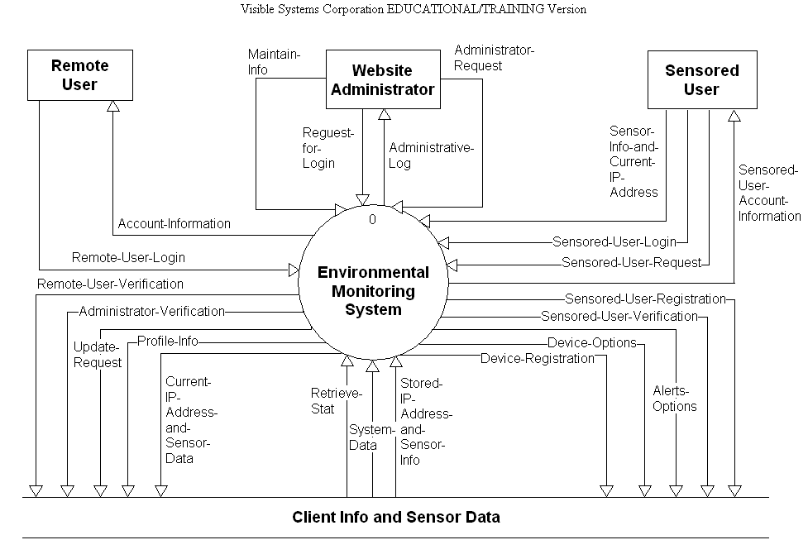

Level 0: Environmental Monitoring System

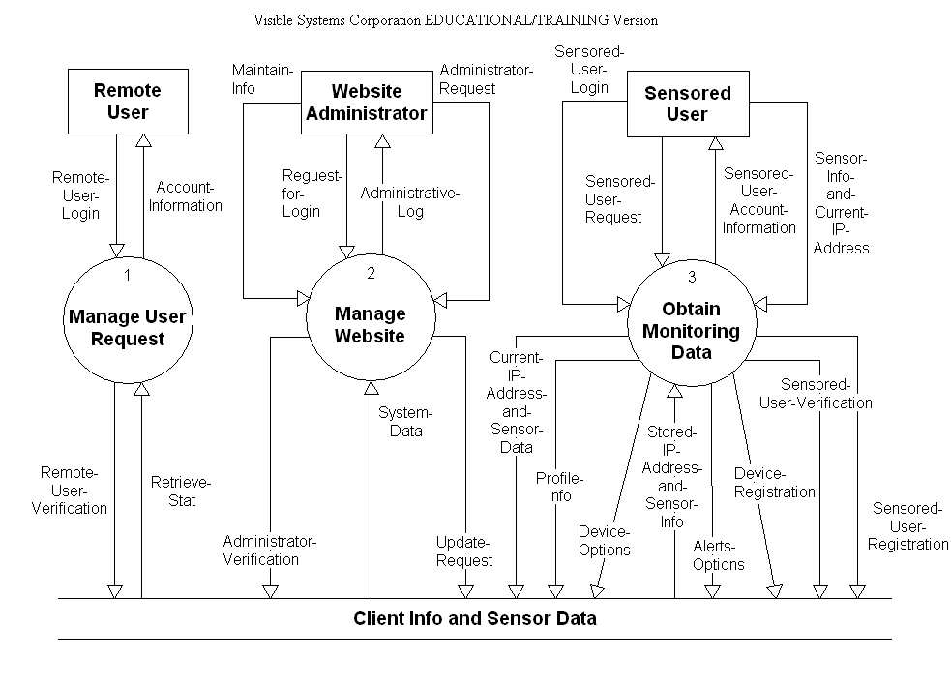
Level 1: Manage User Request
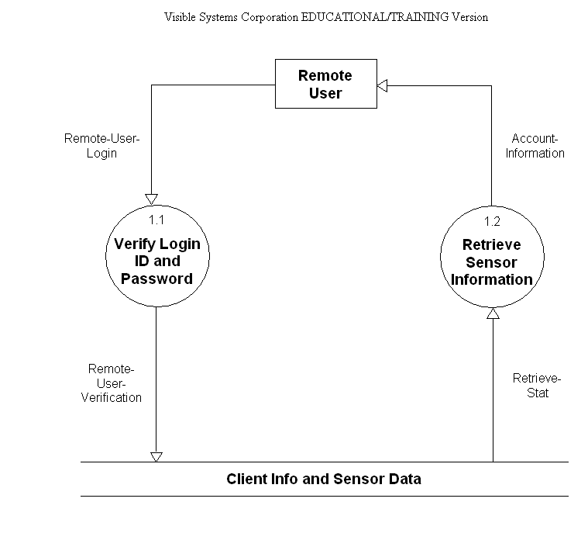

Level 2: Manage Website

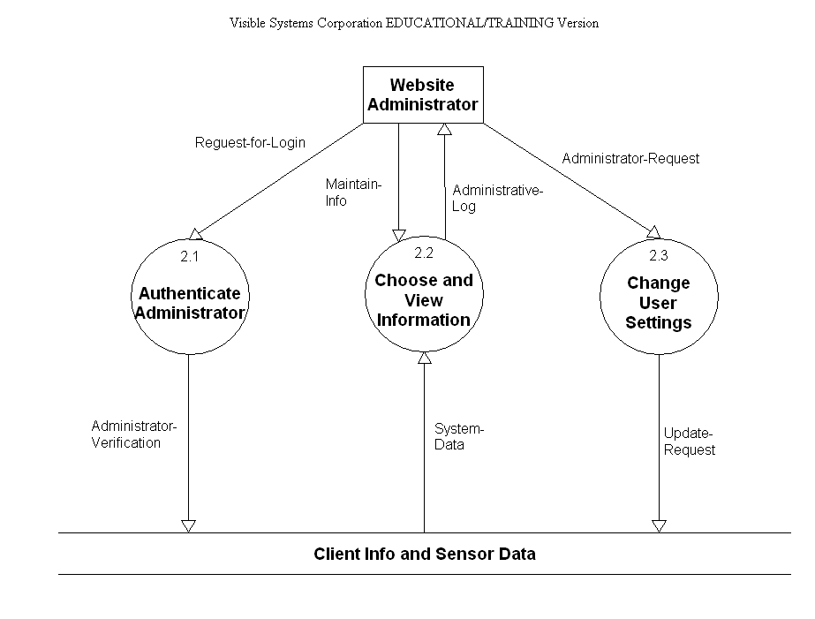

Level 3: Obtain Monitoring Data

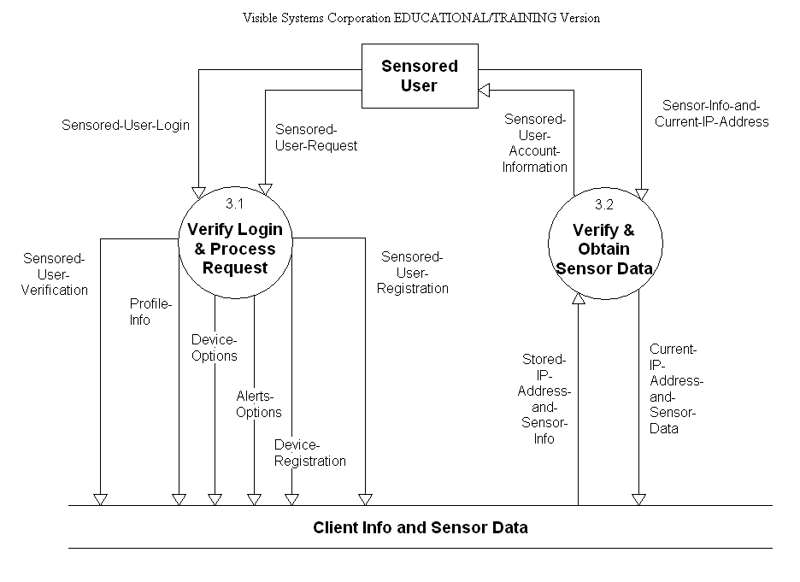

Level 3.1: Verify Login & Process Request

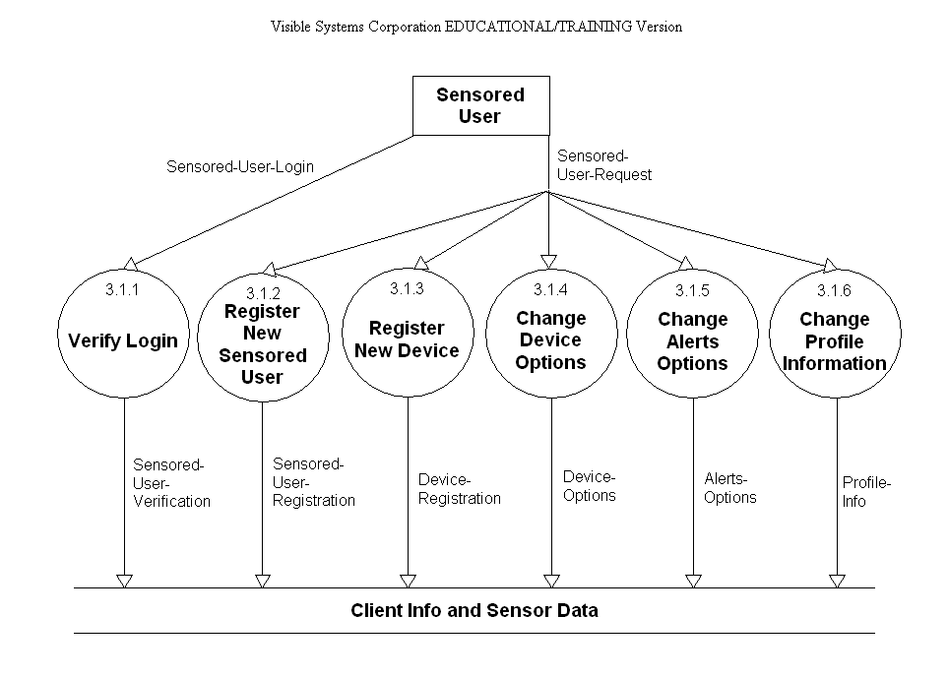

Functional Decomposition Diagram
The functional decomposition diagram (FDD) is a tool that depicts the hierarchy in detail using process models. It breaks down or decomposes the business functions into processes makes complex system much easier to understand and analyze.

Process | 
Connector | 

A Process is an activity that is performed for specific business reason, it is denoted by a rectangle with rounded corners. A process represents a tangible activity that occurs within the organization, each process should only contain one activity.

Connectors are lines that between functions, processes or from a function to a process. They specify hierarchical relationships among the components of the functional decomposition diagram. Connectors should not be named, but their presence implies consists.

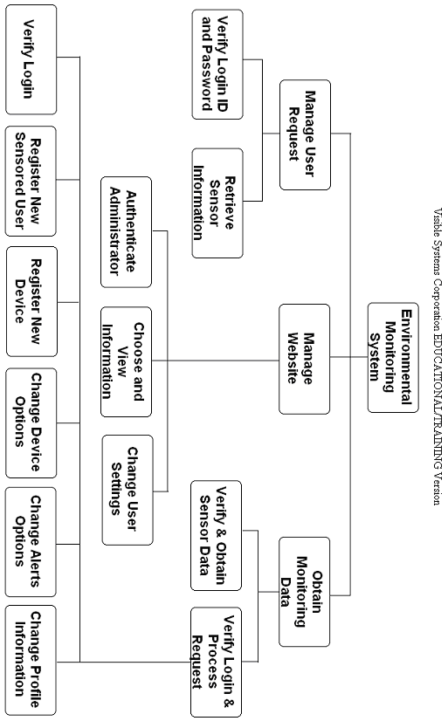

1.5 Logical Data Dictionary

Date: 11/28/2005 Project: DFD DIAGRAM Page: 1
Time: 7:30:35 PM
Detailed Listing -- Alphabetically
All Entries -- Data Flow Diagrams
_______________________________________________________________________
Account-Information Data Flow
Location:
Level 0 ( 0 )
Source: Manage User Request ( Process )
Dest: Remote User ( Source/Sink )
Level 1 ( 1 )
Source: Retrieve Sensor Information ( Process )
Dest: Remote User ( Source/Sink )
Context Diagram ( CONTEXT )
Source: Environmental Monitoring System ( Process )
Dest: Remote User ( Source/Sink )
Date Last Altered: 10/24/2005 Date Created: 10/24/2005
---------------------------------------------------------------------------------------------------------------------------------
Administrative-Log Data Flow
Location:
Level 0 ( 0 )
Source: Manage Website ( Process )
Dest: Website Administrator ( Source/Sink )
Level 2 ( 2 )
Source: Choose and View Information ( Process )
Dest: Website Administrator ( Source/Sink )
Context Diagram ( CONTEXT )
Source: Environmental Monitoring System ( Process )
Dest: Website Administrator ( Source/Sink )
Date Last Altered: 10/24/2005 Date Created: 10/24/2005
---------------------------------------------------------------------------------------------------------------------------------
Administrator-Request Data Flow
Location:
Level 2 ( 2 )
Source: Website Administrator ( Source/Sink )
Dest: Change User Settings ( Process )
Level 0 ( 0 )
Source: Website Administrator ( Source/Sink )
Dest: Manage Website ( Process )
Context Diagram ( CONTEXT )
Source: Website Administrator ( Source/Sink )
Dest: Environmental Monitoring System ( Process )
Date Last Altered: 11/18/2005 Date Created: 11/18/2005
---------------------------------------------------------------------------------------------------------------------------------
Administrator-Verification Data Flow
Location:
Level 2 ( 2 )
Source: Authenticate Administrator ( Process )
Dest: Client Info and Sensor Data ( File )
Level 0 ( 0 )
Source: Manage Website ( Process )
Dest: Client Info and Sensor Data ( File )
Context Diagram ( CONTEXT )
Source: Environmental Monitoring System ( Process )
Dest: Client Info and Sensor Data ( File )
Date Last Altered: 11/18/2005 Date Created: 11/18/2005
---------------------------------------------------------------------------------------------------------------------------------
Alerts-Options Data Flow
Location:
Level 3 ( 3 )
Source: Verify Login & Process Request ( Process )
Dest: Client Info and Sensor Data ( File )
Level 3.1 ( 3.1 )
Source: Change Alerts Options ( Process )
Dest: Client Info and Sensor Data ( File )
Level 0 ( 0 )
Source: Obtain Monitoring Data ( Process )
Dest: Client Info and Sensor Data ( File )
Context Diagram ( CONTEXT )
Source: Environmental Monitoring System ( Process )
Dest: Client Info and Sensor Data ( File )
Date Last Altered: 11/21/2005 Date Created: 11/21/2005
---------------------------------------------------------------------------------------------------------------------------------
Authenticate Administrator Process
Description:
Verify website administrator login information then process it to the client info and sensor data
Process #: 2.1
Location:
Level 2 ( 2 )
Input Flows:
Reguest-for-Login
Output Flows:
Administrator-Verification
Environmental Monitoring System
Date Last Altered: 11/28/2005 Date Created: 11/18/2005
---------------------------------------------------------------------------------------------------------------------------------
Change Alerts Options Process
Description:
Allow sensored user to set their alerts
Process #: 3.1.5
Location:
Level 3.1 ( 3.1 )
Output Flows:
Alerts-Options
Environmental Monitoring System
Children:
Date Last Altered: 11/28/2005 Date Created: 11/21/2005
---------------------------------------------------------------------------------------------------------------------------------
Change Device Options Process
Description:
Enabling user to change threshold values for each sensor, also enables user to deactivate or activate sensor
Process #: 3.1.4
Location:
Level 3.1 ( 3.1 )
Output Flows:
Device-Options
Environmental Monitoring System
Children:
Date Last Altered: 11/28/2005 Date Created: 11/21/2005
---------------------------------------------------------------------------------------------------------------------------------
Change Profile Information Process
Description:
Sensored user are able to change their personal information such as email, phone number, etc.
Process #: 3.1.6
Location:
Level 3.1 ( 3.1 )
Output Flows:
Profile-Info
Environmental Monitoring System
Date Last Altered: 11/28/2005 Date Created: 11/21/2005
---------------------------------------------------------------------------------------------------------------------------------
Change User Settings Process
Description:
Website administrator can request to change all user setting
Process #: 2.3
Location:
Level 2 ( 2 )
Input Flows:
Administrator-Request
Output Flows:
Update-Request
Environmental Monitoring System
Date Last Altered: 11/28/2005 Date Created: 11/18/2005
---------------------------------------------------------------------------------------------------------------------------------
Choose and View Information Process
Description:
It takes the website administrator request, let administrator to maintain their info
Process #: 2.2
Location:
Level 2 ( 2 )
Input Flows:
System-Data
Maintain-info
Output Flows:
Administrative-Log
Environmental Monitoring System
Parent: Manage Website ( Process )
Date Last Altered: 11/28/2005 Date Created: 11/18/2005
---------------------------------------------------------------------------------------------------------------------------------
Client Info and Sensor Data File
Description:
Database that store all client infor and sensor data
Location:
Level 2 ( 2 )
Input Flows:
Administrator-Verification
Update-Request
Output Flows:
System-Data
Level 3.1 ( 3.1 )
Input Flows:
Sensored-User-Registration
Sensored-User-Verification
Alerts-Options
Device-Options
Device-Registration
Profile-Info
Level 0 ( 0 )
Input Flows:
Remote-User-Verification
Current-IP-Address-and-Sensor-Data
Sensored-User-Registration
Sensored-User-Verification
Profile-Info
Update-Request
Administrator-Verification
Device-Options
Alerts-Options
Device-Registration
Output Flows:
Retrieve-Stat
System-Data
Stored-IP-Address-and-Sensor-Info
Level 3 ( 3 )
Input Flows:
Sensored-User-Registration
Sensored-User-Verification
Current-IP-Address-and-Sensor-Data
Alerts-Options
Device-Options
Device-Registration
Profile-Info
Output Flows:
Stored-IP-Address-and-Sensor-Info
Context Diagram ( CONTEXT )
Input Flows:
Sensored-User-Registration
Sensored-User-Verification
Device-Registration
Alerts-Options
Device-Options
Profile-Info
Current-IP-Address-and-Sensor-Data
Update-Request
Administrator-Verification
Remote-User-Verification
Output Flows:
Stored-IP-Address-and-Sensor-Info
System-Data
Retrieve-Stat
Level 1 ( 1 )
Input Flows:
Remote-User-Verification
Output Flows:
Retrieve-Stat
Date Last Altered: 11/28/2005 Date Created: 11/18/2005
---------------------------------------------------------------------------------------------------------------------------------
Current-IP-Address-and-Sensor-Data Data Flow
Location:
Level 3 ( 3 )
Source: Verify & Obtain Sensor Data ( Process )
Dest: Client Info and Sensor Data ( File )
Level 0 ( 0 )
Source: Obtain Monitoring Data ( Process )
Dest: Client Info and Sensor Data ( File )
Context Diagram ( CONTEXT )
Source: Environmental Monitoring System ( Process )
Dest: Client Info and Sensor Data ( File )
Date Last Altered: 11/21/2005 Date Created: 11/21/2005
---------------------------------------------------------------------------------------------------------------------------------
Device-Options Data Flow
Location:
Level 3 ( 3 )
Source: Verify Login & Process Request ( Process )
Dest: Client Info and Sensor Data ( File )
Level 3.1 ( 3.1 )
Source: Change Device Options ( Process )
Dest: Client Info and Sensor Data ( File )
Level 0 ( 0 )
Source: Obtain Monitoring Data ( Process )
Dest: Client Info and Sensor Data ( File )
Context Diagram ( CONTEXT )
Source: Environmental Monitoring System ( Process )
Dest: Client Info and Sensor Data ( File )
Date Last Altered: 11/21/2005 Date Created: 11/21/2005
---------------------------------------------------------------------------------------------------------------------------------
Device-Registration Data Flow
Location:
Level 3 ( 3 )
Source: Verify Login & Process Request ( Process )
Dest: Client Info and Sensor Data ( File )
Level 3.1 ( 3.1 )
Source: Register New Device ( Process )
Dest: Client Info and Sensor Data ( File )
Level 0 ( 0 )
Source: Obtain Monitoring Data ( Process )
Dest: Client Info and Sensor Data ( File )
Context Diagram ( CONTEXT )
Source: Environmental Monitoring System ( Process )
Dest: Client Info and Sensor Data ( File )
Date Last Altered: 11/21/2005 Date Created: 11/21/2005
---------------------------------------------------------------------------------------------------------------------------------
Environmental Monitoring System Process
Description:
A system that allow you to view different sensor information
Process #: 0
Location:
Context Diagram ( CONTEXT )
Input Flows:
Administrator-Request
Sensor-Info-and-Current-IP-Address
Sensored-User-Login
Sensored-User-Request
Stored-IP-Address-and-Sensor-Info
System-Data
Retrieve-Stat
Remote-User-Login
Maintain-info
Reguest-for-Login
Output Flows:
Administrative-Log
Sensored-User-Account-Information
Sensored-User-Registration
Sensored-User-Verification
Device-Registration
Alerts-Options
Device-Options
Profile-Info
Current-IP-Address-and-Sensor-Data
Update-Request
Administrator-Verification
Remote-User-Verification
Account-Information
Environmental Monitoring System
Children: Manage Website ( Process )
Date Last Altered: 11/28/2005 Date Created: 10/24/2005
---------------------------------------------------------------------------------------------------------------------------------
Maintain-info Data Flow
Location:
Level 2 ( 2 )
Source: Website Administrator ( Source/Sink )
Dest: Choose and View Information ( Process )
Level 0 ( 0 )
Source: Website Administrator ( Source/Sink )
Dest: Manage Website ( Process )
Context Diagram ( CONTEXT )
Source: Website Administrator ( Source/Sink )
Dest: Environmental Monitoring System ( Process )
Date Last Altered: 10/24/2005 Date Created: 10/24/2005
---------------------------------------------------------------------------------------------------------------------------------
Manage User Request Process
Description:
Process user login information to let them log in
Process #: 1
Location:
Level 0 ( 0 )
Input Flows:
Remote-User-Login
Retrieve-Stat
Output Flows:
Account-Information
Remote-User-Verification
Environmental Monitoring System
Children:
Date Last Altered: 11/28/2005 Date Created: 10/24/2005
---------------------------------------------------------------------------------------------------------------------------------
Manage Website Process
Description:
A webpage that allow user to login and update their information
Process #: 2
Location:
Level 0 ( 0 )
Input Flows:
System-Data
Maintain-info
Administrator-Request
Reguest-for-Login
Output Flows:
Administrative-Log
Update-Request
Administrator-Verification
Environmental Monitoring System
Children: Choose and View Information ( Process )
Parent: Environmental Monitoring System ( Process )
Date Last Altered: 11/28/2005 Date Created: 10/24/2005
---------------------------------------------------------------------------------------------------------------------------------
Obtain Monitoring Data Process
Description:
Collecting all the data from sensored user then process it to the client info and sensor data
Process #: 3
Location:
Level 0 ( 0 )
Input Flows:
Sensor-Info-and-Current-IP-Address
Sensored-User-Login
Stored-IP-Address-and-Sensor-Info
Sensored-User-Request
Output Flows:
Sensored-User-Account-Information
Current-IP-Address-and-Sensor-Data
Sensored-User-Registration
Sensored-User-Verification
Profile-Info
Device-Options
Alerts-Options
Device-Registration
Environmental Monitoring System
Children:
Date Last Altered: 11/28/2005 Date Created: 10/24/2005
---------------------------------------------------------------------------------------------------------------------------------
Profile-Info Data Flow
Location:
Level 3 ( 3 )
Source: Verify Login & Process Request ( Process )
Dest: Client Info and Sensor Data ( File )
Level 3.1 ( 3.1 )
Source: Change Profile Information ( Process )
Dest: Client Info and Sensor Data ( File )
Level 0 ( 0 )
Source: Obtain Monitoring Data ( Process )
Dest: Client Info and Sensor Data ( File )
Context Diagram ( CONTEXT )
Source: Environmental Monitoring System ( Process )
Dest: Client Info and Sensor Data ( File )
Date Last Altered: 11/21/2005 Date Created: 11/21/2005
------------------------------------------------------------------------------------------------------------------------------------------------
Register New Device Process
Description:
Allow sensored user to register new sensor
Process #: 3.1.3
Location:
Level 3.1 ( 3.1 )
Output Flows:
Device-Registration
Environmental Monitoring System
Children:
Date Last Altered: 11/28/2005 Date Created: 11/21/2005
---------------------------------------------------------------------------------------------------------------------------------
Register New Sensored User Process
Description:
Registration for fist time sensored user
Process #: 3.1.2
Location:
Level 3.1 ( 3.1 )
Output Flows:
Sensored-User-Registration
Environmental Monitoring System
Children:
Date Last Altered: 11/28/2005 Date Created: 11/21/2005
---------------------------------------------------------------------------------------------------------------------------------
Reguest-for-Login Data Flow
Location:
Level 2 ( 2 )
Source: Website Administrator ( Source/Sink )
Dest: Authenticate Administrator ( Process )
Context Diagram ( CONTEXT )
Source: Website Administrator ( Source/Sink )
Dest: Environmental Monitoring System ( Process )
Level 0 ( 0 )
Source: Website Administrator ( Source/Sink )
Dest: Manage Website ( Process )
Date Last Altered: 11/18/2005 Date Created: 11/18/2005
---------------------------------------------------------------------------------------------------------------------------------
Remote-User-Login Data Flow
Description:

Location:
Level 1 ( 1 )
Source: Remote User ( Source/Sink )
Dest: Verify Login ID and Password ( Process )
Level 0 ( 0 )
Source: Remote User ( Source/Sink )
Dest: Manage User Request ( Process )
Context Diagram ( CONTEXT )
Source: Remote User ( Source/Sink )
Dest: Environmental Monitoring System ( Process )
Date Last Altered: 11/28/2005 Date Created: 11/21/2005
------------------------------------------------------------------------------------------------------------------------------------------------
Remote-User-Verification Data Flow
Location:
Level 1 ( 1 )
Source: Verify Login ID and Password ( Process )
Dest: Client Info and Sensor Data ( File )
Level 0 ( 0 )
Source: Manage User Request ( Process )
Dest: Client Info and Sensor Data ( File )
Context Diagram ( CONTEXT )
Source: Environmental Monitoring System ( Process )
Dest: Client Info and Sensor Data ( File )
Date Last Altered: 11/21/2005 Date Created: 11/21/2005
---------------------------------------------------------------------------------------------------------------------------------
Remote User Source/Sink
Description:
User that sign in at a location that does not have register sensor
Location:
Context Diagram ( CONTEXT )
Input Flows:
Account-Information
Output Flows:
Remote-User-Login
Level 0 ( 0 )
Input Flows:
Account-Information
Output Flows:
Remote-User-Login
Level 1 ( 1 )
Input Flows:
Account-Information
Output Flows:
Remote-User-Login
Date Last Altered: 11/28/2005 Date Created: 11/21/2005
---------------------------------------------------------------------------------------------------------------------------------
Retrieve-Stat Data Flow
Location:
Level 0 ( 0 )
Source: Client Info and Sensor Data ( File )
Dest: Manage User Request ( Process )
Level 1 ( 1 )
Source: Client Info and Sensor Data ( File )
Dest: Retrieve Sensor Information ( Process )
Context Diagram ( CONTEXT )
Source: Client Info and Sensor Data ( File )
Dest: Environmental Monitoring System ( Process )
Date Last Altered: 10/24/2005 Date Created: 10/24/2005
---------------------------------------------------------------------------------------------------------------------------------
Retrieve Sensor Information Process
Description:
Get sensor information from the client info and sensor data then process and display the information to remote user
Process #: 1.2
Location:
Level 1 ( 1 )
Input Flows:
Retrieve-Stat
Output Flows:
Account-Information
Environmental Monitoring System
Date Last Altered: 11/28/2005 Date Created: 10/24/2005
---------------------------------------------------------------------------------------------------------------------------------
Sensor-Info-and-Current-IP-Address Data Flow
Location:
Level 0 ( 0 )
Source: Sensored User ( Source/Sink )
Dest: Obtain Monitoring Data ( Process )
Level 3 ( 3 )
Source: Sensored User ( Source/Sink )
Dest: Verify & Obtain Sensor Data ( Process )
Context Diagram ( CONTEXT )
Source: Sensored User ( Source/Sink )
Dest: Environmental Monitoring System ( Process )
Date Last Altered: 10/31/2005 Date Created: 10/31/2005
Sensored-User-Account-Information Data Flow
Location:
Level 3 ( 3 )
Source: Verify & Obtain Sensor Data ( Process )
Dest: Sensored User ( Source/Sink )
Level 0 ( 0 )
Source: Obtain Monitoring Data ( Process )
Dest: Sensored User ( Source/Sink )
Context Diagram ( CONTEXT )
Source: Environmental Monitoring System ( Process )
Dest: Sensored User ( Source/Sink )
Date Last Altered: 11/21/2005 Date Created: 11/21/2005
---------------------------------------------------------------------------------------------------------------------------------
Sensored-User-Login Data Flow
Location:
Level 3 ( 3 )
Source: Sensored User ( Source/Sink )
Dest: Verify Login & Process Request ( Process )
Level 0 ( 0 )
Source: Sensored User ( Source/Sink )
Dest: Obtain Monitoring Data ( Process )
Context Diagram ( CONTEXT )
Source: Sensored User ( Source/Sink )
Dest: Environmental Monitoring System ( Process )
Level 3.1 ( 3.1 )
Source: Sensored User ( Source/Sink )
Dest: Verify Login ( Process )
Date Last Altered: 11/21/2005 Date Created: 11/21/2005
---------------------------------------------------------------------------------------------------------------------------------
Sensored-User-Registration Data Flow
Location:
Level 3 ( 3 )
Source: Verify Login & Process Request ( Process )
Dest: Client Info and Sensor Data ( File )
Level 3.1 ( 3.1 )
Source: Register New Sensored User ( Process )
Dest: Client Info and Sensor Data ( File )
Level 0 ( 0 )
Source: Obtain Monitoring Data ( Process )
Dest: Client Info and Sensor Data ( File )
Context Diagram ( CONTEXT )
Source: Environmental Monitoring System ( Process )
Dest: Client Info and Sensor Data ( File )
Date Last Altered: 11/21/2005 Date Created: 11/21/2005
---------------------------------------------------------------------------------------------------------------------------------
Sensored-User-Request Data Flow
Location:
Level 3 ( 3 )
Source: Sensored User ( Source/Sink )
Dest: Verify Login & Process Request ( Process )
Level 3.1 ( 3.1 )
Source: Sensored User ( Source/Sink )
Dest: *** Not on Diagram ***
Level 0 ( 0 )
Source: Sensored User ( Source/Sink )
Dest: Obtain Monitoring Data ( Process )
Context Diagram ( CONTEXT )
Source: Sensored User ( Source/Sink )
Dest: Environmental Monitoring System ( Process )
Date Last Altered: 11/21/2005 Date Created: 11/21/2005
---------------------------------------------------------------------------------------------------------------------------------
Sensored-User-Verification Data Flow
Location:
Level 3 ( 3 )
Source: Verify Login & Process Request ( Process )
Dest: Client Info and Sensor Data ( File )
Level 3.1 ( 3.1 )
Source: Verify Login ( Process )
Dest: Client Info and Sensor Data ( File )
Level 0 ( 0 )
Source: Obtain Monitoring Data ( Process )
Dest: Client Info and Sensor Data ( File )
Context Diagram ( CONTEXT )
Source: Environmental Monitoring System ( Process )
Dest: Client Info and Sensor Data ( File )
Date Last Altered: 11/21/2005 Date Created: 11/21/2005
------------------------------------------------------------------------------------------------------------------------------------------------
Sensored User Source/Sink
Description:
User that sign in at a location that have register sensor
Location:
Context Diagram ( CONTEXT )
Input Flows:
Sensored-User-Account-Information
Output Flows:
Sensor-Info-and-Current-IP-Address
Sensored-User-Login
Sensored-User-Request
Level 0 ( 0 )
Input Flows:
Sensored-User-Account-Information
Output Flows:
Sensor-Info-and-Current-IP-Address
Sensored-User-Login
Sensored-User-Request
Level 3 ( 3 )
Input Flows:
Sensored-User-Account-Information
Output Flows:
Sensored-User-Login
Sensor-Info-and-Current-IP-Address
Sensored-User-Request
Level 3.1 ( 3.1 )
Output Flows:
Sensored-User-Login
Sensored-User-Request
Date Last Altered: 11/28/2005 Date Created: 11/21/2005
---------------------------------------------------------------------------------------------------------------------------------
Stored-IP-Address-and-Sensor-Info Data Flow
Location:
Level 0 ( 0 )
Source: Client Info and Sensor Data ( File )
Dest: Obtain Monitoring Data ( Process )
Level 3 ( 3 )
Source: Client Info and Sensor Data ( File )
Dest: Verify & Obtain Sensor Data ( Process )
Context Diagram ( CONTEXT )
Source: Client Info and Sensor Data ( File )
Dest: Environmental Monitoring System ( Process )
Date Last Altered: 10/31/2005 Date Created: 10/31/2005
System-Data Data Flow
Location:
Level 0 ( 0 )
Source: Client Info and Sensor Data ( File )
Dest: Manage Website ( Process )
Level 2 ( 2 )
Source: Client Info and Sensor Data ( File )
Dest: Choose and View Information ( Process )
Context Diagram ( CONTEXT )
Source: Client Info and Sensor Data ( File )
Dest: Environmental Monitoring System ( Process )
Date Last Altered: 10/24/2005 Date Created: 10/24/2005
---------------------------------------------------------------------------------------------------------------------------------
Update-Request Data Flow
Location:
Level 2 ( 2 )
Source: Change User Settings ( Process )
Dest: Client Info and Sensor Data ( File )
Level 0 ( 0 )
Source: Manage Website ( Process )
Dest: Client Info and Sensor Data ( File )
Context Diagram ( CONTEXT )
Source: Environmental Monitoring System ( Process )
Dest: Client Info and Sensor Data ( File )
Date Last Altered: 11/18/2005 Date Created: 11/18/2005
---------------------------------------------------------------------------------------------------------------------------------
Verify & Obtain Sensor Data Process
Description:
To store sensored user info and current IP address
Process #: 3.2
Location:
Level 3 ( 3 )
Input Flows:
Stored-IP-Address-and-Sensor-Info
Sensor-Info-and-Current-IP-Address
Output Flows:
Sensored-User-Account-Information
Current-IP-Address-and-Sensor-Data
Environmental Monitoring System
Date Last Altered: 11/28/2005 Date Created: 10/24/2005
---------------------------------------------------------------------------------------------------------------------------------
Verify Login Process
Description:
Verify sensored user login information with the client info and sensor data
Process #: 3.1.1
Location:
Level 3.1 ( 3.1 )
Input Flows:
Sensored-User-Login
Output Flows:
Sensored-User-Verification
Environmental Monitoring System
Children:
Date Last Altered: 11/28/2005 Date Created: 11/21/2005
---------------------------------------------------------------------------------------------------------------------------------
Verify Login & Process Request Process
Description:
Process sensored user login information then vertify with the client infor and sensor data
Process #: 3.1
Location:
Level 3 ( 3 )
Input Flows:
Sensored-User-Login
Sensored-User-Request
Output Flows:
Sensored-User-Registration
Sensored-User-Verification
Alerts-Options
Device-Options
Device-Registration
Profile-Info
Environmental Monitoring System
Children:
Date Last Altered: 11/28/2005 Date Created: 10/24/2005
---------------------------------------------------------------------------------------------------------------------------------
Verify Login ID and Password Process
Description:
Check remote user login then verification with the client info and sensor data
Process #: 1.1
Location:
Level 1 ( 1 )
Input Flows:
Remote-User-Login
Output Flows:
Remote-User-Verification
Environmental Monitoring System
Date Last Altered: 11/28/2005 Date Created: 10/24/2005
---------------------------------------------------------------------------------------------------------------------------------
Website Administrator Source/Sink
Description:
Able to view and change user information
Location:
Context Diagram ( CONTEXT )
Input Flows:
Administrative-Log
Output Flows:
Administrator-Request
Maintain-info
Reguest-for-Login
Level 0 ( 0 )
Input Flows:
Administrative-Log
Output Flows:
Maintain-info
Administrator-Request
Reguest-for-Login
Level 2 ( 2 )
Input Flows:
Administrative-Log
Output Flows:
Administrator-Request
Maintain-info
Reguest-for-Login
Date Last Altered: 11/28/2005 Date Created: 10/24/2005
---------------------------------------------------------------------------------------------------------------------------------

1.6 Logical Data Stores
The following information is an initial description of the data we will store in our database as well as a representation of its layout in table form
Underlined entries represent the primary key for its corresponding table
User_Info
user_id: a value assigned by the software to uniquely identify the user to accommodate for changes to the username; VARCHAR(8)
fname: the user’s first name as entered during the registration process; VARCHAR(20)
lname: the user’s last name as entered during the registration process; VARCHAR(20)
user_name: the username will for our purposes be the user’s primary e-mail address VARCHAR(40)
password: a string of characters that conform to a predefined formula; VARCHAR(10)
primary_phone: the default phone number for the purposes of contacting the user; VARCHAR(9)

Location_Info
user_id: : a value assigned by the software to uniquely identify the user to accommodate for changes to the username; VARCHAR(8)
location: the named assigned to the location by the user during its registration to uniquely identify it to the user (ex: office, home, school, etc.) : a value assigned by the software to uniquely identify the user to accommodate for changes to the username; VARCHAR(15)
ip_address: the ip address associated to the specified location; VARCHAR(15)
street_addr: the street address associated with the location; VARCHAR(50)
city: the city where the specified location is located; VARCHAR(20)
state: the state where the specified location is located; VARCHAR( 25)
zip: the zip code where the specified location is located; VARCHAR(8)
phone: the phone number specific to the location specified, may also be identified as the primary phone number; VARCHAR(9)
phone_type: identifies the phone number as either a cell phone or a landline phone; VARCHAR(4)
e-mail: the e-mail address specific to the location specified, may also be identified as the primary e-mail address (username); VARCHAR(40)
last_login: saves the date and time of the last time the user logged in from the specified location; VARCHAR(14)

Sensor_Info
user_id: a value assigned by the software to uniquely identify the user to accommodate for changes to the username; VARCHAR(8)
location: the named assigned to the location by the user during its registration to uniquely identify it to the user (ex: office, home, school, etc.) : a value assigned by the software to uniquely identify the user to accommodate for changes to the username; VARCHAR(15)
sensor1: references the specific sensor connected to the user’s computer at that location; VARCHAR(10)
sensor2: references the specific sensor connected to the user’s computer at that locationVARCHAR(10)
sensor3: references the specific sensor connected to the user’s computer at that locationVARCHAR(10)
threshold1: a user defined formula for alerts, refers to data from sensor 1, VARCHAR(10)
threshold2: a user defined formula for alerts, refers to data from sensor 2, VARCHAR(10)
threshold3: a user defined formula for alerts, refers to data from sensor 3, VARCHAR(10)
last_recieved1: contains the most recently received data from the sensor, refers to sensor1
last_recieved2: contains the most recently received data from the sensor, refers to sensor2
last_recieved3: contains the most recently received data from the sensor, refers to sensor3

Functional Requirements
- Sensored User
1. Log in screen
- allow the user to log in
- give the user an retrieve their password if they forget it
- allow the user to register if they are a new user
- display recent news on the screen

2. New User screen
- allow the user to fill in all informational fields
- allow the user to submit their information
- allow the user to go back to the previous page

3. Contact Information screen
- allow the user to fill in all informational fields
- allow the user to submit their information
- allow the user to go back to the previous page

4. Notification Information screen
- automatically display the user’s email address
- allow the user to enter other email addresses and phone numbers
- allow the user to submit their information
- allow the user to go back to the previous page

5. Sensored User Home screen
- automatically display the user’s location and IP address
- allow the user add a device
- allow the user go to the home page
- allow the user view their profile
- allow the user refresh the page with the refresh button
- allow the user log out

6. Register Sensors screen
- automatically display the user’s location and IP address
- allow the user to fill in all informational fields
- allow the user to submit their information
- allow the user to go back to the previous page

7. User Home screen with devices
- display a welcome message
- automatically display the user’s location and IP address
- display all of the Sensored devices
- allow the user to view the alert history for each device
- allow the user to view the device options for each device
- allow the user to delete each device if they wish

8. Alert History screen
- display the history for the correct device
- display the alerts
- allow the user to go back to the previous page

9. Device Options screen
- display the proper information for the specific type of device
- allow the user to fill in all informational fields
- allow the user to enable and/or disable a device
- allow the user to submit their information
- allow the user to go back to the previous page

- Delete Button clicked
- allow the user to delete a device

- User Profile Screen
- allow the user to fill in all informational fields
- automatically display the user’s default email and phone number
- allow the user to change the default notification
- allow the user to submit their information
- allow the user to go back to the previous page

12. Refresh Button clicked
- allow the user to refresh all the devices

- Log Out Button clicked
- allow the user to log out of the system

2. Remote User

1. Remote User Home screen
- automatically display the user’s location and IP address
- display all of the Sensored devices
- allow the user to view the alert history for each device
- allow the user to refresh the page
- allow the user to add a device
- allow the user to log out

2. Alert History screen
- display the history for the correct device
- display the alerts
- allow the user to go back to the previous page

3. Register Sensors screen
- automatically display the user’s location and IP address
- allow the user to fill in all informational fields
- allow the user to submit their information
- if the user clicks submit, they become a Sensored user
- allow the user to go back to the previous page

4. Log Out button clicked
- allow the user to log out of the system

3. Administrator

1. Administrator Home screen
- display a welcome message
- automatically display the admin’s location and IP address
- display the statistics and recent alerts
- allow the admin to perform a search
- allow the admin to select search criteria
- allow the admin to change his/her location
- allow the admin to refresh the page
- allow the admin to change his/her email
- allow the admin to change his/her password
- allow the admin to log off
- allow the admin to delete a user account
- allow the admin to deactivate a user account
- allow the admin to disable and/or enable a sensor
- allow the admin to activate a user account

2. Query Results screen
- display the results with the correct fields
- sort the results
- allow each column to be sorted
- allow the admin to modify a user’s profile information
- allow the admin to go back to the previous page

3. User Profile Screen
- allow the admin to fill in all informational fields
- automatically display the user’s default email and phone number
- allow the admin to change the default notification
- allow the admin to submit the user’s information
- allow the admin to go back to the previous page

4. Admin Location Screen
- automatically display the admin’s IP address
- allow the admin to edit the location text box
- allow the admin to submit their information
- allow the admin to go back to the previous page

5. Refresh Button clicked
- allow the admin to refresh all the devices

6. Change Email Screen
- allow the admin to fill in all informational fields
- allow the admin to submit their information
- if the admin clicks submit, their email address will change
- allow the admin to go back to the previous page

7. Change Password Screen
- allow the admin to fill in all informational fields
- allow the admin to submit their information
- if the admin clicks submit, their password will change
- allow the admin to go back to the previous page

8. Log Out button clicked
- allow the admin to log out of the system

9. Delete Account Button clicked
- allow the admin to delete a user’s account

10. Deactivate Account Button clicked
- allow the admin to deactivate a user’s account

11. Disable/Enable Sensor Screen
- display the correct user name
- display the correct sensors
- allow the admin to enable and/or disable the devices
- allow the admin to submit their information
- allow the admin to go back to the previous page

12. Activate Button clicked
- allow the admin to activate a user’s account

1.8 Production/Development Environments
The following information is the hardware and software specifics for our production and development environments. For the hardware the RAM, processor information, and name are specified. For the software the name and version number is specified.

Server Environment
Oracle, version 10g
Mysql, version 4.1.14
PHP, version 4.3.11
Apache, version 2.0.46
Red Hat Linux – ES Release 3
Dell 2550 Server
1.125 Mhz Intel Pentium III
512 Kb Cache
Hard drives
2 x 73 GB
2 x 36 GB
2 x 18 GB

Browser Environment
Microsoft Internet Explorer version 6.0.2800.1106
Microsoft Internet Explorer version 6.0.2900.2180.xpsp_sp2_gdr.050301-1519

Mozilla Firefox version 1.0 preview release
Mozilla Firefox version 1.0

Netscape version 7.1

Software Environment
Adobe Acrobat version 5.0.5
Adobe Reader version 6.0.0
Microsoft Office Word 2000 9.0.4402
Microsoft Office Word 2002 10.2627.2625
Microsoft Office Word 2003 11.6361.6360 SP1
Microsoft Office PowerPoint 2000 SR1 9.0.3821
Microsoft Office PowerPoint 2002 10.2623.2625
Microsoft Office PowerPoint 2003 11.6361.6360 SP1
WinSCP version 3.1.0 (Build 165)
Putty Release 0.53b
Macromedia Dreamweaver MX Education Edition 6.0
Macromedia Fireworks MX Education Edition 6.0
Microsoft Paint Version 5.0 (Build 2195 service pack 3)
Microsoft Paint Version 5.1 (Build 2600.xpsp_sp2_gdr.050301-1519)
Visible Analyst Education Edition version 7.5.5
Microsoft Project 2000 9.0.2001.0219SR1

Microsoft Windows Environments
Microsoft Windows 2000 5.00.2195 Service Pack 3
Microsoft Windows XP Professional Version 2002 Service Pack 2

PC Environment
Dell Dimension Dim4550
Intel Pentium 4 2.40 GHz
512 MB of RAM

Gateway E4600 SE
Intel Pentium 4 1300 MHz
130,352 KB RAM

2. Testing Requirements

2.1 Acceptance Test
1. Sensored User

1. Log in screen
- can the user log in
- does the forget password link work
- can the user register if they are a new user
- does the more news load

2. New User screen
- can all the fields be filled in
- does the submit button work properly
- does the back button work properly

3. Contact Information screen
- can all the fields be filled in
- does the submit button work properly
- does the back button work properly

4. Notification Information screen
- does the user’s email automatically load in the first row
- can other email addresses and phone numbers be entered
- does the submit button work properly
- does the back button work properly

5. Sensored User Home screen
- does the location and IP address display correctly
- can the user add a device
- can the user go to the home page
- can the user view their profile
- can the user refresh the page with the refresh button
- can the user log out

6. Register Sensors screen
- does the IP address and operating system automatically appear
- can all the fields be filled out
- does the submit button work properly
- does the back button work properly

7. User Home screen with devices
- does the welcome message display properly
- does the IP address and location display correctly
- does all of the Sensored devices display
- can the user view the alert history for each device
- can the user view the device options for each device
- can the user delete each device

8. Alert History screen
- does the history for the correct device load
- are the alerts displayed
- does the back button work properly

9. Device Options screen
- does the proper information load for the specific type of device
- can all the fields be filled out
- can the device be enabled and/or disabled
- does the submit button work properly
- does the back button work properly

- Delete Button clicked
- can the device be deleted

- User Profile Screen
- can all the fields be filled out
- does the user’s default email and phone number automatically
display
- can the default notification be changed
- does the submit button work properly
- does the back button work properly

12. Refresh Button clicked
- do all the devices refresh correctly

- Log Out Button clicked
- does the user become logged out of the system

2. Remote User

1. Remote User Home screen
- does the location and IP address display correctly
- does all of the Sensored devices display
- can the user view the alert history for each device
- can the user refresh the page
- can the user add a device
- can the user log out

2. Alert History screen
- does the history for the correct device load
- are the alerts displayed
- does the back button work properly

3. Register Sensors screen
- does the IP address and operating system automatically appear
- can all the fields be filled out
- does the submit button work properly
- if the user clicks submit, do they become a Sensored user
- does the back button work properly

4. Log Out button clicked
- does the user become logged out of the system

3. Administrator

1. Administrator Home screen
- does the welcome message display correctly
- does the location and IP address display correctly
- does the statistics and recent alerts display
- can the admin perform a search
- can the admin select search criteria
- can the admin change his/her location
- can the admin refresh the page
- can the admin change his/her email
- can the admin change his/her password
- can the admin log off
- can the admin delete a user account
- can the admin deactivate a user account
- can the admin disable and/or enable a sensor
- can the admin activate a user account

2. Query Results screen
- does the results display with the correct fields
- are the results sorted corrected
- can each column be sorted
- can the admin modify a user’s profile information
- does the back button work properly

3. User Profile Screen
- can all the fields be filled out
- does the user’s default email and phone number automatically display
- can the default notification be changed
- does the submit button work properly
- does the back button work properly

4. Admin Location Screen
- does the admin’s IP address display correctly
- can the location text box be edited
- does the submit button work properly
- does the back button work properly

5. Refresh Button clicked
- does the page refresh correctly

6. Change Email Screen
- can all the fields be filled in
- does the submit button work properly
- if submit is clicked, does the email address change
- does the back button work properly

7. Change Password Screen
- can all the fields be filled in
- does the submit button work properly
- if submit is clicked, does the password change
- does the back button work properly

8. Log Out button clicked
- does the user become logged out of the system

9. Delete Account Button clicked
- can the admin delete a user’s account

10. Deactivate Account Button clicked
- can the admin deactivate a user’s account

11. Disable/Enable Sensor Screen
- does the correct user name load
- does the correct sensors display
- can the devices be enabled and/or disabled
- does the submit button work properly
- does the back button work properly

12. Activate Button clicked
- can the admin activate a user’s account

Unit Test Example
The following is an example of the format we will be using next semester during the testing phase of development. Each individual screen from the user interface will have a corresponding unit test to individually test its functionality.

Unit Test: 1. Sensored User Screen
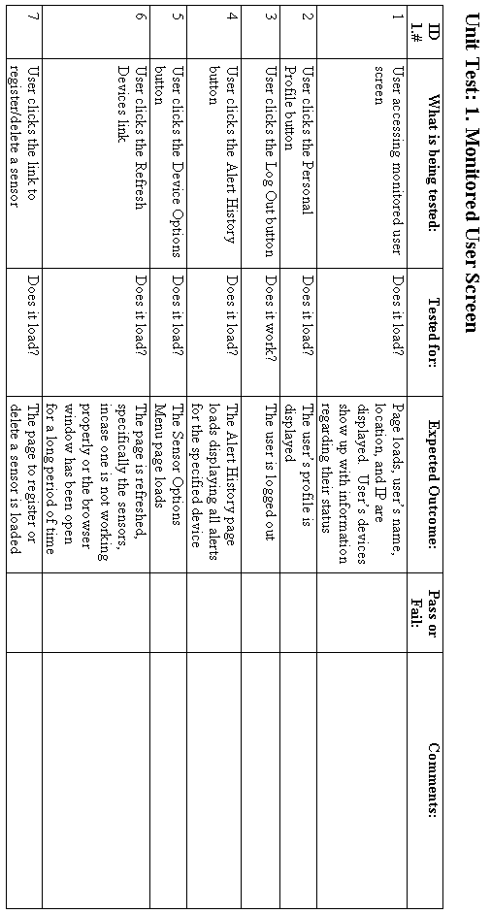

3. Appendices

3.1 Gantt Chart

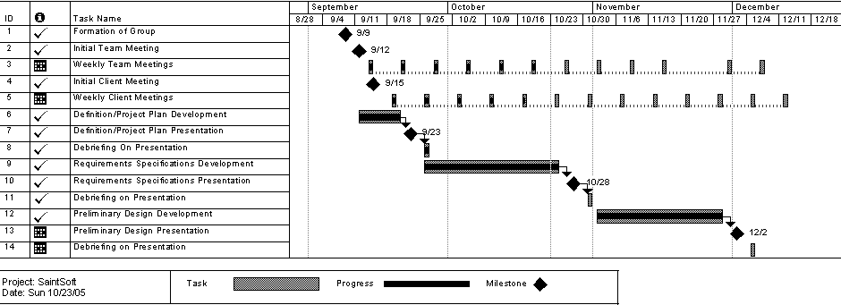

Glossary of Terms
Apache- Apache is an open source web server that runs on most commonly used platforms

Database – A collection of data arranged for ease and speed of search and retrieval.

Gantt Chart: A chart that depicts progress in relation to time, often used in planning and tracking a project.

IP Address – Each machine connected to the Internet has an address known as an Internet Protocol address that takes the form of four numbers separated by dots, for example: 123.45.67.890.

MySql- An open source relational database management system (RDBMS) that uses Structured Query Language (SQL), the most popular language for adding, accessing, and processing data in a database.

Oracle - a relational database management system (RDBMS) developed and copyrighted by the Oracle Corporation.

PHP- The PHP Hypertext Preprocessor is a programming language that allows web developers to create dynamic content that interacts with databases.

Remote User - A registered user who is accessing the system from a computer that doesn’t have any devices attached to it. This user is able to view the information from other sensors, but can not change information or settings for those sensors. The user, however, is able to add new devices to their account.

Sensored User - A user accessing the system from a computer in which at least one device is registered. This type of user is able to view information pertaining to their sensors as well as make changes to the sensors specific to that computer. The user is able to add or remove sensors from their account.

Website Administrator – User that oversees the web based system, performing maintenance as needed, and also has the ability to make specified changes to other user accounts and devices.

