Acceptance Test

Requested By: Mr. Ken Swarner
Systems Administrator
Computer Science Department of Siena College

Dr. Tim Lederman
Professor of Computer Science
Computer Science Department of Siena College

Environmental Monitoring System

SaintSoft

Prepared By: David Moore – Team Leader

Daniel Schuldt
Hannah Palmer
Christian Damberg

Lioubov Mikhailova

Tina Ting

May 1, 2006

Table Of Contents

1. Product Overview and Summary 3

2. Deliverables 3

3. External Interfaces 4

4. User Command Summary 19

5. Testing Requirements 23

6. Testing Forms 27

7. Source Code File Listing 59

8. How To Use the System 62

9. Environmental Constraints/Specs 62

10. Appendices 63
10.1 Glossary of Terms 63
10.2 Gantt Chart 64

1. Product Overview and Summary

The Environmental Monitoring System is a software package that will allow for the monitoring of many different aspects in numerous user-specified locations. The software is designed to obtain information from specified devices that will be registered to the system. The user will set thresholds specific to each sensor and upon the triggering of those thresholds, the system will notify the user of the alert. Overall, the Environmental Monitoring System will allow for a secure and convenient way to oversee the safety of an office, home or any other location that can be monitored.

2. Deliverables

The deliverables for the Environmental Monitoring System include a compact disk including a copy of the Acceptance Test document in addition to the previous documents, the team website as well as the project website. Also included in the deliverables is a hard copy of the Acceptance Test document.

3. External Interfaces

Login Screen

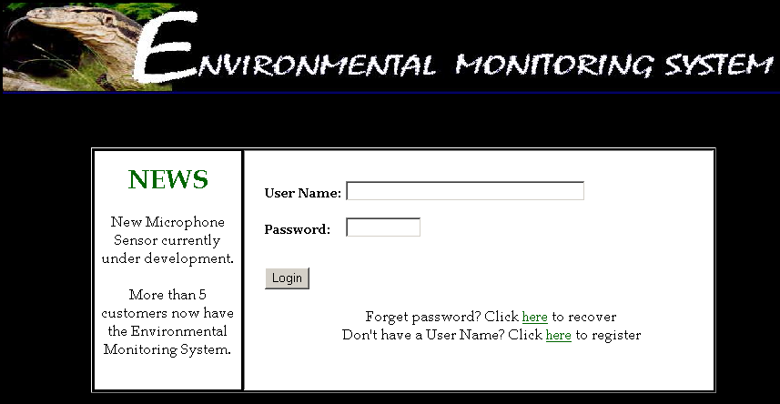

The login screen allows a new user to create an account, a registered user to login using their user name (registered e-mail address) and password or to retrieve a lost password.

New User Registration Screen (1)

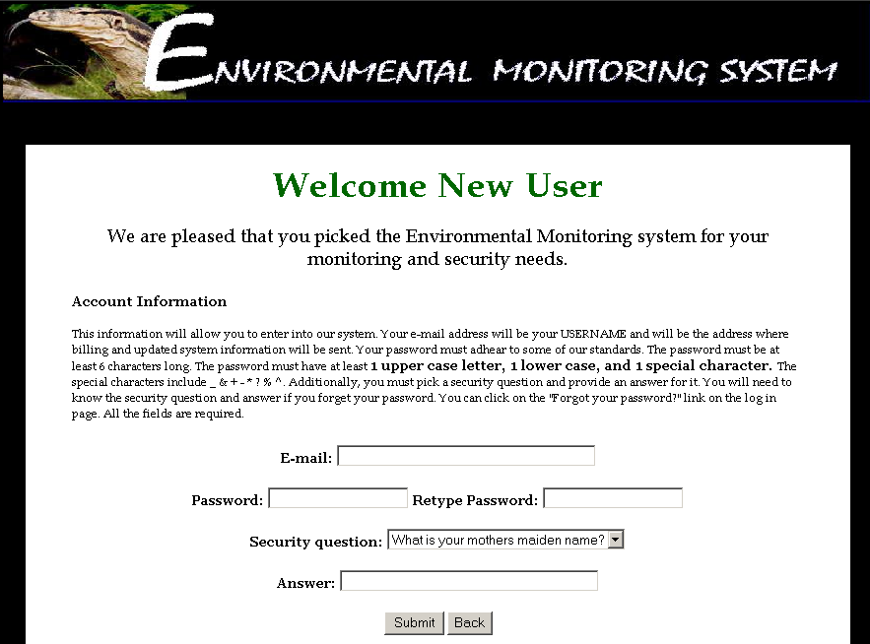

The New User Registration Screen allows the user to begin the registration process by choosing a user name (e-mail address), password and security questions.

New User Registration Screen (2)

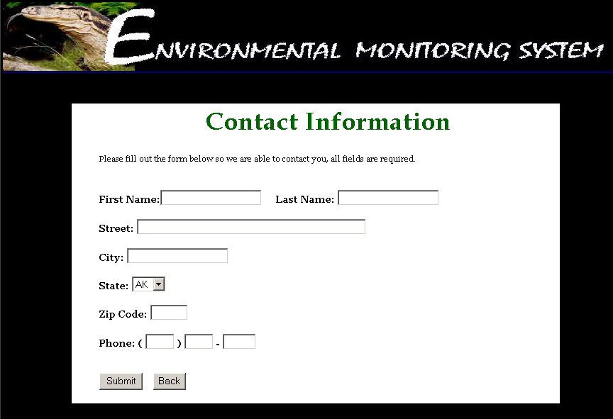

The New User Register Screen (2) prompts the user for personal contact information to be used for records and for emergency contact.

Password Recovery Screen

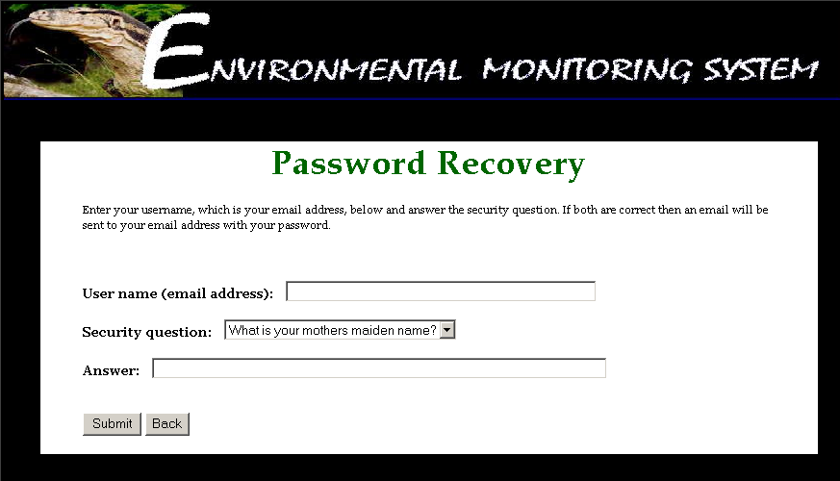

The Password Recovery Screen allows the user to reset their password in the event that it is lost or forgotten. The system prompts the user of their user name (e-mail address), asks them to select the security question chosen during the registration process and provide the corresponding answer.

User Welcome Screen

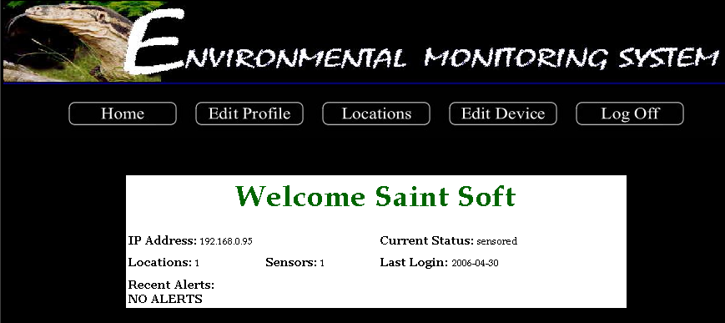

The User Welcome Screen provides the user specific information regarding their account upon login.

Remote User Location Screen

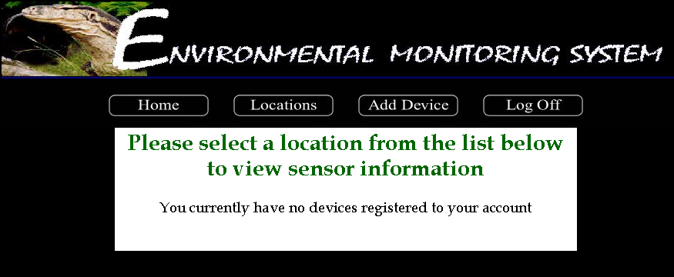

When a Remote User attempts to view any registered sensors on the account, this screen appears to inform the user that there aren’t any registered devices on the account.

Add Device Screen

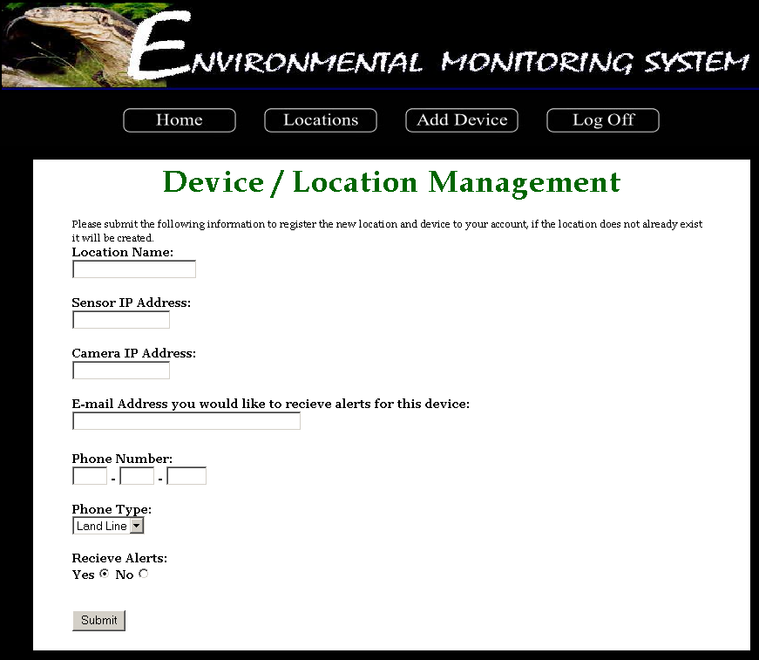

The Add Device Screen allows a Remote User to add a device to their account. The system prompts the user for sensor specific information as well as alert information.

Sensored User Location Screen

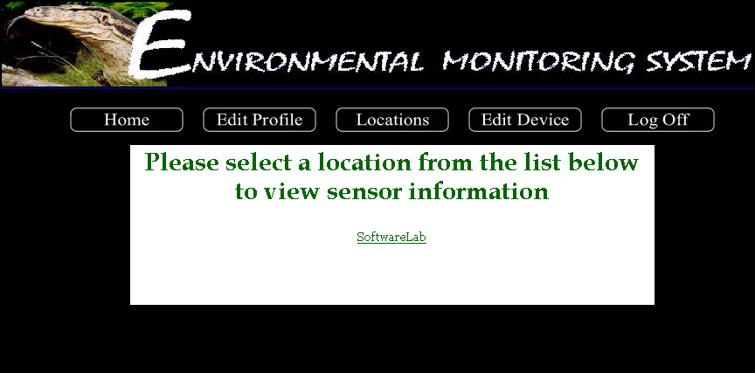

Viewing the location screen as a Sensored User allows the user to view all of the sensors that are registered to the account and choose which sensors they want to view the details of.

Device Screen

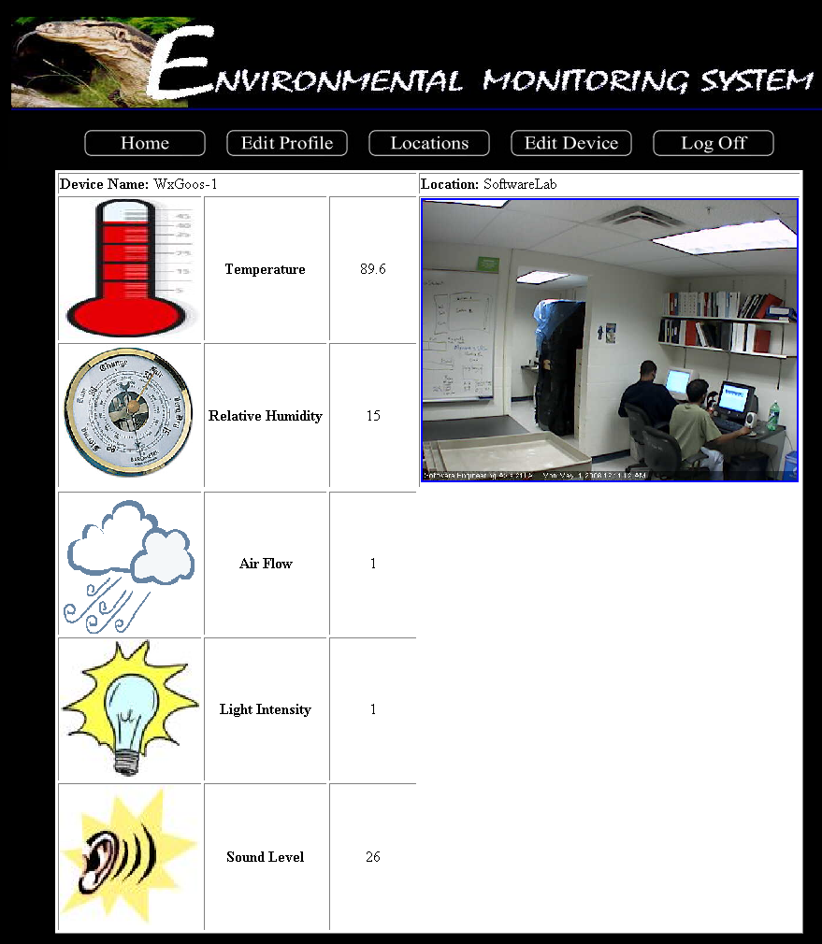

The Device Screen displays the readings for each sensor and allows the user to view the current status of each of their registered sensors individually.

Edit Profile Screen

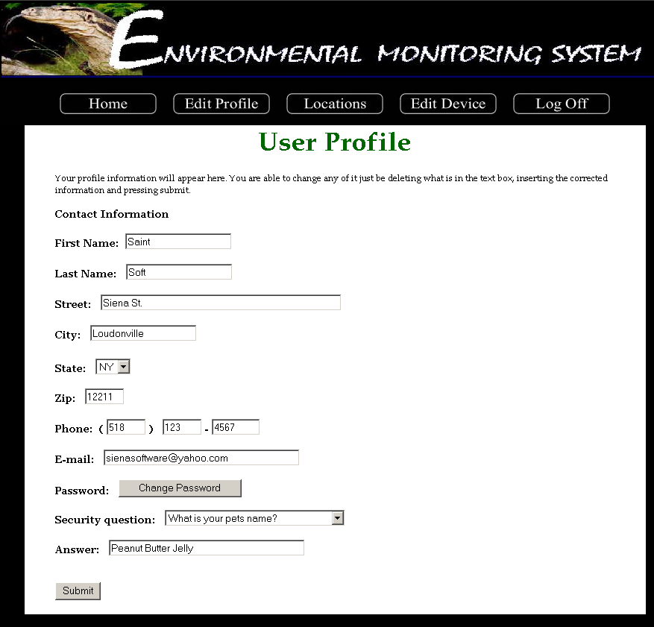

The Edit Profile Screen displays the information entered during the registration process and allows a Sensored User to change any of the information.

Edit Device Screen

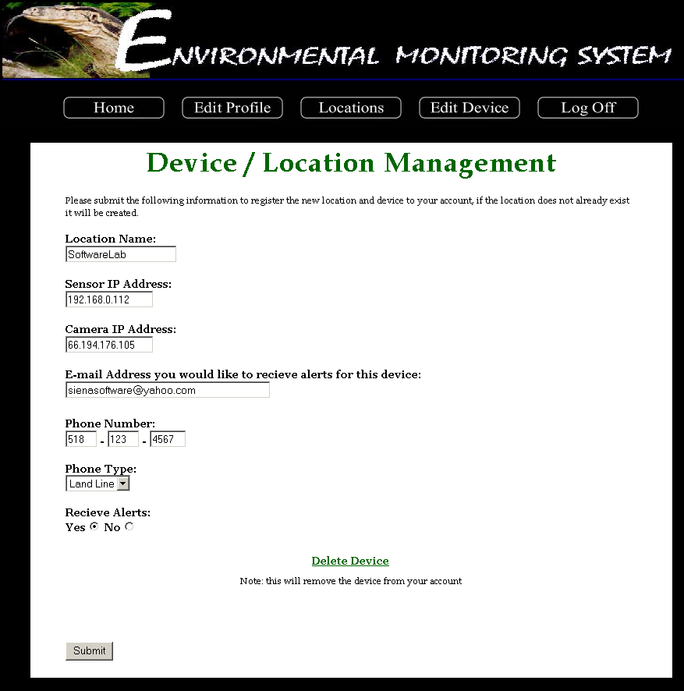

The Edit Device Screen allows a Sensored User to change any of the information specific to any of their registered devices/sensors as well as the information stored for alert contacts. The screen also allows the user to remove a device from their account.

Administrator Welcome Screen

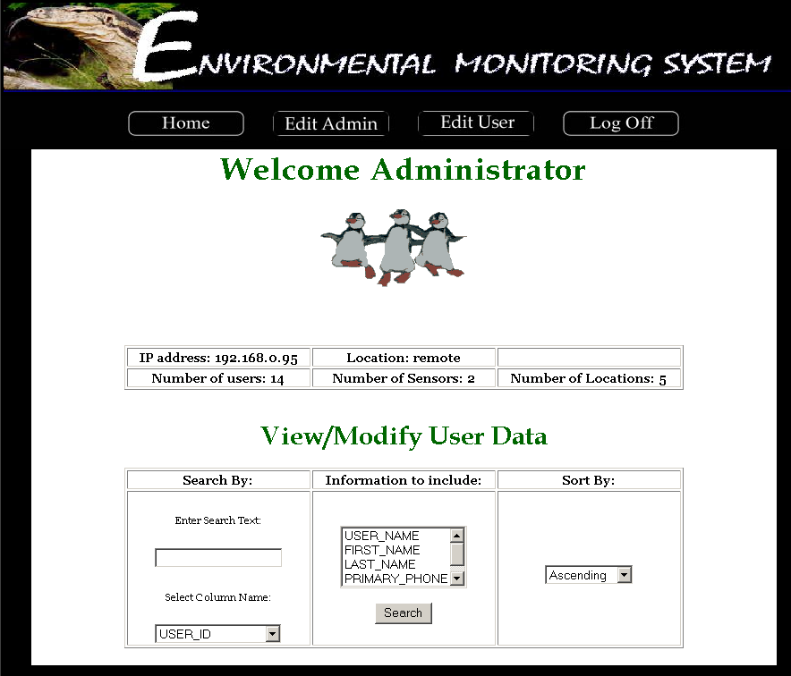

The Administrator Welcome Screen displays information regarding the status of the system including the Administrators IP address and location as well as statistical readings concerning the number of users, sensors and locations. The Welcome Screen also allows the Administrator to query the database of users.

Query Results Screen

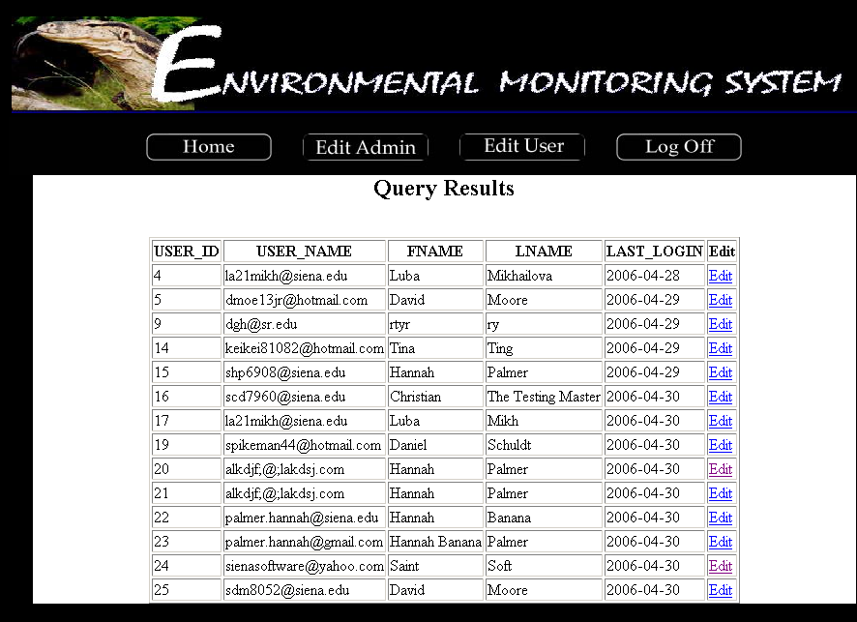

The Query Results Screen allows the Administrator to view the results of a database query as specified by the Administrator on the previous screen. From this point, the Administrator can choose a user to edit information for.

Administrator Edit User Screen

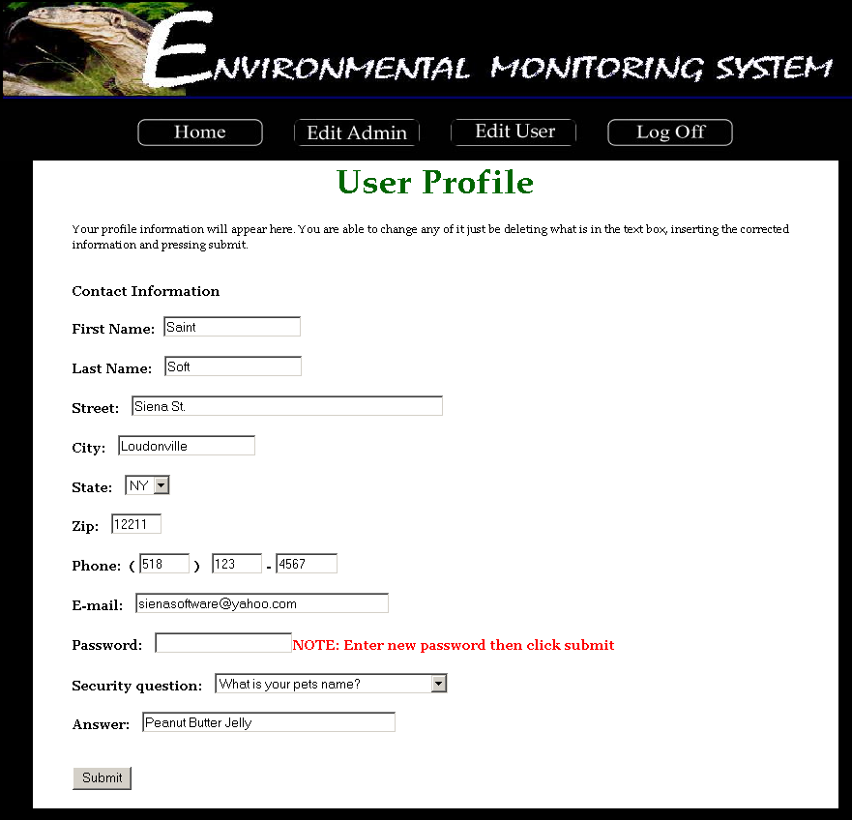

The Administrator Edit User Screen allows for any change of information including password that may need to be edited by the Administrator.

Administrator Edit Screen

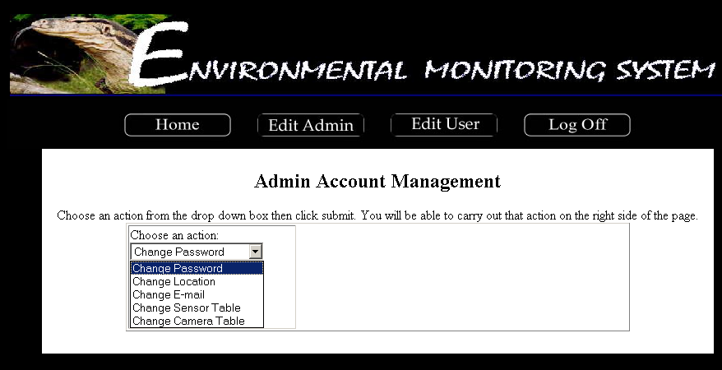

This screen allows the Administrator to choose information regarding the Admin account in which they want to change.

Edit User Screen

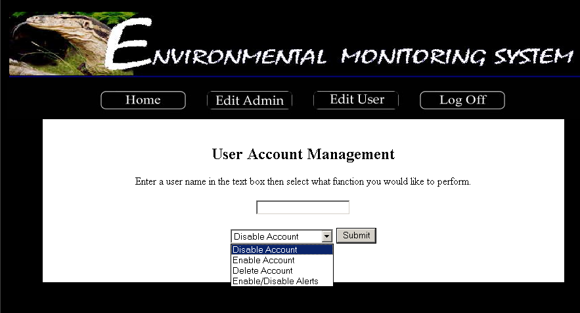

The Edit User Screen allows the Administrator to grant permissions to specific users accounts if ever the system/sensors encounter a problem.

4. User Command Summary

Login Screen:
The Login Screen is the first screen that a user is faced with upon access to the system. This screen contains a section in which current news is displayed. Such news could include upgrades to the system, new sensors available to users or a simple system status. The screen also contains two entry fields. The first field is for the user name, the second for the user’s password. Upon correctly completing the specified information, the user is then directed to the corresponding user welcome screen. The initial login screen also provides the user with two links. The first link allows the user to retrieve a lost password. Upon clicking the link, the user is directed to the password recover screen. The second link allows a new user to create a new account and when clicked, directs the user to the first register screen.

New User Registration Screen (Account Information):
This screen is the first of two screens that the user must complete during the registration process. The First Registration Screen contains five entry fields. The user is first provided with a summary of the screen, informing them of the rules and restrictions applying to the information the user must supply. The first entry field is the E-mail field. The user is given notice that this e-mail address will serve as the username from that point on. The second entry field prompts the user for a password to associate with the account. The user is then able to enter a password that must meet the specified restrictions in order to be considered valid. The third entry field prompts the user to re-enter the password for verification. The fourth field is a drop down menu that provides the user with a list of possible security questions and the fourth entry field provides the user to enter an answer to the selected security question. As described in the summary at the top of the screen, the user is to choose a security question that will be used in the future for password recovery purposes. When all fields are complete the user can click the “Submit” button to submit the information to the system. Upon the submission of information, the user is directed to the next screen prompting the user for information, the Second Registration Screen. At any time during the process the user is able to click on the “Back” button to return to the initial Login Screen.

New User Second Registration Screen (Contact Information):
The Second Register Screen is accessed from the previous register screen. This screen provides the user with nine entry fields. The user is then prompted for their personal information. The first and second entry fields allow the user to enter their First Name and Last Name respectively. The user is then prompted for the address, Street, City, State and Zip Code in the third, fourth, fifth and sixth entry fields respectively. The seventh, eighth and ninth entry fields prompts the user for a telephone number for contact purposes. When the user has completed the requested information the “Submit” button can be clicked, submitting the information to the system. Upon submission, the user is directed to the User Welcome Screen. At any time in the process, the user can click on the “Back” button to go to the previous page.

Password Recovery Screen:
The Password Recover Screen allows a user to retrieve a lost or forgotten password. This screen contains three fields. After being directed to this screen from the Login Screen, the user is prompted for the user name (e-mail address) in the first entry field. In addition, the user must select a security question from a drop down menu and provide the correct answer to that question in the last entry field. The information is entered into the system when the user clicks the provided submit button. Both the question and answer must match those specified by the user during the registration process. Upon confirmation of both the question and answer, the user will receive message confirming the delivery of the user’s password to the specified e-mail address. At anytime during the password recovery process the user can click on the “Back” button to return to the initial Login Screen.

User Welcome Screen:
The user is directed to this screen upon the completion of the registration process, after logging in or by clicking on the “Home” button on the top navigation bar. The User Welcome Screen provides the user with a welcome message as well as the current IP address of the computer in which the user is accessing the system. If this IP address is recognized by the system, the screen will also display the status specific to that IP address; either remote or sensored. The system displays a number of statistics for the user including the number of locations and sensors registered to the account, the last time the account was logged on as well as any recent alerts that any registered sensors my have triggered. If the user has no sensors registered to their account, the user has two options, view current sensor “locations” (which will indicate that there are no sensors registered to the account) and “add a device”. If the user is a sensored user and has sensors registered to the account, they are able to “edit profile”, view “locations” or “edit device”.

Remote User Location Screen:
The Location Screen is intended to show the user the various sensors they have registered at various locations. Since the Remote User doesn’t have any devices registered, they will see a screen informing them that they have no devices.

Add Device Screen:
The Register Sensors Screen, first, provides the user with a brief explanation of the screen and its functionality. The Screen has seven entry fields in which the user must complete in order to register a sensor to their computer. The first of the three prompts the user for the location name that will be associated with the sensor. The second and third fields prompt the user for the IP addresses associated with the sensor and camera. The next two sets of entry fields allow for the user to enter information for future alerts. The fourth field prompts the user for the e-mail address associated with the sensor, while the fifth, sixth and seventh fields will contain the user’s telephone number. The system then prompts the user to specify whether the provided telephone number is a land line or cellular phone. Upon completion of the fields, the user can click the “Submit” button, submitting the information to the system. Upon the submission of information the user is directed to the User Location Screen. At any time during the process, the user is able to click on the “Back” button to return to the previous page.

Sensored User Location Screen:
The Sensored User Location Screen allows for the devices registered to one’s account to be displayed for user interaction. A Sensored User will have at least one location available for viewing. Each location will be provided as a link, and upon choosing a location, the user will be directed to the page specific to that sensor.

Device Screen:
The device screen shows a Sensored User a specific device along with all of the readings that apply to that device. If a camera is registered to the account, a still image will be displayed until the image is clicked when a live feed will begin. In addition, each of the individual sensors of a device will show the output for each sensor.

Edit Profile Screen:
The Edit Profile Screen is accessed through the “Edit Profile” button on the top navigation bar. The screen allows the user to view and/or change any of the given information including name, address, phone number, e-mail address, password, and security question. By clicking the “Submit” button, the user can submit all (if any) changes made to the information. Upon submitting the new information, the user remains on the Edit Profile Screen to view the changes made.

Edit Device Screen:
The Edit Device Screen is accessed through the “Edit Device” button on the top navigation bar. The screen allows the user to view and/or change any of the given information including location, sensor IP address, camera IP address, contact e-mail and phone number. At this point, the user is able to delete the specified device from the account if desired. By clicking the “Submit” button, the user can submit all (if any) changes made to the information. Upon submitting the new information, the user remains on the Edit Device Screen to view the changes made.

Administrator Screen:
The Administrator Screen is accessed from the login screen only after entering a special username and password. From this point, the Administrator is faced with a welcome screen that displays the current IP Address of the computer accessing the system as well as the location status (sensored or remote) of that computer. The user is also provided with a set of statistics specific to the system, including the number of users, the number of sensors, the number of locations within the system. The user is provided with a section in which the database containing user and sensor information can be searched.
The Administrator is provided with two additional buttons on the top navigation bar; Edit Admin and Edit User. These two buttons will allow the Administrator to Edit information specific to their account as well as information that pertains to the users within the system.

Query Result Screen:
The Query Result Screen is accessed after the Administrator submits a query into the system. The user is provided with a screen displaying the information requested (username, sensor, alerts, name, date, etc) in the order requested (ascending, descending). At the end of each line the user is able to select any of the query results to make changes to those accounts. To do so, the user selects a query result followed by the “Edit” link. This action will direct the user to a screen allowing the Administrator to edit the user information. By clicking the “Submit” button, the user can submit all (if any) changes made to the information.

Administrator Edit User Screen:
The Administrator reaches this screen after choosing the “Edit” link on the Query User Page. The screen allows the Administrator to view and/or change any of the given information for a user including name, address, phone number, e-mail address, password, and security question. By clicking the “Submit” button, the user can submit all (if any) changes made to the information. Upon submitting the new information, the user remains on the Edit Profile Screen to view the changes made.

Administrator Edit Screen:
The Administrator Edit Screen allows the user to change a number of different pieces of information within the system. The Administrator is able to choose from a number of options, including: Change Password, Change Location, Change E-mail, Change Sensor Table, and Change Camera Table. Each of these aspects can be changed by selecting the option and entering the pertaining information.

Edit User Screen:
The Edit User Screen allows the Administrator to give permissions regarding user accounts. If for any reason the Administrator needs to disable, enable or delete an account or disable/enable alerts, the user can perform these actions here. By entering the user name associated with the account in question, the Administrator can quickly and easily make such changes.

5. Testing Requirements
The testing process of the development cycle for the software package can be considered one of the most important phases. Once the project has passed the design stage, thoroughly testing the system in order to correct any design flaws that were previously overlooked is of utmost importance.
The Environmental Monitoring System is intended to provide functionability for three different types of users; remote user, sensored user and the system administrator. The following functional requirements will be tested to ensure full functionability and quality of the final software package.

- Sensored User
1. Log in screen
- allow the user to log in
- give the user an retrieve their password if they forget it
- allow the user to register if they are a new user
- display recent news on the screen

2. New User Registration screen
- allow the user to fill in all informational fields
- allow the user to submit their information
- allow the user to go back to the previous page

3. Contact Information screen
- allow the user to fill in all informational fields
- allow the user to submit their information
- allow the user to go back to the previous page
4. Sensored User Home screen
- automatically display the user’s location and IP address
- allow the user add a device
- allow the user go to the home page
- allow the user view their profile
- allow the user refresh the page with the refresh button
- allow the user log out

5. Add Device screen
- automatically display the user’s location and IP address
- allow the user to fill in all informational fields
- allow the user to submit their information
- allow the user to go back to the previous page

6. User Home screen
- display a welcome message
- automatically display the user’s location and IP address

7. Edit Device screen
- display the proper information for the specific type of device
- allow the user to fill in all informational fields
- allow the user to delete the device from account
- allow the user to submit their information

- Delete Button clicked
- allow the user to delete a device

- Edit Profile Screen
- allow the user to fill in all informational fields
- automatically display the user’s default email and phone number
- allow the user to change the default notification
- allow the user to submit their information

10. Refresh Button clicked
- allow the user to refresh all the devices

- Log Out Button clicked
- allow the user to log out of the system

2. Remote User

1. Remote User Home screen
- automatically display the user’s location and IP address
- allow the user to refresh the page
- allow the user to add a device
- allow the user to log out

2. Add Device screen
- automatically display the user’s location and IP address
- allow the user to fill in all informational fields
- allow the user to submit their information
- if the user clicks submit, they become a Sensored user
- allow the user to go back to the previous page

3. Log Out button clicked
- allow the user to log out of the system

3. Administrator

1. Administrator Home screen
- display a welcome message
- automatically display the admin’s location and IP address
- display the statistics of the system
- allow the admin to perform a query of the database
- allow the admin to select search criteria for query
- allow the admin to change his/her location
- allow the admin to refresh the page
- allow the admin to change his/her email
- allow the admin to change his/her password
- allow the admin to log off
- allow the admin to delete a user account
- allow the admin to deactivate a user account
- allow the admin to disable and/or enable a sensor
- allow the admin to activate a user account

2. Query Results screen
- display the results with the correct fields
- sort the results
- allow each column to be sorted
- allow the admin to modify a user’s profile information
- allow the admin to go back to the previous page

3. User Profile Screen
- allow the admin to fill in all informational fields
- automatically display the user’s default email and phone number
- allow the admin to change the default notification
- allow the admin to submit the user’s information

4. Admin Location Screen
- automatically display the administrator’s IP address
- allow the admin to edit the location text box
- allow the admin to submit their information
- allow the admin to go back to the previous page

5. Refresh Button clicked
- allow the admin to refresh all the devices

6. Change Email Screen
- allow the admin to fill in all informational fields
- allow the admin to submit their information
- if the admin clicks submit, their email address will change
- allow the admin to go back to the previous page

7. Change Password Screen
- allow the admin to fill in all informational fields
- allow the admin to submit their information
- if the admin clicks submit, their password will change
- allow the admin to go back to the previous page

8. Log Out button clicked
- allow the admin to log out of the system

9. Delete Account Button clicked
- allow the admin to delete a user’s account

10. Deactivate Account Button clicked
- allow the admin to deactivate a user’s account

11. Disable/Enable Sensor Screen
- display the correct user name
- display the correct sensors
- allow the admin to enable and/or disable the devices
- allow the admin to submit their information
- allow the admin to go back to the previous page

12. Activate Button clicked
- allow the admin to activate a user’s account

6. Testing Forms

1. Remote User
ID  1.# | What is being tested: | Tested for: | Expected Outcome: | Pass or Fail: | Comments:
1 | User accessing Login Screen | Does it load? | Page loads, News display on the left hand side, user get prompt to log in with their user name and password, if the user forgot their password they can click the on the link to recover, and if the user did not register yet, they can click on the link to register | Pass | Page loads normally, everything that we expect shows on this page
2 | User click on password recovery link | Does it load? | The password recovery page display | Pass | Page load normally
3 | User click on register link | Does it load? | The register page display | Pass | Page load normally
4 | User input their user name and password then click login | Does it process? | The welcome page will display | Pass | Page load normally
5 | User input an invalid user name during login | Does it load? | A warning should display to tell user that the e-mail address or password is incorrect. Please retype the e-mail address and password, or register. | Pass | A warning message display
6 | User input an invalid password during login | Does it load? | A warning message should display to tell user that the e-mail address or password is incorrect. Please retype the e-mail address and password, or register. | Pass | A warning message display

Unit Test: 1.1 Login Screen

Unit Test: 1.2 Register Page Screen

ID  2.# | What is being tested: | Tested for: | Expected Outcome: | Pass of Fail: | Comments:
1 | User accessing the register screen | Does it load? | Page loads, a direction of how to register will display and prompt the user to input their information. | Pass | Page loads normally, it displays everything that we expect
2 | User enter information but have the email column left out | Does the page show a warning to user and stop processing the register information? | The register page will load and show that user have to enter an email address | Pass | Page reload with a warning of the user have to input their email address in order to register
3 | User input information without typing in their password | Does the page show a warning to user and stop processing the register information? | The register page will be reload and show a warning message to user that they have to enter a password | Pass | Page reload with warning of the user have to input their password
4 | User input information without re-typing in their password | Does the page show a warning to user and stop processing the register information? | The register page will be reload and show a warning message of password does not match | Pass | Page reload with a warning of the user does not have a matching password
5 | User input information without answering the security question “What is your mother maiden name” | Does the page show a warning to user and stop processing the register information? | The register page will be reload and show that the user need to answer the security question | Pass | Page load with a warning of the user need to answer the security question
6 | User input information without answering the security question “What is your pet’s name” | Does the page show a warning to user and stop processing the register information? | The register page will be reload and show that the user need to answer the security question | Pass | Page load with a warning of the user need to answer the security question
7 | User input information without answering the security question “Where were you born” | Does the page show a warning to user and stop processing the register information? | The register page will be reload and show that the user need to answer the security question | Pass | Page load with a warning of the user need to answer the security question
8 | User input information without answering the security question “What is your brothers name” | Does the page show a warning to user and stop processing the register information? | The register page will be reload and show that the user need to answer the security question | Pass | Page load with a warning of the user need to answer the security question
9 | User input their password without following the instruction (input all uppercase letter) | Does the page show a warning to user and stop processing the register information? | The register page will be reload and show that the user need to type in a password that match with our requirement | Pass | Page load with a warning message of user password does not follow rules
10 | User input their password without following the instruction (input all lowercase letter) | Does the page show a warning to user and stop processing the register information? | The register page will be reload and show that the user need to type in a password that match with our requirement | Pass | Page load with a warning message of user password does not follow rules
11 | User input their email without following the instruction (input without a special character) | Does the page show a warning to user and stop processing the register information? | The register page will be reload and show that the user need to type in a email address that match with our requirement | Pass | Page load with a warning message of user password does not follow rules
12 | User input their password without following the instruction (password that have less than 6 characters) | Does the page show a warning to user and stop processing the register information? | The register page will be reload and show that the user need to type in a password that match with our requirement | Pass | Page load with a warning message of user password does not follow rules
13 | User input all the information and clicks the submit button | Does it process? | The register process continue with the contact information page display | Pass | Page load normally
14 | User click on the back button | Does it load? | The login page will be display | Pass

ID  3.# | What is being tested: | Tested for: | Expected Outcome: | Pass or Fail: | Comments:
1 | User accessing contact information screen | Does it load? | Page loads, user prompt to fill in their contact information | Pass | Page loads normally
2 | User input information without filling in their first name | Does it stop the process and warn user? | Page should display a warning message that user did not input their first name | Pass | Page display a warning message of user need to enter their first name
3 | User input information without filling in their last name | Does it stop the process and warn user? | Page should display a warning message that user did not input their last name | Pass | Page display a warning message of user need to enter their last name
4 | User input information without filling in the street name | Does it stop the process and warn user? | Page should display a warning message that user did not input their street name | Pass | Page display a warning message of user need to enter a street
5 | User input information without filling in the city name | Does it stop the process and warn user? | Page should display a warning message that user did not input their city name | Pass | Page display a warning message of user need to enter a city
6 | User input information without filling in the phone number | Does it stop the process and warn user? | Page should display a warning message that user did not input their phone number | Pass | Page display a warning message of user need to enter a phone number
7 | User click on the submit button | Does it process? | Welcome page should display | Pass | Page display normally
8 | User click on the back button | Does it work? | It will bring user back to the register page | Pass
Unit Test: 1.3 Contact information screen

ID  4.# | What is being tested: | Tested for: | Expected Outcome: | Pass or Fail: | Comments:
1 | User accessing Password recover screen | Does it load? | Page loads, it should prompt user to input their email address, security question, and answer for the security question to recover their password | Pass | Page loads normally, everything that we expect loads on the page
2 | User input information without entering their email address | Does it stop the process and display a warning message? | Page should display a warning message of user did not enter a email address | Pass
3 | User input information without entering their security answer | Does it stop the process and display a warning message? | Page should display a warning message of user did not enter an answer for the security question | Pass
4 | User clicks on the Submit button | Does it process? | A page should display with a message that let user know their password is send to their email | Pass
5 | User clicks on the Back button | Does it work? | It should bring user back to the login page | Pass | Login page display
Unit Test: 1.4 Password recovery screen
Unit Test: 1.5 Welcome Screen (Remote User)

ID  5.# | What is being tested: | Tested for: | Expected Outcome: | Pass or Fail: | Comments:
1 | User accessing Welcome screen | Does it load? | Page loads and it will display user name, IP address, current status, number of locations, sensors, and the last login date | Pass | Page displays every information that we expect
2 | User clicks on the Home button | Does it work? | Welcome page will display | Pass | Page loads normally
3 | User clicks on the Location button | Does it work? | Location page will display | Pass | Page loads normally
4 | User clicks on the Add Device button | Does it work? | Add Device page will display | Pass | Page loads normally
5 | User clicks on the Log Off button | Does it work? | User will log out of the system and the login page will display | Pass | User log out and log in page display

Unit Test: 1.6 Add Device Screen
ID  6.# | What is being tested: | Tested for: | Expected Outcome: | Pass or Fail: | Comments:
1 | User accessing the Add Device screen | Does it load? | Page loads and prompt user to input information | Pass | Page loads, everything that we expected display normally
2 | User clicks on the Home button | Does it work? | Welcome page display | Pass | Page display
3 | User clicks on the Location button | Does it work? | Location page display | Pass | Page display
4 | User clicks on the Add Device button | Does it work? | Add Device page display | Pass | Page display
5 | User clicks on the Log Off button | Does it work? | User will log out and log in page will display | Pass | User log out and log in page display
6 | User input information without entering a location for the device | Does it stop the process and display a warning message? | Process stops and it should display a warning message to tell user to enter a location | Pass | Warning message display
7 | User input information without entering a IP address for sensor | Does it stop the process and display a warning message? | Process stops and it should display a warning message to tell user to enter a IP address | Pass | Warning message display
8 | User input information without entering a IP address for camera | Does it process? | Information will get process and a page will display that user successfully add a device | Pass | Page display
9 | User input information without entering a email address | Does it stop the process and display a warning message? | Process stops and it should display a warning message to tell user to enter a email address | Pass | Warning message display
10 | User input information without entering a phone number | Does it stop the process and display a warning message? | Process stops and it should display a warning message to tell user to enter a valid phone number | Pass | Warning message display
11 | User clicks submit button with all the information fill in | Does it work? | Information will get process and a page will display that user successfully add a device | Pass | Page display
Unit Test: 1.7 Location Screen

ID  7.# | What is being tested: | Tested for: | Expected Outcome: | Pass or Fail: | Comments:
1 | User accessing Location screen | Does it load? | Page loads, it display sensor location information, if user does not have their device added, it will tell user that they do not have a device added yet | Pass | Page display all the information that we expect
2 | User clicks on the Home button | Dose it work? | Welcome page display | Pass | Welcome page display
3 | User clicks on the Location button | Does it work? | Location page display, if user added a device already, it will display the name of the location, if not it will display that user did not add a device yet | Pass | Location page display
4 | User clicks on the Add Device button | Does it work? | The Device/ Location Management page will display with information | Pass | Page loads with information
6 | User clicks on the Log Off button | Does it work? | User get log off and the log in page will display | Pass | User get log off and the log in page display
7 | User clicks on the location link | Does it work? | A page will display all the information for the device | Pass | Page display

Unit Test: 1.8 Device Information Screen

ID  8.# | What is being tested: | Tested for: | Expected Outcome: | Pass or Fail: | Comments:
1 | User accessing Device Information Screen | Does it load? | Page loads with all the device information | Pass | Page display with all the information that we expect
2 | User clicks on the Home button | Does it work? | Welcome page display | Pass | Page display
3 | User clicks on the Edit Profile button | Does it work? | User Profile page display | Pass | Page display
4 | User clicks on the Location button | Does it work? | The Location page display, if user have added a device, it will show the location of the device, otherwise it will show that user have not add a device yet | Pass | Page display with information
5 | User clicks on the Edit Device button | Does it work? | The Device/ Location Management page display with information | Pass | Page display with information
6 | User clicks on the Log Off | Does it work? | User will get log off and the log in page will display | Pass | User get log off and the log in page display

ID  9.# | What is being tested: | Tested for: | Expected Outcome: | Pass or Fail: | Comments:
1 | User accessing the Password reset screen | Does it load? | Page loads, it will prompt user to enter their old password, new password and re-type the new password | Pass | Page display
2 | User clicks on the Home button | Does it work? | Welcome page display | Pass | Page display
3 | User clicks on the Edit Profile button | Does it work? | Edit Profile page will display | Pass | Page display
4 | User clicks on the Location button | Does it work? | Location page will display, if the user has a device added, it will display the location, if not it will show user that they do not have a device added yet | Pass | Location page display with information
5 | User clicks on the Edit Device button | Does it work? | The Device/Location management page will display with information | Pass | Page display with information
6 | User clicks on the Log Off button | Does it work? | User will log off and Log in page will display | Pass | User log off and log in page display
7 | User input information without entering the old password | Does it stop the process and display a warning message? | A warning message will display to tell user to enter their old password | Pass | Warning message display
8 | User input information without entering the new password | Does it stop the process and display a warning message? | A warning message will display to tell user to enter their new password | Pass | Warning message display
9 | User input information without retyping their new password | Does it stop the process and display a warning message? | A warning message will display to tell user the password does not match | Pass | Warning message display
10 | User click on the submit button after fill out all the information | Does it process? | The Edit Profile page will display with a message to tell user that their password is successfully reset and sent it to their email address | Pass | Page display with message
11 | User click on the back button | Does it work? | The Edit Profile page will display | Pass | Page display

Unit Test: 1.9 Password reset screen

2. Sensored User

ID  1.# | What is being tested: | Tested for: | Expected Outcome: | Pass or Fail: | Comments:
1 | User accessing Login Screen | Does it load? | Page loads, News display on the left hand side, user get prompt to log in with their user name and password, if the user forgot their password they can click the on the link to recover, and if the user did not register yet, they can click on the link to register | Pass | Page loads normally, everything that we expect shows on this page
2 | User click on password recovery link | Does it load? | The password recovery page display | Pass | Page load normally
3 | User click on register link | Does it load? | The register page display | Pass | Page load normally
4 | User input their user name and password then click login | Does it process? | The welcome page will display | Pass | Page load normally
5 | User input an invalid user name during login | Does it load? | A warning should display to tell user that the e-mail address or password is incorrect. Please retype the e-mail address and password, or register. | Pass | A warning message display
6 | User input an invalid password during login | Does it load? | A warning message should display to tell user that the e-mail address or password is incorrect. Please retype the e-mail address and password, or register. | Pass | A warning message display
Unit Test: 2.1 Login Screen

Unit Test: 2.2 Register Page Screen

ID  2.# | What is being tested: | Tested for: | Expected Outcome: | Pass of Fail: | Comments:
1 | User accessing the register screen | Dose it load? | Page loads, a direction of how to register will display and prompt the user to input their information. | Pass | Page loads normally, it displays everything that we expect
2 | User enter information but have the email column left out | Does the page show a warning to user and stop processing the register information? | The register page will load and show that user have to enter an email address | Pass | Page reload with a warning of the user have to input their email address in order to register
3 | User input information without typing in their password | Does the page show a warning to user and stop processing the register information? | The register page will be reload and show a warning message to user that they have to enter a password | Pass | Page reload with warning of the user have to input their password
4 | User input information without re-typing in their password | Does the page show a warning to user and stop processing the register information? | The register page will be reload and show a warning message of password does not match | Pass | Page reload with a warning of the user does not have a matching password
5 | User input information without answering the security question “What is your mother maiden name” | Does the page show a warning to user and stop processing the register information? | The register page will be reload and show that the user need to answer the security question | Pass | Page load with a warning of the user need to answer the security question
6 | User input information without answering the security question “What is your pet’s name” | Does the page show a warning to user and stop processing the register information? | The register page will be reload and show that the user need to answer the security question | Pass | Page load with a warning of the user need to answer the security question
7 | User input information without answering the security question “Where were you born” | Does the page show a warning to user and stop processing the register information? | The register page will be reload and show that the user need to answer the security question | Pass | Page load with a warning of the user need to answer the security question
8 | User input information without answering the security question “What is your brothers name” | Does the page show a warning to user and stop processing the register information? | The register page will be reload and show that the user need to answer the security question | Pass | Page load with a warning of the user need to answer the security question
9 | User input their password without following the instruction (input all uppercase letter) | Does the page show a warning to user and stop processing the register information? | The register page will be reload and show that the user need to type in a password that match with our requirement | Pass | Page load with a warning message of user password does not follow rules
10 | User input their password without following the instruction (input all lowercase letter) | Does the page show a warning to user and stop processing the register information? | The register page will be reload and show that the user need to type in a password that match with our requirement | Pass | Page load with a warning message of user password does not follow rules
11 | User input their email without following the instruction (input without a special character) | Does the page show a warning to user and stop processing the register information? | The register page will be reload and show that the user need to type in a email address that match with our requirement | Pass | Page load with a warning message of user password does not follow rules
12 | User input their password without following the instruction (password that have less than 6 characters) | Does the page show a warning to user and stop processing the register information? | The register page will be reload and show that the user need to type in a password that match with our requirement | Pass | Page load with a warning message of user password does not follow rules
13 | User input all the information and clicks the submit button | Does it process? | The register process continue with the contact information page display | Pass | Page load normally
14 | User click on the back button | Does it load? | The login page will be display | Pass

ID  3.# | What is being tested: | Tested for: | Expected Outcome: | Pass or Fail: | Comments:
1 | User accessing contact information screen | Does it load? | Page loads, user prompt to fill in their contact information | Pass | Page loads normally
2 | User input information without filling in their first name | Does it stop the process and warn user? | Page should display a warning message that user did not input their first name | Pass | Page display a warning message of user need to enter their first name
3 | User input information without filling in their last name | Does it stop the process and warn user? | Page should display a warning message that user did not input their last name | Pass | Page display a warning message of user need to enter their last name
4 | User input information without filling in the street name | Does it stop the process and warn user? | Page should display a warning message that user did not input their street name | Pass | Page display a warning message of user need to enter a street
5 | User input information without filling in the city name | Does it stop the process and warn user? | Page should display a warning message that user did not input their city name | Pass | Page display a warning message of user need to enter a city
6 | User input information without filling in the phone number | Does it stop the process and warn user? | Page should display a warning message that user did not input their phone number | Pass | Page display a warning message of user need to enter a phone number
7 | User click on the submit button | Does it process? | Welcome page should display | Pass | Page display normally
8 | User click on the back button | Does it work? | It will bring user back to the register page | Pass
Unit Test: 2.3 Contact information screen

ID  4.# | What is being tested: | Tested for: | Expected Outcome: | Pass or Fail: | Comments:
1 | User accessing Password recover screen | Does it load? | Page loads, it should prompt user to input their email address, security question, and answer for the security question to recover their password | Pass | Page loads normally, everything that we expect loads on the page
2 | User input information without entering their email address | Does it stop the process and display a warning message? | Page should display a warning message of user did not enter a email address | Pass
3 | User input information without entering their security answer | Does it stop the process and display a warning message? | Page should display a warning message of user did not enter an answer for the security question | Pass
4 | User clicks on the Submit button | Does it process? | A page should display with a message that let user know their password is send to their email | Pass
5 | User clicks on the Back button | Does it work? | It should bring user back to the login page | Pass | Login page display
Unit Test: 2.4 Password recovery screen
Unit Test: 2.5 Welcome Screen (Sensored User)

ID  5.# | What is being tested: | Tested for: | Expected Outcome: | Pass or Fail: | Comments:
1 | User accessing Welcome screen | Does it load? | Page loads and it will display user name, IP address, current status, number of locations, sensors, and the last login date | Pass | Page displays every information that we expect
2 | User clicks on the Home button | Does it work? | Welcome page will display | Pass | Page loads normally
3 | User clicks on the Edit Profile button | Does it work? | User profile page will display | Pass | Page loads normally
3 | User clicks on the Location button | Does it work? | Location page will display | Pass | Page loads normally
4 | User clicks on the Edit Device button | Does it work? | Device/Location Management page will display | Pass | Page loads normally
5 | User clicks on the Log Off button | Does it work? | User will log out of the system and the login page will display | Pass | User log out and log in page display

ID  6.# | What is being tested: | Tested for: | Expected Outcome: | Pass or Fail: | Comments:
1 | User accessing the Edit Device screen | Does it load? | Page loads and prompt user to input information | Pass | Page loads, everything that we expected display normally
2 | User clicks on the Home button | Does it work? | Welcome page display | Pass | Page display
4 | User clicks on the Edit Profile button | Does it work/ | User profile page display | Pass | Page display
3 | User clicks on the Location button | Does it work? | Location page display | Pass | Page display
4 | User clicks on the Edit Device button | Does it work? | Device/Location Management page display | Pass | Page display
5 | User clicks on the Log Off button | Does it work? | User will log out and log in page will display | Pass | User log out and log in page display
6 | User input information without entering a location for the device | Does it stop the process and display a warning message? | Process stops and it should display a warning message to tell user to enter a location | Pass | Warning message display
7 | User input information without entering a IP address for sensor | Does it stop the process and display a warning message? | Process stops and it should display a warning message to tell user to enter a IP address | Pass | Warning message display
8 | User input information without entering a IP address for camera | Does it process? | Information will get process and a page will display that user successfully add a device | Pass | Page display
9 | User input information without entering a email address | Does it stop the process and display a warning message? | Process stops and it should display a warning message to tell user to enter a email address | Pass | Warning message display
10 | User input information without entering a phone number | Does it stop the process and display a warning message? | Process stops and it should display a warning message to tell user to enter a valid phone number | Pass | Warning message display
Unit Test: 2.6 Edit Device Screen

11 | User clicks on the submit button after input all the information | Does it process? | User will get a message to notify them their information got updated | Pass
12 | User clicks on the Delete Device page | Does it work? | Device delete and display message to let user know | Pass | Device got delete from the database
13 | User clicks on the log out button | Does it work? | User log out of the system and the log in page will display | Pass | User log out and page display

Unit Test: 2.7 Location Screen

ID  7.# | What is being tested: | Tested for: | Expected Outcome: | Pass or Fail: | Comments:
1 | User accessing Location screen | Does it load? | Page loads, it display sensor location information, if user does not have their device added, it will tell user that they do not have a device added yet | Pass | Page display all the information that we expect
2 | User clicks on the Home button | Dose it work? | Welcome page display | Pass | Welcome page display
3 | User clicks on the Edit Profile button | Does it work? | User profile page display | Pass | User profile page display with user information
4 | User clicks on the Location button | Does it work? | Location page display, if user added a device already, it will display the name of the location, if not it will display that user did not add a device yet | Pass | Location page display
5 | User clicks on the Edit Device button | Does it work? | The Device/ Location Management page will display with information | Pass | Page loads with information
6 | User clicks on the Log Off button | Does it work? | User get log off and the log in page will display | Pass | User get log off and the log in page display
7 | User clicks on the location link | Does it work? | A page will display all the information for the device | Pass | Page display

Unit Test: 2.8 Device Information Screen

ID  8.# | What is being tested: | Tested for: | Expected Outcome: | Pass or Fail: | Comments:
1 | User accessing Device Information Screen | Does it load? | Page loads with all the device information | Pass | Page display with all the information that we expect
2 | User clicks on the Home button | Does it work? | Welcome page display | Pass | Page display
3 | User clicks on the Edit Profile button | Does it work? | User Profile page display | Pass | Page display
4 | User clicks on the Location button | Does it work? | The Location page display, if user have added a device, it will show the location of the device, otherwise it will show that user have not add a device yet | Pass | Page display with information
5 | User clicks on the Edit Device button | Does it work? | The Device/ Location Management page display with information | Pass | Page display with information
6 | User clicks on the Log Off | Does it work? | User will get log off and the log in page will display | Pass | User get log off and the log in page display

Unit Test: 2.9 Edit Profile screen
ID  9.# | What is being tested: | Tested for: | Expected Outcome: | Pass or Fail: | Comments:
1 | User accessing the user profile screen | Does it load? | User profile page will display with the user information | Pass | Page loads and displaying user information
2 | User clicks on the Home button | Does it work? | Welcome page will display | Pass | Page display
3 | User clicks on the Edit Profile button | Does it work? | User profile page will display | Pass | Page display
4 | User clicks on the Location button | Does it work? | Location page will display, if the user already has a device added, it will display the device location name, otherwise it will let user know they do not have any device added yet | Pass | Page display with information
5 | User clicks on the Edit Device button | Does it work? | The Device/Location Management page will display | Pass | Page display with information
6 | User clicks on the Log Off button | Does it work? | User will get log off and the log in page will display
7 | User update their information without entering their first name | Does it stop the process and display a warning message? | A warning message to user to enter their first name | Pass | Warning message display
8 | User update their information without entering their last name | Does it stop the process and display a warning message? | A warning message to user to enter their last name | Pass | Warning message display
9 | User update their information without entering the street | Does it stop the process and display a warning message? | A warning message to user to enter a street | Pass | Warning message display
10 | User update their information without entering the city | Does it stop the process and display a warning message? | A warning message to user to enter a city | Pass | Warning message display

11 | User update their information without entering the zip code | Does it stop the process and display a warning message? | A warning message to user to enter a zip code | Pass | Warning message display
12 | User update their information without entering the phone number | Does it stop the process and display a warning message? | A warning message to user to enter a phone number | Pass | Warning message display
13 | User update their information without entering an email address | Does it stop the process and display a warning message? | A warning message to user to enter an email address | Pass | Warning message display
14 | User update their information without entering an answer for the security question | Does it stop the process and display a warning message? | A warning message to user to enter an answer for the security question | Pass | Warning message display
15 | User clicks on change password button | Does it work? | A password reset page will display | Pass | Page display
16 | User clicks on submit button after they input all the information | Does it process? | User profile will display with a message telling user that they are successfully get their information update | Pass | Page display with the message

ID  10.# | What is being tested: | Tested for: | Expected Outcome: | Pass or Fail: | Comments:
1 | User accessing the Password reset screen | Does it load? | Page loads, it will prompt user to enter their old password, new password and re-type the new password | Pass | Page display
2 | User clicks on the Home button | Does it work? | Welcome page display | Pass | Page display
3 | User clicks on the Edit Profile button | Does it work? | Edit Profile page will display | Pass | Page display
4 | User clicks on the Location button | Does it work? | Location page will display, if the user has a device added, it will display the location, if not it will show user that they do not have a device added yet | Pass | Location page display with information
5 | User clicks on the Edit Device button | Does it work? | The Device/Location management page will display with information | Pass | Page display with information
6 | User clicks on the Log Off button | Does it work? | User will log off and Log in page will display | Pass | User log off and log in page display
7 | User input information without entering the old password | Does it stop the process and display a warning message? | A warning message will display to tell user to enter their old password | Pass | Warning message display
8 | User input information without entering the new password | Does it stop the process and display a warning message? | A warning message will display to tell user to enter their new password | Pass | Warning message display
9 | User input information without retyping their new password | Does it stop the process and display a warning message? | A warning message will display to tell user the password does not match | Pass | Warning message display
10 | User click on the submit button after fill out all the information | Does it process? | The Edit Profile page will display with a message to tell user that their password is successfully reset and sent it to their email address | Pass | Page display with message
11 | User click on the back button | Does it work? | The Edit Profile page will display | Pass | Page display
Unit Test: 2.10 Password reset screen
3. Administrator

Unit Test: 3.1 Administrator Home Screen

ID  3.1.# | What is being tested: | Tested for: | Expected Outcome: | Pass or Fail: | Comments:
1 | Admin logs into the home screen | Does it load? | Page loads, welcome message is displayed properly, location and IP are displayed, statistics and recent alerts are displayed. | Pass | Page loads as expected
2 | Admin performs a search by USER_ID | Does it work? | The Query Results page loads displaying the search results | Pass | Expected results are displayed
3 | Admin performs a search by USER_NAME | Does it work? | The Query Results page loads displaying the search results | Pass | Expected results are displayed
4 | Admin performs a search by USER_NAME | Does it work? | The Query Results page loads displaying the search results | Pass | Expected results are displayed
5 | Admin performs a search by FIRST_NAME | Does it work? | The Query Results page loads displaying the search results | Pass | Expected results are displayed
6 | Admin performs a search by LAST_NAME | Does it work? | The Query Results page loads displaying the search results | Pass | Expected results are displayed
7 | Admin performs a search by PRIMARY_PHONE | Does it work? | The Query Results page loads displaying the search results | Pass | Expected results are displayed
8 | Admin performs a search by LAST_LOGIN | Does it work? | The Query Results page loads displaying the search results | Pass | Expected results are displayed
9 | Admin performs a search by entering text in the search text field | Does it work? | The Query Results page loads displaying the search results, if any | Pass | Expected results are displayed
10 | Admin clicks the Home button | Does it load? | The Admin Home page loads | Pass | Page is displayed
11 | Admin clicks the Edit Admin button | Does it load? | The Admin Account Management page loads | Pass | Page is displayed
12 | Admin clicks the Edit User button | Does it load? | The User Account Management page loads | Pass | Page is displayed
13 | Admin clicks the Log Off button | Does it work? | The Admin is logged out and the User Log In screen is loaded | Pass | User is brought back to the Log In screen

Unit Test: 3.2 Query Results Screen

ID  3.2.# | What is being tested: | Tested for: | Expected Outcome: | Pass or Fail: | Comments:
1 | Admin performs a search and is brought to the Query Results page | Does it load? | Page loads and displays the search results with the correct fields | Pass | Expected results are displayed
2 | Admin sorts the results ascending | Does it work? | The results sort correctly | Pass | Expected results are displayed
3 | Admin sorts the results descending | Does it work? | The results sort correctly | Pass | Expected results are displayed
4 | Admin clicks the edit button | Does it work? | The User Profile page is displayed | Pass | Page loads

Unit Test: 3.3 User Profile Screen

ID  3.3.# | What is being tested: | Tested for: | Expected Outcome: | Pass or Fail: | Comments:
1 | Admin selects a user to edit his/her profile | Does it load? | Page loads and displays the users contact information, email information, and cell phone numbers | Pass | Page loads
2 | Admin edits the First Name field | Does it work? | Changes are made to the users profile | Pass | Page loads displaying the edited information and a “successful update” message
3 | Admin edits the Last Name field | Does it work? | Changes are made to the users profile | Pass | Page loads displaying the edited information and a “successful update” message
4 | Admin edits the Street field | Does it work? | Changes are made to the users profile | Pass | Page loads displaying the edited information and a “successful update” message
5 | Admin edits the City field | Does it work? | Changes are made to the users profile | Pass | Page loads displaying the edited information and a “successful update” message
6 | Admin edits the State field | Does it work? | Changes are made to the users profile | Pass | Page loads displaying the edited information and a “successful update” message
7 | Admin edits the Zip field | Does it work? | Changes are made to the users profile | Pass | Page loads displaying the edited information and a “successful update” message
8 | Admin edits the Phone field | Does it work? | Changes are made to the users profile | Pass | Page loads displaying the edited information and a “successful update” message
9 | Admin edits the Email field | Does it work? | Changes are made to the users profile | Pass | Page loads displaying the edited information and a “successful update” message
10 | Admin edits the Password field | Does it work? | Changes are made to the users profile | Pass | Page loads displaying the edited information and a “successful update” message
11 | Admin edits the Security Question | Does it work? | Changes are made to the users profile | Pass | Page loads displaying the edited information and a “successful update” message
12 | Admin edits the Answer field | Does it work? | Changes are made to the users profile | Pass | Page loads displaying the edited information and a “successful update” message

Unit Test: 3.4 Administrator Account Management Screen

ID  3.4.# | What is being tested: | Tested for: | Expected Outcome: | Pass or Fail: | Comments:
1 | Admin clicks the Edit Admin button | Does it load? | Page loads and displays “Choose an action” drop down menu | Pass | Page loads
2 | Admin clicks Change Password | Does it load? | The Password Reset fields come up on the right side of the screen | Pass | Page loads
3 | Admin changes the password | Does it work? | The Admin’s password is changed and an email is sent out | Pass | Password correctly changed and email recieved
4 | Admin attempts to change password but does not follow the rules | Does it work? | The Password Reset fields are reset and a message comes up saying “password does not follow the rules” | Pass | Password not changed
5 | Admin clicks Change Location | Does it load? | The Admin Location field comes up on the right side of the screen | Pass | Page loads
6 | Admin changes the location | Does it work? | The Admin’s location is changed | Pass | Location changed correctly
7 | Admin clicks Change Email | Does it load? | The Email Change fields come up on the right side of the screen | Pass | Page loads
8 | Admin changes their email address | Does it work? | The Admin’s email address gets changed | Pass | Email changes correctly
9 | Admin clicks Change Sensor Table | Does it load? | The Edit Sensors table is displayed with the current sensors | Pass | Page loads and displays the correct information
10 | Admin adds a sensor | Does it work? | New sensor is now displayed in the Edit Sensors table and a message saying “Sensor Added” is displayed | Pass | Sensor becomes added
11 | Admin deletes a sensor | Does it work? | Sensor is deleted from the Edit Sensors table | Pass | Sensor removed
9 | Admin clicks Change Camera Table | Does it load? | The Edit Camera table is displayed with the current cameras | Pass | Page loads and displays the correct information
10 | Admin adds a camera | Does it work? | New camera is now displayed in the Edit Camera table and a message saying “Camera Added” is displayed | Pass | Camera becomes added
11 | Admin deletes a camera | Does it work? | Camera is deleted from the Edit Camera table | Pass | Camera removed

Unit Test: 3.5 User Account Management Screen

ID  3.5.# | What is being tested: | Tested for: | Expected Outcome: | Pass or Fail: | Comments:
1 | Admin clicks the Edit User button | Does it load? | Page loads and displays a text field and an action drop down menu | Pass | Page loads
2 | Admin disables an account | Does it work? | Account becomes disabled | Pass | Account disabled
3 | Admin enables an account | Does it work? | Account becomes enabled | Pass | Account enabled
4 | Admin deletes an account | Does it work? | Account becomes deleted | Pass | Account deleted
5 | Admin clicks Enable/Disable Alerts | Does it load? | Enable/Disable Alert page loads displaying current locations, IP address, and Alerts (Y/N) | Pass | Page loads
6 | Admin enables an alert | Does it work? | Alerts become updated and message “Alerts updated” is displayed | Pass | Alerts successfully updated
7 | Admin disables an alert | Does it work? | Alerts become updated and message “Alerts updated” is displayed | Pass | Alerts successfully updated

Unit Test: 3.6 Log Out Button Clicked

ID  3.8.# | What is being tested: | Tested for: | Expected Outcome: | Pass or Fail: | Comments:
1 | Admin clicks the Log Out button | Does it work? | The Admin is logged out and the User Log In screen is loaded | Pass | Page loads and logs out the Admin

7. Source Code File Listing

/home/perm_saintsoft/public_html/working_prototype
top.html
index.html
fonts_and_more.css
functions.php

/home/perm_saintsoft/public_html/working_prototype/adddevice
images directory
adddevice.php
adddevice_action.php
delete.php
deviceadded.html
edit.html
getip.html
index.html
remote.html
sensored.html

/home/perm_saintsoft/public_html/working_prototype/admin
images directory
admin.php
adminMenu.html
index.html
navtext.html
query.php
userProfile.php
userProfile_action.php

/home/perm_saintsoft/public_html/working_prototype/admin/account
adminAcc.php
adminAcc_action.php
adminMenu.html
camera.html
index.html
location.html
mail.html
password.html
sensor.html

/home/perm_saintsoft/public_html/working_prototype/admin/user
adminMenu.html
alerts.php
alerts_action.php
index.html
userAcc.php
userAcc_action.php

/home/perm_saintsoft/publick_html/working_prototype/editprofile
images directory
changePass.php
changePass_action.php
index.html
password.php
password_action.php
profile.php
profile_action.php
sensored.html

/home/perm_saintsoft/publick_html/working_prototype/location
images directory
index.html
index.php
remote.html
sensored.html
wxgoos1.html
wxgoos3.html

/home/perm_saintsoft/publick_html/working_prototype/login
images directory
index.html
login.html
login.php
Login_action.php
logout.php

/home/perm_saintsoft/publick_html/working_prototype/main
images directory
content.html
index.html
index.php
remote.html
sensored.html

/home/perm_saintsoft/publick_html/working_prototype/menu files
remote.html
sensored.html

/home/perm_saintsoft/publick_html/working_prototype/register
index.html
register.html
register.php
register_action.php
register2.html
register2.php
register2_action.php

/home/perm_saintsoft/publick_html/working_prototype/welcome
images directory
content.html
index.html
link.txt
remote.html
sensored.html

8. How To Use the System

- At the Login screen, select the “Click to Register” link to create a new account.
- Begin Registration process by entering all information according to the instructions provided on the two registration pages.
- Add your devices to your Environmental Monitoring System account by clicking the “Add Device” button on the top navigation bar.
- Continue by entering all information pertaining to each sensor, including sensor IP address and optional camera IP address.
- To view possible sensored locations, click on the “Locations” button on the top navigation bar and select a location from the list to view information pertaining to that sensored location.
- To set alert thresholds for each of the registered sensors, please refer to the instructions provided by your device manufacturer.
- To edit information for a device or to delete a device, click on the “Edit Device” button located on the top navigation bar at the top of the page, continue by following all instructions.
- To edit your user profile, click on the “Edit Profile” button at the top of the page and follow all instructions.
- To view user information including location status, IP address and alerts, click on the “Home” button located on the top navigation bar.
- To securely log out of the system, click on the “Log Out” button.

9. Environmental Constraints/Specs
Our Environmental Monitoring System was created using Oracle 9i to create our database on an Apache server, Dreamweaver, and PHP 4.1.2 to create the web pages. We also used the Windows XP (service pack 2) as an operating system. Our system will run on Windows XP, Windows 2000, Mac OS X, Internet explorer (ver. - 6.0.2800.1106), Firefox, and Netscape (ver 7.1).

10. Appendices

Glossary of Terms

Apache- Apache is an open source web server that runs on most commonly used platforms

Database – A collection of data arranged for ease and speed of search and retrieval.

Gantt Chart: A chart that depicts progress in relation to time, often used in planning and tracking a project.

IP Address – Each machine connected to the Internet has an address known as an Internet Protocol address that takes the form of four numbers separated by dots, for example: 123.45.67.890.

MySql- An open source relational database management system (RDBMS) that uses Structured Query Language (SQL), the most popular language for adding, accessing, and processing data in a database.

Oracle - a relational database management system (RDBMS) developed and copyrighted by the Oracle Corporation.

PHP- The PHP Hypertext Preprocessor is a programming language that allows web developers to create dynamic content that interacts with databases.

Remote User - A registered user who is accessing the system from a computer that doesn’t have any devices attached to it. This user is able to view the information from other sensors, but can not change information or settings for those sensors. The user, however, is able to add new devices to their account.

Sensored User - A user accessing the system from a computer in which at least one device is registered. This type of user is able to view information pertaining to their sensors as well as make changes to the sensors specific to that computer. The user is able to add or remove sensors from their account.

Administrator – User that oversees the web based system, performing maintenance as needed, and also has the ability to make specified changes to other user accounts and devices.

Gantt Chart



