Detailed Design

Requested by: Dr. Darren Lim
Assistant Professor
Department of Computer Science
Siena College

Mrs. Pauline White
Visiting Instructor
Department of Computer Science
Siena College

Generation Java

ID-10t Consultants

Prepared by: Christine Fox
Nick Miller
Kevin Mulcahy
Jordan Steans

March 10, 2009

Generation Java

Detailed Design

Table of Contents

Section 1: Product Overview and Summary------------------------------------------------------- 4

External Design Specifications--------------------------------------------------------------------- 4

Section 2: User displays, report formats, and user command summary------------------------ 4
2.1: Login Page------------------------------------------------------------------------------- 4
2.2: Forgot Password------------------------------------------------------------------------ 5
2.3: Student Home Screen------------------------------------------------------------------6
2.4: System Administrator Home Screen-------------------------------------------------8
2.5: Program Administrator Home Screen----------------------------------------------- 9
2.6: Instructor Home Screen--------------------------------------------------------------- 10
2.7: Student Account Creation------------------------------------------------------------ 11
2.8: Student Account Creation Pop-up--------------------------------------------------- 12
2.9: Created Account – System Administrator------------------------------------------ 13
2.10: Created User Account System Administrator------------------------------------ 14
2.11: Create Question – Instructor/Program & System Administrator--------------- 18
2.12: Student Question/ Question Set Answer Page------------------------------------ 19
2.13: Student Grade book-------------------------------------------------------------------20
2.14: Administrator Grade book---------------------------------------------------------- 21
2.15: Instructor Grade book--------------------------------------------------------------- -22
2.16: System Admin Course Management – Link to Create Course------------------23
2.17: System Administrator – Create Course-------------------------------------------- 24
2.18: Instructor – Published Content Pool------------------------------------------------25
2.19: Instructor – My Pool------------------------------------------------------------------26
2.20: Instructor – Course Pool--------------------------------------------------------------27
2.21: Instructor – Global Pool------------------------------------------------------------- 28
2.22: Question Set Creation-----------------------------------------------------------------29
2.23: Question Set (Adding Question)---------------------------------------------------- 30
2.24: Submitted Created Question--------------------------------------------------------- 31
2.25: Question Set Publication------------------------------------------------------------- 32
2.26: Editing Live Question-----------------------------------------------------------------33
2.27: Editing Live Question Set------------------------------------------------------------34
2.28: Account Management – Student---------------------------------------------------- 35
2.29: Account Management – Instructor--------------------------------------------------36
2.30: Account Management – Program Administrator----------------------------------38
2.31: Account Management – System Administrator----------------------------------- 39
2.32: Course Home Page – Student--------------------------------------------------------40
2.33: Course Home Page – Instructor/ Program & System Admin--------------------41
2.34: Pool Management – Program Administrator-------------------------------------- 42
2.35: Pool Management – System Administrator----------------------------------------43
2.36: Student Question Compile and Run-------------------------------------------------44
2.37: Pop-up Save Student Question-------------------------------------------------------45
2.38: Created Course – System Administrator------------------------------------------- 46
2.39: Approval of Global Pool Requests – System Administrator---------------------47
2.40: Approval of Course Pool Requests – Program Administrator-------------------48

Section 3: Logical data stores------------------------------------------------------------------------ 49

Section 4: Logical data dictionary------------------------------------------------------------------- 50

Architectural Design Specification---------------------------------------------------------------- 55

Section 5: Structure diagram------------------------------------------------------------------------- 55

Section 6: Data Flow Diagrams (See attached Data Flow Diagram Document)

Testing Requirements------------------------------------------------------------------------------- 56

Section 7: Functional Requirements Inventory---------------------------------------------------- 56
7.1: Non-Functional Requirements Inventory-------------------------------------------- 62

Section 8: Acceptance Test (See attached Test Plan Document)

Section 9: Unit Tests (See attached Test Plan Document)

Section 10: Subprogram Interface Specification--------------------------------------------------62

Section 11: Appendix--------------------------------------------------------------------------------- 63
11.1 Glossary of Terms--------------------------------------------------------------------- 63
11.3 Packaging Specifications------------------------------------------------------------- 63

Section 1: Product Overview and Summary

Students learn best through practice and application of course materials. Generation Java will provide students with the ability to practice, complete homework assignments, take quizzes and test, in an input based web application that will compile and run the student’s Java code for instantaneous feedback. Instructors will be able to create question sets and allow student access as well as being able to offer more practice for students. Administrators will manage, update, and maintain this application management system.

External Design Specifications

Section 2: User displays, report formats, and user command summary

2.1: Login Page

This is the page that all users will see when first locating the website. This page is where all users will enter their username and password. If a user has not already created an account, they can click on the appropriate "New Account" link that will take them to the account creation page.

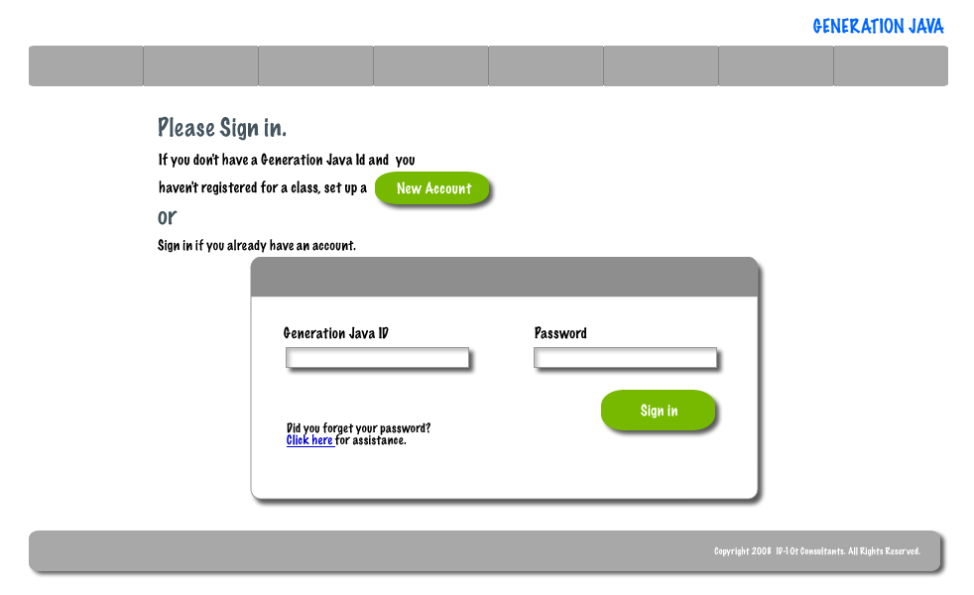

2.2: Forgot Password

When a user forgets their password they must be able to provide their user id. The system will then send an e-mail to the user’s e-mail address that was given at registration with their password.

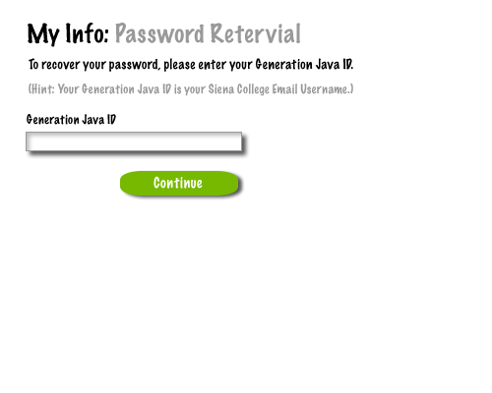
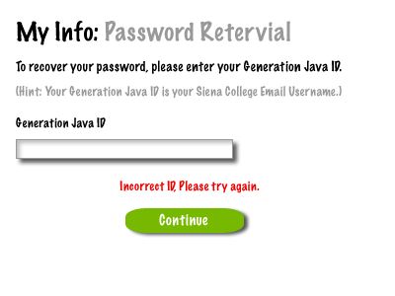

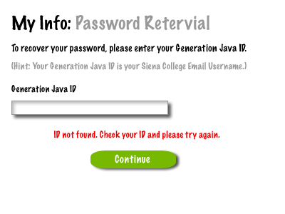

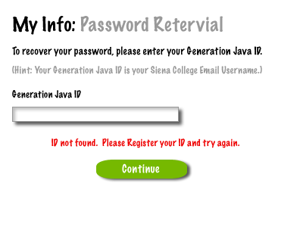

2.3: Student Home Screen

After a student successfully logs in they will be redirected to their home page.

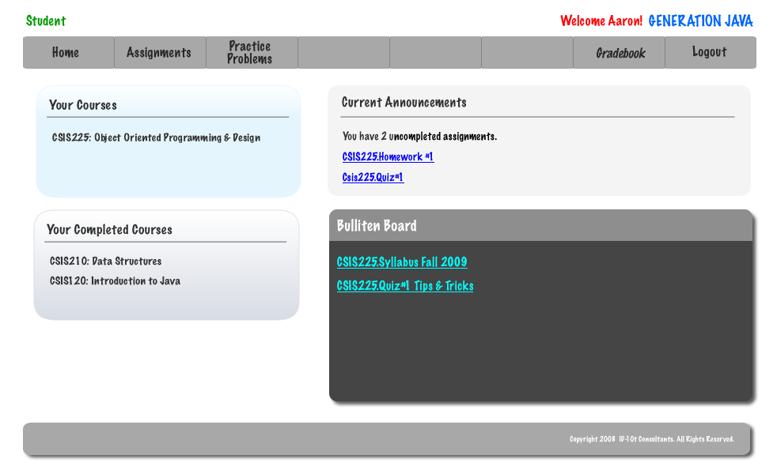

2.4: System Administrator Home Screen

Once the System Administrator has logged in using the correct username and password they will be redirected to their Home Screen.

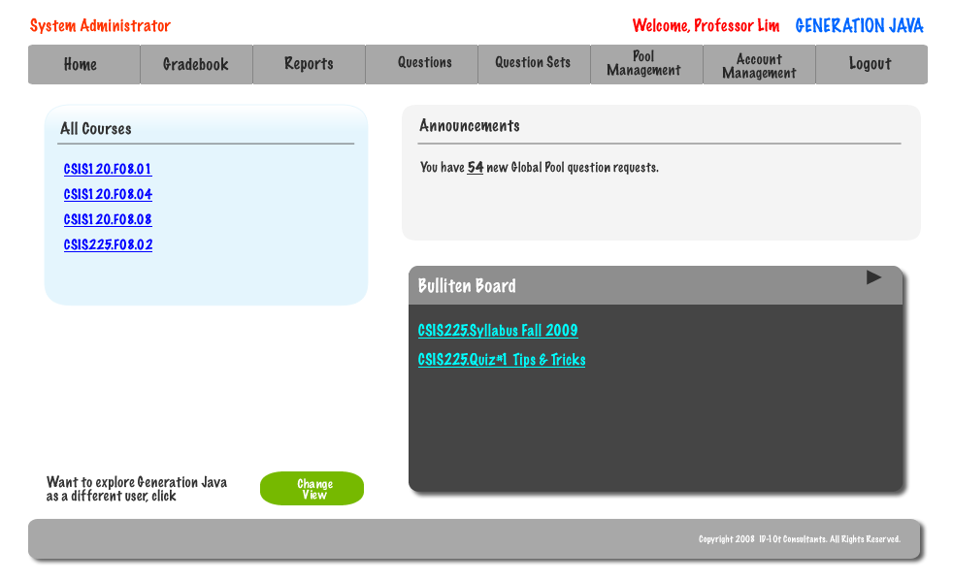

2.5: Program Administrator Home Screen

Once a Program Administrator has logged in using the correct username and password they will be redirected to their Home Screen.

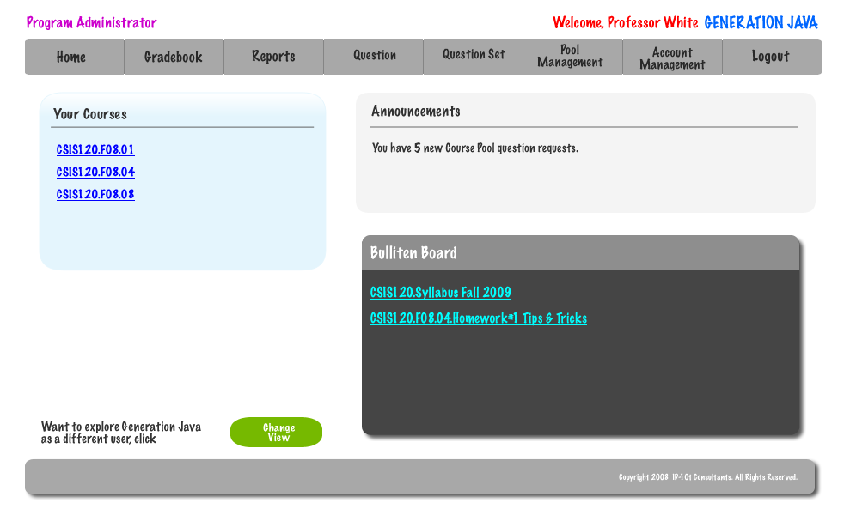

2.6: Instructor Home Screen

Once an Instructor has logged in using the correct username and password they will be redirected to their Home Screen.

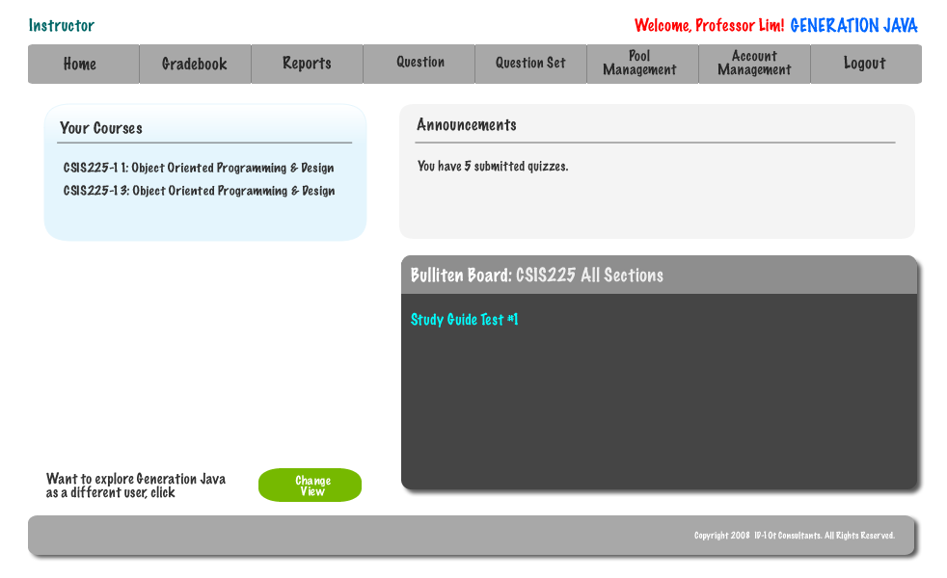

2.7: Student Account Creation

A student must successfully fill out this screen in order to be given a account for Generation Java.

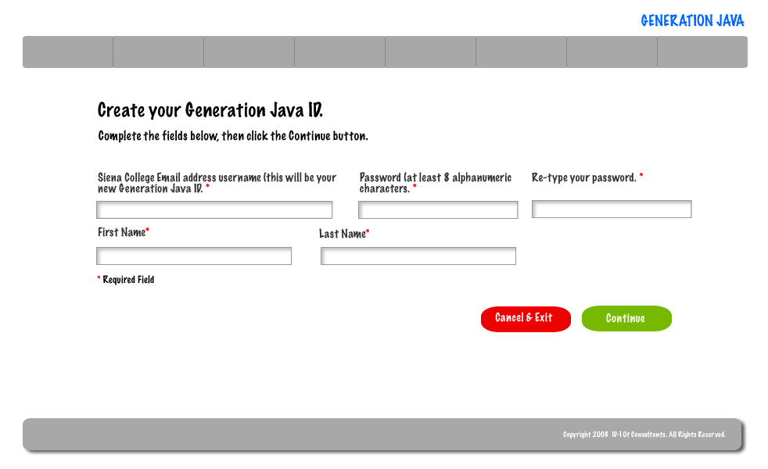
If a student is trying to register with an e-mail address that has already been used and registered they will be given an error.
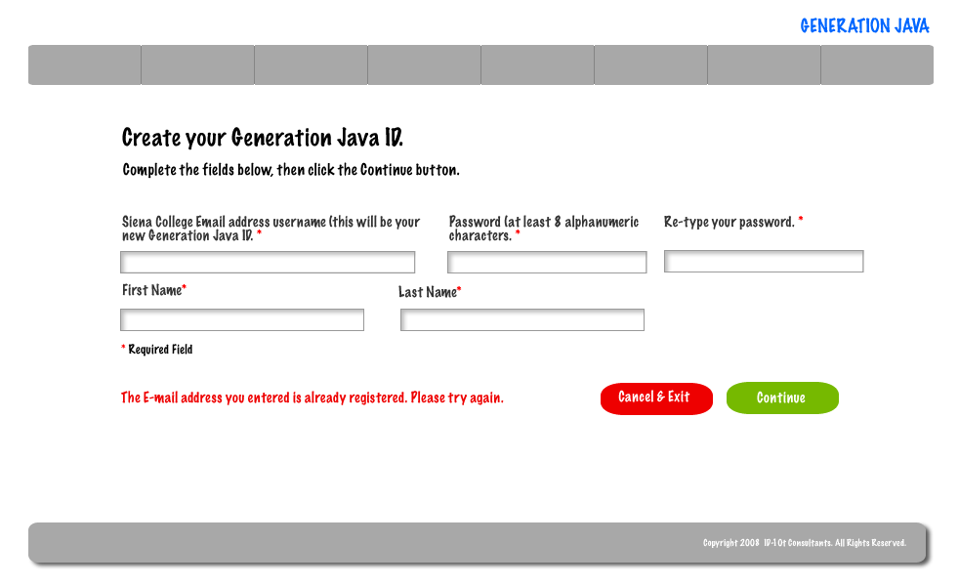
If a student cannot enter the same password in both of the necessary boxes they will be given an error message.
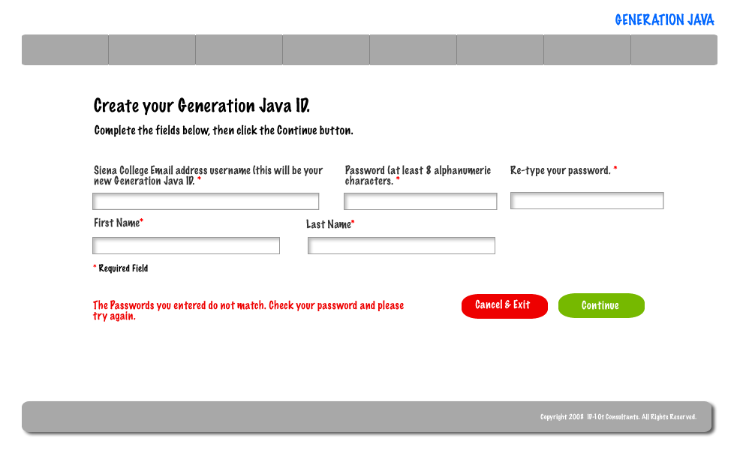
If a student did not complete all the necessary fields on the registration field they will be shown an error message.
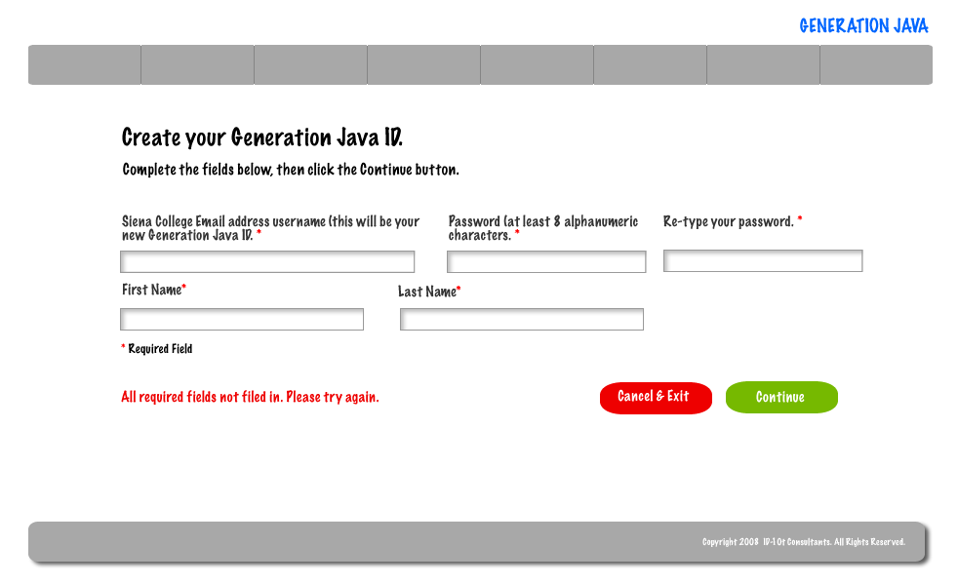

If the system encounters an error beyond the student’s control they will be shown an error message that will instructor them to contact the System Administrator.
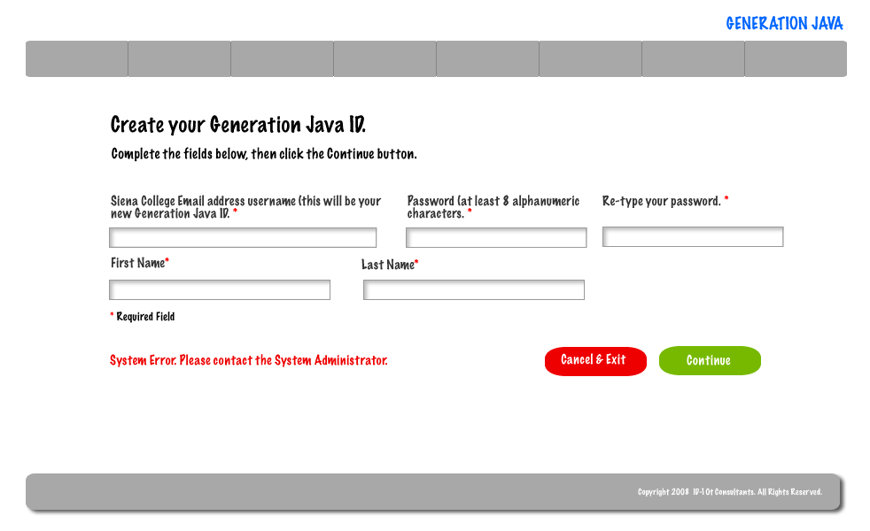

2.8: Student Account Creation Pop-up

After a student successfully registers for a Generation Java a pop-up will appear that will allow them to log into the system.
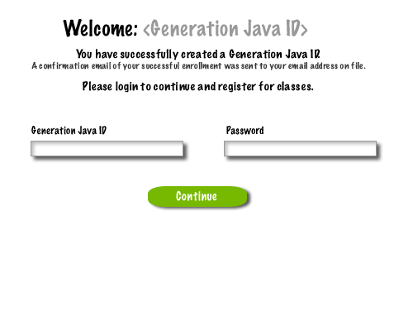
If a student enters a user ID and password that don’t match they will be shown an error and allowed to retry entering a user ID and password.

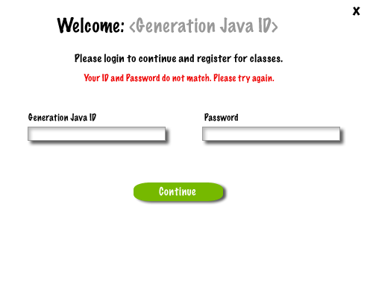
2.9: Created Account – System Administrator

Once the System Administrator has successfully created a user a pop-up will appear that allows them to return to their home page or to create another user account.
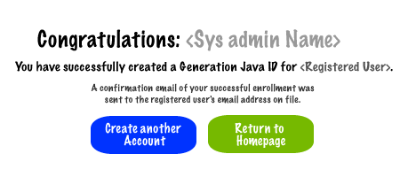

2.10: Created User Account System Administrator

The System Administrator must complete all the of these fields in order to successfully create a user account.

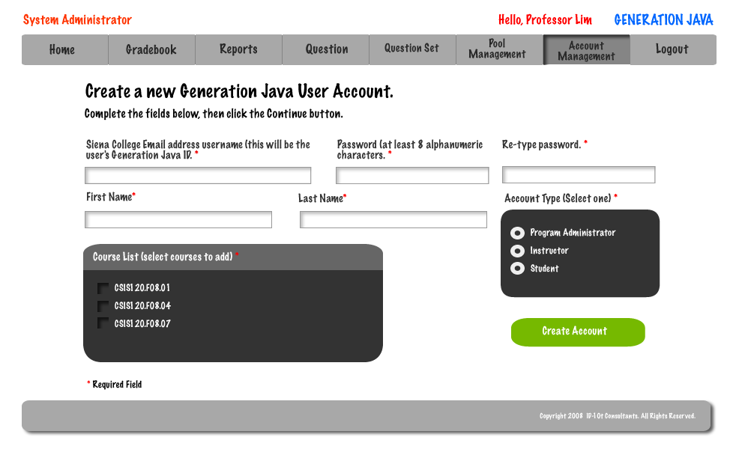
If the passwords that the System Administrator entered do not match they will be given an error message.

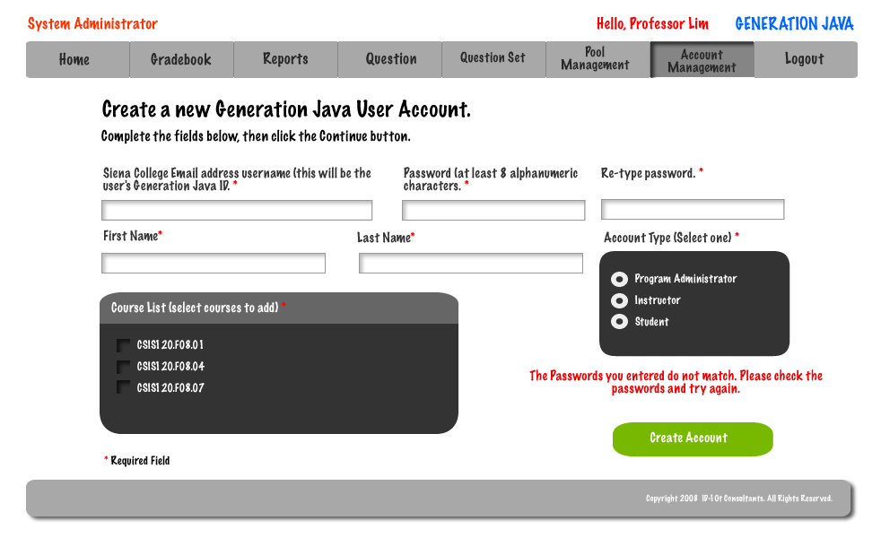
If the System Administrator enters a user ID that has already been registered then they will be given an error message.
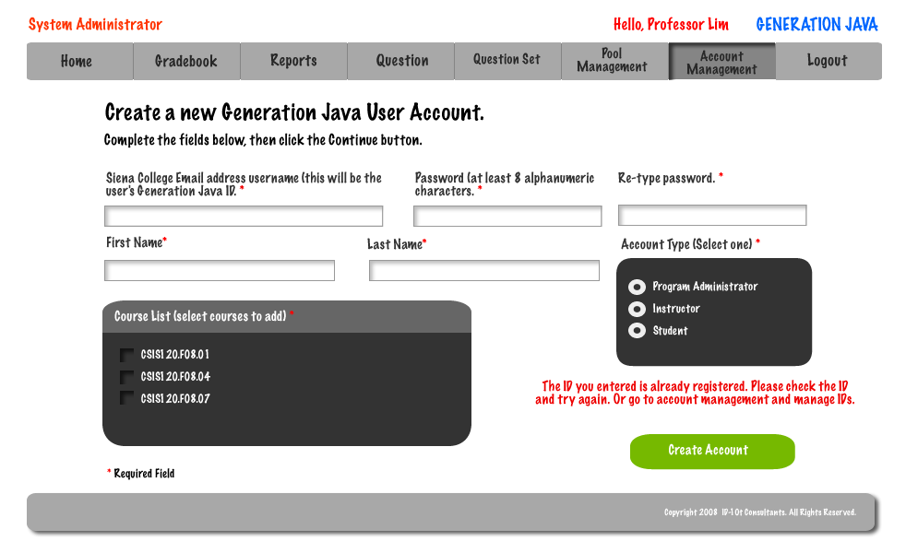

2.11: Create Question – Instructor/Program & System Administrator

In order for an Instructor, Program Administrator, or System Administrator to create a questions they must complete several required fields.

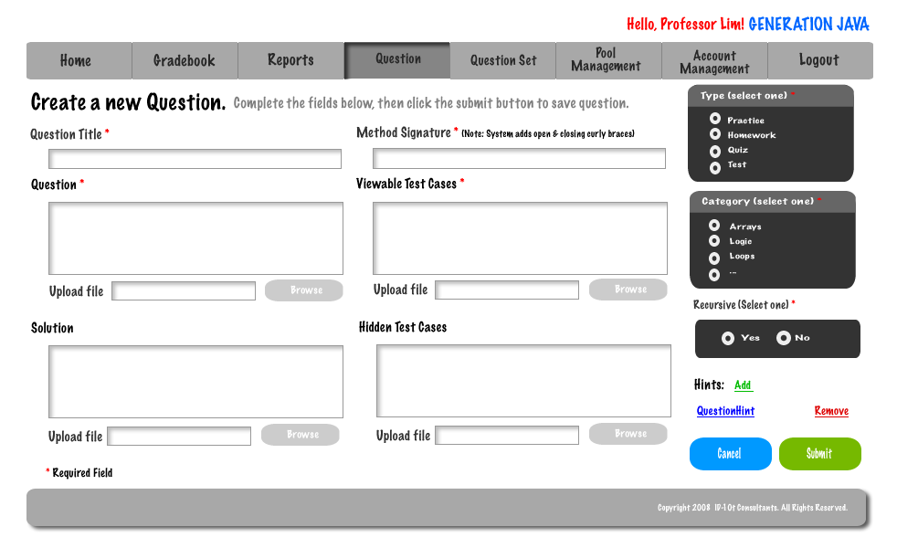

2.12: Student Question/ Question Set Answer Page

This is the screen that students will have when they are going to answer a question.
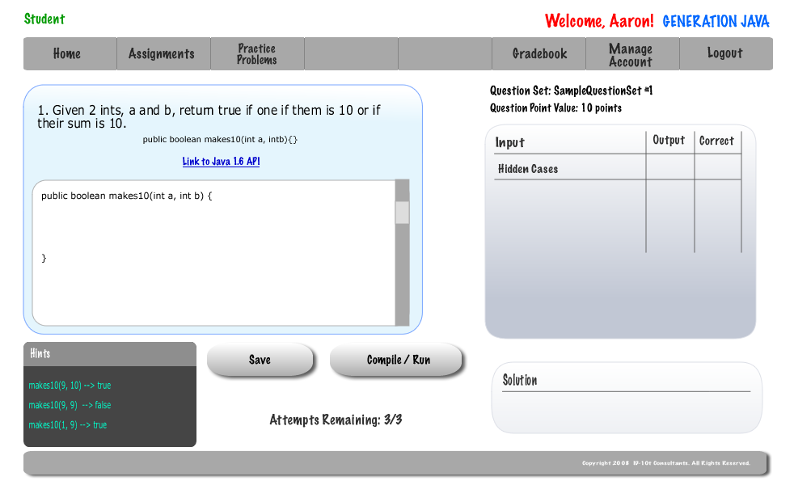

2.13: Student Grade book

In order for a student to view their grades or a completed assignment they must use the gradebook.

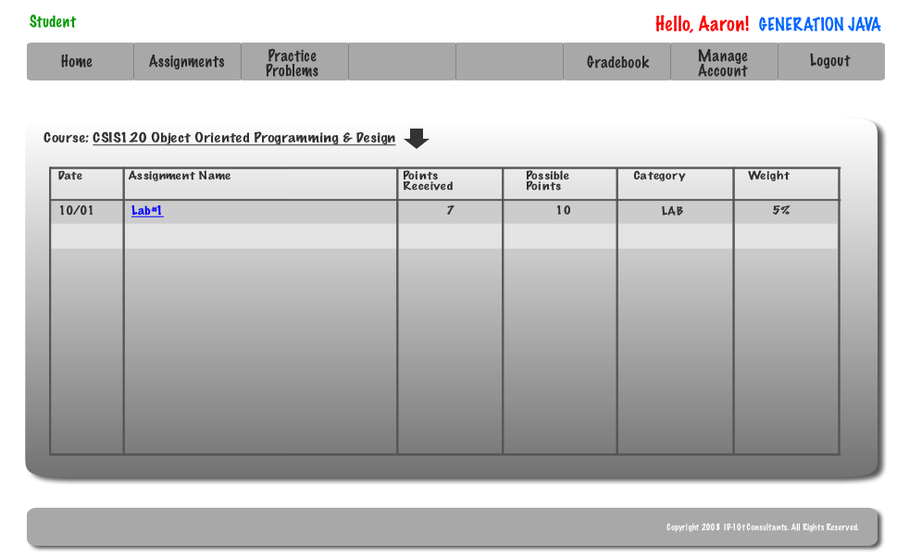

2.14: Administrator Grade book
Program Administrators are able to view a grade book for a course they are coordinating.

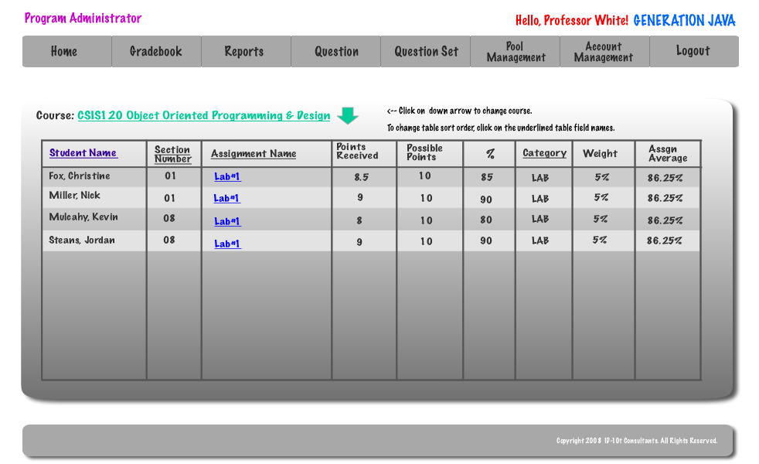

The System Administrator is able to view the grade book for any course.

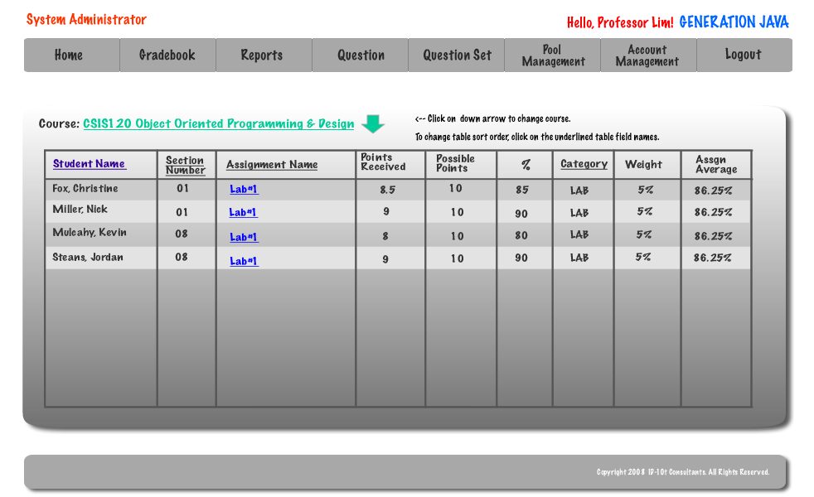

2.15: Instructor Grade book

An Instructor is able to view the grade book for any course that they are instructing and can sort the grade book by student, section, assignment, and category.

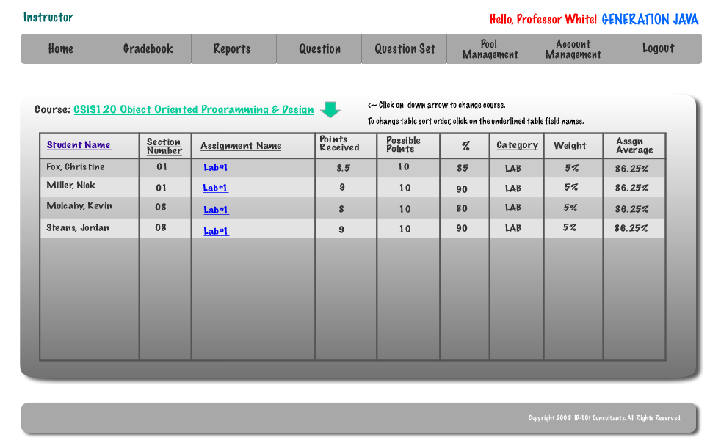

2.16: System Admin Course Management – Link to Create Course

The System Administrator has the ability to create a new course by entering a title, course number, section, and instructor.

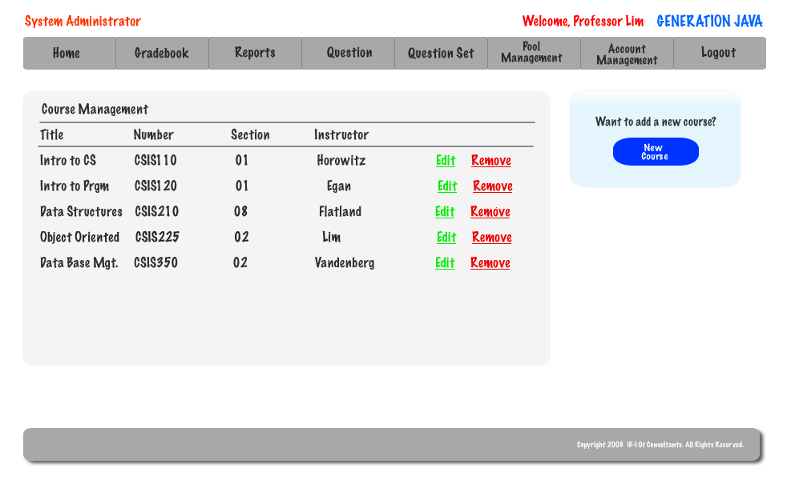

2.17: System Administrator – Create Course

The System Administrator must enter 4 fields in order to create a course.

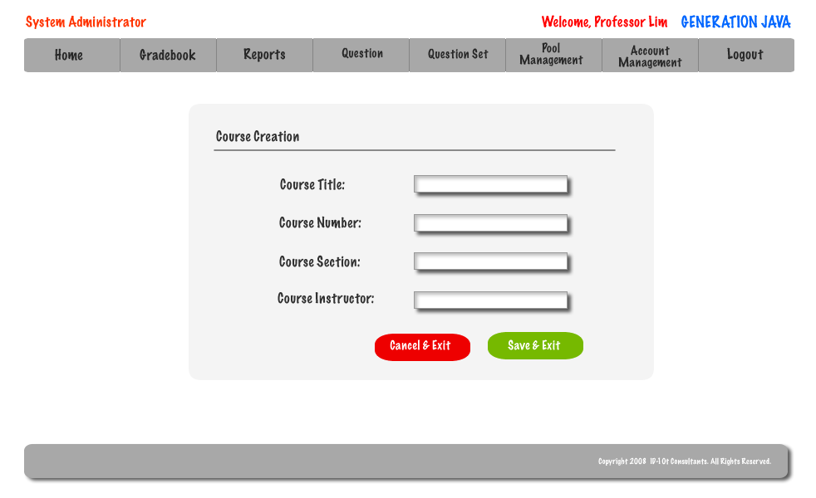

2.18: Instructor – Published Content Pool

An Instructor has a pool that contains just the questions that are currently published.

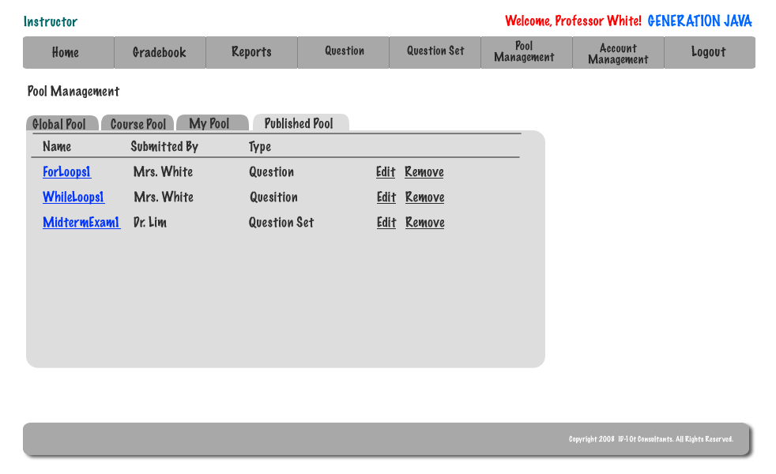

2.19: Instructor – My Pool

An Instructor is able to view questions in the global and course pools as well as submit questions to be considered for them. They are able to edit and add questions to their pool as well as the published pool.

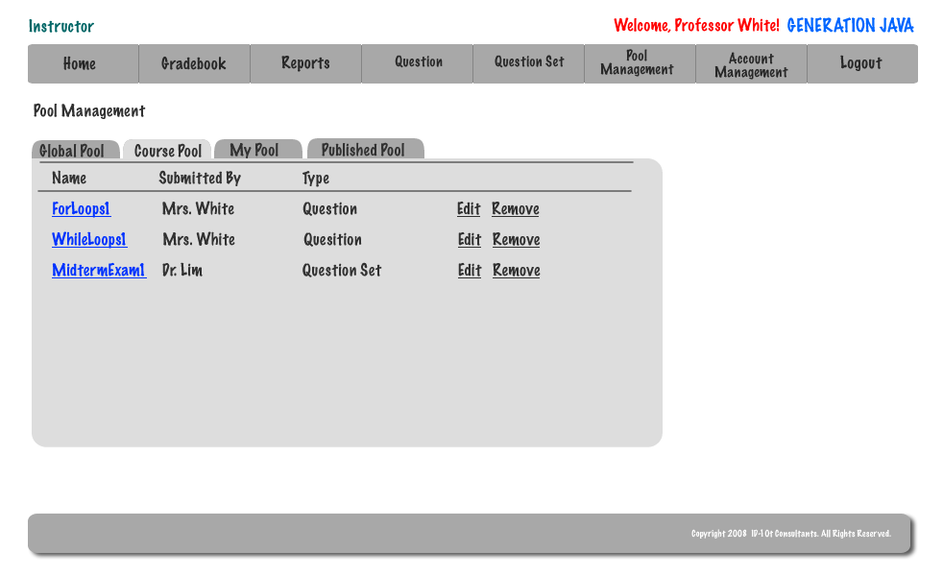

2.20: Instructor – Course Pool

An Instructor is able to view questions in the global and course pools as well as submit questions to be considered for them. They are able to edit and add questions to their pool as well as the published pool.

2.21: Instructor – Global Pool

An Instructor is able to view questions in the global and course pools as well as submit questions to be considered for them. They are able to edit and add questions to their pool as well as the published pool.

2.22: Question Set Creation

In order to create a question set the user (Instructor, Program Administrator, or System Administrator) must give the set a name and select a type for the set.

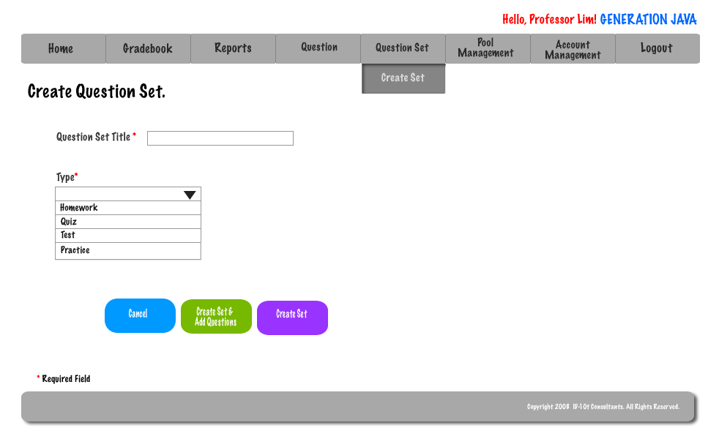

2.23: Question Set (Adding Question)

An Instructor, Program Administrator, or System Administrator is able to easily add an already completed question to a set.

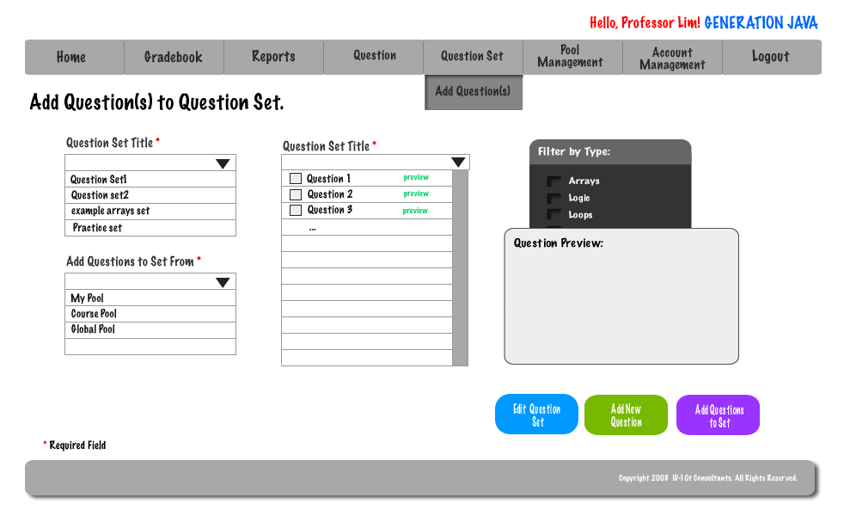

2.24: Submitted Created Question

When a user has successfully created a question a pop-up will appear on their screen allowing them to either be redirected to create another question or to be redirected to their homepage.



2.25: Question Set Publication

When an Instructor, Program Administrator, or System Administrator would like to publish a question set they must first fill out 9 required fields.

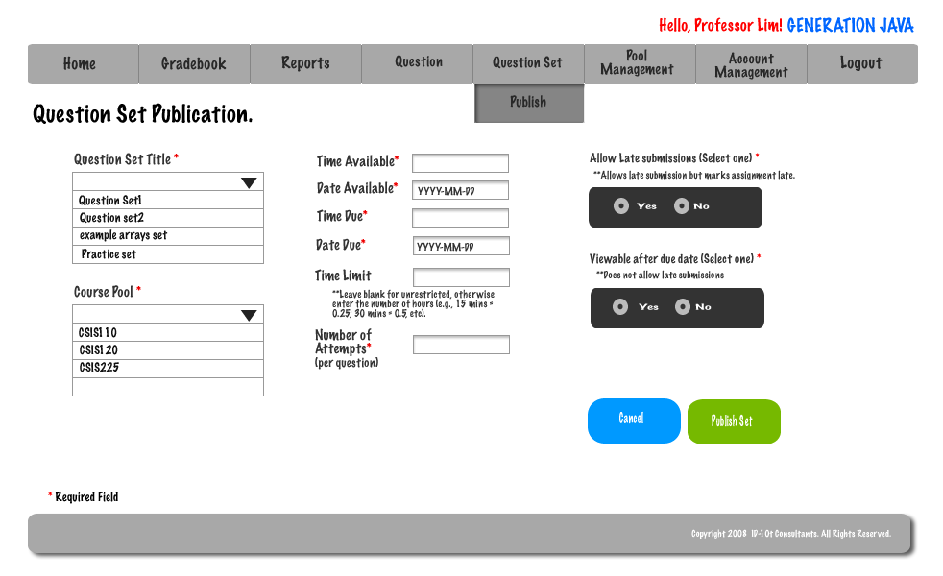

2.26: Editing Live Question

An Instructor, Program Administrator, or System Administrator is able to edit a live question.

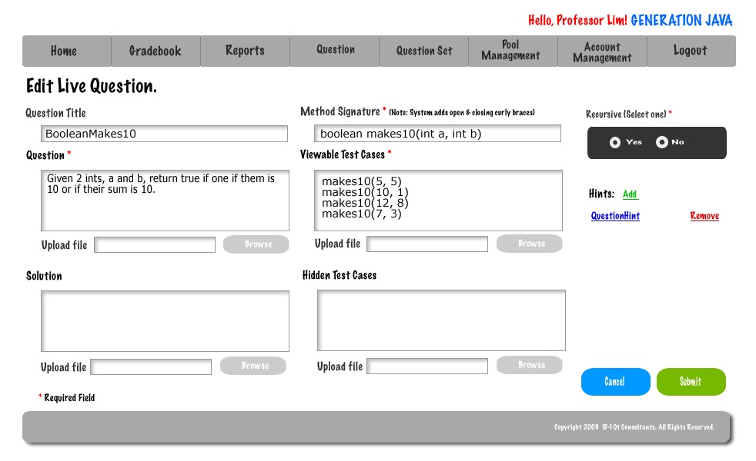

2.27: Editing Live Question Set

An Instructor, Program Administrator, or System Administrator is able to edit a live question set. They are able to edit a question in the set, the date due, or the time limit.
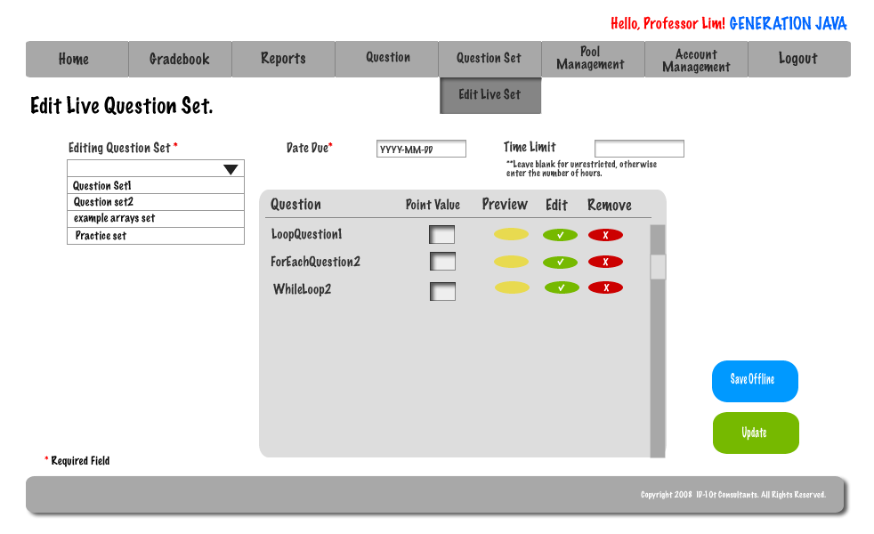

2.28: Account Management - Student

A student is able to change their password by utilizing the account management section of the system.

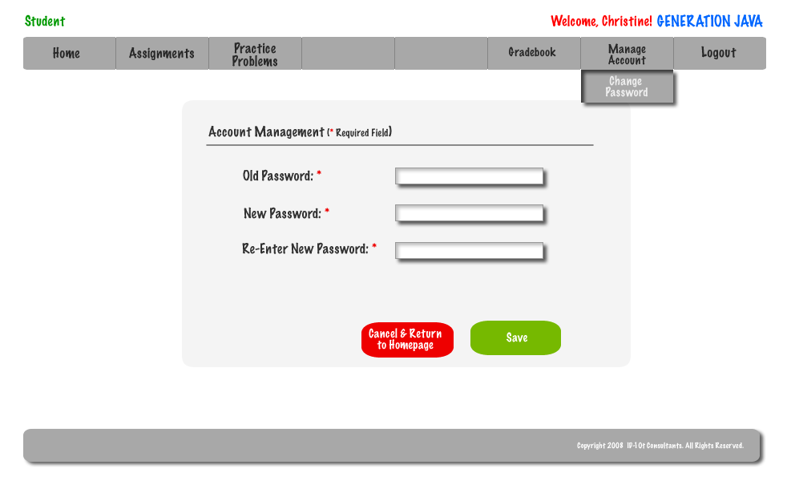

2.29: Account Management – Instructor

An Instructor is able to change their password by utilizing the account management section of the system.

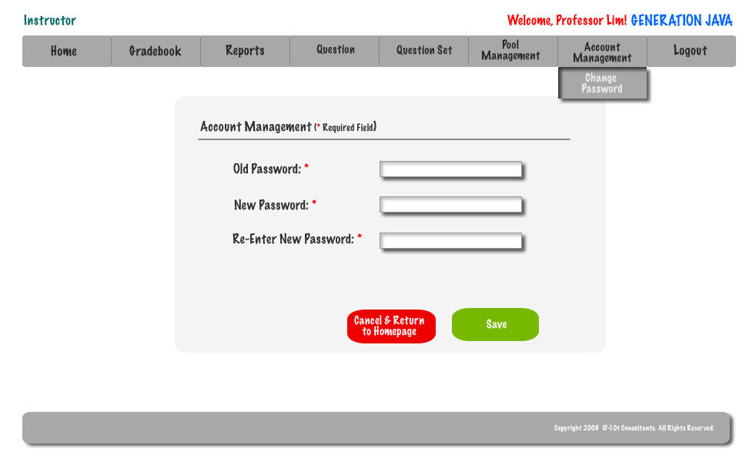

2.30: Account Management – Program Administrator

If a Program Administrator wishes to change their password they must use Account Management.
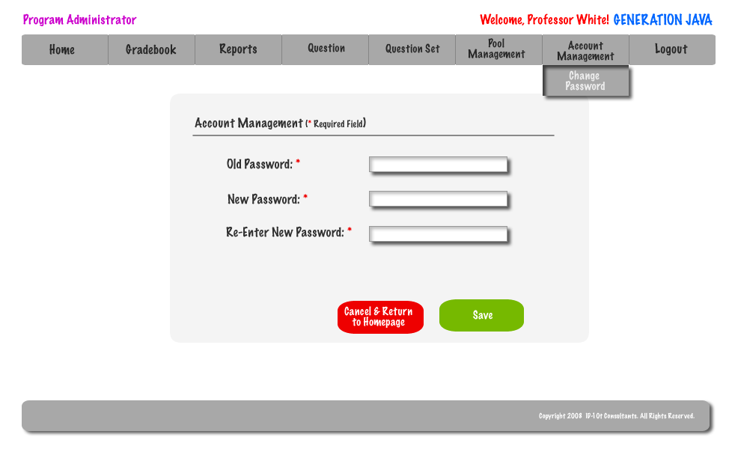
When changing a password the user must be able to identify their old password or they will be given an error.

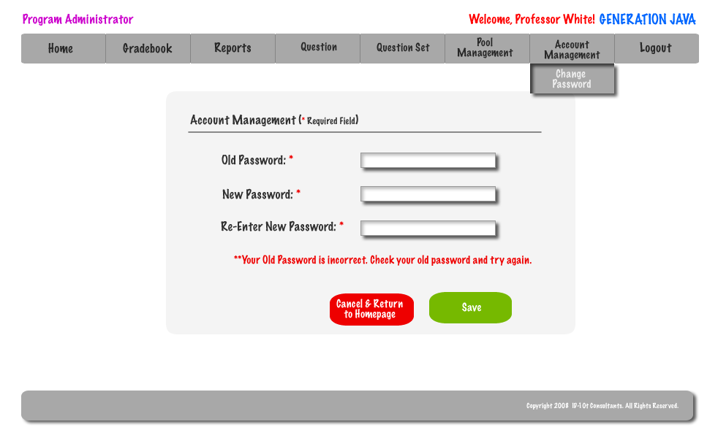

When creating a new Password a user must be able to type the password twice so the system can verify that the user did not have a typo in their first attempt.
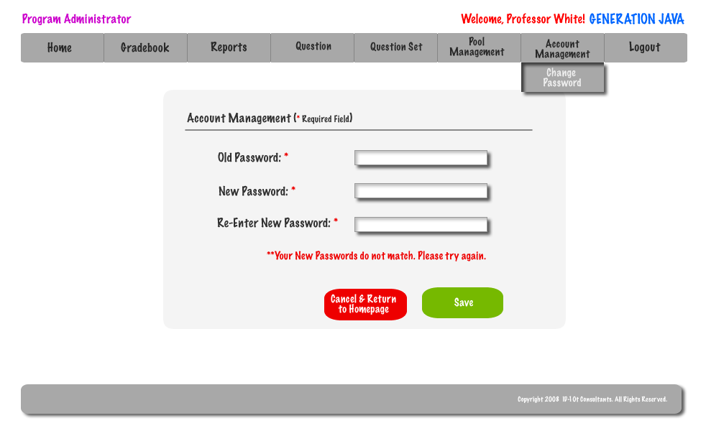
To enhance the security of the system a password must meet certain parameters.
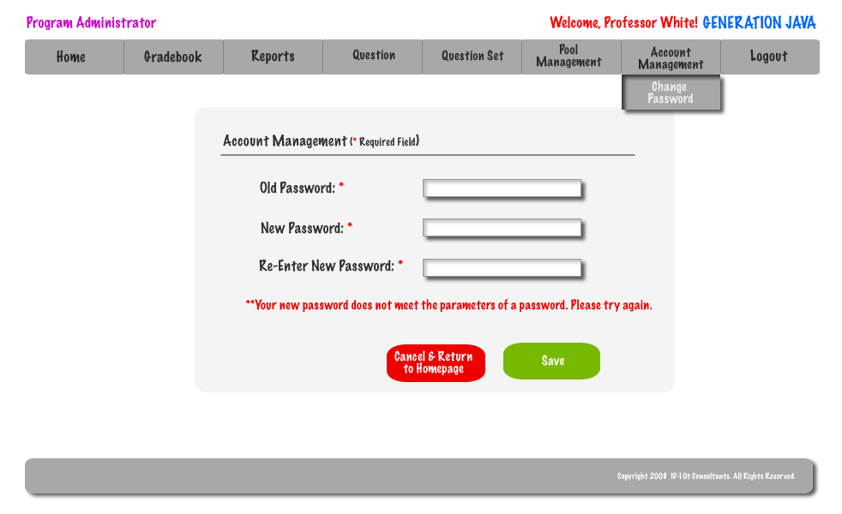

2.31: Account Management – System Administrator

The System Administrator is able to delete users as well as reset their passwords if they are incurring difficulties doing it on their own.

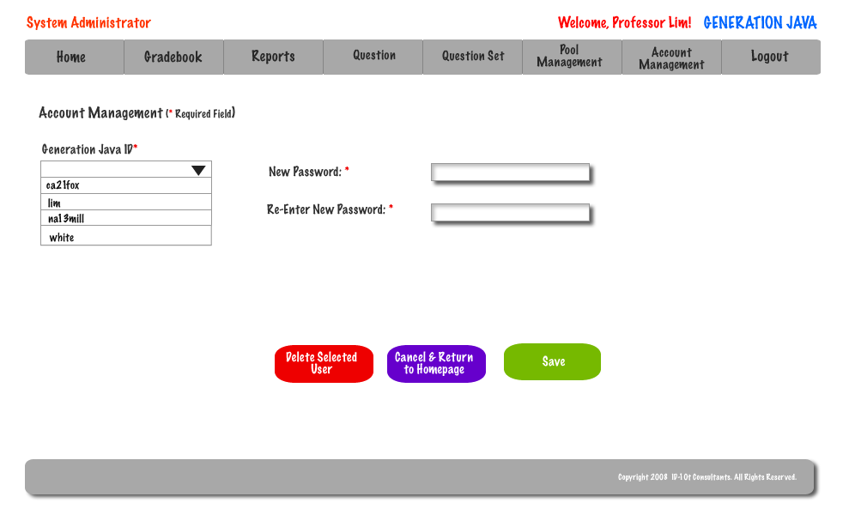

2.32: Course Home Page - Student

When a Student selects a course they will be redirected to the course home page.

2.33: Course Home Page – Instructor/ Program & System Admins

When a Instructor/Program Administrator or System Administrator chooses a course they will be redirected to the course home page.

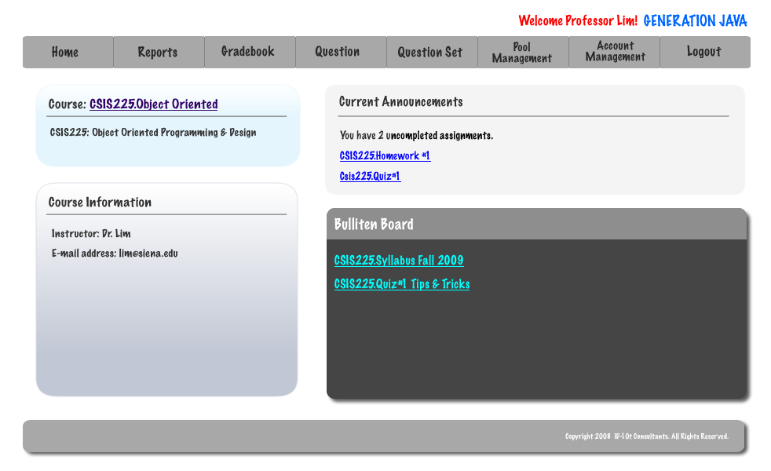

2.34: Pool Management – Program Administrator

A Program Administrator has access to their pool, the course pool, and the global pool.

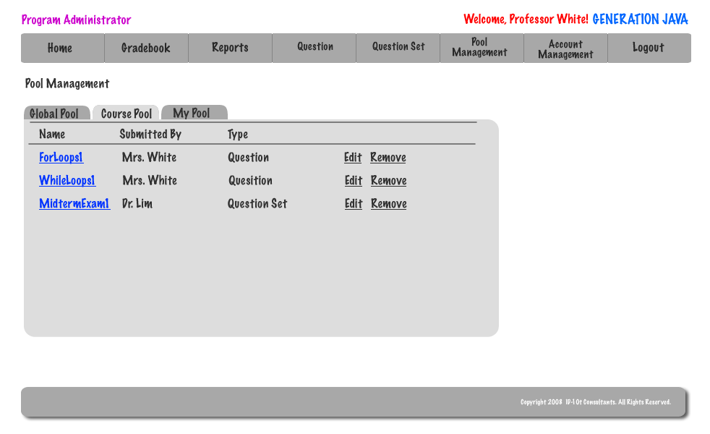

2.35: Pool Management – System Administrator

The System Administrator has access to their pool, all course pools, and the global pool.

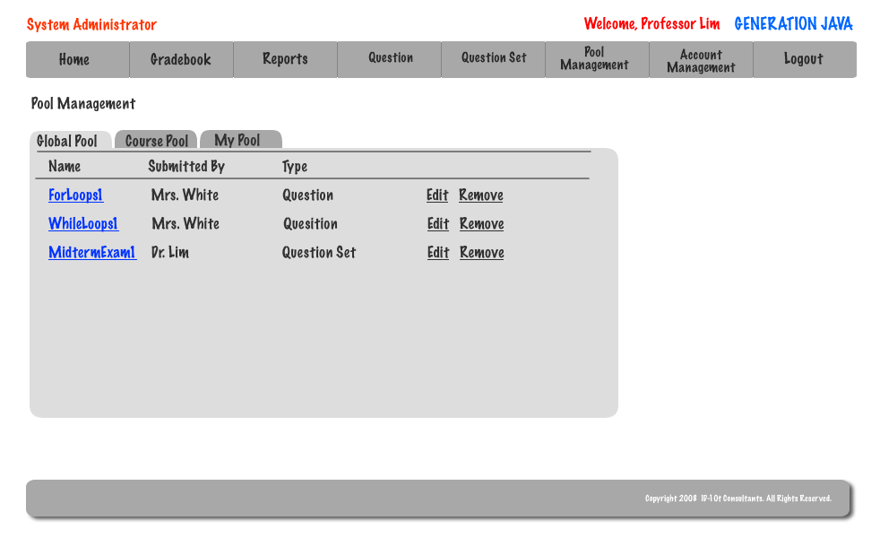

2.36: Student Question Compile and Run

After a student feels their code is correct they are able to have the system compile and then run it. If the code compiles then the student will receive feedback based on viewable and hidden test cases.

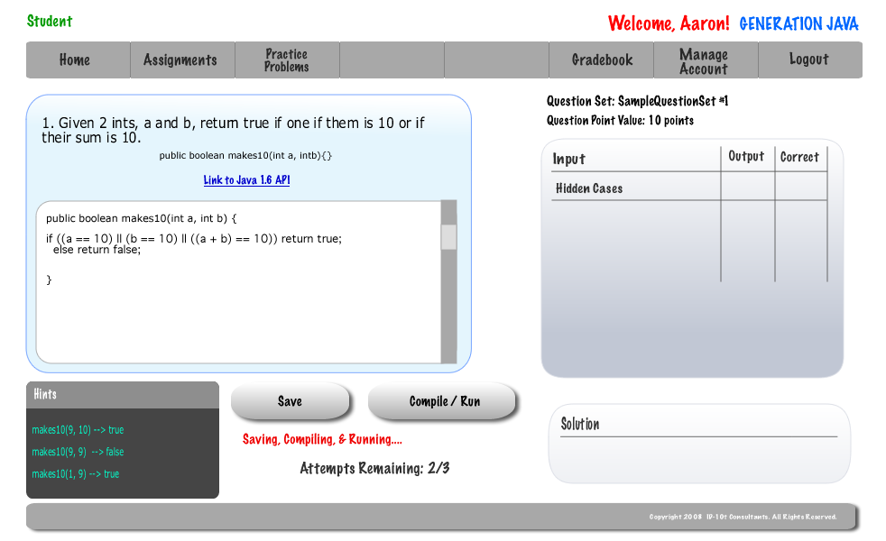

2.37: Pop-up Save Student Question

Once a student saves a question a popup will appear to confirm the success of the saving and allow the student to either navigate back to the question or to their home page.



2.38: Created Course – System Administrator – Popup

Once the System Administrator successfully creates a course a popup will appear to confirm the creation of the course and allows the System Administrator to navigate back to creating another course or to their homepage.



2.39: Approval of Global Pool Requests – System Administrator

Before a question can be admitted into the Global Pool the System Administrator must first approve it.

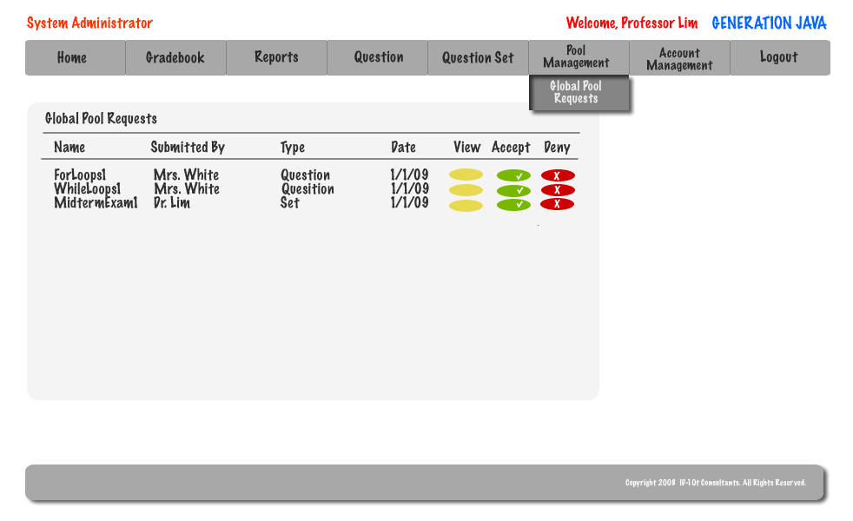

2.40: Approval of Course Pool Requests – Program Administrator

Before a question can be admitted into the Course Pool the Program Administrator must first approve it.

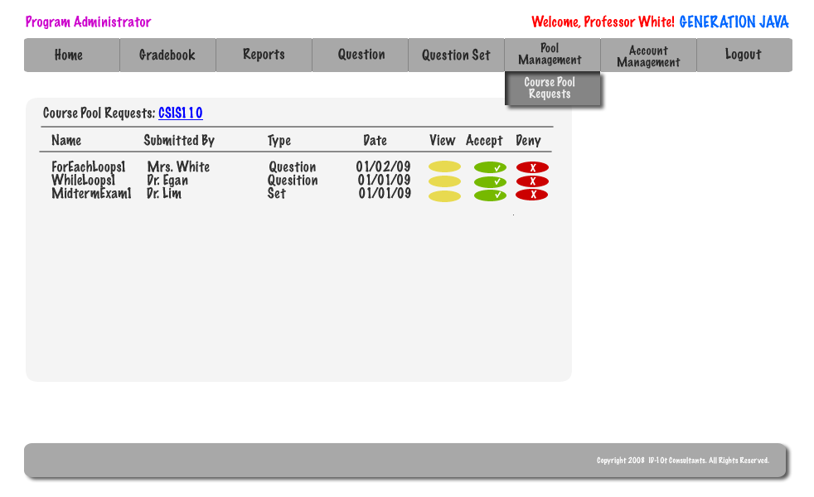

Section 3: Logical data stores

The following information presents a detailed description of the data stored in the Generation Java database. The data is presented in a layout of the table structure.

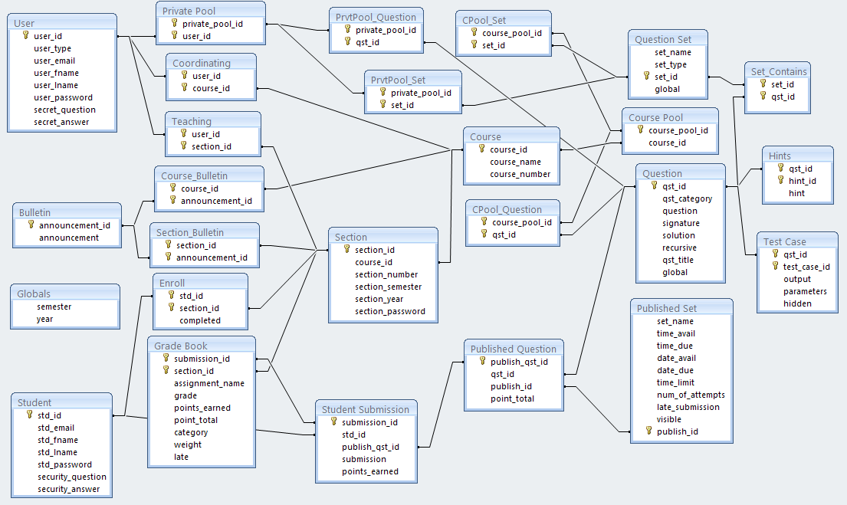

Section 4: Logical data dictionary
ID-10t Consulants
Data Dictionary
 |  |  |  |  | Date: 03/02/09
TABLE | COLUMN | DATA TYPE | DESCRIPTION | NOTES | VALIDATION
students | std_id | VARCHAR(8) | Siena College network login  -first & middle initial  -the day of the month you were born (two digits)  -the first four letters of your last name | Primary Key  Varations/Exceptions:  -If you have no middle initial, just skip it  -if you have an apostrophie in your name (e.g., O'Brien), leave it out  -if your last name is less than four letters, write what you have | AlphaNumeric
students | std_email | VARCHAR(30) | student's e-mail address
students | std_fname | VARCHAR(20) | student's first name
students | std_lname | VARCHAR(20) | student's last name
students | std_password | VARCHAR(15) | student's password | Chosen by student at account creation | AlphaNumeric
students | secret_question | VARCHAR(128) | student's secret question
students | secret_answer | VARCHAR(30) | student's answer to secret question
users | user_id | AUTONUMBER | users identification number
users | user_type | VARCHAR(15) | type of user | Types of users are:  -System Administrator  -Program Administrator  -Instructor
users | user_email | VARCHAR(30) | user's email
users | user_fname | VARCHAR(20) | user's first name
users | user_lname | VARCHAR(20) | user's last name
users | user_password | VARCHAR(15) | user's password |  | AlphaNumeric
users | secret_question | VARCHAR(128) | user's secret question
users | secret_answer | VARCHAR(30) | user's answer to secret question
course | course_id | AUTONUMBER | course id number | Primary Key
course | course_name | VARCHAR(30) | course name | Example: Intro to Computer Science
course | course_number | CHAR(7) | course number | Example: CSIS110 | AlphaNumeric
section | section_id | AUTONUMBER | section id number | Primary Key
section | section_number | CHAR(2) | section number
section | course_id | CHAR(7) | course id number | Foreign Key referencing course_id from Course
section | section_semester | VARCHAR(10) | semester the section is offered
section | section_year | NUMBER | year the section is offered
section | section_password | VARCHAR(10) | password to enroll in the section
teaching | user_id | VARCHAR(8) | instructor teaching the section | PK  Foreign Key referencing user_id from Users | AlphaNumeric
teaching | section_id | AUTONUMBER | course and section being taught | PK  Foreign Key referencing section_id from Section
coordinating | user_id | VARCHAR(8) | coordinating program administrator | PK  Foreign Key referencing user_id from Users | AlphaNumeric
coordinating | course_id | AUTONUMBER | course that is coordinated | PK  Foreign Key referencing course_id from Course
enroll | std_id | VARCHAR(8) | student enrolled in the section | PK  Foreign Key referencing std_id from Student | AlphaNumeric
enroll | section_id | AUTONUMBER | course and section students are enrolled | PK  Foreign Key referencing section_id from Section
enroll | completed | BOOL | true if course is compelted, false if not
question_set | set_name | VARCHAR(20) | question set name
question_set | set_type | VARCHAR(8) | question set type | Types available:  -Test  -Quiz  -Homework  -Practice
question_set | set_id | AUTONUMBER | question set id number | Primary Key
question_set | global | BOOL | true if in global pool, false if not
published_set | set_name | VARCHAR(20) | question set name
published_set | time_avail | TIME | the time the question set becomes available | Chosen at publication of the question set
published_set | time_due | TIME | the time the question set is due or becomes unavailable | Chosen at publication of the question set
published_set | date_avail | DATE | the date the question set becomes available | Chosen at publication of the question set
published_set | date_due | DATE | the date the question set is due or becomes unavailable | Chosen at publication of the question set
published_set | time_limit | TIME | how long a user has to submit the question set once the user has started answering the question set | Chosen at publication of the question set. This is an optional field and can be left empty
published_set | num_of_attempts | NUMBER | the number of attempts a user has per question | Chosen at publication of the question set
published_set | late_submission | YES/NO | whether a published question set accepts late submissions | Chosen at publication of the question set. Yes or No will be entered into this field
published_set | visible | YES/NO | whether a published question set is visible to users after the date and time due | Chosen at publication of the question set. Yes or No will be entered into this field
published_set | publish_id | AUTONUMBER | published question set id number | Primary Key
published_question | publish_qst_id | AUTONUMBER | published question id number | Primary Key
published_question | qst_id | AUTONUMBER | question in the published question set | Foreign Key referencing qst_id from Question
published_question | publish_id | AUTONUMBER | published set the question belongs to | Foreign Key referencing publish_id from Published Set
published_question | point_total | NUMBER | total points a student can receive on a question
question | qst_id | AUTONUMBER | question id number | Primary Key
question | qst_title | VARCHAR(30) | question title
question | qst_category | VARCHAR(15) | question category
question | question | TEXT | question text
question | signature | TEXT | question signature
question | solution | TEXT | question solution
question | recursive | YES/NO | whether the question is recursive or not
question | global | BOOL | true if in global pool, false if not
hints | qst_id | AUTONUMBER | question the hint belongs to | PK  Foreign Key referencing qst_id from Question
hints | hint_id | AUTONUMBER | hint id number | Primary Key
hints | hint | TEXT | hint text
test_case | qst_id | AUTONUMBER | question the test case belongs to | PK  Foreign Key referencing qst_id from Question
test_case | test_case_id | AUTONUMBER | test case id number | Primary Key
test_case | output | TEXT | test case output
test_case | parameters | TEXT | test case parameters
test_case | hidden | YES/NO | whether the test case is hidden or not
set_contains | set_id | AUTONUMBER | question set holding the question | PK  Foreign Key referencing set_id from Question Set
set_contains | qst_id | AUTONUMBER | question in the question set | PK  Foreign Key referencing qst_id from Question
private_pool | private_pool_id | AUTONUMBER | private pool id number | Primary Key
private_pool | user_id | VARCHAR(8) | user who the private pool belongs to | PK  Foreign Key referencing user_id from Users
course_pool | course_pool_id | AUTONUMBER | course pool id number | Primary Key
course_pool | course_id | AUTONUMBER | course the course pool belongs to | Foreign Key referencing course_id from Course
prvtpool_question | private_pool_id | AUTONUMBER | private pool holding the question | PK  Foreign Key referencing private_pool_id from Private Pool
prvtpool_question | qst_id | AUTONUMBER | question in the private pool | PK  Foreign Key referencing qst_id from Question
prvtpool_set | private_pool_id | AUTONUMBER | private pool holding the question set | PK  Foreign Key referencing private_pool_id from Private Pool
prvtpool_set | set_id | AUTONUMBER | question set in the private pool | PK  Foreign Key referencing set_id from Question Set
cpool_question | course_pool_id | AUTONUMBER | course pool holding the question | PK  Foreign Key referecing course_pool_id from Course Pool
cpool_question | qst_id | AUTONUMBER | question in the course pool | PK  Foreign Key referencing qst_id from Question
cpool_set | course_pool_id | AUTONUMBER | course pool holding the question set | PK  Foreign Key referecing course_pool_id from Course Pool
cpool_set | set_id | AUTONUMBER | question in the course pool | PK  Foreign Key referencing set_id from Question Set
bulletin | announcement_id | AUTONUMBER | announcement id number | Primary Key
bulletin | announcement | TEXT | announcement text
course_bulletin | course_id | AUTONUMBER | course the bulletin belongs to | PK  Foreign Key referencing course_id from Course
course_bulletin | announcement_id | AUTONUMBER | announcement on the course bulletin | PK  Foreign Key referencing announcement_id from Bulletin
section_bulletin | section_id | AUTONUMBER | section the bulletin belongs to | PK  Foreign Key referencing section_id from Section
section_bulletin | announcement_id | AUTONUMBER | announcement on the section bulletin | PK  Foreign Key referencing announcement_id from Bulletin
gradebook | submission_id | AUTONUMBER | student grade book | PK  Foreign Key referencing submission_id from Student_Submission
gradebook | section_id | AUTONUMBER | section the student receives a grade in | PK  Foreign Key referencing section_id from Section
gradebook | assignment_name | VARCHAR(8) | name of assignment the student was graded on
gradebook | grade | PERCENT | grade received on an assignment
gradebook | points_earned | NUMBER | points earned out of the total points
gradebook | point_total | NUMBER | total points a student can receive on an assignment
gradebook | category | VARCHAR(15) | category of the assignment
gradebook | weight | PERCENT | weight of the assignment
gradebook | late | YES/NO | whether the assignment was submitted late
student_submission | submission_id | AUTONUMBER | student submission id number | Primary Key
student_submission | std_id | VARCHAR(8) | student that answered the question | Foreign Key referencing std_id from Student
student_submission | publish_qst_id | AUTONUMBER | published question that is being answered | Foreign Key referencing publish_qst_id from Published Question
student_submission | submission | TEXT | question answer text
student_submission | points_earned | NUMBER | number of points earned for the student on the question
globals | semester | VARCHAR(15) | current system semester
globals | year | NUMBER | current system year

Architectural Design Specification

Section 5: Structure diagram

Structure Diagram - The Structure Diagram is used to provide a road map of how the application is built by using the data flow diagram as a template.

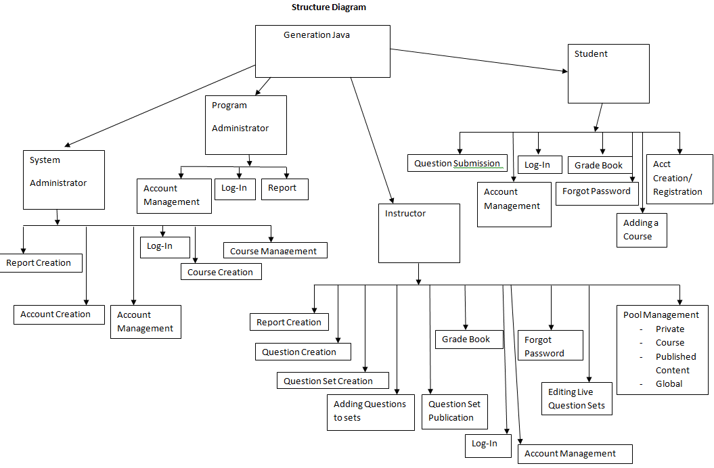

Section 6: Data Flow Diagrams

See attached Data Flow Diagram Document.

Testing Requirements

Section 7: Functional Requirements Inventory

Functional Requirements Inventory

The following list outlines the required functionality to be included in the final solution. The requirements are listed according to user case and then by screens the user will view.

Requirements Inventory

Functional Requirements
Requirements grouped according to Use Case.
System Administrator:
There is only one System Administrator.
Once logged in, a System Administrator has three views available:
- Student
- Instructor
- Administrator

The System Administrator can perform different tasks based on which view is currently be used:

Student View
- Registration
- The System Administrator views the system as a Student that is registered in all possible courses.
- The System Administrator is not seen as registered for any course by any user.
- The System Administrator does not need to log out to switch between courses.

- Questions/Question Sets
- The System Administrator is able to attempt any question set, including all homework, quiz, test, and practice sets for any section of any course by having the same functionality a student would have in attempting a question set.
- The System Administrator is able to save code to a database.
- Once code is compiled and executed, the System Administrator will receive feedback on it.
- The feedback received by the System Administrator is identical to that of a Student; however, it is not viewable by any Instructor.
- The System Administrator’s grades are not counted in any reports, including reports run by an Administrator.
- The System Administrator should be aware when the maximum number of attempts (if specified) has been reached on a question, but should not be restricted by it as a Student would be.
- The System Administrator has the ability to click any links (if provided and enabled) on any question.
- The System Administrator can view all files posted by all Instructors.

Instructor View
- Registration
- The System Administrator views the system as an Instructor that is instructing all possible courses.
- The System Administrator is not seen as an Instructor of any course by any user.
- The System Administrator does not need to log out to switch between courses.
- Questions/Question Sets
- The System Administrator can create, edit, delete, and distribute all questions and question sets.
- The System Administrator can set a time and date for any question set to become available.
- The System Administrator can set a time and date for any questions set to be due.
- The System Administrator can assign point totals to any question set.
- Instructor Privileges
- The System Administrator can see all Students’ last submissions and submission information for every (attempted) question in every question set.
- The System Administrator can see all Students’ statistics (including login information) and all statistics for every question in every question set.
- Statistics will be provided in a report that can be requested by the System Administrator.

Administrator View
- The System Administrator can create, edit, and delete the following types of accounts:
- Program Administrator
- Instructor
- Student

- Editing an account consist of changing a user’s account type, e-mail, password and courses taught or enrolled in.
- The System Administrator can add questions/question sets to the global pool.
- The System Administrator may logout in any view.

Program Administrator:
A Program Administrator coordinates one more sections/courses.
There may be multiple Program Administrators.
Program Administrators do not register.
A Program Administrator’s account is created by the System Administrator.

Once logged in, a System Administrator has three views available:
- Student
- Instructor
- Administrator
A Program Administrator can perform different tasks based on which view is currently be used:

Student View
- Registration
- A Program Administrator views the system as a Student that is registered in all courses specified by the System Administrator.
- A Program Administrator is not seen as registered for any course by any user except by the System Administrator.
- A Program Administrator does not need to log out to switch between courses.

- Questions/Question Sets
- A Program Administrator is able to attempt any of the question sets specified by the System Administrator, including homework, quiz, test, and practice sets.
- A Program Administrator is able to save code to a database.
- Once code is compiled and executed, A Program Administrator will receive feedback on it.
- The feedback received by a Program Administrator is identical to that of a Student; however, it cannot be viewed by any Instructor.
- A Program Administrator’s grades are not counted in any reports, including reports run by an Administrator.
- A Program Administrator should be aware when the maximum number of attempts (if specified) has been reached on a question, but should not be restricted by it as a Student would be.
- A Program Administrator has the ability to click any links (if provided and enabled) on any question specified by the System Administrator.
- A Program Administrator can view all files posted by Instructors specified by the System Administrator.

Instructor View
- Registration
- A Program Administrator views the system as an Instructor that is instructing all courses specified by the System Administrator.
- A Program Administrator is not seen as an Instructor of any course by any user.
- A Program Administrator does not need to log out to switch between courses.
- Questions/Question Sets
- A Program Administrator can create, edit, delete, and distribute course-specific questions and question sets.
- A Program Administrator can set a time and date for any question set specified by the System Administrator to become available.
- A Program Administrator can set a time and date for any questions set specified by the System Administrator to be due.
- A Program Administrator can assign point totals to any question set specified by the System Administrator.
- Instructor Privileges
- A Program Administrator can see all Students’ (specified by the System Administrator) last submissions and submission information for every (attempted) question in every question set.
- A Program Administrator can see all Students’ (specified by the System Administrator) statistics (including login information) and all statistics for every question in every question set (also specified by the System Administrator).

Administrator View

- A Program Administrator can create, edit, and delete the following types of accounts:
- Instructor
- Student
- The Program Administrator can add question/question sets to any of the course-specific pools specified by the System Administrator.
- The Program Administrator may logout in any view.

Instructor:
An Instructor does not register.
An Instructor’s account is created by a Program Administrator or the System Administrator.
Once logged in, an Instructor has two views available:
- Student
- Instructor

An Instructor can perform different tasks based on which view is currently be used:

Student View
- Registration
- An Instructor views the system as a Student that is registered in all courses specified by the Program Administrator.
- An Instructor is not seen as registered for any course by any user.
- An Instructor does not need to log out to switch between courses.

- Questions/Question Sets
- An Instructor is able to attempt any of the question sets specified by the Program Administrator, including homework, quiz, test, and practice sets.
- An Instructor is able to save code to a database.
- Once code is compiled and executed, an Instructor will receive feedback on it.
- The feedback received by an Instructor is identical to that of a Student. No one else can view this feedback.
- An Instructor’s grades are not counted in any reports, even reports run by an Administrator.
- An Instructor should be aware when the maximum number of attempts (if specified) has been reached on a question, but should not be restricted by it as a Student would be.
- An Instructor has the ability to click any links (if provided and enabled) on any question specified by the Program Administrator.
- An Instructor can view all files posted by themselves or other Instructors specified by the Program Administrator.

Instructor View
- Registration
- An Instructor can view all courses specified by a Program Administrator.
- An Instructor is seen as the Instructor for all courses specified by the Program Administrator.
- An Instructor does not need to log out to switch between courses.
- If an Instructor wishes to teach a new course, the new course may be added by inputting the Course ID into the appropriate location. A Course ID is provided by the Program Administrator or System Administrator.
- Questions/Question Sets
- An Instructor has the ability to create, edit, and delete java questions in the Instructor’s own private pool.
- An Instructor can upload a question or enter it into a text box.
- An Instructor may provide links to aid a Student.
- An Instructor has the ability to create, edit and delete question sets in the Instructor’s own private pool.
- An Instructor can use questions from the Instructor’s private pool, the course-specific pool, or the global pool when creating question sets.
- When creating a question set, an Instructor can set point totals and a maximum number of attempts allowed for each question.
- An Instructor can set a time and date for a question set to become available and unavailable.
- If an Instructor wishes to add a question or question set to the course-specific pool, it must be submitted to the Program Administrator.
- If an Instructor wishes to add a question or question set to global pool, it must be submitted to the System Administrator.
- Instructor Privileges
- An Instructor can see all Students’ (registered in the Instructor’s course) last submissions and submission information for every (attempted) question in every question set.
- An Instructor can see all Students’ (registered in the Instructor’s course) statistics (including login information) and all statistics for every question in every question set (also in the Instructor’s course).
- These statistics (which include grade information) can be generated into reports and exported to a tab delimited or .pdf file.
- An Instructor may edit a Student’s grade as seen fit.
- An Instructor may deny a student access to a course.
- An Instructor may post files that can be viewed by Students in the Instructor’s course.

An Instructor can log out in either view.

Student:
A Student has only one view.

- Registration
- A Student must register in a specific course by entering a Course ID in the appropriate location.
- A Course ID is provided by the Instructor of that course.
- A Student may be registered in multiple courses under the same username and password.
- A Student does not need to log out in order to change which course is currently being worked in.
- Question Sets
- A Student has the ability to view and attempt any question set provided by the Instructor.
- When a Student submits code, feedback is returned indicating the code’s degree of correctness.
- A Student can retry a question until the number of attempts (if specified) has run out.
- A Student may see only their own grades and statistics.
- Additional Privileges/Restrictions
- A Student may view any link or file provided by the Instructor (if enabled).
- A Student may not click out of the testing window during a test or the test will be terminated.
- A Student may log out as desired.

Non-Functional Requirements Inventory

- The system should be quick and smooth, using fast servers and databases.
- The system should also be aesthetically pleasing.
- The system should be user-friendly.

Section 8: Acceptance Test

See attached Test Plan Document.

Section 9: Unit Tests

See attached Test Plan Document.

Section 10: Subprogram Interface Specifications

Generation Java is comprised of four modules (users) which are the Student, Instructor, Program Administrator, and System Administrator. These users are independent of one another and this is represented in the database but, the users also share some data in the database. Each user is allowed to perform specific tasks that will allow the system to perform its desired functionality.
Section 11: Appendix

11.1 Glossary of Terms

CSS – Cascading Style Sheets – These are used to describe a specific style for a web page or set of pages, a website.

Database - A collection of data arranged for ease and speed of search and retrieval.

Data Flow Diagram – A representation of the functional decomposition of a system.

Gantt Chart - A chart that depicts progress of jobs in relation to time. It is often used in planning and tracking a project.

Hypertext Markup Language (HTML) – Predominant markup language used for the creation of web pages.

Internet - A vast computer network linking smaller computer networks worldwide. The Internet includes commercial, educational, governmental, and other networks, all of which use the same set of communications protocols.

Internet Explorer(IE) – Microsoft based program used for browsing the Internet.

Linear Sequential Model / Classic Waterfall Model – A systematic, sequential approach to software development that begins at the system level and progresses through analysis, design, coding, testing, and support.

MySQL – A Multithreaded, multi-user Relational Database Management System.

OS X - The latest operating system for Macintosh computers, based on the Linux kernel but with a more user-friendly graphic interface. It includes networking capabilities.

PHP – PHP Hypertext Preprocessor – An open source (free) programming language that is used for dynamic pages and is a high-level scripting language.

XHTML – Extensible HyperText Markup Language – has same capabilities of HTML but is more restricted to allow for conformity among multiple platforms.

11.2 Packaging Specifications

ID-10t Consultants will install all the necessary files of Generation java on Oraserve. A CD containing a full copy of ID-10t’s website including all folders, files, images, etc., as well as a full copy of all files that comprise Generation Java.

