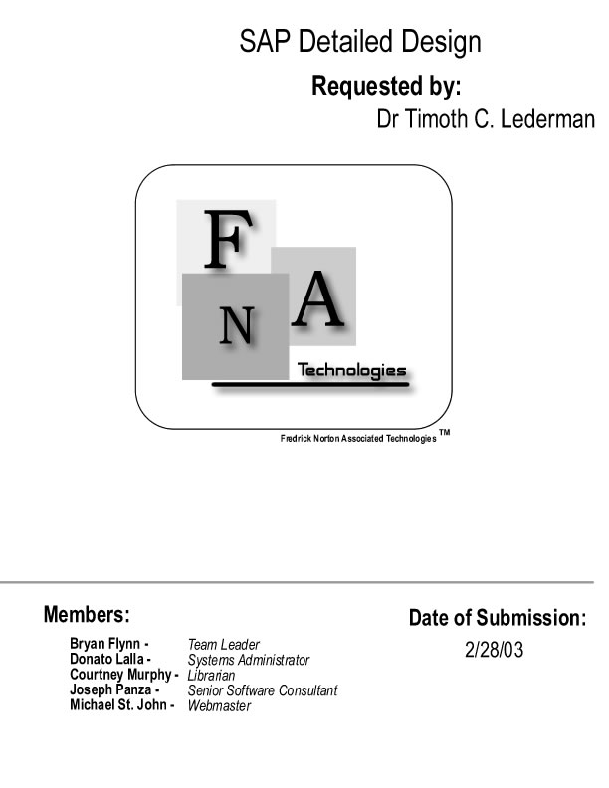
Table of Contents

Project Overview | 3
External Design Specifications
- User displays and report formats | 4
- User command summary | 12
- Detailed data flow diagrams | 14
- Logical data dictionary | 22
- File and data cross-reference | 88

Architectural Design Specification
- Structure diagrams | 125
- Parameter specifications | 133
- Logical data Structures | 134
- Functional descriptions | 135

Test Requirements
- Requirements inventory | 136
- Design inventory | 137
- Testing plan | 137

Detailed Design Specification
- Subprogram interface specifications and pseudo-code for each routine | 147
- Documentation prologue for each routine | 153
- Physical data structures and data file specifications | 155
- Packaging specifications | 156
Glossary | 157

Project Overview

The SAP (Service Award Program) will be a software package that works in conjunction with a Microsoft Access database. This package will allow for information to be easily accessible, data entry to be performed more efficiently, and making point calculations an automated task provided by the system. This system is being developed in cooperation with our client, Dr. Timoth Lederman, on behalf of the Castleton Volunteer Ambulance Service. Operators of the SAP system will interface with menus, forms, and reports. All of these attributes of the system will be developed through the use of Microsoft Visual Basic 6.0, and Microsoft Access. To summarize, this system will make the management of data much easier then was ever possible before, along with creating a product that will be timely and efficient.
Section 1: External Design Specifications

User Displays and Report Formats

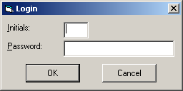

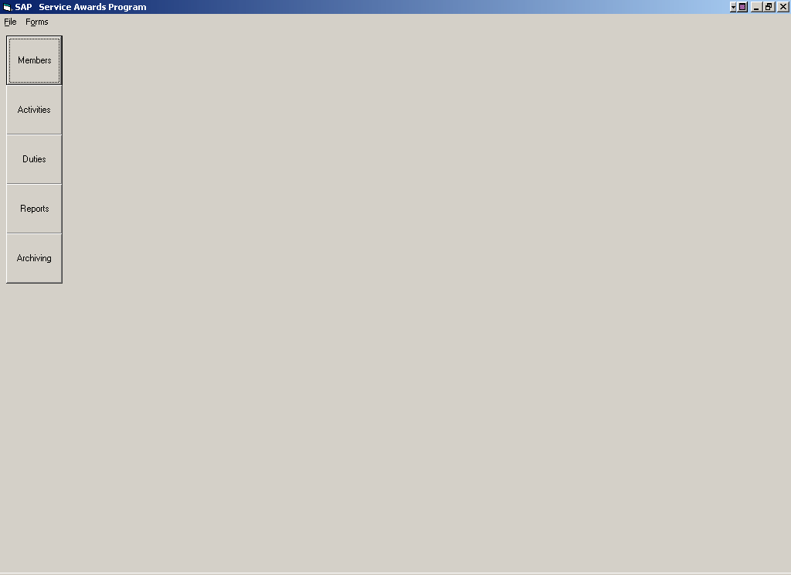

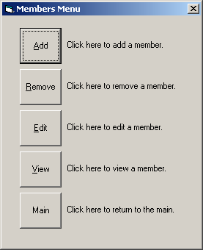

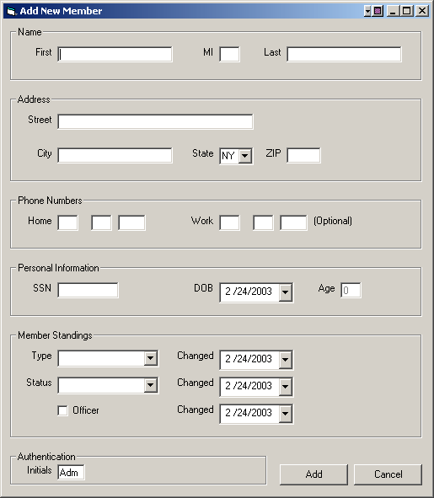

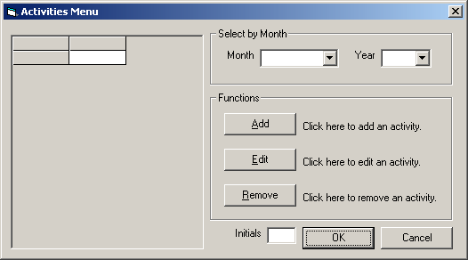

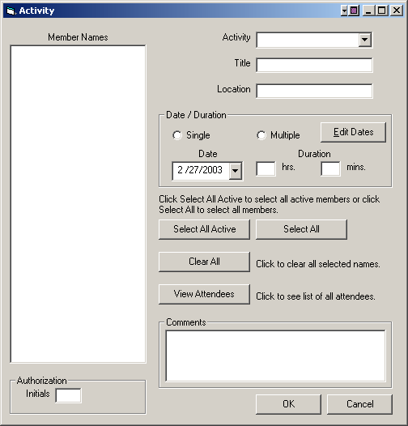

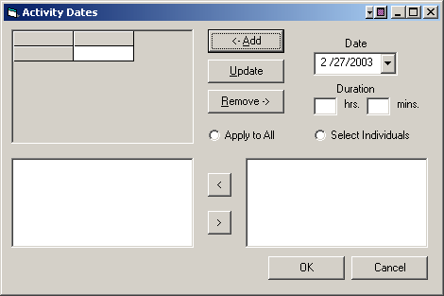

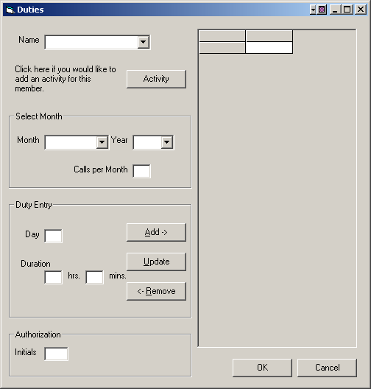

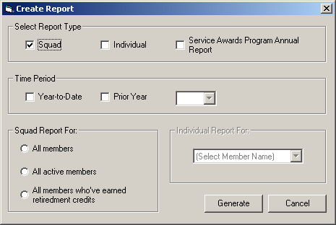

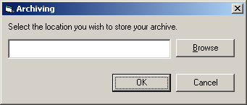

User Command Summary

Log In
The user may enter in their initials along with the system password and then click Ok. They will then enter the main menu. If the user opts to click the Cancel button, the program will then close.

Main Screen
The user is prompted with several options. If the Members button is clicked the user will be brought to the Member profile sub-menu. If the user clicks on the Activities button, it will bring them to the Activities Menu. If they click on Duties, it will bring them to the Duty Form. By clicking on Reports, the Report Form will be displayed. If they click on Archiving, it brings the user to the Archiving screen. The majority of the main screen will be occupied by the generated reports.

Members
The user can choose to Add, Remove, Edit, or View a member’s information. If they click on Add, the user is brought to the add member form. If they click Remove, they are brought to the Remove Member screen, and if the user clicks on Edit, they will be taken to the Edit User form. The member’s profile can be viewed by clicking on the View button. The user may also choose to return to the Main menu by clicking on Main.

Activity Menu
If the activity the user wishes to enter information about is not shown in the column displayed on the left of the screen, which is searchable by month, they can then choose to Add a new Activity by clicking Add. A new activity form will be displayed.
If the activity is displayed in the column, the user can edit the activity information by selecting the activity and then clicking Edit. The user will be taken to an Existing Activity Form.
If the user wants to remove an activity from the database, they can select the activity and then click remove. After the user is done making changes, they will click Ok and return to the Main Menu. The user can choose to return to the Main Menu at any time by clicking Cancel.

New Activity Form
The user enters in the activity type, title and location. Then selects whether the activity took place over one day or over several. If the user selects a single date, they will then enter in that date. If they select multiple, they will then select edit dates and enter in the dates the activity took place. The user also has the option of applying the additional dates to all attending members, or individual ones. After the dates are entered in both instances, the user will then select the member names for the entire activity. The user also has the option of selecting single users by clicking on each individual name, by selecting all members and selecting all active members by clicking on their respective buttons. There is also the option of clearing all names that have been selected by clicking Clear All. The user may also view the names that have been selected by clicking on View Attendees. The user then enters their initials, and when all information has been entered, clicks OK. The user will then be taken back to the Activity Menu. At any point, the user can return to the Activity Menu by clicking Cancel.

Existing Activity Form
The user can edit any information pertaining to a specific activity on this form. All steps in the New Activity Form apply to this form as well. At any point, the user can return to the Activity Menu by clicking Cancel.

Duties
The user enters in all Duty Data and then clicks add. The added duty information will be displayed to the user. The user can then enter in more duty data until they have entered all the duty for the member. To commit the data to the database, the user will click Update and the database will be updated. The user is sent a verification message and will then return to the duty form. The user can remove any duty data by selecting the duty in the display screen and then clicking Remove. The user will be giving a remove verification and then go back to Duty Data. If the user wants to enter in a full activity, they can enter the date in and then select Activity and the user will be taken to the New Activity form.

Reports
The user can request several reports. They can request an Individual Report, a Squad Report or a Service Awards Program Annual Report. To view an Individual Report, the user will click on Individual box, select the year that they want the report for, and the member the report is for, then click Generate to create and view the report. If the user would like to request a Squad Report, they will click on the Squad box, select the year they want the report for, type of squad report they which to view, and click Generate to create and view the report. If the user would like a Service Awards Program Annual Report, they would click on the Service Awards Program Annual Report box, select the year of the report they wish to view, and again click Generate to create and view the report.

Archiving
The user will be prompted to select the device where they want to store the database. The database will be stored as a Microsoft Access Database with an *.mdb extension. They will click Ok, and receive a verification message when the storage is completed or an error message if there is a problem with storing the data.

Detailed Data Flow Diagrams
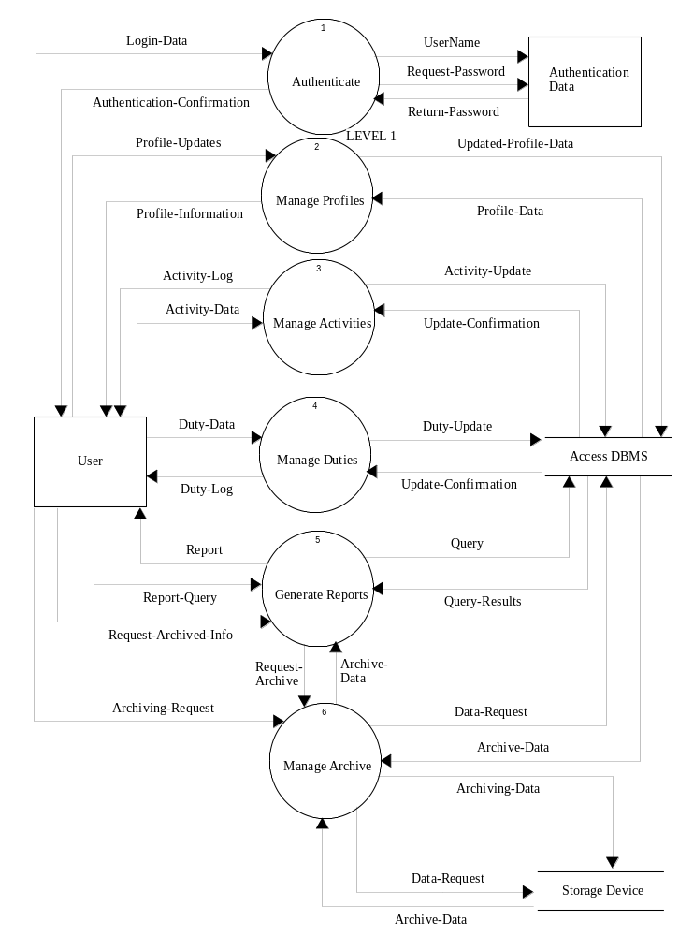
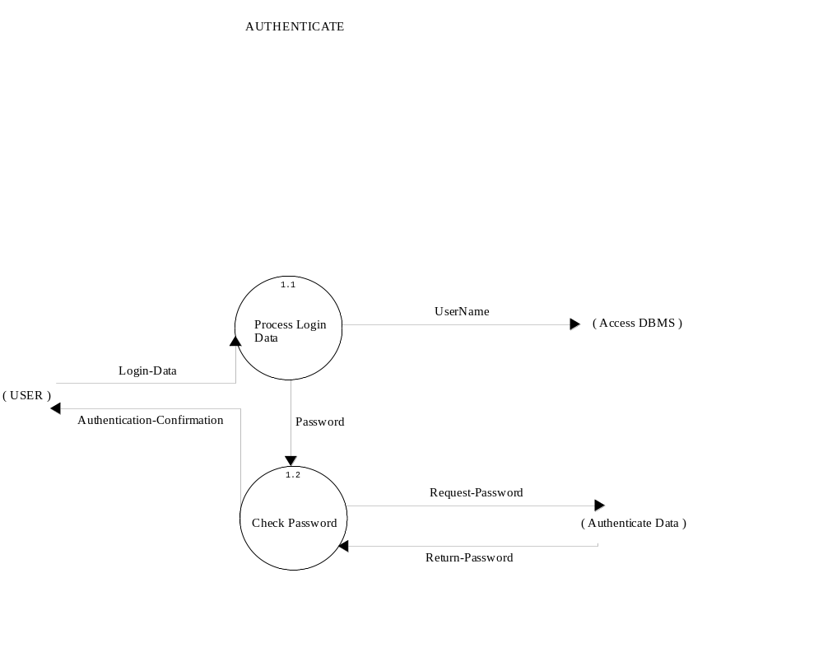
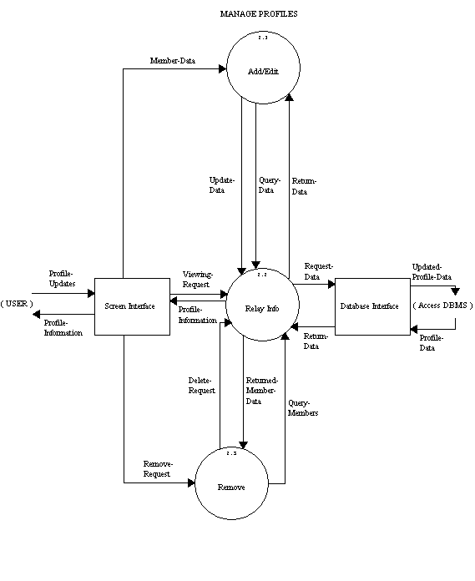
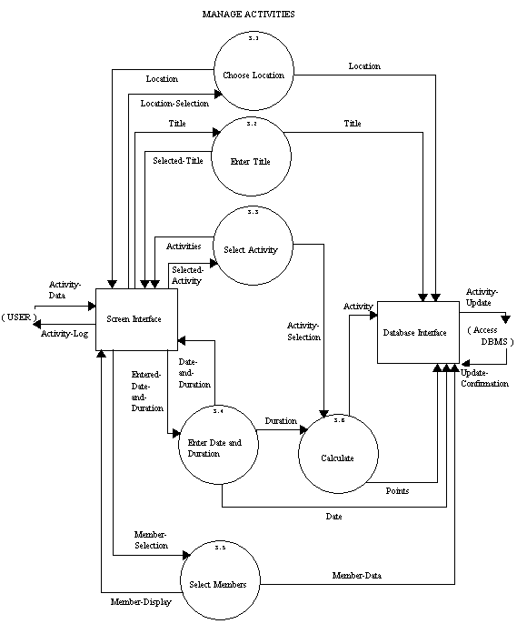
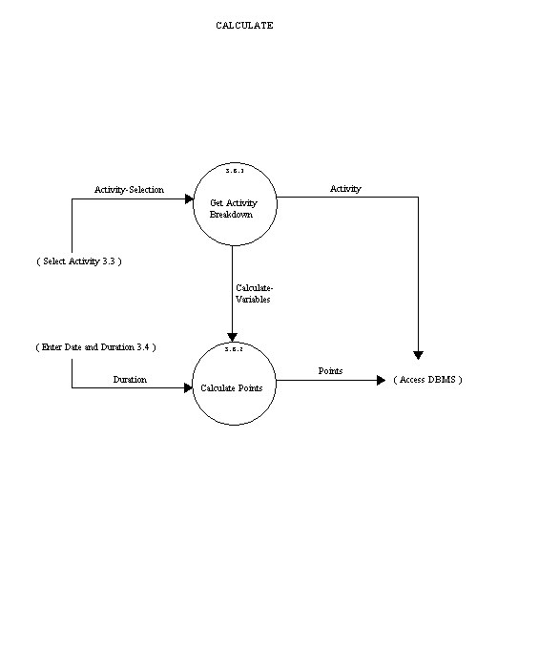
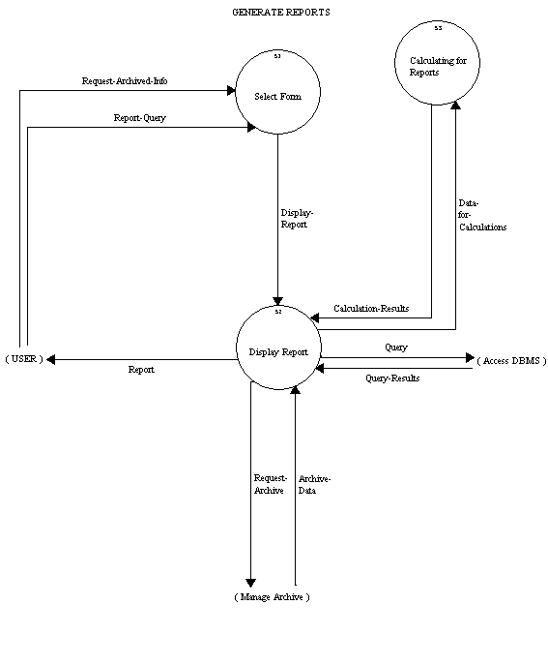
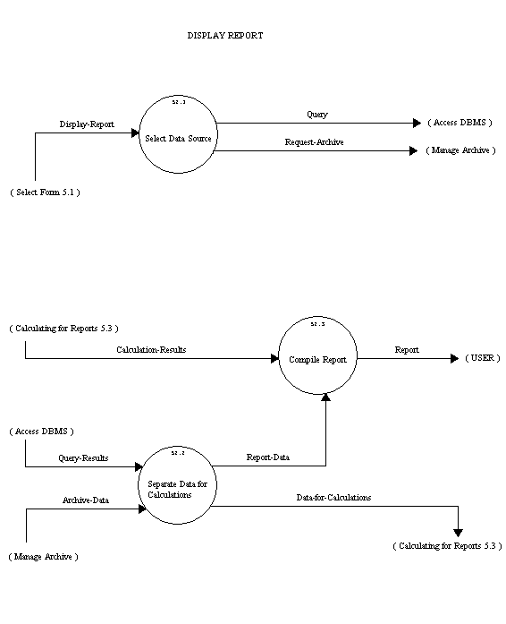
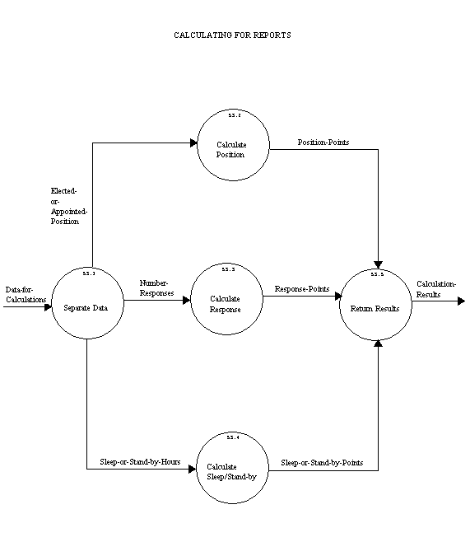
Logical Data Dictionary

LEVEL 1

Authentication Data Source/Sink
Description:
A file holding the information that allows users to access the system.
Location:
level 1 ( 0 )
Input Flows:
Request-Password
Initials
Output Flows:
Return-Password
Date Last Altered:11/24/2002 Date Created:11/24/2002
---------------------------------------------------------------------------------
User Source/Sink
Description:
The person logged in and operating the software.
Location:
level 1 ( 0 )
Input Flows:
Duty-Log
Activity-Log
Report
Authentication-Confirmation
Profile-Information
Authentication-Confirmation
Output Flows:
Activity-DAta
Request-Archived-Info
Archiving-Request
Login-Data
Profile-Updates
Duty-Data
Login-Data
Profile-Updates
Request-Archived-Info
Date Last Altered:11/24/2002 Date Created:11/24/2002
---------------------------------------------------------------------------------
Access DBMS File
Description:
The Microsoft Access Database in which all Member/Activity/Duty data will
be stored.
Composition:
Activity-Update
Archive-Data
Data-Request
Profile-Data
Query
Query-Results
Update-Confirmation
Updated-Profile-Data
Location:
level 1 ( 0 )
Input Flows:
Duty-Update
Activity-Update
Query
Data-Requst
Updated-Profile-Data
Initials
Updated-Profile-Data
Data-Request
Output Flows:
Update-Confirmation
Archive-Data
Profile-Data
Update-Confirmation
Profile-Data
Query-Results
Archive-Data
Date Last Altered:11/24/2002 Date Created:11/24/2002
---------------------------------------------------------------------------------
Storage Device File
Description:
Anything that data will be archived to, such as disk, cd or hard drive, etc.
Location:
level 1 ( 0 )
Input Flows:
Data-Request
Archiving-Data
Data-Request
Output Flows:
Archive-Data
Archive-Data
Date Last Altered:11/24/2002 Date Created:11/24/2002
---------------------------------------------------------------------------------
Authenticate Process
Description:
Secures the system from entry from unwanted users.
Process #: 1
Process Description:
Takes the user entered log in data and sends the password on to be
verified and sends the user's initials to the database. A confirmation is
then sent back to the user.
Location:
level 1 ( 0 )
Input Flows:
Return-Password
Login-Data
Output Flows:
Request-Password
Authentication-Confirmation
Initials
Date Last Altered:11/24/2002 Date Created:11/24/2002
---------------------------------------------------------------------------------
Generate Reports Process
Description:
Allows the user to choose from five different query types from the
database, this includes current information and archived data.
Process #: 5
Process Description:
Takes in a query or archive request from the user and returns the report
from the database or storage device.
Notes:
The five types of queries are: annual report, individual summary,
individual detailed, squad summary and squad detailed.
Location:
level 1 ( 0 )
Input Flows:
Report-Query
Archive-Data
Report-Query
Query-Results
Output Flows:
Request-Archive
Query
Report
Date Last Altered:11/24/2002 Date Created:11/24/2002
---------------------------------------------------------------------------------
Manage Activities Process
Description:
Stores activity information in the database.
Process #: 3
Process Description:
Takes the activities information as inputed by the user and stores them
into the database.
Location:
level 1 ( 0 )
Input Flows:
Activity-DAta
Update-Confirmation
Output Flows:
Activity-Log
Activity-Update
Date Last Altered:11/24/2002 Date Created:11/24/2002
---------------------------------------------------------------------------------
Manage Archive Process
Description:
Archives data from database to a specific storage device.
Process #: 6
Process Description:
Retrieves the requested data from the database as specified by the user
and stores to a storage device.
Location:
level 1 ( 0 )
Input Flows:
Archiving-Request
Request-Archive
Archive-Data
Archive-Data
Output Flows:
Data-Requst
Archiving-Data
Data-Request
Date Last Altered:11/24/2002 Date Created:11/24/2002
---------------------------------------------------------------------------------
Manage Duties Process
Description:
Stores Duty information entered by the user in the database.
Process #: 4
Process Description:
Takes the Duty information as inputed by the user and stores them
into the database.
Location:
level 1 ( 0 )
Input Flows:
Update-Confirmation
Duty-Data
Output Flows:
Duty-Log
Duty-Update
Date Last Altered:11/24/2002 Date Created:11/24/2002
---------------------------------------------------------------------------------
Manage Profiles Process
Description:
Allows the addition, editing, deletion and viewing of member profiles.
Process #: 2
Process Description:
Any changes the user may need to make are modified in the database.
Location:
level 1 ( 0 )
Input Flows:
Profile-Updates
Profile-Data
Output Flows:
Profile-Information
Updated-Profile-Data
Date Last Altered:11/24/2002 Date Created:11/24/2002
---------------------------------------------------------------------------------
Activity-DAta Data Flow
Description:
All the activity data inputted by the user.
Location:
level 1 ( 0 )
Source:User ( Source/Sink )
Dest: Manage Activities ( Process )
Manage Activities ( 3 )
Source:*** Not on Diagram ***
Dest: Screen Interface ( Source/Sink )
Date Last Altered:11/24/2002 Date Created:11/24/2002
---------------------------------------------------------------------------------
Activity-Log Data Flow
Description:
The activity information which needs to be displayed to the user .
Location:
level 1 ( 0 )
Source:Manage Activities ( Process )
Dest: User ( Source/Sink )
Manage Activities ( 3 )
Source:Screen Interface ( Source/Sink )
Dest: *** Not on Diagram ***
Date Last Altered:11/24/2002 Date Created:11/24/2002
---------------------------------------------------------------------------------
Activity-Update Data Flow
Description:
The new activity information to be sent to the database to update it.
Location:
level 1 ( 0 )
Source:Manage Activities ( Process )
Dest: Access DBMS ( File )
Manage Activities ( 3 )
Source:Database Interface ( Source/Sink )
Dest: *** Not on Diagram ***
File --> Access DBMS
Date Last Altered:11/24/2002 Date Created:11/24/2002
---------------------------------------------------------------------------------
Archive-Data Data Flow
Description:
Data that has been archived already and it being inputed from a storage
device.
Location:
level 1 ( 0 )
Source:Manage Archive ( Process )
Dest: Generate Reports ( Process )
Source:Access DBMS ( File )
Dest: Manage Archive ( Process )
Source:Storage Device ( File )
Dest: Manage Archive ( Process )
Generate Reports ( 5 )
Source:*** Not on Diagram ***
Dest: Display Report ( Process )
Manage Archive ( 6 )
Source:*** Not on Diagram ***
Dest: Manage Storage Device ( Process )
Source:Manage Storage Device ( Process )
Dest: *** Not on Diagram ***
Source:Storage Device ( File )
Dest: *** Not on Diagram ***
File --> Access DBMS
Display Report ( 5.2 )
Source:*** Not on Diagram ***
Dest: Separate Data for Calculations ( Process )
Date Last Altered:11/24/2002 Date Created:11/24/2002
---------------------------------------------------------------------------------
Archiving-Data Data Flow
Description:
Data that is being transferred to a storage device to be archived.
Location:
level 1 ( 0 )
Source:Manage Archive ( Process )
Dest: Storage Device ( File )
Manage Archive ( 6 )
Source:*** Not on Diagram ***
Dest: Handle Archiving ( Process )
Source:Manage Archive ( Process )
Dest: *** Not on Diagram ***
Date Last Altered:11/24/2002 Date Created:11/24/2002
---------------------------------------------------------------------------------
Archiving-Request Data Flow
Description:
An index to data that is going to be transferred from a database to a
storage device.
Location:
level 1 ( 0 )
Source:User ( Source/Sink )
Dest: Manage Archive ( Process )
Manage Archive ( 6 )
Source:*** Not on Diagram ***
Dest: Handle Archiving ( Process )
Date Last Altered:11/24/2002 Date Created:11/24/2002
---------------------------------------------------------------------------------
Authentication-Confirmation Data Flow
Description:
The information displayed to the user verifying their sucessful/failed log in
attempt.
Location:
level 1 ( 0 )
Source:Authenticate ( Process )
Dest: User ( Source/Sink )
Generate Reports ( 5 )
Source:*** Not on Diagram ***
Dest: *** Not on Diagram ***
Authenticate ( 1 )
Source:Check Password ( Process )
Dest: *** Not on Diagram ***
Source:Authenticate ( Process )
Dest: User ( Source/Sink )
Date Last Altered:11/24/2002 Date Created:11/24/2002
---------------------------------------------------------------------------------
Data-Request Data Flow
Description:
The archived data requested to be retrieved from the storage device.
Location:
level 1 ( 0 )
Source:Manage Archive ( Process )
Dest: Storage Device ( File )
Manage Archive ( 6 )
Source:Manage Storage Device ( Process )
Dest: *** Not on Diagram ***
Source:Manage Archive ( Process )
Dest: Storage Device ( File )
File --> Access DBMS
Date Last Altered:11/24/2002 Date Created:11/24/2002
---------------------------------------------------------------------------------
Duty-Data Data Flow
Description:
The name, date, duration of duties, and calls per month.
Location:
level 1 ( 0 )
Source:User ( Source/Sink )
Dest: Manage Duties ( Process )
Manage Duties ( 4 )
Source:*** Not on Diagram ***
Dest: Screen Interface ( Source/Sink )
Date Last Altered:11/24/2002 Date Created:11/24/2002
---------------------------------------------------------------------------------
Duty-Log Data Flow
Description:
The duty information which needs to be displayed to the user.
Location:
level 1 ( 0 )
Source:Manage Duties ( Process )
Dest: User ( Source/Sink )
Manage Duties ( 4 )
Source:Screen Interface ( Source/Sink )
Dest: *** Not on Diagram ***
Date Last Altered:11/24/2002 Date Created:11/24/2002
---------------------------------------------------------------------------------
Duty-Update Data Flow
Description:
All new duty data to be inputed into the Access DBMS.
Location:
level 1 ( 0 )
Source:Manage Duties ( Process )
Dest: Access DBMS ( File )
Manage Duties ( 4 )
Source:Database Interface ( Source/Sink )
Dest: *** Not on Diagram ***
Date Last Altered:11/24/2002 Date Created:11/24/2002
---------------------------------------------------------------------------------
Initials Data Flow
Description:
The user's initials that are inputed at the log in screen that will be stored in
the database.
Notes:
2-3 characters in length
Location:
level 1 ( 0 )
Source:Authenticate ( Process )
Dest: Access DBMS ( File )
Source:Authenticate ( Process )
Dest: Authentication Data ( Source/Sink )
Authenticate ( 1 )
Source:Process Login Data ( Process )
Dest: *** Not on Diagram ***
Date Last Altered:11/24/2002 Date Created:11/24/2002
---------------------------------------------------------------------------------
Login-Data Data Flow
Description:
The initials and password inputed by the user at the log-in screen.
Location:
level 1 ( 0 )
Source:User ( Source/Sink )
Dest: Authenticate ( Process )
Generate Reports ( 5 )
Source:*** Not on Diagram ***
Dest: *** Not on Diagram ***
Authenticate ( 1 )
Source:*** Not on Diagram ***
Dest: Process Login Data ( Process )
Source:User ( Source/Sink )
Dest: *** Not on Diagram ***
Date Last Altered:11/24/2002 Date Created:11/24/2002
---------------------------------------------------------------------------------
Profile-Data Data Flow
Description:
Member data requested from the database.
Location:
level 1 ( 0 )
Source:Access DBMS ( File )
Dest: Manage Profiles ( Process )
Manage Profiles ( 2 )
Source:Access DBMS ( File )
Dest: Database Interface ( Source/Sink )
File --> Access DBMS
Date Last Altered:11/24/2002 Date Created:11/24/2002
---------------------------------------------------------------------------------
Profile-Information Data Flow
Description:
The member information to be displayed to the user.
Location:
level 1 ( 0 )
Source:Manage Profiles ( Process )
Dest: User ( Source/Sink )
Manage Profiles ( 2 )
Source:Screen Interface ( Source/Sink )
Dest: *** Not on Diagram ***
Source:Relay Info ( Process )
Dest: Screen Interface ( Source/Sink )
Date Last Altered:11/24/2002 Date Created:11/24/2002
---------------------------------------------------------------------------------
Profile-Updates Data Flow
Description:
Changes made to member profiles.
Location:
level 1 ( 0 )
Source:User ( Source/Sink )
Dest: Manage Profiles ( Process )
Manage Profiles ( 2 )
Source:User ( Source/Sink )
Dest: Manage Profiles ( Process )
Date Last Altered:11/24/2002 Date Created:11/24/2002
---------------------------------------------------------------------------------
Query Data Flow
Description:
The report requested from the database.
Location:
level 1 ( 0 )
Source:Generate Reports ( Process )
Dest: Access DBMS ( File )
Generate Reports ( 5 )
Source:Display Report ( Process )
Dest: *** Not on Diagram ***
File --> Access DBMS
Display Report ( 5.2 )
Source:Select Data Source ( Process )
Dest: *** Not on Diagram ***
Date Last Altered:11/24/2002 Date Created:11/24/2002
---------------------------------------------------------------------------------
Query-Results Data Flow
Description:
The requested report information as queried from the database.
Location:
level 1 ( 0 )
Source:Access DBMS ( File )
Dest: Generate Reports ( Process )
Generate Reports ( 5 )
Source:*** Not on Diagram ***
Dest: Display Report ( Process )
File --> Access DBMS
Display Report ( 5.2 )
Source:*** Not on Diagram ***
Dest: Separate Data for Calculations ( Process )
Date Last Altered:11/24/2002 Date Created:11/24/2002
---------------------------------------------------------------------------------
Report Data Flow
Description:
One of the 5 different forms of data to be displayed to the user.
Location:
level 1 ( 0 )
Source:Generate Reports ( Process )
Dest: User ( Source/Sink )
Generate Reports ( 5 )
Source:Display Report ( Process )
Dest: *** Not on Diagram ***
Display Report ( 5.2 )
Source:Compile Report ( Process )
Dest: *** Not on Diagram ***
Date Last Altered:11/24/2002 Date Created:11/24/2002
---------------------------------------------------------------------------------
Report-Query Data Flow
Description:
Request for one of the 5 types of reports.
Location:
level 1 ( 0 )
Source:User ( Source/Sink )
Dest: Generate Reports ( Process )
Generate Reports ( 5 )
Source:*** Not on Diagram ***
Dest: Select Form ( Process )
Date Last Altered:11/24/2002 Date Created:11/24/2002
---------------------------------------------------------------------------------
Request-Archive Data Flow
Description:
Information requested to be archived from the database.
Location:
level 1 ( 0 )
Source:Generate Reports ( Process )
Dest: Manage Archive ( Process )
Generate Reports ( 5 )
Source:Display Report ( Process )
Dest: *** Not on Diagram ***
Manage Archive ( 6 )
Source:*** Not on Diagram ***
Dest: Manage Storage Device ( Process )
Display Report ( 5.2 )
Source:Select Data Source ( Process )
Dest: *** Not on Diagram ***
Date Last Altered:11/24/2002 Date Created:11/24/2002
---------------------------------------------------------------------------------
Request-Archived-Info Data Flow
Description:
Requested information to be retreived from a storage device.
Location:
level 1 ( 0 )
Source:User ( Source/Sink )
Dest: Generate Reports ( Process )
Generate Reports ( 5 )
Source:*** Not on Diagram ***
Dest: Select Form ( Process )
Date Last Altered:11/24/2002 Date Created:11/24/2002
---------------------------------------------------------------------------------
Request-Password Data Flow
Description:
The password entered by the user to be sent to the authenticate data for
verification.
Location:
level 1 ( 0 )
Source:Authenticate ( Process )
Dest: Authentication Data ( Source/Sink )
Generate Reports ( 5 )
Source:*** Not on Diagram ***
Dest: *** Not on Diagram ***
Authenticate ( 1 )
Source:Check Password ( Process )
Dest: *** Not on Diagram ***
Source:*** Not on Diagram ***
Dest: *** Not on Diagram ***
Date Last Altered:11/24/2002 Date Created:11/24/2002
---------------------------------------------------------------------------------
Return-Password Data Flow
Description:
Returns whether or not the entered password was found in Authenticate
Data.
Location:
level 1 ( 0 )
Source:Authentication Data ( Source/Sink )
Dest: Authenticate ( Process )
Generate Reports ( 5 )
Source:*** Not on Diagram ***
Dest: Authenticate ( Process )
Authenticate ( 1 )
Source:*** Not on Diagram ***
Dest: Check Password ( Process )
Source:*** Not on Diagram ***
Dest: *** Not on Diagram ***
Date Last Altered:11/24/2002 Date Created:11/24/2002
---------------------------------------------------------------------------------
Update-Confirmation Data Flow
Description:
The data sent back to the database interface confirming that an update has
been made to the database.
Location:
level 1 ( 0 )
Source:Access DBMS ( File )
Dest: Manage Duties ( Process )
Source:Access DBMS ( File )
Dest: Manage Activities ( Process )
Manage Duties ( 4 )
Source:*** Not on Diagram ***
Dest: Database Interface ( Source/Sink )
Manage Activities ( 3 )
Source:*** Not on Diagram ***
Dest: Database Interface ( Source/Sink )
File --> Access DBMS
Date Last Altered:11/24/2002 Date Created:11/24/2002
---------------------------------------------------------------------------------
Updated-Profile-Data Data Flow
Description:
Member data that has been edited by the user that is being sent to
update the database
Location:
level 1 ( 0 )
Source:Manage Profiles ( Process )
Dest: Access DBMS ( File )
Manage Profiles ( 2 )
Source:Database Interface ( Source/Sink )
Dest: Access DBMS ( File )
File --> Access DBMS
Date Last Altered:11/24/2002 Date Created:11/24/2002
---------------------------------------------------------------------------------

LEVEL 2

AUTHENTICATE (1)

Check Password Process
Description:
Varifies the user password to allow access to the system.
Process #: 1.2
Process Description:
Takes in the user entered password, sends it to be authenticated and
then sends the user confirmation on the sucessful or failed log in
attempt.
Location:
Authenticate ( 1 )
Input Flows:
Return-Password
Password
Output Flows:
Request-Password
Authentication-Confirmation
Date Last Altered:11/24/2002 Date Created:11/24/2002
---------------------------------------------------------------------------------
Process Login Data Process
Description:
Separates the log in data into initials and password.
Process #: 1.1
Process Description:
Takes the log in information entered by the user and sends the initials to
be stored in the database and the password to be verified.
Location:
Authenticate ( 1 )
Input Flows:
Login-Data
Output Flows:
Initials
Password
Date Last Altered:11/24/2002 Date Created:11/24/2002
---------------------------------------------------------------------------------
Authentication-Confirmation Data Flow
Description:
The information displayed to the user verifying their sucessful/failed log in
attempt.
Location:
level 1 ( 0 )
Source:Authenticate ( Process )
Dest: User ( Source/Sink )
Generate Reports ( 5 )
Source:*** Not on Diagram ***
Dest: *** Not on Diagram ***
Authenticate ( 1 )
Source:Check Password ( Process )
Dest: *** Not on Diagram ***
Source:Authenticate ( Process )
Dest: User ( Source/Sink )
Date Last Altered:11/24/2002 Date Created:11/24/2002
---------------------------------------------------------------------------------
Initials Data Flow
Description:
The user's initials that are inputed at the log in screen that will be stored in
the database.
Notes:
2-3 characters in length
Location:
level 1 ( 0 )
Source:Authenticate ( Process )
Dest: Access DBMS ( File )
Source:Authenticate ( Process )
Dest: Authentication Data ( Source/Sink )
Authenticate ( 1 )
Source:Process Login Data ( Process )
Dest: *** Not on Diagram ***
Date Last Altered:11/24/2002 Date Created:11/24/2002
---------------------------------------------------------------------------------
Login-Data Data Flow
Description:
The initials and password inputed by the user at the log-in screen.
Location:
level 1 ( 0 )
Source:User ( Source/Sink )
Dest: Authenticate ( Process )
Generate Reports ( 5 )
Source:*** Not on Diagram ***
Dest: *** Not on Diagram ***
Authenticate ( 1 )
Source:*** Not on Diagram ***
Dest: Process Login Data ( Process )
Source:User ( Source/Sink )
Dest: *** Not on Diagram ***
Date Last Altered:11/24/2002 Date Created:11/24/2002
---------------------------------------------------------------------------------
Password Data Flow
Description:
The password entered by the user.
Location:
Authenticate ( 1 )
Source:Process Login Data ( Process )
Dest: Check Password ( Process )
Date Last Altered:11/24/2002 Date Created:11/24/2002
---------------------------------------------------------------------------------
Request-Password Data Flow
Description:
The password entered by the user to be sent to the authenticate data for
verification.
Location:
level 1 ( 0 )
Source:Authenticate ( Process )
Dest: Authentication Data ( Source/Sink )
Generate Reports ( 5 )
Source:*** Not on Diagram ***
Dest: *** Not on Diagram ***
Authenticate ( 1 )
Source:Check Password ( Process )
Dest: *** Not on Diagram ***
Source:*** Not on Diagram ***
Dest: *** Not on Diagram ***
Date Last Altered:11/24/2002 Date Created:11/24/2002
---------------------------------------------------------------------------------
Return-Password Data Flow
Description:
Returns whether or not the entered password was found in Authenticate
Data.
Location:
level 1 ( 0 )
Source:Authentication Data ( Source/Sink )
Dest: Authenticate ( Process )
Generate Reports ( 5 )
Source:*** Not on Diagram ***
Dest: Authenticate ( Process )
Authenticate ( 1 )
Source:*** Not on Diagram ***
Dest: Check Password ( Process )
Source:*** Not on Diagram ***
Dest: *** Not on Diagram ***
Date Last Altered:11/24/2002 Date Created:11/24/2002
---------------------------------------------------------------------------------

MANAGE PROFILES (2)

Add/Edit Process
Description:
Allows the user to add or edit members and member information into the
database.
Process #: 2.1
Process Description:
Takes the inputed user updates and sends it to Relay Info which will
send it on to the database interface.
Location:
Manage Profiles ( 2 )
Input Flows:
Member-Data
Return-Data
Output Flows:
Update-Data
Query-Data
Date Last Altered:11/24/2002 Date Created:11/24/2002
---------------------------------------------------------------------------------
Relay Info Process
Description:
Transfers the requested member information to the process in which it is
needed.
Process #: 2.2
Process Description:
It can 1) relay member information to be viewed to user. 2) Allow
member data in the database to be added or edited or 3) Allow member
data stored in the database to be removed.
Location:
Manage Profiles ( 2 )
Input Flows:
Viewing-Request
Query-Members
Delete-Request
Update-Data
Query-Data
Return-Data
Output Flows:
Returned-Member-Data
Return-Data
Request-Data
Profile-Information
Date Last Altered:11/24/2002 Date Created:11/24/2002
---------------------------------------------------------------------------------
Remove Process
Description:
Allows the user to remove a member and their corresponding member
information from the database.
Process #: 2.3
Process Description:
Takes the remove request made by the user and matches it with the
database information and removes all relevant information.
Location:
Manage Profiles ( 2 )
Input Flows:
Remove-Request
Returned-Member-Data
Output Flows:
Query-Members
Delete-Request
Date Last Altered:11/24/2002 Date Created:11/24/2002
---------------------------------------------------------------------------------
Delete-Request Data Flow
Description:
The index of the data to be deleted.
Location:
Manage Profiles ( 2 )
Source:Remove ( Process )
Dest: Relay Info ( Process )
Date Last Altered:11/24/2002 Date Created:11/24/2002
---------------------------------------------------------------------------------
Member-Data Data Flow
Description:
Information regarding a volunteer, as entered by the user.
Notes:
Data to be stored: First Name, Last Name, Middle Initial,SSN, Street,
Street2, City, State, Zip, Home Phone, Work Phone.
Location:
Manage Activities ( 3 )
Source:Select Members ( Process )
Dest: Database Interface ( Source/Sink )
Manage Profiles ( 2 )
Source:Screen Interface ( Source/Sink )
Dest: Add/Edit ( Process )
Date Last Altered:11/24/2002 Date Created:11/24/2002
---------------------------------------------------------------------------------
Profile-Data Data Flow
Description:
Member data requested from the database.
Location:
level 1 ( 0 )
Source:Access DBMS ( File )
Dest: Manage Profiles ( Process )
Manage Profiles ( 2 )
Source:Access DBMS ( File )
Dest: Database Interface ( Source/Sink )
File --> Access DBMS
Date Last Altered:11/24/2002 Date Created:11/24/2002
---------------------------------------------------------------------------------
Profile-Information Data Flow
Description:
The member information to be displayed to the user.
Location:
level 1 ( 0 )
Source:Manage Profiles ( Process )
Dest: User ( Source/Sink )
Manage Profiles ( 2 )
Source:Screen Interface ( Source/Sink )
Dest: *** Not on Diagram ***
Source:Relay Info ( Process )
Dest: Screen Interface ( Source/Sink )
Date Last Altered:11/24/2002 Date Created:11/24/2002
---------------------------------------------------------------------------------
Profile-Updates Data Flow
Description:
Changes made to member profiles.
Location:
level 1 ( 0 )
Source:User ( Source/Sink )
Dest: Manage Profiles ( Process )
Manage Profiles ( 2 )
Source:User ( Source/Sink )
Dest: Manage Profiles ( Process )
Date Last Altered:11/24/2002 Date Created:11/24/2002
---------------------------------------------------------------------------------
Query-Data Data Flow
Description:
The requested data to be edited by the user.
Location:
Manage Profiles ( 2 )
Source:Add/Edit ( Process )
Dest: Relay Info ( Process )
Date Last Altered:11/24/2002 Date Created:11/24/2002
---------------------------------------------------------------------------------
Query-Members Data Flow
Description:
Member information to be matched up with database members for deletion.
Location:
Manage Profiles ( 2 )
Source:Remove ( Process )
Dest: Relay Info ( Process )
Date Last Altered:11/24/2002 Date Created:11/24/2002
---------------------------------------------------------------------------------
Remove-Request Data Flow
Description:
The requested member information to be removed from the database.
Location:
Manage Profiles ( 2 )
Source:Screen Interface ( Source/Sink )
Dest: Remove ( Process )
Date Last Altered:11/24/2002 Date Created:11/24/2002
---------------------------------------------------------------------------------
Request-Data Data Flow
Description:
Information to be retrieved from the database to be viewed by the user.
Location:
Manage Profiles ( 2 )
Source:Relay Info ( Process )
Dest: Database Interface ( Source/Sink )
Date Last Altered:11/24/2002 Date Created:11/24/2002
---------------------------------------------------------------------------------
Return-Data Data Flow
Description:
Member data retrieved from the database to be edited or viewed by the
user.
Location:
Manage Profiles ( 2 )
Source:Relay Info ( Process )
Dest: Add/Edit ( Process )
Source:Database Interface ( Source/Sink )
Dest: Relay Info ( Process )
Date Last Altered:11/24/2002 Date Created:11/24/2002
---------------------------------------------------------------------------------
Returned-Member-Data Data Flow
Description:
Member data from the database to be removed.
Location:
Manage Profiles ( 2 )
Source:Relay Info ( Process )
Dest: Remove ( Process )
Date Last Altered:11/24/2002 Date Created:11/24/2002
---------------------------------------------------------------------------------
Update-Data Data Flow
Description:
Sends the data edited by the user to be updated to Relay Info to be
updated to the database.
Location:
Manage Profiles ( 2 )
Source:Add/Edit ( Process )
Dest: Relay Info ( Process )
Date Last Altered:11/24/2002 Date Created:11/24/2002
---------------------------------------------------------------------------------
Updated-Profile-Data Data Flow
Description:
Member data that has been edited by the user that is being sent to
update the database
Location:
level 1 ( 0 )
Source:Manage Profiles ( Process )
Dest: Access DBMS ( File )
Manage Profiles ( 2 )
Source:Database Interface ( Source/Sink )
Dest: Access DBMS ( File )
File --> Access DBMS
Date Last Altered:11/24/2002 Date Created:11/24/2002
---------------------------------------------------------------------------------
Viewing-Request Data Flow
Description:
The member information requested from the database by the user to be
viewed.
Location:
Manage Profiles ( 2 )
Source:Screen Interface ( Source/Sink )
Dest: Relay Info ( Process )
Date Last Altered:11/24/2002 Date Created:11/24/2002
---------------------------------------------------------------------------------

MANAGE ACTIVITIES (3)

Calculate Process
Description:
Tallies the points in which the members recieve for various
activities/duties performed.
Process #: 3.6
Process Description:
Takes the inputed activity/duty, by using the guidelines the comptroller
has designed, it will calculate the points the member recieves.
Location:
Manage Activities ( 3 )
Input Flows:
Activity-Selection
Duration
Output Flows:
Activity
Points
Date Last Altered:11/24/2002 Date Created:11/24/2002
---------------------------------------------------------------------------------
Choose Location Process
Description:
Allows the user to enter or select the location of an activity and store it in
the database.
Process #: 3.1
Process Description:
Takes the user selected/entered location and stores it in the database
and then displays that information back to the user.
Location:
Manage Activities ( 3 )
Input Flows:
Location-Selection
Output Flows:
Location
Location
Date Last Altered:11/24/2002 Date Created:11/24/2002
---------------------------------------------------------------------------------
Enter Date And Duration Process
Description:
Stores inputed Date and Duration as objects to be entered into the
database and also used for calculations.
Process #: 3.4
Process Description:
User enters the date and duration, they are processed through Calculate
and then stored into the database.
Location:
Manage Activities ( 3 )
Input Flows:
Entered-Date-and-Duration
Output Flows:
Date-and-Duration
Duration
Date
Date Last Altered:11/24/2002 Date Created:11/24/2002
---------------------------------------------------------------------------------
Enter Title Process
Description:
The user selects the activity title.
Process #: 3.2
Process Description:
The title is highlighted from the screen menu.
Location:
Manage Activities ( 3 )
Input Flows:
Title
Output Flows:
Title
Selected-Title
Date Last Altered:11/24/2002 Date Created:11/24/2002
---------------------------------------------------------------------------------
Select Activity Process
Description:
Takes activity selected by the user and sends it to be calculated which is
process 2.5
Process #: 3.3
Location:
Manage Activities ( 3 )
Input Flows:
Selected-Activity
Output Flows:
Activities
Activity-Selection
Date Last Altered:11/24/2002 Date Created:11/24/2002
---------------------------------------------------------------------------------
Select Members Process
Description:
Allows the user to select the members who attended a certain activity.
Process #: 3.5
Process Description:
The user inputs the names of members who were in attendance and then
sends that information to be calculated.
Location:
Manage Activities ( 3 )
Input Flows:
Member-Selection
Output Flows:
Member-Display
Member-Data
Date Last Altered:11/24/2002 Date Created:11/24/2002
---------------------------------------------------------------------------------
Activities Data Flow
Description:
The activity information to be displayed to the user for confirmation.
Location:
Manage Activities ( 3 )
Source:Select Activity ( Process )
Dest: Screen Interface ( Source/Sink )
Date Last Altered:11/24/2002 Date Created:11/24/2002
---------------------------------------------------------------------------------
Activity Data Flow
Description:
The selected activity transferred to the database after calculations take
place.
Location:
Manage Activities ( 3 )
Source:Calculate ( Process )
Dest: Database Interface ( Source/Sink )
Calculate ( 3.6 )
Source:Get Activity Breakdown ( Process )
Dest: *** Not on Diagram ***
Date Last Altered:11/24/2002 Date Created:11/24/2002
---------------------------------------------------------------------------------
Activity-DAta Data Flow
Description:
All the activity data inputted by the user.
Location:
level 1 ( 0 )
Source:User ( Source/Sink )
Dest: Manage Activities ( Process )
Manage Activities ( 3 )
Source:*** Not on Diagram ***
Dest: Screen Interface ( Source/Sink )
Date Last Altered:11/24/2002 Date Created:11/24/2002
---------------------------------------------------------------------------------
Activity-Log Data Flow
Description:
The activity information which needs to be displayed to the user .
Location:
level 1 ( 0 )
Source:Manage Activities ( Process )
Dest: User ( Source/Sink )
Manage Activities ( 3 )
Source:Screen Interface ( Source/Sink )
Dest: *** Not on Diagram ***
Date Last Altered:11/24/2002 Date Created:11/24/2002
---------------------------------------------------------------------------------
Activity-Selection Data Flow
Description:
The user selected activity which is being sent to be calculated.
Location:
Manage Activities ( 3 )
Source:Select Activity ( Process )
Dest: Calculate ( Process )
Calculate ( 3.6 )
Source:*** Not on Diagram ***
Dest: Get Activity Breakdown ( Process )
Date Last Altered:11/24/2002 Date Created:11/24/2002
---------------------------------------------------------------------------------
Activity-Update Data Flow
Description:
The new activity information to be sent to the database to update it.
Location:
level 1 ( 0 )
Source:Manage Activities ( Process )
Dest: Access DBMS ( File )
Manage Activities ( 3 )
Source:Database Interface ( Source/Sink )
Dest: *** Not on Diagram ***
File --> Access DBMS
Date Last Altered:11/24/2002 Date Created:11/24/2002
---------------------------------------------------------------------------------
Date Data Flow
Description:
The date, composed of the day, month and year.
Location:
Manage Activities ( 3 )
Source:Enter Date and Duration ( Process )
Dest: Database Interface ( Source/Sink )
Date Last Altered:11/24/2002 Date Created:11/24/2002
---------------------------------------------------------------------------------
Date-and-Duration Data Flow
Description:
The date of the activity or duty along with the duration.
Location:
Manage Activities ( 3 )
Source:Enter Date and Duration ( Process )
Dest: Screen Interface ( Source/Sink )
Date Last Altered:11/24/2002 Date Created:11/24/2002
---------------------------------------------------------------------------------
Duration Data Flow
Description:
The amount of time spent, in hours and minutes.
Location:
Manage Activities ( 3 )
Source:Enter Date and Duration ( Process )
Dest: Calculate ( Process )
Calculate ( 3.6 )
Source:*** Not on Diagram ***
Dest: Calculate Points ( Process )
Date Last Altered:11/24/2002 Date Created:11/24/2002
---------------------------------------------------------------------------------
Entered-Date-and-Duration Data Flow
Description:
It is the date and duration as inputed by the user.
Location:
Manage Activities ( 3 )
Source:Screen Interface ( Source/Sink )
Dest: Enter Date And Duration ( Process )
Date Last Altered:11/24/2002 Date Created:11/24/2002
---------------------------------------------------------------------------------
Location Data Flow
Description:
The location of the activity as inputed by the user.
Location:
Manage Activities ( 3 )
Source:Choose Location ( Process )
Dest: Screen Interface ( Source/Sink )
Source:Choose Location ( Process )
Dest: Database Interface ( Source/Sink )
Date Last Altered:11/24/2002 Date Created:11/24/2002
---------------------------------------------------------------------------------
Location-Selection Data Flow
Description:
The location to be displayed through the screen interface.
Location:
Manage Activities ( 3 )
Source:Screen Interface ( Source/Sink )
Dest: Choose Location ( Process )
Date Last Altered:11/24/2002 Date Created:11/24/2002
---------------------------------------------------------------------------------
Member-Data Data Flow
Description:
Information regarding a volunteer, as entered by the user.
Notes:
Data to be stored: First Name, Last Name, Middle Initial,SSN, Street,
Street2, City, State, Zip, Home Phone, Work Phone.
Location:
Manage Activities ( 3 )
Source:Select Members ( Process )
Dest: Database Interface ( Source/Sink )
Manage Profiles ( 2 )
Source:Screen Interface ( Source/Sink )
Dest: Add/Edit ( Process )
Date Last Altered:11/24/2002 Date Created:11/24/2002
---------------------------------------------------------------------------------
Member-Display Data Flow
Description:
The information to be displayed regarding a specific member.
Location:
Manage Activities ( 3 )
Source:Select Members ( Process )
Dest: Screen Interface ( Source/Sink )
Date Last Altered:11/24/2002 Date Created:11/24/2002
---------------------------------------------------------------------------------
Member-Selection Data Flow
Description:
The name of the member selected by the user.
Location:
Manage Activities ( 3 )
Source:Screen Interface ( Source/Sink )
Dest: Select Members ( Process )
Date Last Altered:11/24/2002 Date Created:11/24/2002
---------------------------------------------------------------------------------
Points Data Flow
Description:
The calculated points the member recieves towards retirement based on
the activities/duties performed.
Location:
Manage Activities ( 3 )
Source:Calculate ( Process )
Dest: Database Interface ( Source/Sink )
Calculate ( 3.6 )
Source:Calculate Points ( Process )
Dest: *** Not on Diagram ***
Date Last Altered:11/24/2002 Date Created:11/24/2002
---------------------------------------------------------------------------------
Selected-Activity Data Flow
Description:
The activity selected by the user in the screen interface.
Location:
Manage Activities ( 3 )
Source:Screen Interface ( Source/Sink )
Dest: Select Activity ( Process )
Date Last Altered:11/24/2002 Date Created:11/24/2002
---------------------------------------------------------------------------------
Selected-Title Data Flow
Description:
The title that has been highlighted by the user.
Location:
Manage Activities ( 3 )
Source:Enter Title ( Process )
Dest: Screen Interface ( Source/Sink )
Date Last Altered:11/24/2002 Date Created:11/24/2002
---------------------------------------------------------------------------------
Title Data Flow
Description:
The activity title; user will be able to select from a pull down menu.
Location:
Manage Activities ( 3 )
Source:Screen Interface ( Source/Sink )
Dest: Enter Title ( Process )
Source:Enter Title ( Process )
Dest: Database Interface ( Source/Sink )
Date Last Altered:11/24/2002 Date Created:11/24/2002
---------------------------------------------------------------------------------
Update-Confirmation Data Flow
Description:
The data sent back to the database interface confirming that an update has
been made to the database.
Location:
level 1 ( 0 )
Source:Access DBMS ( File )
Dest: Manage Duties ( Process )
Source:Access DBMS ( File )
Dest: Manage Activities ( Process )
Manage Duties ( 4 )
Source:*** Not on Diagram ***
Dest: Database Interface ( Source/Sink )
Manage Activities ( 3 )
Source:*** Not on Diagram ***
Dest: Database Interface ( Source/Sink )
File --> Access DBMS
Date Last Altered:11/24/2002 Date Created:11/24/2002
---------------------------------------------------------------------------------

MANAGE DUTIES (4)

Choose Name Process
Description:
Allows the user to choose a member name to record duty data in the
database.
Process #: 41
Process Description:
The user selects a name and the name is displayed to the user and the
information is updated in the database.
Location:
Manage Duties ( 4 )
Input Flows:
Name-Selection
Return-Names
Output Flows:
Member-Name
Query-Names
Date Last Altered:11/24/2002 Date Created:11/24/2002
---------------------------------------------------------------------------------
Display Info Process
Description:
Displays the member names chosen by the user along with all other
relevent information.
Process #: 42
Process Description:
Takes the member name which has been selected by the user and
retrieves all corresponding data from the database and displays it.
Location:
Manage Duties ( 4 )
Input Flows:
New-Duty-Data
Member-Name
Return-Member-Info
Output Flows:
Display-Member-Data
Query-Member-Info
Date Last Altered:11/24/2002 Date Created:11/24/2002
---------------------------------------------------------------------------------
Enter Duty Info Process
Description:
Takes the inputed duty data and stores it into the database.
Process #: 43
Process Description:
User enters all duty data through the screen interface and as entered,
the display will refresh and show the new data. When the user is done,
the data is committed to the database.
Location:
Manage Duties ( 4 )
Input Flows:
Enter-Duty-Data
Output Flows:
New-Duty-Data
Commit-Data
Date Last Altered:11/24/2002 Date Created:11/24/2002
---------------------------------------------------------------------------------
Commit-Data Data Flow
Description:
The information that the user made which is sent to the database for
update.
Location:
Manage Duties ( 4 )
Source:Enter Duty Info ( Process )
Dest: Database Interface ( Source/Sink )
Date Last Altered:11/24/2002 Date Created:11/24/2002
---------------------------------------------------------------------------------
Display-Member-Data Data Flow
Description:
The member information that is to be displayed to the user.
Location:
Manage Duties ( 4 )
Source:Display Info ( Process )
Dest: Screen Interface ( Source/Sink )
Date Last Altered:11/24/2002 Date Created:11/24/2002
---------------------------------------------------------------------------------
Duty-Data Data Flow
Description:
The name, date, duration of duties, and calls per month.
Location:
level 1 ( 0 )
Source:User ( Source/Sink )
Dest: Manage Duties ( Process )
Manage Duties ( 4 )
Source:*** Not on Diagram ***
Dest: Screen Interface ( Source/Sink )
Date Last Altered:11/24/2002 Date Created:11/24/2002
---------------------------------------------------------------------------------
Duty-Log Data Flow
Description:
The duty information which needs to be displayed to the user.
Location:
level 1 ( 0 )
Source:Manage Duties ( Process )
Dest: User ( Source/Sink )
Manage Duties ( 4 )
Source:Screen Interface ( Source/Sink )
Dest: *** Not on Diagram ***
Date Last Altered:11/24/2002 Date Created:11/24/2002
---------------------------------------------------------------------------------
Duty-Update Data Flow
Description:
All new duty data to be inputed into the Access DBMS.
Location:
level 1 ( 0 )
Source:Manage Duties ( Process )
Dest: Access DBMS ( File )
Manage Duties ( 4 )
Source:Database Interface ( Source/Sink )
Dest: *** Not on Diagram ***
Date Last Altered:11/24/2002 Date Created:11/24/2002
---------------------------------------------------------------------------------
Enter-Duty-Data Data Flow
Description:
Holds the name, year, month, day, duration, minutes and calls per month.
Location:
Manage Duties ( 4 )
Source:Screen Interface ( Source/Sink )
Dest: Enter Duty Info ( Process )
Date Last Altered:11/24/2002 Date Created:11/24/2002
---------------------------------------------------------------------------------
Member-Name Data Flow
Description:
The name of the specific volunteer to be stored in the database.
Location:
Manage Duties ( 4 )
Source:Choose Name ( Process )
Dest: Display Info ( Process )
Date Last Altered:11/24/2002 Date Created:11/24/2002
---------------------------------------------------------------------------------
Name-Selection Data Flow
Description:
The name of the volunteer selected by the user.
Location:
Manage Duties ( 4 )
Source:Screen Interface ( Source/Sink )
Dest: Choose Name ( Process )
Date Last Altered:11/24/2002 Date Created:11/24/2002
---------------------------------------------------------------------------------
New-Duty-Data Data Flow
Description:
The duty information that was entered by the user to be displayed.
Location:
Manage Duties ( 4 )
Source:Enter Duty Info ( Process )
Dest: Display Info ( Process )
Date Last Altered:11/24/2002 Date Created:11/24/2002
---------------------------------------------------------------------------------
Query-Member-Info Data Flow
Description:
Member name sent to the database in order to retrieve the other member
information.
Location:
Manage Duties ( 4 )
Source:Display Info ( Process )
Dest: Database Interface ( Source/Sink )
Date Last Altered:11/24/2002 Date Created:11/24/2002
---------------------------------------------------------------------------------
Query-Names Data Flow
Description:
Name to be matched up with the database.
Location:
Manage Duties ( 4 )
Source:Choose Name ( Process )
Dest: Database Interface ( Source/Sink )
Date Last Altered:11/24/2002 Date Created:11/24/2002
Return-Member-Info Data Flow
Description:
Retrieved duty information from the database to be displayed to the user.
Location:
Manage Duties ( 4 )
Source:Database Interface ( Source/Sink )
Dest: Display Info ( Process )
Date Last Altered:11/24/2002 Date Created:11/24/2002
---------------------------------------------------------------------------------
Return-Names Data Flow
Description:
Names retrieved from the database to be sent to process 1.1
Location:
Manage Duties ( 4 )
Source:Database Interface ( Source/Sink )
Dest: Choose Name ( Process )
Date Last Altered:11/24/2002 Date Created:11/24/2002
---------------------------------------------------------------------------------
Update-Confirmation Data Flow
Description:
The data sent back to the database interface confirming that an update has
been made to the database.
Location:
level 1 ( 0 )
Source:Access DBMS ( File )
Dest: Manage Duties ( Process )
Source:Access DBMS ( File )
Dest: Manage Activities ( Process )
Manage Duties ( 4 )
Source:*** Not on Diagram ***
Dest: Database Interface ( Source/Sink )
Manage Activities ( 3 )
Source:*** Not on Diagram ***
Dest: Database Interface ( Source/Sink )
File --> Access DBMS
Date Last Altered:11/24/2002 Date Created:11/24/2002
---------------------------------------------------------------------------------

GENERATE REPORTS (5)

Calculating for Reports Process
Description:
Determines which members have met the requirements for retirement
benefits.
Process #: 5.3
Process Description:
Takes the calculations for all the activities and duties and then
determines whether or not the members meet the retirement benefits.
Location:
Generate Reports ( 5 )
Input Flows:
Data-for-Calculations
Output Flows:
Calculation-Results
Date Last Altered:11/24/2002 Date Created:11/24/2002
---------------------------------------------------------------------------------
Display Report Process
Description:
Displays the information for report the user has selected.
Process #: 5.2
Process Description:
Displays the information for one of the 5 main reports.
Location:
Generate Reports ( 5 )
Input Flows:
Display-Report
Archive-Data
Query-Results
Calculation-Results
Output Flows:
Report
Request-Archive
Query
Data-for-Calculations
Date Last Altered:11/24/2002 Date Created:11/24/2002
---------------------------------------------------------------------------------
Select Form Process
Description:
Allows the user to select one of the 5 types of forms.
Process #: 5.1
Process Description:
Takes the type of report the user wants to view and sends it on to be
processed by display reports.
Location:
Generate Reports ( 5 )
Input Flows:
Request-Archived-Info
Report-Query
Output Flows:
Display-Report
Date Last Altered:11/24/2002 Date Created:11/24/2002
---------------------------------------------------------------------------------
Archive-Data Data Flow
Description:
Data that has been archived already and it being inputed from a storage
device.
Location:
level 1 ( 0 )
Source:Manage Archive ( Process )
Dest: Generate Reports ( Process )
Source:Access DBMS ( File )
Dest: Manage Archive ( Process )
Source:Storage Device ( File )
Dest: Manage Archive ( Process )
Generate Reports ( 5 )
Source:*** Not on Diagram ***
Dest: Display Report ( Process )
Manage Archive ( 6 )
Source:*** Not on Diagram ***
Dest: Manage Storage Device ( Process )
Source:Manage Storage Device ( Process )
Dest: *** Not on Diagram ***
Source:Storage Device ( File )
Dest: *** Not on Diagram ***
File --> Access DBMS
Display Report ( 5.2 )
Source:*** Not on Diagram ***
Dest: Separate Data for Calculations ( Process )
Date Last Altered:11/24/2002 Date Created:11/24/2002
---------------------------------------------------------------------------------
Calculation-Results Data Flow
Description:
The final information regarding whether or not the member qualifies for
retirement benefits and is displayed to the user.
Location:
Generate Reports ( 5 )
Source:Calculating for Reports ( Process )
Dest: Display Report ( Process )
Calculating for Reports ( 5.3 )
Source:Return Results ( Process )
Dest: *** Not on Diagram ***
Display Report ( 5.2 )
Source:*** Not on Diagram ***
Dest: Compile Report ( Process )
Date Last Altered:11/24/2002 Date Created:11/24/2002
---------------------------------------------------------------------------------
Data-for-Calculations Data Flow
Description:
The total credits obtained by a specific member.
Location:
Generate Reports ( 5 )
Source:Display Report ( Process )
Dest: Calculating for Reports ( Process )
Calculating for Reports ( 5.3 )
Source:*** Not on Diagram ***
Dest: Separate Data ( Process )
Display Report ( 5.2 )
Source:Separate Data for Calculations ( Process )
Dest: *** Not on Diagram ***
Date Last Altered:11/24/2002 Date Created:11/24/2002
---------------------------------------------------------------------------------
Display-Report Data Flow
Description:
Sends the report information to the process Display Report.
Location:
Generate Reports ( 5 )
Source:Select Form ( Process )
Dest: Display Report ( Process )
Display Report ( 5.2 )
Source:*** Not on Diagram ***
Dest: Select Data Source ( Process )
Date Last Altered:11/24/2002 Date Created:11/24/2002
---------------------------------------------------------------------------------
Query Data Flow
Description:
The report requested from the database.
Location:
level 1 ( 0 )
Source:Generate Reports ( Process )
Dest: Access DBMS ( File )
Generate Reports ( 5 )
Source:Display Report ( Process )
Dest: *** Not on Diagram ***
File --> Access DBMS
Display Report ( 5.2 )
Source:Select Data Source ( Process )
Dest: *** Not on Diagram ***
Date Last Altered:11/24/2002 Date Created:11/24/2002
---------------------------------------------------------------------------------
Query-Results Data Flow
Description:
The requested report information as queried from the database.
Location:
level 1 ( 0 )
Source:Access DBMS ( File )
Dest: Generate Reports ( Process )
Generate Reports ( 5 )
Source:*** Not on Diagram ***
Dest: Display Report ( Process )
File --> Access DBMS
Display Report ( 5.2 )
Source:*** Not on Diagram ***
Dest: Separate Data for Calculations ( Process )
Date Last Altered:11/24/2002 Date Created:11/24/2002
---------------------------------------------------------------------------------
Report Data Flow
Description:
One of the 5 different forms of data to be displayed to the user.
Location:
level 1 ( 0 )
Source:Generate Reports ( Process )
Dest: User ( Source/Sink )
Generate Reports ( 5 )
Source:Display Report ( Process )
Dest: *** Not on Diagram ***
Display Report ( 5.2 )
Source:Compile Report ( Process )
Dest: *** Not on Diagram ***
Date Last Altered:11/24/2002 Date Created:11/24/2002
---------------------------------------------------------------------------------
Report-Query Data Flow
Description:
Request for one of the 5 types of reports.
Location:
level 1 ( 0 )
Source:User ( Source/Sink )
Dest: Generate Reports ( Process )
Generate Reports ( 5 )
Source:*** Not on Diagram ***
Dest: Select Form ( Process )
Date Last Altered:11/24/2002 Date Created:11/24/2002
---------------------------------------------------------------------------------
Request-Archive Data Flow
Description:
Information requested to be archived from the database.
Location:
level 1 ( 0 )
Source:Generate Reports ( Process )
Dest: Manage Archive ( Process )
Generate Reports ( 5 )
Source:Display Report ( Process )
Dest: *** Not on Diagram ***
Manage Archive ( 6 )
Source:*** Not on Diagram ***
Dest: Manage Storage Device ( Process )
Display Report ( 5.2 )
Source:Select Data Source ( Process )
Dest: *** Not on Diagram ***
Date Last Altered:11/24/2002 Date Created:11/24/2002
---------------------------------------------------------------------------------
Request-Archived-Info Data Flow
Description:
Requested information to be retreived from a storage device.
Location:
level 1 ( 0 )
Source:User ( Source/Sink )
Dest: Generate Reports ( Process )
Generate Reports ( 5 )
Source:*** Not on Diagram ***
Dest: Select Form ( Process )
Date Last Altered:11/24/2002 Date Created:11/24/2002
---------------------------------------------------------------------------------

MANAGE ARCHIVE (6)

Handle Archiving Process
Description:
Retrieves data to be archived from the database.
Process #: 6.2
Process Description:
Takes the inputed archive request and retrieves the data from the
database and returns it to be sent to the storage device.
Location:
Manage Archive ( 6 )
Input Flows:
Archiving-Request
Output Flows:
Data-Request
Archiving-Data
Date Last Altered:11/24/2002 Date Created:11/24/2002
---------------------------------------------------------------------------------
Manage Storage Device Process
Description:
Both takes the data to be archived and transfers it to the storage device,
and retrieves the storage device for reports.
Process #: 6.1
Process Description:
Takes the requested archive information from Generate Reports and
retrieves the data from the storage device or takes the archiving data
from 4.2 and stores it in the storage device.
Location:
Manage Archive ( 6 )
Input Flows:
Request-Archive
Archive-Data
Archiving-Data
Output Flows:
Archive-Data
Data-Request
Archive-Data
Date Last Altered:11/24/2002 Date Created:11/24/2002
---------------------------------------------------------------------------------
Archive-Data Data Flow
Description:
Data that has been archived already and it being inputed from a storage
device.
Location:
level 1 ( 0 )
Source:Manage Archive ( Process )
Dest: Generate Reports ( Process )
Source:Access DBMS ( File )
Dest: Manage Archive ( Process )
Source:Storage Device ( File )
Dest: Manage Archive ( Process )
Generate Reports ( 5 )
Source:*** Not on Diagram ***
Dest: Display Report ( Process )
Manage Archive ( 6 )
Source:*** Not on Diagram ***
Dest: Manage Storage Device ( Process )
Source:Manage Storage Device ( Process )
Dest: *** Not on Diagram ***
Source:Storage Device ( File )
Dest: *** Not on Diagram ***
File --> Access DBMS
Display Report ( 5.2 )
Source:*** Not on Diagram ***
Dest: Separate Data for Calculations ( Process )
Date Last Altered:11/24/2002 Date Created:11/24/2002
---------------------------------------------------------------------------------
Archiving-Data Data Flow
Description:
Data that is being transferred to a storage device to be archived.
Location:
level 1 ( 0 )
Source:Manage Archive ( Process )
Dest: Storage Device ( File )
Manage Archive ( 6 )
Source:*** Not on Diagram ***
Dest: Handle Archiving ( Process )
Source:Manage Archive ( Process )
Dest: *** Not on Diagram ***
Date Last Altered:11/24/2002 Date Created:11/24/2002
---------------------------------------------------------------------------------
Archiving-Request Data Flow
Description:
An index to data that is going to be transferred from a database to a
storage device.
Location:
level 1 ( 0 )
Source:User ( Source/Sink )
Dest: Manage Archive ( Process )
Manage Archive ( 6 )
Source:*** Not on Diagram ***
Dest: Handle Archiving ( Process )
Date Last Altered:11/24/2002 Date Created:11/24/2002
---------------------------------------------------------------------------------
Data-Request Data Flow
Description:
The archived data requested to be retrieved from the storage device.
Location:
level 1 ( 0 )
Source:Manage Archive ( Process )
Dest: Storage Device ( File )
Manage Archive ( 6 )
Source:Manage Storage Device ( Process )
Dest: *** Not on Diagram ***
Source:Manage Archive ( Process )
Dest: Storage Device ( File )
File --> Access DBMS
Date Last Altered:11/24/2002 Date Created:11/24/2002
---------------------------------------------------------------------------------
Request-Archive Data Flow
Description:
Information requested to be archived from the database.
Location:
level 1 ( 0 )
Source:Generate Reports ( Process )
Dest: Manage Archive ( Process )
Generate Reports ( 5 )
Source:Display Report ( Process )
Dest: *** Not on Diagram ***
Manage Archive ( 6 )
Source:*** Not on Diagram ***
Dest: Manage Storage Device ( Process )
Display Report ( 5.2 )
Source:Select Data Source ( Process )
Dest: *** Not on Diagram ***
Date Last Altered:11/24/2002 Date Created:11/24/2002
---------------------------------------------------------------------------------

LEVEL 3

DISPLAY REPORT (5.2)

Compile Report Process
Description:
Puts together the report to be outputed to the user.
Process #: 5.2.3
Process Description:
Takes in the calculation results from 5.3 and the report data from 5.2.2
and generates the report to be seen by the user.
Location:
Display Report ( 5.2 )
Input Flows:
Calculation-Results
Report-Data
Output Flows:
Report
Date Last Altered:11/24/2002 Date Created:11/24/2002
---------------------------------------------------------------------------------
Select Data Source Process
Description:
Allows the user to choose to access the archive or the database.
Process #: 5.2.1
Process Description:
Provides the link between the user and the Access DBMS or the
Archives.
Location:
Display Report ( 5.2 )
Input Flows:
Display-Report
Output Flows:
Request-Archive
Query
Date Last Altered:11/24/2002 Date Created:11/24/2002
Separate Data for Calculations Process
Description:
Breaks down the data to be sent for calculating.
Process #: 5.2.2
Process Description:
Finds the information needed for calculations from either the Access
DBMS, or an archive.
Location:
Display Report ( 5.2 )
Input Flows:
Query-Results
Archive-Data
Output Flows:
Data-for-Calculations
Report-Data
Date Last Altered:11/24/2002 Date Created:11/24/2002
---------------------------------------------------------------------------------
Archive-Data Data Flow
Description:
Data that has been archived already and it being inputed from a storage
device.
Location:
level 1 ( 0 )
Source:Manage Archive ( Process )
Dest: Generate Reports ( Process )
Source:Access DBMS ( File )
Dest: Manage Archive ( Process )
Source:Storage Device ( File )
Dest: Manage Archive ( Process )
Generate Reports ( 5 )
Source:*** Not on Diagram ***
Dest: Display Report ( Process )
Manage Archive ( 6 )
Source:*** Not on Diagram ***
Dest: Manage Storage Device ( Process )
Source:Manage Storage Device ( Process )
Dest: *** Not on Diagram ***
Source:Storage Device ( File )
Dest: *** Not on Diagram ***
File --> Access DBMS
Display Report ( 5.2 )
Source:*** Not on Diagram ***
Dest: Separate Data for Calculations ( Process )
Date Last Altered:11/24/2002 Date Created:11/24/2002
---------------------------------------------------------------------------------
Calculation-Results Data Flow
Description:
The final information regarding whether or not the member qualifies for
retirement benefits and is displayed to the user.
Location:
Generate Reports ( 5 )
Source:Calculating for Reports ( Process )
Dest: Display Report ( Process )
Calculating for Reports ( 5.3 )
Source:Return Results ( Process )
Dest: *** Not on Diagram ***
Display Report ( 5.2 )
Source:*** Not on Diagram ***
Dest: Compile Report ( Process )
Date Last Altered:11/24/2002 Date Created:11/24/2002
---------------------------------------------------------------------------------
Data-for-Calculations Data Flow
Description:
The total credits obtained by a specific member.
Location:
Generate Reports ( 5 )
Source:Display Report ( Process )
Dest: Calculating for Reports ( Process )
Calculating for Reports ( 5.3 )
Source:*** Not on Diagram ***
Dest: Separate Data ( Process )
Display Report ( 5.2 )
Source:Separate Data for Calculations ( Process )
Dest: *** Not on Diagram ***
Date Last Altered:11/24/2002 Date Created:11/24/2002
---------------------------------------------------------------------------------
Display-Report Data Flow
Description:
Sends the report information to the process Display Report.
Location:
Generate Reports ( 5 )
Source:Select Form ( Process )
Dest: Display Report ( Process )
Display Report ( 5.2 )
Source:*** Not on Diagram ***
Dest: Select Data Source ( Process )
Date Last Altered:11/24/2002 Date Created:11/24/2002
---------------------------------------------------------------------------------
Query Data Flow
Description:
The report requested from the database.
Location:
level 1 ( 0 )
Source:Generate Reports ( Process )
Dest: Access DBMS ( File )
Generate Reports ( 5 )
Source:Display Report ( Process )
Dest: *** Not on Diagram ***
File --> Access DBMS
Display Report ( 5.2 )
Source:Select Data Source ( Process )
Dest: *** Not on Diagram ***
Date Last Altered:11/24/2002 Date Created:11/24/2002
---------------------------------------------------------------------------------
Query-Results Data Flow
Description:
The requested report information as queried from the database.
Location:
level 1 ( 0 )
Source:Access DBMS ( File )
Dest: Generate Reports ( Process )
Generate Reports ( 5 )
Source:*** Not on Diagram ***
Dest: Display Report ( Process )
File --> Access DBMS
Display Report ( 5.2 )
Source:*** Not on Diagram ***
Dest: Separate Data for Calculations ( Process )
Date Last Altered:11/24/2002 Date Created:11/24/2002
---------------------------------------------------------------------------------
Report Data Flow
Description:
One of the 5 different forms of data to be displayed to the user.
Location:
level 1 ( 0 )
Source:Generate Reports ( Process )
Dest: User ( Source/Sink )
Generate Reports ( 5 )
Source:Display Report ( Process )
Dest: *** Not on Diagram ***
Display Report ( 5.2 )
Source:Compile Report ( Process )
Dest: *** Not on Diagram ***
Date Last Altered:11/24/2002 Date Created:11/24/2002
---------------------------------------------------------------------------------
Report-Data Data Flow
Description:
Contains all the report data from either the archive or the database.
Location:
Display Report ( 5.2 )
Source:Separate Data for Calculations ( Process )
Dest: Compile Report ( Process )
Date Last Altered:11/24/2002 Date Created:11/24/2002
---------------------------------------------------------------------------------
Request-Archive Data Flow
Description:
Information requested to be archived from the database.
Location:
level 1 ( 0 )
Source:Generate Reports ( Process )
Dest: Manage Archive ( Process )
Generate Reports ( 5 )
Source:Display Report ( Process )
Dest: *** Not on Diagram ***
Manage Archive ( 6 )
Source:*** Not on Diagram ***
Dest: Manage Storage Device ( Process )
Display Report ( 5.2 )
Source:Select Data Source ( Process )
Dest: *** Not on Diagram ***
Date Last Altered:11/24/2002 Date Created:11/24/2002
---------------------------------------------------------------------------------

CALCULATING FOR REPORTS (5.3)

Calculate Position Process
Description:
Calculates the number of points you get for the position of the member.
Process #: 5.3.2
Process Description:
Takes in the separated data and calculates the number of points that
should be returned based on the members position.
Location:
Calculating for Reports ( 5.3 )
Input Flows:
Elected-or-Appointed-Position
Output Flows:
Position-Points
Date Last Altered:11/24/2002 Date Created:11/24/2002
---------------------------------------------------------------------------------
Calculate Response Process
Description:
Calculates the points to be allotted for the responses the member
responded to.
Process #: 5.3.3
Process Description:
Takes in the number of responses from the separated data and
calculates the number of points to be given for the specific number
responded to.
Location:
Calculating for Reports ( 5.3 )
Input Flows:
Number-Responses
Output Flows:
Response-Points
Date Last Altered:11/24/2002 Date Created:11/24/2002
Calculate Sleep/Stand-by Process
Description:
Calculates the number of points to be given out for sleep and stand-by
time.
Process #: 5.3.4
Process Description:
Takes in the sleep or stand-by hours and uses the calculations to
compute the number of points to be given out.
Location:
Calculating for Reports ( 5.3 )
Input Flows:
Sleep-or-Stand-by-Hours
Output Flows:
Sleep-or-Stand-by-Points
Date Last Altered:11/24/2002 Date Created:11/24/2002
---------------------------------------------------------------------------------
Return Results Process
Description:
Returns the total number of points calculated.
Process #: 5.3.5
Process Description:
Adds together the points found from the members position, calls
responded to, and sleep/stand-by time, and returns them.
Location:
Calculating for Reports ( 5.3 )
Input Flows:
Position-Points
Response-Points
Sleep-or-Stand-by-Points
Output Flows:
Calculation-Results
Date Last Altered:11/24/2002 Date Created:11/24/2002
---------------------------------------------------------------------------------
Separate Data Process
Description:
Breaks the data down into specific variables.
Process #: 5.3.1
Process Description:
The variables that are broken down by this process are the members
position, number of calls responded to, and sleep/stand-by hours.
Location:
Calculating for Reports ( 5.3 )
Input Flows:
Data-for-Calculations
Output Flows:
Elected-or-Appointed-Position
Sleep-or-Stand-by-Hours
Number-Responses
Date Last Altered:11/24/2002 Date Created:11/24/2002
---------------------------------------------------------------------------------
Calculation-Results Data Flow
Description:
The final information regarding whether or not the member qualifies for
retirement benefits and is displayed to the user.
Location:
Generate Reports ( 5 )
Source:Calculating for Reports ( Process )
Dest: Display Report ( Process )
Calculating for Reports ( 5.3 )
Source:Return Results ( Process )
Dest: *** Not on Diagram ***
Display Report ( 5.2 )
Source:*** Not on Diagram ***
Dest: Compile Report ( Process )
Date Last Altered:11/24/2002 Date Created:11/24/2002
---------------------------------------------------------------------------------
Data-for-Calculations Data Flow
Description:
The total credits obtained by a specific member.
Location:
Generate Reports ( 5 )
Source:Display Report ( Process )
Dest: Calculating for Reports ( Process )
Calculating for Reports ( 5.3 )
Source:*** Not on Diagram ***
Dest: Separate Data ( Process )
Display Report ( 5.2 )
Source:Separate Data for Calculations ( Process )
Dest: *** Not on Diagram ***
Date Last Altered:11/24/2002 Date Created:11/24/2002
---------------------------------------------------------------------------------
Elected-or-Appointed-Position Data Flow
Description:
The current position of the member.
Location:
Calculating for Reports ( 5.3 )
Source:Separate Data ( Process )
Dest: Calculate Position ( Process )
Date Last Altered:11/24/2002 Date Created:11/24/2002
---------------------------------------------------------------------------------
Number-Responses Data Flow
Description:
The number of responses a member has responded to.
Location:
Calculating for Reports ( 5.3 )
Source:Separate Data ( Process )
Dest: Calculate Response ( Process )
Date Last Altered:11/24/2002 Date Created:11/24/2002
---------------------------------------------------------------------------------
Position-Points Data Flow
Description:
The points calculated from the members position.
Location:
Calculating for Reports ( 5.3 )
Source:Calculate Position ( Process )
Dest: Return Results ( Process )
Date Last Altered:11/24/2002 Date Created:11/24/2002
---------------------------------------------------------------------------------
Response-Points Data Flow
Description:
The number of points calculated based on the number of calls responded
to.
Location:
Calculating for Reports ( 5.3 )
Source:Calculate Response ( Process )
Dest: Return Results ( Process )
Date Last Altered:11/24/2002 Date Created:11/24/2002
---------------------------------------------------------------------------------
Sleep-or-Stand-by-Hours Data Flow
Description:
The number of hours a member has spent on stand-by or sleeping on call.
Location:
Calculating for Reports ( 5.3 )
Source:Separate Data ( Process )
Dest: Calculate Sleep/Stand-by ( Process )
Date Last Altered:11/24/2002 Date Created:11/24/2002
---------------------------------------------------------------------------------
Sleep-or-Stand-by-Points Data Flow
Description:
The calculated number of points based on sleep or stand-by hours.
Location:
Calculating for Reports ( 5.3 )
Source:Calculate Sleep/Stand-by ( Process )
Dest: Return Results ( Process )
Date Last Altered:11/24/2002 Date Created:11/24/2002
---------------------------------------------------------------------------------

CALCULATE (5.6)

Calculate Points Process
Description:
Calculates the amount of points that should be allotted.
Process #: 3.6.2
Process Description:
Takes in the variables required from activity and calculates the number
of points to enter into the database.
Location:
Calculate ( 3.6 )
Input Flows:
Duration
Calculate-Variables
Output Flows:
Points
Date Last Altered:11/24/2002 Date Created:11/24/2002
---------------------------------------------------------------------------------
Get Activity Breakdown Process
Description:
Breaks down the activity information.
Process #: 3.6.1
Process Description:
Takes the variables needed from activities to be passed on to calculate
the points with.
Location:
Calculate ( 3.6 )
Input Flows:
Activity-Selection
Output Flows:
Activity
Calculate-Variables
Date Last Altered:11/24/2002 Date Created:11/24/2002
---------------------------------------------------------------------------------
Activity Data Flow
Description:
The selected activity transferred to the database after calculations take
place.
Location:
Manage Activities ( 3 )
Source:Calculate ( Process )
Dest: Database Interface ( Source/Sink )
Calculate ( 3.6 )
Source:Get Activity Breakdown ( Process )
Dest: *** Not on Diagram ***
Date Last Altered:11/24/2002 Date Created:11/24/2002
---------------------------------------------------------------------------------
Activity-Selection Data Flow
Description:
The user selected activity which is being sent to be calculated.
Location:
Manage Activities ( 3 )
Source:Select Activity ( Process )
Dest: Calculate ( Process )
Calculate ( 3.6 )
Source:*** Not on Diagram ***
Dest: Get Activity Breakdown ( Process )
Date Last Altered:11/24/2002 Date Created:11/24/2002
---------------------------------------------------------------------------------
Calculate-Variables Data Flow
Description:
The specific data required for point calculations that are taken from
activities.
Location:
Calculate ( 3.6 )
Source:Get Activity Breakdown ( Process )
Dest: Calculate Points ( Process )
Date Last Altered:11/24/2002 Date Created:11/24/2002
---------------------------------------------------------------------------------
Duration Data Flow
Description:
The amount of time spent, in hours and minutes.
Location:
Manage Activities ( 3 )
Source:Enter Date and Duration ( Process )
Dest: Calculate ( Process )
Calculate ( 3.6 )
Source:*** Not on Diagram ***
Dest: Calculate Points ( Process )
Date Last Altered:11/24/2002 Date Created:11/24/2002
---------------------------------------------------------------------------------
Points Data Flow
Description:
The calculated points the member recieves towards retirement based on
the activities/duties performed.
Location:
Manage Activities ( 3 )
Source:Calculate ( Process )
Dest: Database Interface ( Source/Sink )
Calculate ( 3.6 )
Source:Calculate Points ( Process )
Dest: *** Not on Diagram ***
Date Last Altered:11/24/2002 Date Created:11/24/2002
---------------------------------------------------------------------------------

Detailed Listing -- by Type
All Entries -- Data Flow Diagrams
_______________________________________________________________________________________
Add/Edit Process
Description:
Allows the user to add or edit members and member information into the
database.
Process #: 6.1
Process Description:
Takes the inputted user updates and sends it to Relay Info which will
send it on to the database interface.
Location:
Manage Profiles ( 6 )
Input Flows:
Member-Data
Return-Data
Output Flows:
Update-Data
Query-Data
Date Last Altered:10/28/2002 Date Created:10/28/2002
---------------------------------------------------------------------------------
Authenticate Process
Description:
Secures the system from entry from unwanted users.
Process #: 5
Process Description:
Takes the user entered log in data and sends the password on to be
verified and sends the user's initials to the database. A confirmation is
then sent back to the user.
Location:
level 1 ( 0 )
Input Flows:
Return-Password
Login-Data
Output Flows:
Request-Password
Date: 10/28/2002 Project: FNA
Time: 2:30 AM
Detailed Listing -- by Type
All Entries -- Data Flow Diagrams
_______________________________________________________________________________________
Authentication-Confirmation
Initials
Date Last Altered:10/28/2002 Date Created:10/28/2002
---------------------------------------------------------------------------------
Calculate Process
Description:
Tallies the points in which the members receive for various
activities/duties performed.
Process #: 2.5
Process Description:
Takes the inputted activity/duty, by using the guidelines the comptroller
has designed, it will calculate the points the member receives.
Location:
Manage Activities ( 2 )
Input Flows:
Activity-Selection
Date-and-Duration
Member-Data
Output Flows:
Date-and-Duration
Activity
Points
Member-Name
Date Last Altered:10/28/2002 Date Created:10/28/2002
---------------------------------------------------------------------------------
Calculating for Reports Process
Description:
Determines which members have met the requirements for retirement
benefits.
Process #: 3.3
Process Description:
Takes the calculations for all the activities and duties and then
Date: 10/28/2002 Project: FNA
Time: 2:30 AM
Detailed Listing -- by Type
All Entries -- Data Flow Diagrams
_______________________________________________________________________________________
determines whether or not the members meet the retirement benefits.
Location:
Generate Reports ( 3 )
Input Flows:
Data-for-Calculations
Output Flows:
Calculation-Results
Date Last Altered:10/28/2002 Date Created:10/28/2002
---------------------------------------------------------------------------------
Check Password Process
Description:
Verifies the user password to allow access to the system.
Process #: 5.2
Process Description:
Takes in the user entered password, sends it to be authenticated and
then sends the user confirmation on the successful or failed log in
attempt.
Location:
Authenticate ( 5 )
Input Flows:
Return-Password
Password
Output Flows:
Request-Password
Authentication-Confirmation
Date Last Altered:10/28/2002 Date Created:10/28/2002
---------------------------------------------------------------------------------
Choose Location Process
Description:
Allows the user to enter or select the location of an activity and store it in
the database.
Process #: 2.1
Date: 10/28/2002 Project: FNA
Time: 2:30 AM
Detailed Listing -- by Type
All Entries -- Data Flow Diagrams
_______________________________________________________________________________________
Process Description:
Takes the user selected/entered location and stores it in the database
and then displays that information back to the user.
Location:
Manage Activities ( 2 )
Input Flows:
Location-Selection
Output Flows:
Location
Location
Date Last Altered:10/28/2002 Date Created:10/28/2002
---------------------------------------------------------------------------------
Choose Name Process
Description:
Allows the user to choose a member name to record duty data in the
database.
Process #: 1.1
Process Description:
The user selects a name and the name is displayed to the user and the
information is updated in the database.
Location:
Manage Duties ( 1 )
Input Flows:
Name-Selection
Return-Names
Output Flows:
Member-Name
Query-Names
Date Last Altered:10/28/2002 Date Created:10/28/2002
---------------------------------------------------------------------------------
Date: 10/28/2002 Project: FNA
Time: 2:30 AM
Detailed Listing -- by Type
All Entries -- Data Flow Diagrams
_______________________________________________________________________________________
Display Info Process
Description:
Displays the member names chosen by the user along with all other
relevant information.
Process #: 1.2
Process Description:
Takes the member name which has been selected by the user and
retrieves all corresponding data from the database and displays it.
Location:
Manage Duties ( 1 )
Input Flows:
New-Duty-Data
Member-Name
Return-Member-Info
Output Flows:
Display-Member-Data
Query-Member-Info
Date Last Altered:10/28/2002 Date Created:10/28/2002
---------------------------------------------------------------------------------
Display Report Process
Description:
Displays the information for report the user has selected.
Process #: 3.2
Process Description:
Displays the information for one of the 5 main reports.
Location:
Generate Reports ( 3 )
Input Flows:
Display-Report
Archive-Data
Query-Results
Calculation-Results
Date: 10/28/2002 Project: FNA
Time: 2:30 AM
Detailed Listing -- by Type
All Entries -- Data Flow Diagrams
_______________________________________________________________________________________
Output Flows:
Report
Request-Archive
Query
Data-for-Calculations
Date Last Altered:10/28/2002 Date Created:10/28/2002
---------------------------------------------------------------------------------
Enter Date And Duration Process
Description:
Stores inputted Date and Duration as objects to be entered into the
database and also used for calculations.
Process #: 2.3
Process Description:
User enters the date and duration, they are processed through Calculate
and then stored into the database.
Location:
Manage Activities ( 2 )
Input Flows:
Entered-Date-and-Duration
Output Flows:
Date-and-Duration
Date Last Altered:10/28/2002 Date Created:10/28/2002
---------------------------------------------------------------------------------
Enter Duty Info Process
Description:
Takes the inputted duty data and stores it into the database.
Process #: 1.3
Process Description:
User enters all duty data through the screen interface and as entered,
the display will refresh and show the new data. When the user is done,
the data is committed to the database.
Date: 10/28/2002 Project: FNA
Time: 2:30 AM
Detailed Listing -- by Type
All Entries -- Data Flow Diagrams
_______________________________________________________________________________________
Location:
Manage Duties ( 1 )
Input Flows:
Enter-Duty-Data
Output Flows:
New-Duty-Data
Commit-Data
Date Last Altered:10/28/2002 Date Created:10/28/2002
---------------------------------------------------------------------------------
Generate Reports Process
Description:
Allows the user to choose from five different query types from the
database, this includes current information and archived data.
Process #: 3
Process Description:
Takes in a query or archive request from the user and returns the report
from the database or storage device.
Notes:
The five types of queries are: annual report, individual summary,
individual detailed, squad summary and squad detailed.
Location:
level 1 ( 0 )
Input Flows:
Report-Query
Request-Archived-Info
Archive-Data
Query-Results
Output Flows:
Report
Request-Archive
Query
Date Last Altered:10/28/2002 Date Created:10/28/2002
---------------------------------------------------------------------------------
Date: 10/28/2002 Project: FNA
Time: 2:30 AM
Detailed Listing -- by Type
All Entries -- Data Flow Diagrams
_______________________________________________________________________________________
Handle Archiving Process
Description:
Retrieves data to be archived from the database
Process #: 4.2
Process Description:
Takes the inputted archive request and retrieves the data from the
database and returns it to be sent to the storage device.
Location:
Manage Archive ( 4 )
Input Flows:
Archiving-Request
Output Flows:
Data-Request
Archiving-Data
Date Last Altered:10/28/2002 Date Created:10/28/2002
---------------------------------------------------------------------------------
Manage Activities Process
Description:
Stores activity information in the database.
Process #: 2
Process Description:
Takes the activities information as inputted by the user and stores them
into the database.
Location:
level 1 ( 0 )
Input Flows:
Activity-Data
Update-Confirmation
Output Flows:
Activity-Log
Activity-Update
Date: 10/28/2002 Project: FNA
Time: 2:30 AM
Detailed Listing -- by Type
All Entries -- Data Flow Diagrams
_______________________________________________________________________________________
Date Last Altered:10/28/2002 Date Created:10/28/2002
---------------------------------------------------------------------------------
Manage Archive Process
Description:
Archives data from database to a specific storage device
Process #: 4
Process Description:
Retrieves the requested data from the database as specified by the user
and stores to a storage device.
Location:
level 1 ( 0 )
Input Flows:
Archiving-Request
Request-Archive
Archive-Data
Archive-Data
Output Flows:
Archive-Data
Data-Request
Archiving-Data
Data-Request
Date Last Altered:10/28/2002 Date Created:10/28/2002
---------------------------------------------------------------------------------
Manage Duties Process
Description:
Stores Duty information entered by the user in the database.
Process #: 1
Process Description:
Takes the Duty information as inputted by the user and stores them
into the database.
Location:
level 1 ( 0 )
Date: 10/28/2002 Project: FNA
Time: 2:30 AM
Detailed Listing -- by Type
All Entries -- Data Flow Diagrams
_______________________________________________________________________________________
Input Flows:
Duty-Data
Update-Confirmation
Output Flows:
Duty-Log
Duty-Update
Date Last Altered:10/28/2002 Date Created:10/28/2002
---------------------------------------------------------------------------------
Manage Profiles Process
Description:
Allows the addition, editing, deletion and viewing of member profiles.
Process #: 6
Process Description:
Any changes the user may need to make are modified in the database.
Location:
level 1 ( 0 )
Input Flows:
Profile-Updates
Profile-Data
Output Flows:
Profile-Information
Updated-Profile-Data
Date Last Altered:10/28/2002 Date Created:10/28/2002
---------------------------------------------------------------------------------
Manage Storage Device Process
Description:
Both takes the data to be archived and transfers it to the storage device,
and retrieves the storage device for reports.
Process #: 4.1
Process Description:
Takes the requested archive information from Generate Reports and
retrieves the data from the storage device or takes the archiving data
Date: 10/28/2002 Project: FNA
Time: 2:30 AM
Detailed Listing -- by Type
All Entries -- Data Flow Diagrams
_______________________________________________________________________________________
from 4.2 and stores it in the storage device.
Location:
Manage Archive ( 4 )
Input Flows:
Request-Archive
Archive-Data
Archiving-Data
Output Flows:
Archive-Data
Data-Request
Archive-Data
Date Last Altered:10/28/2002 Date Created:10/28/2002
---------------------------------------------------------------------------------
Process Login Data Process
Description:
Separates the log in data into initials and password.
Process #: 5.1
Process Description:
Takes the log in information entered by the user and sends the initials to
be stored in the database and the password to be verified.
Location:
Authenticate ( 5 )
Input Flows:
Login-Data
Output Flows:
Initials
Password
Date Last Altered:10/28/2002 Date Created:10/28/2002
---------------------------------------------------------------------------------
Relay Info Process
Description:
Transfers the requested member information to the process in which it is
needed.
Date: 10/28/2002 Project: FNA
Time: 2:30 AM
Detailed Listing -- by Type
All Entries -- Data Flow Diagrams
_______________________________________________________________________________________
Process #: 6.2
Process Description:
It can 1) relay member information to be viewed to user. 2) Allow
member data in the database to be added or edited or 3) Allow member
data stored in the database to be removed.
Location:
Manage Profiles ( 6 )
Input Flows:
Viewing-Request
Query-Members
Delete-Request
Update-Data
Query-Data
Return-Data
Output Flows:
Returned-Member-Data
Return-Data
Request-Data
Profile-Information
Date Last Altered:10/28/2002 Date Created:10/28/2002
---------------------------------------------------------------------------------
Remove Process
Description:
Allows the user to remove a member and their corresponding member
information from the database.
Process #: 6.3
Process Description:
Takes the remove request made by the user and matches it with the
database information and removes all relevant information.
Location:
Manage Profiles ( 6 )
Input Flows:
Remove-Request
Returned-Member-Data
Output Flows:
Query-Members
Date: 10/28/2002 Project: FNA
Time: 2:30 AM
Detailed Listing -- by Type
All Entries -- Data Flow Diagrams
_______________________________________________________________________________________
Delete-Request
Date Last Altered:10/28/2002 Date Created:10/28/2002
---------------------------------------------------------------------------------
Select Activity Process
Description:
Takes activity selected by the user and sends it to be calculated which is
process 2.5
Process #: 2.2
Location:
Manage Activities ( 2 )
Input Flows:
Selected-Activity
Output Flows:
Activities
Activity-Selection
Date Last Altered:10/28/2002 Date Created:10/28/2002
---------------------------------------------------------------------------------
Select Form Process
Description:
Allows the user to select one of the 5 types of forms.
Process #: 3.1
Process Description:
Takes the type of report the user wants to view and sends it on to be
processed by display reports.
Location:
Generate Reports ( 3 )
Input Flows:
Request-Archived-Info
Report-Query
Output Flows:
Display-Report
Date: 10/28/2002 Project: FNA
Time: 2:30 AM
Detailed Listing -- by Type
All Entries -- Data Flow Diagrams
_______________________________________________________________________________________
Date Last Altered:10/28/2002 Date Created:10/28/2002
---------------------------------------------------------------------------------
Select Members Process
Description:
Allows the user to select the members who attended a certain activity.
Process #: 2.4
Process Description:
The user inputs the names of members who were in attendance and then
sends that information to be calculated.
Location:
Manage Activities ( 2 )
Input Flows:
Member-Selection
Output Flows:
Member-Display
Member-Data
Date Last Altered:10/28/2002 Date Created:10/28/2002
---------------------------------------------------------------------------------
Access DBMS File
Description:
The Microsoft Access Database in which all Member/Activity/Duty data will
be stored.
Location:
level 1 ( 0 )
Input Flows:
Duty-Update
Activity-Update
Query
Data-Request
Updated-Profile-Data
Initials
Initials
Output Flows:
Update-Confirmation
Query-Results
Date: 10/28/2002 Project: FNA
Time: 2:30 AM
Detailed Listing -- by Type
All Entries -- Data Flow Diagrams
_______________________________________________________________________________________
Archive-Data
Profile-Data
Update-Confirmation
...

File and Data Cross Reference

ActivityDay Data Element
Entered-Date-and-Duration Data Flow
Manage Activities ( 3 )
Date-and-Duration Data Flow
Manage Activities ( 3 )
Date Data Flow
Manage Activities ( 3 )
-------------------------------------------------------------
ActivityMonth Data Element
Entered-Date-and-Duration Data Flow
Manage Activities ( 3 )
Date-and-Duration Data Flow
Manage Activities ( 3 )
Date Data Flow
Manage Activities ( 3 )
-------------------------------------------------------------
ActivityYear Data Element
Entered-Date-and-Duration Data Flow
Manage Activities ( 3 )
Date-and-Duration Data Flow
Manage Activities ( 3 )
Date Data Flow
Manage Activities ( 3 )
-------------------------------------------------------------
Age Data Element
Member-Data Data Flow
Manage Activities ( 3 )
Manage Profiles ( 2 )
Update-Data Data Flow
Manage Profiles ( 2 )
Return-Data Data Flow
Manage Profiles ( 2 )
Request-Data Data Flow
Manage Profiles ( 2 )
Updated-Profile-Data Data Flow
level 1 ( 0 )
Manage Profiles ( 2 )
File --> Access DBMS
Profile-Data Data Flow
level 1 ( 0 )
Manage Profiles ( 2 )
File --> Access DBMS
Returned-Member-Data Data Flow
Manage Profiles ( 2 )
Profile-Information Data Flow
level 1 ( 0 )
Manage Profiles ( 2 )
Activity-Update Data Flow
level 1 ( 0 )
Manage Activities ( 3 )
File --> Access DBMS
Update-Confirmation Data Flow
level 1 ( 0 )
Manage Activities ( 3 )
File --> Access DBMS
Activity-Data Data Flow
level 1 ( 0 )
Manage Activities ( 3 )
Activity-Log Data Flow
level 1 ( 0 )
Manage Activities ( 3 )
Archiving-Request Data Flow
level 1 ( 0 )
Manage Archive ( 6 )
Archiving-Data Data Flow
level 1 ( 0 )
Manage Archive ( 6 )
Data-Request Data Flow
level 1 ( 0 )
Manage Archive ( 6 )
File --> Access DBMS
Archive-Data Data Flow
level 1 ( 0 )
Generate Reports ( 5 )
Manage Archive ( 6 )
File --> Access DBMS
Display Report ( 5.2 )
Request-Archive Data Flow
level 1 ( 0 )
Generate Reports ( 5 )
Manage Archive ( 6 )
Display Report ( 5.2 )
Display-Report Data Flow
Generate Reports ( 5 )
Display Report ( 5.2 )
Query-Results Data Flow
level 1 ( 0 )
Generate Reports ( 5 )
File --> Access DBMS
Display Report ( 5.2 )

CallsPerMonth Data Element
Duty-Data Data Flow
level 1 ( 0 )
Manage Duties ( 4 )
Duty-Log Data Flow
level 1 ( 0 )
Manage Duties ( 4 )
Return-Member-Info Data Flow
Manage Duties ( 4 )
Duty-Update Data Flow
level 1 ( 0 )
Manage Duties ( 4 )
Duty-Update-Confirmation Data Flow
Manage Duties ( 4 )
Commit-Data Data Flow
Manage Duties ( 4 )
Enter-Duty-Data Data Flow
Manage Duties ( 4 )
New-Duty-Data Data Flow
Manage Duties ( 4 )
Archiving-Request Data Flow
level 1 ( 0 )
Manage Archive ( 6 )
Archiving-Data Data Flow
level 1 ( 0 )
Manage Archive ( 6 )
Data-Request Data Flow
level 1 ( 0 )
Manage Archive ( 6 )
File --> Access DBMS
Archive-Data Data Flow
level 1 ( 0 )
Generate Reports ( 5 )
Manage Archive ( 6 )
File --> Access DBMS
Display Report ( 5.2 )
Request-Archive Data Flow
level 1 ( 0 )
Generate Reports ( 5 )
Manage Archive ( 6 )
Display Report ( 5.2 )
Display-Report Data Flow
Generate Reports ( 5 )
Display Report ( 5.2 )
Query-Results Data Flow
level 1 ( 0 )
Generate Reports ( 5 )
File --> Access DBMS
Display Report ( 5.2 )
City Data Element
Member-Data Data Flow
Manage Activities ( 3 )
Manage Profiles ( 2 )
Update-Data Data Flow
Manage Profiles ( 2 )
Return-Data Data Flow
Manage Profiles ( 2 )
Request-Data Data Flow
Manage Profiles ( 2 )
Updated-Profile-Data Data Flow
level 1 ( 0 )
Manage Profiles ( 2 )
File --> Access DBMS
Profile-Data Data Flow
level 1 ( 0 )
Manage Profiles ( 2 )
File --> Access DBMS
Returned-Member-Data Data Flow
Manage Profiles ( 2 )
Profile-Information Data Flow
level 1 ( 0 )
Manage Profiles ( 2 )
Activity-Update Data Flow
level 1 ( 0 )
Manage Activities ( 3 )
File --> Access DBMS
Update-Confirmation Data Flow
level 1 ( 0 )
Manage Activities ( 3 )
File --> Access DBMS
Activity-Data Data Flow
level 1 ( 0 )
Manage Activities ( 3 )
Activity-Log Data Flow
level 1 ( 0 )
Manage Activities ( 3 )
Archiving-Request Data Flow
level 1 ( 0 )
Manage Archive ( 6 )
Archiving-Data Data Flow
level 1 ( 0 )
Manage Archive ( 6 )
Data-Request Data Flow
level 1 ( 0 )
Manage Archive ( 6 )
File --> Access DBMS
Archive-Data Data Flow
level 1 ( 0 )
Generate Reports ( 5 )
Manage Archive ( 6 )
File --> Access DBMS
Display Report ( 5.2 )
Request-Archive Data Flow
level 1 ( 0 )
Generate Reports ( 5 )
Manage Archive ( 6 )
Display Report ( 5.2 )
Display-Report Data Flow
Generate Reports ( 5 )
Display Report ( 5.2 )
Query-Results Data Flow
level 1 ( 0 )
Generate Reports ( 5 )
File --> Access DBMS
Display Report ( 5.2 )
-------------------------------------------------------------
Comments Data Element
Activity-Update Data Flow
level 1 ( 0 )
Manage Activities ( 3 )
File --> Access DBMS
-------------------------------------------------------------
DOBDay Data Element
Member-Data Data Flow
Manage Activities ( 3 )
Manage Profiles ( 2 )
Update-Data Data Flow
Manage Profiles ( 2 )
Return-Data Data Flow
Manage Profiles ( 2 )
Request-Data Data Flow
Manage Profiles ( 2 )
Updated-Profile-Data Data Flow
level 1 ( 0 )
Manage Profiles ( 2 )
File --> Access DBMS
Profile-Data Data Flow
level 1 ( 0 )
Manage Profiles ( 2 )
File --> Access DBMS
Returned-Member-Data Data Flow
Manage Profiles ( 2 )
Profile-Information Data Flow
level 1 ( 0 )
Manage Profiles ( 2 )
Activity-Update Data Flow
level 1 ( 0 )
Manage Activities ( 3 )
File --> Access DBMS
Update-Confirmation Data Flow
level 1 ( 0 )
Manage Activities ( 3 )
File --> Access DBMS
Activity-Data Data Flow
level 1 ( 0 )
Manage Activities ( 3 )
Activity-Log Data Flow
level 1 ( 0 )
Manage Activities ( 3 )
Archiving-Request Data Flow
level 1 ( 0 )
Manage Archive ( 6 )
Archiving-Data Data Flow
level 1 ( 0 )
Manage Archive ( 6 )
Data-Request Data Flow
level 1 ( 0 )
Manage Archive ( 6 )
File --> Access DBMS
Archive-Data Data Flow
level 1 ( 0 )
Generate Reports ( 5 )
Manage Archive ( 6 )
File --> Access DBMS
Display Report ( 5.2 )
Request-Archive Data Flow
level 1 ( 0 )
Generate Reports ( 5 )
Manage Archive ( 6 )
Display Report ( 5.2 )
Display-Report Data Flow
Generate Reports ( 5 )
Display Report ( 5.2 )
Query-Results Data Flow
level 1 ( 0 )
Generate Reports ( 5 )
File --> Access DBMS
Display Report ( 5.2 )
-------------------------------------------------------------
DOBMonth Data Element
Member-Data Data Flow
Manage Activities ( 3 )
Manage Profiles ( 2 )
Update-Data Data Flow
Manage Profiles ( 2 )
Return-Data Data Flow
Manage Profiles ( 2 )
Request-Data Data Flow
Manage Profiles ( 2 )
Updated-Profile-Data Data Flow
level 1 ( 0 )
Manage Profiles ( 2 )
File --> Access DBMS
Profile-Data Data Flow
level 1 ( 0 )
Manage Profiles ( 2 )
File --> Access DBMS
Returned-Member-Data Data Flow
Manage Profiles ( 2 )
Profile-Information Data Flow
level 1 ( 0 )
Manage Profiles ( 2 )
Activity-Update Data Flow
level 1 ( 0 )
Manage Activities ( 3 )
File --> Access DBMS
Update-Confirmation Data Flow
level 1 ( 0 )
Manage Activities ( 3 )
File --> Access DBMS
Activity-Data Data Flow
level 1 ( 0 )
Manage Activities ( 3 )
Activity-Log Data Flow
level 1 ( 0 )
Manage Activities ( 3 )
Archiving-Request Data Flow
level 1 ( 0 )
Manage Archive ( 6 )
Archiving-Data Data Flow
level 1 ( 0 )
Manage Archive ( 6 )
Data-Request Data Flow
level 1 ( 0 )
Manage Archive ( 6 )
File --> Access DBMS
Archive-Data Data Flow
level 1 ( 0 )
Generate Reports ( 5 )
Manage Archive ( 6 )
File --> Access DBMS
Display Report ( 5.2 )
Request-Archive Data Flow
level 1 ( 0 )
Generate Reports ( 5 )
Manage Archive ( 6 )
Display Report ( 5.2 )
Display-Report Data Flow
Generate Reports ( 5 )
Display Report ( 5.2 )
Query-Results Data Flow
level 1 ( 0 )
Generate Reports ( 5 )
File --> Access DBMS
Display Report ( 5.2 )
-------------------------------------------------------------
DOBYear Data Element
Member-Data Data Flow
Manage Activities ( 3 )
Manage Profiles ( 2 )
Update-Data Data Flow
Manage Profiles ( 2 )
Return-Data Data Flow
Manage Profiles ( 2 )
Request-Data Data Flow
Manage Profiles ( 2 )
Updated-Profile-Data Data Flow
level 1 ( 0 )
Manage Profiles ( 2 )
File --> Access DBMS
Profile-Data Data Flow
level 1 ( 0 )
Manage Profiles ( 2 )
File --> Access DBMS
Returned-Member-Data Data Flow
Manage Profiles ( 2 )
Profile-Information Data Flow
level 1 ( 0 )
Manage Profiles ( 2 )
Activity-Update Data Flow
level 1 ( 0 )
Manage Activities ( 3 )
File --> Access DBMS
Update-Confirmation Data Flow
level 1 ( 0 )
Manage Activities ( 3 )
File --> Access DBMS
Activity-Data Data Flow
level 1 ( 0 )
Manage Activities ( 3 )
Activity-Log Data Flow
level 1 ( 0 )
Manage Activities ( 3 )
Archiving-Request Data Flow
level 1 ( 0 )
Manage Archive ( 6 )
Archiving-Data Data Flow
level 1 ( 0 )
Manage Archive ( 6 )
Data-Request Data Flow
level 1 ( 0 )
Manage Archive ( 6 )
File --> Access DBMS
Archive-Data Data Flow
level 1 ( 0 )
Generate Reports ( 5 )
Manage Archive ( 6 )
File --> Access DBMS
Display Report ( 5.2 )
Request-Archive Data Flow
level 1 ( 0 )
Generate Reports ( 5 )
Manage Archive ( 6 )
Display Report ( 5.2 )
Display-Report Data Flow
Generate Reports ( 5 )
Display Report ( 5.2 )
Query-Results Data Flow
level 1 ( 0 )
Generate Reports ( 5 )
File --> Access DBMS
Display Report ( 5.2 )
-------------------------------------------------------------
DutyDay Data Element
Duty-Data Data Flow
level 1 ( 0 )
Manage Duties ( 4 )
Duty-Log Data Flow
level 1 ( 0 )
Manage Duties ( 4 )
Return-Member-Info Data Flow
Manage Duties ( 4 )
Duty-Update Data Flow
level 1 ( 0 )
Manage Duties ( 4 )
Duty-Update-Confirmation Data Flow
Manage Duties ( 4 )
Commit-Data Data Flow
Manage Duties ( 4 )
Enter-Duty-Data Data Flow
Manage Duties ( 4 )
New-Duty-Data Data Flow
Manage Duties ( 4 )
Archiving-Request Data Flow
level 1 ( 0 )
Manage Archive ( 6 )
Archiving-Data Data Flow
level 1 ( 0 )
Manage Archive ( 6 )
Data-Request Data Flow
level 1 ( 0 )
Manage Archive ( 6 )
File --> Access DBMS
Archive-Data Data Flow
level 1 ( 0 )
Generate Reports ( 5 )
Manage Archive ( 6 )
File --> Access DBMS
Display Report ( 5.2 )
Request-Archive Data Flow
level 1 ( 0 )
Generate Reports ( 5 )
Manage Archive ( 6 )
Display Report ( 5.2 )
Display-Report Data Flow
Generate Reports ( 5 )
Display Report ( 5.2 )
Query-Results Data Flow
level 1 ( 0 )
Generate Reports ( 5 )
File --> Access DBMS
Display Report ( 5.2 )
-------------------------------------------------------------
DutyHours Data Element
Duty-Data Data Flow
level 1 ( 0 )
Manage Duties ( 4 )
Duty-Log Data Flow
level 1 ( 0 )
Manage Duties ( 4 )
Return-Member-Info Data Flow
Manage Duties ( 4 )
Duty-Update Data Flow
level 1 ( 0 )
Manage Duties ( 4 )
Duty-Update-Confirmation Data Flow
Manage Duties ( 4 )
Commit-Data Data Flow
Manage Duties ( 4 )
Enter-Duty-Data Data Flow
Manage Duties ( 4 )
New-Duty-Data Data Flow
Manage Duties ( 4 )
Archiving-Request Data Flow
level 1 ( 0 )
Manage Archive ( 6 )
Archiving-Data Data Flow
level 1 ( 0 )
Manage Archive ( 6 )
Data-Request Data Flow
level 1 ( 0 )
Manage Archive ( 6 )
File --> Access DBMS
Archive-Data Data Flow
level 1 ( 0 )
Generate Reports ( 5 )
Manage Archive ( 6 )
File --> Access DBMS
Display Report ( 5.2 )
Request-Archive Data Flow
level 1 ( 0 )
Generate Reports ( 5 )
Manage Archive ( 6 )
Display Report ( 5.2 )
Display-Report Data Flow
Generate Reports ( 5 )
Display Report ( 5.2 )
Query-Results Data Flow
level 1 ( 0 )
Generate Reports ( 5 )
File --> Access DBMS
Display Report ( 5.2 )
-------------------------------------------------------------
DutyMins Data Element
Duty-Data Data Flow
level 1 ( 0 )
Manage Duties ( 4 )
Duty-Log Data Flow
level 1 ( 0 )
Manage Duties ( 4 )
Return-Member-Info Data Flow
Manage Duties ( 4 )
Duty-Update Data Flow
level 1 ( 0 )
Manage Duties ( 4 )
Duty-Update-Confirmation Data Flow
Manage Duties ( 4 )
Commit-Data Data Flow
Manage Duties ( 4 )
Enter-Duty-Data Data Flow
Manage Duties ( 4 )
New-Duty-Data Data Flow
Manage Duties ( 4 )
Archiving-Request Data Flow
level 1 ( 0 )
Manage Archive ( 6 )
Archiving-Data Data Flow
level 1 ( 0 )
Manage Archive ( 6 )
Data-Request Data Flow
level 1 ( 0 )
Manage Archive ( 6 )
File --> Access DBMS
Archive-Data Data Flow
level 1 ( 0 )
Generate Reports ( 5 )
Manage Archive ( 6 )
File --> Access DBMS
Display Report ( 5.2 )
Request-Archive Data Flow
level 1 ( 0 )
Generate Reports ( 5 )
Manage Archive ( 6 )
Display Report ( 5.2 )
Display-Report Data Flow
Generate Reports ( 5 )
Display Report ( 5.2 )
Query-Results Data Flow
level 1 ( 0 )
Generate Reports ( 5 )
File --> Access DBMS
Display Report ( 5.2 )
-------------------------------------------------------------
DutyMonth Data Element
Duty-Data Data Flow
level 1 ( 0 )
Manage Duties ( 4 )
Duty-Log Data Flow
level 1 ( 0 )
Manage Duties ( 4 )
Return-Member-Info Data Flow
Manage Duties ( 4 )
Duty-Update Data Flow
level 1 ( 0 )
Manage Duties ( 4 )
Duty-Update-Confirmation Data Flow
Manage Duties ( 4 )
Commit-Data Data Flow
Manage Duties ( 4 )
Enter-Duty-Data Data Flow
Manage Duties ( 4 )
New-Duty-Data Data Flow
Manage Duties ( 4 )
Archiving-Request Data Flow
level 1 ( 0 )
Manage Archive ( 6 )
Archiving-Data Data Flow
level 1 ( 0 )
Manage Archive ( 6 )
Data-Request Data Flow
level 1 ( 0 )
Manage Archive ( 6 )
File --> Access DBMS
Archive-Data Data Flow
level 1 ( 0 )
Generate Reports ( 5 )
Manage Archive ( 6 )
File --> Access DBMS
Display Report ( 5.2 )
Request-Archive Data Flow
level 1 ( 0 )
Generate Reports ( 5 )
Manage Archive ( 6 )
Display Report ( 5.2 )
Display-Report Data Flow
Generate Reports ( 5 )
Display Report ( 5.2 )
Query-Results Data Flow
level 1 ( 0 )
Generate Reports ( 5 )
File --> Access DBMS
Display Report ( 5.2 )
-------------------------------------------------------------
DutyName Data Element
Duty-Data Data Flow
level 1 ( 0 )
Manage Duties ( 4 )
Duty-Log Data Flow
level 1 ( 0 )
Manage Duties ( 4 )
Return-Member-Info Data Flow
Manage Duties ( 4 )
Duty-Update Data Flow
level 1 ( 0 )
Manage Duties ( 4 )
Duty-Update-Confirmation Data Flow
Manage Duties ( 4 )
Commit-Data Data Flow
Manage Duties ( 4 )
Enter-Duty-Data Data Flow
Manage Duties ( 4 )
New-Duty-Data Data Flow
Manage Duties ( 4 )
Archiving-Request Data Flow
level 1 ( 0 )
Manage Archive ( 6 )
Archiving-Data Data Flow
level 1 ( 0 )
Manage Archive ( 6 )
Data-Request Data Flow
level 1 ( 0 )
Manage Archive ( 6 )
File --> Access DBMS
Archive-Data Data Flow
level 1 ( 0 )
Generate Reports ( 5 )
Manage Archive ( 6 )
File --> Access DBMS
Display Report ( 5.2 )
Request-Archive Data Flow
level 1 ( 0 )
Generate Reports ( 5 )
Manage Archive ( 6 )
Display Report ( 5.2 )
Display-Report Data Flow
Generate Reports ( 5 )
Display Report ( 5.2 )
Query-Results Data Flow
level 1 ( 0 )
Generate Reports ( 5 )
File --> Access DBMS
Display Report ( 5.2 )
-------------------------------------------------------------
DutyYear Data Element
Duty-Data Data Flow
level 1 ( 0 )
Manage Duties ( 4 )
Duty-Log Data Flow
level 1 ( 0 )
Manage Duties ( 4 )
Return-Member-Info Data Flow
Manage Duties ( 4 )
Duty-Update Data Flow
level 1 ( 0 )
Manage Duties ( 4 )
Duty-Update-Confirmation Data Flow
Manage Duties ( 4 )
Commit-Data Data Flow
Manage Duties ( 4 )
Enter-Duty-Data Data Flow
Manage Duties ( 4 )
New-Duty-Data Data Flow
Manage Duties ( 4 )
Archiving-Request Data Flow
level 1 ( 0 )
Manage Archive ( 6 )
Archiving-Data Data Flow
level 1 ( 0 )
Manage Archive ( 6 )
Data-Request Data Flow
level 1 ( 0 )
Manage Archive ( 6 )
File --> Access DBMS
Archive-Data Data Flow
level 1 ( 0 )
Generate Reports ( 5 )
Manage Archive ( 6 )
File --> Access DBMS
Display Report ( 5.2 )
Request-Archive Data Flow
level 1 ( 0 )
Generate Reports ( 5 )
Manage Archive ( 6 )
Display Report ( 5.2 )
Display-Report Data Flow
Generate Reports ( 5 )
Display Report ( 5.2 )
Query-Results Data Flow
level 1 ( 0 )
Generate Reports ( 5 )
File --> Access DBMS
Display Report ( 5.2 )
Fname Data Element
Member-Data Data Flow
Manage Activities ( 3 )
Manage Profiles ( 2 )
Update-Data Data Flow
Manage Profiles ( 2 )
Return-Data Data Flow
Manage Profiles ( 2 )
Request-Data Data Flow
Manage Profiles ( 2 )
Updated-Profile-Data Data Flow
level 1 ( 0 )
Manage Profiles ( 2 )
File --> Access DBMS
Profile-Data Data Flow
level 1 ( 0 )
Manage Profiles ( 2 )
File --> Access DBMS
Returned-Member-Data Data Flow
Manage Profiles ( 2 )
Profile-Information Data Flow
level 1 ( 0 )
Manage Profiles ( 2 )
Activity-Update Data Flow
level 1 ( 0 )
Manage Activities ( 3 )
File --> Access DBMS
Update-Confirmation Data Flow
level 1 ( 0 )
Manage Activities ( 3 )
File --> Access DBMS
Activity-Data Data Flow
level 1 ( 0 )
Manage Activities ( 3 )
Activity-Log Data Flow
level 1 ( 0 )
Manage Activities ( 3 )
Archiving-Request Data Flow
level 1 ( 0 )
Manage Archive ( 6 )
Archiving-Data Data Flow
level 1 ( 0 )
Manage Archive ( 6 )
Data-Request Data Flow
level 1 ( 0 )
Manage Archive ( 6 )
File --> Access DBMS
Archive-Data Data Flow
level 1 ( 0 )
Generate Reports ( 5 )
Manage Archive ( 6 )
File --> Access DBMS
Display Report ( 5.2 )
Request-Archive Data Flow
level 1 ( 0 )
Generate Reports ( 5 )
Manage Archive ( 6 )
Display Report ( 5.2 )
Display-Report Data Flow
Generate Reports ( 5 )
Display Report ( 5.2 )
Query-Results Data Flow
level 1 ( 0 )
Generate Reports ( 5 )
File --> Access DBMS
Display Report ( 5.2 )
-------------------------------------------------------------
HomePhone Data Element
Member-Data Data Flow
Manage Activities ( 3 )
Manage Profiles ( 2 )
Update-Data Data Flow
Manage Profiles ( 2 )
Return-Data Data Flow
Manage Profiles ( 2 )
Request-Data Data Flow
Manage Profiles ( 2 )
Updated-Profile-Data Data Flow
level 1 ( 0 )
Manage Profiles ( 2 )
File --> Access DBMS
Profile-Data Data Flow
level 1 ( 0 )
Manage Profiles ( 2 )
File --> Access DBMS
Returned-Member-Data Data Flow
Manage Profiles ( 2 )
Profile-Information Data Flow
level 1 ( 0 )
Manage Profiles ( 2 )
Activity-Update Data Flow
level 1 ( 0 )
Manage Activities ( 3 )
File --> Access DBMS
Update-Confirmation Data Flow
level 1 ( 0 )
Manage Activities ( 3 )
File --> Access DBMS
Activity-Data Data Flow
level 1 ( 0 )
Manage Activities ( 3 )
Activity-Log Data Flow
level 1 ( 0 )
Manage Activities ( 3 )
Archiving-Request Data Flow
level 1 ( 0 )
Manage Archive ( 6 )
Archiving-Data Data Flow
level 1 ( 0 )
Manage Archive ( 6 )
Data-Request Data Flow
level 1 ( 0 )
Manage Archive ( 6 )
File --> Access DBMS
Archive-Data Data Flow
level 1 ( 0 )
Generate Reports ( 5 )
Manage Archive ( 6 )
File --> Access DBMS
Display Report ( 5.2 )
Request-Archive Data Flow
level 1 ( 0 )
Generate Reports ( 5 )
Manage Archive ( 6 )
Display Report ( 5.2 )
Display-Report Data Flow
Generate Reports ( 5 )
Display Report ( 5.2 )
Query-Results Data Flow
level 1 ( 0 )
Generate Reports ( 5 )
File --> Access DBMS
Display Report ( 5.2 )
-------------------------------------------------------------
Hours Data Element
Duration Data Flow
Manage Activities ( 3 )
Calculate ( 3.6 )
-------------------------------------------------------------
Mins Data Element
Duration Data Flow
Manage Activities ( 3 )
Calculate ( 3.6 )

Mname Data Element
Member-Data Data Flow
Manage Activities ( 3 )
Manage Profiles ( 2 )
Update-Data Data Flow
Manage Profiles ( 2 )
Return-Data Data Flow
Manage Profiles ( 2 )
Request-Data Data Flow
Manage Profiles ( 2 )
Updated-Profile-Data Data Flow
level 1 ( 0 )
Manage Profiles ( 2 )
File --> Access DBMS
Profile-Data Data Flow
level 1 ( 0 )
Manage Profiles ( 2 )
File --> Access DBMS
Returned-Member-Data Data Flow
Manage Profiles ( 2 )
Profile-Information Data Flow
level 1 ( 0 )
Manage Profiles ( 2 )
Activity-Update Data Flow
level 1 ( 0 )
Manage Activities ( 3 )
File --> Access DBMS
Update-Confirmation Data Flow
level 1 ( 0 )
Manage Activities ( 3 )
File --> Access DBMS
Activity-Data Data Flow
level 1 ( 0 )
Manage Activities ( 3 )
Activity-Log Data Flow
level 1 ( 0 )
Manage Activities ( 3 )
Archiving-Request Data Flow
level 1 ( 0 )
Manage Archive ( 6 )
Archiving-Data Data Flow
level 1 ( 0 )
Manage Archive ( 6 )
Data-Request Data Flow
level 1 ( 0 )
Manage Archive ( 6 )
File --> Access DBMS
Archive-Data Data Flow
level 1 ( 0 )
Generate Reports ( 5 )
Manage Archive ( 6 )
File --> Access DBMS
Display Report ( 5.2 )
Request-Archive Data Flow
level 1 ( 0 )
Generate Reports ( 5 )
Manage Archive ( 6 )
Display Report ( 5.2 )
Display-Report Data Flow
Generate Reports ( 5 )
Display Report ( 5.2 )
Query-Results Data Flow
level 1 ( 0 )
Generate Reports ( 5 )
File --> Access DBMS
Display Report ( 5.2 )
-------------------------------------------------------------
Name Data Element
Login-Data Data Flow
level 1 ( 0 )
Generate Reports ( 5 )
Authenticate ( 1 )
UserName Data Flow
level 1 ( 0 )
Authenticate ( 1 )
Delete-Request Data Flow
Manage Profiles ( 2 )
Query-Members Data Flow
Manage Profiles ( 2 )
Query-Data Data Flow
Manage Profiles ( 2 )
Remove-Request Data Flow
Manage Profiles ( 2 )
Viewing-Request Data Flow
Manage Profiles ( 2 )
Member-Selection Data Flow
Manage Activities ( 3 )
Name-Selection Data Flow
Manage Duties ( 4 )
Member-Name Data Flow
Manage Duties ( 4 )
Query-Names Data Flow
Manage Duties ( 4 )
Return-Names Data Flow
Manage Duties ( 4 )
Query-Member-Info Data Flow
Manage Duties ( 4 )

Password Data Element
Request-Password Data Flow
level 1 ( 0 )
Generate Reports ( 5 )
Authenticate ( 1 )
Return-Password Data Flow
level 1 ( 0 )
Generate Reports ( 5 )
Authenticate ( 1 )
-------------------------------------------------------------
SSN Data Element
Member-Data Data Flow
Manage Activities ( 3 )
Manage Profiles ( 2 )
Update-Data Data Flow
Manage Profiles ( 2 )
Return-Data Data Flow
Manage Profiles ( 2 )
Request-Data Data Flow
Manage Profiles ( 2 )
Updated-Profile-Data Data Flow
level 1 ( 0 )
Manage Profiles ( 2 )
File --> Access DBMS
Profile-Data Data Flow
level 1 ( 0 )
Manage Profiles ( 2 )
File --> Access DBMS
Returned-Member-Data Data Flow
Manage Profiles ( 2 )
Profile-Information Data Flow
level 1 ( 0 )
Manage Profiles ( 2 )
Activity-Update Data Flow
level 1 ( 0 )
Manage Activities ( 3 )
File --> Access DBMS
Update-Confirmation Data Flow
level 1 ( 0 )
Manage Activities ( 3 )
File --> Access DBMS
Activity-Data Data Flow
level 1 ( 0 )
Manage Activities ( 3 )
Activity-Log Data Flow
level 1 ( 0 )
Manage Activities ( 3 )

Archiving-Request Data Flow
level 1 ( 0 )
Manage Archive ( 6 )
Archiving-Data Data Flow
level 1 ( 0 )
Manage Archive ( 6 )
Data-Request Data Flow
level 1 ( 0 )
Manage Archive ( 6 )
File --> Access DBMS
Archive-Data Data Flow
level 1 ( 0 )
Generate Reports ( 5 )
Manage Archive ( 6 )
File --> Access DBMS
Display Report ( 5.2 )
Request-Archive Data Flow
level 1 ( 0 )
Generate Reports ( 5 )
Manage Archive ( 6 )
Display Report ( 5.2 )
Display-Report Data Flow
Generate Reports ( 5 )
Display Report ( 5.2 )
Query-Results Data Flow
level 1 ( 0 )
Generate Reports ( 5 )
File --> Access DBMS
Display Report ( 5.2 )
-------------------------------------------------------------
State Data Element
Member-Data Data Flow
Manage Activities ( 3 )
Manage Profiles ( 2 )
Update-Data Data Flow
Manage Profiles ( 2 )
Return-Data Data Flow
Manage Profiles ( 2 )
Request-Data Data Flow
Manage Profiles ( 2 )
Updated-Profile-Data Data Flow
level 1 ( 0 )
Manage Profiles ( 2 )
File --> Access DBMS
Profile-Data Data Flow
level 1 ( 0 )
Manage Profiles ( 2 )
File --> Access DBMS
Returned-Member-Data Data Flow
Manage Profiles ( 2 )
Profile-Information Data Flow
level 1 ( 0 )
Manage Profiles ( 2 )
Activity-Update Data Flow
level 1 ( 0 )
Manage Activities ( 3 )
File --> Access DBMS
Update-Confirmation Data Flow
level 1 ( 0 )
Manage Activities ( 3 )
File --> Access DBMS
Activity-Data Data Flow
level 1 ( 0 )
Manage Activities ( 3 )
Activity-Log Data Flow
level 1 ( 0 )
Manage Activities ( 3 )
Archiving-Request Data Flow
level 1 ( 0 )
Manage Archive ( 6 )
Archiving-Data Data Flow
level 1 ( 0 )
Manage Archive ( 6 )
Data-Request Data Flow
level 1 ( 0 )
Manage Archive ( 6 )
File --> Access DBMS
Archive-Data Data Flow
level 1 ( 0 )
Generate Reports ( 5 )
Manage Archive ( 6 )
File --> Access DBMS
Display Report ( 5.2 )
Request-Archive Data Flow
level 1 ( 0 )
Generate Reports ( 5 )
Manage Archive ( 6 )
Display Report ( 5.2 )
Display-Report Data Flow
Generate Reports ( 5 )
Display Report ( 5.2 )
Query-Results Data Flow
level 1 ( 0 )
Generate Reports ( 5 )
File --> Access DBMS
Display Report ( 5.2 )
-------------------------------------------------------------
Status Data Element
Member-Data Data Flow
Manage Activities ( 3 )
Manage Profiles ( 2 )
Update-Data Data Flow
Manage Profiles ( 2 )
Return-Data Data Flow
Manage Profiles ( 2 )
Request-Data Data Flow
Manage Profiles ( 2 )
Updated-Profile-Data Data Flow
level 1 ( 0 )
Manage Profiles ( 2 )
File --> Access DBMS
Profile-Data Data Flow
level 1 ( 0 )
Manage Profiles ( 2 )
File --> Access DBMS
Returned-Member-Data Data Flow
Manage Profiles ( 2 )
Profile-Information Data Flow
level 1 ( 0 )
Manage Profiles ( 2 )
Activity-Update Data Flow
level 1 ( 0 )
Manage Activities ( 3 )
File --> Access DBMS
Update-Confirmation Data Flow
level 1 ( 0 )
Manage Activities ( 3 )
File --> Access DBMS
Activity-Data Data Flow
level 1 ( 0 )
Manage Activities ( 3 )
Activity-Log Data Flow
level 1 ( 0 )
Manage Activities ( 3 )
Archiving-Request Data Flow
level 1 ( 0 )
Manage Archive ( 6 )
Archiving-Data Data Flow
level 1 ( 0 )
Manage Archive ( 6 )
Data-Request Data Flow
level 1 ( 0 )
Manage Archive ( 6 )
File --> Access DBMS
Archive-Data Data Flow
level 1 ( 0 )
Generate Reports ( 5 )
Manage Archive ( 6 )
File --> Access DBMS
Display Report ( 5.2 )
Request-Archive Data Flow
level 1 ( 0 )
Generate Reports ( 5 )
Manage Archive ( 6 )
Display Report ( 5.2 )
Display-Report Data Flow
Generate Reports ( 5 )
Display Report ( 5.2 )
Query-Results Data Flow
level 1 ( 0 )
Generate Reports ( 5 )
File --> Access DBMS
Display Report ( 5.2 )
-------------------------------------------------------------
Street Data Element
Member-Data Data Flow
Manage Activities ( 3 )
Manage Profiles ( 2 )
Update-Data Data Flow
Manage Profiles ( 2 )
Return-Data Data Flow
Manage Profiles ( 2 )
Request-Data Data Flow
Manage Profiles ( 2 )
Updated-Profile-Data Data Flow
level 1 ( 0 )
Manage Profiles ( 2 )
File --> Access DBMS
Profile-Data Data Flow
level 1 ( 0 )
Manage Profiles ( 2 )
File --> Access DBMS
Returned-Member-Data Data Flow
Manage Profiles ( 2 )
Profile-Information Data Flow
level 1 ( 0 )
Manage Profiles ( 2 )
Activity-Update Data Flow
level 1 ( 0 )
Manage Activities ( 3 )
File --> Access DBMS
Update-Confirmation Data Flow
level 1 ( 0 )
Manage Activities ( 3 )
File --> Access DBMS
Activity-Data Data Flow
level 1 ( 0 )
Manage Activities ( 3 )
Activity-Log Data Flow
level 1 ( 0 )
Manage Activities ( 3 )
Archiving-Request Data Flow
level 1 ( 0 )
Manage Archive ( 6 )
Archiving-Data Data Flow
level 1 ( 0 )
Manage Archive ( 6 )
Data-Request Data Flow
level 1 ( 0 )
Manage Archive ( 6 )
File --> Access DBMS
Archive-Data Data Flow
level 1 ( 0 )
Generate Reports ( 5 )
Manage Archive ( 6 )
File --> Access DBMS
Display Report ( 5.2 )
Request-Archive Data Flow
level 1 ( 0 )
Generate Reports ( 5 )
Manage Archive ( 6 )
Display Report ( 5.2 )
Display-Report Data Flow
Generate Reports ( 5 )
Display Report ( 5.2 )
Query-Results Data Flow
level 1 ( 0 )
Generate Reports ( 5 )
File --> Access DBMS
Display Report ( 5.2 )
-------------------------------------------------------------
Type Data Element
Member-Data Data Flow
Manage Activities ( 3 )
Manage Profiles ( 2 )
Update-Data Data Flow
Manage Profiles ( 2 )
Return-Data Data Flow
Manage Profiles ( 2 )
Request-Data Data Flow
Manage Profiles ( 2 )
Updated-Profile-Data Data Flow
level 1 ( 0 )
Manage Profiles ( 2 )
File --> Access DBMS
Profile-Data Data Flow
level 1 ( 0 )
Manage Profiles ( 2 )
File --> Access DBMS
Returned-Member-Data Data Flow
Manage Profiles ( 2 )
Profile-Information Data Flow
level 1 ( 0 )
Manage Profiles ( 2 )
Activity-Update Data Flow
level 1 ( 0 )
Manage Activities ( 3 )
File --> Access DBMS
Update-Confirmation Data Flow
level 1 ( 0 )
Manage Activities ( 3 )
File --> Access DBMS
Activity-Data Data Flow
level 1 ( 0 )
Manage Activities ( 3 )
Activity-Log Data Flow
level 1 ( 0 )
Manage Activities ( 3 )
Archiving-Request Data Flow
level 1 ( 0 )
Manage Archive ( 6 )
Archiving-Data Data Flow
level 1 ( 0 )
Manage Archive ( 6 )
Data-Request Data Flow
level 1 ( 0 )
Manage Archive ( 6 )
File --> Access DBMS
Archive-Data Data Flow
level 1 ( 0 )
Generate Reports ( 5 )
Manage Archive ( 6 )
File --> Access DBMS
Display Report ( 5.2 )
Request-Archive Data Flow
level 1 ( 0 )
Generate Reports ( 5 )
Manage Archive ( 6 )
Display Report ( 5.2 )
Display-Report Data Flow
Generate Reports ( 5 )
Display Report ( 5.2 )
Query-Results Data Flow
level 1 ( 0 )
Generate Reports ( 5 )
File --> Access DBMS
Display Report ( 5.2 )
-------------------------------------------------------------
TypeDateDay Data Element
Member-Data Data Flow
Manage Activities ( 3 )
Manage Profiles ( 2 )
Update-Data Data Flow
Manage Profiles ( 2 )
Return-Data Data Flow
Manage Profiles ( 2 )
Request-Data Data Flow
Manage Profiles ( 2 )
Updated-Profile-Data Data Flow
level 1 ( 0 )
Manage Profiles ( 2 )
File --> Access DBMS
Profile-Data Data Flow
level 1 ( 0 )
Manage Profiles ( 2 )
File --> Access DBMS
Returned-Member-Data Data Flow
Manage Profiles ( 2 )
Profile-Information Data Flow
level 1 ( 0 )
Manage Profiles ( 2 )
Activity-Update Data Flow
level 1 ( 0 )
Manage Activities ( 3 )
File --> Access DBMS
Update-Confirmation Data Flow
level 1 ( 0 )
Manage Activities ( 3 )
File --> Access DBMS
Activity-Data Data Flow
level 1 ( 0 )
Manage Activities ( 3 )
Activity-Log Data Flow
level 1 ( 0 )
Manage Activities ( 3 )
Archiving-Request Data Flow
level 1 ( 0 )
Manage Archive ( 6 )
Archiving-Data Data Flow
level 1 ( 0 )
Manage Archive ( 6 )
Data-Request Data Flow
level 1 ( 0 )
Manage Archive ( 6 )
File --> Access DBMS
Archive-Data Data Flow
level 1 ( 0 )
Generate Reports ( 5 )
Manage Archive ( 6 )
File --> Access DBMS
Display Report ( 5.2 )
Request-Archive Data Flow
level 1 ( 0 )
Generate Reports ( 5 )
Manage Archive ( 6 )
Display Report ( 5.2 )
Display-Report Data Flow
Generate Reports ( 5 )
Display Report ( 5.2 )
Query-Results Data Flow
level 1 ( 0 )
Generate Reports ( 5 )
File --> Access DBMS
Display Report ( 5.2 )
-------------------------------------------------------------
TypeDateMonth Data Element
Member-Data Data Flow
Manage Activities ( 3 )
Manage Profiles ( 2 )
Update-Data Data Flow
Manage Profiles ( 2 )
Return-Data Data Flow
Manage Profiles ( 2 )
Request-Data Data Flow
Manage Profiles ( 2 )
Updated-Profile-Data Data Flow
level 1 ( 0 )
Manage Profiles ( 2 )
File --> Access DBMS
Profile-Data Data Flow
level 1 ( 0 )
Manage Profiles ( 2 )
File --> Access DBMS
Returned-Member-Data Data Flow
Manage Profiles ( 2 )
Profile-Information Data Flow
level 1 ( 0 )
Manage Profiles ( 2 )
Activity-Update Data Flow
level 1 ( 0 )
Manage Activities ( 3 )
File --> Access DBMS
Update-Confirmation Data Flow
level 1 ( 0 )
Manage Activities ( 3 )
File --> Access DBMS
Activity-Data Data Flow
level 1 ( 0 )
Manage Activities ( 3 )
Activity-Log Data Flow
level 1 ( 0 )
Manage Activities ( 3 )
Archiving-Request Data Flow
level 1 ( 0 )
Manage Archive ( 6 )
Archiving-Data Data Flow
level 1 ( 0 )
Manage Archive ( 6 )
Data-Request Data Flow
level 1 ( 0 )
Manage Archive ( 6 )
File --> Access DBMS
Archive-Data Data Flow
level 1 ( 0 )
Generate Reports ( 5 )
Manage Archive ( 6 )
File --> Access DBMS
Display Report ( 5.2 )
Request-Archive Data Flow
level 1 ( 0 )
Generate Reports ( 5 )
Manage Archive ( 6 )
Display Report ( 5.2 )
Display-Report Data Flow
Generate Reports ( 5 )
Display Report ( 5.2 )
Query-Results Data Flow
level 1 ( 0 )
Generate Reports ( 5 )
File --> Access DBMS
Display Report ( 5.2 )
-------------------------------------------------------------
TypeDateYear Data Element
Member-Data Data Flow
Manage Activities ( 3 )
Manage Profiles ( 2 )
Update-Data Data Flow
Manage Profiles ( 2 )
Return-Data Data Flow
Manage Profiles ( 2 )
Request-Data Data Flow
Manage Profiles ( 2 )
Updated-Profile-Data Data Flow
level 1 ( 0 )
Manage Profiles ( 2 )
File --> Access DBMS
Profile-Data Data Flow
level 1 ( 0 )
Manage Profiles ( 2 )
File --> Access DBMS
Returned-Member-Data Data Flow
Manage Profiles ( 2 )
Profile-Information Data Flow
level 1 ( 0 )
Manage Profiles ( 2 )
Activity-Update Data Flow
level 1 ( 0 )
Manage Activities ( 3 )
File --> Access DBMS
Update-Confirmation Data Flow
level 1 ( 0 )
Manage Activities ( 3 )
File --> Access DBMS
Activity-Data Data Flow
level 1 ( 0 )
Manage Activities ( 3 )
Activity-Log Data Flow
level 1 ( 0 )
Manage Activities ( 3 )
Archiving-Request Data Flow
level 1 ( 0 )
Manage Archive ( 6 )
Archiving-Data Data Flow
level 1 ( 0 )
Manage Archive ( 6 )
Data-Request Data Flow
level 1 ( 0 )
Manage Archive ( 6 )
File --> Access DBMS
Archive-Data Data Flow
level 1 ( 0 )
Generate Reports ( 5 )
Manage Archive ( 6 )
File --> Access DBMS
Display Report ( 5.2 )
Request-Archive Data Flow
level 1 ( 0 )
Generate Reports ( 5 )
Manage Archive ( 6 )
Display Report ( 5.2 )
Display-Report Data Flow
Generate Reports ( 5 )
Display Report ( 5.2 )
Query-Results Data Flow
level 1 ( 0 )
Generate Reports ( 5 )
File --> Access DBMS
Display Report ( 5.2 )
-------------------------------------------------------------
WorkPhone Data Element
Member-Data Data Flow
Manage Activities ( 3 )
Manage Profiles ( 2 )
Update-Data Data Flow
Manage Profiles ( 2 )
Return-Data Data Flow
Manage Profiles ( 2 )
Request-Data Data Flow
Manage Profiles ( 2 )
Updated-Profile-Data Data Flow
level 1 ( 0 )
Manage Profiles ( 2 )
File --> Access DBMS
Profile-Data Data Flow
level 1 ( 0 )
Manage Profiles ( 2 )
File --> Access DBMS
Returned-Member-Data Data Flow
Manage Profiles ( 2 )
Profile-Information Data Flow
level 1 ( 0 )
Manage Profiles ( 2 )
Activity-Update Data Flow
level 1 ( 0 )
Manage Activities ( 3 )
File --> Access DBMS
Update-Confirmation Data Flow
level 1 ( 0 )
Manage Activities ( 3 )

_______________________________________________________________________________________
File --> Access DBMS
Activity-Data Data Flow
level 1 ( 0 )
Manage Activities ( 3 )
Activity-Log Data Flow
level 1 ( 0 )
Manage Activities ( 3 )
Archiving-Request Data Flow
level 1 ( 0 )
Manage Archive ( 6 )
Archiving-Data Data Flow
level 1 ( 0 )
Manage Archive ( 6 )
Data-Request Data Flow
level 1 ( 0 )
Manage Archive ( 6 )
File --> Access DBMS
Archive-Data Data Flow
level 1 ( 0 )
Generate Reports ( 5 )
Manage Archive ( 6 )
File --> Access DBMS
Display Report ( 5.2 )
Request-Archive Data Flow
level 1 ( 0 )
Generate Reports ( 5 )
Manage Archive ( 6 )
Display Report ( 5.2 )
Display-Report Data Flow
Generate Reports ( 5 )
Display Report ( 5.2 )
Query-Results Data Flow
level 1 ( 0 )
Generate Reports ( 5 )
File --> Access DBMS
Display Report ( 5.2 )
---------------------------------------------------------------------------------
Zip Data Element
Member-Data Data Flow
Manage Activities ( 3 )
Manage Profiles ( 2 )
Update-Data Data Flow
Manage Profiles ( 2 )
Return-Data Data Flow
Manage Profiles ( 2 )
Request-Data Data Flow
Manage Profiles ( 2 )
Date: 2/26/2003 Project: SWEE Page: 34
Time: 7:51 PM
Cross Reference Listing -- Alphabetically
Whole Repository
_______________________________________________________________________________________
Updated-Profile-Data Data Flow
level 1 ( 0 )
Manage Profiles ( 2 )
File --> Access DBMS
Profile-Data Data Flow
level 1 ( 0 )
Manage Profiles ( 2 )
File --> Access DBMS
Returned-Member-Data Data Flow
Manage Profiles ( 2 )
Profile-Information Data Flow
level 1 ( 0 )
Manage Profiles ( 2 )
Activity-Update Data Flow
level 1 ( 0 )
Manage Activities ( 3 )
File --> Access DBMS
Update-Confirmation Data Flow
level 1 ( 0 )
Manage Activities ( 3 )
File --> Access DBMS
Activity-Data Data Flow
level 1 ( 0 )
Manage Activities ( 3 )
Activity-Log Data Flow
level 1 ( 0 )
Manage Activities ( 3 )
Archiving-Request Data Flow
level 1 ( 0 )
Manage Archive ( 6 )
Archiving-Data Data Flow
level 1 ( 0 )
Manage Archive ( 6 )
Data-Request Data Flow
level 1 ( 0 )
Manage Archive ( 6 )
File --> Access DBMS
Archive-Data Data Flow
level 1 ( 0 )
Generate Reports ( 5 )
Manage Archive ( 6 )
File --> Access DBMS
Display Report ( 5.2 )
Request-Archive Data Flow
level 1 ( 0 )
Generate Reports ( 5 )
Manage Archive ( 6 )
Display Report ( 5.2 )
Display-Report Data Flow
Generate Reports ( 5 )
Display Report ( 5.2 )
Query-Results Data Flow
level 1 ( 0 )
Generate Reports ( 5 )
File --> Access DBMS
Display Report ( 5.2 )
-------------------------------------------------------------

Section 2: Architectural Design Specification

Structure Diagrams

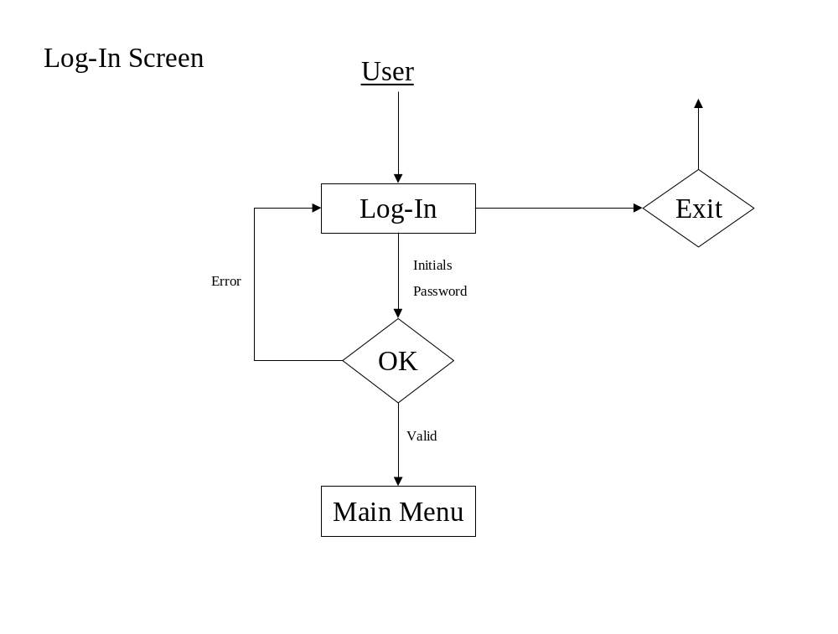

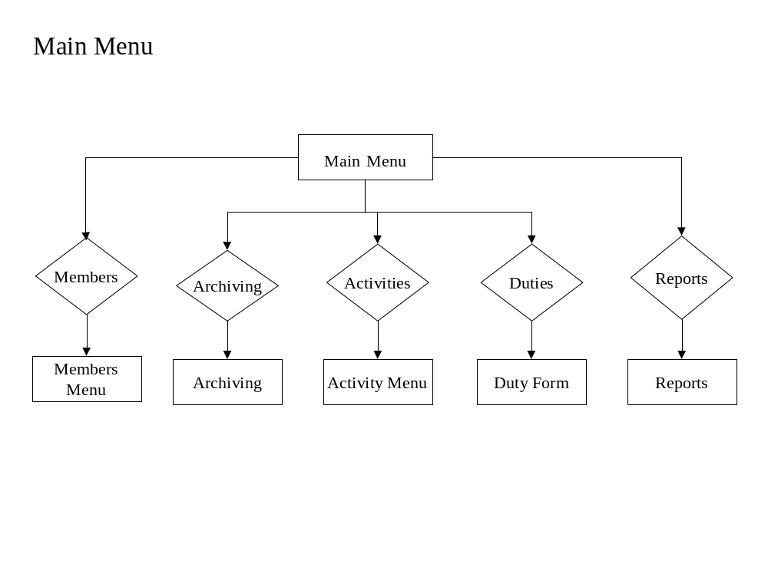

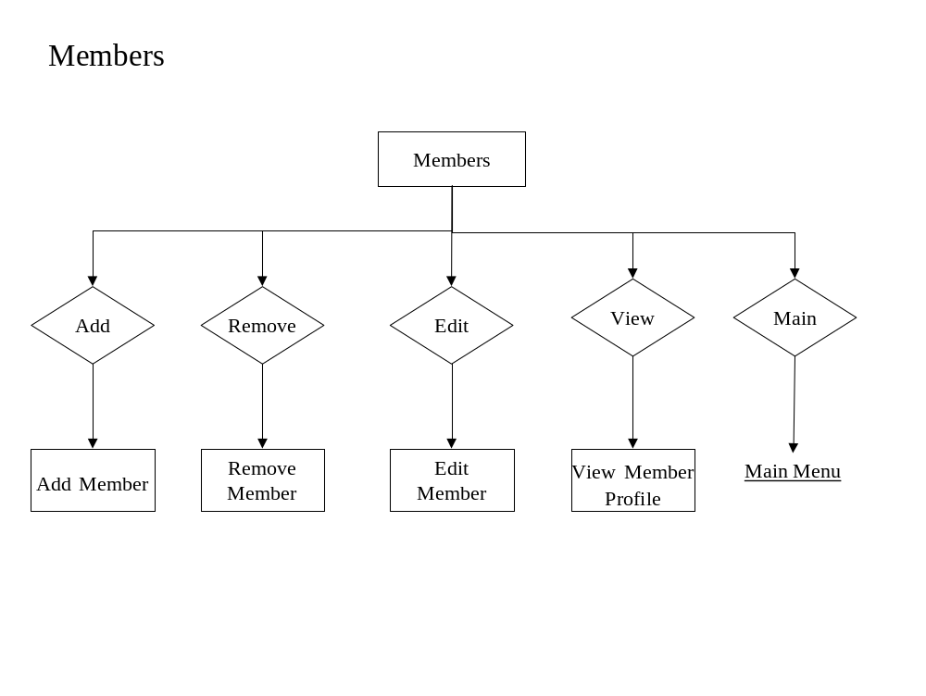

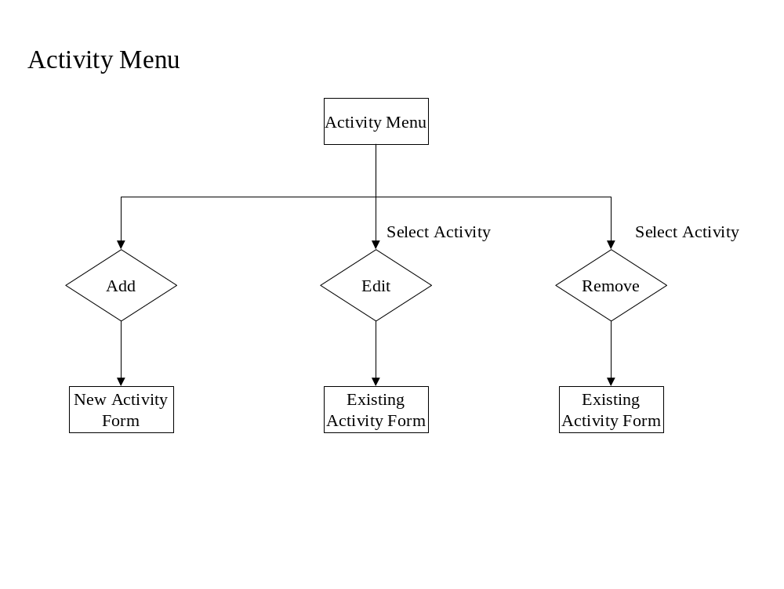

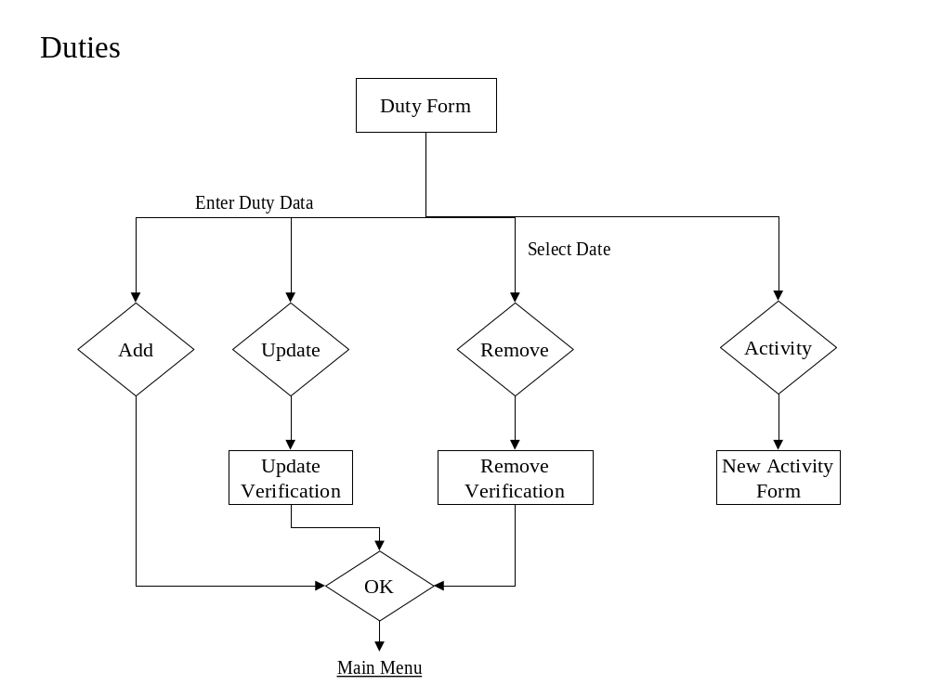

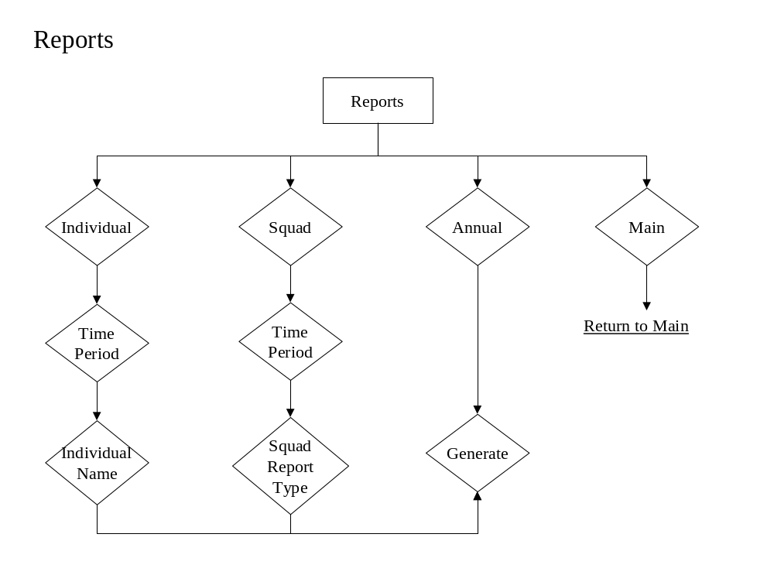

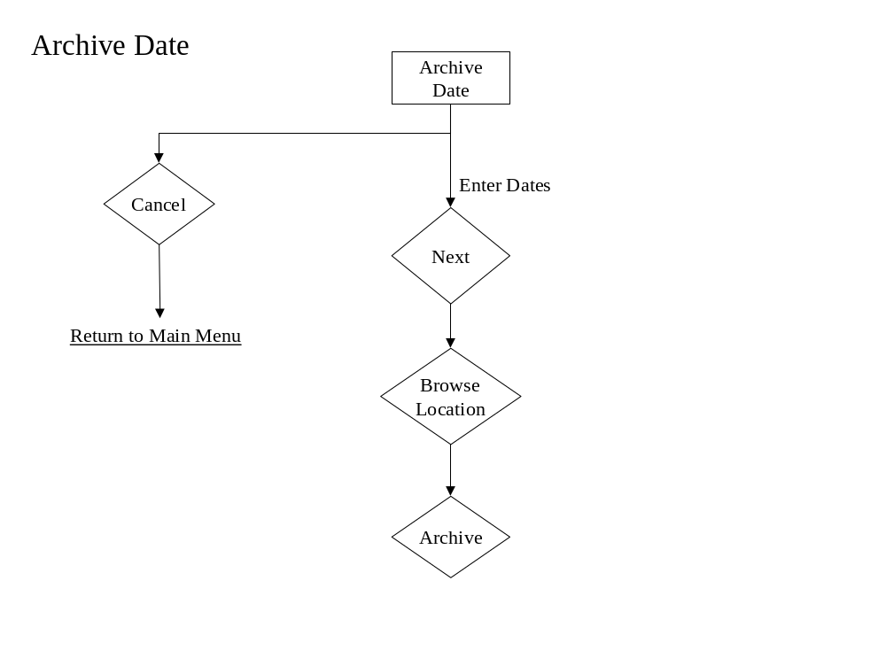

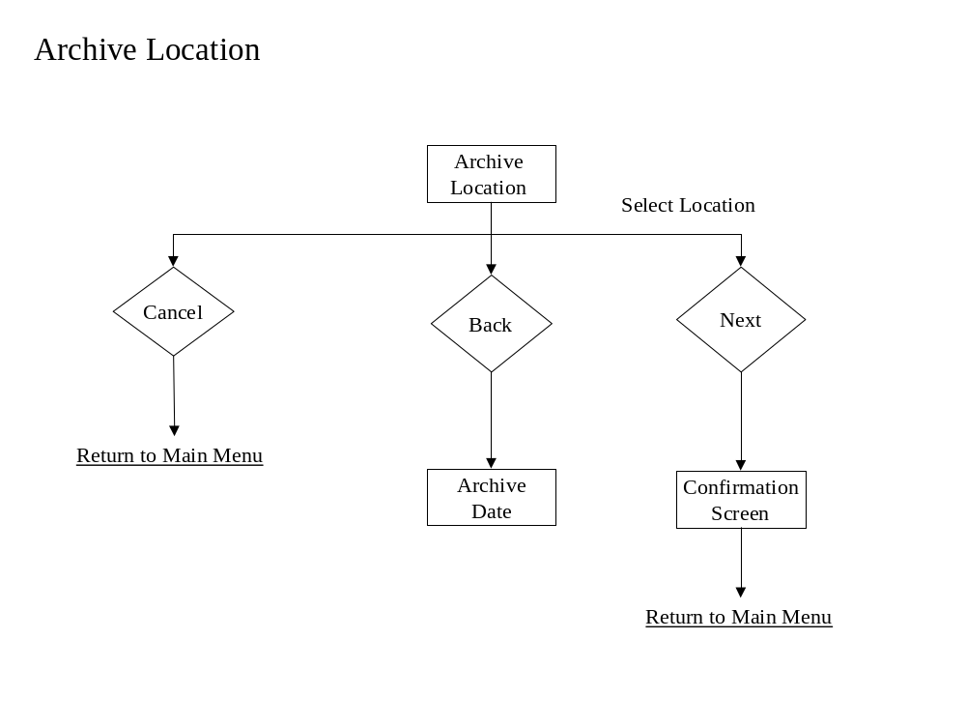

Parameter Specifications

Members Table: This table will store all of the personal information for each member’s profile. Among the items stored will be their name, address, phone, numbers, social security number, date-of-birth, member type, member status, and whether or not they are an officer or not.

Activity Table: This table will store the information about each activity that is held. The information it holds will be one of the six types of activities, the title of the activity, the location and date of the activity.

Attends Table: This table is used to link each member to the activities that they attend. It can also be used to generate a list of members who attended an activity.

Additional Dates Table: This table is used to store additional dates and durations of an activity that already exists.

Additional Attend Table: This table is used to link each member to the additional activity dates that they attended.

Duty Table: This table is used to link each member to their tour-of-duty information along with the calls they attend per month.

Member Duty Table: This table is used to store the tour-of-duty information for each member. This information is the dates and duration of their duty.

Calls per Month: This table is used to store the number of calls a member responds to on a monthly basis.

Logical Data Structures

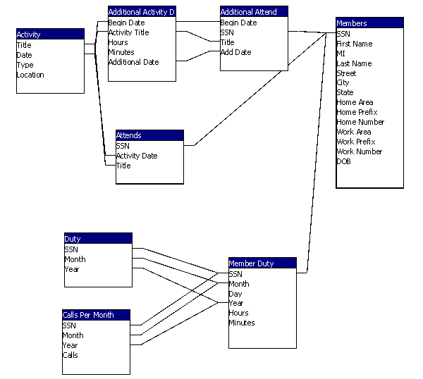

Functional Descriptions

- Allow for a user to track the activities and tours of duty, in which EMS members have participated in throughout the course of a year.
- The system must have an authentication process that secures the software from entry by unauthorized users.
- The system must allow the user to add, remove, edit or view a specific members’ personal information.
- The activity log includes one of the six predefined activities, the location of the activity, the date on which the activity occurred, and the duration of the activity.
- The duty logs consist of the dates and duration that a specific member was on duty. It will also keep track of the calls a member responded to per month.
- Allow the user to compose various reports based upon the activities and duty log information.
- Allow the user to archive the current database to a specified storage device. Also, retrieve archived data that is requested by the user to generate a report on information within that data.
- Authorized users can easily access the system.
- The response time of the system is dependant upon Microsoft Access’ ability to retrieve and update information in the database, along with the amount of data to be compiled and calculated for the generation of reports.
- Screen Interface should be no smaller than 1024 x 768 pixels.

Section 3: Testing Requirements

Testing of the software package can be considered one of the most important phases of the development process. Once the project has passed the design stage, it is important to thoroughly test the system in order to correct any design, development, or programming flaws that were previously overlooked. The testing provisions of this system were established during the requirement specification portion of development, and will be further elaborated upon in the next phase of the project, the Detailed Design.

Requirements Inventory

Requirement: The SAP system must provide an authentication process to secure the system from unwanted users.
Test: FNA will test this requirement through entry of both valid and invalid information into the logon screen.

Requirement: The system must allow the user to add, remove, edit, or view, a specific members’ personal information.
Test: FNA will test this requirement by creating a set of sample data and running it through all of the steps of the system.

Requirement: System should allow the user to archive the current database to a specified storage device.
Test: FNA will test this requirement by archiving test data onto various disk drives.

Requirement: Upon request, the system should be able to retrieve data that is archived on a specified storage device, in order to generate reports.
Test: FNA will test this requirement by retrieving the archived test data and then generating all possible reports for that data set.

Requirement: System should allow the user to compose reports based upon the various activities and duty log information.
Test: Sample data will be inputted into the system, and generated reports will be compared with expected results.

Requirement: The activity logs must include the six predefined activities, the location of the activity, the date on which the activity occurred, the duration of the activity, the title of the activity, and any comments the user would like to associate with the activity.
Test: FNA will test this requirement through viewing the fields of the activity form upon completion.

Requirement: The duty logs must consist of the dates and durations that a specific member was on duty for. Along with, keeping track of the calls a member responded to per month
Test: FNA will test this requirement through viewing the fields of the duty form upon completion.

Requirement: The system should be able to calculate points towards retirement benefits based on the calculation guidelines specified by the NYS Comptroller.
Test: Sample data will be inputted into the system, and generated reports will be compared with expected results.

Requirement: The system should be able to generate reports in the following fields: detailed/summarized individual report, detailed/summarized squad report, and an annual reports for submission to the NYS Comptroller
Test: Sample data will be inputted into the system, and generated reports will be compared with expected results.

Design Inventory

Design Goal: The system should be user-friendly.
Test: FNA will test this design goal through the use of specified test users.

Design Goal: The system should allow quick and easy data entry.
Test: FNA will test this design goal through external consulting.

Design Goal: The system will support multiple menus, created to broaden the user-friendly aspects of the software.
Test: FNA will test this design goal through critique from various potential users of the system.

Testing Plan

Test One: This procedure verifies the log-in function of the software. It tests the authentication process to make sure that the user enters a valid password along with their initials.

Procedure | Measure | Pass/Fail (Rec. Number)
1. Enter BR into user name and wrong_pass into password and click ‘OK’. | Error is received, not a valid password. | P F
2. Enter BR into user name, enter test_pass for the password | System logs you on. | P F

Test Two: This procedure tests the ability to add a new member to the database accurately.

Procedure | Measure | Pass/Fail (Rec. Number)
1. Log-in as BRock.
2. From the main menu, select Members. | Members Menu appears. | P F
3. Select Add from the Members Menu. | Member information form appears. | P F
4. Enter Jillian for first name, Vaughn for last name. Enter 490 Boston Post Rd for the address. Enter Loudonville for the city, NY for State and 12211 for the zip code. Enter the DOB as 7/6/1981. Select associative member for type and active as status along with dates for both. Enter BR for initials. Leave SSN blank. Click ‘OK’. | Verify that the age was calculated correctly  Error received. Must enter SSN. | P F  P F
5. Enter 046722468 for SSN and change Member status to be blank. Click ‘OK’. | Error Received. Must enter Member Status | P F
6. Select active for Member Status and change Member Type to be blank. Click ‘OK’. | Error Received. Must enter Member Type. | P F
7. Select associative member for Member Type and change the address field to be blank. Click ‘OK’. | Error Received. Must enter address | P F
8. Refill the address fields and leave the first name blank. Click ‘OK’. | Error Received. Must enter first name. | P F
9. Refill Jillian for the first name and delete the last name. Click ‘OK’. | Error Received. Must enter a last name | P F
10. Enter Vaughn for the last name. Enter Work Phone as 518-782-5510 and home phone as 518-782-5565. Click ‘OK’. | No errors received, verify that all data is stored in correct fields in database. | P F

Test Three: This procedure tests the ability to view a member’s information.
Procedure | Measure | Pass/Fail (Rec. Number)
1. Log-in
2. From the main menu, select Members. | Members Menu appears. | P F
3. Select View from the Members Menu. | A list of all the members appears | P F
4. Select a member’s name from the list and click ‘OK.’ | The member’s information is displayed. | P F
5. Verify that the information displayed is what is entered in the database. | All information in the database matches the displayed information. | P F

Test Four: This procedure tests the ability to edit a member’s information to the database accurately.

Procedure | Measure | Pass/Fail (Rec. Number)
1. Log-in.
2. From the main menu, select Members. | Members Menu appears. | P F
3. Select Edit from the Members Menu. | A list of all the members appears | P F
4. Select a name from the list and click ‘OK.’ | All the previously entered information are displayed in a form | P F
5. Change the first name and click ‘OK’ | Return to the member menu. | P F
6. Select View from the Member Menu and select the member name. | Member information is displayed. Verify that the change from #5 is being displayed | P F
7. Repeat steps 5-6 with all fields. |  | P F

Test Five: This procedure tests the ability to remove a member and all their information from the database.

Procedure | Measure | Pass/Fail (Rec. Number)
1. Log-in.
2. From the main menu, select Members. | Members Menu appears. | P F
3. Select Remove from the Members Menu. | A list of all the members appears | P F
4. Select a name from the list and click ‘OK.’ | Information for that member is displayed. | P F
5. Click ‘Remove.’ | A warning screen is displayed asking the user if they are sure they want to delete a member. | P F
6. Click ‘Ok’. | Verify that the information in the database has been deleted. | P F

Test Six: This procedure tests the ability to add new activity information accurately.

Procedure | Measure | Pass/Fail (Rec. Number)
1. Log-in.
2. Click the Activity button on the Main Menu.
3. Click the Add button. | An activity form will appear. | P F
4. Select Fundraiser as the activity type. | Fundraiser appears as the selected activity type. | P F
5. Click ‘OK.’ | Error. Must enter more information. | P F
6. Enter Barbeque as the activity title
7. Click ‘OK.’ | Error. Must enter more information. | P F
8. Enter the location of the activity
9. Click ‘OK.’ | Error. Must enter more information. | P F
10. Make sure Single date is selected and enter 7/06/02 for the date. Set the duration to 2 hours and 30 minutes.
11. Click ‘OK’. | Error. Must enter attendees. | P F
12. Click Select All | Members Alexandra Susen, Jillian Vaughn, Sarah Levasseur, Elizabeth Virga and Meg McElroy should be highlighted. | P F
13. Click Clear All | No members should be highlighted. | P F
14. Click All Active | Members Alexandra Susen, Jillian Vaughn and Elizabeth Virga should be highlighted | P F
15. Click Clear All | No members should be highlighted. | P F
16. Click on the names Sarah Levasseur, Jillian Vaughn and Meg McElroy. | Sarah Levasseur, Jillian Vaughn and Meg McElroy should be highlighted. | P F
17. Click view attendees. | Sarah Levasseur, Jillian Vaughn and Meg McElroy should be highlighted. | P F
18. Enter in Comments, “Testing comments”.
19. Click ‘Ok.’ | Return to Activity main page; verify in database that all info is in correct fields. | P F

Test Seven: This procedure tests the ability to remove an activity from the database.

Procedure | Measure | Pass/Fail (Rec. Number)
1. Log-in.
2. Click the Activity button on the Main Menu.
3. Select the Month and Year. | The activities for that month are displayed. | P F
4. Click the Remove button. | A list of all the activities is displayed. | P F
5. Select the Activity to be removed and click ‘OK.’ | The information for that activity is displayed. | P F
6. Click Remove. | A warning is displayed. | P F
8. Click ‘OK.’ | Verify that the activity has been deleted. | P F

Test Eight: This procedure tests the ability to edit activity information.

Procedure | Measure | Pass/Fail (Rec. Number)
1. Log-in.
2. Click the Activity button on the Main Menu.
3. Select the Month and Year. | Activities occurring in that particular month/year are displayed. | P F
4. Click an activity. | All the entered information for the activity is displayed. | P F
5. Click the Edit button. | An list of activities is displayed | P F
6. Edit the activity title and click ‘OK’.
7. Verify in the database that the change has been stored accurately. | The change is stored in the database accurately. | P F
8. Repeat steps 5 and 6 for all fields. | The changes are stored in the database accurately. | P F

Test Nine: This procedure tests the ability to generate a report.

Procedure | Measure | Pass/Fail (Rec. Number)
1. Log-in.
2. Click the Reports button on the Main Menu. | Create Report Screen comes up | P F
3. Click the ‘individual’ check box | Time period and Individual selection area are enabled.
4. Select ‘Year to Date’.
5. Select member, Elizabeth Virga. | Elizabeth Virga is highlighted | P F
6. Click Generate. | A year to date report is displayed for Elizabeth Virga.  Verify that all information is correct. | P F  P F
7. Return to the Create Report screen.
8. Select the Individual checkbox again.
9. Select ‘Prior Year’ for the time period and select the year 2001.
10. Select Elizabeth Virga for the member.
11. Click Generate. | Report for Elizabeth Virga for 2001 should be displayed  Verify that the data is correct. | P F
12. Return to the Create Report screen.
13. Select the Squad checkbox. | The time period and squad report sections are enabled. | P F
14. Select Year-to-Date
15. Select All Members in the Squad Report Section and click Generate. | Report for members Alexandra Susen, Jillian Vaughn, Sarah Levasseur, Elizabeth Virga and Meg McElroy should be displayed  Verify that the data is correct. | P F
16. Return to the Create Report screen.
17. Select the Squad checkbox.
18. Select Prior Year and select the year 2001.
19. Select All Members in the Squad Report Section and click Generate. | Report for members Alexandra Susen, Jillian Vaughn, Sarah Levasseur, Elizabeth Virga and Meg McElroy for the year 2001 should be displayed  Verify that the data is correct. | P F
20. Return to the Create Report screen.
21. Select the Squad checkbox.
22. Select Year-to-Date
23. Select All Active Members and click Generate. | Year to date information for members Alexandra Susen, Jillian Vaughn and Elizabeth Virga should be displayed.  Verify that all information is correct. | P F
24. Return to the Create Report screen.
25. Select the Squad checkbox.
26. Select Year to Date.
27. Select All Members who Earned Retirement Credits and select Generate. | Any members who have earned credit should be displayed verify that this information is correct. | P F
28. Return to the Create Report screen.
29. Select the Squad checkbox.
30. Select Prior Year and select the year 2001.
31. Select All Members who Earned Retirement Credits and select Generate. | Any members who have earned credit should be displayed verify that this information is correct. | P F
32. Return to the Create Report screen.
33. Select Comptroller’s Annual Report; Select the year and Click Generate. | The comptroller’s report is displayed.  Verify that all the information is correct and in the right format. | P F

Test Ten: This procedure tests the ability to enter a tour-of-duty.

Procedure | Measure | Pass/Fail (Rec. Number)
1. Log-in.
2. From the main menu, select Duties | Duties Menu appears. | P F
3. Highlight Jillian Vaughn from the Name pull-down menu | Member name is selected | P F
4. Highlight March from Month Menu | March should be selected | P F
5. Highlight 2001 from the Year Menu | 2001 should be selected from year | P F
 | The correct number of calls per month should appear in the ‘Calls per month’ box | P F
 | The dates and durations of the duties for the selected month, year and member should appear in the right columns | P F
6. Highlight 31 from the Day pull-down menu under Duty Entry | The number 31 should be selected | P F
7. Highlight February from the Month pull-down menu | February should be selected | P F
 | Duties should change for the month of February | P F
 | Day under Duty Entry should not be 31 | P F
 | Maximum day selectable should be 28 | P F
 | Calls per month should change for February | P F
8. Highlight 1996 under Year | 1996 should be selected | P F
9. Highlight number 29 from the Day pull-down under Duty Entry | 29 should be selected | P F
10. Type 3 in the hrs. box and 30 in the mins. Box, and click the Add button | Correct Date and Duration should appear on the right | P F
11. Change mins. to 70 | Correct Date and ‘4 hrs. 10 mins. should appear on the right | P F
12. Select February 29, and 4hrs 10 mins from the right side, and click remove | Date and time should disappear from the list | P F
13. Erase Initials and click update | Should give error: Initials required | P F
14. Enter initials and click update | Confirmation should be given | P F
15. Click Activity | Should return to Activity Menu | P F

Test Eleven: This procedure tests the ability to archive the database.

Procedure | Measure | Pass/Fail (Rec. Number)
1. Log-in.
2. From the main menu, select Archive | Archiving Menu appears. | P F
3. Click Browse and select a non-write CD-ROM drive and click OK | Error is reported | P F
4. Highlight C:\ and click OK | Confirmation should be sent, and archiving should take place | P F

Section IV: Detailed Design Specification

Subprogram interface specifications and

pseudo-code for each routine

GetActivity Breakdown (Activity Selection)
{
Give variable names for each field
Process which/what activity is being given
Declare all Calc variables
Calculatepoints(calcVariables)
Return activity to database
}

Calculatepoints (calcvarables, duration)
{
Calculate points using calc variables + duration
Return points to database
}
__

Selectform (Req-Arch-info, reportquery)
{
Process which report/request
Return display report
}

DisplayReport (CalculationResults, queryResults, Archivedata, displayreport,)
{
Process report type
Calculaterep(dataforcalculations)
Query info from DB
Display info to user
}

Calculatingforreports(all variables for member/squad)
{
Take all data use formulas
Return result
}
__

SelectDataSource(Displayreport)
{
Retrieve info from DB
Save to source user selects
}

Compilereport(Calc-results, report-data)
{
Merge calculated data with report data
Return report to user
}

Separatedata(Query-results, Archive-Data)
{
Take query-results send to Compilereport
Send all data for calculations to calc reports
}

SeperateData(dataforcalc)
{
send position to calculate position
send number responses to calculate response
send hours to calculate sleep/standby
}
Calculateposition(elected or appointed position)
{
Process which position
Send position-points to return results
}

calculateResponse (numberresponses)
{
send responsePoints to Return Results
}

Calculate Sleep/Stand-by( sleep/stand-by hours)
{
calculate the points for hours
send sleep stand-by points to return results
}

returnResults(Positionpoints,Responsepoints,sleep/standbypoints)
{
compile all points to one variable
send sum of all points to Calculation Results
}
Add Activity:

ChooseLocation (Location-Selection)
{
Send (Location) to database interface
}

Database Interface (Location)
{
Send (Activity-Update) to Database
Return Update-Confirmation
}

EnterTitle (Title)
{
Send Title to database interface
}

Database Interface (Title)
{
Send (Activity-Update) to Database
Return Update-Confirmation
}

SelectActivity (Selected-Activity)
{
Send Activity to database interface
}

Database Interface (Selected-Activity)
{
Send (Activity-Update) to Database
Return Update-Confirmation
}

EnterDateandDuration (Entered-Date-and-Duration)
{
Send Duration to database interface
}

Database Interface (Duration)
{
Send (Activity-Update) to Database
Return Update-Confirmation
}

SelectMembers (Member-Selection)
{
Send Member-Data to database interface
}

Database Interface (Location)
{
Send (Activity-Update) to Database
Return Update-Confirmation
}

ChooseLocation ( )
{
call database interface ( )
send Location to screen interface
}

EnterTitle ( )
{
call database interface ( )
send Selected-Title to the screen interface
}

SelectActivity ( )
{
call database interface ( )
send Activities to the screen interface
}

EnterDateandDuration ( )
{
call database interface ( )
send Date-and-Duration to the screen interface
}

SelectMembers ( )
{
call database interface ( )
send Member-Display to the screen interface
}
Database Interface ( )
{
Calls Database for required information
Returns Information to Module
}

Remove Activity:

SelectActivity (Selected-Activity)
{
Send Activity to database interface
}

Database Interface (Activity)
{
Sends Activity to Database
Returns Update-Confirmation
}

Manage Profiles:

Add Member:

Add/Edit (Member-Data)
{
Send Query-Data to Relay Info (Query-Data)
}

Database Interface ( Request-Data )
{
Send Request-Data to Database
Return Data
}

Edit Member:

Add/Edit (Member-Data)
{
Send Query-Data to Relay Info
}

RelayInfo (Query-Data)
{
Send Request Data to Database Interface
}

Database Interface (Request-Data)
{
Send Request-Data to Database
Return Data
}

View Member:

Relay Info ( )
{
call Database Interface ()
}

Database Interface ( )
{
Request Data from Database
Send Return-Data to Relay Info
}

Relay Info (Return-Data)
{
Send Return-Data to Screen Interface
}

Remove Member:

Remove (Remove-Request)
{
Send Query-Members to RelayInfo
}

RelayInfo (Query-Members)
{
Send Request-Data to Database Interface
}

Database Interface (Updated-Profile-Data)
{
Send Update-Profile-Data to Database
Return Update-Confirmation
}

Documentation Prologue

Each function will have a header in the format shown below. This will tell what the function name is, the company that created it, the date the function was created, the original programmer of the function, and a brief description of what the function is supposed to accomplish. There will also be modification log to keep track of when the function was modified and who modified it.

‘*********************************************************
‘ Function Name: Sample_Function
‘ Company Info: FNA Technologies
‘ File created: 2/26/03
‘ Programmer: Courtney Murphy
‘ Description: The purpose of this file is to provide a sample of
‘ the documentation style for this project.
‘
‘ Modification Log:
‘ Programmer:
‘ Begin Date:
‘ End Date:
‘ Description:
‘*********************************************************

The following table lists the object naming conventions and includes an example of each.

Object Prefix Example
Combo box cbo cboEnglish
Check box chk chkReadOnly
Command button cmd cmdCancel
Common dialog dlg dlgOpen
Data dat datBiblio
Data-bound combo box dbc dbcEnglish
Data-bound list box dbl dblPolicyCode
Directory list box dir dirSource
Drive list box drv drvTarget
File list box fil filSource
Frame fra fraLanguage
Form frm frmPrintForm
Horizontal scroll bar hsb hsbVolume
Image img imgEmptyBarrel
Label lbl lblInstructions
Line lin linUnderline
List box lst lstPeripherals
Menu mnu mnuFileOpen
OLE ole oleObject1
Option button opt optFrench
Picture box pic picSmokeCloud
Shape shp shpWireScreen
Text txt txtGenName
Timer tmr tmrRunAnnimation
Vertical scroll bar vsb vsbTemperature

Physical Data Structures

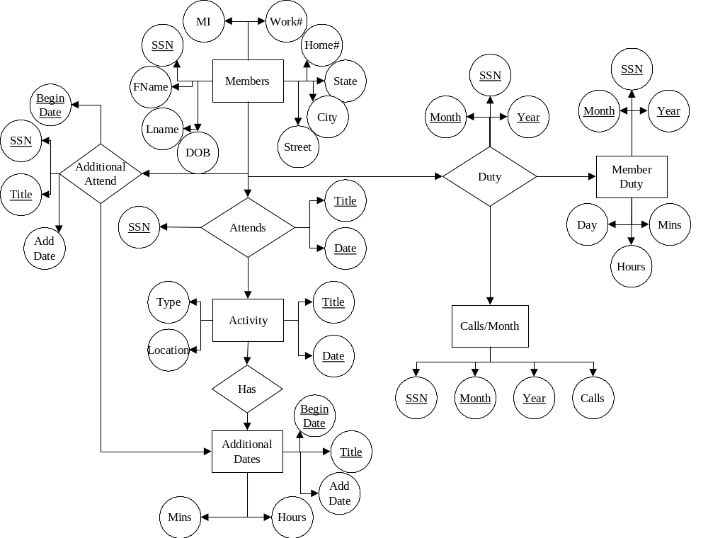

Packaging Specifications

The software will come packaged with a simple step-by-step instruction booklet, which will be written in very basic terms making the installation simple for anyone at almost any level of computer skill. After inserting the packaged CD-ROM, the user will be forced to make very few decisions, because there is no need for a custom installation since the program only has one set configuration. The only option that a user will need to select is where the program will be installed to, and a default location will be selected. The packaging will also contain a more in depth trouble shooting guide that will help the
user by providing step-by-step instructions on any given task.

Glossary

Microsoft Visual Basic 6.0: A development tool used to easily create applications that work in a Windows environment.

Pixels: Short for picture element. A pixel is the smallest logical unit of visual information that can be used to build an image. Pixels are the little squares that can be seen when a graphics image is enlarged.

SAP: (Service Awards Program) Software package that tracks credits towards benefits for volunteer EMS members.

SQL: (Structured Query Language) a language used to create, maintain, and query relational databases. SQL uses regular English words for many of its commands, which makes it easy to use. It is often embedded within other programming languages.

Windows: A Microsoft product that provides a platform on which to run software and interact with peripheral hardware on personal computers.

