Data Flow Diagrams – Preliminary Design
Client: Dr. Darren Lim, Assistant Professor



Proposed Project: Java Online Learning Toolkit (J.O.L.T.)

Delivered by: 518 Interactive
Team Members:
Lawrence Gregory
Christopher Hughto
Erik Stegmann
Connor Vander Bogart
Jedidiah Turnbull

Revision: 1.0
Date: 12/08/09
Contents
1 Data Flow Diagrams 1
2 Data Flow Diagram: Context 2
3 Data Flow Diagram: Level 0 3
3.1 Process 1, Level 1: Answer Problem 4
3.2 Process 2, Level 1 View Gradebook 5
3.3 Process 3, Level 1Manage Problems and Problem Sets 6
3.3.1 Process 3.1 Level 2 Create Problem 7
3.3.2 Process 3.2 Level 2 Edit Problem 8
3.3.3 Process 3.3 Level 2 Create Problem Set 9
3.3.4 Process 3.4 Level 2 Edit Problem Set 10
3.4 Process 4 Level 1 Manage Courses 11
3.4.1 Process 4.1 Level 2 Create Course 12
3.4.2 Process 4.2 Level 2 Edit Course 13
3.4.3 Process 4.3 Level 2 Create Section 14
3.4.4 Process 4.4 Level 2 Edit Section 15
3.5 Process 5 Level 1 Registration 16
3.6 Process 6 Level 1 Authentication 17
3.7 Process 7 Level 1 Manage Pools 18
3.7.1 Process 7.1 Level 2 Manage Private Pool 19
3.7.2 Process 7.2 Level 2 Manage Course Pool 20
3.7.3 Process 7.3 Level 2 Manage Sandbox 21
3.7.4 Process 7.4 Level 2 Manage Global Pool 22
3.8 Process 8 Level 1 Manage Users 23
3.8.1 Process 8.1 Level 2 Create Faculty Account 24
3.8.2 Process 8.2 Level 2 Create Course Coordinator Account 25
3.8.3 Process 8.3 Level 2 Edit User Account Information 26
3.8.4 Process 8.3.1 Level 3 Edit Student Account 27
3.8.5 Process 8.3.2 Level 3 Edit Faculty Account 28
3.8.6 Process 8.3.3 Level 3 Edit Course Coordinator Account 29

Data Flow Diagrams
The Data Flow Diagrams (DFDs) are used for structure analysis and design. DFDs show the flow of data from external entities into the system. DFDs also show how the data moves and is transformed from one process to another, as well as its logical storage. The following symbols are used within DFDs. For clarity, a key has been provided at the bottom of this page.
At the request of our client, Dr. Lim, some of our diagrams have been done in the UML Activity Diagram format. These documents are contained in the “Activity Diagram” Document, which is found on the 518 Interactive website. The processes that break down to activity diagrams are indicated with a “AN” Label at the bottom of the process bubble, where N is an integer.

Source/Sink: Represented by rectangles in the diagram. Sources and Sinks are external entities which are sources or destinations of data, respectively.
Process: Represented by circles in the diagram. Processes are responsible for manipulating the data. They take data as input and output an altered version of the data.
Data Store: Represented by a segmented rectangle with an open end on the right. Data Stores are both electronic and physical locations of data. Examples include databases, directories, files, and even filing cabinets and stacks of paper.
Data Flow: Represented by a unidirectional arrow. Data Flows show how data is moved through the System. Data Flows are labeled with a description of the data that is being passed through it.

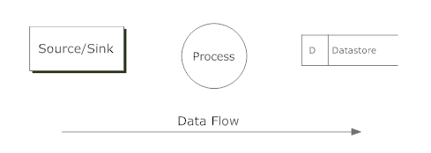

Data Flow Diagram: Context
A context diagram is a top level data flow diagram. It only contains one process node (Process 0) that generalizes the function of the entire system in relationship to external entities.

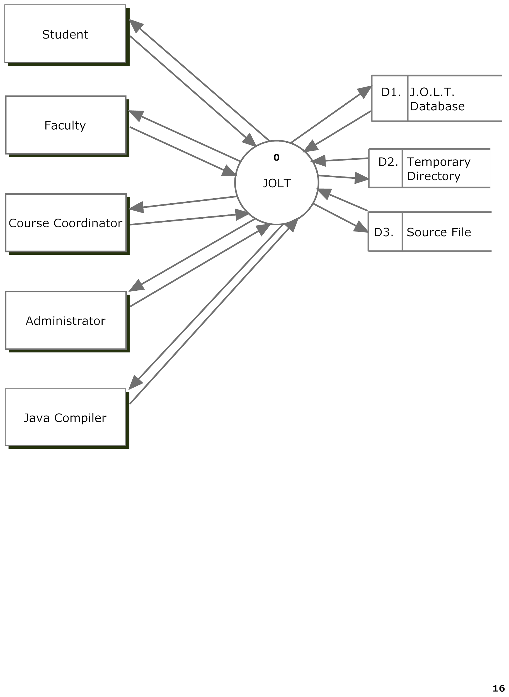

Data Flow Diagram: Level 0
The Level 0 Data Flow Diagram shows all of the main, high-level functions of JOLT. Note that each process uses one or more data stores. For clarity, the data stores have been omitted from this diagram. Further detail is provided in subsequent diagrams.
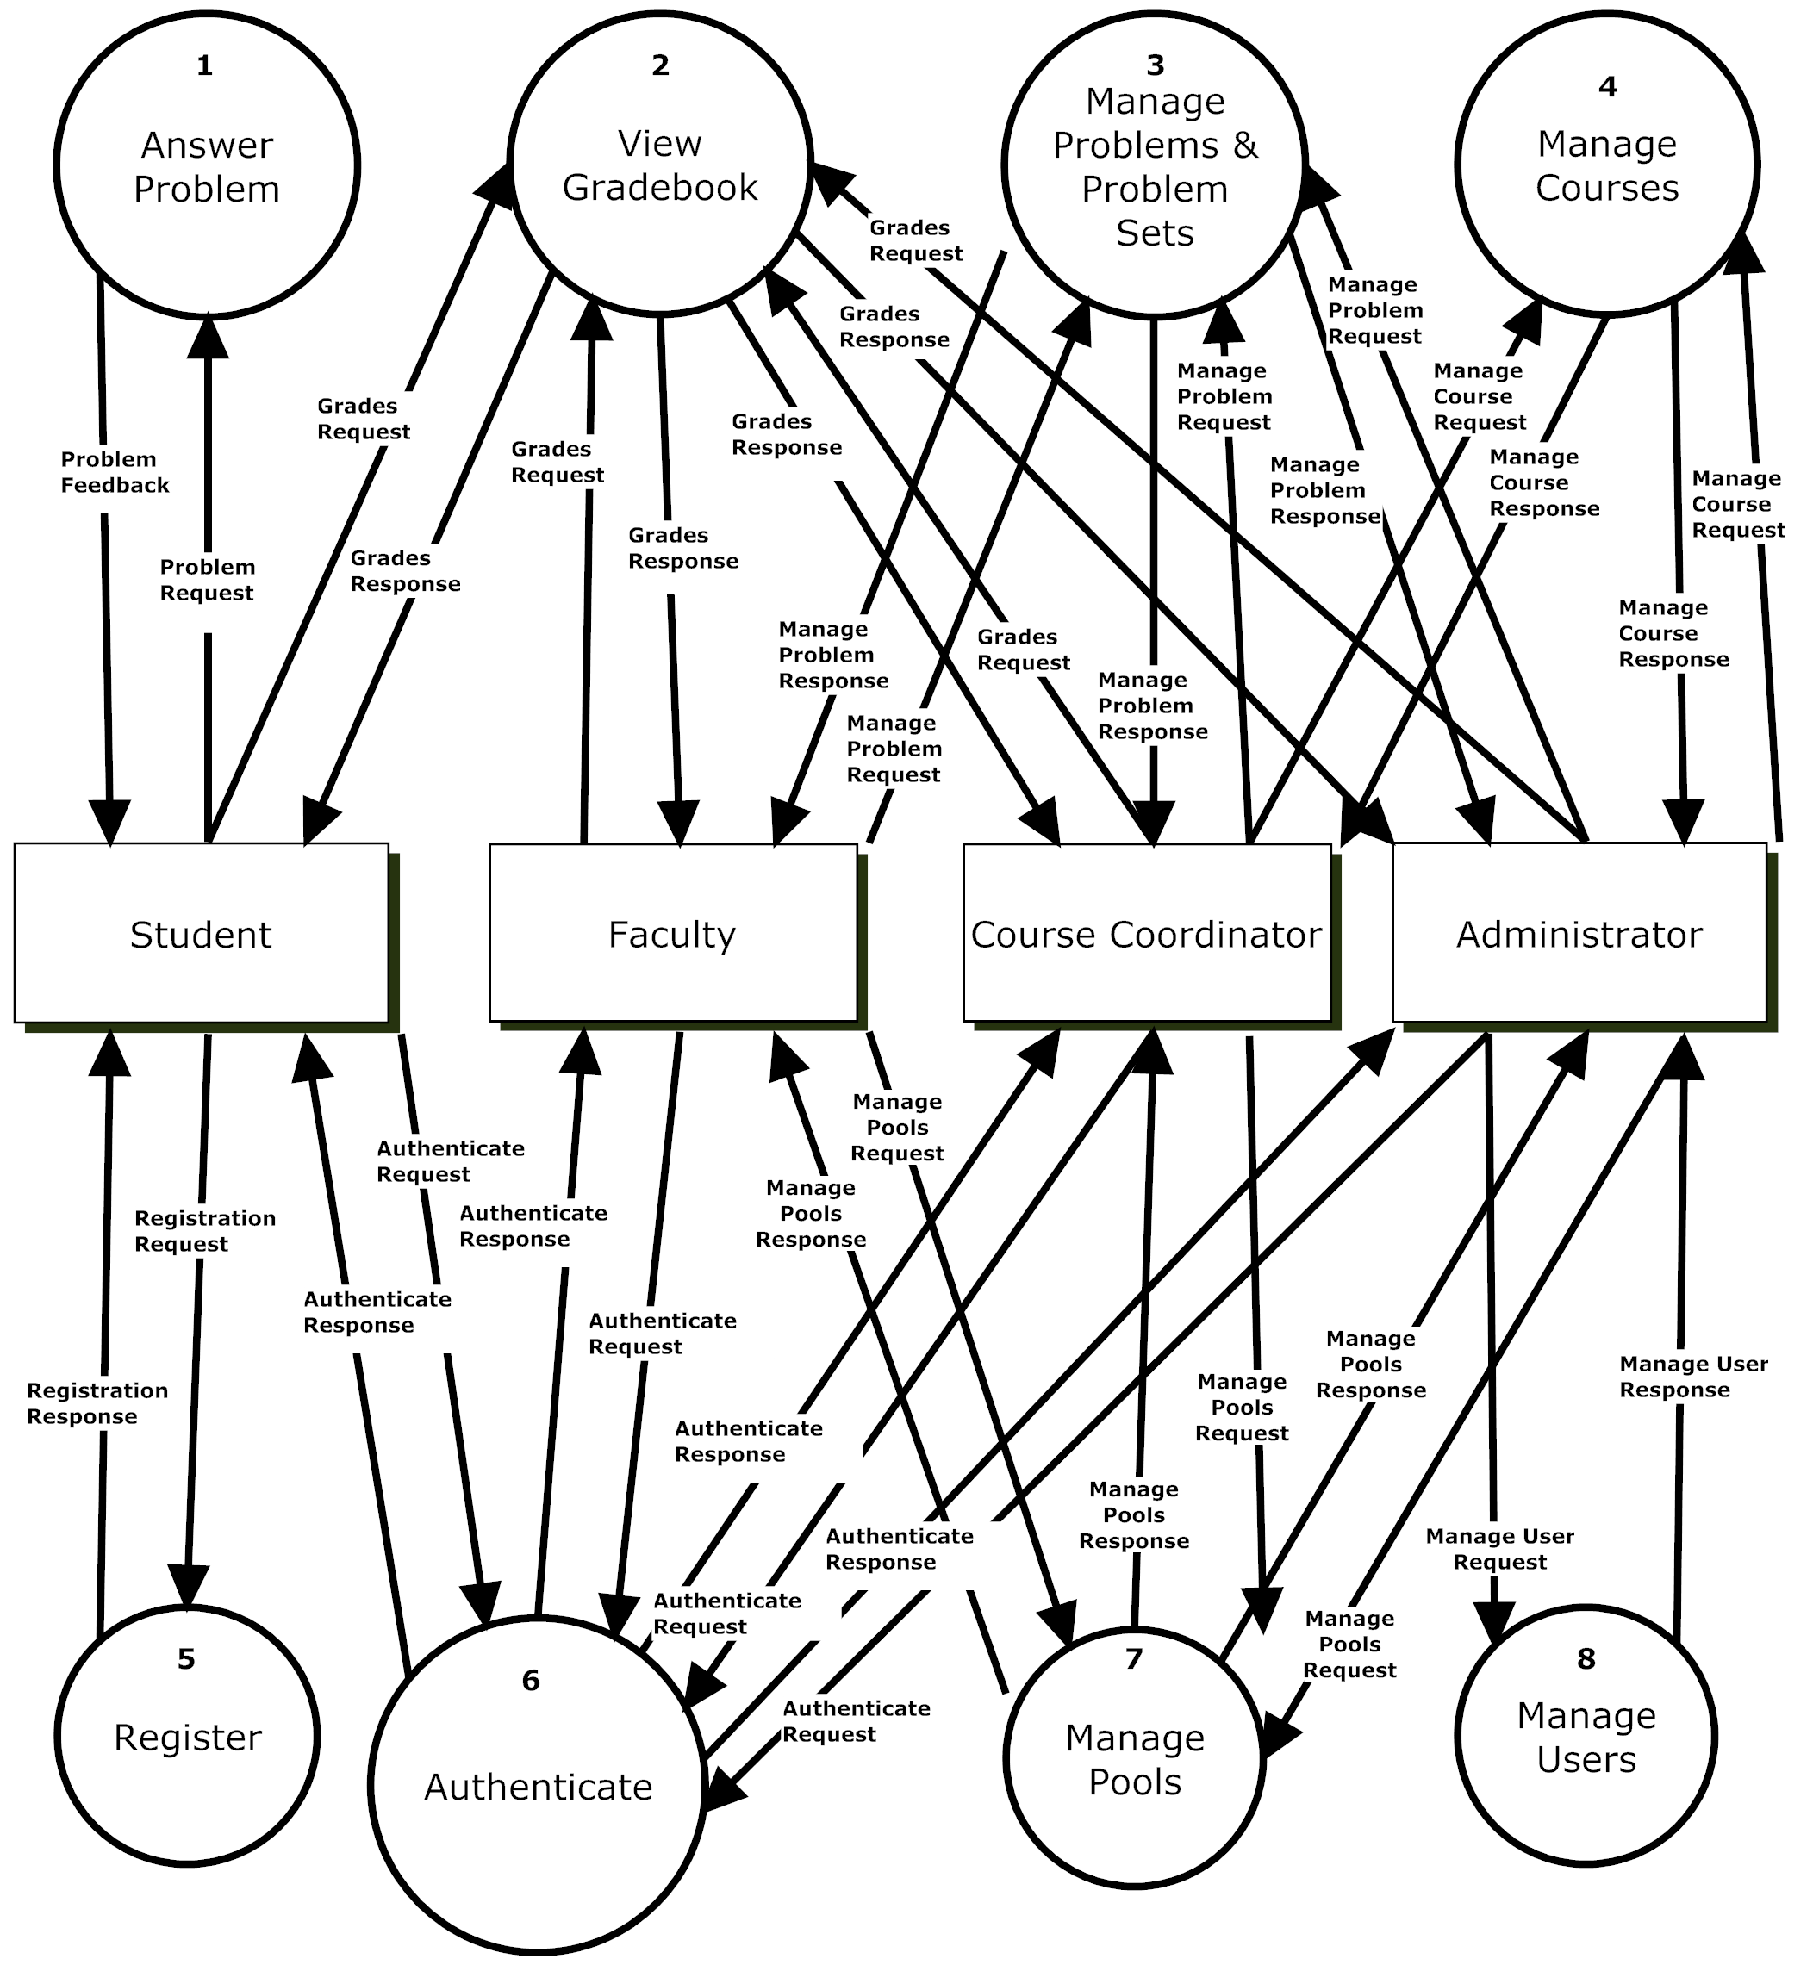

Process 1, Level 1: Answer Problem
This diagram represents the high-level functions involved in answering a problem from a student’s perspective. Note the absence of process numbers: These processes represent UML Activity diagrams, which are contained in the Activity Diagrams Document.
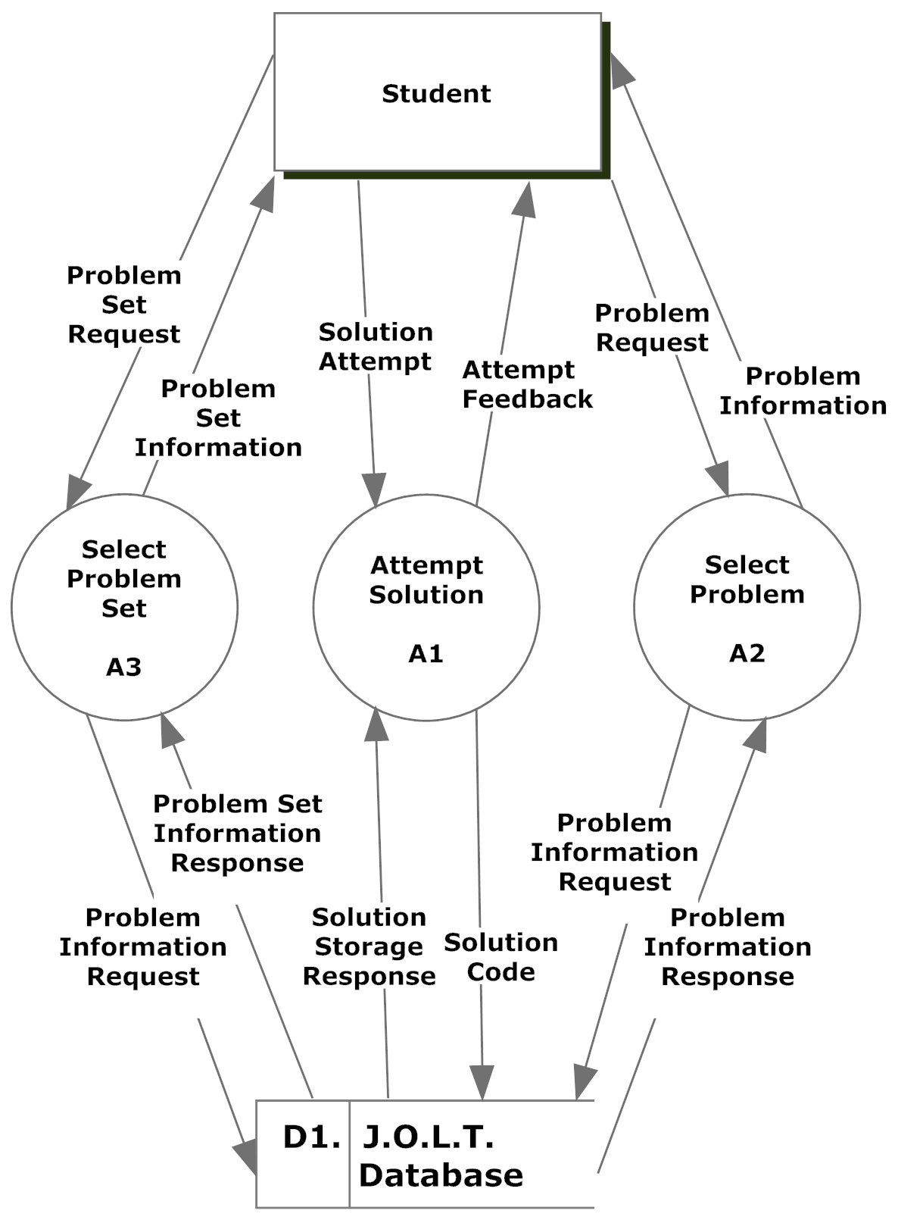

Process 2, Level 1 View Gradebook
This process is represented as an Activity Diagram, per request of the client. Please reference Diagram “A4” for the Faculty, Course Coordinator, and Administrator users, and Diagram “A5” for the Student user.

Process 3, Level 1Manage Problems and Problem Sets
This diagram represents the high level functions involved in managing problems and problem sets.
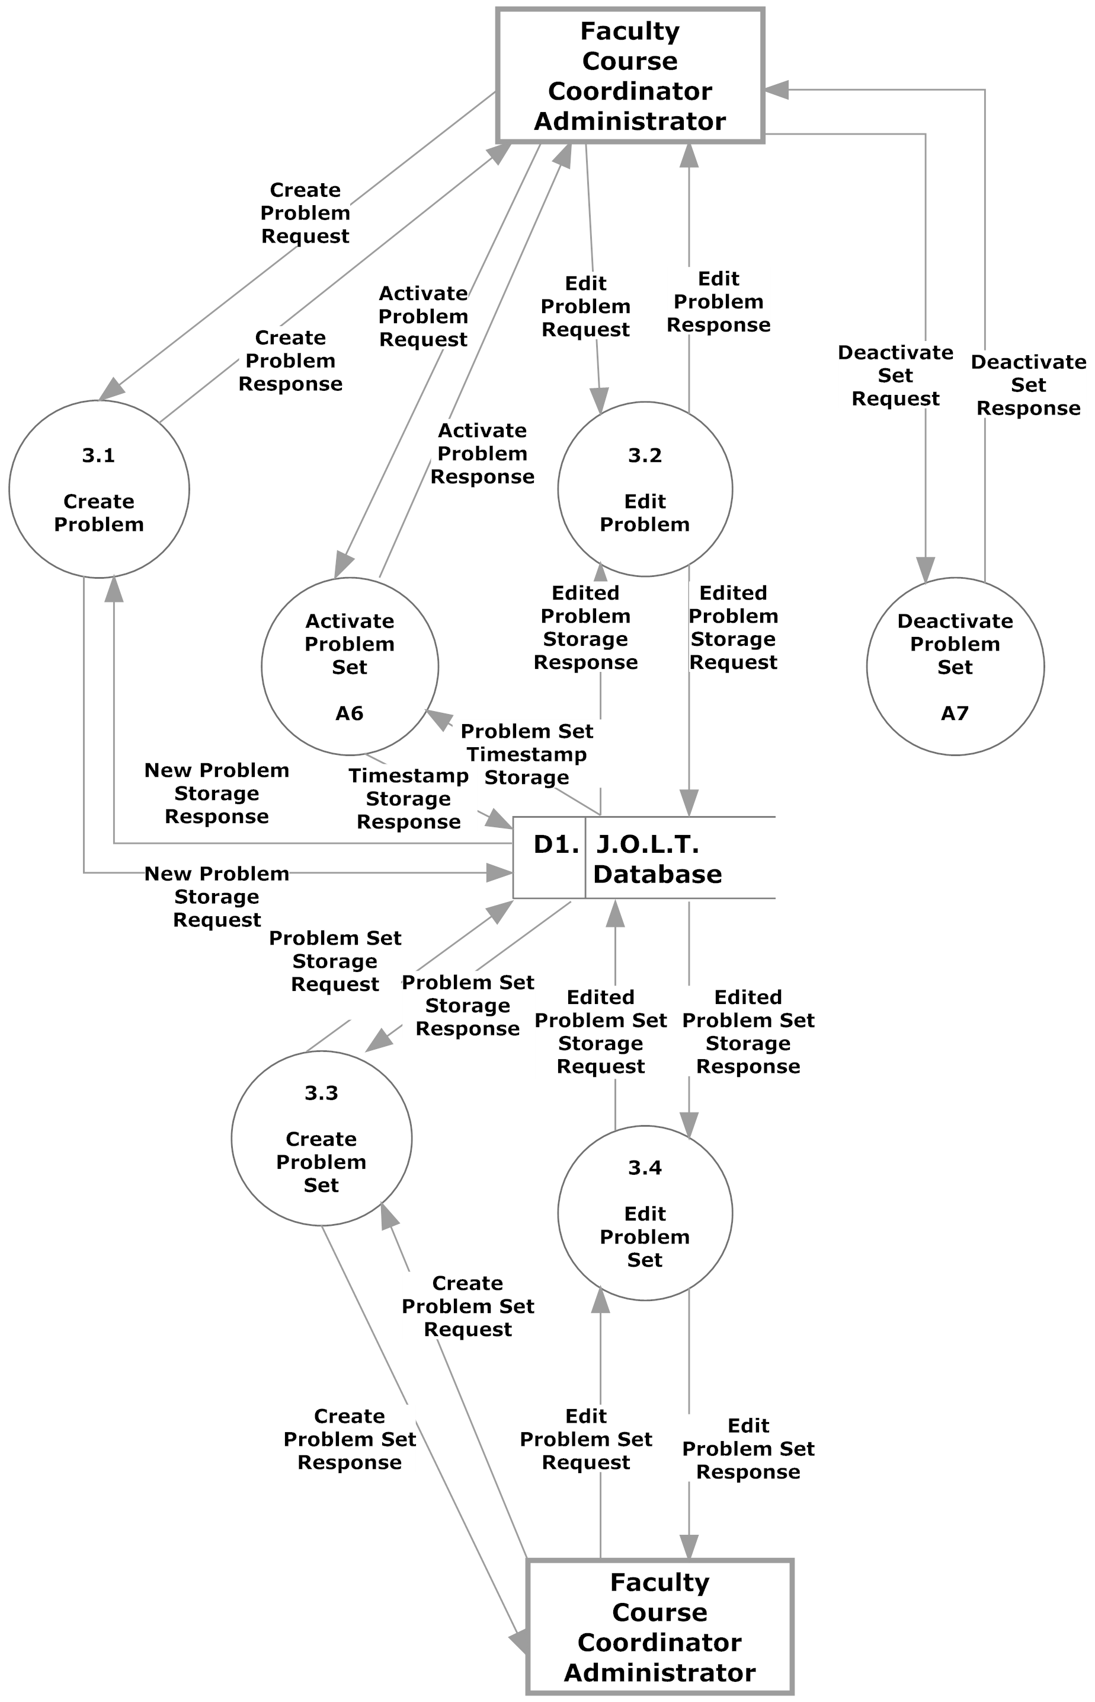

Process 3.1 Level 2 Create Problem
This diagram represents a breakdown of how a problem is created by a Faculty, Course Coordinator, or Administrator user.
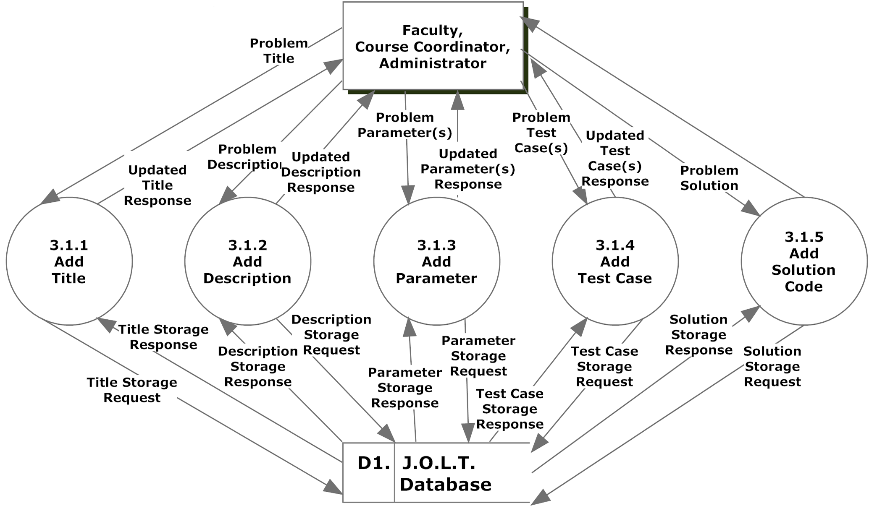

Process 3.2 Level 2 Edit Problem
This diagram represents a breakdown of how a problem is edited by a Faculty, Course Coordinator, or Administrator user.
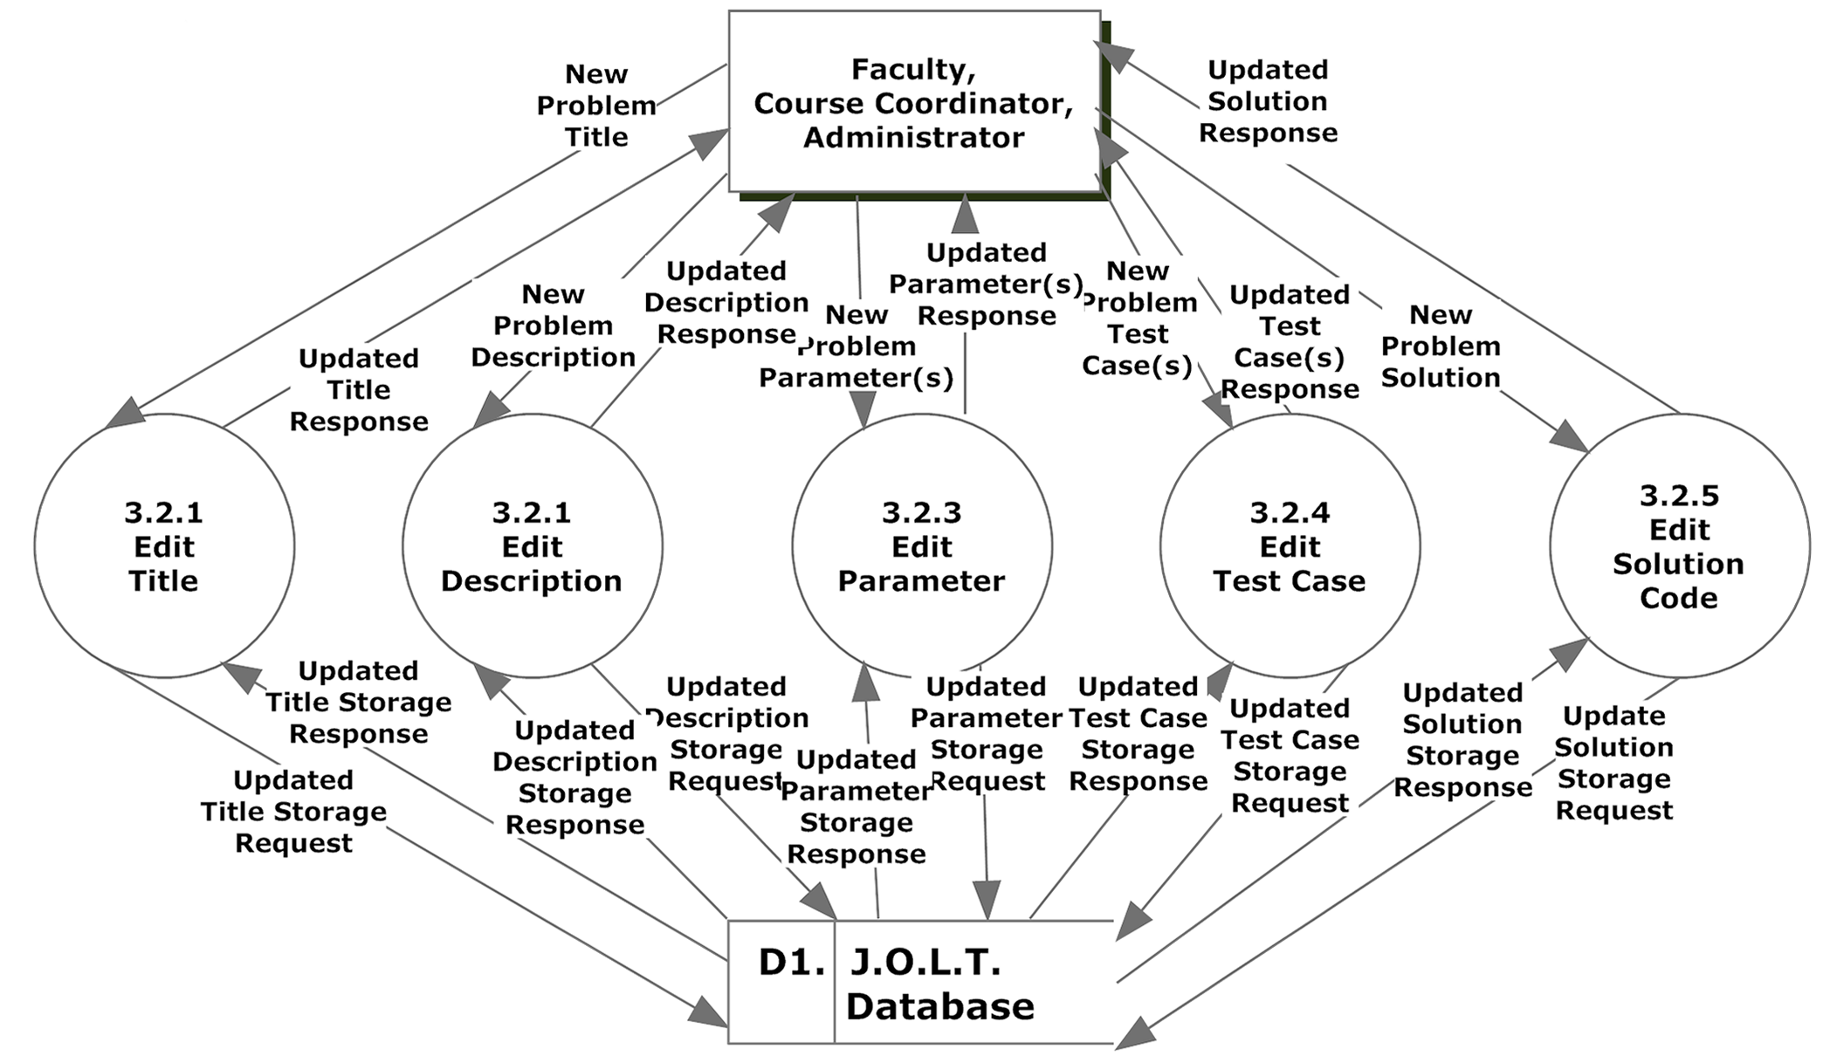

Process 3.3 Level 2 Create Problem Set
This diagram represents a breakdown of how a problem set is created by a Faculty, Course Coordinator, or Administrator user.
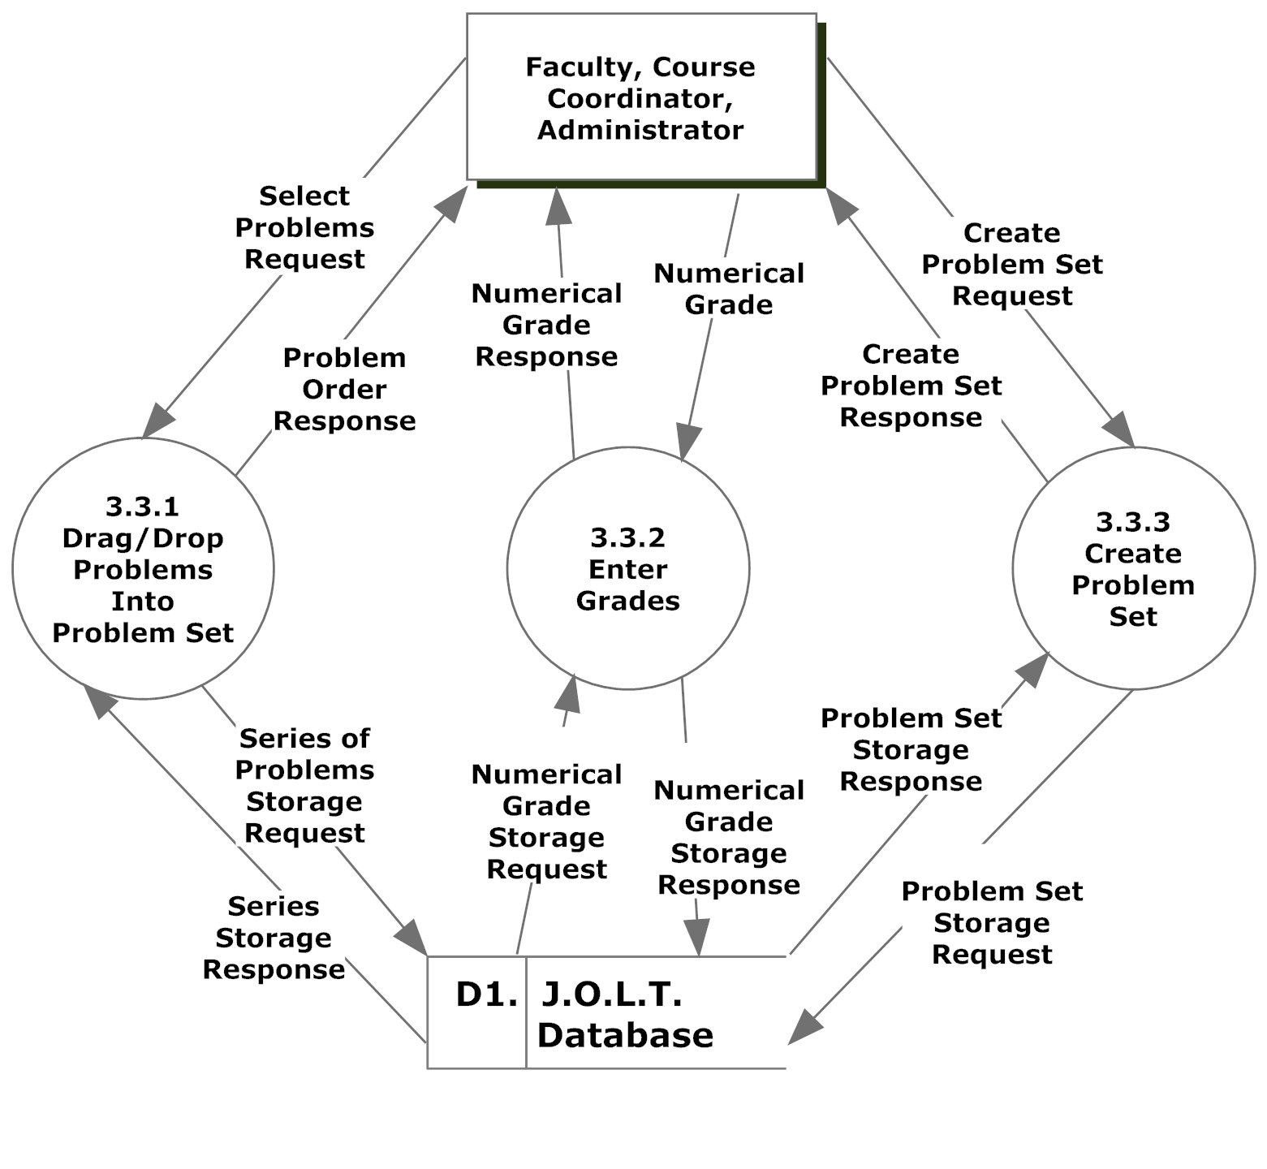

Process 3.4 Level 2 Edit Problem Set
This diagram represents a breakdown of how a problem set is edited by a Faculty, Course Coordinator, or Administrator user.
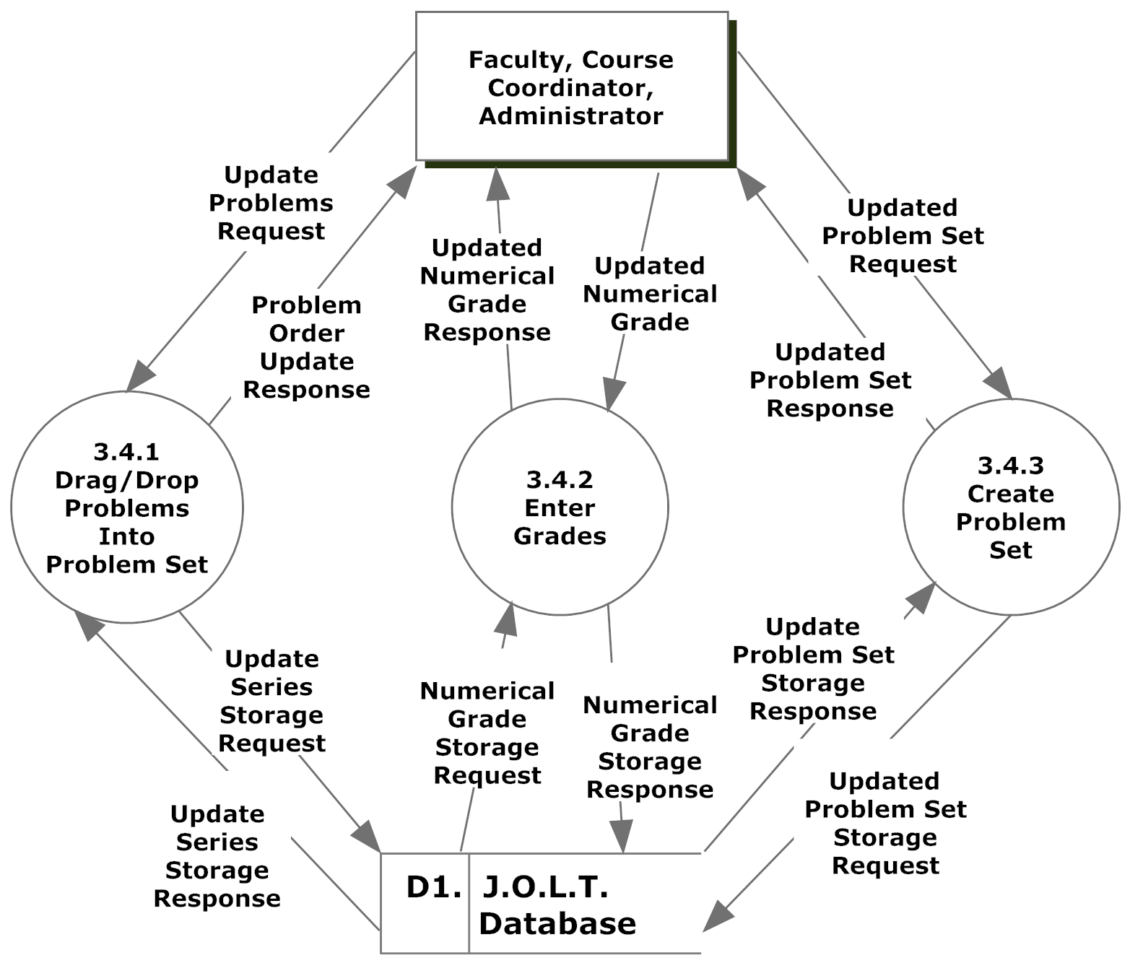

Process 4 Level 1 Manage Courses
This diagram represents a breakdown of how courses are managed by Faculty, Course Coordinator, or Administrator users.
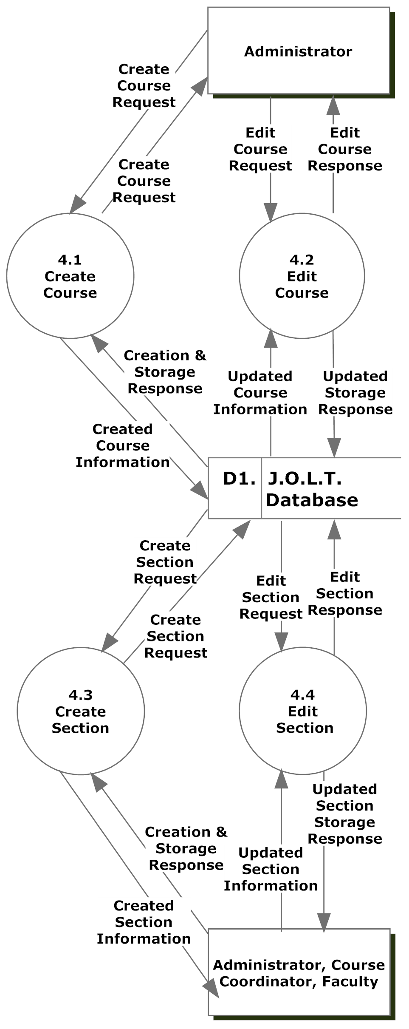
.

Process 4.1 Level 2 Create Course
This diagram represents a breakdown of how course is by an Administrator user.
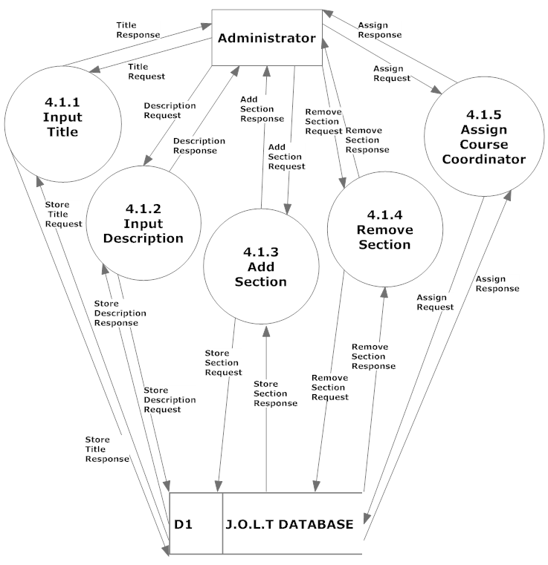

Process 4.2 Level 2 Edit Course
This diagram represents a breakdown of how a course is edited by an Administrator user.
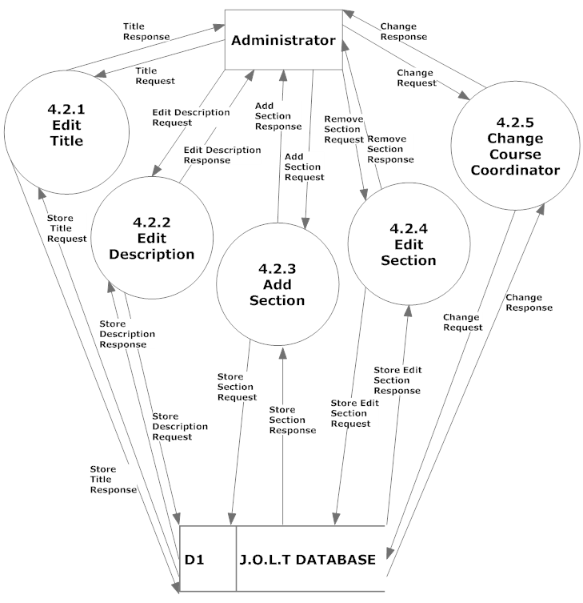

Process 4.3 Level 2 Create Section
This diagram represents a breakdown of how a section is created by an Administrator and Course Coordinator user.
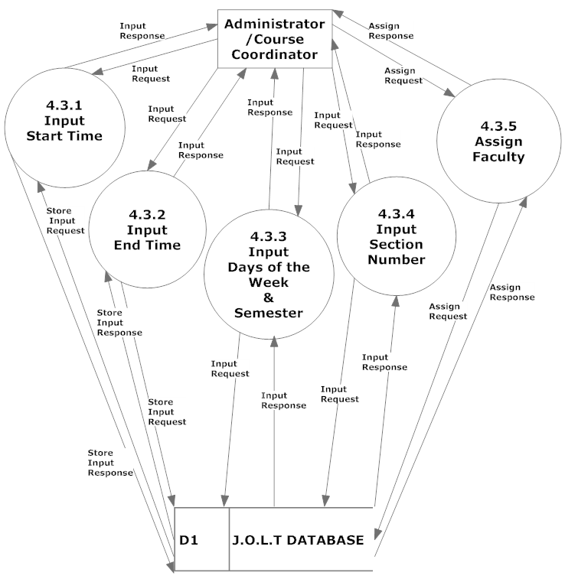

Process 4.4 Level 2 Edit Section
This diagram represents a breakdown of how a section is edited by an Administrator and Course Coordinator user.
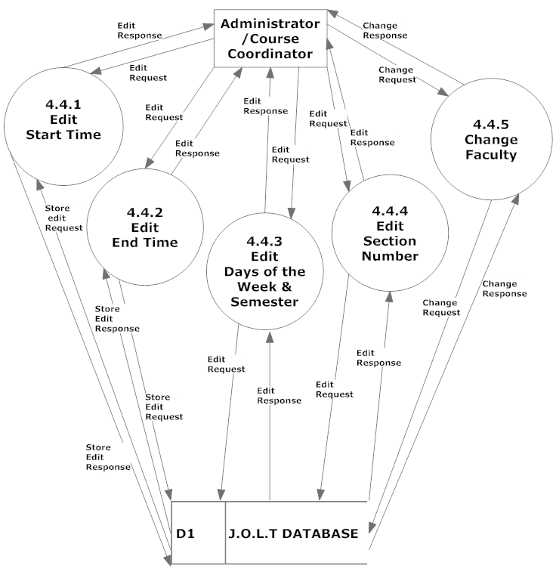

Process 5 Level 1 Registration
This diagram represents a breakdown of how students register with the system.
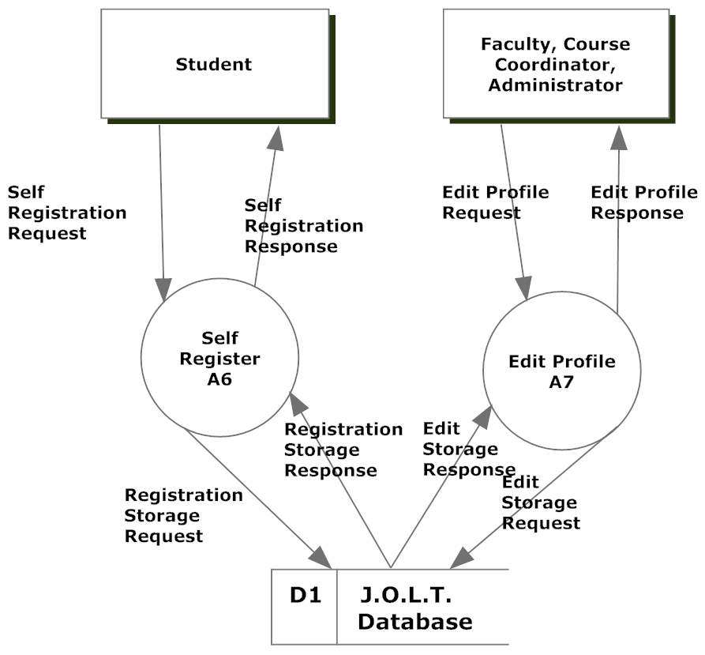

The containing processes are represented as Activity Diagrams, per request of the client. Please reference Diagrams “A6” and “A7” in the Activity Diagram Document.

Process 6 Level 1 Authentication
This diagram represents a breakdown of how authentication is handled within JOLT.
This process is represented as an Activity Diagram, per request of the client. Please reference Diagram “A8” in the Activity Diagram Document.

Process 7 Level 1 Manage Pools
This diagram represents a breakdown of how pools are managed with JOLT for Faculty, Course Coordinators, and the Administrator.
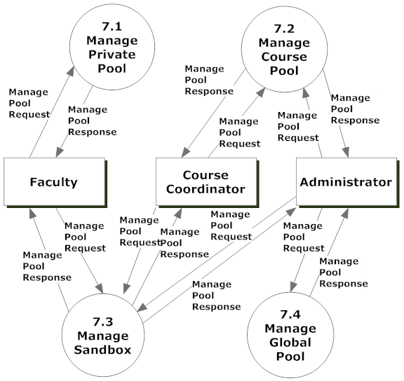

Process 7.1 Level 2 Manage Private Pool
This diagram represents a breakdown of how a private pool is managed by a Faculty, Course Coordinator, or Administrator user.
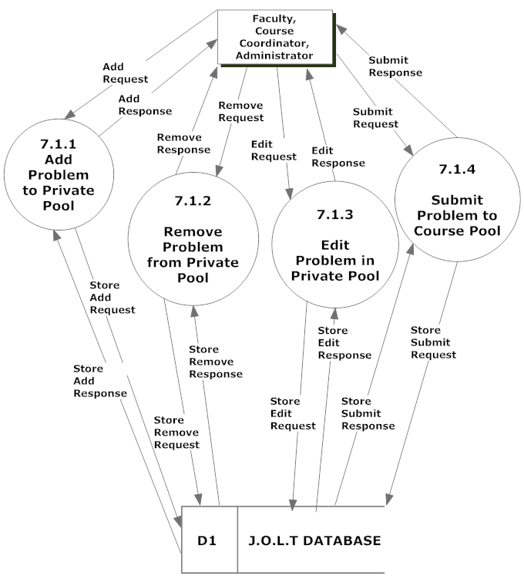

Process 7.2 Level 2 Manage Course Pool
This diagram represents a breakdown of how a course pool is managed by a Course Coordinator, or Administrator user. 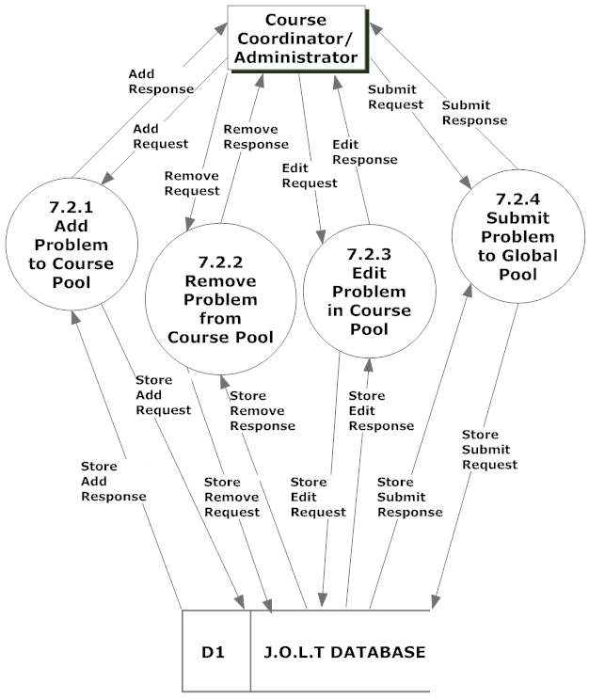

Process 7.3 Level 2 Manage Sandbox
This diagram represents a breakdown of how a sandbox is managed by a Faculty, Course Coordinator, or Administrator user.
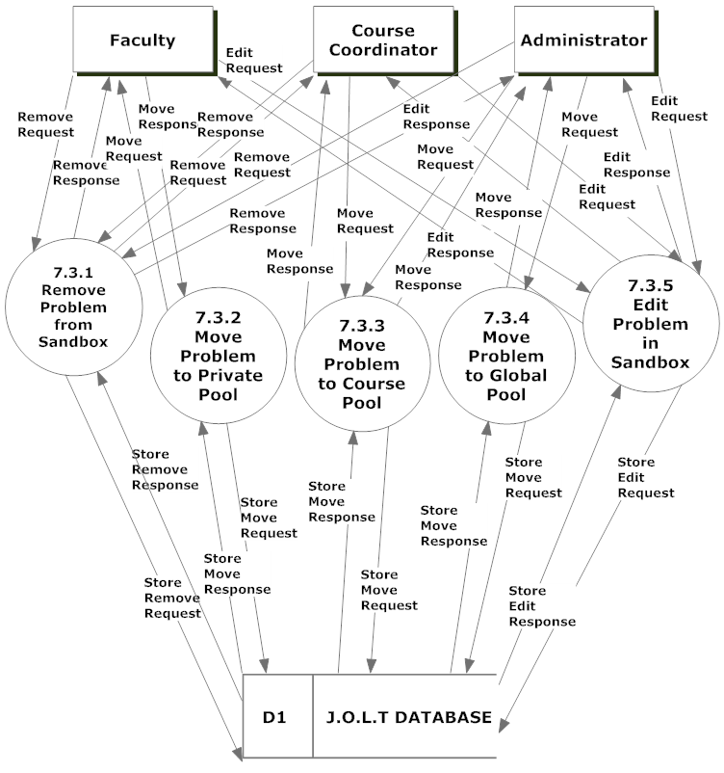

Process 7.4 Level 2 Manage Global Pool
This diagram represents a breakdown of how the Global Pool is managed by the Administrator user.
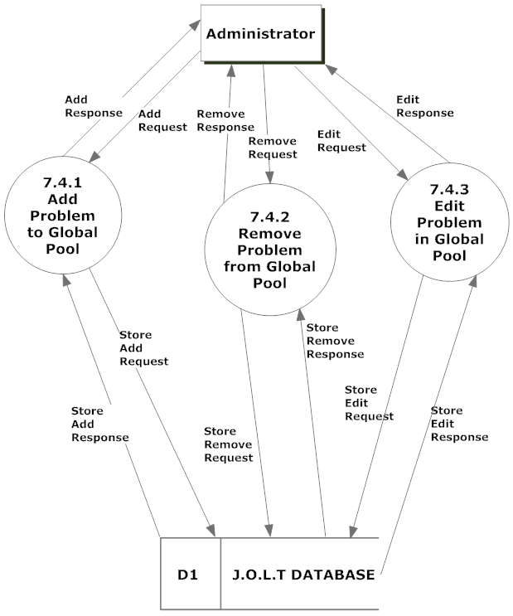

Process 8 Level 1 Manage Users
This diagram represents a breakdown of how users are managed by Course Coordinator, or Administrator users.
Please note that the details for Unlocking, enabling, and disabling accounts have not been established, so those processes (8.4, 8.5, 8.6, respectively) have not been broken down.
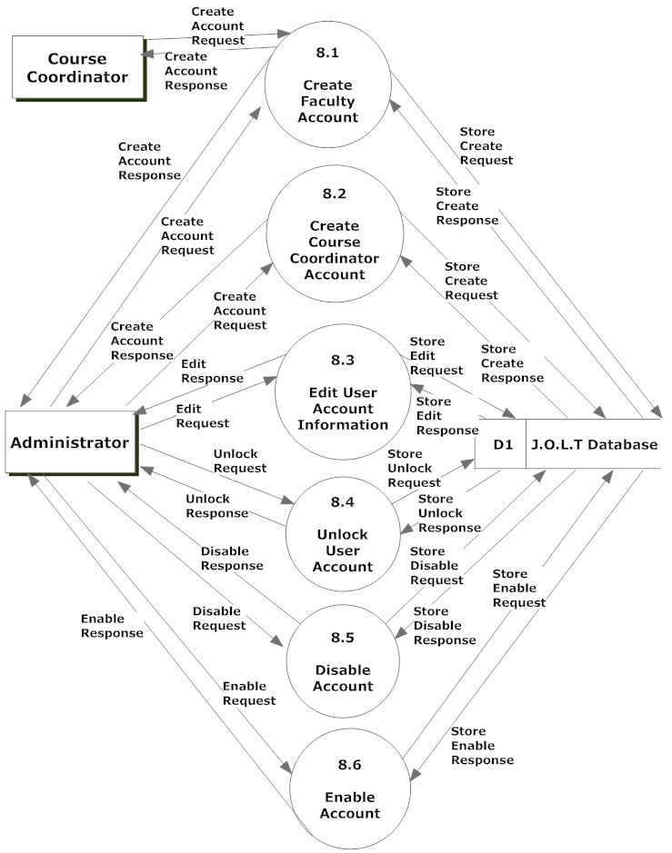

Process 8.1 Level 2 Create Faculty Account
This diagram represents a breakdown of how the Faculty Accounts are created.

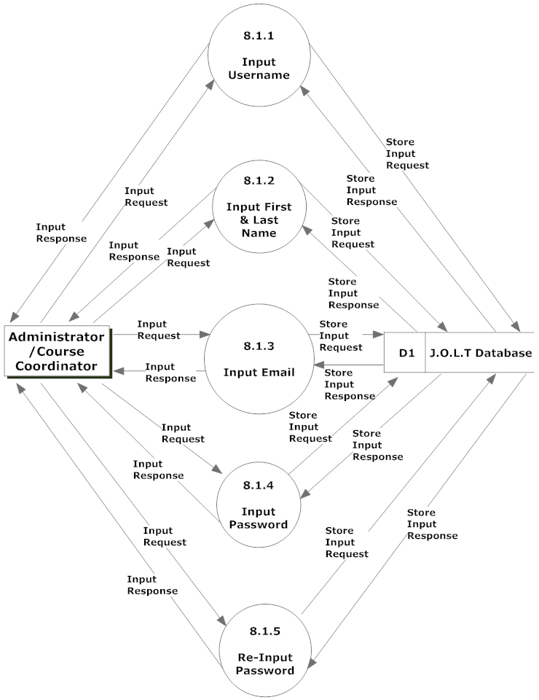

Process 8.2 Level 2 Create Course Coordinator Account
This diagram represents a breakdown of how the Course Coordinator accounts are created.
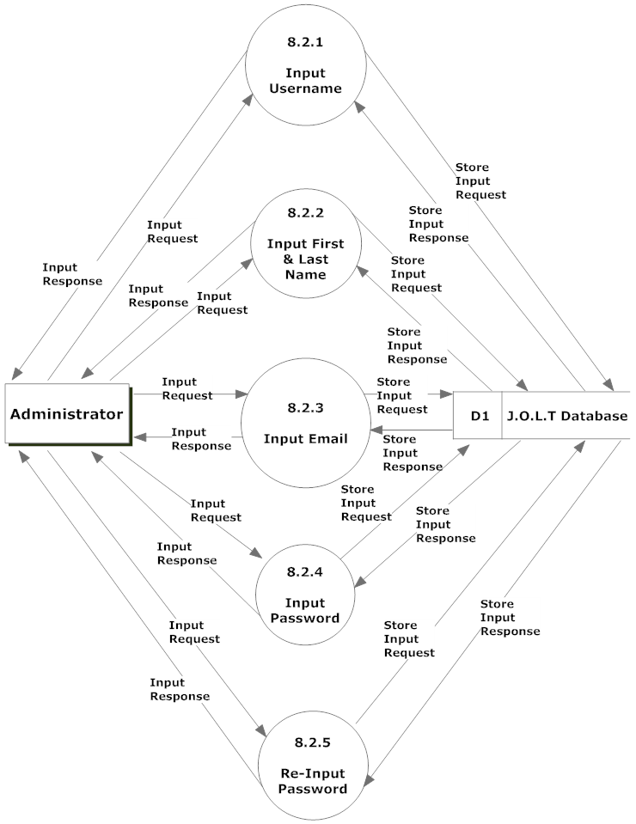

Process 8.3 Level 2 Edit User Account Information
This diagram represents a breakdown of how user accounts are edited.

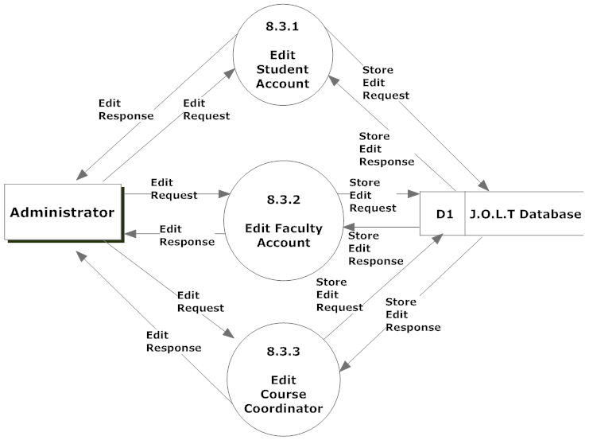

Process 8.3.1 Level 3 Edit Student Account
This diagram represents a breakdown of how student accounts are edited.
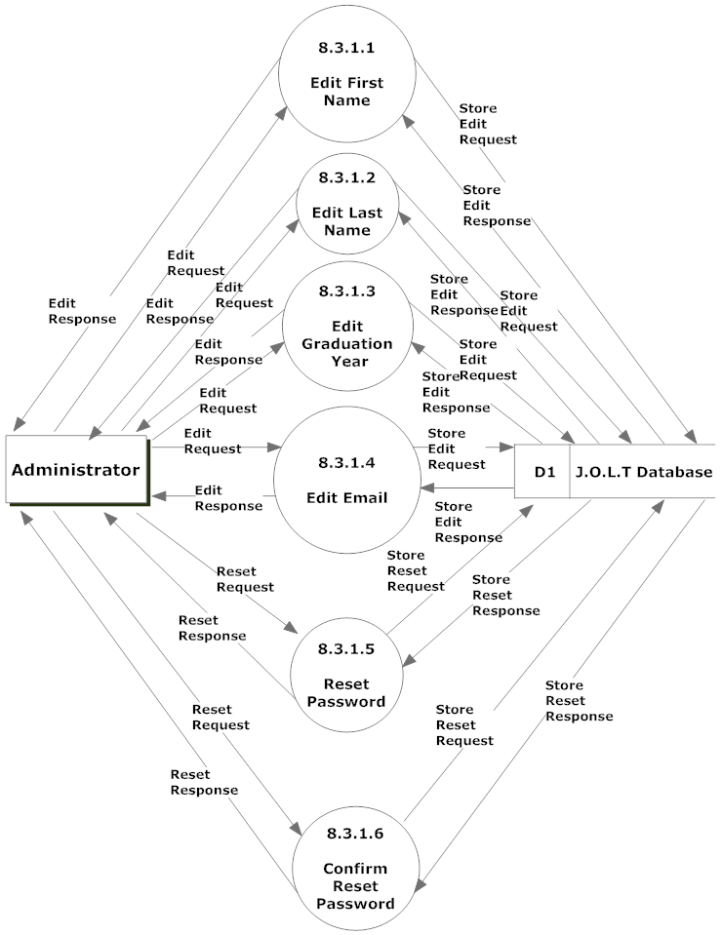

Process 8.3.2 Level 3 Edit Faculty Account
This diagram represents a breakdown of how faculty accounts are edited.
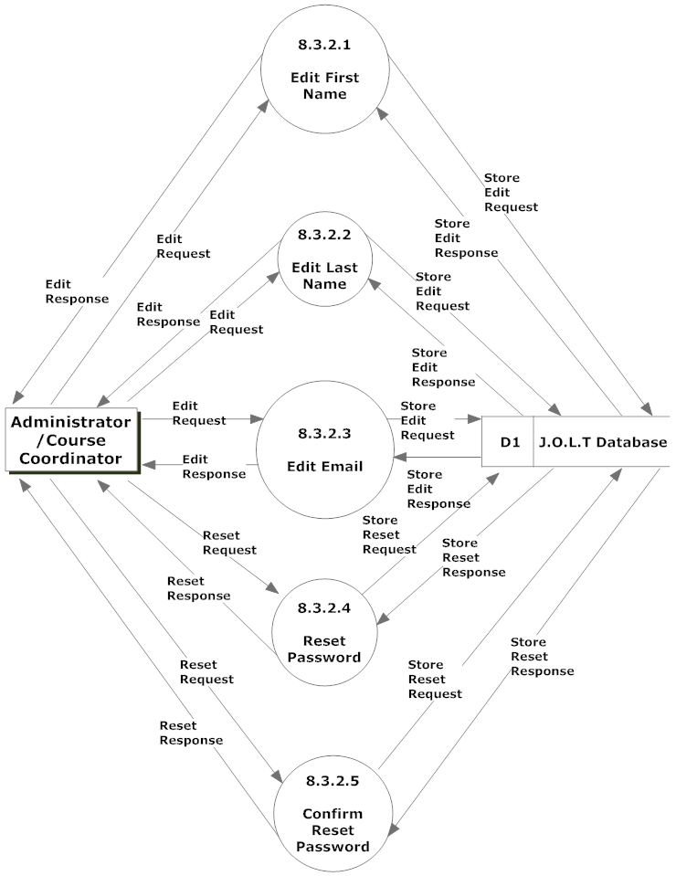

Process 8.3.3 Level 3 Edit Course Coordinator Account
This diagram represents a breakdown of how course coordinator accounts are edited.


